[Title Here, up to 12 Words, on One to Two Lines].

OWEN MILLER
BAE SYSTEMS, UNIVERSITY OF WALES TRINITY ST DAVID
…/11/2025

Abstract

Table of Figures
Figure No | Figure

Table of Tables
Table No | Table

Table of Contents
I. Abstract 2
II. Table of Figures 3
III. Table of Tables 3
IV. Table of Contents 4
1. Aim 5
2. Hypothesis 5
3. Variables 5
4. Theory 6
5. Calculations 7
6. Data & Observations 8
7. Results & Observations 9
8. Conclusion 12
9. References 13
10. Appendix A – Experimental Procedure [1] 13
11. Appendix B – Excel calculator Workbook 13

Aim
The reaction orders in hydrogen peroxide and iodide for the iodine clock system were to be determined, and the rate constant was to be evaluated under fixed experimental conditions using the clock-time method. A secondary aim was to illustrate how empirical kinetics can inform timing elements relevant to Ordnance, Munitions and Explosives (OME).

Hypothesis
It was hypothesised that the time to the first permanent blue colour, $t$, would be inversely proportional to the initial rate of iodine formation [1]. Accordingly, increasing the initial concentration of any reactant present in the rate law would be expected to decrease $t$and increase $1/t$. Linear relations were therefore anticipated between ${log⁡}_{10}(1/t)$and ${log⁡}_{10}[\text{reactant}]_{0}$, with slopes equal to the corresponding reaction orders [2].

Variables
Independent: Part 1—initial $[H_{2}O_{2}]_{0}$,Part 2—initial $[I^{-}]_{0}$.
Dependent: Clock time $t$(s) and reciprocal $1/t$($s^{-1}$).
Controlled: Temperature, acidity, vitamin C concentration, starch concentration, glassware, timing protocol; in both parts the total volume was fixed at 25.0 mL.

Theory
  - Concepts, equations and definitions
In acidic solution, hydrogen peroxide oxidises iodide to iodine:
$$H_{2}O_{2}+2I^{-}+2H^{+}→I_{2}+2H_{2}O.$$
Vitamin C reduces $I_{2}$back to $I^{-}$until the reductant is exhausted; once consumed, free iodine accumulates and forms the blue iodine–starch complex [3]. Because a fixed iodine threshold triggers the visible change, the elapsed time acts as a clock inversely proportional to the initial rate. The empirical rate expression used is:
$$\frac{1}{t}=k [H_{2}O_{2}]^{m}[I^{-}]^{n}.$$
For parameter estimation, ${log⁡}_{10}(1/t)$was regressed on ${log⁡}_{10}[\text{reactant}]_{0}$using ordinary least squares (OLS).

  - Importance of Kinetics in OME
Kinetic characterisation can estimate delay and timing management in OME.
A benign chemical delay element can be tuned by concentration control. Using the present scaling’s (as per 7. Derived rate law), doubling $[I^{-}]_{0}$shortens the delay by $2^{0.88}≈1.84$, whereas a 50% increase in $[H_{2}O_{2}]_{0}$shortens it by ${1.5}^{0.59}≈1.30$. Such levers allow a nominal 30s delay to be adjusted while temperature and acidity are held fixed [4].

Calculations
  - Stock Concentration Conversion
Using 3% (w/w) means $3.00g H_{2}O_{2}$per $100\text{ml}$ of solution:
$$n_{H_{2}O_{2}}=\frac{m}{M_{r}}=\frac{3.00}{34.01}=0.0882 mol\text{(in 100 mL}\text{)}$$
Per litre:
$$[H_{2}O_{2}]_{\text{stock}}=\frac{0.0882 \text{M}}{0.100L}×\frac{0.100}{1.000}=0.882 \text{Mol}L^{-1}=0.88 M$$

  - Initial Concentration by Dilution
For any species $X$delivered from a stock $C_{X,\text{stock}}$at volume $V_{X}$ into a mixture of total volume $V_{\text{tot}}$:
$$[X]_{0}=\frac{C_{X,\text{stock}} V_{X}}{V_{\text{tot}}}(\text{with }V\text{ in L or mL consistently}).$$
Worked example (Part 1, Trial I.2):
$$[H_{2}O_{2}]_{0}=\frac{0.88×2.0}{25.0}=0.0704M;[I^{-}]_{0}=\frac{0.20×3.0}{25.0}=0.02400 \text{M}.$$

  - Transformations used for regression
$$y=\log_{10}\left(\frac{1}{t}\right),x={log⁡}_{10}[\text{reactant}]_{0}.$$

The fitted OLS line is $y=a+bx$. For Part 1, $b=m$(order in $H_{2}O_{2}$); for Part 2, $b=n$(order in $I^{-}$). The intercept $a={log⁡}_{10}k^{'}$is a pseudo-constant for each series.

  - Computing the overall rate constant $k$
From the empirical rate law ,
$$k=\frac{1/t}{[H_{2}O_{2}]^{m}[I^{-}]^{n}}.$$
Worked example (Part 2, Trial II.3):
$$\begin{matrix}t & =90s ,\frac{1}{t}=0.011111 s^{-1} \\ [H_{2}O_{2}]_{0} & =0.1056 \text{M},[I^{-}]_{0}=0.02400 \\ k & =\frac{0.011111}{(0.1056)^{0.5939}(0.02400)^{0.8755}}=1.106 s^{-1} M^{-1.47}.\end{matrix}$$
The pooled estimate (mean ± sample standard deviation) was $k=1.113±0.091s^{-1} M^{-1.47}$with relative standard deviation (RSD) = 8.2% (this was calculated as the sample standard deviation divided by the mean, multiplied by 100%, using the per-trial $k$ values from Parts 1 and 2: sections 6.1, 6.2).

Data & Observations
  - Part 1: Order in $[H_{2}O_{2}]$
Trial | [H2O2] (M) | t (s) | 1/t (s⁻¹) | log10[H2O2] | k (s⁻¹ M⁻¹·⁴⁷)
I.1 | 0.03520000 | 167 | 0.00598802 | −1.453457 | 1.144
I.2 | 0.07040000 | 131 | 0.00763359 | −1.152427 | 0.967
I.3 | 0.10560000 | 88 | 0.01136364 | −0.976336 | 1.131
I.4 | 0.14080000 | 75 | 0.01333333 | −0.851397 | 1.119

  - Part 2: Order in $[I^{-}]$
Trial | [I−]0 (M) | t (s) | 1/t (s⁻¹) | log10[I−]0 | k (s⁻¹ M⁻¹·⁴⁷)
II.1 | 0.00800000 | 215 | 0.00465116 | −2.096910 | 1.211
II.2 | 0.01600000 | 142 | 0.00704225 | −1.795880 | 1.000
II.3 | 0.02400000 | 90 | 0.01111111 | −1.619789 | 1.106
II.4 | 0.03200000 | 63 | 0.01587302 | −1.494850 | 1.228

Results & Observations

Figure 1 - versus ${log⁡}_{10}[\text{reactant}]_{0}$for both parts
Goodness of fit and orders. Linear fits were strong (Part 1 $R^{2}=0.953$, Part 2 $R^{2}=0.968$) with no trend in residuals. The order in hydrogen peroxide was $m=0.5939$(fractional) and in iodide $n=0.8755$(near first order). The rate law:
$$\text{Rate}=k [H_{2}O_{2}]^{0.59}[I^{-}]^{0.88}$$
Described the data within the tested ranges. Per-trial $k$values were consistent (relative standard deviation ≈ 8%).
  - What is weak in the data
Single runs per condition. Each concentration level was recorded once. Without replicates there is no direct estimate of within-condition variance, so the standard errors on slopes and intercepts are optimistic. A single mistimed endpoint can shift the slope noticeably because there are only four points per series [5].

Narrow dynamic range. Each series spans only a ~4× concentration range and roughly a 2–3× change in $1/t$. Slopes from such short baselines are sensitive to small timing or concentration errors; leverage from the end points is high [6].

Potential heteroscedasticity. Timing precision is worse at short times (mixing and reaction overlap) and at very long times (operator drift). Residuals were visually even, but with $n=4$this cannot be tested reliably, unequal variance would bias ordinary least squares.

Endpoint definition. “First permanent blue” is subjective and operator-dependent. Small differences (≈1–2 s) matter when $t$is 60–90 s. Rounding to whole seconds introduces quantisation error that propagates in $1/t$and ${\log{}}_{10}\left(\frac{1}{t}\right) CITATION Ton23 \backslash l 2057 [5]$.
Mixing dead time. The clock starts when reagents contact, not when the mixture is homogeneous. Variable dead time adds a run-specific offset to $t$, bending the log–log relationship if it changes with condition [5].

  - Mitigation methods
Photometric endpoint: Replace the visual call with a fixed absorbance threshold using a colorimeter or simple LED/photodiode at the iodine–starch band. This removes operator bias, reduces second-level jitter, and produces continuous time stamps for better regression [7].

Thermostatting and logging: Run in a water bath at a fixed temperature and record it each run. This converts a major uncontrolled factor (ambient temperature) into a controlled condition

Standardised mixing with replication: Fix the addition order, vessel geometry, and stirring protocol. then collect at least triplicate runs at each concentration. Replicates exposed outliers and allow proper standard errors and confidence intervals on $m$, $n$, and $k$.
  - Overall
The current dataset supports the reported orders and an average $k$, but its evidential strength is limited by single runs, a short concentration span, and subjective endpoints. The three mitigations above would most directly improve reliability, and the alternative routes would offer stronger tests of the rate law with reduced bias.

Conclusion
The iodine clock data were described by a power-law model with fractional order in hydrogen peroxide and near-unity order in iodide. From log–log fits, the orders were $m=0.5939$and $n=0.8755$; the pooled rate constant was $k=1.113±0.091 s^{-1} M^{-1.47}$. The fits were linear over the tested ranges and the trial-by-trial $k$values were consistent, indicating that the model was adequate for prediction within these conditions.
The evidential strength was limited by single runs per condition, a narrow concentration span, subjective visual endpoints, and uncontrolled temperature. These factors likely inflated uncertainty in slopes and intercepts. The reliability of the parameters could be improved by photometric endpoint detection, thermostatted operation, and standardised mixing with replication. For OME use, the quantified rate law provides a practical basis to tune benign timing elements by concentration adjustment and to set defensible margins in design and safety documentation. Further work should obtain Arrhenius parameters for $k$from a temperature series and validate the orders using initial-rate methods that minimise mixing and endpoint bias.

References

[1] | M. L. M. V. B. a. S.-D. Szilárd Pesek, “On the Origin of the Blue Color in The Iodine/Iodide/Starch Supramolecular Complex,” Babeş-Bolyai University, Cluj-Napoca.
[2] | S. L. Goldsmith, “Tracing the Evolution of the Iodine Biogeochemical Cycle,” ProQuest, Manchester, 2007.
[3] | “Determination of Vitamin C Concentration by Titration,” Canterbury.
[4] | Handbook on the Management of Ordnance and Explosives at Closed, Transferring, and Transferred Ranges and Other Sites, 2002.
[5] | A. S. B. Tony Badrick1, “Identifying human factors as a source of error in laboratory quality control,” Journal of Laboratory and precision medicine, vol. 8, 30 07 2023.
[6] | J. Chen, “Line of Best Fit in Regression Analysis: Definition & Calculation,” 07 10 2025. [Online]. Available: https://www.investopedia.com/terms/l/line-of-best-fit.asp. [Accessed 29 10 2025].
[7] | D. R. Paschotta, “Photometers,” RP photonics, [Online]. Available: https://www.rp-photonics.com/photometers.html. [Accessed 30 10 2025].
[8] | E. Kazimierska, “Exp_2_Rate of reaction_lab_report Adv Chem 2526,” University of Wales Trinity St David, Swansea, 2025.

Appendix A – Experimental Procedure [8]
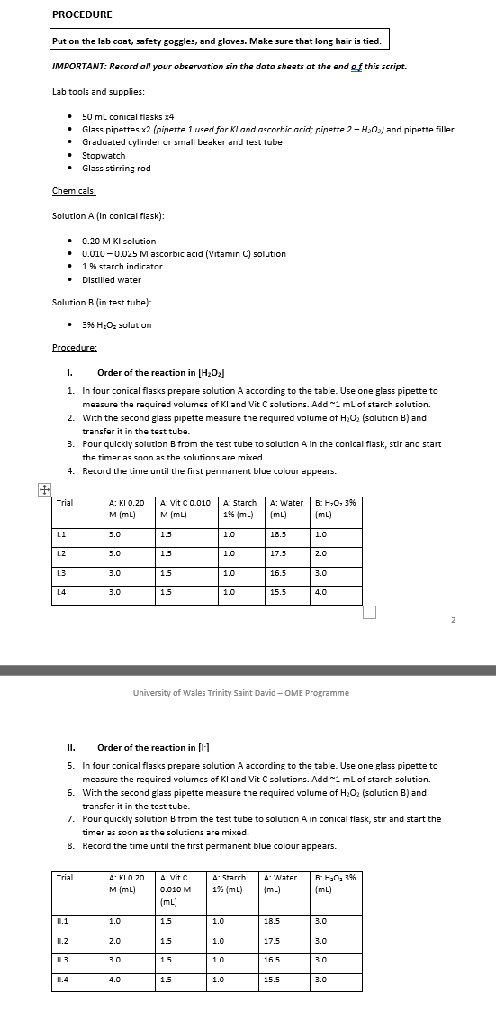

Appendix B – Excel calculator Workbook


