Module Name: Hotel Placement – Managing Food and Beverage Operations
Assignment Title: Student Learning Log
Module Code: BMIH6002

Sumaiya Begum Tanni
Student ID: 2211676

LEVEL 6
Lecturer: Jessica Newport

Declaration

I declare that this dissertation is the result of my own independent and original investigation and that all sources are duly acknowledged in the reference list. I have not used Ai in my work.

Name: Sumaiya Begum Tanni
Date: 12/06/2025

Acknowledgement

I am very grateful to my course supervisor for her kind cooperation, guidance, and suggestions to improve this project.

Moreover, I am thankful to my lecturer (Jessica Newport) and placement hotel whose support and cooperation aided me in accomplishing this project.

Thank you again to all of them.

Table of Contents
Introduction 1
Section 1: Role Reflection 2
Application of Gibbs' Reflective Cycle 2
Role Analysis and Key Responsibilities 2
Supervisory Skills Reflection 2
Critical Incidents Analysis 2
Professional Development Action Plan 3
Section 2: Development Journey 4
Comparative Analysis of Placement Experiences 4
Integration of Academic Learning 4
Section 3: Service Improvement Proposal 5
Identified Improvement Area 5
Justification Through Firsthand Observations 5
Improvement Plan Development 5
Conclusion 7
References 8

Introduction
Ibis Shipley Hotel is a contemporary low-cost hotel that operates a lean F&B operation to serve business and leisure travellers efficiently. The hotel will have a modern restaurant serving British and continental dishes, a relaxed bar lounge and room service focusing on consistency, quick services and budget friendliness. I identified three learning outcomes during my placement: to observe and gain advanced supervisory skills through leadership involvement, to increase my knowledge in operational efficiencies and workflow improvements and to gain customer service skills by handling guest relations and working in demanding and hectic-paced service situations characteristic of the mid-market hospitality industry (Fallon and Rutherford, 2010).

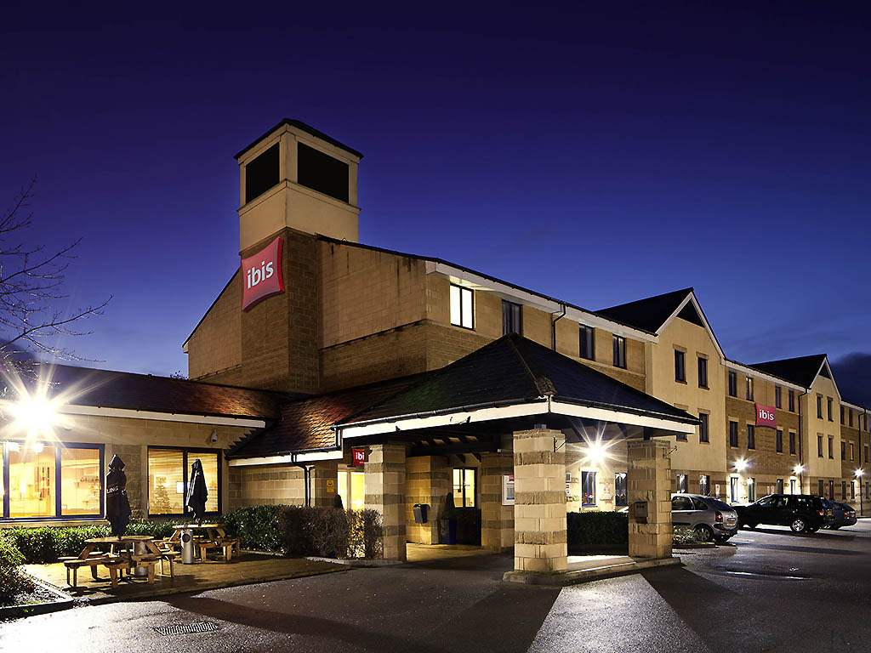
Figure: Ibis Shipley (ibis, 2025)

Section 1: Role Reflection

Application of Gibbs' Reflective Cycle
By applying the reflective model of Gibbs as my theoretical framework, I will be able to reflect on my placement experiences in a structured manner using the descriptions, feelings, evaluation, analysis, conclusion and action planning (Galli and New, 2022). This systematic process allows more in-depth learning as it bridges the gap between theory and practice.

Role Analysis and Key Responsibilities
The scope of my job allowed me to combine both receptionist and housekeeping tasks, thus giving me a rare perspective on the acute interdependence of operations in a hotel, especially the direct influence of front-of-house functions on the F&B service operations. The decision-making activities which I was able to observe included instantaneous responses to guest services to strategic changes in operations depending on occupancy levels and guest suggestions (Hagg, 2013). The experiences made the cooperative effort between departments as well as the essential role of communication in ensuring the standards of service particularly evident.

Supervisory Skills Reflection
The active observation and participation allowed me to learn that successful supervision of F&B operations should be balanced between technical expertise, emotional intelligence, and adaptive leadership. I was strong in the area of communication and mediating guest operations expectations, but saw the necessity to gain confidence in high-stress decision making and providing difficult feedback. Supervisors who employed situational leadership came out as the most effective, as they changed their styles depending on the needs of the team and tasks, which was essential at peak service periods to sustain quality and normal flow of operations (Rodić and Marić, 2021).

Critical Incidents Analysis
Among the most serious accidents, there was a case when a big party came at the time of the rush breakfast orders, and the equipment failure in the kitchen happened simultaneously. The reaction of the F&B supervisor proved to be an outstanding crisis management skill, which restructured the service flow, provided clear communication to the guests regarding the delays, and offered alternative solutions. This event was an example of how proper management could turn possible service recovery situations into a chance to show dedication to guest satisfaction (Johnston, Clark and Shulver, 2012).

On the other hand, I encountered an instance in which a lack of effective communication among the supervisory personnel led to giving contradicting orders to the team members, which caused confusion to them and affected the efficiency of the services being offered (Kamal, Raihan and Maidin, 2023). This situation reaffirmed the significance of effective communication lines and coherent leadership strategies towards operational efficiency.

Professional Development Action Plan
In my action plan, I address three important areas that need improvement. To begin, I will seek further conflict resolution and decision-making under pressure training via professional development workshops and mentoring relationships. Second, I will enhance my technical understanding of F&B operations by achieving special certifications and traversing training options. Third, to overcome the lack of leadership presence, I will actively pursue supervisory duties in future jobs and request feedback regularly from more experienced managers (Walker, 2021).

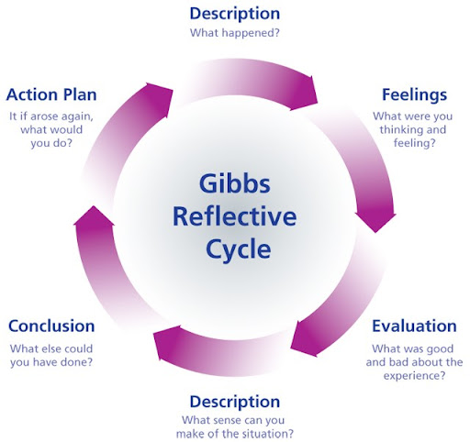
Figure: Gibbs Reflective cycle (Galli and New, 2022)

Section 2: Development Journey

Comparative Analysis of Placement Experiences
When taking a look back at my Level 4 F&B Valentines menu experiences, I can confidently say that my perceptions and views on how a hospitality operation works have evolved greatly. As the menus do differ according to the occasions or the theme the hotel has chosen. The Ibis Shipley experience revealed the significance of the standardised processes and operational effectiveness within the branded hotel settings. This comparison made me appreciate various operation models and their suitability in serving various market segments.

Ibis Shipley's operations were large and complex, something that compelled me to become more systematic in my thinking regarding service delivery and resource management (Walker, 2021). My level 4 Food & Beverages was a written experience that focused mosyly on research and investigation whereas my experience in Food and Beverages in Ibis Shipley for Level 6 was largely based on one-on-one encounters with guests, this placement reinforced the need to be aware of bigger picture operational structures and how they contribute to the overall guest experience.

Integration of Academic Learning
The knowledge I gained in my Level 4 Food & Beverage Operations module was a real asset in this placement, especially when it comes to menu planning principles and streamlining the service flow (Cousins and Weekes, 2020). These concepts, however, came to be felt in practice, the implementation part in real real-world setting where numerous variables are continuously affecting operations. The theoretical knowledge concerning the area of cost control and revenue management acquired a new sense when I saw the process of making decisions every day based on the balance between profitability and guest satisfaction.

The Level 5 Sustainable Hospitality & Tourism Management module has played a major role in enhancing my observation of environmental practices in the F&B operation. I observed the waste reduction, local sourcing in progress and use of energy-efficient equipment in the hotel that matched with the modern sustainability models we learned. This theoretical background allowed me to approach these practices critically and think about their efficiency regarding the bigger picture of corporate social responsibility practices.

Section 3: Service Improvement Proposal

Identified Improvement Area
Systematic observation and colleagues' talk allowed me to state the consistency of staff training as the key aspect that should be improved in the F&B operation. I found that the service standards varied across shifts and team members, indicating a potential disconnect in training delivery and continued professional growth support.

Justification Through Firsthand Observations
Placement experiences I witnessed some team members who had joined the team recently had issues with menu knowledge and upselling methods, and at the same time, some long-term employees had mixed methods of approaching guest complaints. The discussion with the peers showed that they were frustrated by the lack of training opportunities and the clarity of performance requirements. These insights indicated that more effective training systems would be very useful in boosting the confidence of employees as well as the level of guest satisfaction (Fanthorne, 2004).

Improvement Plan Development
In my enhancement proposal, I focus on the introduction of the complex training enhancement program that consists of three actionable items. The first one will be the introduction of standardised training modules that encompass both theoretical aspects and the development of practical skills, which will result in uniform service delivery regardless of the shift. Second, the use of a mentorship program, where senior employees are matched with newer members of the team, to transfer knowledge and develop confidence (Kamal, Raihan and Maidin, 2023). Third, implementing frequent performance feedback meetings, issuing constructive advice, and rewarding outstanding service provision.

Modern academic sources endorse the positivity of well-planned training initiatives to enhance hospitality service levels (Sandy, 2025). The study proves that an effective training program can extend beyond technical skills to boost engagement and retention rates, leading to better operational performance and guest satisfaction. The performance measures of this improvement plan would be based on quantifiable results such as guest satisfaction ratings, service delivery rate, and staff confidence level. The improvement of technical knowledge would be measured by periodic competency tests and analysis of guest comment cards, and would be constantly improved to match the standards of hotel service.

Conclusion
This position provided significant knowledge on the intricacy of the hospitality business, particularly F&B. Reflecting on my learning with the help of the Gibbs reflective model promoted professional development. My objectives in supervisory skills and operating knowledge were achieved, but customer service requires additional attention. The combination of the academic theory and practice improved my comprehension of evidence-based decisions. The experience as a whole affirmed my interest in hospitality leadership and the need to engage in lifelong learning to achieve excellence and guest satisfaction.

References
Cousins, J. and Weekes, S. (2020). Food and Beverage Service. 10th Ed. London: Hodder Education.
Fallon, M. and Rutherford, D. (2010). Hotel Management and Operations. London: Wiley.
​​Fanthorne, C. (2004). Work Placements – Survival Guide for Students. Basingstoke: Macmillan.
Galli, F. and New, K. (2022). Gibbs’ cycle review. Emotions as a part of the cycle. [online] ResearchGate. Available at: https://www.researchgate.net/publication/366459771_Gibbs.
Hagg, E. (2013). Internship Guide: Work Placements Step by Step. 5th Ed. The Hague: Eleven International Publishing.
ibis (2025). Ibis Bradford Shipley | Comfortable Hotel in Bradford - ALL. [online] all.accor.com. Available at: https://all.accor.com/hotel/3158/index.en.shtml
Johnston, R., Clark, G. and Shulver, M. (2012) Service Operations Management: Improving Service Delivery. 5th Ed. London: Pearson.
Kamal, N., Raihan, N. and Maidin, A. (2023). Communication Barriers in Work Environment: Understanding Impact and Challenges. [online] ResearchGate. Available at: https://www.researchgate.net/publication/375903142_Communication_Barriers_in_Work_Environment_Understanding_Impact_and_Challenges.
Rodić, M. and Marić, S. (2021). Leadership style and employee readiness: Basic factors of leadership efficiency. Strategic Management, [online] 26(1), pp.53–65. doi:https://doi.org/10.5937/straman2101053r.
Sandy, M.Y. (2025). Linking Employee Training And Development To Enhanced Customer Satisfaction In Hotels. Journal of International Multidisciplinary Research, [online] 3(1), pp.56–70. doi:https://doi.org/10.62504/jimr1151.
Walker, J.C. (2021). Introduction to Hospitality. 8th Ed. Harlow: Pearson Education Limited.

