Electronics Principles and Concepts
ABU BOKKOR TALUKDER
Task 1: Identification of circuit elements in the power supply unit of any electronic equipment and their roles
In any electronic equipment, there are certain circuit elements in the power supply unit of it. Those are the followings,
- A DC power supply which is also known as PSU
- Transformers and rectifiers
- Filter circuits
All of these have different roles.

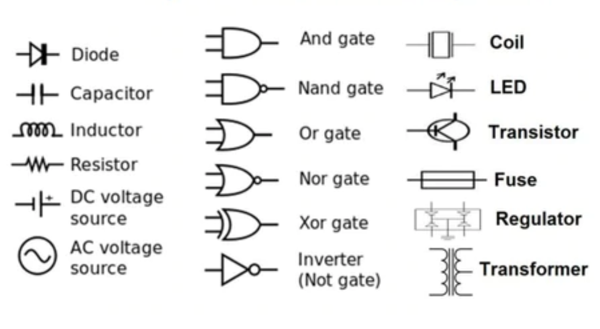
Figure 1: Circuit symbols of electronic components
(Source: LinkedIn, 2022)
Task 2: Drawing of circuit diagrams
a)
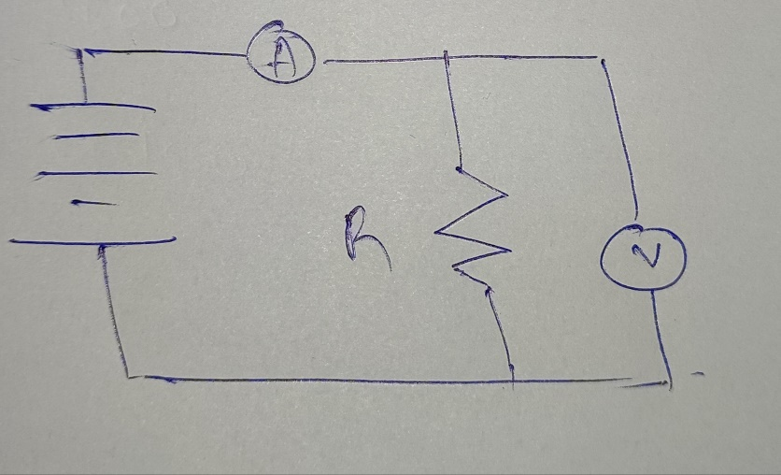
b)
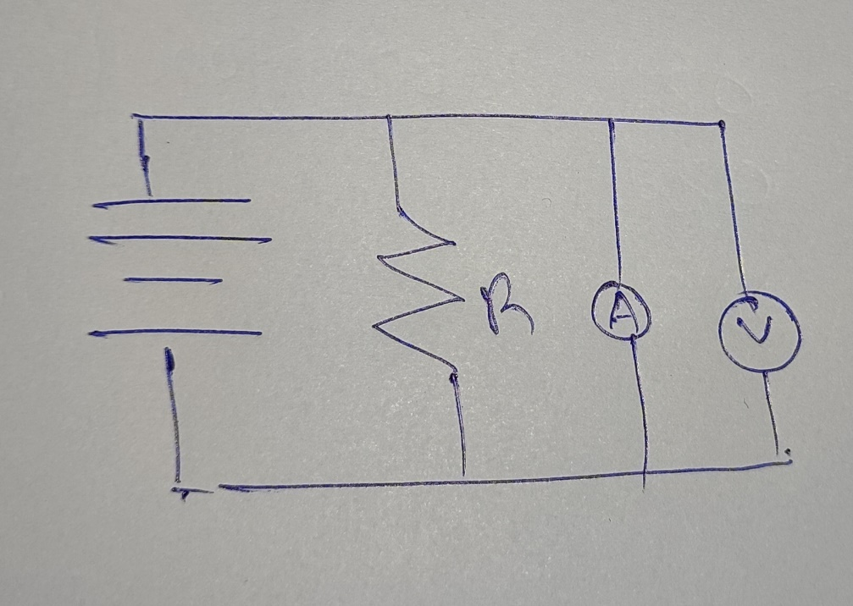

c)
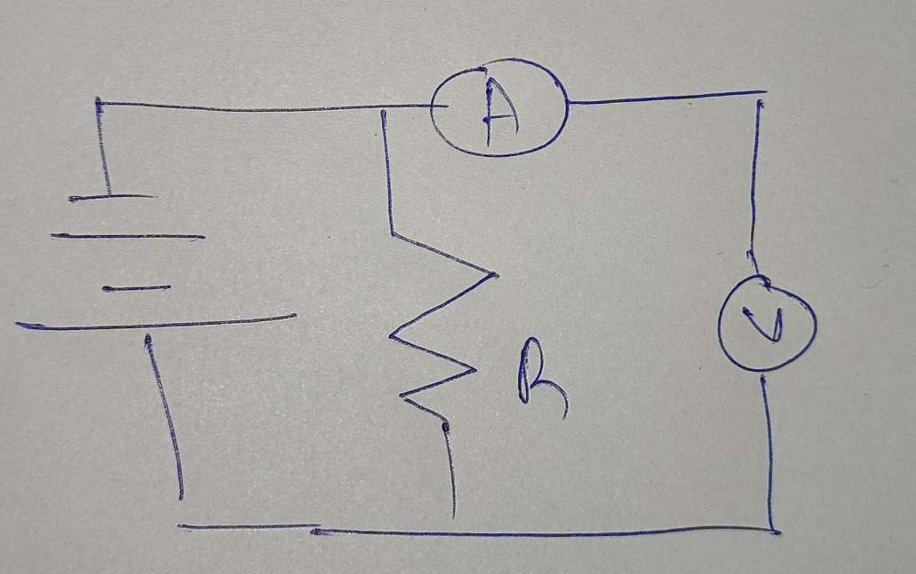

Task 3: How to identify the power supply requirements of electronic equipment?

The voltage of charger equipment is 20
Current and the power requirement of 1.5

Task 4: Analysis of the practical benefits of using electrical laws and theorems in electrical circuits
Avoiding Uncertainties: The Confusion Mitigation element is about how a group addresses the question of never knowing the future. This uncertainty causes fear and various people have learned to cope in diverse situations with this stress. In the Avoidance Of uncertainty score, the degree to which cultures feel menaced by unclear or unexpected events and have developed behaviours and organizations which prefer to avoid these circumstances (Pan et al. 2017). With 30 China, the High Uncertainty score is poor (Hofstede, 2021). Reality can be subjective but it narrates that only the strict laws are concerned with the specific social groups. Nevertheless, obedience to rules and regulations can be versatile, and rationality is a part of life. The people of China are familiar with vagueness. Chinese are creative and able to adapt. The majority of the enterprises seem to be operated by small and moderate and family-owned companies. in writing.
Individualism: With a score of 20, the Chinese people can be stated to behave in the desires of the party and not actually individually, which is a strongly collectivist culture (Hofstede, 2021). Group-wide factors shape recruitment and special care is given to the promotion of classes. Employee involvement with the company but not generally with the people is minimal (Cai and Li, 2018). Although in-group connections are friendly with friends, including out connections are hostile and aggressive. Task and business are known to be dominated by personal partnerships.
Task 5: Logbook for the module

Weeks | Topic and areas of concern | Answers
Week 1 | Fundamental concept of electricity | Within the basics of electricity, there are current, voltage, power and energy. Current is the flow of charge that passes through a certain boundary. In any metallic material, the current is carried by electrons as those are free to move within metals. Practically, the current is made up of moving electrons in a metal. There are different situations where current is carried by either positive or negative charges. Current is the result of the response to electric and magnetic forces by charged objects. Voltage is an electromotive force which is the energy per unit charge. It can also be referred to as the difference in the electric potential between two points. Electrical power can be defined as the energy which is transferred or transformed over time. There is a requirement for an electric circuit for the transferring of power. Here, current can be said as the rate of flow of charge and the measurement of energy transferred per unit of charge is done by identification of voltage. All of these definitions are also used for the formation of formulas to find these.
Week 2 | Important electronic components and their roles | There are active and passive electronic components. The active components are the ones that have directionality such as integrated circuits, logic gates, and transistors. On the other hand, passive components are the ones that do not have any directionality. These are known as electrical components such as capacitors, diodes, resistors, inductors etc. All of these electronic components have different functions. Connectors or terminals are used for making electrical connections. Resister is there for resisting current as per the requirement of the users. Switches are used for conduction or avoiding conduction. Capacitors are there for storing electrical charge in the electrical field. Magnetic or inductive components are there for being used in magnetism. The network components are those that are used by more than one type of passive component. There are also semiconductors for controlling electronics with no moving parts. Transistors are a type of semiconductor which is capable of amplification. The integrated circuit can be termed as a microelectronic computer circuit which is incorporated within a semiconductor. It is a complete system not a single component of electronics.
Week 3 | Main laws that are used for governing voltage and currents in circuits such as Kirchhoff's law, Ohm's law etc.
Week 4 | Electronic components which are used in the circuit (Circuit components) | 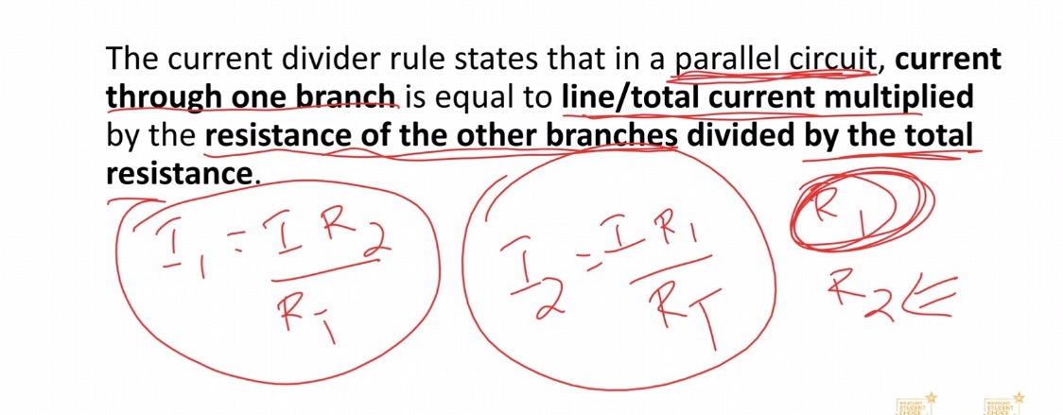
Week 5 | Circuit theory
Week 6 | Power electronics devices and circuits | 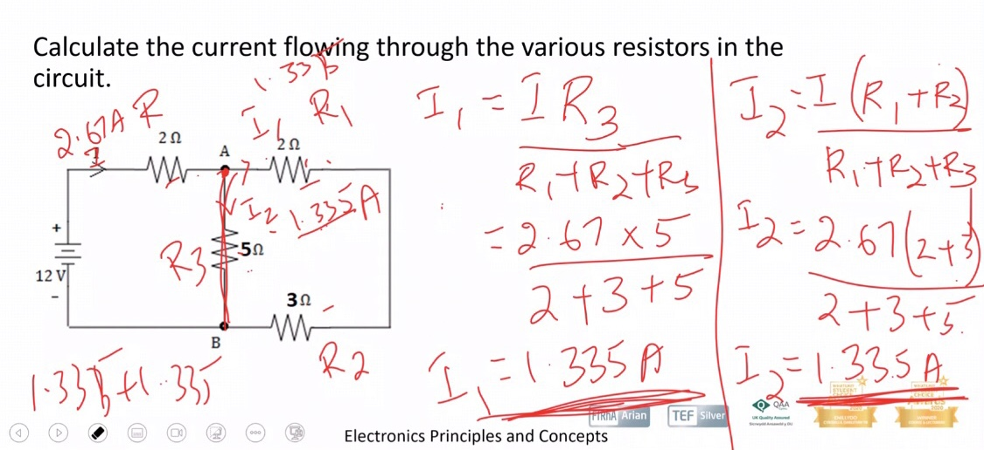
Week 7 | Physical electronics

Reference List
Beerbaum, D. O., Piechocki, M., & Weber, C. (2021). Is there a conflict between principles-based standard setting and structured electronic reporting with XBRL?. Available at SSRN 3837235.
Duranti, L. (2001). Concepts, principles, and methods for the management of electronic records. The Information Society, 17(4), 271-279.
Gao, H., Venderbos, J. W., Kim, Y., & Rappe, A. M. (2019). Topological semimetals from first principles. Annual Review of Materials Research, 49, 153-183.
Geerlings, Paul, Eduardo Chamorro, Pratim Kumar Chattaraj, Frank De Proft, José L. Gázquez, Shubin Liu, Christophe Morell, Alejandro Toro-Labbé, Alberto Vela, and Paul Ayers. "Conceptual density functional theory: status, prospects, issues." Theoretical Chemistry Accounts 139, no. 2 (2020): 1-18.
Maini, A. K. (2007). Digital electronics: principles, devices and applications. John Wiley & Sons.
Xin, N., Guan, J., Zhou, C., Chen, X., Gu, C., Li, Y., ... & Guo, X. (2019). Concepts in the design and engineering of single-molecule electronic devices. Nature Reviews Physics, 1(3), 211-230.

