Individual Presentation on ‘Training and Development needs for a HR officer’

Student name ……………….. Maxim Babin
Student number ………………… 1909116
Lecturer name ……………….. Nandish Patel
Module title ………………… Developing Relationships and Workplace Achievements
Module code ………………… BMSW 5102

Slide 1

Slide 2

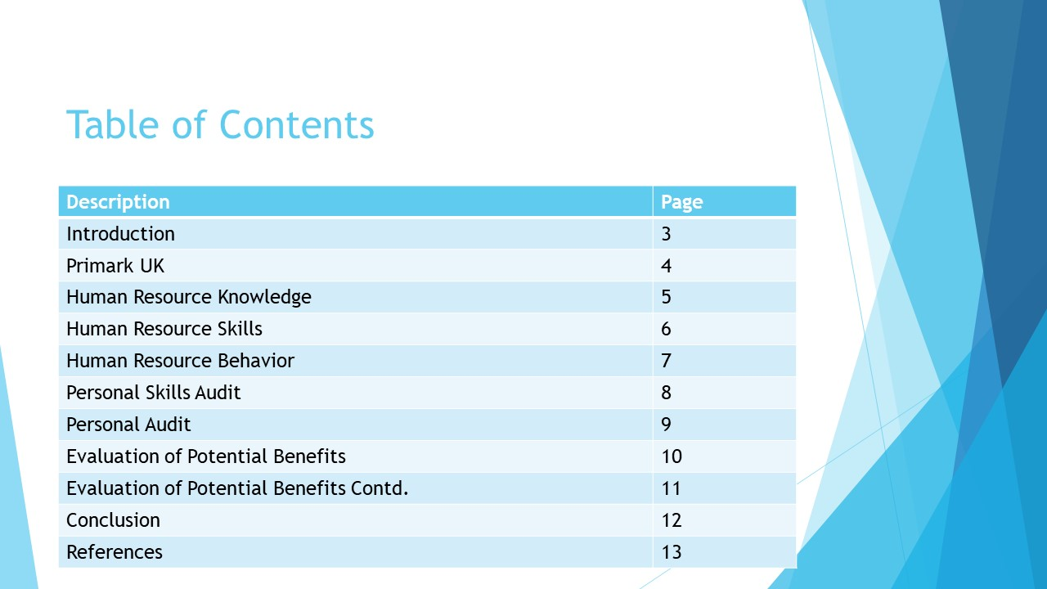
Slide 3

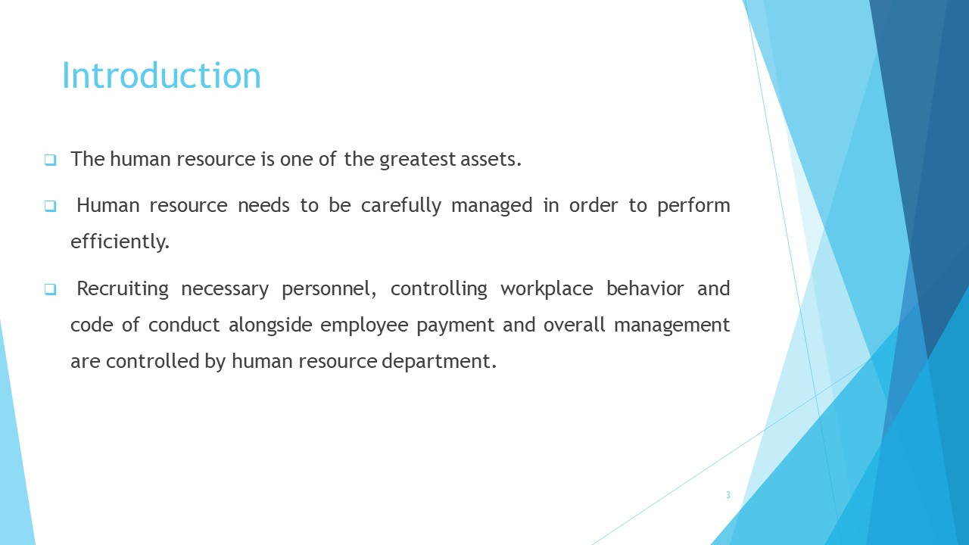

Human resource management is a complex process which requires dedicated attention. Managing the people aspect of an organisation is perhaps one of the critical operations for the firm.
Human resource management provides top management to effectively handle the employees and create an effective workplace where communication and professional behavior is implemented, and performance is ensured.

Slide 4
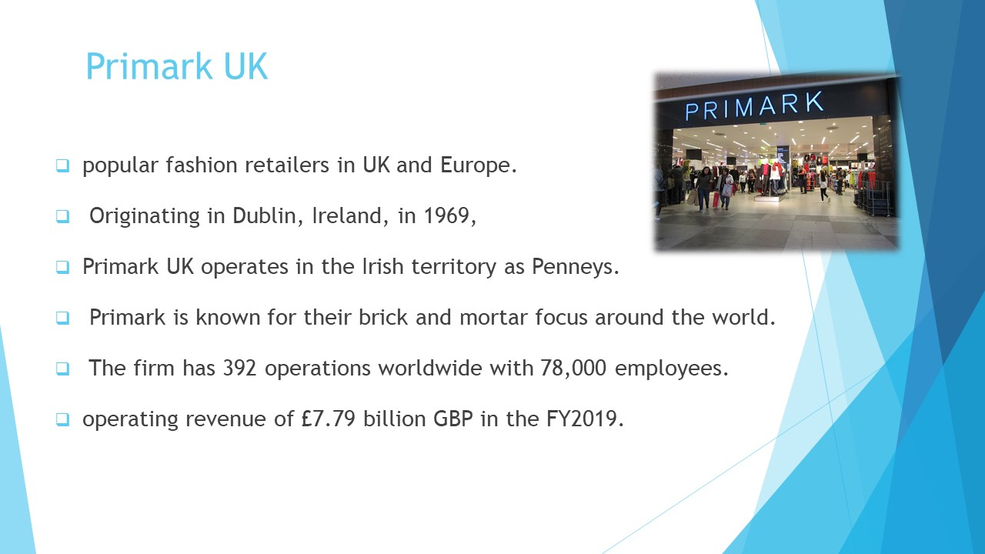
Slide 5

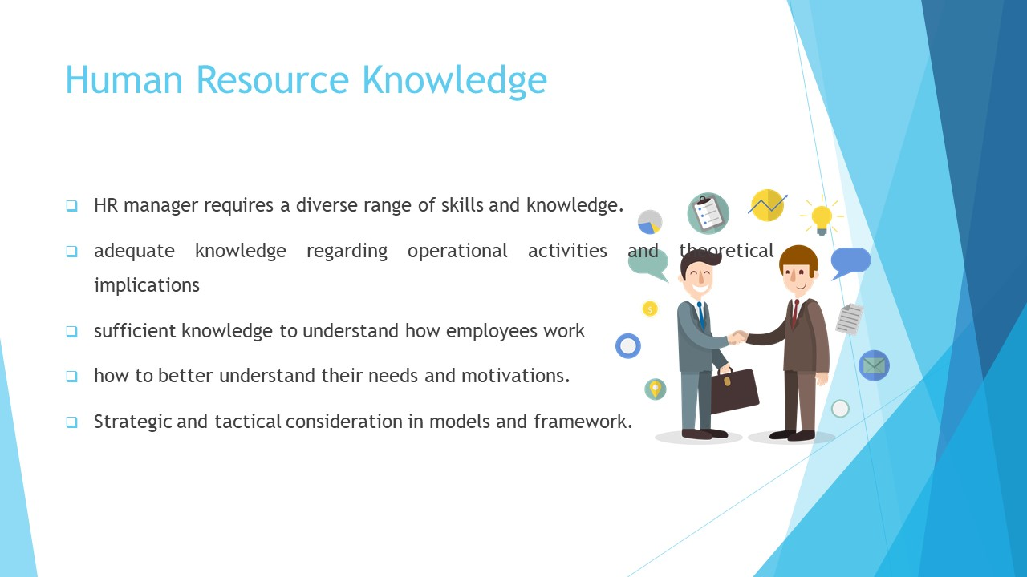

Human resource management is a tactical department that not only controls the human resource of an organisation, but also provides directions and guidelines about how to behave and work in a professional manner.
The case is same for Primark UK. As an HR manager for the firm, an extensive knowledge regarding the theoretical aspects of human resources management strategies and tactical considerations is also required.
In order to manage the employees of the firm effectively and Primark should ensure that the employees are performing adequately.
Also, a smooth transition and workflow should be present, different theories, models and strategic approaches can be used by an HR manager to implement and provide a framework to operations.

Slide 6

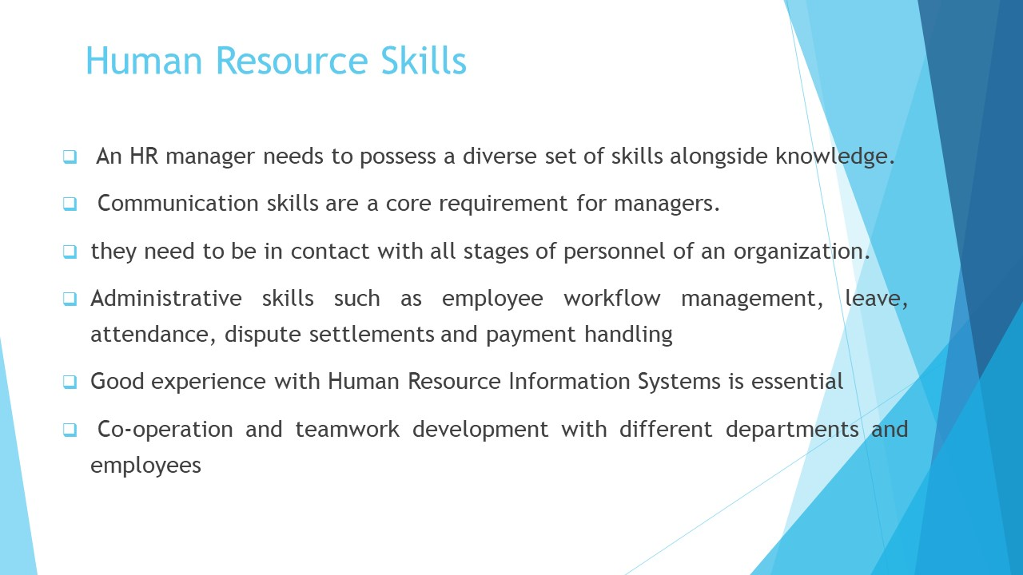

In terms of skills required, a manager should possess some relevant skills and abilities to manage the employees appropriately. One of the most basic skills required by managers of the Human resource is the ability to communicate effectively. Communication skills are an important tool for HR managers as they need to constantly remain in contact and exchange information with different employees of the organisation.
By communicating the instructions of the top management and understanding the needs, motivations and requirements of the employees, the manager aims to establish a balance within the organisation.
Another important aspect of the skillset is the ability to conduct recruitment procedures effectively, as often human resource management is in charge of hiring employees for the firm. As a result, the performance of the firm directly depends on their selection criteria and ability to determine fitting employees for the firm.

Slide 7

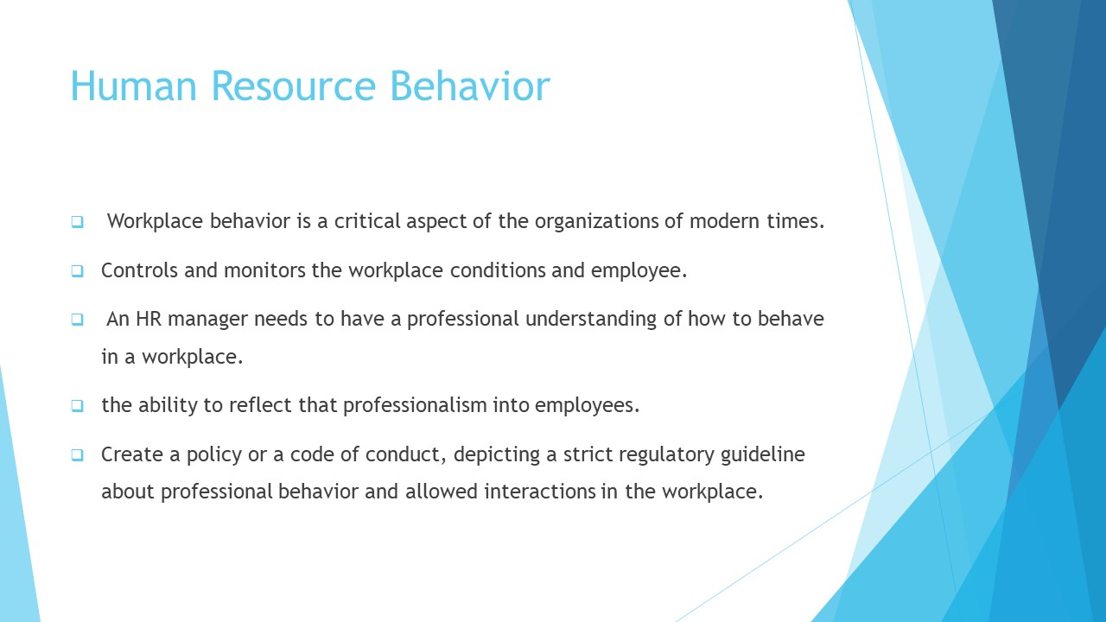

Finally, behavioral aspects are also a critical part of the job description of an HR manager. In Primark UK, there is a certain culture and professionalism embed into their workplace behavior.
Managers need to control their own behavior and ensure that the employees of the organisation are also behaving appropriately.
There should not be any sort of interaction that is not allowed by the code of compliance by the firm. Sexual harassments, unethical practices or behavior that can make fellow co-workers uncomfortable is prohibited.

Slide 8

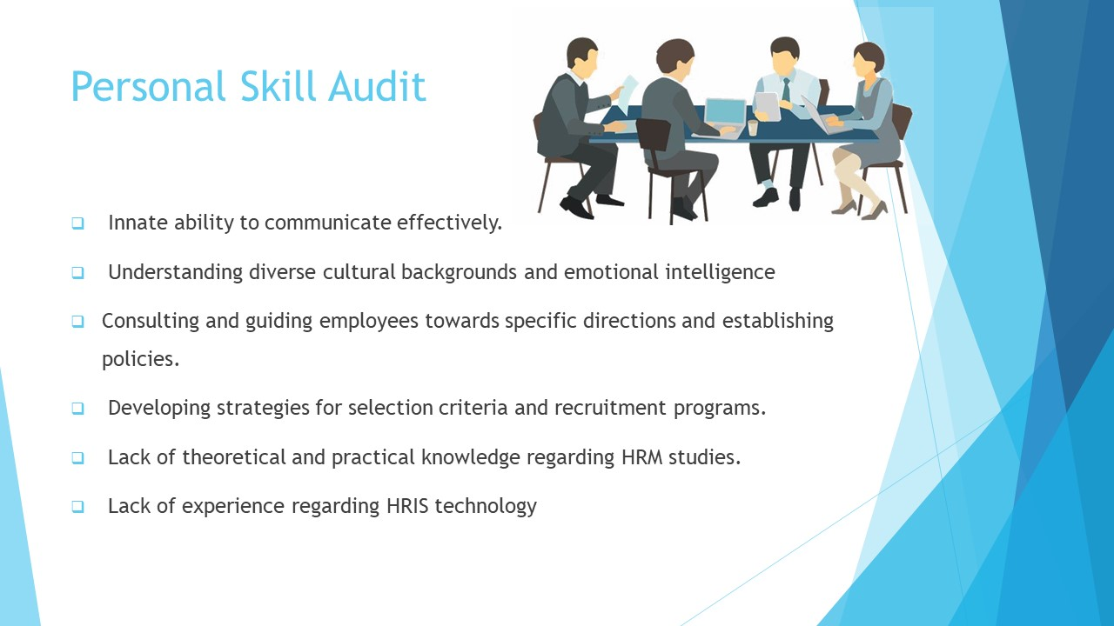
Self-evaluation and personal audit can enable a manager to have a better understanding about the abilities of oneself in relation to the ones that are required by the certain job.
By conducting a personal audit, a manager can improve and develop his or her abilities to fit the needs of the firm and perform efficiently.
In the case of Primark UK, the required knowledge, skills and abilities and behavioral characteristics that are essential for performing well for a manager have been proposed above.
In contrast, after conducting a personal audit of my own abilities and requirements, I believe that I have some of the core skills required for Primark HR manager position.
However, there are certain aspects of my skillset that can improve greatly with adequate training and development programs.
For example, I have an innate ability to communicate with people from different backgrounds and ages. I can remain empathetic and try to understand what the other person is trying to express.
I am also able to simplify complex directions and guide people to follow the strategic instructions and code of conduct inside the organisation.
I am also able to organize and operate administrative tasks effectively. I have the required skills to conduct processing of documents of employees and performance evaluation tactics.
Slide 9

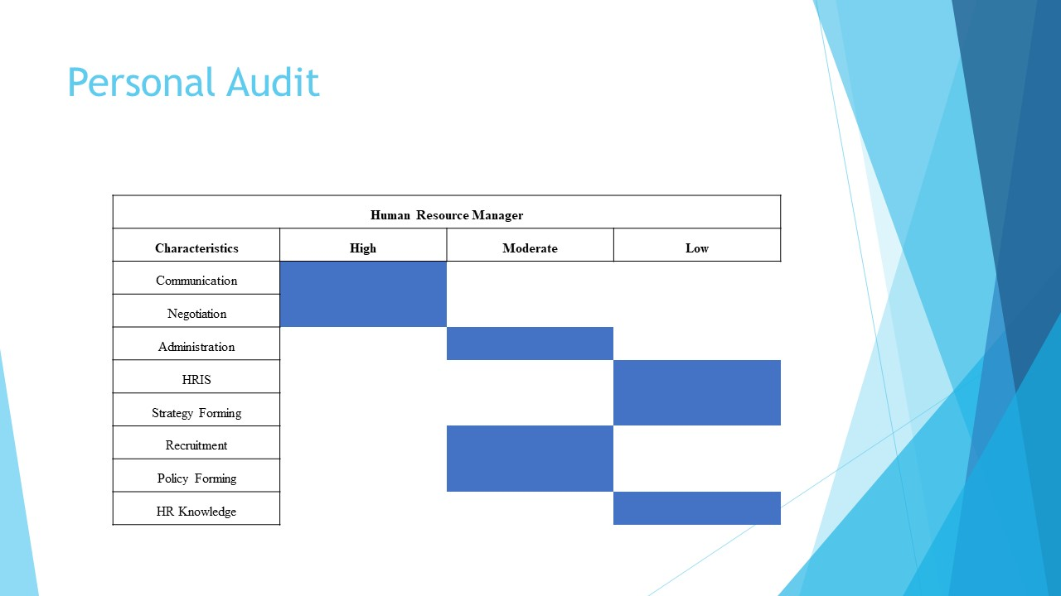

However, my skillset lacks a certain degree of organisational and theoretical knowledge background, which can help me to greatly improve strategic decision-making process.
Moreover, I do not possess adequate knowledge and experience with the technological compound of Human Resource Management, the HRIS.
With ample training and development provided by the firm, my knowledge can be enhanced significantly and with training on how to use the HRIS technology, I will be able to provide value to the efficiency and managerial prospects of the firm.

Slide 10

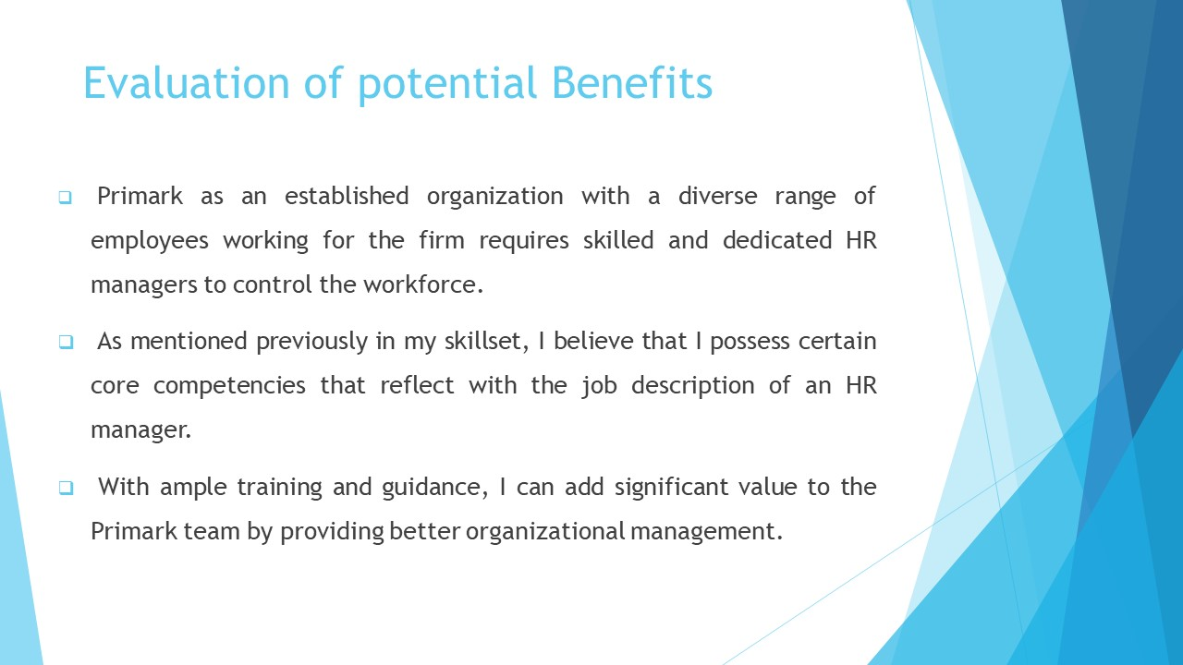

If Primark decides to provide me with the previously mentioned training and development opportunities, it is safe to state that I will be able to perform better, create better strategies and policies, take better decisions and manage the administrative duties endowed upon me with improve efficiency.
If my knowledge base is developed, I will possess a strong understanding about how human resource management works and how it is developed gradually and in-depth within an organisation.
Knowledge base will also enable me to develop more meaningful and impactful strategies and policies within the firm that will motivate the employees and guide them towards performing their tasks in an effective manner.

Slide 11

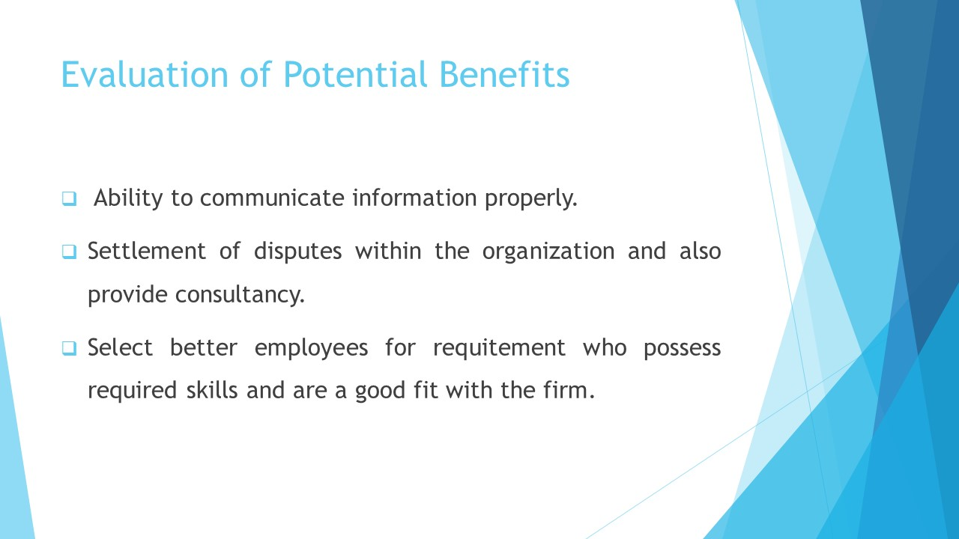

Additionally, a training program to introduce me and teach me how to use the Human Resources Information Systems technology will allow me to learn about the management techniques of the software. This will allow me to manage the inventories, administrative operations, documentations and employee performance evaluation efficiently.
The HRIS will also greatly help me to conduct monitoring and inspection operations such as employee leaves, absences, requests and settlement of disputes.
Overall, by implementing the HRIS system into the department, I will be able to increase the effectiveness and efficiency of the performance of the department while reducing costs and expenses in the form of time and money.
It should be noted that such training and development programs require money and resources.
However, considering the potential benefits and the long-term advantages that the firm will receive through this program, Primark should go forward with this step and create experienced and skillful HR managers for the organisation.

Slide 12

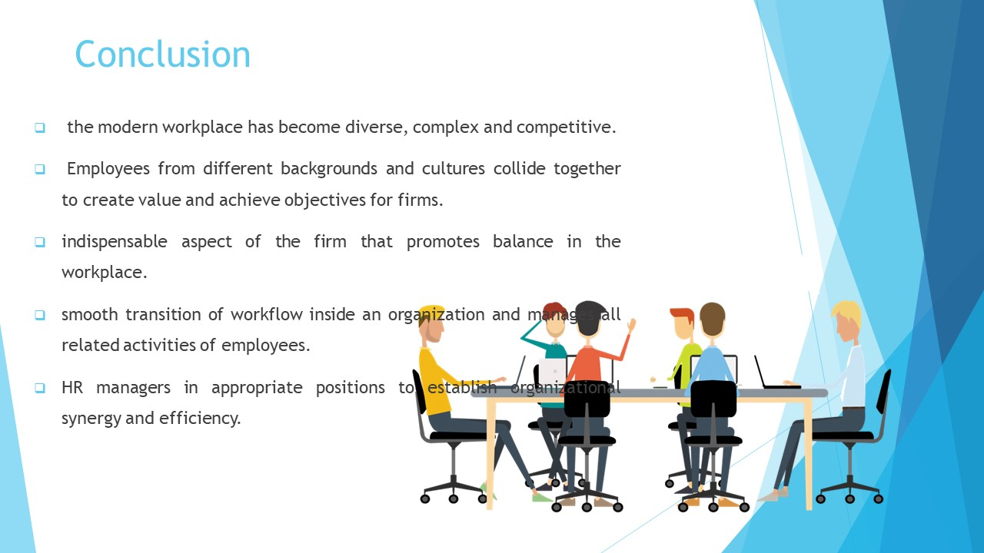

The modern working environment is diversified as different people from different places around the world come together to achieve unitary tasks and work for organisations.
Primark being a diverse and complex organisation, should realize the potential benefits of hiring an HR manager who will effectively manage the human resource of the organisation and allow them to perform effectively while maintaining workplace conditions in a balance.

Slide 13
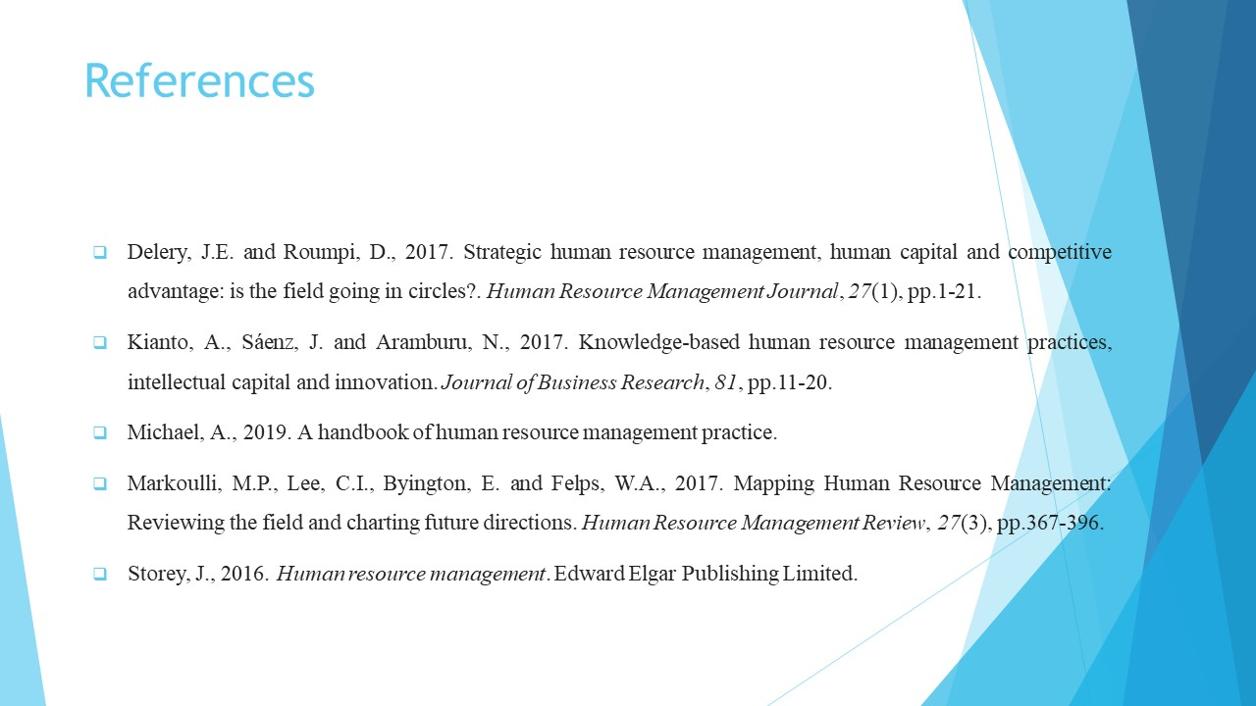
Delery, J.E. and Roumpi, D., 2017. Strategic human resource management, human capital and competitive advantage: is the field going in circles? Human Resource Management Journal, 27(1), pp.1-21.
Kianto, A., Sáenz, J. and Aramburu, N., 2017. Knowledge-based human resource management practices, intellectual capital and innovation. Journal of Business Research, 81, pp.11-20.
Michael, A., 2019. A handbook of human resource management practice.
Markoulli, M.P., Lee, C.I., Byington, E. and Felps, W.A., 2017. Mapping Human Resource Management: Reviewing the field and charting future directions. Human Resource Management Review, 27(3), pp.367-396.
Storey, J., 2016. Human resource management. Edward Elgar Publishing Limited.

Slide 14




