
Skills for the Workplace
Module Assignment Submission
Student Name: | Daniela Marietta Ventrice
Student Number: | 1910840
Module No: | BMSK5008
Module Title: | Building your personal brand

Statement of Confirmation of Authenticity
By the act of making this submission, the student declares that this is the work of the student named above. The work has not, in whole or in part, been knowingly presented elsewhere for assessment, or where assessment has been built on a previous assessment, this has been identified. Where materials have been used from other sources it has been properly acknowledged. If this statement is untrue, the student acknowledges that an assessment offence has been committed.
Attention is drawn to the plagiarism and unfair practice policies of both the University and of ILM.
Permission for ILM to use this script
ILM uses learners’ submissions – on an anonymous basis – for assessment standardisation. By submitting, both the centre and the learner agree that ILM may use this script on condition that identifying information is removed. However, if you are unwilling to allow ILM use this script, please refuse by ticking the box: □

Contents
A brand of many 3
Introduction 3
What makes you employable? 3
My Zander Letter 3
Personal development plan 7
Reflection 7
References 8
Appendix 1 – CV 9
11
Appendix 2 - Swot Analysis 12
Appendix 3 14

A brand of many

Introduction
By assessing your own employability skills, you are assessing current capabilities in order to progress to an end goal.
This report is a document on myself as a student and discusses my current skills as well as the skills I need to get where I need to be.

What makes you employable?
Employability skills are the skills that enable an individual to enter different lines of work, meaning they are transferable and are needed when entering a new job role and/or profession. Employability skills are different to academic skills because academic skills are taught through education such as schools, colleges, and universities. Employability skills, however, are the foundations that enable an individual to enter work and then build upon. Employability skills are foundational and could be considered internal because they are built and acquired in everyday life, interactions, and communication. How an individual chooses to apply and decide to operate in a way that is beneficial to themselves within a working environment that in turn benefits their everyday lifestyle.

My Zander Letter

Where do I start.
Having dealt with a life of abuse and addiction and battling inner demons along the way, 10 years of medication I finally broke the chain. I finally found myself, my voice my passions to understand my dreams. A Dream to create stability, and a dream to heal myself, my children and to help heal others too. Not only that the courage to break out from the norm and boy it has caused controversy but it’s my story not theirs.
You see, at 39 years of age, recently diagnosed with c-ptsd (but I don’t let that define me) I have come to understand that unless you believe in you, you are likely to never achieve anything. If you look for acceptance and praise from others, you begin to hold contradiction that you are not quite good enough and just as zander says those voices in your head will be you biggest obstacle. One needs to break the cycle of negative thought before dreams can become possibility.
I have made more mistakes than you can imagine but I must admit each mistake, each downfall was a lesson needed to learn and in the end I have realised that what breaks you is in fact what makes you.
I was never any good in school always the loner, didn’t really communicate well with others and I was ok with staying in my safe place . Until I joined the university the only person that said they were proud of me was my grandfather who passed away just before the covid pandemic.
Everything I speak today has been my own learning through life and now I have gained the wisdom of understanding that I was never meant to be like anyone else. But through lack of understanding from everyone around me I spent my life trying to be like them when I ought to bite the bullet and just be me.
I was always one to dream big and as you read further into my dreams and aspirations you will begin to understand that I am built from many things, but I have one purpose to create stability and goon to help others by doing things I love and help people see their true potential and bring them forward to.
We don’t make the change we be the change. It starts with us.

MY BUSINESS MY BRAND

Pixie Dreams

Pixie dreams would be an online business selling personalised handmade dreamcatchers with crystals.
These would be sold at price; I already know how to do this although sales are low and usually seasonal. However, will adaption into different sources to purchase materials profit is doubled on each dreamcatcher that is purchased.
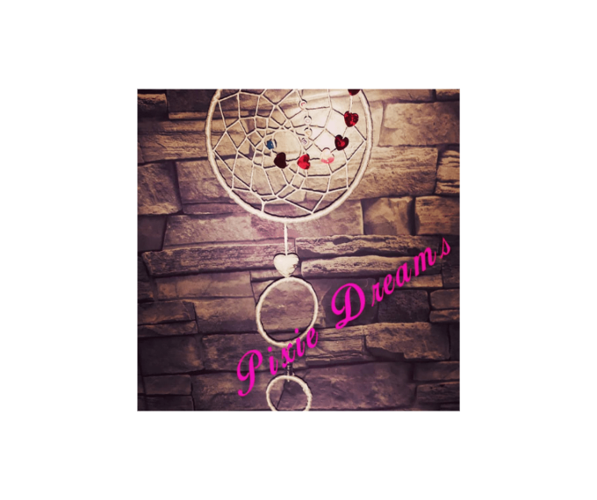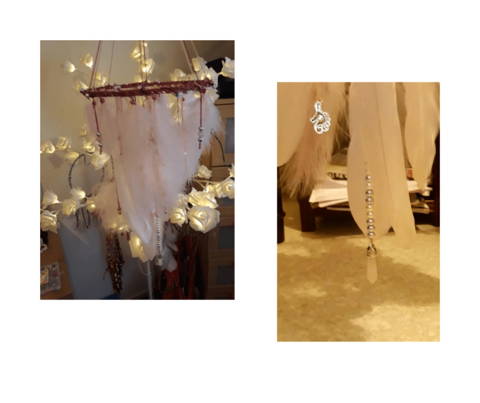
Dreamcatchers are considered spiritual; the legend says they offer a sleeping child protection from nightmares and bad dreams so these items act as a safety net if I child chooses to believe. Dreamcatcher.com. (2023).

Roots aromas
Roots aromas would be an online website selling essential oil blends that promote natural healing. they will be packaged in rollerball form as well as Moroccan style vintage perfume bottles. these will be top end selling products meaning they will cost that little extra.
There are various factors that needs to be assessed when looking at this. Factors were established after doing a swot analysis are as follows.
- You need to be certified aromatherapist to market the blends for medicinal needs.
HOWEVER
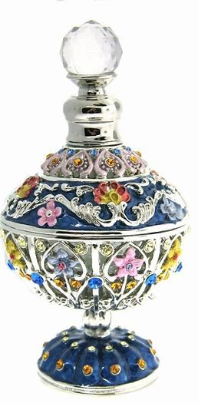
- You can get around this by marketing as a fragrance as well as advertise to promote better wellbeing.
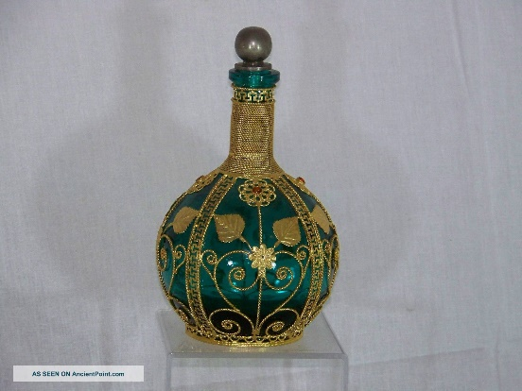

Pixie the madness of me
A biography of how a girl came from abuse and still survived I am wanting to write a book on my life.

Personal development plan

Current skills | GAP ANALYSIS | END GOAL
Roots Aromas | Website building, marketing and advertisement , make enquiries to potential suppliers  Look at legal aspect to cover copyright issues . patent , logos etc | Successful online website where spiritual products and natural organic products can be purched
My own book | Shadow writer and finance to cover the cost | Potential publication

Reflection

It only when we begin to look at ourselves and notice our own errors can we then address and learn in order to change. After completing this assignment, I have realised my dreams and aspirations are far from small, but I have always been the same, was never one to fit in a box but rather fit in many. And you know what that’s ok.
Having watched some zander videos and the art of possibility I began to see that I don’t have to be like everyone else its ok to set your sights high even if you are not successful . it is better to try than to live on what ifs .
Unlike others my mind thrives for action colour design and expression through art music dance I am all about that life.
I could be a cleaner and clean elderly homes, a service they can trust and could even recruit a few locals which probably holds more possibility, but it doesn’t make my heart sing. And fro the past two years and everything I have overcome I believe in what Benjamin zander says and I am choosing to believe that dream come true.
The biggest gaps established from me achieving this end goal would be the finance and the areas of legislation. The website building fries my brain, was never good at reading can barely remember a book I am more of a visual art individual.
I am definitely a zander fan after this module .

References

Bouhl. G. (2022). url : How to Start an Essential Oils Business - StartingYourBusiness.com . How to start an aromatherapy business. Updated : 22 November 2022. Accessed January 2023.
Tzapinar. (2013). Benjamin Zander How to give an A . Url: Benjamin Zander - Work (How to give an A) - YouTube. Dated : 2013 . Accessed 2023.
Dreamcatcher.com. The legend of the dreamcatcher. The DreamCatcher Legend and Dream Catcher History Accessed January 2023.
Essential oil suppliers (, 2023, Essential Oils : Cosy Owl, Candle Making Supplies & Soap Making | Craft Supplies Specialists accessed 2023.

Appendix 1 – CV
DANIELA VENTRICE
CARDIFF, SOUTH WALES

PERSONAL STATEMENT
I am enthusiastic with a professional disposition. Basic computer knowledge and administration skills held. Enjoy creating visual and graphic content, dexterously creative, good at implementing different ideas and seeing from all perspective. Comfortable to work solo but able to also, good team player that possesses impeccable imaginative and creative ideas of innovation, adaptable to different environments cultures and backgrounds.

CORE QUALIFICATIONS
- Computer literate  - Administration level 1  - Skills for the workplace Leadership and -management, Level 4 | - Digital media and content creation  - Assertive  - adaptable  - Multitasking abilities  - Create Handmade products

EDUCATION
1993-1999
Whitchurch High School

 |  | WORK EXPERIENCE  Content Creator - 10/2020 - Present  - Diverse topic video creation.  - Can accommodate to different target markets / social influence  - Potential work offering for visual artist collaborating with up-and-coming djs for festivals and community-based projects.  Founder of PixieDreams - 09/2018 - Present  - Personalized handmade dreamcatcher sentimental and unique to the owner  - Originality and sentimental value.  Freelance artist - 01/2017 - present  - Founder of ArtFreakz Gallery  - Creating Artwork on commission.  - Creating and selling single pieces

CERTIFICATIONS
- Skills for the workplace level 4 ( 2019)
- OCR Level 1 certificate in Administration (2004)
- Level 3 Adult Numeracy (2003)

PROFESSIONAL RELEVANT SKILLS
- LibreOffice
- MS Office, including Word and PowerPoint

- Content Management Systems (CMS)
- Adobe Photoshop

HOBBIES AND INTERESTS
- Content creation via YouTube channel
- Walking
- Art
- Music
- Aromatherapy

For portfolios, pictures and more information regarding my work please contact using the email above.

Appendix 2 - Swot Analysis

Swot table to establish strengths and weaknesses, identify opportunities and notice the future threats when looking to become an entrepreneur. With a potential of being able to run more than 1 business.

STRENGTHS  Creative  Dextrous art skills  Generate new ideas.  Various business ideas | WEAKNESSES  Lack confidence.  Lack of finances to fund  No website
OPPORTUNITIES  Possible entrepreneurship  Website opportunities  Ownership of various businesses  Stability  Future investment for family | THREATS  Other competitors

.

Wonder share Edraw mind .2022). Diagram creator. App.

Appendix 3


