

Assessment 1 – Reading Task Template
PART 1: Upload your photo of your A3 in-class notes here:
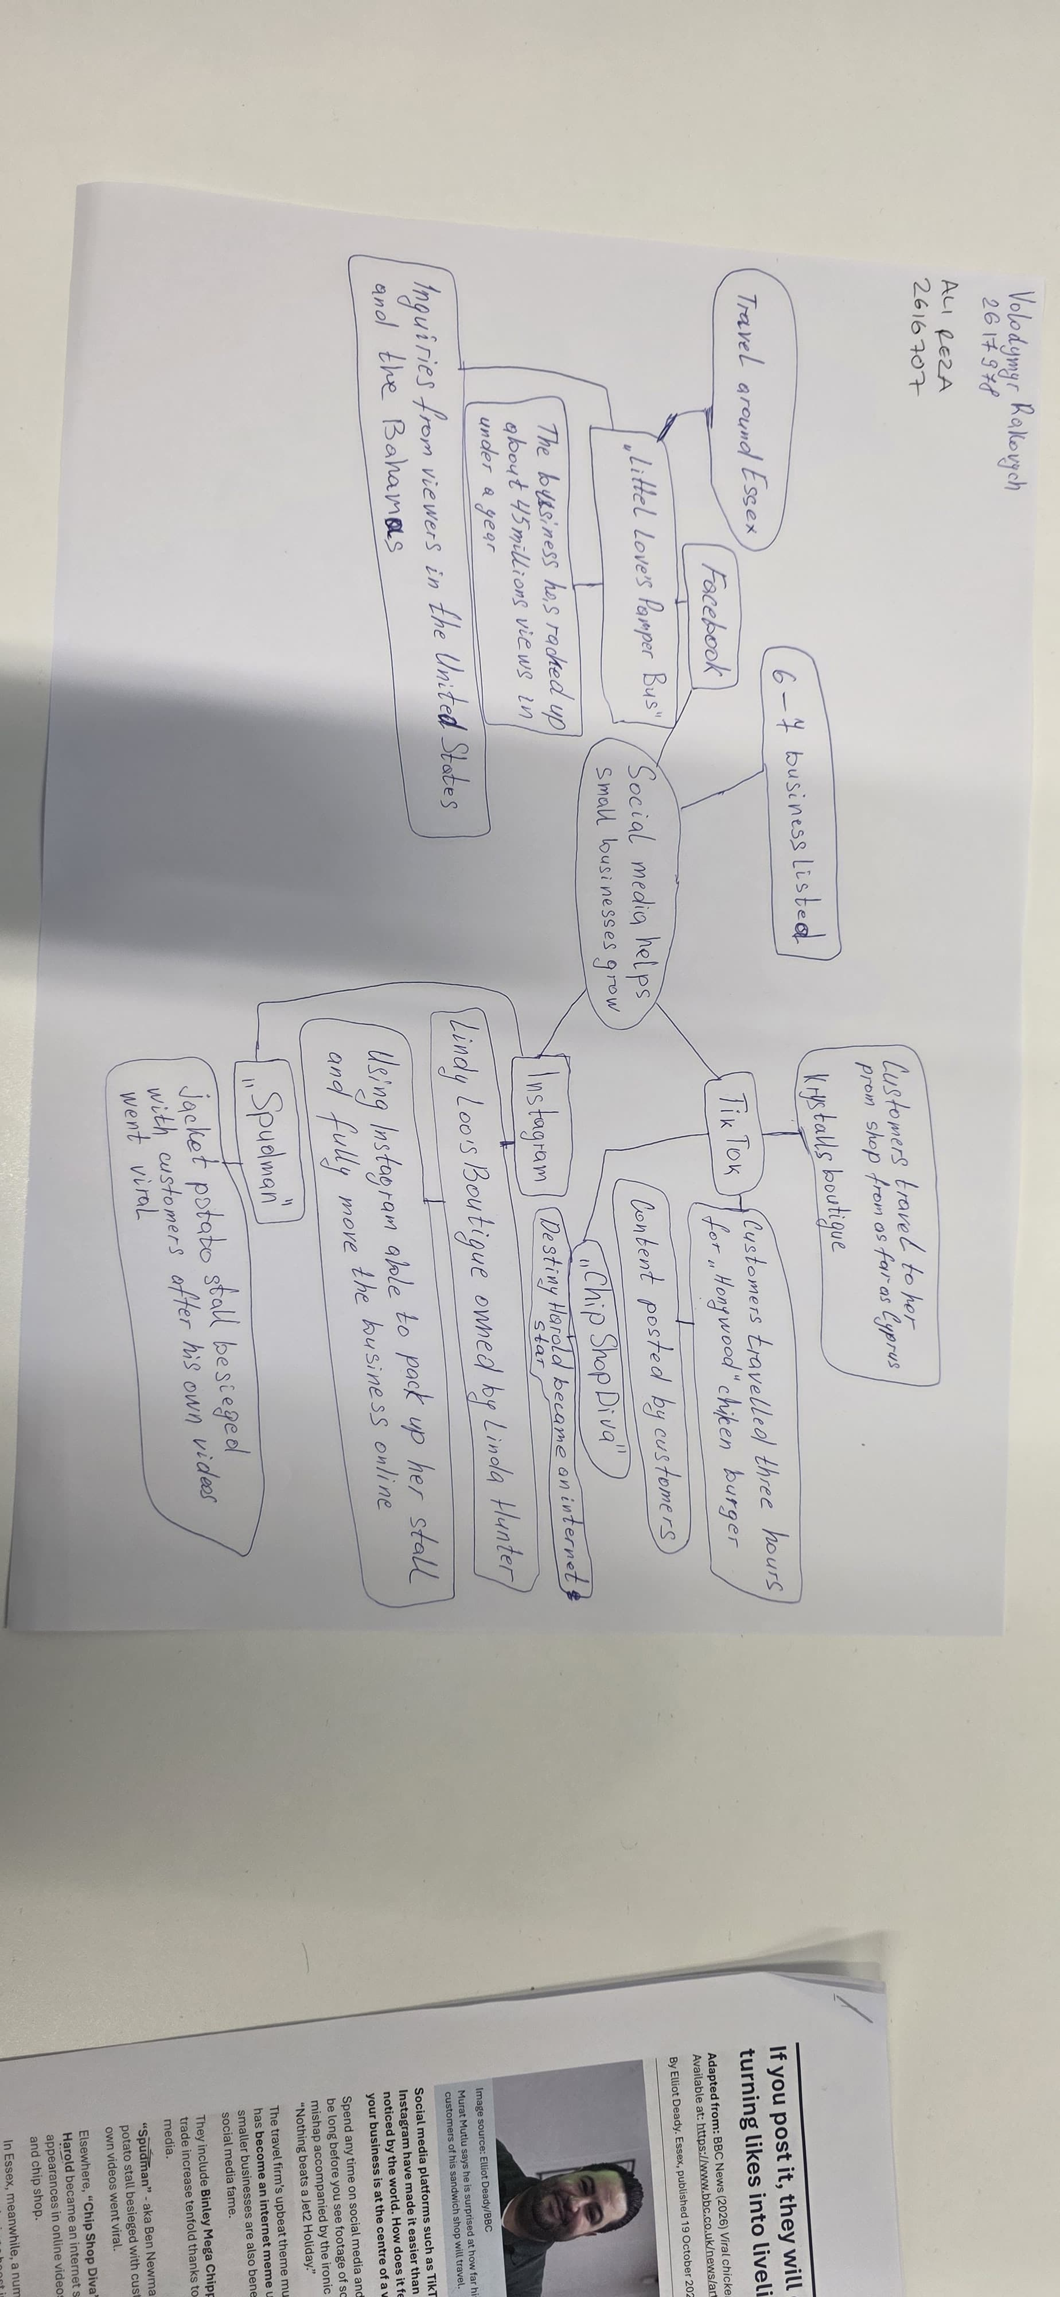

PART 2:
- Answer every question below in 1-3 full sentences.
- Use your own words. Do not use generative AI to answer these questions.
- Include a specific detail from the text when asked.
REMINDER
- The main idea is the overall message of the whole text.
- A key point helps to explain the main idea.
- A specific detail or example from the text shows that the key point is true.

- What is the main idea of the whole text?
Social media helps small business to grow their business and the hype that can be generated. (news, 2025) (news, 2025)

- What is one key point that supports the main idea, and which specific example from the text shows this?
Data and customer feed back and reviews on social network. Helps get more customers and example would be about the chicken burger.

- What is a different key point that supports the main idea, and which specific example from the text shows this?

Customers traveling from far and wide to visit a business like honywood customers travelled 3 hours to try the chicken burger.
- Which part of the text do you think is most important, and why?

The most important in my view is customers revies and the distance travelled by some.
Reflection:
- What did you find difficult in this task (including in-class components), and why was it difficult?
I think I found difficult understanding and organising

- What helped you with this difficulty, and how did it help you? Asking to be shown and to be explained again which helped me understand what needs to be done.

(news, 2025)

https://www.bbc.co.uk/news/articles/cm2701py5npo

