Michael Oldham (2235684)
2235684@student.uwtsd.ac.uk
Network operating systems & services
Research, build and deploy a Virtualised Network

Contents
Task 1 – Research Report 2
Research on Hypervisors (Type 1 & Type 2) 2
Research on IP Addressing 4
Research on Routing 5
Research on Network Services 6
Task 2 – Report: Technical Documentation 7
Configuring the Windows 10 Client Network and IP Address 17
Configuring the Windows Server 2022 (Server) 19
Installing & Configuring the Linux Debian Server 26
Installing the Linux Debian Client (ClientC1) 35
Task 3 – Reflection 43

Task 1 – Research Report

Research on Hypervisors (Type 1 & Type 2)

There are two types of Hypervisor technologies, type 1 and 2, which make it possible to run multiple Virtual Machines (VMs) on a single physical machine. Type 1 is known as a bare metal Hypervisor which is installed on the host machine’s hardware, not through an operating system. Type 2 Hypervisors are installed on a machine where it runs as an application. This is explained on Amazon’s AWS website. [1]

A type 1 Hypervisor has better performance on their virtual machines due to fact that they have direct access to the resources on the host machine, whilst a type 2 can only use the operating system’s resources which have been willingly provided.

Bare metal hypervisors are usually used in larger environments such as web servers and data centres and the hosted hypervisors (type 2) are usually used in desktop or development environments. This is because of the workloads typically being less intense on the resource and used in less critical situations.

Some examples of type 1 hypervisors include VMware vSphere, Microsoft Hyper-V and Oracle VM. On the other hand, some examples of type 2s consist of Oracle VM VirtualBox, QEMU and Parallels Desktop. [2]
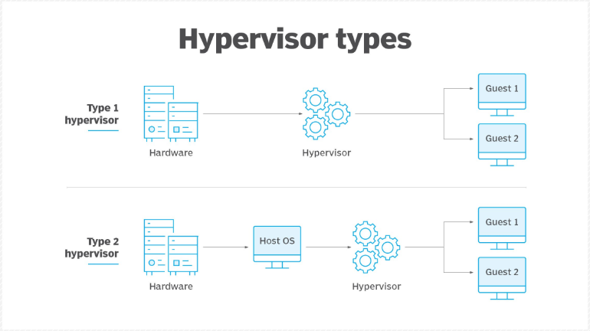
Hypervisors, also called virtual machine managers or monitors (VMM), act as a layer of software that abstracts the physical hardware allowing each Virtual Machine to operate independently like a standalone machine. [3]

Some of the features of a type 1 hypervisor include the high performance because of the direct access to the hardware, embedded virtual switches for networking and advanced resource scheduling. For type 2 these include a simpler installation and operation and they support multiple operating systems on personal computers.

Hardware requirements for a bare metal hypervisor starting with the CPU require them to support virtualisation technology such as the Intel VT-x or the AMD-V. It is also important that the CPU has multiple cores for it to execute the tasks of the VMs simultaneously. Sufficient RAM is also required to run the hypervisor itself and the VMs which are set up on it, the number of VMs being run would determine the amount needed. This is the same for Storage.

On the other hand, type 2 Hypervisors also require a CPU that supports the technology, but as this is run over an existing OS, they rely on the hosts system hardware. Memory requirements are like type 1; however, they usually require more memory in comparison.
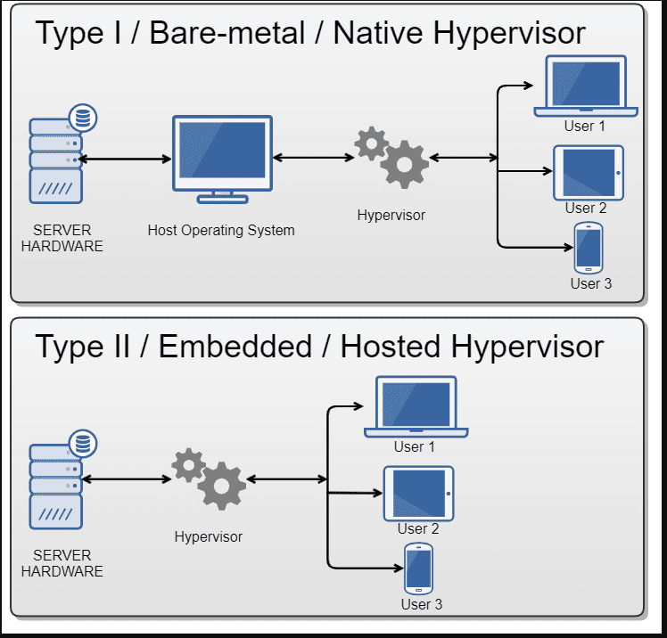

Image from www.parallels.com showing the architecture of type 1 & 2 Hypervisors.

Research on IP Addressing

All devices that are connected in a network require a distinctive ID so that other devices can communicate with it. An IP address is the ID that is used for all these devices.

Data is transferred across the network in packets which are broken down into smaller chunks and then reassembled at the destination. Packets are assigned with IP addresses of the source computer sending the information and the destination so that it can be routed to the correct end point. Routing tables are created and maintained within the network in order to guide the data packets to the destinations. [4]

Transmission Control Protocol / Internet Protocol (TCP / IP), is the protocol which defines how data is transmitted over networks. This was designed by the Department of Defence in the 1960s and has 4 layers. [5]

A previous IP address was IPv4 which is a 32bit number whereas the latest version IPv6 is 128 bit. IPv4 has a structure of 4 sets of numbers which are split into 2 sections which are not equal meaning the network could be defined by just the first part or the first 3 parts of the IP address, the first part defines the network and the second part defines the computer or host, these are known as the network ID and the host ID. [6]
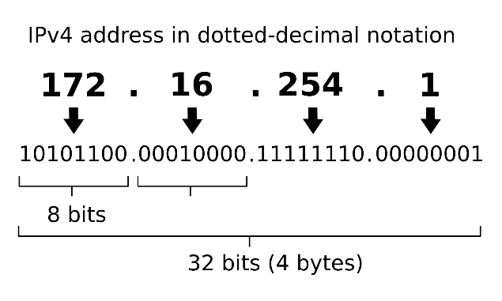
Devices on a network most commonly have 3 types of identities. These are MAC Addresses (Physical Address), IP Addresses (Logical Address) and a Hostname which makes it easier for a device to be identified. [7]

IP Addresses also have different classes which are used to split private and public IP’s but also the different classes define how the IP address octets are split to make up the network and host ID portion of the IP address. There are five classes A,B,C,D and E, which have a range of IP addresses between different ranges. For example a Class A Public range would be from 1.0.0.0 to 127.0.0.0 and a private range from 10.0.0.0 to 10.255.255.255. Private IP addresses are only used on local networks and cannot be used on the internet. Because they are only used on local networks they can be reused on multiple local networks.

Research on Routing
Network Routing is the process which directs and routes where and how packets are sent across a network. Routes are chosen along with an Internet Protocol to get packets to their final destination. A Router is the network device that manages this routing process and forwards packets between the networks. It also uses the IP address to direct the traffic.
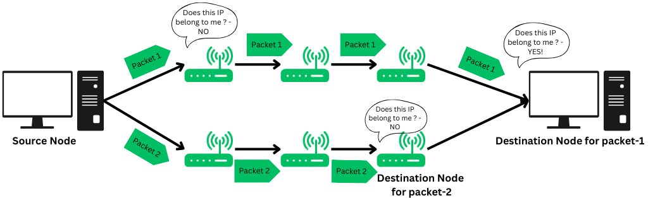
There are 3 different types of routing, these are Default Routing, Dynamic Routing and Static Routing.

Default routing allows a router to send all packets for unknown networks to a specific next-hop router. This is especially helpful in small networks where adding routes for every destination would be difficult. The router uses one default route when it doesn’t know the destination.

Dynamic routing lets routers automatically find and update routes as the network changes. It uses protocols like RIP (Routing Information Protocol), OSPF (Open Shortest Path First), and BGP (Border Gateway Protocol) to share information with other routers and update route tables. This makes it more flexible and easier to scale than static routing.

Static routing means manually setting up routes in a router. The administrator decides the path for data to reach its destination. These routes stay the same unless changed by the administrator, making static routing reliable but not flexible. [8]

Research on Network Services
Virtual Private Networks (VPNs), Dynamic Host Configuration Protocol (DHCP), and Active Directory Domain Services are essential components in modern networking.

VPNs create secure, encrypted connections between devices and remote networks, ensuring privacy over untrusted networks, such as public Wi-Fi. Key features of VPNs include encryption, IP address masking, and remote access capabilities. Best practices for VPNs involve keeping software up-to-date, monitoring and logging usage, and utilising features like kill switches to protect data during connection drops.

On the other hand, DHCP automates the assignment of IP addresses to devices, simplifying network management and reducing errors. It also provides devices with necessary network configuration details, such as DNS servers and gateways, and manages IP lease durations. Best practices for DHCP include separating DHCP and domain controller roles, implementing failover for redundancy, and reserving IP addresses for critical devices to ensure stable configurations.

Active Directory Domain Services is a Microsoft technology that enables management of user authentication, resource access, and network communication. It stores directory data and facilitates login processes, authentication, and directory searches. Key features of Active Directory Domain Services include group policy enforcement, and scalability through server replication. To ensure it runs efficiently, best practices recommend regular backups, the use of Organisational Units (OUs) for delegating control and applying policies, and securing domain controllers to prevent unauthorised access.

By implementing these technologies and adhering to best practices, organisations can enhance network security, ensure efficient administration, and maintain reliable access to essential resources.

Task 2 – Report: Technical Documentation
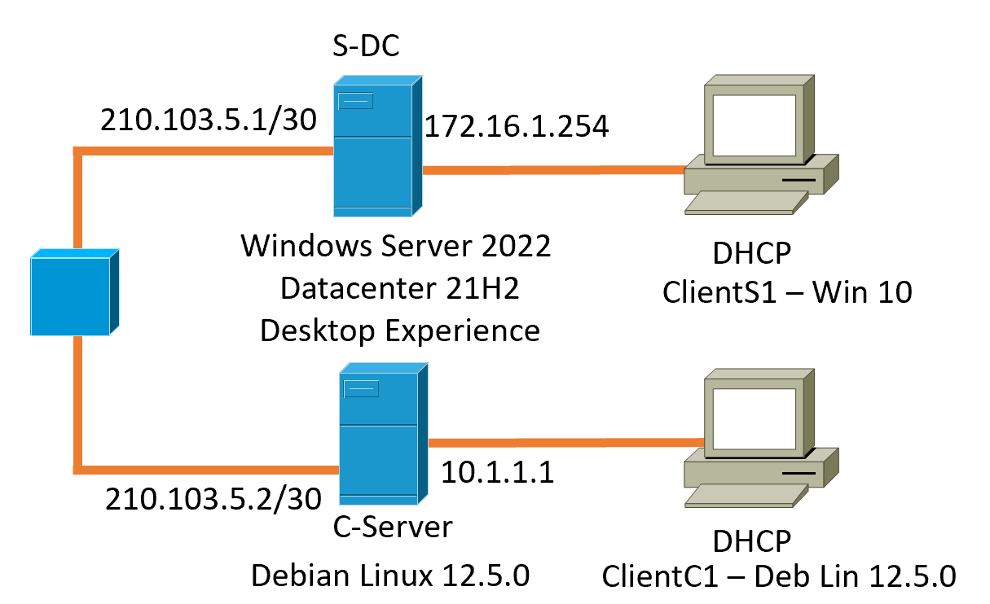
Topology for Assignment network with a windows Server, windows client, Linux server and Linux client.

IPv4 Address for my Windows Server will be a Class C private network address of 192.168.1.1
IPv4 Address for my Windows Client will be a Class C private network address of 192.168.1.10

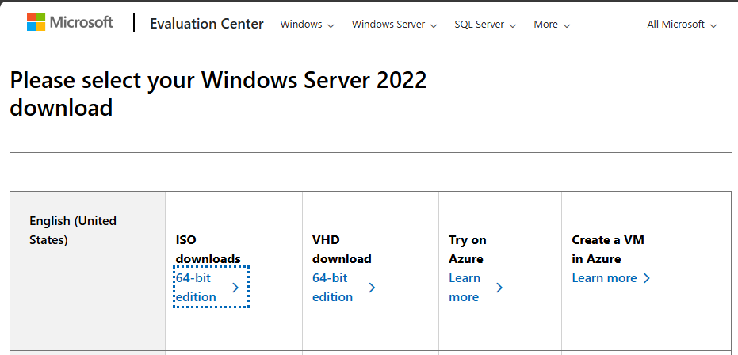
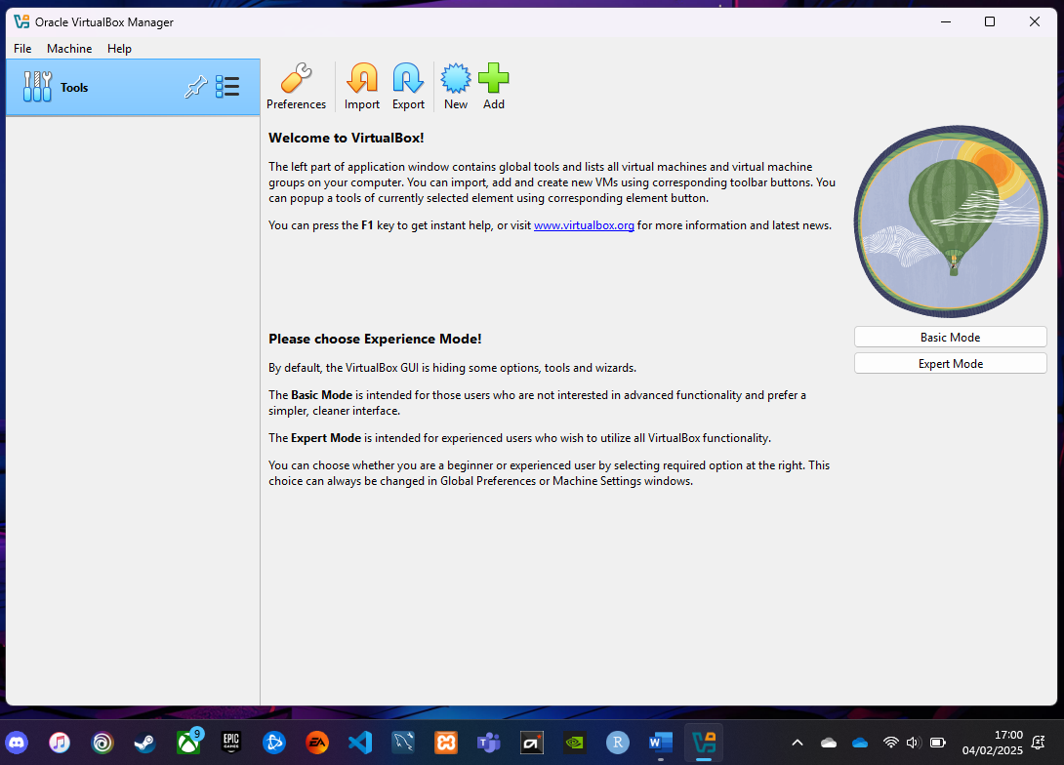Installed VirtualBox
Downloaded the ISO for Windows Server 2022

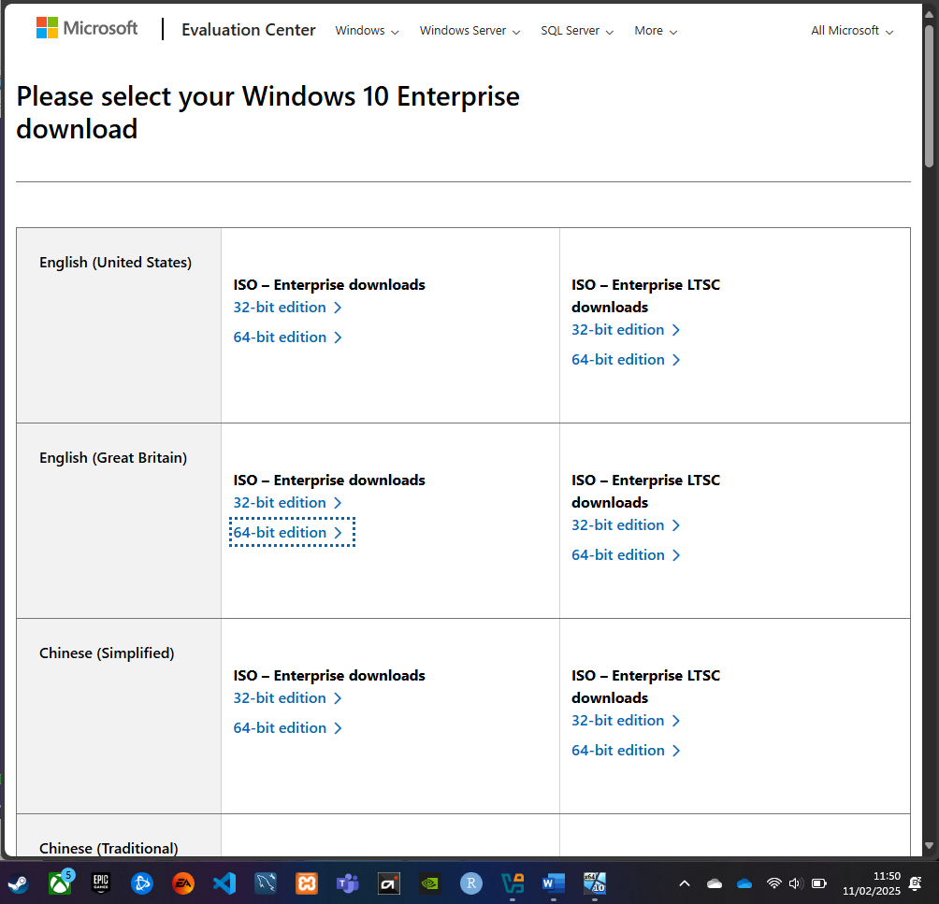
Downloaded Windows 10 ISO from Evaluation Centre for my windows client.

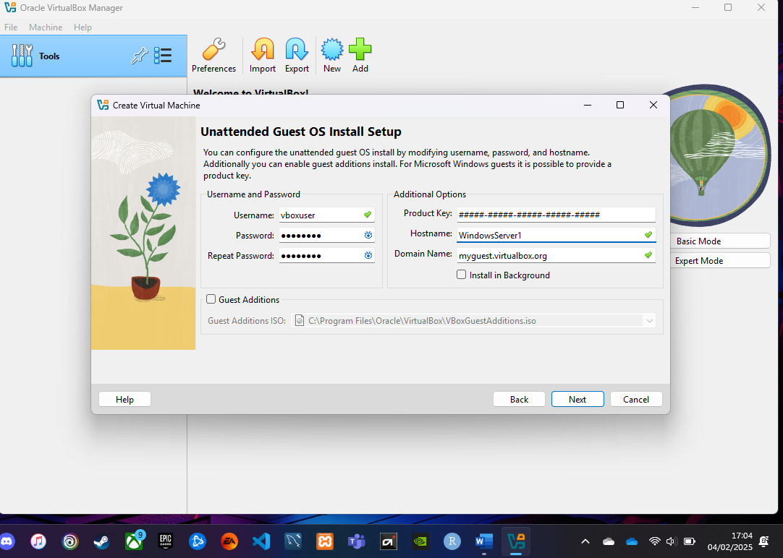
Installing the Windows Server

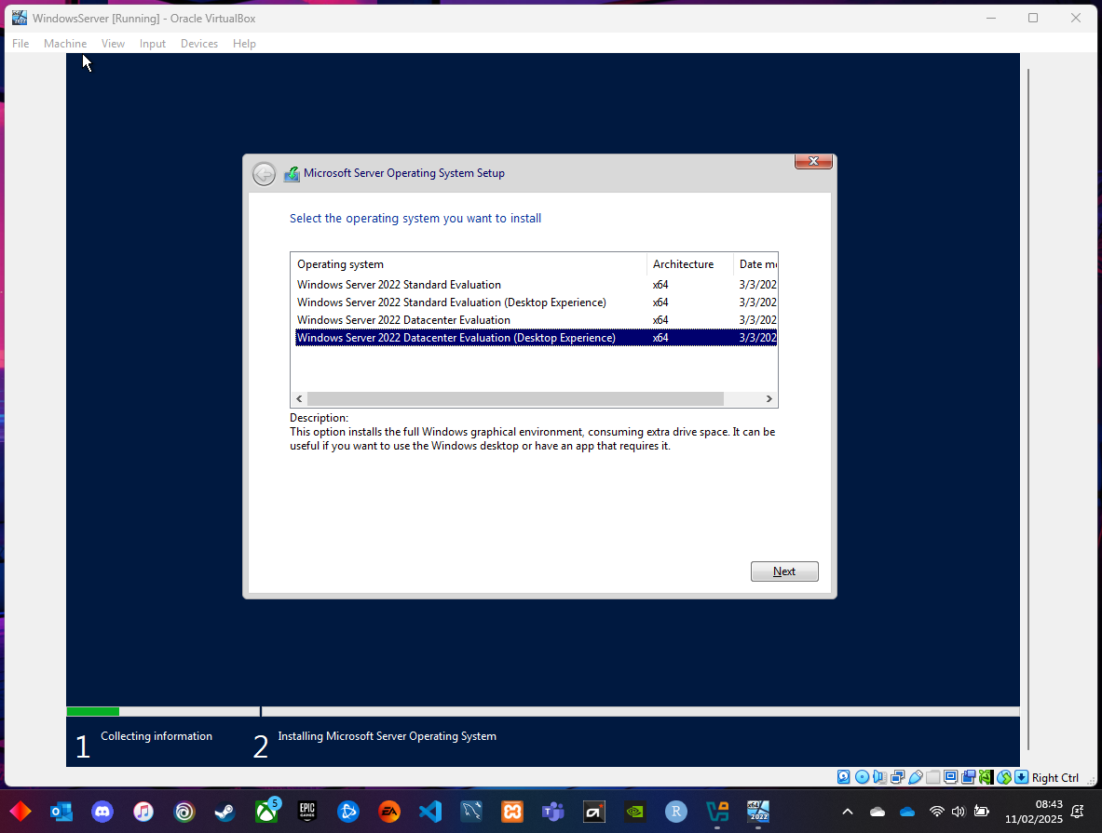
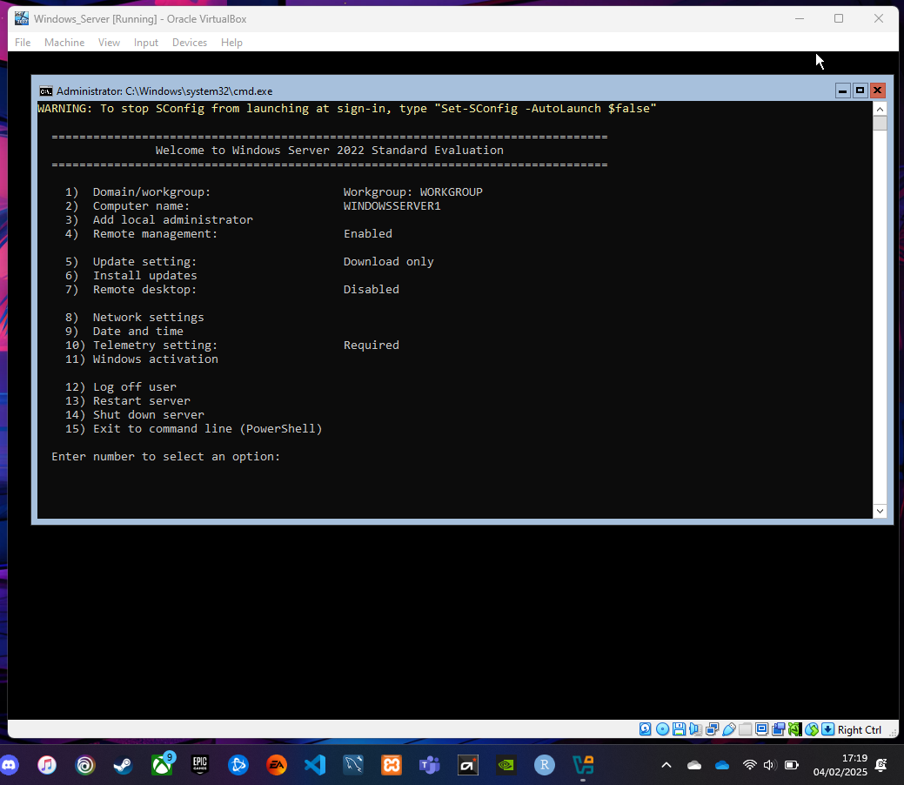
When first installing the Windows Server, I accidentally installed the Command Line version instead of the Desktop GUI, so I removed this to reinstall the correct one:
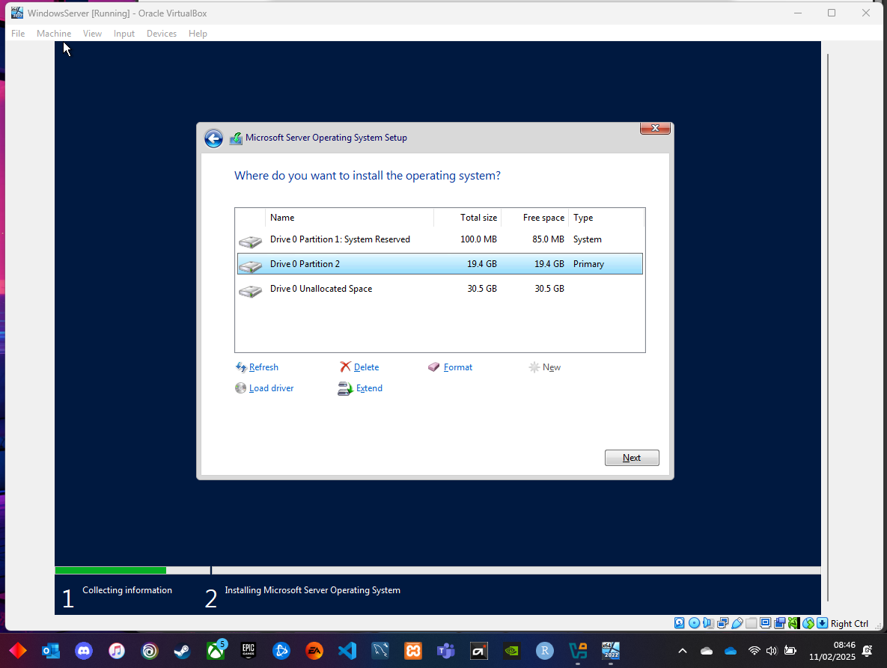
When installing, I also created another partition

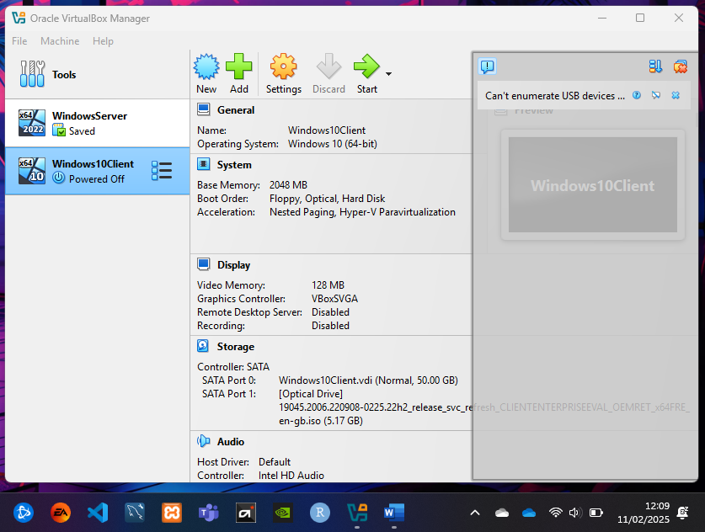
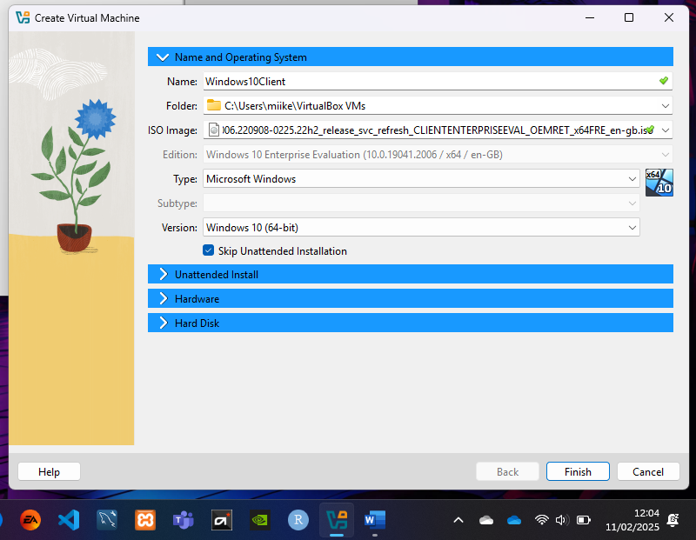
Installing Windows 10 Enterprise (Client)
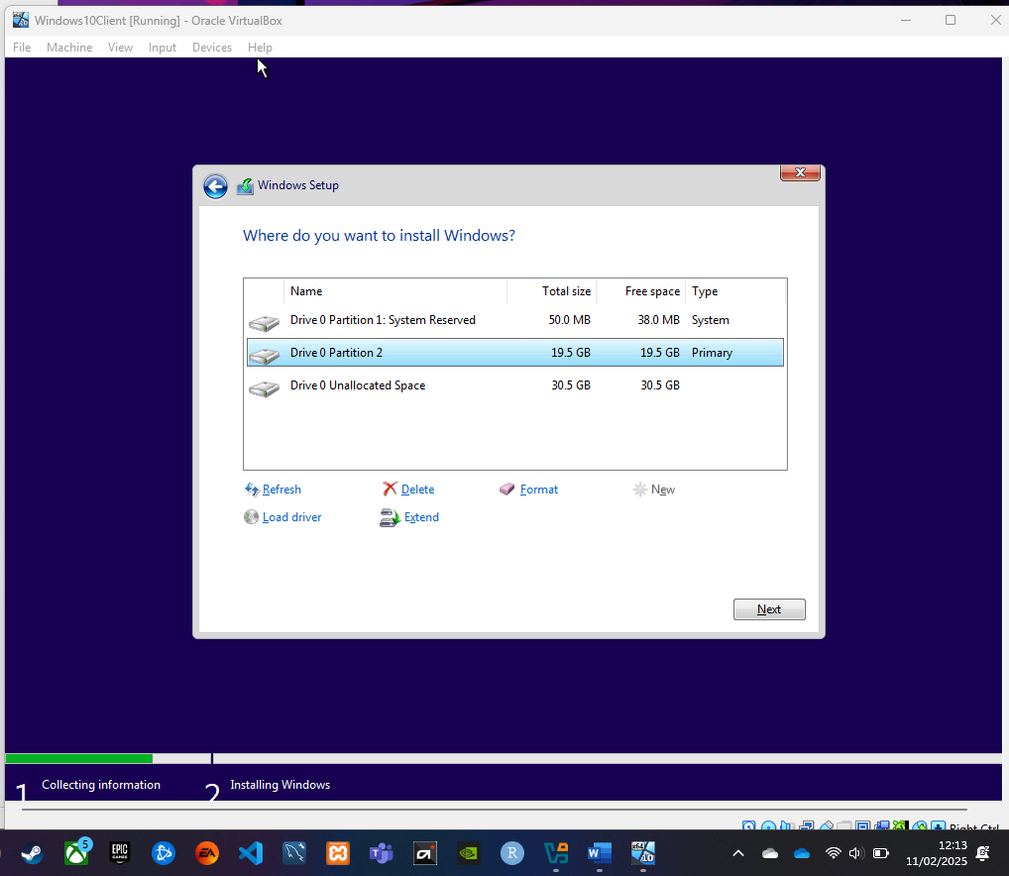
Added another partition in the Windows Client for 20GB

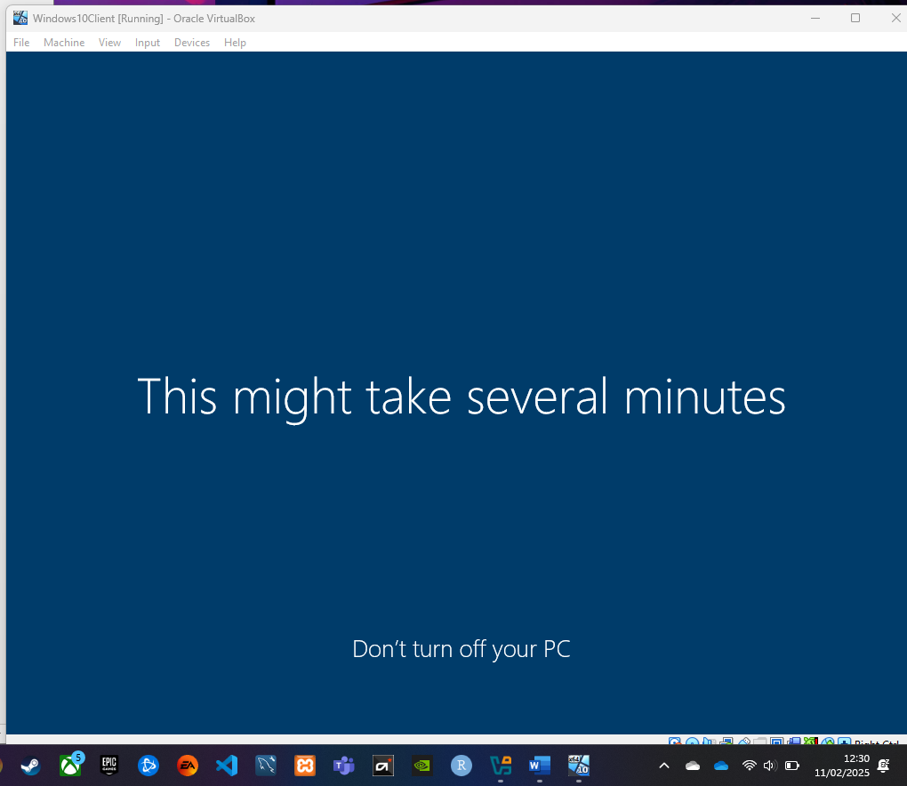
Install processing for Windows 10 Enterprise
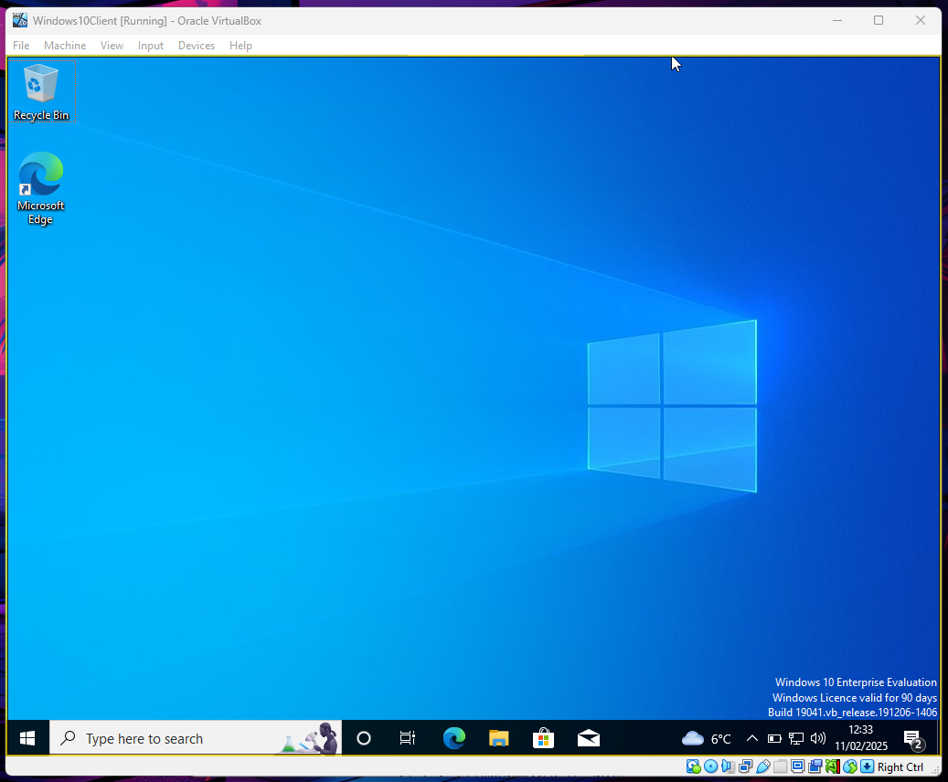

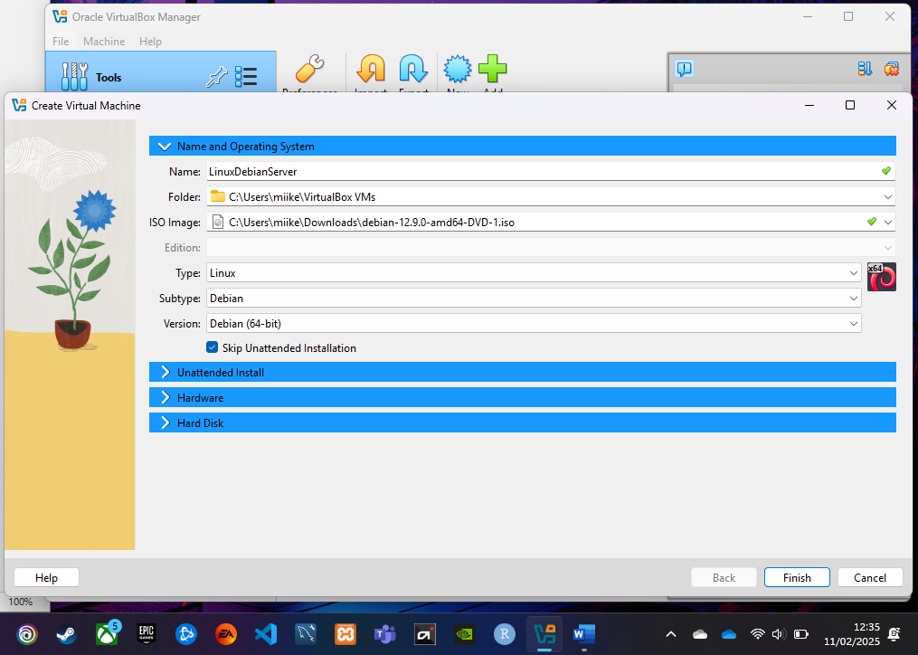
Installing the Debian Linux Server on Virtualbox
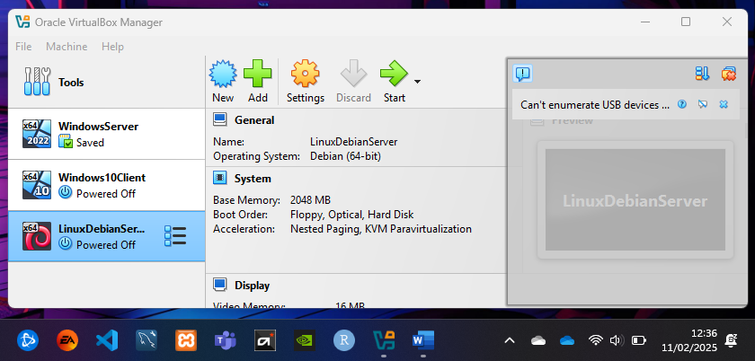

Configuring the Windows 10 Client Network and IP Address

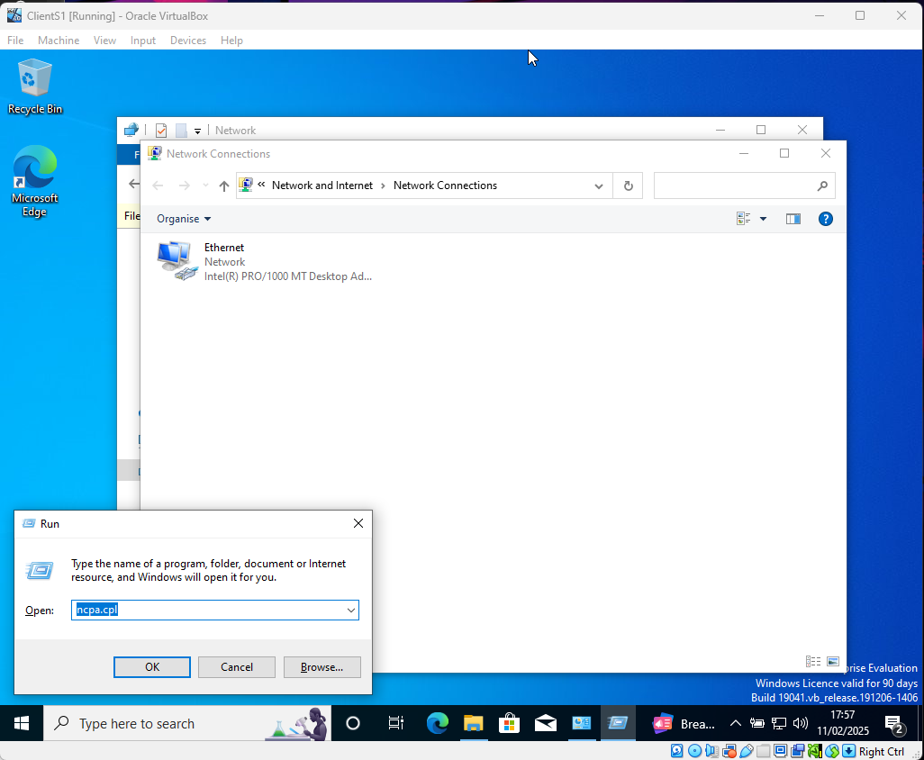
I have used the windows command ‘ncpa.cpl’ to open the network connections window.

Renamed the Ethernet to ‘Local Network’

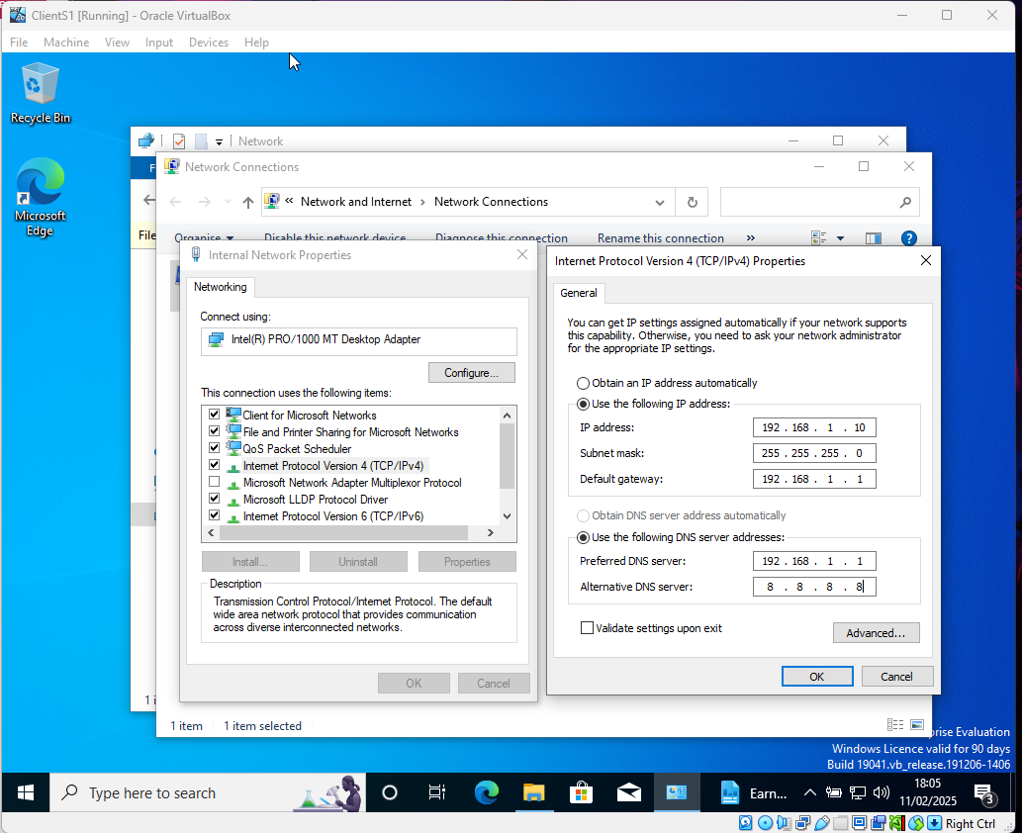
I have then gone into the properties of the Internal Network adapter to configure the IP address of 192.168.1.10, the subnet mask as 255.255.255.0, the default gateway as 192.168.1.1 and the preferred DNS server of 192.168.1.1 with an alternative DNS server as 8.8.8.8 which is a public DNS server.

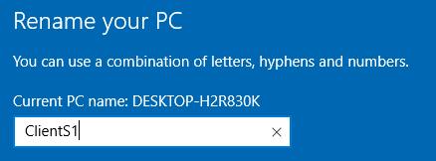
For best practice I have also renamed the PC as ‘ClientS1’.

Configuring the Windows Server 2022 (Server)

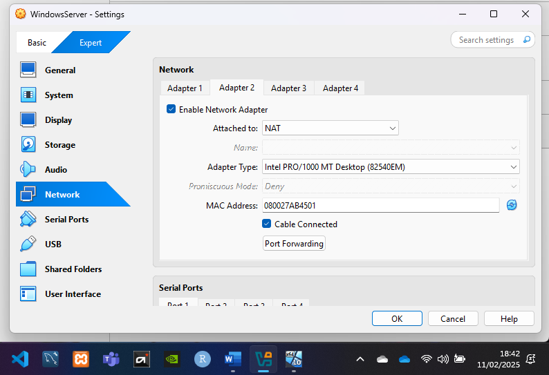
When I went into the Server (VM) and into the network adapters, I only had 1 network adapter showing. I shut down the VM and proceeded into the settings within Virtualbox for this Server. Into the networks tab and then enabled the network adapter from the Adapter 2 tab.
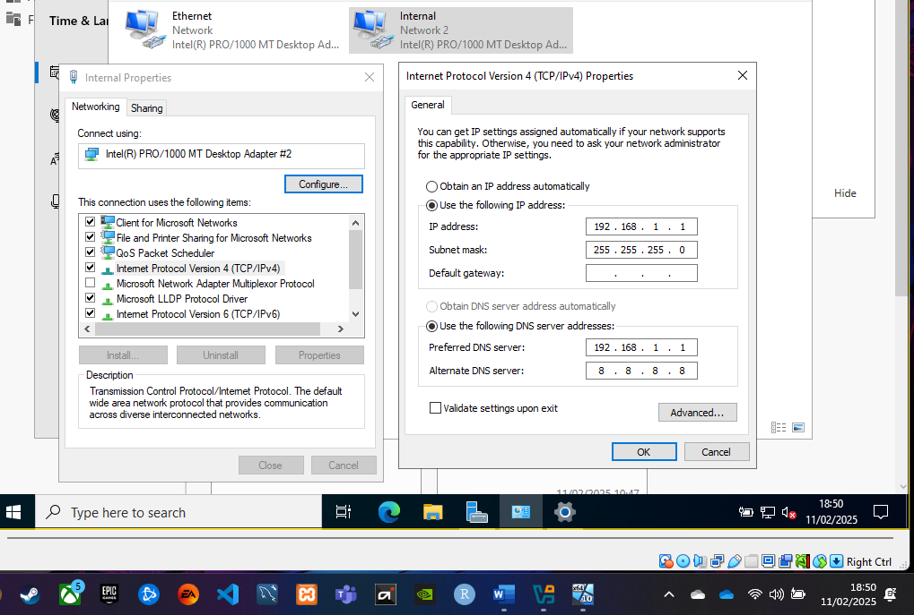
Now that I have restarted the VM, you can see my 2 network adapters and I have renamed the 2nd to Internal, opened the properties so that the IPv4 address and DNS can be configured. Here I have used the IP of 192.168.1.1, subnet mask of 255.255.255.0 and as this is the Server and the default gateway, this has been left blank. The preferred DNS has been set to 192.168.1.1 with the alternate as 8.8.8.8.

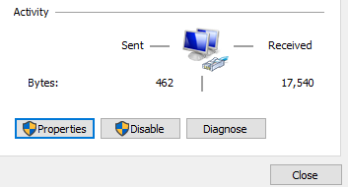
Once the IP had been configured, you can see that Bytes were being sent and received on the network.
I then used the CMD prompt to bring up the CLI. By using the ipconfig /all prompt, I am able to see the details of the network adapters and the IP configurations which I have made:
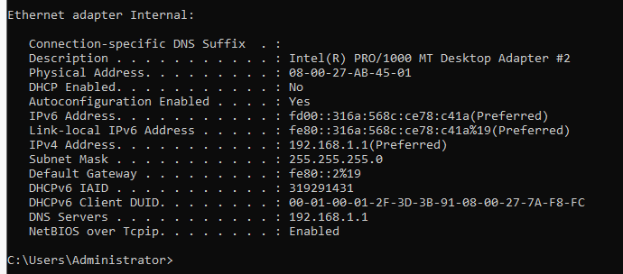
Whilst in the settings, I’ve ensured to update the name of the server to S-DC to match the topology and for best practice.
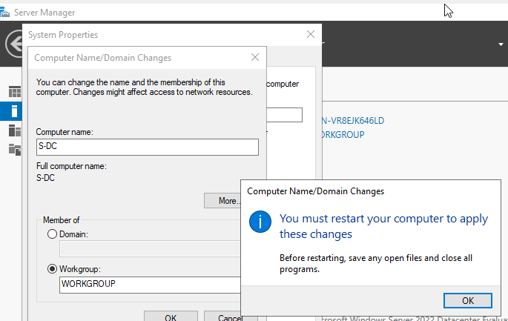
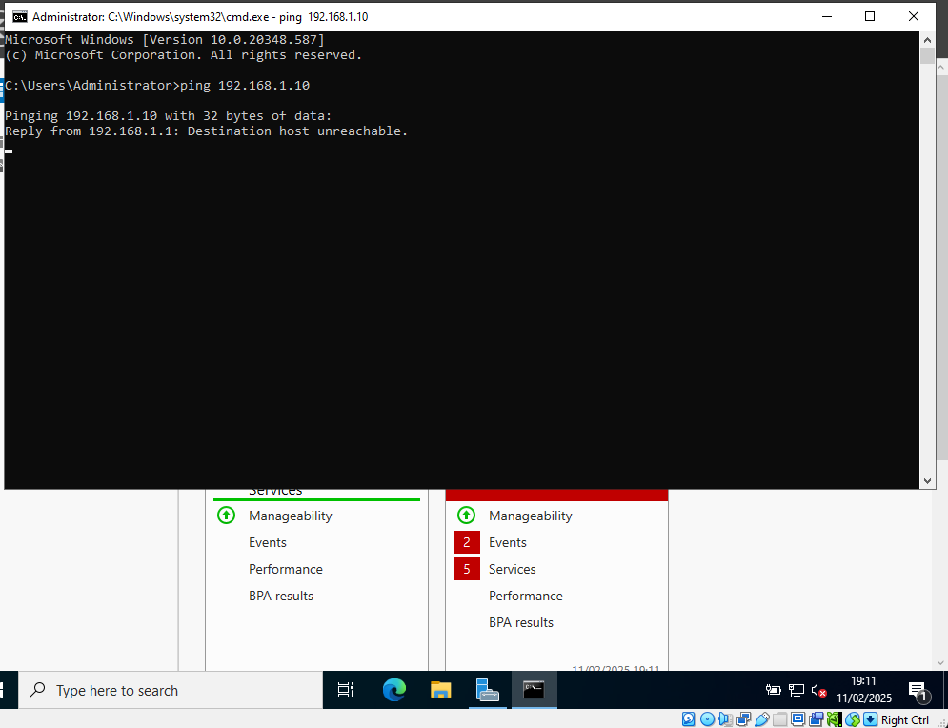
As a Ping to the Client on 192.168.1.10 has been unreachable and timed out, I now need to troubleshoot why this is and start by looking at the firewall.

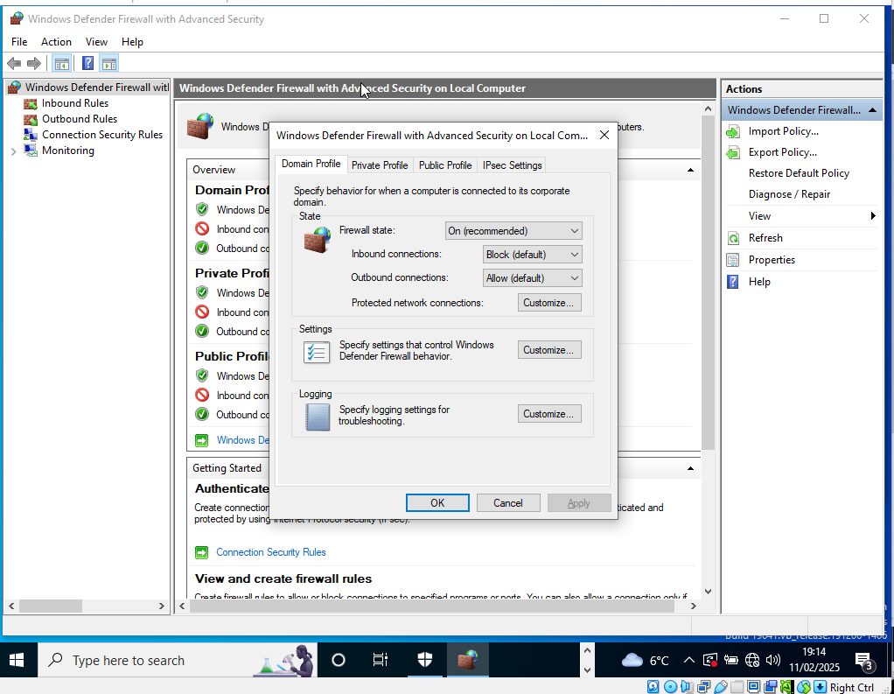
Within the Windows Defender Firewall Advanced Settings, the Firewall State needs to be turned off in the Domain, Private and Public Profiles to prevent the connections being blocked.

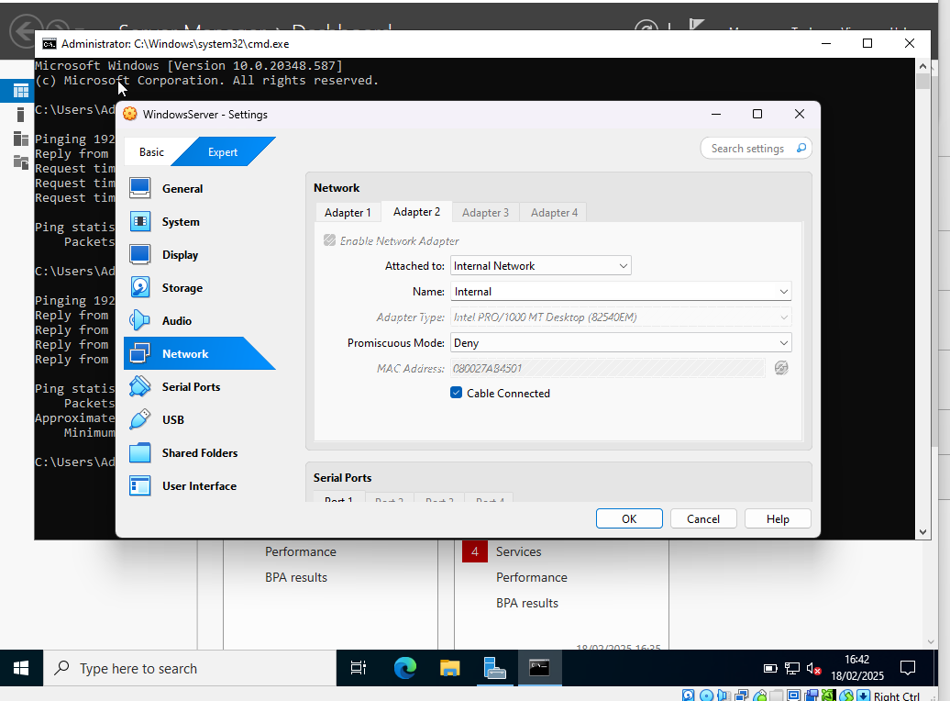
After completing some troubleshooting it turned out that my Windows 10 Client machines network adapter was set to NAT instead of Internal Network. I also needed to change this on the Windows Server as the original adapter that I enabled was set to NAT also.

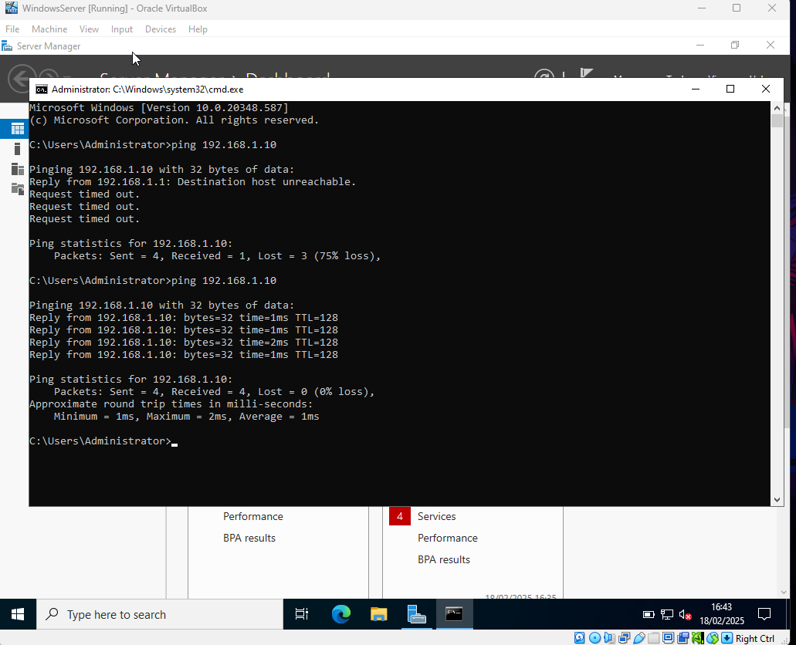
After making these changes, I am successfully able to get a reply when pinging 192.168.1.10 from the Windows Server.
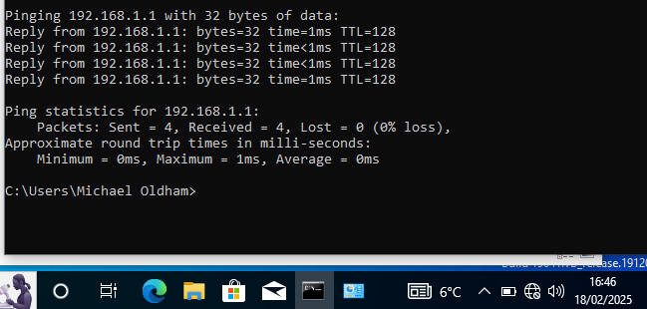
I was then able to get the same result when pinging from the Client to Server on 192.168.1.1

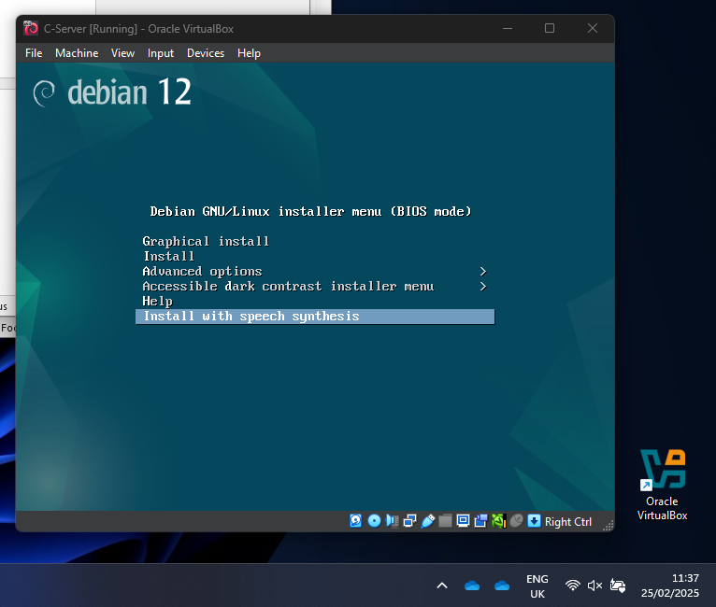
Installing & Configuring the Linux Debian Server
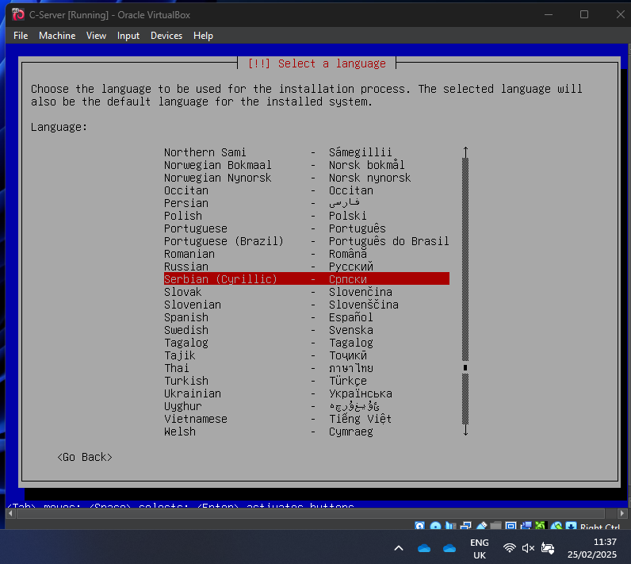

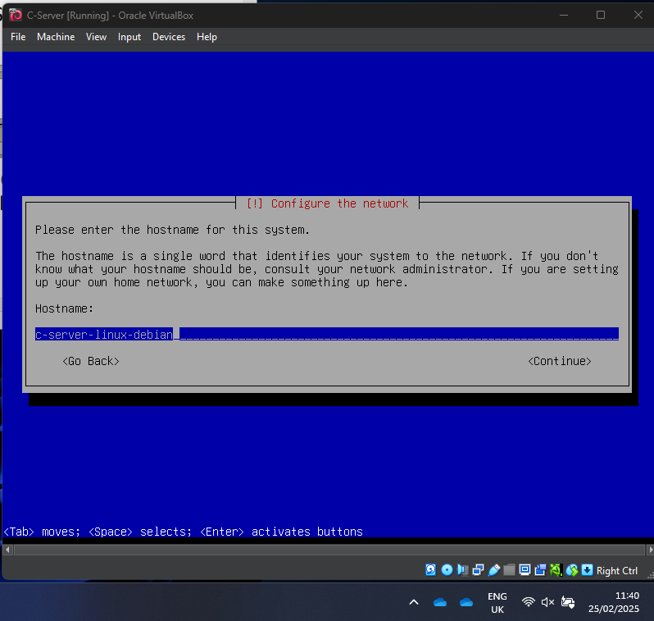
hostname for the system (c-server)

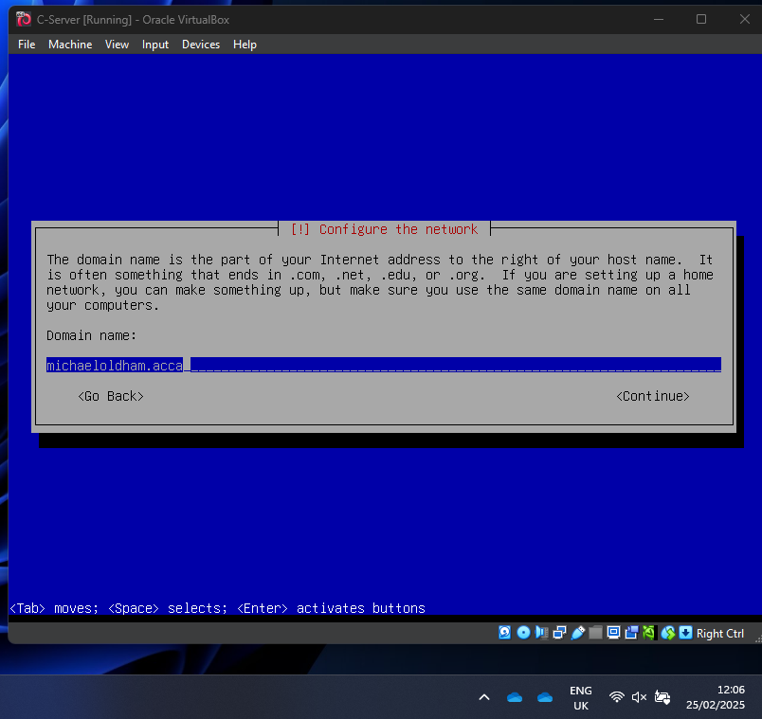
(Domain name: michael.acca)
I then set up the root password, added a user with a username and password.

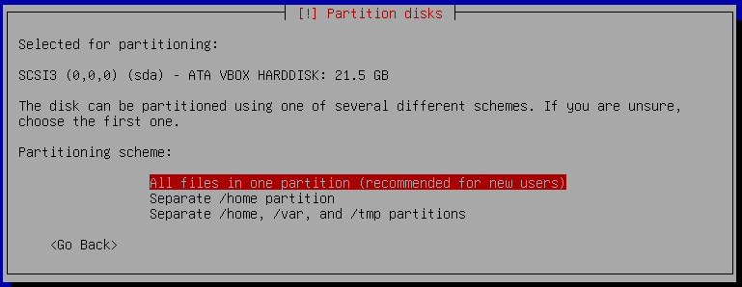
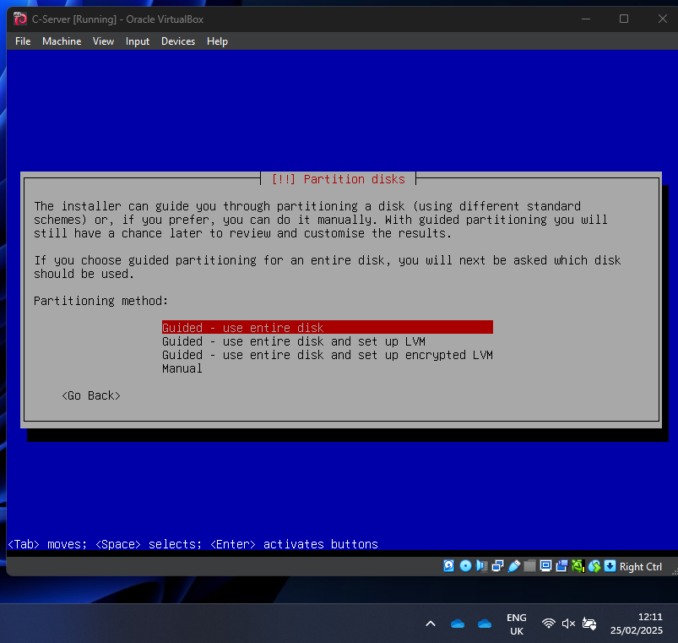
For the installer, I have opted for the guided disk partitioning using the entire disk.
I then chose to have all files in one partition.

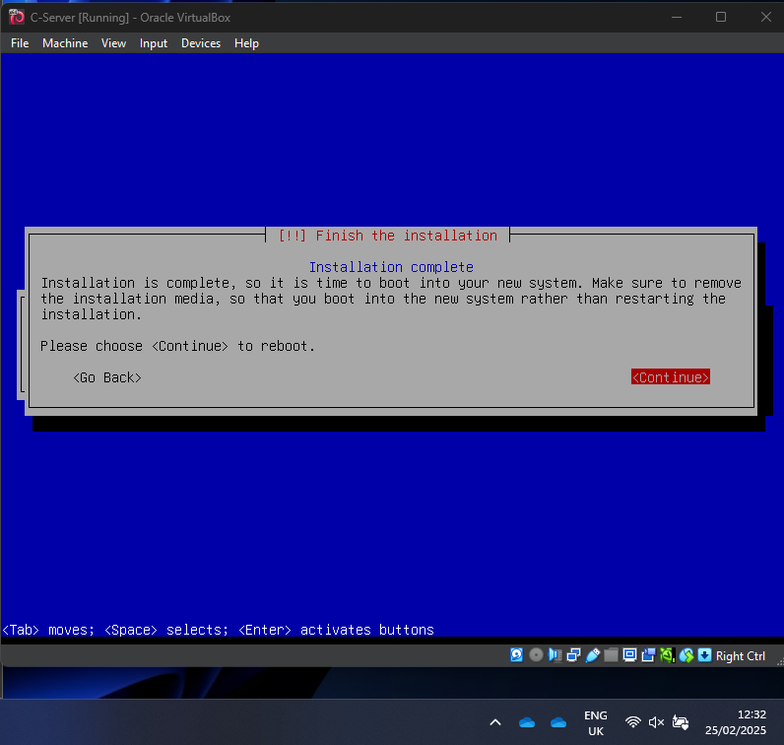
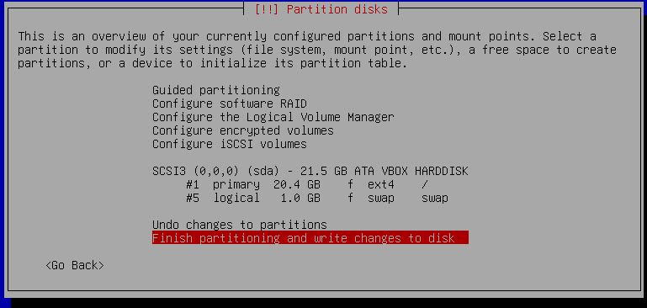
Once this has finished installing and I have chosen all the relevant options. I then need to reboot the system.
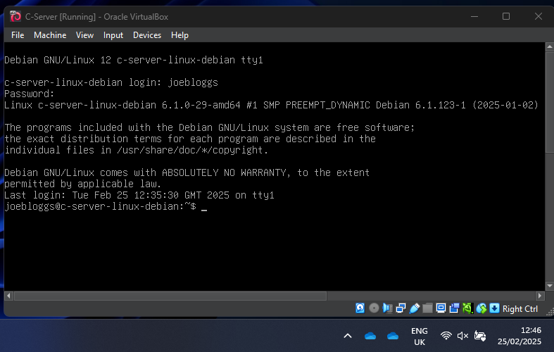
I have now been able to log into the Linux Server using the username and password created earlier in the installation.

After installing this, it became clear that I had incorrectly installed the Debian netinst.iso file which did not allow me to install the SSH Server. So I then removed this VM and started again with the correct complete ISO file and ensured that I installed the SSH Server at the same time. When doing this, I also decided to change the user details to a new one.

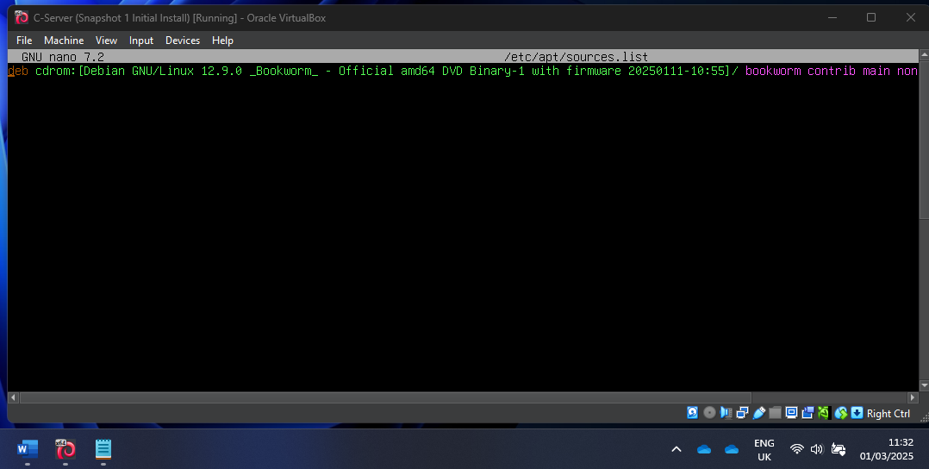
As this was causing problems Ive commented it out using ##
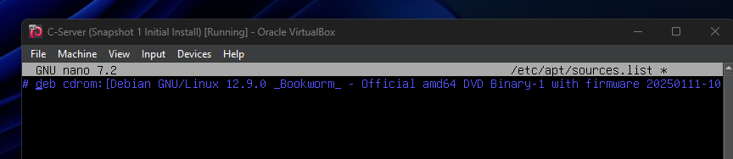
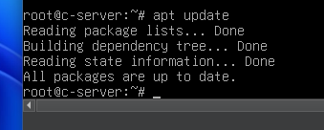

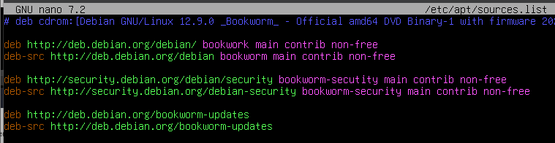
When adding the repository links in the etc/apt/sources.list file, I made a couple of errors so when trying to run apt update, this would not work.

After checking all the spelling and correcting these, here is the list I added:

- deb http://deb.debian.org/debian/ bookworm main
- deb http://security.debian.org/debian-security/ bookworm-security main
- deb http://deb.debian.org/debian/ bookworm-updates main
- deb http://deb.debian.org/debian/ bookworm-backports main

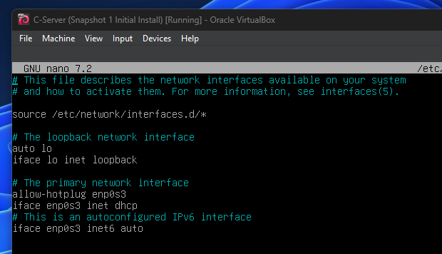
I then accessed the network interfaces file using nano /etc/network/interfaces in order to start configuring the static IP address for my server.
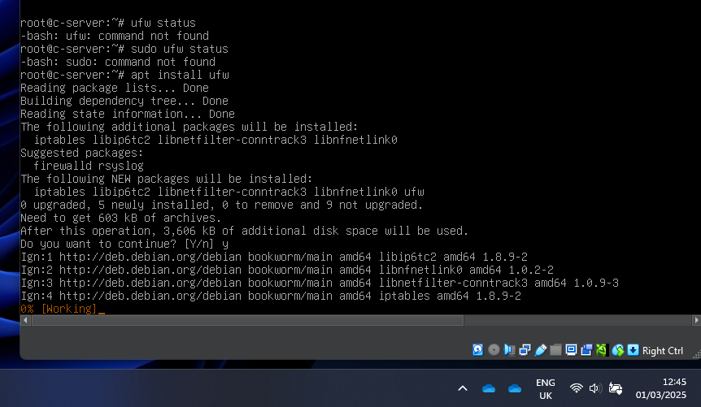
I have installed ufw which is (uncomplicated firewall, in order to check and configure this on the Linux server to allow ICMP, so that I can ping the client and server without disabling the firewall completely. After further changes made to my Linux networks, I did not need to use this feature for the time being.

Installing the Linux Debian Client (ClientC1)

When installing the Linux ClientC1 for the GUI Desktop version, as I removed the NAT network adapter and made it an internal network, when completing the install, I was prompted to set up the IP address details here.
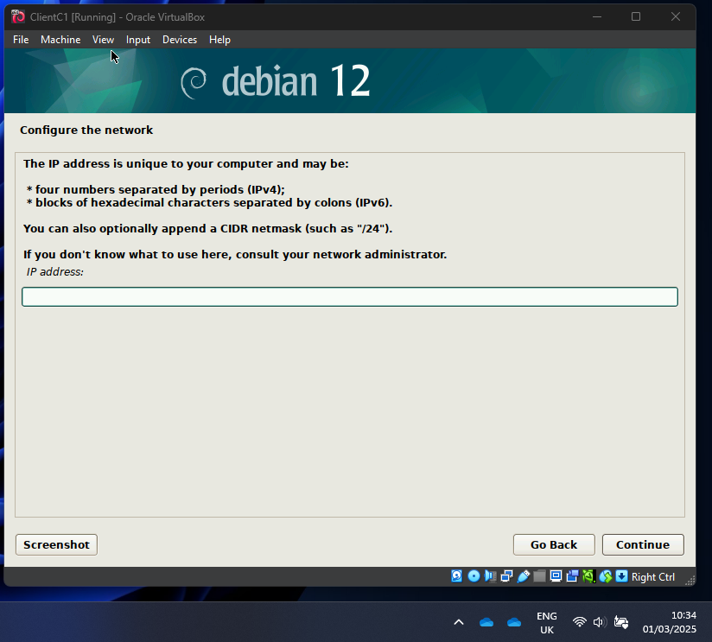

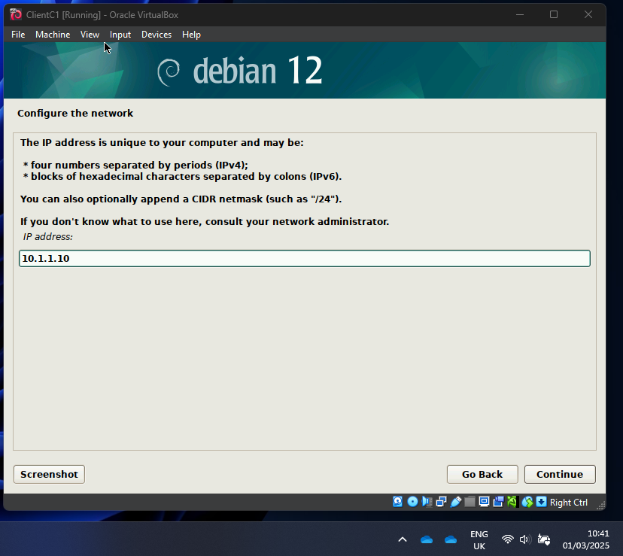
Here I have chosen 10.1.1.10 as my static IP address for my Linux ClientC1 with the default Gateway to 10.1.1.1. I will then use this as my Server’s IP address.
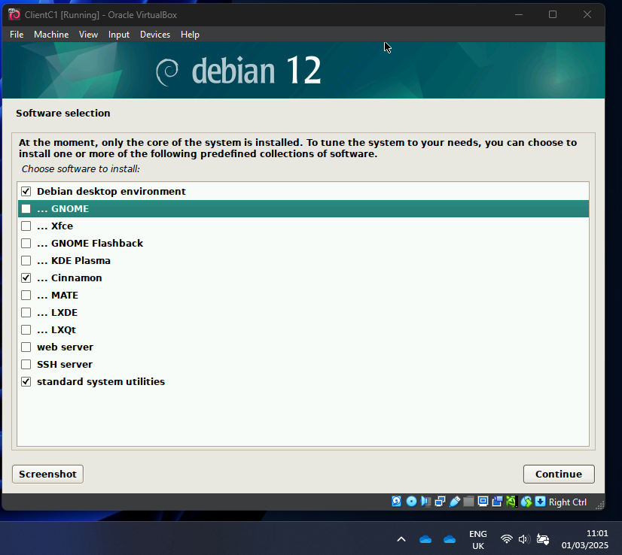
I have decided to install the Cinnamon Desktop version as my GUI for the Linux Client.

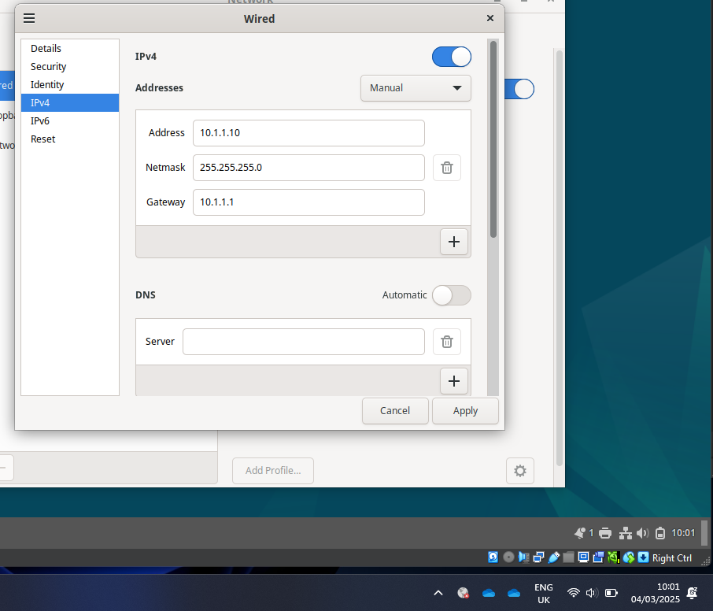
On my Linux client, I have configured my IP address as 10.1.1.10, netmask as 255.255.255.0 and gateway as 10.1.1.1

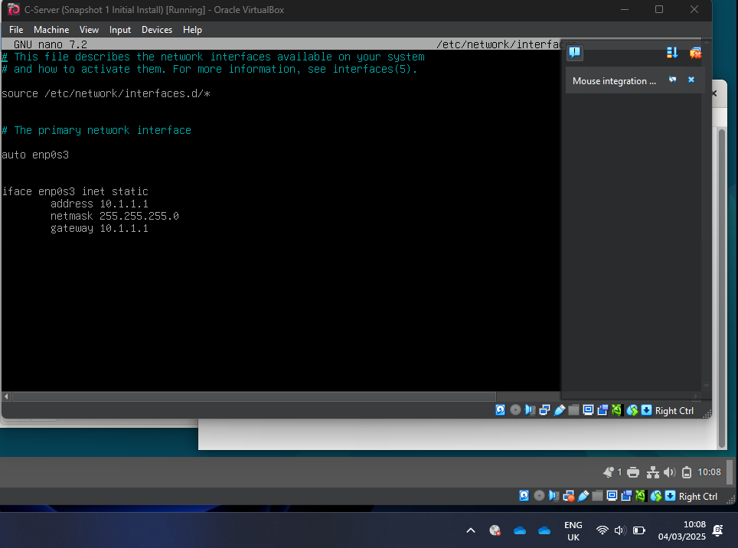
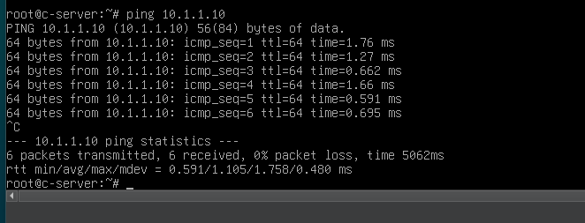
I was then able to successfully ping the Linux ClientC1 from my Server.
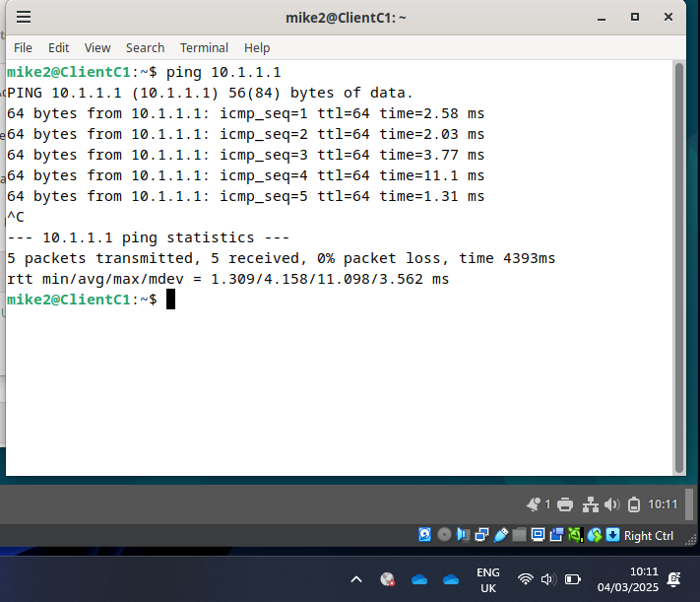
I was also able to successfully ping the server from my client machine.
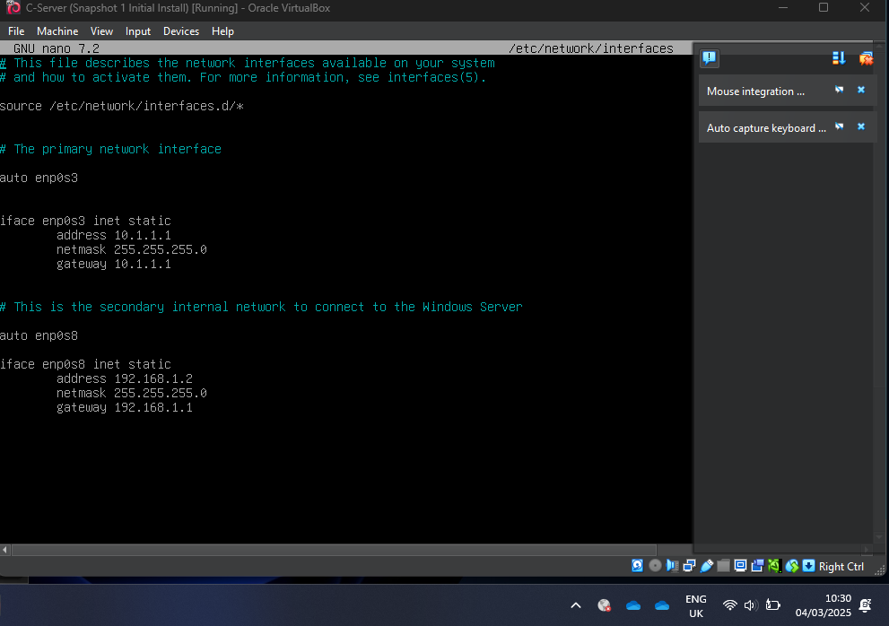
I then enabled another internal network adapter on my Linux machine which is enp0s8 and configured this with an address of 192.196.1.2 with a gateway of 192.168.1.1 (Which is my windows server IP) I was then able to ping between servers.
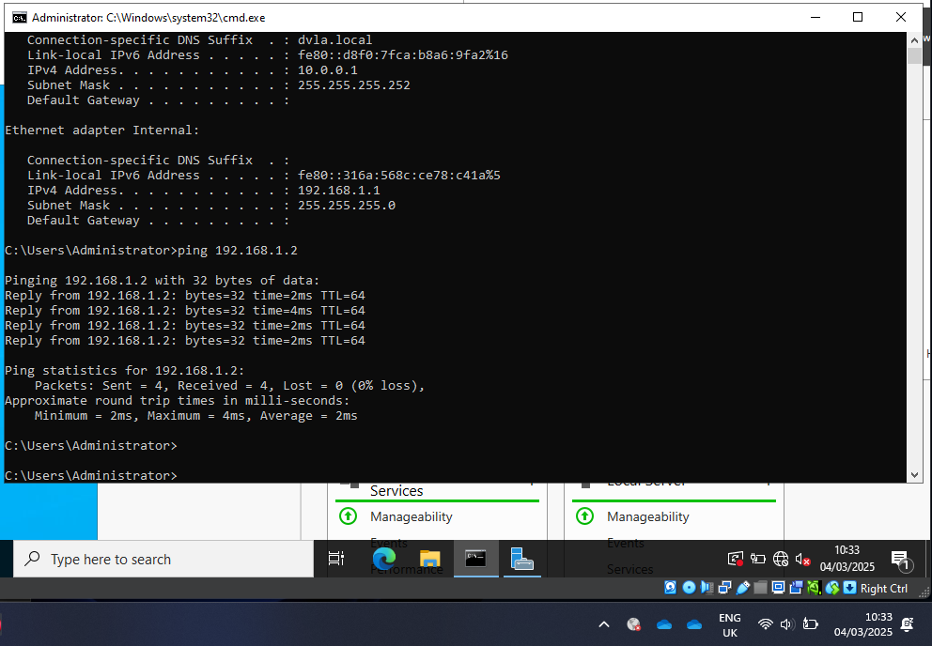
Here is my Windows Server pinging to my Linux Server.
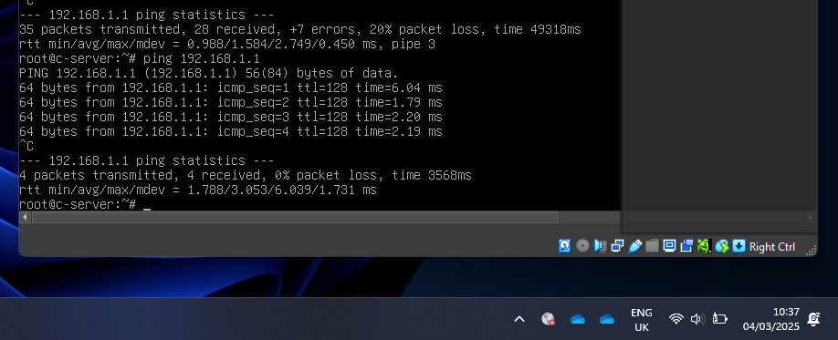
Here is my Linux server pinging my Windows Server.

Task 3 – Reflection
Throughout installing and configuring the Windows and Linux Servers/Clients, I had a few issues. I needed to install the VMs multiple times due to downloading the incorrect ISO image, or choosing the wrong install as either GUI or CLI.
I had issues when trying to ping between networks which led to disabling the firewalls. A better option in future will be to configure these to allow ping. Overall I am happy that I have managed to configure the IP addresses and successfully connected the clients to the respective servers and also managed to create a connection between the servers.

References
[1] Anonymous . Hypervisors Type 1 & 2. Available: https://aws.amazon.com/compare/the-difference-between-type-1-and-type-2-hypervisors/.
[2] Anonymous . What's the difference between Type 1 vs. Type 2 hypervisor? | TechTarget. Available: https://www.techtarget.com/searchitoperations/tip/Whats-the-difference-between-Type-1-vs-Type-2-hypervisor.
[3] Anonymous . Hyper-V Architecture. Available: https://learn.microsoft.com/en-us/virtualization/hyper-v-on-windows/reference/hyper-v-architecture.
[4] Anonymous (-12-20). TCP/IP Stack: Network Layers and Protocols - 101 Computing. Available: https://www.101computing.net/tcp-ip-stack-network-layers-and-protocols/.
[5] Anonymous (-10-04). TCP/IP Model. Available: https://www.geeksforgeeks.org/tcp-ip-model/.
[6] C. Parker. (-08-28). The 4 Parts of IPv4 IP Addressing. Available: https://whatismyipaddress.com/ipv4-parts.
[7] Anonymous . Introduction to IP addressing and subnetting | TechTarget. Available: https://www.techtarget.com/searchnetworking/tip/Introduction-to-IP-addressing-and-subnetting.
[8] Anonymous (-12-11). What is Routing?. Available: https://www.geeksforgeeks.org/what-is-routing/.

