
APPENDIX GA36c

LEVEL 6 ASSESSMENT SPECIFICATION

Student name: | Sam Chivers | Student ID number: | 1801265
Programme: | Outdoor Adventure Education
Module: | Critical Incidents in Adventurous Activities
Module code: | BMOE6001 | Contribution to Overall Module Assessment (%): | 50%
Lecturer: | Graham Harvey | Internal Verifier: | Denise Leonard
Assignment Title: | Critical Incident Portfolio | Word count (or equivalent): | 2,500
Submission deadline: | 15th January 2021 | Return date of provisional marks & written feedback: | 22nd February 2021
Submission method: | All written assessments, where practical and possible, must be submitted via Turnitin unless otherwise instructed by the Lecturer. (Please DO NOT put this assessment specification into Turnitin or it will match many similarities with other students’ submissions.)  Alternative submission method (if applicable):  Late submission of the assessment will result in a late penalty mark. Penalties for late submission: Up to one week late, maximum mark of 40%. Over one week late, 0%. Only the Extenuating Circumstances Panel may approve a change to submission dates.
Academic honesty / referencing: | Academic honesty is required. In the main body of your submission you must give credit to authors on whose research and ideas your work is based. Append to your submission a reference list that indicates the books, articles, etc. that you have used, cited or quoted in order to complete this assessment.

Module Learning Outcomes
(from module syllabus)
- Critically reflect on the antecedents and prevailing conditions relevant to the cases being studied
- Suggest a range of pragmatic preventative and remedial measures relevant to the cases being studied
- Demonstrate the ability to critically assess and respond positively to critical incident scenarios in a range of complex and/or unpredictable contexts

TASK DESCRIPTION

With reference to Reason’s (1990) “Swiss cheese model” produce a portfolio that explores the systemic factors relevant to the 1999 Saxetenbach Canyon disaster. Your account should explore critically the systemic factors that contributed to the incident, the event itself and the key outcomes.

Your portfolio can be submitted as a presentation, a film, a blog, an audio account or any other agreed format. It should have 4 distinct elements:

The first section should set the scene- the history of the activity at that site, the activity providers approach, the nature of the site and the people involved.

The second section should accurately describe the incident- what happened on the day, focussing on key factors that were instrumental in the outcome.

The third section should examine the immediate response and the long term implications of the incident.

The final section should be a reflective account which highlights your own learning from studying this incident and if/ how it might affect your personal approach to outdoor adventures.

STUDENT FEEDBACK FORM

This section details the extent to which the assessment criteria are demonstrated by you, which in turn determines your mark. The marks available for each category of skill are shown. Lecturers will use the space provided to comment on the achievement of the task(s), including those areas in which you have performed well and areas that would benefit from development/improvement.

Generic Assessment Criteria | Marks available | Marks  awarded
1. Engagement with Literature Skills  . | 10
Refer to a good range of technical and academic literature to support your critical analysis of the critical incident
2. Knowledge and Understanding Skills | 20
Clearly demonstrate your critical appreciation of Reason’s Swiss Cheese model (1990). Demonstrate your knowledge and understanding of the dynamic environment of “combined water rock activities” as described by AALA in note 6.06 (2016) and the guidance notes from other governing bodies that might be considered relevant to this incident.

3. Cognitive and Intellectual Skills | 30
Explore this critical incident with reference to Reason’s Swiss Cheese model (1990), Critically analyse the key responses to the incident and the impact the incident has had on the organisation/ delivery of adventurous activities in Switzerland. Highlight parallels and notable differences between how the Swiss operate and current UK system.

4. Practical Application Skills | 30
Identify and critically analyse the contributory factors that led to the incident.
Make explicit links between these factors and control measures that you would promote to mitigate these factors
With reference to the current Swiss system of regulating adventurous activities, and other relevant technical and environmental considerations, indicate whether you think that the contributory factors can be mitigated against so that this activity can be safely undertaken.
5. Transferable Skills for Life and Professional Practice | 10
Highlight how your critical examination of this incident might relate to your own practice of outdoor adventurous activities, from the perspective of a member of activity staff, as a commissioning agent or participant.

Assessment Mark (Assessment marks are subject to ratification at the Exam Board. These comments and marks are to give feedback on module work and are for guidance only until they are confirmed. ) | Late Submission Penalties (tick if appropriate) |  | %
 | Up to 1 week late (40% Max) |  | %
 | Over 1 week late (0%) |  | %

How the Swiss Cheese Model relates to the Saxetbach Canyoning Incident.

In 1999 Adventure World were at the top of the adventure industry(1). They were one of the largest outdoor companies in Europe and ran most of their activities out of Interlaken, Switzerland(6). As the company was so large they employed many new outdoor guides every year and frequently had guides working for them with little to no experience. The area was the adventure seekers paradise, centred in the Bernese Oberland area of the Swiss Alps the many mountains and rivers in the area allow for a plethora of outdoor activities to occur. People from all over the world seeking an adrenaline rush lined up to visit the area which had skydiving, climbing, white water rafting and snowboarding/skiing (in the winter months) all in the same place. What’s not to love! The nature of the mountains and the rivers that flowed from them allowed for another adventurous activity to take place, canyoning. Canyoning can be seen as one of the ultimate outdoor activities, bringing together the skills used in climbing, scrambling, tidal/river swimming and caving all whilst wearing a wetsuit and buoyancy aid and trying to navigate the rough terrain of a flowing river.

The Call for Adventure
Ever since the late 70’s Interrailing has been extremely popular amongst young people, traveling all Europe and being able to visit landmark cities and areas in many different countries for a relatively cheap price meant many young people were interested(2). And as one of the adventuring capitals of the world (6) at the time Interlaken was one of the necessary stops for many young adults. In the summer of 1999 young people from all over the world came to Interlaken through the company Contiki Adventure(3) to have an adventure.

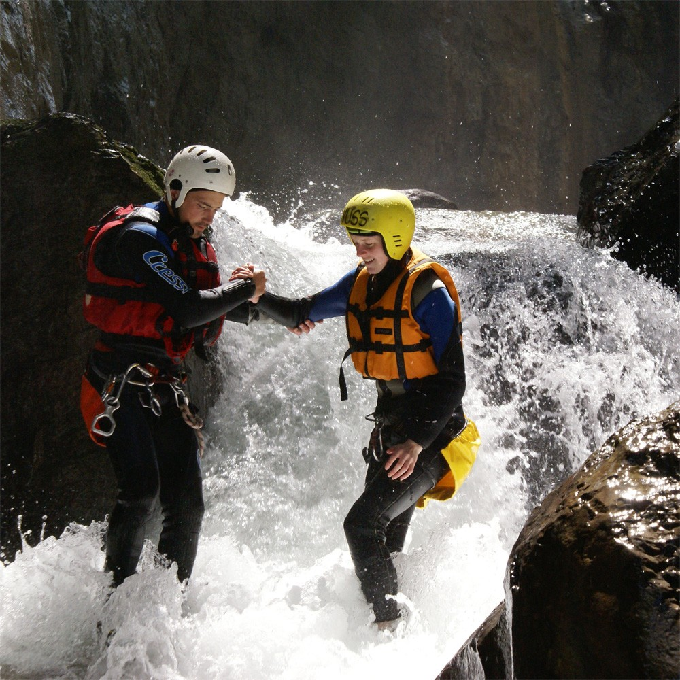
(5)

That Fateful Day
On July the 27th 1999 at around 4:30pm the first group of 4 for that evening consisting of 12 young participants and 2 guides entered the canyon to undertake the canyoning experience. There were dark clouds in the sky and it was raining, there was an atmosphere of excitement and anticipation from the participants as they eagerly awaited starting the activity. Within the next hour the rest of the groups all entered the canyon about to start the activity. At the midpoint of the river section that is used 100m of the river flows through a section with high rock walls on either side, making this section quite dangerous and also exhilarating for the people taking part in the activity.

Roughly just before 6pm the first group in were coming to a difficult point in the canyon after the section with built up high walls on either side as the first participant in the group entered the water and was helped out by an instructor the more experienced instructor of the group turned around and in an alarmed manner started yelling for the group to get out of the water(1).

The Wave
A brown wave of water roughly 2 metres high swept through the canyon raising the river level. People from the level most group in the river watched in horror as people that had jumped into the water higher up the canyon above them began to be swept past fighting the current. The instructor that had called out for their group to get out of the water started to jump in and rescue people, they were able to manage to save four people individually before they were fatally swept away.

The wave was described as an avalanche ‘brown thick water [...] carrying boulders and logs’ (1)(2). Group members were swept down the river, some of the more fortunate were swept into a large swirling eddie just downstream where they were able to be rescued by some of the guides running down the edge of the river. Most of the people in the group at the end of the river section and the group at the start of the river were able to get out and only one present from each group died, most of the casualties came from the groups that were trapped within the section of the canyon with high walls, meaning they were not able to escape. As the water levels began to rise the groups had no option to get out as the rock walls on either side of the canyon were smooth rock from the water erosion. In all 18 participants and 3 guides were swept away and died to the influx of water. 14 Australians, 2 Swiss, 2 New Zealanders, 2 South Africans and 1 person from the UK(1)(3). Due to the power of the water some of the bodies of the casualties even surfaced a couple miles downstream in the popular boating lake, Lake Brienz, during the peak summer boating season. It is documented that when it is much harder for people to get out of water, especially then shocked or in a state of panic or high tension (10).

Could it have been prevented?
There were many red flags before the event took place. It was raining that day and the forecasts predicted worse weather and thunderstorms that evening. The head guide and leader of the only other outdoor company that offered canyoning in the same area cancelled their canyoning sessions that evening and when talking to investigators and journalists after the incident stated his main rule, ‘Never go in the canyon in a storm’ (1). Locals knew of the dangers of the ‘wave’ and said that it was almost seasonal and came around a couple of times a year. Another red flag was when a volunteer firefighter from a village upstream of the canyon approached the last group just before they were about to get into the water and warned them that there was a quite severe thunderstorm happening upstream of the canyon, however the guides brushed off the waring and carried on with the activity anyway(3).

Why did the guides carry on?
According to multiple sources(1)(2)(3), Adventure World were becoming increasingly profit hungry. In 1990 Adventure World brought in 2 guides with years of experience in canyoning to create the safety guy lines in the canyon, writing the safety and emergency procedures for the canyoning activity, however according to them over the years Adventure World became more and more ‘financially driven’ (3) they started to cut corners and looked at making as much of a profit as possible from their activities. When the company first started running canyoning trips their safety guidelines stated that at least one experienced guide should be in each group, who would also be accompanied by a less experienced assistant guide. However, as the years progressed the more experienced guides became replaced by less experienced guides that were cheaper to hire, the less experienced guides were also more likely to go along with what the company wanted and would be less strict as they were eager to get the job and have experience and make some money. This in turn meant that the safety standards of the company could slip slightly as the newer guides did not have the experience of leading in the ideal scenario with the correct safety standards.

Some accounts of what happened (3) also claim that Adventure World could have been under pressure to deliver the sessions to the group, signing the contract with Contiki Adventure was big for them as it brought in hundreds of clients, this was the first year that Adventure World had the contract so they may have been under some pressure to perform to keep the working partnership with Contiki Adventure so they can make more profit. There may also have been some pressure on guides to perform and deliver sessions otherwise they would go without pay, this could have led to the guides feeling like they had no choice but to do the activity and they felt like they could not cancel on the group.

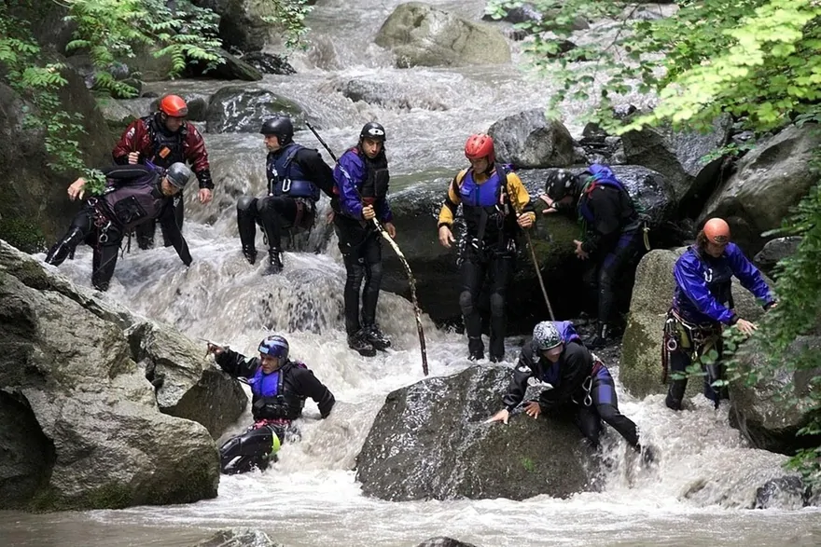
Guides looking for casualties in the river immediately after the incident(4).

"It is basically a classic case of profit over safety.”(3)

What happened afterwards?
Immediately after the incident happened many people were not sure what the cause of the incident was. Word of the incident spread out as some of the people were identified as missing/dead were tourists from other countries. The local radio station began to receive a large number of calls asking for information, the BBC and ABC Australian Radio (5) were in contact to find out what has happened as word has spread that people from their countries are amongst the casualties, however still not much was known by the local people in Interlaken. Police and reports descended to the scene to try and make sense of what was happening and talked to the people that were running Adventure World and in charge of the activities.

There was a rumour spread around the town suggesting that a natural dam upstream of the canyon had burst and this led to a lot more water coming down the canyon that the guides had anticipated, however, this was later dismissed as many locals and people from other outdoor companies in the area came forward and told reporters that the wave phenomenon was well known by the locals and that it happened a few times per year (1).

After the incident a police inquiry into the reasoning behind the incident led to 6 members of staff for Adventure World being charged with manslaughter through negligence (6), they were given suspended sentences and fines of up to 7500 CHF (Swiss Franc). Two of the younger less experienced guides that survived the disaster were not charged as it was deemed it was not their decision to cancel the activity (6).

Adventure World tried to be proactive following the incident and reached out to a Zurich based company, Meteodat, to create an in depth weather gauge system to make future canyoning trips safer. According to SwissInfo, ‘The company designed a concept for an alert system that would combine near-term and longer-term weather predictions with runoff gauges and precipitation gauges in the gorge itself’(4), however when the company went bankrupt a year later in 2000 after another incident the project was scrapped and no other company wanted to take up the project with Meteodat (4). Other companies had different views on the system and some had the view that it was the guides responsibility before they delivered an activity to check and be responsible, and not ‘rely on such systems’ (4).

Another change that occurred after the incident is that it was decided by the Swiss Outdoor Association (4) that all canyoning guides must attain a certain level of training and a certificate before they can provide sessions, however there was no common standard in place at the time. A voluntary certification programme was introduced in 2000 however it was not very popular within the industry at the time. It wasn’t until legislation was passed in 2014 that it became mandatory for all outdoor businesses earning more than 2300 CHF (£1893) per year to have a safety certification. Change has been slow but over time more precautions have come into place to prevent incidents.

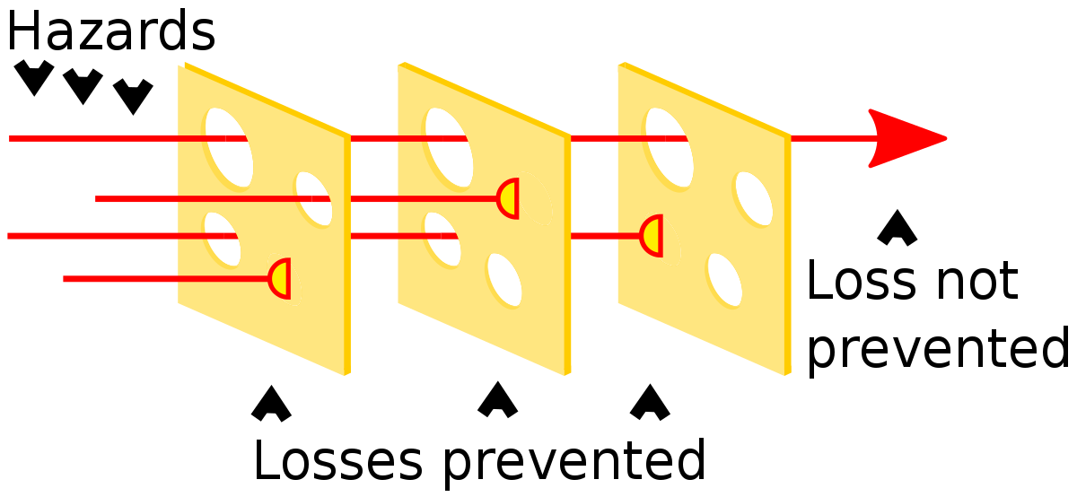
(7)

How does this relate to the Swiss Cheese Model?
The Swiss Cheese model, developed in 2000 (8). is a model used for risk analysis and management to determine if the safety measures implemented are enough to stop all possible dangers and able to limit any risks from the activities. The symbolism from the model shows the dangers/risks as penetrating each layer of security that is put in place (through the holes) however, as the holes are in different places on each piece, each layer of safety measures put in place will limit different risks (8). This model relates to the incident quire well. For example, although Adventure World brought in qualified external instructors with lots of experience to create the safety measures for the canyoning experience, over the years the more experienced guides were replaced by younger less experienced guides that didn't know the safety procedures as well… which could lead to some of the safety measures not being followed.

During the court case with the company it was found that Adventure World did not have written risk assessments for the activity (9), this is another factor that could have led to the incident. Not having the risk assessments written down means that the safety protocols were not set in stone, having the safety measures spread by word of mouth only could lead to some measures being lost in translation or forgotten, possibly lowering the safety standards.

One of the members of staff themselves, when interviewed, stated, ‘There was a macho attitude in the company, an attitude that slowly turned into arrogance, which is very dangerous when you're taking people's lives into your own hands every day’(1). This sort of attitude can be a serious issue when it comes to matters of safety, especially in the outdoor industry where there are so many uncontrollable variables to consider when on an activity such as the environment around them.

Another theory that is represented here is the Domino theory. The theory suggests that an incident does not occur because of one single factor, but because multiple factors line up and then a resulting incident happens. One of the people interviewed also backed up this view saying ‘The main point is this accident didn't happen on the 27th of July. It was created over years’ (1).

Personal thoughts.
I know that from investigating this incident in future I will also make sure that safety procedures are in place before I guide/lead an outdoor activity. I believe that the most important thing to take from the Saxetbach Canyon Disaster is that a guide must not become complacent, being a ‘yes man’ might work when entering a new job in an office but when leading in the outdoors a guide needs to be able to make their own decisions and know their limits. Arrogance doesn't have a place in the outdoor industry, especially when in a leadership position and other people's lives are in a person's hands.

Word Count: 2284

References:

- Jenkins, M. (1999) A Storm in the Distance. Available at: https://www.outsideonline.com/1889196/storm-distance (Accessed: 13/1/21)

- Lashmar, P. and Karacs, I. (1999) Swiss river disaster: Black wall of water swept down the gorge, crushing everyone in its path. Available at: https://www.independent.co.uk/news/swiss-river-disaster-black-wall-of-water-swept-down-the-gorge-crushing-everyone-in-its-path-1109256.html (Accessed: 12/1/21)

- Head, M. (1999). Profit drive blamed for Swiss canyon tragedy. Available at: https://www.wsws.org/en/articles/1999/08/swss-a06.html (Accessed: 14/1/21)

- SwissInfo. (1999) Safety still a question 20 years after Interlaken canyoning accident. Available at: https://www.swissinfo.ch/eng/risk-sports_safety-still-a-question-20-years-after-interlaken-canyoning-accident/45105312 (Accessed: 15/1/21)

- Hoffman, G. (2019). Canyoning in Saxetbach - How an Accident can Change one’s Perspective. Available at: https://www.linkedin.com/pulse/canyoning-saxetbach-how-accident-can-change-ones-hoffmann (Accessed: 15/1/21)

- Allison, R. (2001) Tour firm staff guilty of Swiss Deaths. Available at: https://www.theguardian.com/uk/2001/dec/12/travelnews.travel (Accessed: 15/1/21)

- Image for Swiss Cheese Model. (No Date). Available at: https://upload.wikimedia.org/wikipedia/commons/thumb/0/07/Swiss_cheese_model.svg/660px-Swiss_cheese_model.svg.png (Accessed: 15/1/21)

- Reason, J. (2000). Human error: models and management. Available at: https://www.ncbi.nlm.nih.gov/pmc/articles/PMC1117770/ (Accessed: 15/1/21)

- SwissInfo. (2001). Managers deny responsibility for canyoning disaster. Available at: https://www.swissinfo.ch/eng/managers-deny-responsibility-for-canyoning-tragedy/2409930 (Accessed: 15/1/21)

- Moran, K. (2014). Getting out of the water: How hard can it be?. International Journal of Aquatic Research and Education, 8(4). Available at: https://moodle.uwtsd.ac.uk/pluginfile.php/440411/mod_resource/content/0/Getting%20Out%20of%20the%20Water_Moran_2015.pdf?redirect=1 (Accessed: 15/1/21)

