

Destination Management: Lake District

Student Name: Laxshan Rajagopalasingam
Student ID: 2017474
Tutor – Dr Huw Thomas
Table of Contents
1. Introduction 3
2. Lake District Tourism and Hospitality Industry in the UK 3
Butler’s Life Cycle Model 3
Doxey’s Irridex Model 4
3. Concept of Sustainability in the Tourism and Hospitality Industry 5
4. Principles of Sustainable Tourism: Three Pillars of Sustainability 7
5. Future Sustainable Development of the Destination 9
5. Conclusion 10
References 11

1. Introduction
Sustainability, which is the practical use of a supply to minimise depletion or harm, is crucial to the hospitality industry. For hospitality businesses to succeed, it is crucial to safeguard the common and social attractions that draw visitors to a location. Destination management is a planned process in which virtually every aspect of a destination is regulated, including promotional activities, local resources, hotels, entertainment, festivals, environmental issues, tourist attractions, and transportation (Global Sustainable Tourism Council (GSTC), 2022). A destination management business typically has responsibility for it (DMC). In managing commerce for their area, they use a comprehensive strategy and might even provide extra services like training. The investors and members of destination management companies, which are primarily membership-based organisations, may include governments, local business owners, civic leaders, non-profit groups, and others engaged in travel and tourism (Fyall, and Garrod 2019). In the below report, the mountainous lake district in northwest England is discussed. The two well-known models Butler’s life cycle and Doxey’sIrridex Model are also elaborated briefly. The three pillars of sustainability or principles are described here. The sustainable development of the destination in future is described here.

2. Lake District Tourism and Hospitality Industry in the UK
Every year, hundreds of millions of people travel domestically and abroad as part of the global tourism sector. However, the growth of mass tourism and the escalating urban population also put pressure on the environment. Numerous quantitative analyses are starting to focus on how a tourism location develops, particularly in terms of sustainability. One of them is the analysis of the destination’s life cycle, which shows that environmental development puts more pressure on the environment. Butler’s model of the tourist endpoint life cycle, published in 1980, states that the destination goes through several stages as it develops: exploration, involvement, development, consolidation and stagnation, and rejuvenation or decline.

Butler’s Life Cycle Model
Tourism is one of the biggest industries in the world. The sector is extremely busy and is always changing. Tourist destinations need to be managed carefully because they are usually vulnerable. The feasibility and density of attractions have been a topic of discussion among a considerable number of authors over the years (Berry, 2000). One of the most famous is geography and tourism professor Richard W. Butler. The Tourism Area Life Cycle Model (TALC), which he created, is based on the notion of the Product Life Cycle. The model can be used to track changes in vacation spots over time (Butler, 2004). The five stages of Butler’s Life Cycle Model are Exploration, Involvement, Development, Consolidation, Stagnation, and Decline.

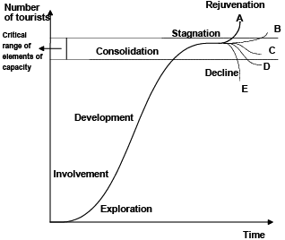
Fig 1: Butler’s Life Cycle Model
(Source: Porter, 2020)

Doxey’sIrridex Model
This system was introduced by Doxey in 1975 and is also referred to as the Irridex. It is based on knowledge about how locals feel about tourists, including how their attitudes toward them have changed over time, and how tourism has developed throughout a destination’s life cycle (Shobha, 2019). George Doxey, whose name is not generally known outside of the academic world of tourism, suggested. According to the Reported team’s model, locals’ opinions on tourism should evolve in a consistent one-way sequence. It implies that there is a sense of uniformity in locals’ opinions and responses to tourism. Euphoria, apathy, irritation, and antagonism are the four stages of the progression.
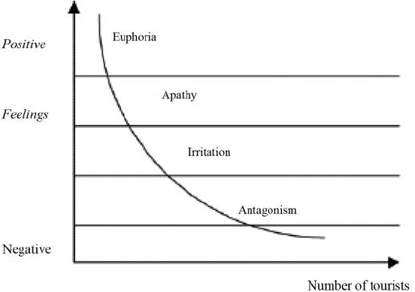
Fig 2: Doxey’sIrridex Model
(Source: Cordero, 2008)

3. Concept of Sustainability in the Tourism and Hospitality Industry
Sustainable tourism denotes sustainable approaches secondhand in and by the travel and tourism sector. To acknowledge both the negative and positive effects of tourism is an area. The goal is to increase good properties while minimizing harmful ones. Overcrowding, environmental harm, and economic leakage are examples of adverse effects on a destination (Weaver, 2007). The benefits of a destination include the creation of jobs, and the protection of the environment, wildlife, and terrain. The capability to care provision or preserve a process throughout time is mentioned as sustainability. In corporate policy, sustainability aims to halt the depletion of a natural or physical resource and ensure its long-term availability. The National Park Authority bases what it does on sustainability. “The Lake District National Park will be an inspirational model of sustainable development in action”, reads their shared vision. They want the local ecology and culture to be protected while the tourism sector is prosperous and flourishing.
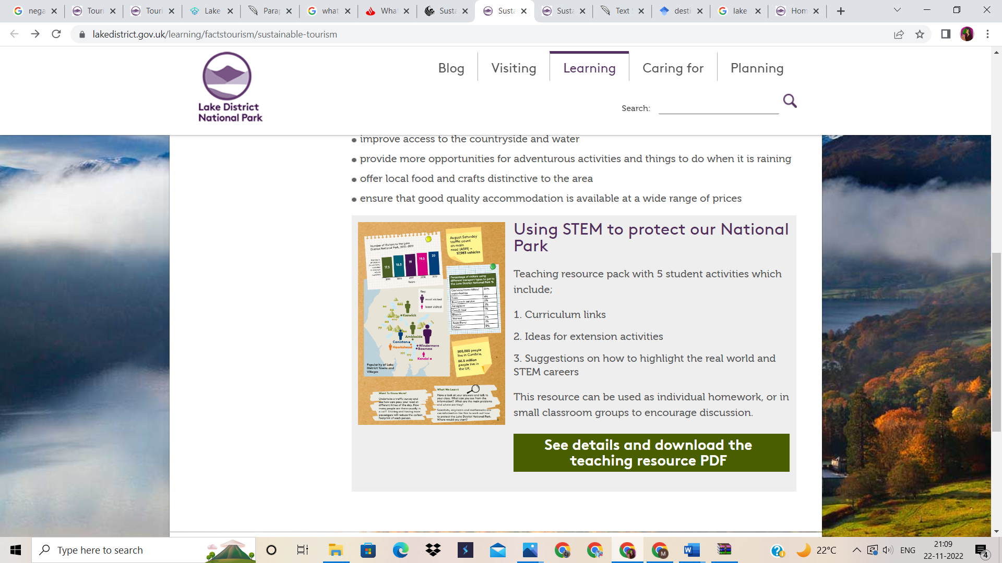
Fig 3: Lake District Sustainability
(Source: Lake District National Park, 2022)
To minimise resource reduction or harm, sustainability is essential to the hospitality area. For hospitality businesses to succeed, the conservation of the natural and cultural features that draw tourists to a location is essential. One of Thailand’s most well-known beaches, Maya Bay, will be closed for three years starting in 2018 due to daily visits by 5,000 tourists destroying the majority of the coral and threatening the area’s original allure. Failure of enterprises owned by neighbourhood tour operators. Like this, the Lake District received 15.8 million visitors annually on average, spending £1.48 million in 2018. However, despite the positive effects that tourism has on the area, there are also many drawbacks. North West England’s Lake District, sometimes referred to as the Lakes or Lakeland, is a mountainous area consisting of mountains, forests, and lakes. Having a total size of 2,362 square kilometres (912 sq mi)., the Lake District National Park was founded in 1951. 2017 saw its UNESCO designation as a World Heritage Site. The countryside of Finland is spotted with second residences, which account for a sizable portion of domestic travel (Lake District National Park, 2022).
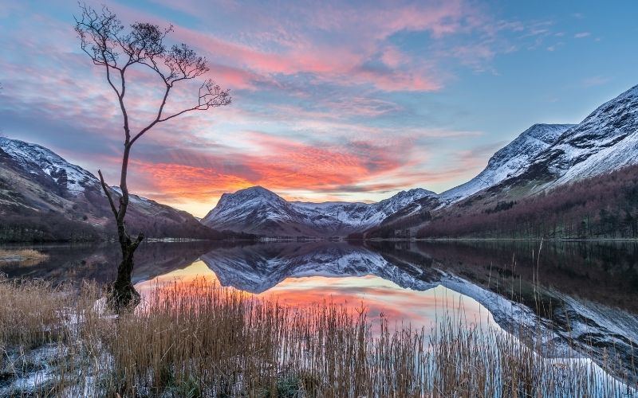
Fig 4: Lake District Sunset View
(Source: Lake District National Park, 2022)
The Go Lakes Travel program is a £6.9 million Department of Transport-funded project. It aims to encourage more people to use environmentally friendly modes of transportation (Lake District National Park, 2022). Without sacrificing any of their key characteristics, this program attempts to lower the carbon emissions and operating expenses of traditional cottages. The Lake District’s footpaths suffer greatly from the fifteen million pairs of feet that walk across them each year. Six organizations are working together on the Fix the Fells initiative, with the National Trust as the project’s coordinator. To stop future erosion, it maintains and fixes the upland paths. To combat traffic and cut down on delays, traffic management and public transportation systems must be improved. Pay-as-you-go rental vehicles and bicycle fees create safe, continuous pathways for wheelchair and bicycle use (Lake District National Park, 2022). Combining ticketing and providing discounts to individuals arriving by public transportation will reduce costs.

4. Principles of Sustainable Tourism: Three Pillars of Sustainability
As a matter of principle, sustainable tourism differentiates itself from mass tourism and only loosely interacts with all kinds of modern tourism. As a fundamental principle, sustainable tourism differentiates itself from mass tourism and only loosely ties itself with other, more cutting-edge (post-mass) kinds of tourism (Dumbrăveanu, 2004). Taking Lake District National Park as an example, the park administration is keen on fostering a tourist sector that both benefits the economy and helps preserve the area’s unique history and culture. Because of the world’s present situation, the tourist and hospitality sectors must make every effort to become more sustainable. So, stakeholders need to strike a balance between the ecological, economic, and social-cultural aspects (Álvarez-Herranz and Macedo-Ruíz, 2021).
Economic | Socio-cultural | Environmental
One of the cornerstones of sustainability is ensuring the economy can remain stable. Some of the factors that may be taken into account when deciding the economic viability of a project are the following: the equitable distribution of costs and benefits; the use of local labour; the guarantee of employment; and the availability of competitive wages, salaries, and perks. There are 11,500 permanent employments made possible by the Lake District’s tourist industry. For the better part of three decades, the tourist industry has been a driving force in the expansion of economies throughout the world. As a result of the work done in this field, several nations’ economies have been provided with a crucial lift. The social and economic well-being of the individuals who reside and work in the Lake District is among three goals in considering the area as one of the national parks throughout the UK. The Lake District is a popular tourist destination, bringing in many people every day who spend money at the region’s top attractions. Home rentals to visitors during the summer months are a major source of income for the local community. | Sustainable practices are increasingly factoring into consumers’ day-to-day buying and using habits as they become more conscious of the effects of their consumption habits, both good and bad. A destination’s vision and objectives should reflect the importance of addressing socio-cultural influences as part of any tourist development plan if it is to have any chance of being successful in the long run. One reason this area is being considered for national park status is so that locals and visitors alike would have a place to go for fun and relaxation. The arrival of a tourist business to a region often results in a virtuous circle of its own, since the resulting local employment opportunities benefit other members of the community. Agriculture is no longer the dominant industry in the area, as tourism has taken its place. The tourist industry offers many direct and indirect jobs, particularly in the provision of goods and services to visitors. Agriculture, laundromat labour, building construction, and similar occupations fall under this category. | Several holiday destinations draw visitors because of the quality of the local ecosystem or natural environment. Indeed, a destination’s tourist offering is typically built on the opportunity to immerse oneself in a one-of-a-kind setting. All across the world, these occurrences of nature are the driving force behind the tourist businesses of many cities and countries. If their worth goes down, fewer people will want to visit the area. Residents of the area have the most to gain from the successful preservation of their natural surroundings, hence the community must take the lead in this effort. The tourist sector also plays a crucial role by offering economic incentives, including financing, that promotes the preservation and conservation of the environment and by guaranteeing that any tourism development causes as little disruption to natural systems as possible. Tourist travel to the Lake District began in earnest there, among the mountains and lakes that have always awed visitors and kept them coming back. The primary goal of this national park is to protect and improve the area’s stunning natural beauty.
(Source: Cumbria Tourism, n. d; lakedistrict.gov.uk, n. d; Amerta, Sara and Bagiada, 2018; Tajeddini et al., 2019; Ranjbari et al., 2021; Álvarez-Herranz and Macedo-Ruíz, 2021)

5. Future Sustainable Development of the Destination
One of the goals of Lake District National Park is to serve as a model for other places interested in sustainable development. Any plan to increase tourism must, therefore, take into account the needs and goals of locals in terms of the economy. For this to work, tourism has to prove it can sustain a robust economy (Rebanks, 2015).
An approach to strategic market planning is proposed by Kotler et al. (1993), as mentioned by Ritchie and Crouch (2003). Strategic market planning includes five steps: a site analysis, the development of a strategic direction, the creation of a tactical plan, and the management of the plan’s execution.
Each tourist hotspot should use a plan to promote long-term, environmentally friendly tourism to operate as a responsible custodian of its visitors and resources. Lake District must focus on sustaining the landscape, cultural heritage and wildlife that will attract more visitors who are increasingly being inclined towards preserved natural locations (Tajeddini et al., 2019).

5. Conclusion
Based on the models used in this report and the sustainability analysis afterwards, the Lake District is considerate of carefully managing the location for outsiders to visit, as well as of locals and their situations to be improved holding the hand of enhancement in tourism sustainability in the area. The three pillars of sustainability—ecological sustainability, social and cultural sustainability, and economic sustainability—are essential to the development of tourism that is both environmentally friendly and profitable for future generations. This means that local populations, governments, and investors in the tourist industry should always stand to gain from and experience positive outcomes from sustainable tourism growth, both now and in the future.

References
Álvarez-Herranz, A. and Macedo-Ruíz, E., 2021. An evaluation of the three pillars of sustainability in cities with high Airbnb presence: A case study of the city of Madrid. Sustainability, 13(6), p.3220.
Amerta, I.M.S., Sara, I.M. and Bagiada, K., 2018. Sustainable tourism development. International research journal of management, IT and social sciences, 5(2), pp.248-254.
Berry, E.N., 2000. An application of Butler’s (1980) tourist area life cycle theory to the Cairns Region, Australia, 1876-1998 (Doctoral dissertation, James Cook University).
Butler, R., 2004. The tourism area life cycle in the twenty-first century. A companion to tourism, pp.159-169.
Cordero, J.C.M., 2008. Residents perception of tourism: a critical theoretical and methodological review. CIENCIA ergo-sum, Revista Científica Multidisciplinaria de Prospectiva, 15(1), pp.35-44.
Cumbria Tourism. n. d. Welcome to the Lake District, Cumbria. [online] Available at: https://www.visitlakedistrict.com/ [Accessed on: 23rd November, 2022]
Dumbrăveanu, D., 2004. Principles and practice of sustainable tourism planning. MTCTANT, Bucuresti, Romania Pitoreasca.
Fyall, A. and Garrod, B., 2019. Destination management: a perspective article. Tourism Review.
Global Sustainable Tourism Council (GSTC), 2022; What is Sustainable Tourism [Online] Available At: https://www.gstcouncil.org/what-is-sustainable-tourism/ [Accessed On: 22/11/2022]
Lake District National Park, 2022, Learning [Online] Available At: https://www.lakedistrict.gov.uk/learning/factstourism/sustainable-tourism/sustainable-tourism-initatives Accessed On: 22/11/2022
Lake District National Park, 2022, Sustainable Tourism [Online] Available At: https://www.lakedistrict.gov.uk/learning/factstourism/sustainable-tourism [Accessed On: 22/11/2022]
lakedistrict.gov.uk. n. d. Sustainable tourism. [online] Available at: https://www.lakedistrict.gov.uk/learning/factstourism/sustainable-tourism [Accessed on: 23rd November, 2022]
Porter, N., 2020. Strategic planning and place branding in a World Heritage cultural landscape: a case study of the English Lake District, UK. European Planning Studies, 28(7), pp.1291-1314.
Ranjbari, M., Esfandabadi, Z.S., Zanetti, M.C., Scagnelli, S.D., Siebers, P.O., Aghbashlo, M., Peng, W., Quatraro, F. and Tabatabaei, M., 2021. Three pillars of sustainability in the wake of COVID-19: A systematic review and future research agenda for sustainable development. Journal of Cleaner Production, 297, p.126660.
Rebanks, J., 2015. The shepherd’s life: A tale of the Lake District. Penguin UK.
Ritchie, J.B. and Crouch, G.I., 2003. The competitive destination: A sustainable tourism perspective. Cabi.
Shobha, K.B., 2019. A case study on irritation among local people towards the growth of tourism in Kodagu district: With the reference of Doxey’sirridex model. International Journal of Innovative Research and Advanced Studies, 6(1), pp.146-148.
Tajeddini, K., Ratten, V. and Merkle, T. eds., 2019. Tourism, Hospitality and Digital Transformation: Strategic Management Aspects. Routledge.
Weaver, D., 2007. Sustainable tourism. Routledge.

