

Entrepreneurship LCMB7004

Entrepreneurial Motivation and the Role of Economic and Cultural Environmental Factors

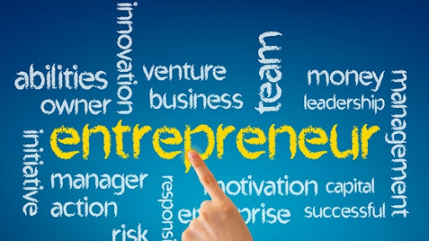

Student name: Nicoleta Mirela Iliescu
Student Number: 1910351
Lecturer: Malani Gunaratnam
Submission Date: 22 May 2020
Table of Contents
Introduction 2
Definition of Enterprise and Entrepreneurship 2
Characteristics of Entrepreneurship 3
The Difference Between Entrepreneurs and Intrapreneurs 4
Entrepreneurs and Owners of Small Businesses 5
Profit and Non-Profit Organisation 7
Different Types of Entrepreneurial Motivation 7
Impacts of Cultural and Economic Environment on Entrepreneurial Motivation 8
Cultural Environment 8
Economic Environment 10
Conclusion 11
References 12
Appendices 15
Appendix A: The 10Ds 15
Appendix B: UK Business Statistics 16
Appendix C: Barriers to Starting A Business in the UK 17

Introduction
Entrepreneurship is a hot topic that takes a variety of forms (Westhead, et al., 2011). It is a major element in the national economy. Therefore, it is essential to understand different dimensions of entrepreneurship process, the motivational characteristics encouraging individuals to become entrepreneurs, the role of external positive/negative effects, and why some people are more successful than others (Collins, et al., 2004). This assignment critically and theoretically evaluates the current perspectives of entrepreneurial motivation. It discusses different key concepts in entrepreneurship and examines how entrepreneurial motivation can be influenced by the external economic and cultural environmental factors.

Definition of Enterprise and Entrepreneurship
Two common meanings are linked with the term “enterprise”. Firstly, and commonly, the word enterprise is used as another name for a business. Secondly, an enterprise is used to describe the actions of an individual who shows some initiative by identifying a business opportunity and taking a risk by investing in, setting up, and running the business. Someone who takes this initiative and shows enterprise is an "entrepreneur" (Cuitandokte, 2018). According to Bygrave and Zacharakis (2011, p. 49), “an entrepreneur is someone who perceives an opportunity and creates an organization to pursue it”. An entrepreneur gathers and then integrates all necessary resources and capabilities such as financial resources, human capital, the business model and the strategy to transform the invention into a viable business (Barringer & Ireland, 2016). Based on the Timmons framework (Figure 1) there are three driving forces vital for a successful business: the opportunity, the entrepreneur (plus the management team, if it’s a potential venture), and the resources needed to start the business and make it grow (Bygrave & Zacharakis, 2011).
Figure 1: Timmons Framework
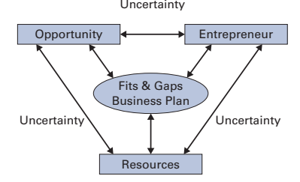
Source: (Bygrave & Zacharakis, 2011)
Entrepreneurship could be defined as an ecosystem where challenges, changes and opportunity arise. Basically, it’s a business area which studies specific people who use various methods to develop or exploit new opportunities in order to create new products or services, new means of organising current technologies, new markets and new production operation or raw materials (Swanson, 2017). Bygrave and Zacharakis (2011) argue the entrepreneurial process is dynamic, and there are some critical factors which influence the transformation of an idea in a successful business. As shown in figure 2, these are sociological, organisational, personal, and environmental. Entrepreneurship takes a variety of forms and appears in all firms (e.g. small, large, family), in all economies (the formal and informal), in both legal and illegal activities, and all economic sub-sectors and regions (Westhead, et al., 2011).
Figure 2: The Entrepreneurial Process Model
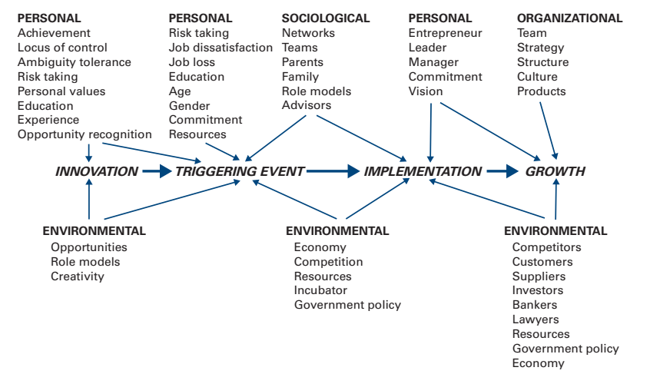
Source: (Bygrave & Zacharakis, 2011)

Characteristics of Entrepreneurship
Successful entrepreneurship involves more than the characteristics and/or skills of the individual. According to GOV (2015), there are six main competencies of the entrepreneurship including identification and definition of a viable market niche, product innovation, idea generation, environmental scanning, formulating strategies for taking advantage of opportunities, recognising and envisioning taking advantage of opportunities. Also, Chell (2013) developed a logical framework for better understanding of entrepreneurship skills, as shown in figure 3. Entrepreneurship skills are related to entrepreneurial ‘traits’, which are associated with environment or upbringing, ethnicity, business experience, education levels, access to business support/training and participation in diverse learning networks.
Figure 3: Categories of Entrepreneurship Skills
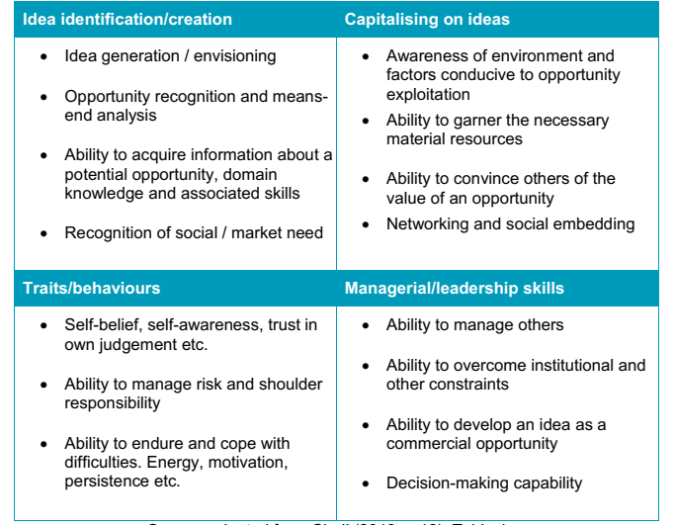
Source: (Chell, 2013)

The Difference Between Entrepreneurs and Intrapreneurs
Based on McClelland 1971, as cited by Welsch (2005), an entrepreneur is a person who exercises control over the production that is not for his own personal use. The main difference between an entrepreneur and intrapreneur is that an entrepreneur is a person who starts his own business with a new idea or concept. In contrast, the intrapreneur is an employee of a business who promotes innovation within the firm. It is widely known that entrepreneurs maximize opportunities which means that this is an intrapreneurial activity.

Entrepreneurs and Owners of Small Businesses
A small business could be defined as a micro-enterprise who employ less than ten people or could be a small enterprise who employs between 10 and 49 people. An answer to the question “who are the people who become entrepreneurs?”, would be the unfulfilled and displaced manager, the young professional, the excluded and the inventor. People are becoming entrepreneurs and start their own business, mainly due to the following reasons to be their own boss, pursue their own concepts, and realise financial compensations. Generally, the entrepreneurs and small business owners have similar traits, but creativity is the key characteristic where the difference between small business owners and successful entrepreneurs could be clearly seen. Other different characteristics of a successful entrepreneur versus the average small business owner could be better outlined in figure 4.
Figure 4: Entrepreneur vs. Small Business Owner
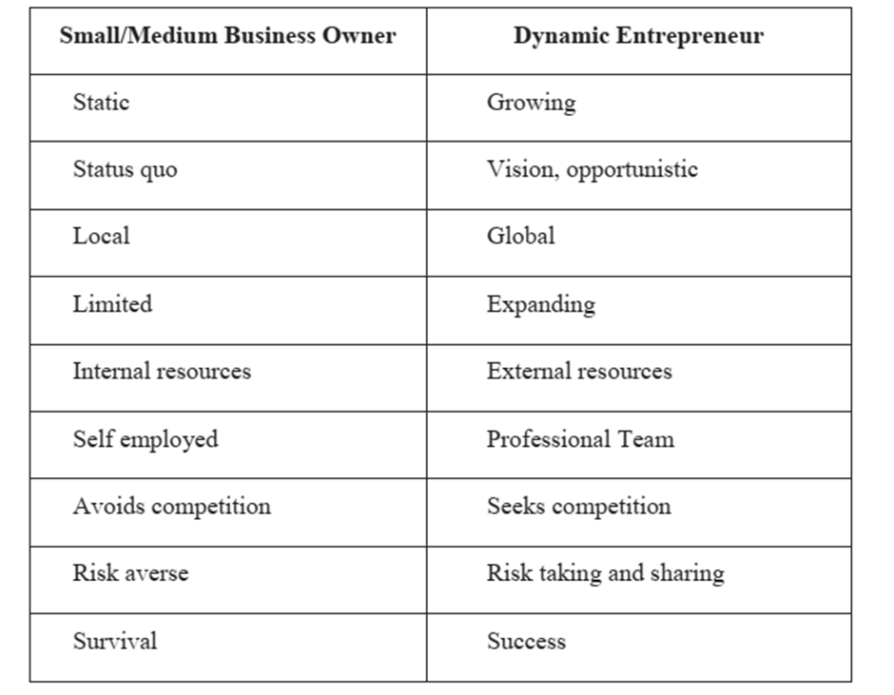
(Source: Shodhganga, 2009)
There are many characteristics attributed to entrepreneurs, and many scholars have tried to discover entrepreneurs’ attributes and characteristics. Barringer and Ireland (2016) have mentioned four main characteristics of successful entrepreneurs. Figure 5 shows these key characteristics.

Figure 5: Four Primary Characteristics of Successful Entrepreneurs
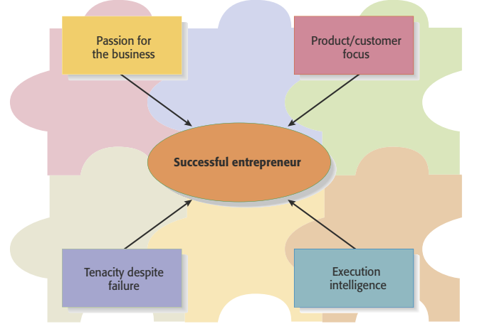
Source: (Barringer & Ireland, 2016)
Passion for business is coming from the belief that the business will make a difference and will have a positive impact on peoples lives. Product/consumer focus has two elements products and customers, and a company should have good products in order to satisfy the customers. Execution intelligence is the ability to transform a good idea into a feasible business. Through tenacity despite failure, a successful entrepreneur proves his ability to keep a business alive if a business doesn't work as expected (Barringer & Ireland, 2016).
Successful entrepreneurs often possess a series of key qualities and attributes which are outlined in three stages. Stage 1: The Right Attitude; All business either large or small should have the advantage of a good mindset and should have the following means: drive and determination, intelligence, ambition, confidence, commercial intellect, the will to win and curiosity. Stage 2: Implementation; In this stage, the entrepreneur should not be a dreamer, but a doer. These attributes are motivation, communication skills, self-discipline, persuasiveness, speed and agility. Stage 3: Diligence is the most difficult attribute as shows the determination and power to stay on track. Diligence requires resilience, humility, reliability, perseverance, flexibility, understanding and a good temperament. Despite all the positive qualities and attributes, yet even successful business owners have their frailties and by admitting those will help overcome the fears. The most common fears associated with an entrepreneur are age, lack of money, fear of rejection and lack of experience or education (Scott, 2017). Personality traits have a positive effect on entrepreneurial intention, and these are the need for achievement, locus of control, risk tolerance, and entrepreneurial alertness. Locus of Control (LoC) can be internal or external., where internal LoC is revealing that a person beliefs can control that person life and external shows how external factors like luck, destiny, other people beyond that person’s decisions can affect that person life. Basically, LoC shows the degree of control feeling, and people with high scores have a clear vision, and this can be used to separate the successful entrepreneurs from the unsuccessful ones. Risk tolerance is the latest tool in entrepreneurship, and it is said that taking the risk could lead to success but also to failure. Risk is vital for entrepreneurs as they have to make a decision in an uncertain condition. Therefore they should have a high tolerance at taking the risk. Entrepreneurial alertness is the main trait as this leads to entrepreneurial intention. This could be defined as the entrepreneurs drive to get and explore the advantage of the new opportunities which arise (Karabulu, 2016). Bygrave and Zacharakis (2011) also defined a set of critical personal attributes for successful entrepreneurs. They named them the 10Ds (Appendix A), which considers key personal attributes such as devotion (they love what they do) and dedication (they are totally dedicated to their aims or businesses).

Profit and Non-Profit Organisation
A non-profit organisation is known as a social enterprise. It has primarily social objectives whose profits are usually reinvested in the business or the community, and are not being used maximise profit for the owners and/or shareholders. Differences between profit and non-profit organisations are social aims, social auditing, social membership. Also, a non-profit enterprise instead of maximising profits, like profit enterprises who are maximising profits while minimising costs, they are more concerned to provide society's needs. Another key difference that makes a non-profit business different is that its income is never shared with the owners or shareholders is rather reintroduced back in their non-profit missions and activities. Profit businesses are responsible for paying taxes based on their income, but non-profit organisations are exempt from income tax.

Different Types of Entrepreneurial Motivation
Entrepreneurial motivation arises when an ordinary person transforms into a strong and influential business person, who can create opportunities, contribute to economic progress and is maximising the wealth (Trivikram, 2019). People are motivated due to several factors to become entrepreneurs, but a clear distinction is made between ‘pull’ the positive factors and ‘push’ the negative factors. Pull motivation factors include independence, innovation, recognition, roles, self-realisation and financial success. Push motivation factors are self-employment, unemployment, and wage employment (Zwan, et al., 2016). Some people are driven neither by pull nor by push, which means there may be a third type of entrepreneurship, doing it as a hobby. The entrepreneurial motivation is also influenced by internal or individual factors and external or environmental factors. There are many types of entrepreneurial motivation, but these could be largely divided into three categories:
1. Opportunity and necessity motivation is also known as push-pull motivation, where opportunity motivation is the pull motivation and necessity motivation-push which is associated with lower entrepreneurial intelligence.
2. Multi-dimensional typologies of entrepreneurial motivation and the most popular are classified under the following categories: achievement, challenge and learning. Independence and autonomy, recognition and status, income security and financial success, dissatisfaction, family and roles and not in the least community and social motivations.
3. Growth ambitions could show a forecast of the business size and sales. There are also growth intentions where a person stipulates his growth and growth plan options (Stephan, et al., 2015).

Impacts of Cultural and Economic Environment on Entrepreneurial Motivation
According to Westhead et al., (2011), entrepreneurs are central to the functioning and growing of market economies. Policy-makers and practitioners of all nations are seeking to promote the supply of these agents of change and growth (entrepreneurs) to encourage both economic benefits (e.g. job generation, wealth creation, and competition) and social benefits (opportunity for under-represented groups and promoting community inclusion). Therefore, empowering entrepreneurs and promoting entrepreneurship are part of the economic success formula. As explained in figure 2, the entrepreneurial process is dynamic, and environmental factors such as economy, competition, and government policy can influence the entrepreneurial process and motivation (Bygrave & Zacharakis, 2011).

Cultural Environment
The culture of a country or a region impact their awareness and motivation of the locals’ entrepreneurship. Research on the relations between culture and entrepreneurship is relatively new. Entrepreneurial motivation can be encouraged by positive entrepreneurial culture (Yushuai, et al., 2014). The relation between entrepreneurship and culture could be successfully analysed through three frameworks as follows the social legitimation approach, the aggregate psychological traits approach and the dissatisfaction approach. In terms of social legitimation a higher entrepreneurial activity is found in societies where the entrepreneur is considered to have a high social status, the system recognises and supports entrepreneurship, where grants and tax incentives support business start-ups. According to the aggregate psychological traits framework for a specific country, the more individuals with entrepreneurial traits are in that society, and the more will show entrepreneurial behaviour. Uncertainty avoidance is a cultural trait closely linked to attitudes of risk and uncertainty. The dissatisfaction approach suggests that in a mostly non-entrepreneurial culture, a clash of values could influence potential self-employed actually to become self-employed (Thurik & Dejardin, 2011). Based on Hofstede Insights (2020), the UK has a low score on Uncertainty Avoidance 35, as shown in figure 6, this means that as a nation they are quite happy to wake up not knowing what the day brings and they are happy to change plans as new information comes to light. Also, the combination of a highly individualist and curious nation means there is a high level of creativity and a strong need for innovation. All these theories confirm their need for achievement, success, innovation in terms of entrepreneurial motivation. Based on a report provided by Cook (2020), there are currently 5.9 million business in the UK (Appendix B), an increase of 69% since 2000. This could also be explained through the aggregate psychological traits framework and Hofstede Insights.
Figure 6: The UK Cultural Dimensions
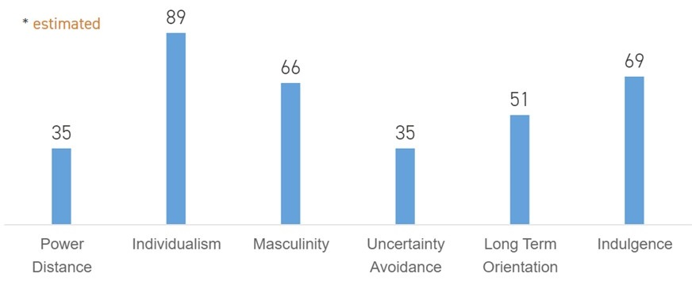
Source: (Hofstede Insights, 2020)

Economic Environment
When the economy is prosperous, people have more money to spend and are willing to buy products and services that enhance economic growth and their lives and vice-versa. Paradoxically, in a weak economy, business opportunities arise for start-ups that help customers and businesses save money. For example, in the great recession, in 2009, a start-up Water Smart Software sold software to water utilities and made it easier for the consumers to save water and money. Another example is Nest Labs founded in 2010, which was later acquired by Google and made the world’s first learning thermostat (Barringer & Ireland, 2016). Also, statistic shows that the main barriers to starting a business are related to economic factors (Appendix C). For example, a lack of financial resources is the main barriers to start a business. A country with a good economic situation can support people to become an entrepreneur and start their own business.
Government policies also show a greater influence on establishing new firms and would lead to economic development. The UK government offers loans of up to £25,000 at a 6% fixed yearly interest rate for new business ideas, funding competitions offered by Innovate UK, tax reliefs for investors who buy new shares in a company, R&D tax credits, which allows companies to claim back R&D costs etc. (Carey & Macaulay, 2019). Also, the UK government offered in 2019, £2 million investment to help small businesses to grow (GOV, 2019). Big economic events such as Brexit can significantly influence entrepreneurship and small businesses. For example, in the no-deal case, people within the UK may decide to produce some goods and services inside the country as any import from the EU will be subject to customs tariffs and checks. However, on 19 May 2020, the government published the final draft of Brexit deal, if the EU does not accept the deal,this will affect many UK businesses (Morris, 2020).
The Coronavirus pandemic is currently the most important economic factor, which impacts the worldwide economy greatly and especially SMEs, which are the most vulnerable. UK government offered £1bn worth of support for struggling start-ups, £750m worth of grants and loans to small and medium-sized businesses focusing on R&D, £250m towards a new £500m fund for high-growth private companies that need money, and others grants and loans scheme through Innovate UK (Stothard, 2020). However, amid this crisis, there are areas of the industries and businesses who are prospering, and there is also space for new start-ups, especially in medical supplies and take away and grocery deliveries. Also, there is a high interest in online education and remote learning software, entertainment, wellness and leisure (including gym equipment, online classes). For example, companies who are currently in trend are Snapchat, Instagram and Facebook due to increased social media use, Amazon (which has seen its shares rise more than 25% ), Zoom, Netflix, Just Eat, Takeaway.com, Domino’s group etc. (Klebnikov, 2020; Haill, 2020).

Conclusion
In conclusion, entrepreneurs and entrepreneurship play a critical role in the national economy. It is essential to understand different dimensions of entrepreneurship process and the motivational characteristics encouraging individuals to become entrepreneurs. As discussed, entrepreneurs have different characteristics and skills that help them to become an entrepreneur. Successful entrepreneurs have four primary characteristics, such as a passion for business and tenacity despite failure. It can be argued that there are different motivational factors such as recognition, achievement and challenge, and independence that encourage entrepreneurship. Cultural and economic factors can positively or negatively influence the entrepreneurship process and activity within a country. As explained, economic factors are crucial as financial issues are the main barriers for entrepreneurship and starting a new business.

References
Barringer, B. R. & Ireland, R. D., 2016. Entrepreneurship: Successfully Launching New Ventures. 5 ed. Essex: Pearson Education Limited.
Bygrave, W. & Zacharakis, A., 2011. Entrepreneurship. 2 ed. NJ: John Wiley & Sons, Inc..
Carey, S. & Macaulay, T., 2019. Tech World. [Online]
Available at: https://www.techworld.com/startups/5-ways-uk-government-supports-tech-startups-3652774/
[Accessed 21 05 2020].
Chell, E., 2013. Review of skill and the entrepreneurial process. International Journal of Entrepreneurial Behaviour and Research, 19(1), pp. 6-31.
Collins, C. J., Hanges, P. J. & Locke, E. A., 2004. The Relationship of Achievement Motivation to Entrepreneurial Behavior: A Meta-Analysis. Human Performance, 17(1), pp. 95-117.
Cook, S., 2020. Start-ups. [Online]
Available at: https://startups.co.uk/small-business-statistics/?p=125252
[Accessed 21 05 2020].
Cuitandokte, 2018. What Is Enterprise?. [Online]
Available at: https://cuitandokter.com/what-is-enterprise.html/
[Accessed 20 05 2020].
GOV, 2015. Entrepreneurship Skills: literature and. [Online]
Available at: https://assets.publishing.service.gov.uk/government/uploads/system/uploads/attachment_data/file/457533/BIS-15-456-entrepreneurship-skills-literature-and-policy-review.pdf
[Accessed 21 05 2020].
GOV, 2019. £2 million investment to help small businesses to grow. [Online]
Available at: https://www.gov.uk/government/news/2-million-investment-to-help-small-businesses-to-grow
[Accessed 21 05 2020].
Haill, O., 2020. Proactive Investors. [Online]
Available at: https://www.proactiveinvestors.co.uk/companies/news/914223/profiting-from-coronavirus-which-companies-are-benefiting-how-investors-should-act-914223.html
[Accessed 21 05 2020].
Hofstede Insights, 2020. COUNTRY COMPARISON. [Online]
Available at: https://www.hofstede-insights.com/country-comparison/the-uk/
[Accessed 22 05 2020].
Karabulu, A. T., 2016. Science Direct. [Online]
Available at: www.sciencedirect.com
[Accessed 21 05 2020].
Klebnikov, S., 2020. Forbes. [Online]
Available at: https://www.forbes.com/sites/sergeiklebnikov/2020/04/25/these-stocks-will-thrive-in-a-post-coronavirus-world-according-to-experts/#141346a76b89
[Accessed 22 05 2020].
Morris, C., 2020. BBC. [Online]
Available at: https://www.bbc.co.uk/news/uk-politics-52721439
[Accessed 22 05 2020].
Scott, J. T., 2017. The Entrepreneur’s Guide to Building a Succesful Business. Brussels: EFMD.
Stephan, U., Hart, M. & Drews, C.-C., 2015. Enterprise Research. [Online]
Available at: https://www.enterpriseresearch.ac.uk/wp-content/uploads/2015/02/Understanding-Motivations-for-Entrepreneurship-Rapid-evidence-assessment-paper..pdf
[Accessed 22 05 2020].
Stothard, M., 2020. Sifted. [Online]
Available at: https://sifted.eu/articles/startups-government-support/
[Accessed 22 05 2020].
Swanson, L. A., 2017. Entrepreneurship and Innovation Toolkit. [Online]
Available at: https://openpress.usask.ca/entrepreneurshipandinnovationtoolkit/front-matter/entrepreneurship-and-innovation-toolkit/
[Accessed 20 05 2020].
Thurik, R. & Dejardin, M., 2011. Research Gate. [Online]
Available at: https://www.researchgate.net/publication/268012523_The_Impact_of_Culture_on_Entrepreneurship
[Accessed 21 05 2020].
Trivikram, S., 2019. My Venture Pad. [Online]
Available at: https://myventurepad.com/entrepreneurial-motivation/
[Accessed 21 may 2020].
Welsch, H. P., 2005. Entrepreneurship A Way Ahead. 2 ed. New York: Taylor & Francis.
Westhead, P., Wright, M. & McElwee, G., 2011. Entrepreneurship: Perspectives and Cases. 1 ed. Essex: Pearson Education Limited.
Yushuai, W., Na, Y. & Changping, W., 2014. An Analysis of Factors Which Influence Entrepreneurial Motivation. Journal of Applied Sciences, 14(8), pp. 767-775.
Zwan, P. v. d., Thurik, R., Verheul, I. & Hessels, J., 2016. Springer Link. [Online]
Available at: https://link.springer.com/article/10.1007/s40821-016-0065-1
[Accessed 21 may 2020].

Appendices

Appendix A: The 10Ds

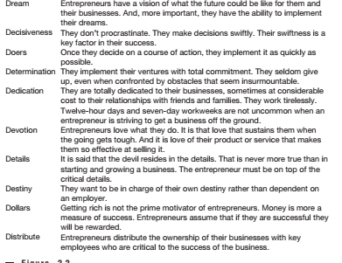
Source: (Bygrave & Zacharakis, 2011)

Appendix B: UK Business Statistics
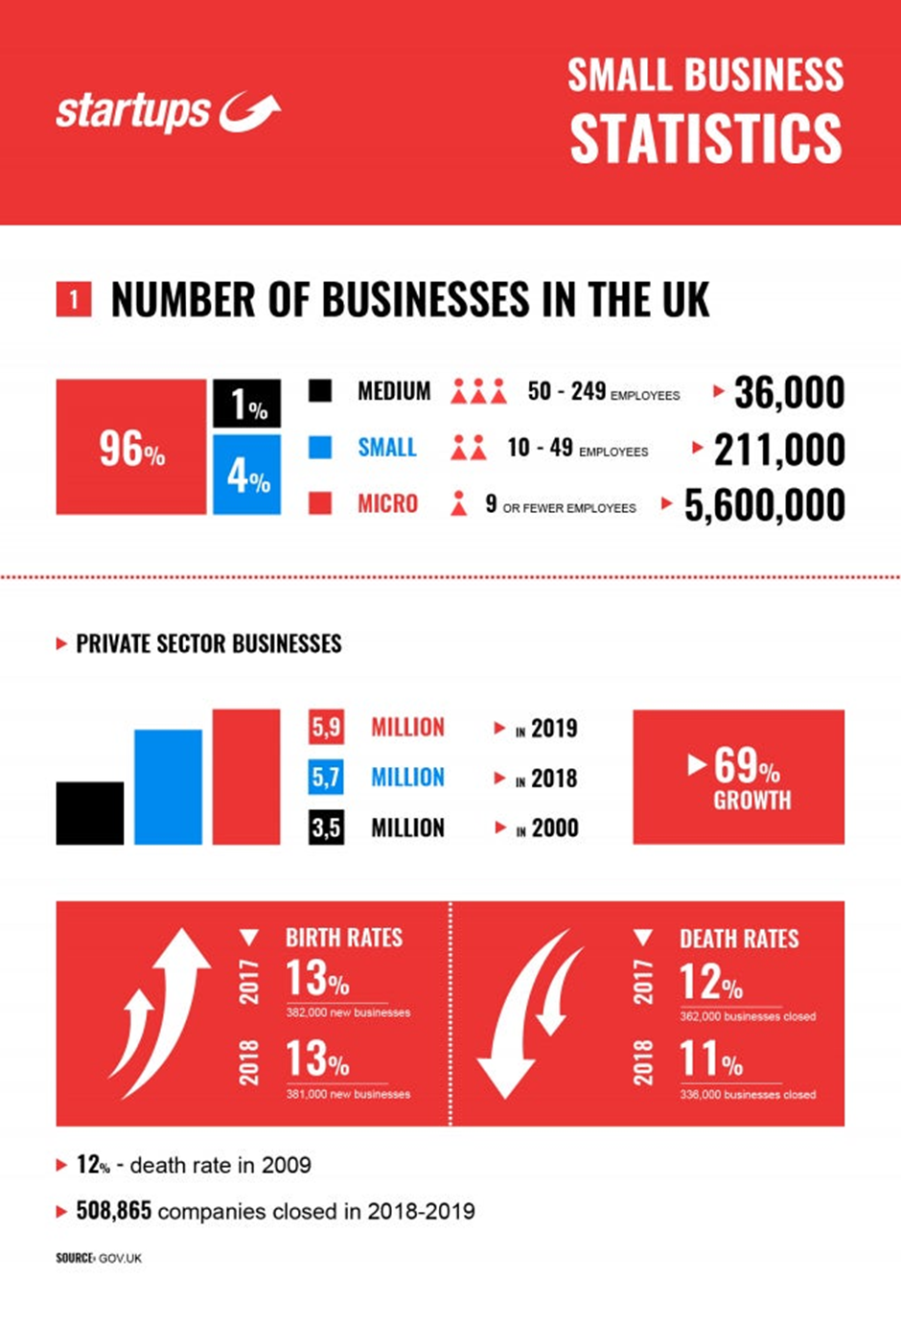
Source: (Cook, 2020)

Appendix C: Barriers to Starting A Business in the UK


