Component 2:
Research Report

Research Question: Are student confident using technology to collaborate?

Written by: ESTHER AKPANMKPUK
Student Number: 2108030

Lecturer: NICHOLAS WORTHINGTON

BMSW4003_BIRM
Digital Skills and Research Methods.

Contents

1. Introduction 3
2. Research design 3
2.1. Method 3
2.2. Research questions 4
2.3. Ethical Considerations 4
3. Results 5/6
5. Conclusion 7
6. Reference List 8
7. Appendix A – A blank copy questionnaire. 9/10

INTRODUCTION

This report discusses the opinions of students on the use of technology when collaborating. Technology is a narrowed term which breaks down to hardware and software. Hardware refers to the physical components of a computer & Software is a collection of instructions, procedures, and documentation that performs different tasks on a computer system. (Geeks 2022) This report will highlight the difference as well as illustrate each student’s confidence when using each off them. This report will consider the challenges students face when using technology, using primary data gathered through a questionnaire, the aim of this report is to answer two questions, are students confident in using technology to collaborate? And subsequently is technology useful in collaboration!

RESEARCH DESIGN
- METHOD

The information for this report was gathered mainly through primary research, by asking individual students at University of Wales Trinity Saint David to partake in filling out a questionnaire, designed to initiate a conversation about technology, and gather each students’ opinions on their confidence in the use of different hardware and software technology. This was done by an in-person approach, by handing out the questionnaire physically rather than sending it out digitally through email. This made gathering results easier as we were able to physically motivate students to participate. Compared to doing so electronically through forms, sufficient results would not be guaranteed as students weren’t motivated to open emails for questionnaires.

-RESEARCH QUESTIONS

The questionnaire given to students only consisted of 4 questions, which were:
How confident are you in using technology to collaborate? This question was listed with 4 possible answers, whereby each student had to pick 1. From the answers we were able to get a general idea of how each student felt about technology before proceeding to differentiate the types of technology in 2 simultaneous questions. On a scale of 1-5 please rate your confidence in using each 1) Hardware 2) Software technology to collaborate.
This question provided students with the choice to rate each type of hardware technology e.g., Laptops and each type of software technology e.g., PowerPoint. Generating a better understanding to each student’s preference, and from the results of the data, conclude which is the most common technology that students feel confident using.
Lastly, the questionnaire asked students, which is the most common challenge they faced when using technology to collaborate. Giving them the option to pick 1 or add a challenge in the ‘other’ section if their choice was not presented. This allowed students to not only be creative in their selection, but also a great way to identify the most common challenges from the result if any, that students have. From this data, a structured analysis of pros and cons of using technology to collaborate can be given, as this report will give. Not only to gain understanding, but possible solutions to these challenges.

-ETHICAL CONSIDERATIONS
To ensure that the chosen method corresponded with ethical considerations and confidentiality, an unbiased approach was taken to make sure that the students felt comfortable when filling out the questionnaire. Providing assurance of confidentiality was important, hence a written outline highlighting the purpose of the questionnaire as well as our assurance of confidentiality, helped make each student aware. Highlighted in bold was information for students to NOT include their names on the questionnaires, in doing so, kept their choices anonymous.

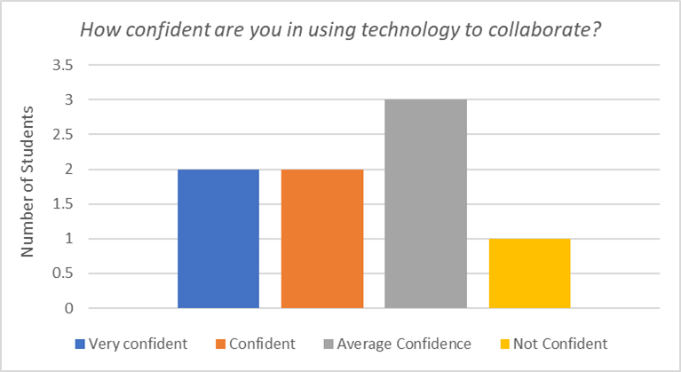
RESULTS

In total 8 students took part in this questionnaire and gave their opinions on each of the 4 questions. The above data shows the results of how confident students are in using technology to collaborate. The bar graph shows that the highest number of students at 3 chose Average Confidence as how confident they are, followed by 2 students choosing very confident and confident. The lowest being 1, for the option of not confident. The result in this graph shows that although some students felt more confident than average, more students felt that they were not fully confident in using technology to collaborate. The least common answer being not confident, indicates that overall students do feel confident about using technology to collaborate, however due to reasons which this report will identify from following questions, students face challenges that prevents their confidence to prevail above average.

Onto the results of challenges students face when using technology to collaborate.
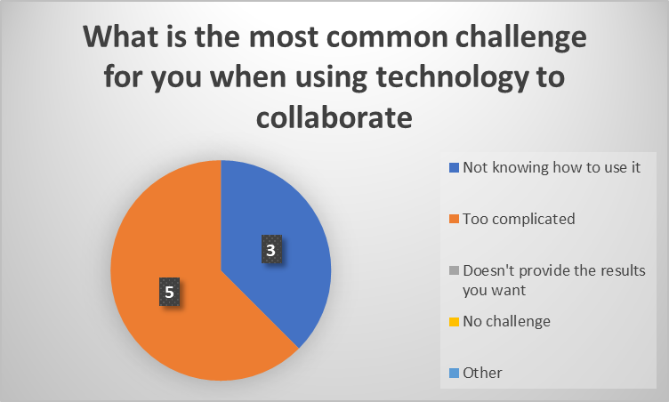

5 students picked too complicated as the most common challenge, whilst 3 students picked, not knowing how to use it as the second most common challenge. None of the students picked doesn’t provide the results you want, no challenge or other as a challenge. Unsurprisingly, this result is anticipated as according to a journal on common technology mistakes, the most common problem revealed by technology reviews is that many employees are not adequately trained to use their technologies. (J. Carlton 2019) Although this is in reference to employees, the same can be referred to students. Not having the proper training to use these different hardware and software can result to students having difficulty navigating. If students don’t know or understand how use technology, then students cannot confidently collaborate using technology.

The last 2 results where tallied due to its various answers. As students were asked to rate each 4 hardware and software from 1- 5 on how confident they were at using each to collaborate. In total, the highest rated in hardware was Laptops whilst the highest rated in software was Word. Research by (Elizabeth Street 2017) shows that when schools provided students with laptops for use in the classroom and at home, learning improved in a number of subjects, including science, math, and English. This goes to show how positive technology can be when used in learning.

CONCLUSION

From data shown, majority of students at UWTSD have said that they are confident using hardware and software technology to collaborate. The most preferred hardware is the use of laptops. As quoted by Zheng (Elizabeth street 2017) “I believe this technology, if implemented correctly, is worth the cost and effort because it lifts student achievement, enhances engagement and enthusiasm among students” Hardware such as laptops provide easy accessibility and comfortability when used to collaborate, it provides a bigger screen for using applications such as PowerPoint, which was the second highest rated software, voted by the students and is easier to document and type when using word which was voted as the software student felt the most confident using. In conclusion If students are educated on how to use the various technologies, hardware, and software, then student would feel more confident using technology to collaborate. Training in lessons for example so students can follow alongside with their technology and replicate what is being learnt, is an effective way to improve confidence in the use of technology, as it automatically creates an environment where student can ask questions is they don’t understand.

REFERENCE LIST

Geeks (2022) – Difference between hardware and software (ONLINE)
https://www.geeksforgeeks.org/difference-between-hardware-and-software/

J. Carlton (2019) – 12 Common technology mistakes you should avoid (ONLINE)
https://www.journalofaccountancy.com/issues/2019/jan/common-technology-mistakes.html#:~:text=The%20most%20common%20problem%20revealed%20by%20technology%20reviews,Excel%2C%20Word%2C%20Outlook%2C%20Windows%2C%20and%20their%20accounting%20system.

Elizabeth Street (2017)– How laptops in the classroom improve student learning (ONLINE)
https://www.learningliftoff.com/how-laptops-in-the-classroom-improve-student-learning/

APPENDIX A
The Questionnaire


