Human Resource Challenges and Contemporary HR Practices at Marks & Spencer 

Student Name: Sadia Nadeem
Student Number: 2434168
Module: LCLM5002 Developing and Managing Individuals and Teams
Lecturer: Dr Samson Oladejo
Assignment Title: HR Challenges and Contemporary HR Practices at Marks & Spencer
Date: 20th July 2026
TABLE OF CONTENTS
Human Resource Challenges and Contemporary HR Practices at Marks & Spencer 1
Executive Summary 4
1. Introduction 4
2. Critical Analysis of Key HR Challenges 5
2.1 Adapting to Technological Advancements 5
2.2 Talent Acquisition and Retention 6
2.3 Diversity, Equity and Inclusion (DEI) 7
3. Evaluation of Contemporary HR Practices 8
3.1 Workforce Analytics and Digital HR Systems 8
3.2 Employer Branding and Strategic Workforce Planning 8
3.3 Employee Engagement and Retention Strategies 9
3.4 Inclusive Recruitment and Selection 9
3.5 DEI Policies and Leadership Development Initiatives 10
4. Critical Evaluation of Managerial Implementation 11
4.1 Leadership Accountability 11
4.2 Communication and Change Management 12
4.3 Monitoring and Performance Measurement 12
4.4 Organisational Culture and Implementation Barriers 13
5. Conclusion 14
Recommendations 15
References 16

Executive Summary
This report critically examines contemporary HRM challenges within Marks & Spencer (M&S), focusing on technological advancement, talent acquisition and retention, and diversity, equity and inclusion (DEI). These issues are increasingly important due to digital transformation, labour market competition, and changing employee expectations.
The analysis highlights that while technology improves organisational performance, it also creates challenges related to skills development, job security, and change management. Talent retention is affected by increasing expectations for flexibility, career growth, and meaningful work, while effective DEI requires cultural transformation rather than policies alone.
The report evaluates HR practices including workforce analytics, employer branding, employee engagement, and inclusive recruitment, while assessing the role of managers in successful implementation. Findings suggest that HR effectiveness depends on strong leadership, communication, and organisational culture. Key recommendations include digital reskilling, improved career pathways, realistic employer branding, DEI accountability, and leadership development.

1. Introduction
Human Resource Management (HRM) has become a strategic function enabling organisations to respond to technological change, globalisation, workforce expectations, and competitive pressures. Effective HR strategies must enhance organisational performance while supporting employee engagement, wellbeing, and sustainability.
Marks & Spencer (M&S) operates in a competitive retail environment shaped by digital transformation, changing consumer demands, and talent competition. This report critically examines three key HR challenges: technological advancement, talent acquisition and retention, and diversity, equity and inclusion (DEI). It evaluates contemporary HR practices addressing these challenges and assesses how managers can effectively implement HR strategies across the organisation.

2. Critical Analysis of Key HR Challenges

2.1 Adapting to Technological Advancements
Technological advancement has transformed the retail sector through AI, automation, digital platforms, workforce analytics, and advanced supply chain systems. M&S has invested in digital technologies to improve efficiency and customer experience; however, these changes create HR challenges related to employee skills, capability, and acceptance of change.
From a Human Capital Theory perspective, employee knowledge and skills are valuable resources requiring continuous investment (Becker, 1964). Therefore, M&S must provide digital training to prevent skill gaps, reduced productivity, and resistance. Failure to invest in workforce development may also weaken organisational competitiveness and limit the benefits of technological innovation.
Technological change may also create concerns about job security. Rousseau’s (1995) Psychological Contract Theory suggests that perceived threats to employment can damage trust, motivation, and organisational commitment. Employees who feel uncertain about their future roles may become less engaged and more resistant to organisational change.

Effective change management is essential. Lewin’s (1951) Change Model highlights employee preparation through unfreezing, changing, and refreezing stages, although it has been criticised for presenting change as a linear process. Similarly, Kotter’s (2018) model emphasises communication, employee support, and cultural integration. Therefore, M&S must combine digital investment with training, communication, and employee involvement to achieve successful transformation.

2.2 Talent Acquisition and Retention
Attracting and retaining talented employees remains a major challenge for M&S due to increasing competition within the retail labour market. Employees increasingly value flexible working arrangements, career progression, wellbeing, and meaningful work experiences. High turnover creates additional costs through recruitment, training, and loss of organisational knowledge.
Although traditional motivation theories emphasise financial rewards, modern retention challenges extend beyond pay. Herzberg’s (1968) Two-Factor Theory suggests that employee satisfaction depends on hygiene factors, such as pay and working conditions, and motivators, including recognition and achievement. However, the theory has limitations in explaining contemporary employment expectations, where employees increasingly prioritise flexibility, development, and work-life balance.

The Ability-Motivation-Opportunity (AMO) Framework provides a broader explanation of employee performance and retention. It suggests that employees require appropriate skills, motivation, and opportunities to contribute effectively. Therefore, M&S can improve retention by investing in training, recognising employee contributions, and creating clearer career pathways.
However, retention challenges are not solely caused by HR practices but also reflect structural issues within retail employment. Shift patterns, weekend working, and operational demands may conflict with employee expectations for flexibility. Therefore, while rewards and development opportunities remain important, M&S must address wider workforce expectations to remain competitive in attracting and retaining talent.

2.3 Diversity, Equity and Inclusion (DEI)

Diversity, equity and inclusion (DEI) have become essential components of contemporary HR strategy. Diverse organisations can benefit from improved innovation, decision-making, and employee engagement (CIPD, 2024). For M&S, which serves a diverse customer base and employs individuals from different backgrounds, effective DEI practices support both organisational performance and social responsibility.
However, genuine inclusion requires more than formal equality policies. Social Identity Theory suggests that individuals naturally categorise themselves and others into social groups, which can create in-group and out-group behaviours contributing to exclusion (Tajfel and Turner, 1979). Therefore, organisations may achieve workforce diversity while still experiencing barriers relating to inclusion and equal opportunity.
Although DEI initiatives can improve representation, critics argue that some programmes become symbolic rather than transformational. Diversity targets alone cannot guarantee inclusion if employees continue to experience unconscious bias, limited progression opportunities, or unequal treatment. Consequently, M&S must embed DEI within organisational culture through inclusive leadership, accountability mechanisms, and fair development processes.
Overall, these HR challenges demonstrate that effective HR management requires more than implementing policies. Sustainable success depends on developing workforce capabilities, managing technological change effectively, improving employee experience, and embedding inclusion into everyday organisational practices.

3. Evaluation of Contemporary HR Practices

3.1 Workforce Analytics and Digital HR Systems
Digital HR systems and workforce analytics are important tools for strategic HR decision-making. They enable organisations to analyse workforce data relating to performance, turnover, absenteeism, and engagement.
According to Armstrong (2021), workforce analytics supports evidence-based decision-making by identifying workforce trends and improving planning. For M&S, analytics can help identify recruitment needs, retention risks, and future skills requirements, enabling proactive HR interventions.
However, workforce analytics also presents challenges. Ball (2010) argues that excessive monitoring may create perceptions of surveillance, reducing employee trust and engagement.

3.2 Employer Branding and Strategic Workforce Planning
Employer branding helps attract and retain talented employees by communicating organisational values, career opportunities, and workplace culture. A strong employer brand can differentiate organisations within competitive labour markets.

From a Resource-Based View perspective, human capital provides sustainable competitive advantage when organisations successfully attract and develop skilled employees (Barney, 1991). For M&S, effective employer branding can strengthen recruitment and support talent development.
Strategic workforce planning complements this by identifying future workforce requirements and skills gaps, ensuring recruitment aligns with business objectives.
Rousseau’s (1995) Psychological Contract Theory suggests that unmet expectations can reduce trust, commitment, and retention. Therefore, employer branding must accurately reflect workplace realities.

3.3 Employee Engagement and Retention Strategies
Employee engagement significantly influences organisational performance and retention. M&S uses training, recognition schemes, wellbeing initiatives, and career development opportunities to improve employee commitment.
Guest (2017) argues that high-performance work practices enhance engagement and organisational outcomes. Similarly, Self-Determination Theory highlights the importance of autonomy, competence, and relatedness in supporting employee motivation (Deci and Ryan, 2000).
However, engagement initiatives may only provide short-term benefits if underlying workplace issues remain unresolved. Recognition programmes may improve morale but fail to address workload pressures, limited progression opportunities, or work-life balance concerns. Therefore, M&S should adopt a holistic engagement approach that considers employee needs, organisational culture, and working conditions. Regular employee feedback mechanisms can help identify dissatisfaction early and allow managers to implement targeted improvements. Effective engagement strategies should also be integrated with leadership development to ensure managers actively support employee wellbeing and motivation.

3.4 Inclusive Recruitment and Selection
Inclusive recruitment supports workforce diversity and equal opportunity by reducing bias and improving selection fairness. Structured interviews, competency-based assessments, and diverse recruitment panels can improve hiring quality.

Boxall and Purcell (2016) argue that effective recruitment enables organisations to attract employees whose skills and values align with organisational objectives. For M&S, inclusive recruitment can strengthen workforce capability while supporting DEI goals.

However, recruitment alone cannot create an inclusive organisation. Without fair promotion opportunities, inclusive leadership, and supportive workplace culture, diversity improvements may not lead to long-term inclusion.

3.5 DEI Policies and Leadership Development Initiatives

DEI policies are increasingly important for creating fair and inclusive workplaces. M&S has introduced inclusion initiatives and employee networks to promote equal opportunities and support workforce diversity.
Research by CIPD (2024) suggests that inclusive organisations benefit from higher employee engagement, innovation, and organisational commitment. Leadership development programmes can strengthen DEI by helping managers recognise unconscious bias, promote inclusive behaviours, and make fair decisions regarding recruitment and progression.
However, DEI policies may become symbolic if organisations focus solely on representation targets rather than cultural change. Social Identity Theory suggests that informal group dynamics can continue to create exclusion despite formal equality policies (Tajfel and Turner, 1979). Consequently, M&S should support DEI initiatives with leadership accountability, measurable objectives, and continuous development programmes to achieve sustainable inclusion.

4. Critical Evaluation of Managerial Implementation

4.1 Leadership Accountability
The successful implementation of HR strategies at Marks & Spencer depends significantly on the capability of departmental managers. Although HR departments develop policies and frameworks, line managers act as the connection between strategic HR objectives and employee experiences. Therefore, HR effectiveness depends not only on policy design but also on consistent managerial application across the organisation.

Ulrich’s (1997) HR Business Partner Model highlights the importance of managers acting as strategic partners who align HR practices with organisational objectives. Within M&S, managers play a critical role in ensuring that digital transformation, employee development, and DEI initiatives are effectively implemented. However, this approach assumes that managers possess sufficient HR knowledge and leadership capability. Differences in managerial skills and commitment may create inconsistent employee experiences across stores and departments.
Guest (2017) argues that HR systems create value only when managers actively support and implement them. Therefore, M&S should incorporate HR-related indicators, including employee engagement levels, turnover rates, training completion, and inclusion outcomes, into managerial performance evaluations. This would encourage managers to view HR responsibilities as strategic priorities rather than additional administrative tasks.

4.2 Communication and Change Management
Effective communication is essential during technological transformation because employees may resist change when they experience uncertainty regarding job security, future roles, or new working practices. Managers therefore play a central role in explaining the purpose of change and supporting employees throughout the transition process.
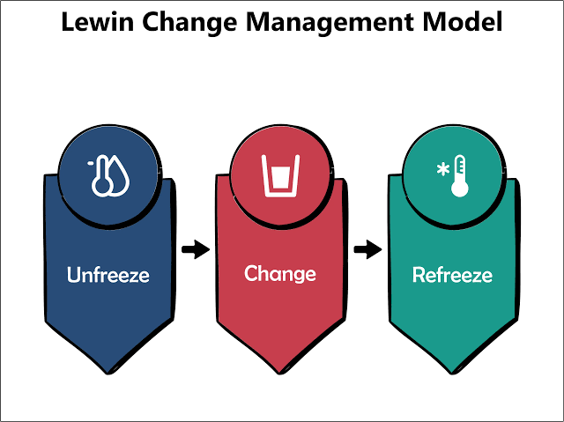
Lewin’s (1951) Change Management Model emphasises preparing employees for change through three stages: unfreezing, changing, and refreezing. Similarly, Kotter’s (2018) Change Model highlights the importance of creating urgency, communicating a clear vision, and building employee commitment. These approaches demonstrate that successful change requires more than introducing new technology, it requires employee involvement and continuous support.
However, Lewin’s model has been criticised for presenting change as a linear process, while modern retail organisations experience continuous and unpredictable transformation. Therefore, M&S should adopt an ongoing change management approach that combines regular communication, employee training, and opportunities for feedback.

4.3 Monitoring and Performance Measurement
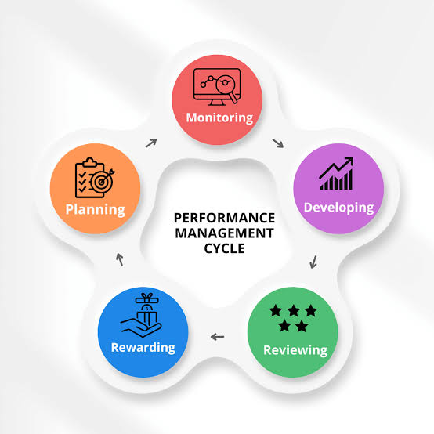
Monitoring HR outcomes is essential for evaluating whether HR strategies achieve their intended objectives. Managers should use a combination of quantitative and qualitative measures, including employee turnover, engagement surveys, training participation, and diversity indicators.
Workforce analytics can provide valuable insights into employee trends and organisational performance. However, excessive reliance on numerical measures may overlook important aspects of employee experience and workplace culture. Ball (2010) highlights that intensive monitoring can create perceptions of surveillance, potentially reducing employee trust and engagement.
Therefore, M&S should adopt a balanced measurement approach that combines data analytics with qualitative feedback methods such as employee discussions, focus groups, and surveys.

4.4 Organisational Culture and Implementation Barriers
Organisational culture influences whether HR strategies become embedded in daily practices. The McKinsey 7S Framework highlights the need for alignment between strategy, systems, skills, staff, style, and shared values.
Although M&S may introduce DEI policies and development programmes, these may fail without supportive managerial behaviours. Diversity initiatives will have limited impact if employees face barriers to progression or exclusion. Key implementation challenges include operational pressures, limited managerial time, inconsistent leadership capability, and resistance to change.

Overall, managerial capability represents a critical factor influencing HR effectiveness.

5. Conclusion
This report has critically examined contemporary HR challenges and practices within Marks & Spencer. The analysis identified technological advancement, talent acquisition and retention, and diversity, equity and inclusion as key factors influencing organisational performance and sustainability.

The findings demonstrate that technological transformation requires continuous employee development and effective change management. Talent retention challenges reflect both motivational and structural labour market factors. Similarly, DEI success depends upon cultural integration rather than policy compliance alone.
While M&S has implemented a range of contemporary HR practices, their effectiveness ultimately depends upon managerial capability, communication quality, and organisational alignment. Sustainable organisational success therefore requires not only effective HR policies but also consistent implementation across all levels of management.

Recommendations

1. Develop a Digital Skills Academy
M&S should establish a Digital Skills Academy to provide training in AI, automation, data analytics, and digital customer service.
2. Strengthen Internal Career Pathways
Clear career progression routes should be introduced to improve retention and reduce turnover.
3. Align Employer Branding with Employee Experience
Employee feedback should be used to ensure employer branding accurately reflects workplace realities and maintains trust.
4. Embed DEI Objectives into Managerial KPIs
Managers should be evaluated against measurable DEI outcomes to strengthen accountability and inclusion.
5. Implement a Leadership Development Framework
Leadership training in change management support consistent HR implementation across the organisation.

References
Armstrong, M. and Taylor, S. (2023) Armstrong's Handbook of Human Resource Management Practice. 16th edn. London: Kogan Page.
Ball, K. (2010) ‘Workplace surveillance: An overview’, Labor History, 51(1), pp. 87–106.
Barney, J. (1991) ‘Firm resources and sustained competitive advantage’, Journal of Management, 17(1), pp. 99–120.
Becker, G.S. (1964) Human Capital: A Theoretical and Empirical Analysis, with Special Reference to Education. Chicago: University of Chicago Press.
Boxall, P. and Purcell, J. (2016) Strategy and Human Resource Management. 4th edn. London: Palgrave Macmillan.
Chartered Institute of Personnel and Development (CIPD) (2024) Resourcing and Talent Planning Survey 2024. London: CIPD. Available at: CIPD Resourcing and Talent Planning Survey 2024 (Accessed: 17 July 2026).
Chartered Institute of Personnel and Development (CIPD) (2024) People Profession Survey. London: CIPD. Available at: CIPD People Profession Survey (Accessed: 17 July 2026).
Deci, E.L. and Ryan, R.M. (2000) ‘The “what” and “why” of goal pursuits: Human needs and the self-determination of behaviour’, Psychological Inquiry, 11(4), pp. 227–268.
Guest, D.E. (2017) ‘Human resource management and employee engagement’, Human Resource Management Journal, 27(1), pp. 1–19.
Herzberg, F. (1968) ‘One more time: How do you motivate employees?’, Harvard Business Review, 46(1), pp. 53–62.
Kotter, J.P. (2018) Leading Change. Boston, MA: Harvard Business Review Press.
Lewin, K. (1951) Field Theory in Social Science: Selected Theoretical Papers. New York: Harper & Row.
Marks and Spencer Group plc (2025) Annual Report and Financial Statements 2025. London: Marks and Spencer Group plc. Available at: Marks & Spencer Corporate Reports (Accessed: 17 July 2026).
Rousseau, D.M. (1995) Psychological Contracts in Organizations: Understanding Written and Unwritten Agreements. Thousand Oaks, CA: Sage Publications.
Tajfel, H. and Turner, J.C. (1979) ‘An integrative theory of intergroup conflict’, in Austin, W.G. and Worchel, S. (eds.) The Social Psychology of Intergroup Relations. Monterey, CA: Brooks/Cole, pp. 33–47.
Ulrich, D. (1997) Human Resource Champions: The Next Agenda for Adding Value and Delivering Results. Boston, MA: Harvard Business School Press.

