An investigation examining whether play therapy reduces social anxiety and improves social skills in young children.

Summary of proposal- indicates the topic, hypothesis (if appropriate) and brief details of your methodology (continue on separate sheet if necessary) (1000 words- as a guide).

Topic area

Diagnostic And Statistical Manual Of Mental Disorder (DSM-5) (2013, p. 202) implies fear or worry about one or further social cases in which the individual can be scrutinised by others is referred to as Social Anxiety Disorder (Social Phobia). For example, conversations, meeting new people, being seen, eating or drinking as well as carrying out in front of an audience, such as offering a speech, are all examples of social interactions.

Furthermore, dread or anxiety in youngsters must arise in peer settings rather than only during interactions with adults.When an individual is exposed to such social situations, he or she is afraid of being judged poorly. The individual is worried of getting marked as worried, weak, insane, foolish, dull, frightening, filthy, or unlikable (DSM-5, 2013, p. 202). The individual is afraid that by blushing, trembling, sweating, stumbling over one's words, or staring, he or she will be judged differently by the audience. Some people are afraid of upsetting others or being rejected as a result of it. In people from traditions with powerful communism placement, the panic of hurting or offending others individuals. For example, by a stare or by displaying anxiety signs, may be the most prevalent panic (DSM-5, p. 203, 2013).

Within the United States, the middle generation of commencement of social anxiety disorder is 13 years, with 75 percent of individuals encountering signs from the age of 8 and 15 shown by (DSM-5, 2013, p. 204). However, approximately 8 million people in the UK suffer from social anxiety disorder. In addition to this, social anxiety among children and adolescents does have a huge disadvantage as it does frequently damage their social skills, family life, academic performance and peer relationships. Furthermore, according to (Kessler et al., 2005), social anxiety disorder is the third most common mental health disorder after depression and substance abuse, with prevalence rates of around 12%. It is very frequent among teenagers.

Linking to play therapy it varies from systemic normal play in which a professional such as a therapist improves as well as enhances their personal social issues. Play therapy draws on how children naturally learn about themselves and their relationships with others in their environment suggested by (Axline et al., 2002). The treatment of play therapy has many advantages. For example, it allows young children to communicate with other individuals, improve and develop social skills, learn to express their feelings as well as adjust their behaviour. Furthermore, play therapy allows a secure psychological gap from their issues as well as grants different expressions of emotions suitable to their full development.

(Terpstra E & Tamura R, 2008) implies that playing with their classmates teaches children numerous social skills. Understanding social roles, involvement, communication, appropriate situational response, verbal actions, association, generosity, waiting one's turn, disputing, and even tearful as well as building noise are all examples of skills (Uren N & Stagnitti K, 2009). Additionally, play is seen to be important in many aspects of development, including social skills (Whitted S, 2011).

Aim of your study

My aim for this analysis proposal is to inspect the impact of play therapy with young youngsters who have social anxiety as well as increasing social skills.

What theory and research will you be including?

There are a few existing theories and research that suggests that play therapy is a successful treatment for young children with social anxiety. For example, (Ahmadvand M, 2011) looked at the strength of group games on preschool children's public skills as well as IQ. The findings revealed that the participants' social skills and intelligence improved as a result of their participation in the game. Another example is (FathAli Pouri, 2013) who also investigated a theory that conveys play therapy's impact on female elementary school students' anxiety and social phobia. The participants' anxiety and social phobia were reduced as a result of play therapy.

In line with other theories, (Ghasemin Siyah Kal Roudi, 2015) concentrated on the impact of play therapy on female elementary school pupils' self-esteem and social skills.The findings revealed that play therapy improves these subjects' self-esteem and social abilities, which overall shows that treatment of play therapy does have many advantages.

Rationale of the study

There are a few reasons why social anxiety was picked for this research proposal. According to (DSM-5, 2013) in common, females contain towering rates of social anxiety disorder aside from males in the common public society (contains odds ratios varying from 1.5 to 2.2) especially in adolescents and young adults, the gender disparity in prevalence is further spoked, implying that social anxiety disorder is highly widespread and can affect even young children. As a result of having social anxiety it could really destroy an individual’s social skills such as lack of interaction with others, having difficulties building social relationships, lack of communication which could be considered from a young age, low self esteem as well as trouble being assertive.

Furthermore, as believed by (ReAttach Therapy International Foundation, 2018) carried out a study on reducing social anxiety within young adults. However, this study was not very broad as it only focused on young adults with social anxiety, which suggests there has been limited amount of research with young children that have the same disorder. Therefore, one of the key rationale for this study is to look at and investigate whether social anxiety works for young children.

Hypothesis

My hypothesis for this research proposal is that the treatment of play therapy could reduce social anxiety within young children and increase social skills. It is predicted that play therapy will help reduce social anxiety and increase social skills within young children.

Proposed Methodology (1000 words- as a guide)

Design (unrelated/related, IVs and DVs, criterion and predictor variables – multiple regression)

The design for this proposal research is quantitative field experiment data, which is a nomothetic approach. The independent variable is play therapy on the other hand the dependent variable is the scores on the social anxiety scale. As well as this, this is a related design as all individuals will be engaged pre and post the investigation.

Participate ( how many, target population, gender, age etc.)

My target and statistical population consist of gender neutral preschool children, thirty participants will take part in this research, and all are formally diagnosed. The researcher works in a primary school setting so it was easier to access and recruit these participants. However, the thirty participants in this study will be split into two groups. Group A will be involved in the research and investigation while Group B will be in a control group. The age of five years old was chosen at random, followed by the age range of three to six years old. The topic covered 15 individuals in the control set and 15 will be involved (case group). The type of sampling that will be used for this research proposal is stratified sampling (STS).

Supporting (Neil J. Salkind, 2010) stratified sampling is when the public is separated into non overlapping categories, or strata, along a linked measurements such as gender, ethnicity, political affiliation as well as other things.The investigator then gathers a random sample of population members from within each and every stratum. Furthermore, this method confirms that all linked observational strata are involved in the trail.

Materials (questionnaires/tests/ intervention/surveys/interview schedules etc.)

The type of play therapy intervention that will be carried out through this research is creative visualisation, and it will last a total of ten weeks as one session will be held each week. Following that, a questionnaire will be given to measure levels of social anxiety.

A questionnaire was picked as the material for the proposal as it is quicker and easier to get an ending result, also it can be accessed through online and mobile tools, it is very reliable and dependable and it can cover every aspect of a topic. The type of questionnaire that will be carried out is based on scales. The researcher will use the subject of happiness scale, the scale includes four questions overall and they are measured on a like good scale. As well as this, the scale has also been used by Mathew Parackal and Sherly M. Parackal. See appendix D for an example of the subject happiness scale. The citing of play therapy would be talked about in the procedure section.

Proposed Procedure

A randomised control trial was utilised. Group A successfully completed the questionnaire and the ten weeks of play therapy, the name of the games is listed in appendix A. However, group B were in a separated environment as a control group and did not participate in the testing as they were on a waiting list. The participants would be measured on the questionnaire for diagnosis before and after the intervention. The study will be conducted by Group A having ten sessions of play therapy which lasted for 45 minutes while Group B was exposed to no intervening variable.The games in each session were chosen to correspond to the children's age and developmental features. Including each meeting, three to four activities were evaluated and following two meetings, one of the activities was deleted and changed with another. At the start of each session, the children were informed of the games that will be played that day.

Due to the therapist's familiarity with the working environment as well as children, she initially attempted to prepare the children by playing a game that maximised the children's level of physical activity. According to (Yazdanipour, 2010), the therapist demonstrated how to play each game to the youngsters before it was implemented. For instance, details on one of the meetings (the second meeting) are given. Balloon and paper activities, a chair game, a napkin game, and acting out a birthday party role were among the games played during this session.

The therapist used a practical and group method to play all of these games in order to improve participants' social skills in terms of social anxiety, group involvement, and group following decrease.Taking into mind the children's lack of collective connection skills and group engagement, the therapist chose intervention plays that reflected these characteristics. Furthermore, the functionality of the plays employed in this study was the most important factor. It helps the child to evaluate the issue instead of talking about it and come up with an acceptable solution.

As a result, children practise skills such as compatibility, communication, cooperation, and involvement in these plays, as well as group formation and adherence to norms, adaptability, and problem solving. In the post-test stage, the final outcome of this study proposal shows the benefits of play therapy in reducing social anxiety and boosting social ability including the case group, as shown in appendix B.

(Yazdanipour, 2010) found that play therapy can help those with social anxiety. Given the large intervention impact, it can be argued that play considerably decreased children's social anxiety. According to the data, post-test social anxiety results in the case group decreased compared to pre-test scores, but post-test social ability scores rinsed contrasts to pre-test scores.This indicates that play therapy has been successful in reducing social anxiety and improving social skills. However, the results revealed that two social skill sub scales (feeling perception and mate search) did not differ remarkably. Nevertheless, there were serious contracts in the outcomes of three additional sub scales of social skill, including group within engagement in group and nonverbal ability.

Results

To test the hypothesis a quantitative design has been used and therefore to further test that hypothesis an appropriate statistical analysis will be utilised.

Ethical Considerations (500 words - as a guide): Any issues identified here and how you will address them:

There are a variety of ethical concepts to examine. Take, for example, dangers. Risk, according to (Oates J et al., 2021), is clarified as the possibility of physical or psychological harm, discomfort, or stress to human participants as a result of a study endeavour. This is an important aspect to consider in psychological research, as there are numerous possible dangers. According to the analysis proposal, potential hazards to the candidate’s self-esteem, social standing, privacy, personal points and views, and particular connections and the negative consequences of disclosing unlawful, sexual, or deviant behaviour, are all possible (Oates J et al., 2021).

Giving Advice

Giving advice is ethical in some variety of testing if it is an integral element of the research, is resolved upon with the candidate, and has been put through to an ethics assessment in advance. In this scenario, the investigator has an obligation to discuss this with the participant as part of the research proposal if the researcher accepts that not doing so may jeopardise the individual's future well-being (Oates J et al., 2021).

Valid Consent

According to (Oates J et al., 2021), the researcher should make sure that everyone whose statistics is gathered for study reasons gives their consent openly and voluntarily after being given enough figures to make an educated conclusion. They should be able to remove or adjust their agreement at any time during the statistics collection phase and appeal the levelling of all or part of the detail they have stated, within agreed-upon and consented-upon boundaries (Oates J et al., 2021).

Moreover, linking to the research proposal which includes participants between the ages of three to six years old children, as well as parents, head teachers and year tutors, the participants themselves should also be given consent. As the participants are young and some cannot give consent by physical words, this procedure is very important as they could use a thumbs up, a nod or a smiling face if it is possible. Additionally, a consent form also needs to be carried out for a successful research. An example of a consent form is shown in appendix C.

Confidentiality

Candidates in psychological study contain the right to assume that the statistics they submit would be handled discreetly and that, if brought out, it will not be identified as theirs (Oates J et al., 2021). If the participant's secrecy or anonymity cannot be guaranteed, he or she must be informed before deciding to participate.

Associating with the research proposal it is vital to make sure all documents and information are protected due to data protection as well as privacy. This could be done by making sure not to include any names or surnames as well as keeping all information in a password protected computer or a safe. This suggests that confidentiality has been carried out correctly. However, if this procedure is performed incorrectly there could be a huge risk linking to confidentiality. For example, having the participants names on a sheet of paper without locking it up breaks the data protection rule and that could easily cause problems with the child and parents.

Debriefing

(Oates J et al., 2021) demonstrates the importance of providing an effective debriefing for participants once the statistics contributes concluded, mainly if there has been any part of dishonesty or retaining of statistics. For example, information on the research proposal will be presented to participants after data collection to educate them of the outcome of their participation, and the debrief form will need to be written in a way that is appropriate for young children aged three to six. Appendix E contains an example of a debriefing form.

References

American Psychiatric Association. (2013) Diagnostic and Statistical Manual of Mental Disorders DSM-5 (5th Edition). Washington. DC.

Association For Play Therapy (2021) Play Therapy Makes a Difference. Available at:
https://www.a4pt.org/page/PTMakesADifference/www.google.com (Accessed: 12 February 2021)

Mollamohammadi, F., & Yazdkhasti, F. (2017). Effect of play therapy on reduction of social anxiety and increasing social skills in preschool children in Omidiyeh. International Journal of Educational and Psychological Researches, 3(2), 128.

Oates, J., Carpenter, D., Fisher, M., Goodson, S., Hannah, B., Kwiatowski, R., & Wainwright, T. (2021, April). BPS Code of Human Research Ethics. British Psychological Society.

Salkind, N. J. (Ed.). (2010). Encyclopedia of research design (Vol. 1). sage.

Appendix

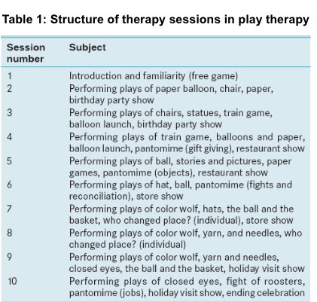

Yazdanipour (2010)

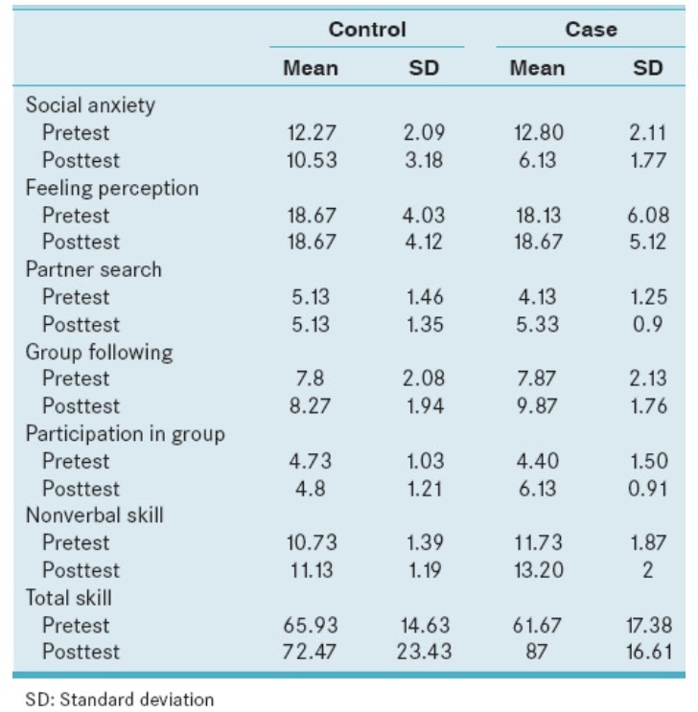
B

Yazdanipour (2010)

C)

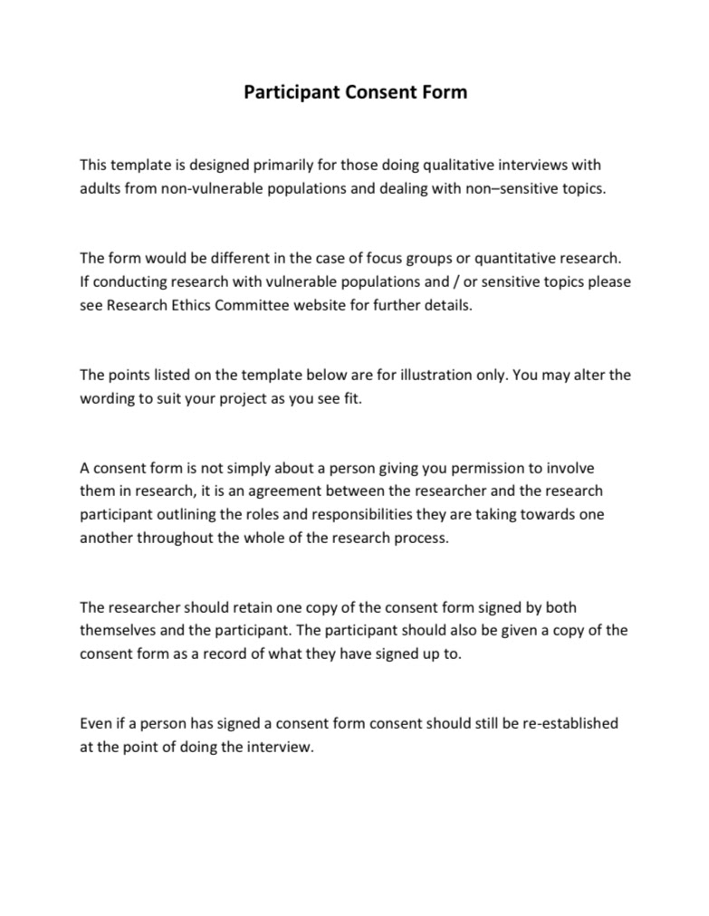

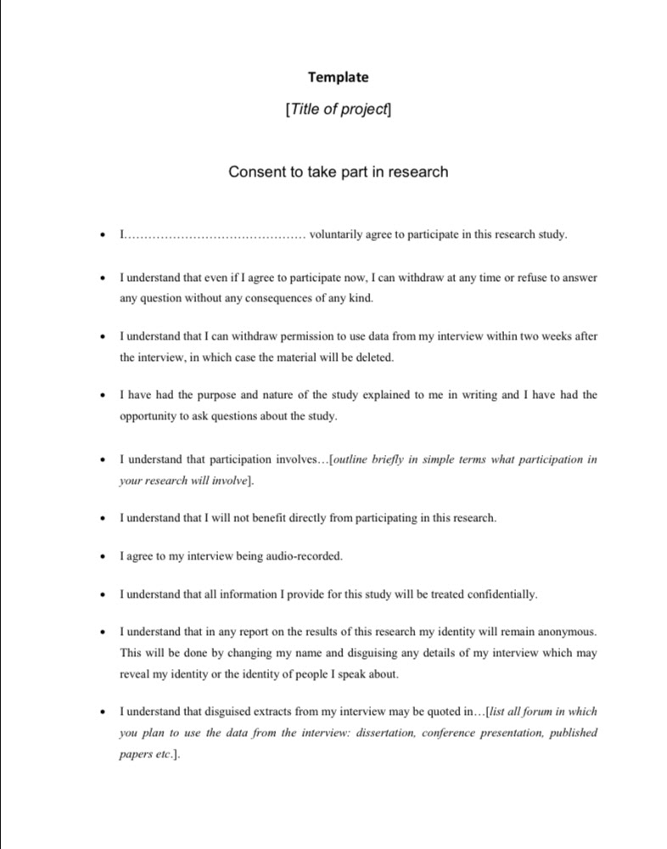

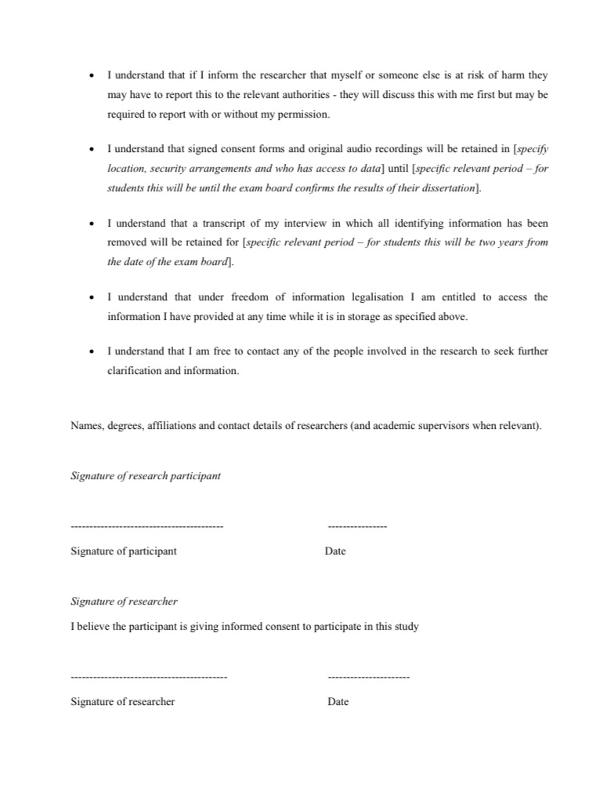
D)
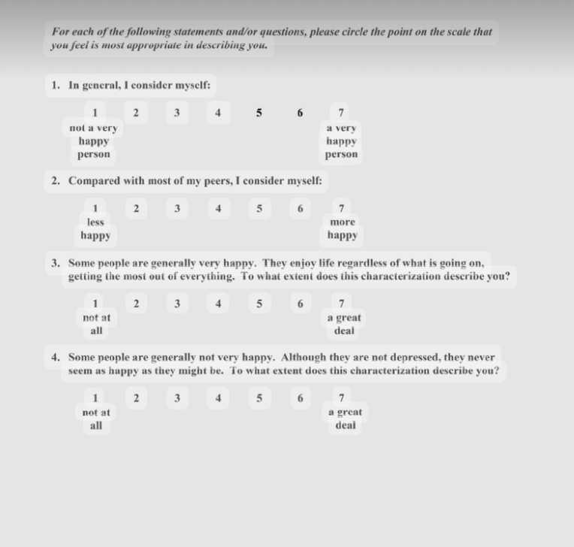

E)

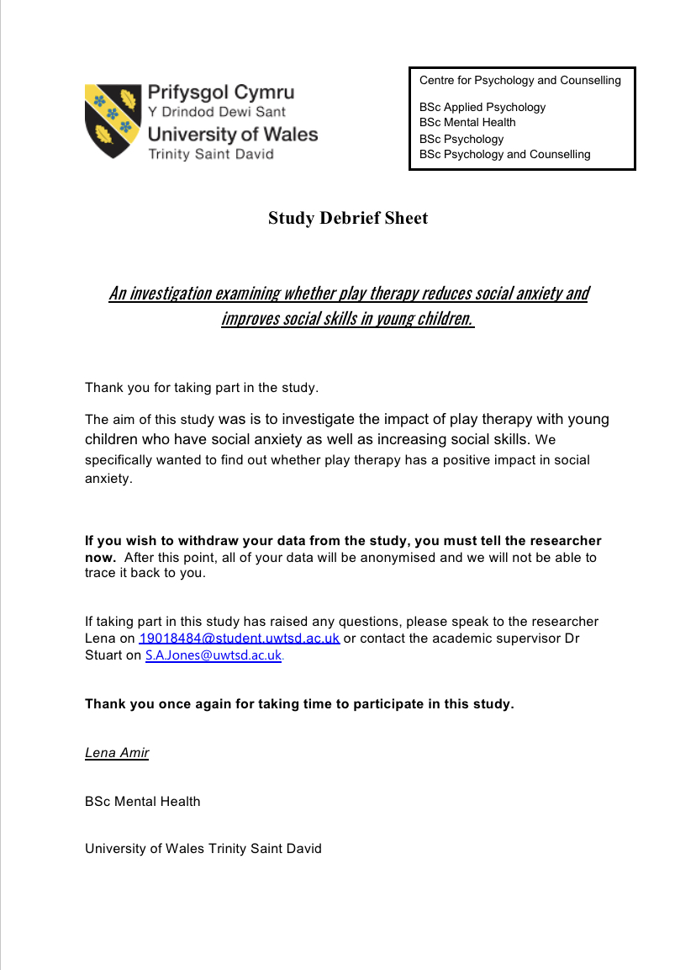
University Of Wales Trinity St David (2021)

