Worksheet 1

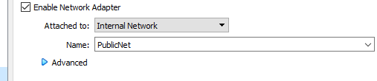
This is the setup of Adapter 1 for Server1
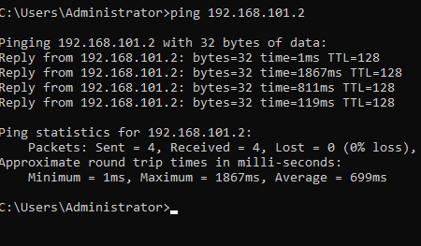
This is a showcase of the ping command between Server2 and Client2
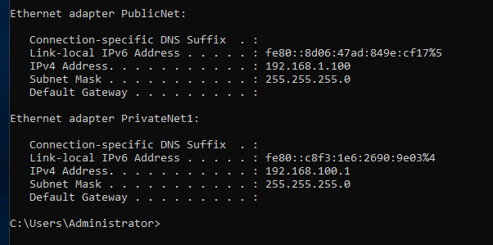
Proof of static IP

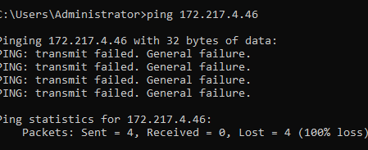
Proof of no DNS server

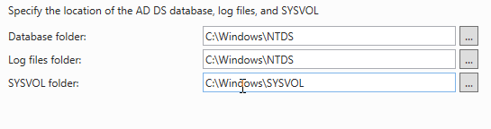
Log Files
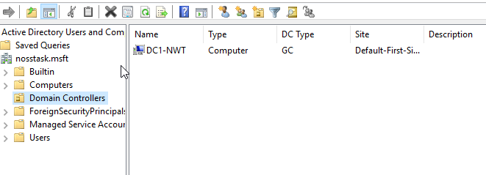
Proof of domain controller
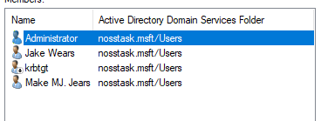
Proof of second user


Proof of logon hours
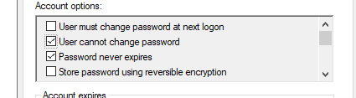
User cannot change password
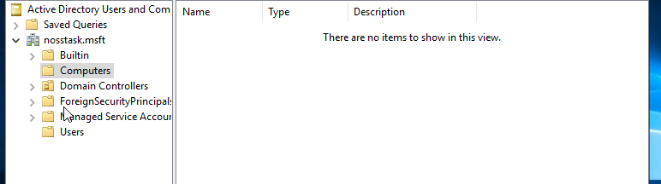
No account for client 1 or 2
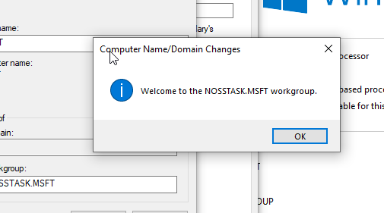
Proof of domain connection for client
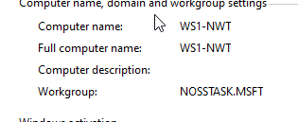
Proof of workgroup connection

Proof of restrictions for logon

Task 3

Difference between type 1 and type 2 Hypervisors

A hypervisor is a program that is used to manage virtual machines on a system. They come in 2 forms, Type 1 and Type 2. They work similarly to emulators as they provide a platform on which to run virtual machines. Virtual Machines are computers within computers and can be used as sandboxes to test software.
Type 1 and Type 2 Hypervisors work differently. Type 1 hypervisors run directly on the hosts hardware. As there is no software in between the hardware and the hypervisor and thus is called a ‘bare-metal hypervisor.’ These run well as they are not running as an operating system within a operating system.
The main drawback to this is the fact that this needs to be on a dedicated system. This means that they are costly. However due to it being a dedicated system it is secure.
Type 2 hypervisors exist within the confines of a operating system. This means they are cheap compared to Type 1’s. However as a result, PC’s running these need to be of a good quality, otherwise the computer will not be able to deal with the sheer amount of data being transferred at once and may crash.
Type 1 hypervisors include VMware ESXi and Microsoft Hyper-V. Type 2’s include VirtualBox and Microsoft Virtual PC

Cloud Computing

Cloud Computing has been a relatively new addition to everything in IT but has been one of the easiest ways to incorporate mass storage into a smaller business. This is because it can be hosted by a bigger company and just paid for by the organisation or business. There are 2 massive names in this industry already. Those being Microsoft and Google with their OneDrive and Google Drive respectively. With these two tech giants involved, cloud computing is becoming easier for people to get a hold of. Both of these offerings provide a client with good storage for documents and files that they need to keep, as well as the ability to share those files with co-workers or clients. This eliminates the need for employers to have all employees on site and affords them the ability to work remotely.
While it is mostly positive, there are some drawbacks to cloud computing. These can include the fact that these cloud storage servers can be less secure than physical servers the business has control over. This can be due to the sheer scale of the cloud storage devices, serving many different systems across many different continents. They is also potential for these systems to be DDOS attacked, preventing almost all access until the problem is resolved.

DNS

DNS servers are essentially translators, they make IP addresses for users and websites. Every router will have a DNS server so that users may connect to the internet. They allow users to access sites.
Bigger more complex DNS servers help to direct queries from users on the internet into searchable information. It does this by taking the query, which is whatever the user put into their search bar and relating it to things that are like what was searched. This helps people with remembering the sites they are trying to reach, as they remember names as opposed to IP addresses which are difficult to remember. Essentially it works by finding the information that is required and helping the search engine in returning it to the user.
This whole process is known as the DNS Resolution

Features of an enterprise network

An enterprise network is a LAN that contains different networks, be they physical or virtual and different protocols all with the purpose of connecting users in a data centre. These networks can be found in schools, bigger businesses, or any organisation where a computer is necessary for a user to work or learn.
These networks most contain WiFi. While it may be an obvious thing to include on a computer network, they are not included by default and may be omitted for certain reasons, including security and exam environments. While WiFi is absolutely necessary and critical for networks, it must be integrated onto a network.
Almost all these networks that have internet connection will also have a firewall. This allows the organisation to stop most malicious software and bytes coming in. This greatly increases the security of these networks. It also provides network administrators a level of control over anyone using the systems. These can be done by imposing restrictions on these users and stopping them from doing undesirable things on the systems. These undesirable actions can include visiting unpermitted websites, restrict access to some software’s stored on a data centre or restrict them from using the internet entirely if required. The main use of these systems is however the security they provide, as being able to guarantee most malware cannot gain access to the network is good peace of mind and good for the organisations systems.

In detail description of networking terminologies

The ping command is an important command. It helps engineers troubleshoot and set up networks. It allows computers to echo signals off each other. It is sent to a specific IP address and pings 4 times, giving the user a detailed report back, detailing the time the ping took to be received by the computer, how long it took to return and if any failed it will also provide that information. This can allow users to ping as long as the PC is connected to a network. For this reason it can be used, as done so in the assignment, to evaluate the setup of the network.
Server management is an application that can be used on systems running operating systems such as Windows 2019. This software allows the user to modify a network and setup said network. It can be used monitor said system after it has been installed as well. It can also allows server administrators to connect to it remotely, allowing access to administrators or allows outsourcing so professionals can sort any issues. An alternative to Windows server 2019 is TrueNAS. TrueNAS is a open source software that can be used as a solid alternative to Windows server. It is also free.

Reflection

This assignment was annoying to work on. This is mainly because of the Virtual Machines that the author used. All of them were slow buggy messes from start to finish and as a result the assignment took longer to complete than initially thought. Once these servers were running decently, progress was relatively trouble free, bar the error on the worksheet which stumped the author for a little bit. However, he worked it out by himself and managed to complete Part 1 of the assignment with relative ease.
There is a sense of accomplishment upon setting up a functioning network, even if following instructions that guide through every step, there is a genuine feel of pride upon completing it. The most annoying section was the continued restart of every virtual machine every few steps. While necessary, the virtual machines made it incredibly tedious as with each restart a wait of 10 or more minutes was usually on the other side.

