Group Project – Thomas Seager 2100805 – Curtis Rees
Abstract
The rise of green energy, electric powered vehicles and machinery is leading to innovation in the form of energy storage. Batteries dominate the industry however supercapacitors are on the rise as they offer a range of different aspects and functions, able to provide quick bursts of energy, or a great back-up power supply with long lasting times. In this project, a circuit will be designed, manufactured, and tested with the goal being to measure the capacitance and charge times of a capacitor or supercapacitor connected to it. The project is fully functional and includes LEDs and an LCD screen for the user to interact with, a variety of buttons to charge or discharge the capacitor and the microcontroller is able to calculate the capacitance, voltage and charge time and inform the user via the display.
Introduction
Supercapacitors, also known as ultracapacitors or electric double-layer capacitors (EDLCs), have gained significant attention in the field of energy storage due to their unique characteristics. The research will explore the reasons behind the use of supercapacitors, the materials employed in their construction, their comparison to conventional batteries, and the mechanisms involved in their charging and discharging processes. Within this report, a circuit designed to measure the capacitance of the supercapacitors will be designed and tested, to compare the effect of different electrolyte liquids on supercapacitors. The supercapacitors will be made from activated carbon, which acts as the electrode, a sheet of cloth acting as a separator and finally the steel mesh, acting as the current collector. The Carbon electrodes will be dipped in milk, and the other in lemon juice to compare the different results yielded from the change of electrolyte and additionally to test the accuracy of the capacitance measuring circuit over a range of capacitances.
Research
The Use and Importance of Supercapacitors
Supercapacitors are used for a wide range of applications that require high power density and rapid energy delivery. They excel in situations where traditional batteries fall short, such as in regenerative braking systems of electric vehicles, grid stabilization, and peak load levelling. Their ability to store and release energy quickly makes them ideal for applications that require frequent charging and discharging cycles. [1]
Materials Used in Supercapacitors
Supercapacitors consist of three primary components: electrodes, electrolytes, and separators. Various materials are utilized in each of these components to optimize the performance of supercapacitors.

Electrode Materials:
- Activated Carbon: Widely used due to its large surface area and high porosity.
- Carbon Nanotubes: Offer enhanced electrical conductivity and surface area.
- Graphene: Provides excellent electrical conductivity and mechanical strength. [2]
Electrolyte Materials:
- Aqueous Electrolytes: Commonly used due to their low cost, high ionic conductivity, and safety.
- Organic Electrolytes: Offer wider operating voltage ranges and higher energy densities.
- Ionic Liquids: Known for their wide electrochemical stability, low volatility, and non-flammability. [3]
Separators prevent short circuits between the electrodes while allowing the ionic flow. Common separator materials include polymeric membranes and ceramic materials. [4]
Comparison to Traditional Batteries
Supercapacitors offer distinct advantages over traditional batteries, making them complementary energy storage devices rather than direct replacements. Supercapacitors store energy electrostatically, utilizing the electric double layer formed at the electrode-electrolyte interface. In contrast, batteries store energy electrochemically through redox reactions. Supercapacitors have lower energy densities compared to batteries. However, their power density is significantly higher, allowing for rapid energy release and absorption.
Supercapacitors provide high power output, making them suitable for applications that require quick bursts of power. Batteries, on the other hand, have lower power densities and deliver energy more slowly. Supercapacitors exhibit excellent cycle life, typically enduring hundreds of thousands to millions of charge-discharge cycles. Batteries have limited cycle life and degrade over time.
Supercapacitors have high charge-discharge efficiency, enabling them to recover a large portion of stored energy. Batteries have higher energy efficiency but often experience energy losses during charge-discharge processes. Supercapacitors are more environmentally friendly than batteries since they do not contain toxic chemicals or heavy metals. [5]
Charging and Discharging Mechanisms
Supercapacitors charge and discharge through electrochemical reactions at the electrode-electrolyte interface. The charging and discharging processes involve several steps:
Charging process: During charging, a voltage is applied across the electrodes, creating an electric field. Ions from the electrolyte are attracted to the electrode surfaces, adsorbing onto them and forming the electric double layer. The stored charge in the double layer accounts for the energy stored in the supercapacitor.
Discharging Process: When a load is connected to the supercapacitor, the stored energy is released. Ions from the electrode surface desorb from the electric double layer, moving into the electrolyte. The movement of ions creates an electric current, allowing the supercapacitor to deliver power to the load.
Supercapacitors have emerged as versatile energy storage devices due to their unique characteristics, including high power density, rapid charge-discharge cycles, and long cycle life. The materials used in their construction, such as activated carbon, carbon nanotubes, and graphene, play a crucial role in optimizing their performance. When compared to traditional batteries, supercapacitors exhibit advantages in terms of power density, cycle life, charge-discharge efficiency, and environmental impact. Understanding the charging and discharging mechanisms of supercapacitors is essential for maximizing their utility in various applications, ranging from electric vehicles to renewable energy integration. Continued research and development in supercapacitor technology hold the potential for further improvements, ultimately driving advancements in energy storage systems. [6]
The PIC18F46K20 is a microcontroller from the PIC18 family manufactured by Microchip Technology. It is a 8-bit microcontroller based on the Enhanced Flash architecture, offering a wide range of features suitable for various applications. Key features of the PIC18F46K20 include:
Architecture: The microcontroller uses a Harvard architecture with an 8-bit CPU and a separate program and data memory. It has a Von Neumann-like internal structure, which allows for faster execution of instructions.
Memory: It has 64 KB of Flash program memory for storing the application code, which can be reprogrammed multiple times. It also has 3.8 KB of RAM for data storage and 1 KB of EEPROM for non-volatile data storage.
Peripherals: The PIC18F46K20 offers a wide range of built-in peripherals, including analogue-to-digital converters (ADC), digital-to-analogue converters (DAC), timers, comparators, UART, SPI, I2C, and PWM modules. These peripherals enable interfacing with various sensors, displays, communication modules, and other external devices.
Clock and Oscillator: It supports both internal and external clock sources. The internal oscillator can be tuned to provide various frequencies, and it also supports external crystal or resonator for precise timing requirements.
Power-saving features: The microcontroller incorporates different power-saving modes to optimize energy consumption, including Sleep mode, Idle mode, and the ability to selectively disable peripherals.
Development tools: Microchip provides a comprehensive development ecosystem for programming and debugging PIC microcontrollers, including integrated development environments (IDEs), compilers, programmers, and simulators.
The PIC18F46K20 is commonly used in various applications, such as industrial control systems, automation, consumer electronics, medical devices, and automotive applications. It offers a good balance between performance, features, and cost, making it popular among embedded system designers. [7]
Method
Supercapacitor Design
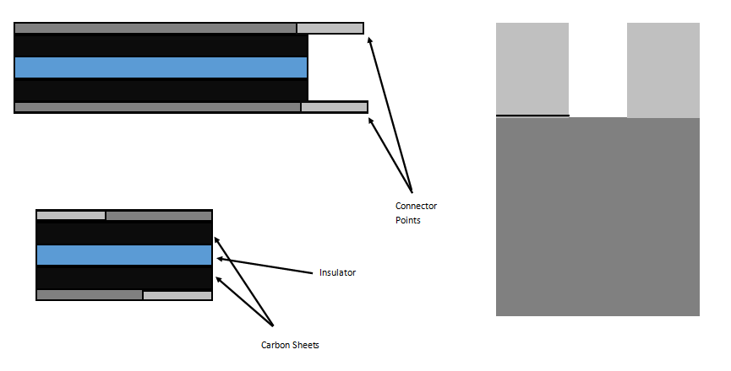
Figure 1
As shown in figure 1, the supercapacitors that will be made are made up of five layers and will then be contained in a vacuum sealed bag to contain the electrolyte liquids. The separator or insulator will be made of a cloth, with activated carbon sheets used as the electrode. There will be a steel mesh layer surrounding this acting as the current collector, this is where the capacitor will be connected to the circuit, with a positive and negative side. This capacitor design has no polarity and can be connected with the positive and negative at either side of the design yielding identical results.
Two supercapacitors will be made to allow the circuit to test multiple capacitors to determine accuracy and to ensure that it works over a range of readings. The first supercapacitor will use milk as its electrolyte, to do this, the activated carbon will be dipped into milk so that it soaks through the material, the layers are then stacked together as shown in figure 1, before being vacuum sealed to contain the liquid and supercapacitor materials. The second supercapacitor will be made using identical materials and in the same way, however this time using lemon juice as the electrolyte to yield different results that can then be analysed.
Circuit Design
The circuit design was a major factor and aspect of the design process as a whole for this project, it needed to successfully accomplish a range of outcomes in order to allow the circuit to charge, discharge and measure the capacitance of the supercapacitors. The first section of the circuit that will be analysed is the charge/discharge portion that is essentially its own sub-circuit within the design. Its role is to charge up the supercapacitor to 5V, and maintain this until the relay switches and the capacitor discharges through a known resistor value. A capacitor will charge when there is a current flowing through it, so in this case when connected to the power supply
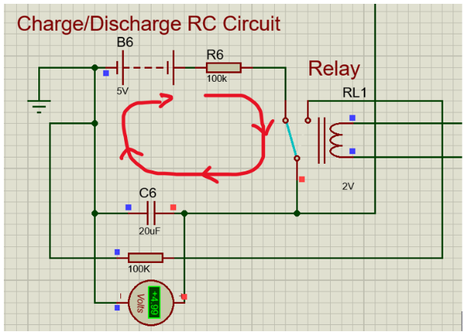
Figure 2 shows the path of the current whilst the capacitor is charging. The current flows from the power supply, through the relay which directs it through the capacitor, charging it. The temporary voltmeter added for the simulation indicates here that the voltage across the capacitor is 5V, showing that it has been fully charged. [8]
Figure 2

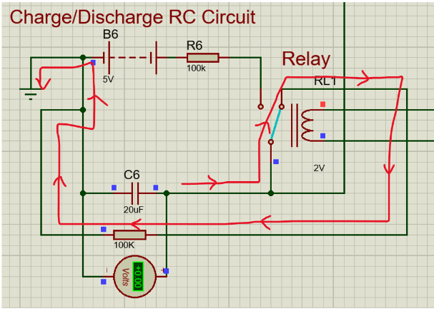
Figure 3 shows the path of the current when the capacitor is discharging. Now, the current flows out of the capacitor, through the relay which directs the current through a known resistor value and to ground. The time taken for the capacitor to discharge 5V through this known resistor value is then used to calculate the capacitance, via the PIC microcontroller. The voltmeter shows 0V here, as the capacitor is fully discharged. [9]
Figure 3

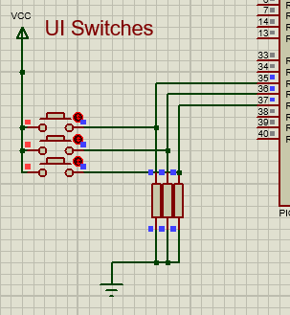
The next feature is the user interface buttons that are used to operate the system. The function of the buttons are to start the capacitor discharging, start the capacitor charging which then displays the capacitance, voltage and time taken for the capacitor to charge, and then finally a reset button to clear the results from the LCD display ready to test the next supercapacitor. The buttons are connected to the input ports of the PIC, and are powered by 5v. Additionally they are grounded via a resistor, shown here in Figure 4.
Figure 4

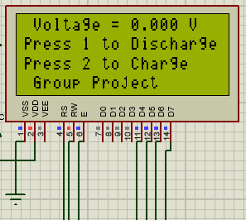
Figure 5
The LCD display in Figure 5, is connected to the microcontroller and powered by a 5V supply. This will display the voltage, and it changing in real time updating every one second. It also begins with a menu to indicate to the user how to charge or discharge the supercapacitor.

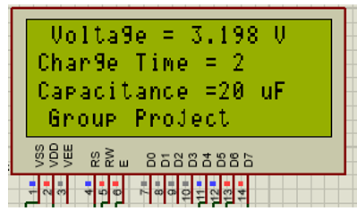
Figure 6

Once charged, the screen will display the voltage reached, the time taken to charge to that point and then the calculated capacitance for the user to read, as shown in Figure 6.

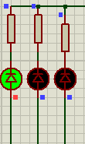
Figure 7
Finally, Figure 7hows that the circuit includes three LEDs to indicate the status of the circuit. A green LED to indicate that the capacitor is fully charged, a red LED to indicate that the circuit is fully discharged, and an amber LED to indicate that the circuit is in the process of either charging or discharging, similar to a loading icon on a webpage.

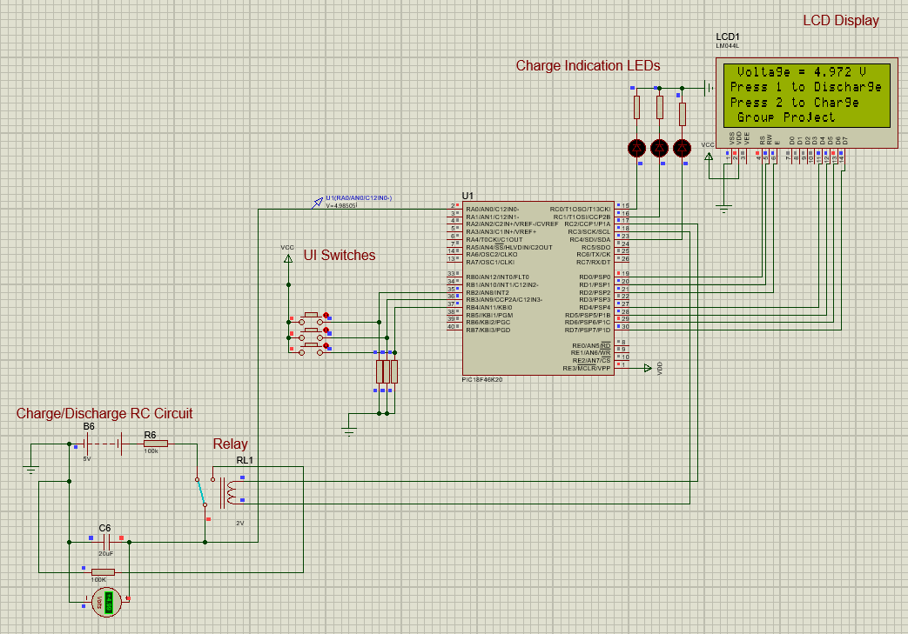
Figure 8
Figure 8 includes the circuit as a whole and shows how the sub-circuits described come together to complete the circuit design.
Programming the PIC
The next step of the design process is to develop the code to program the microcontroller, this will allow the microntroller to interact with the circuit to perform the required function. In this project, the function of the circuit is to take a capacitor or supercapacitor connected to the circuit, then discharge or charge it based on the decision made by the user. After it is discharged and charged, the microcontroller will use the time taken, the known values of the resistor and the voltage, to calculate the capacitance of the capacitor and display it to the user via the lcd screen.
The code is split up into three main scripts, these are named ‘menu’ , ‘charge cycle’ and ‘discharge cycle’. On startup, the menu is displayed on the lcd screen, this shows the voltage of the capacitor and the options for the user to press button 1 to discharge the capacitor, and button 2 to charge it up. If button 1 is pressed, then the code will goto the discharge cycle, and button 2 sends it to the charge cycle script.

Menu script and start-up;

Figure 9
As Shown in Figure 9, the beginning of the code after the variables have been defined as the important mathematical functions and the code that will display the voltage of the analogue pin, this voltage reading is present at all stages of the code as it is important information for the user. The start of the code has the responsibility of detecting the voltage that is present at the analogue pin of the microcontroller, this is the voltage across the capacitor and will be used for the calculations and timing for the capacitance. After this voltage is measured, the analogue reading is calculated from the digital, it is multiplied by 0.0195 to get the direct measurement in volts. The 0.0195 is derived from the conversion between analogue and digital readings and is a constant throughout, regardless of the voltage or capacitor. This voltage is then displayed on the lcd screen and updates every one second.
The next section of the code is simple and displays the menu text onto the lcd screen, this is to instruct the user on how to operate the device, with the prompts, press 1 to discharge and press 2 to charge being displayed. When the microcontroller detects that the capacitor is discharged already, it will show ‘discharged’ on the second line rather than ‘press 1 to discharge’ to make it more clear to the user that the only option is to charge the capacitor. Following this, the microcontroller detects if button 1 or 2 is pressed, if the capacitor is being discharged, the microntroller turns on the red led to indicate this to the user, it then directs the code to the discharge cycle script. If it is charging, the green led turns on and the code goes to the charge cycle script instead.
Discharge cycle;
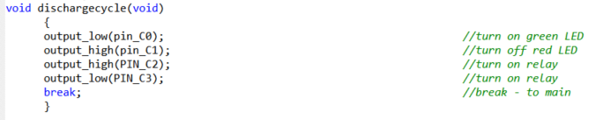
Figure 10
The Discharge cycle shown in Figure 10 is simple, this sets the green LED off and the red led on, this also turns on the relay, disconnecting the capacitor from the power supply and instead directing the current through the 100KΩ resistor, discharging it. This is completed in a matter of milliseconds and the code returns to the menu for the user to chose what to do next. The voltage will be seen decreasing on the LCD and the red LED will be on making it clear that the capacitor is discharging. The choice to use the charge cycle to measure the capacitance was made on the basis that the capacitor will be discharged to begin with, therefore it is more user friendly and efficient to be able to measure the capacitance by just charging it up, rather than charging and then discharging. For large supercapacitors that may be used, this could take several minutes to complete.

Charge cycle;

Figure 11
Figure 11 firstly shows that the microcontroller will detect whether the voltage is above 0V, this will be all of the time keeping the code in this loop. The same code from the beginning is then used to measure the voltage and update the lcd screen, this is updated in one second intervals. The PIC then displays the message ‘charging…’ to indicate to the user that it is in the process of charging up, and again keeps ‘group project on the bottom line. The main aspect of the LCD here is to display the counter on the screen, this is shown as ‘charging time = x’. This is incremented every second using the code counter++ alongside a delay.
The microcontroller then will detect when the voltage reaches 3.115 which is the 3db point, this is how the capacitance can then be calculated and displayed. The green charging LED is turned off and the yellow LED comes on to indicate the capacitance has been calculated. The variable cap is set to the count value at that point, giving the time in seconds. The known value of the resistor is 10Ω, knowing this, the charge time, and the voltage the formula for the capacitance works out as Tx1000=C in mF. Therefore, the capacitance can be displayed onto the LCD screen by multiplying the time calculated by 1000 and stating the units, mF.
If the value measured is milli-Farads, like in the case of the supercapacitors that were made, the resistor values within the circuit can be changed to 10Ω and the cap variable is charge*100. This makes the capacitance calculated in the form of milli-farads and is what is used in the final script as the supercapacitors made are in the low Farad range, and it would take hours to discharge them through a 100KΩ Capacitor. Using millifarads gives a more accurate reading, for example 1600mF rather than 1F.
This was a design choice as the value of resistor and the previous calculations preformed by the microcontroller make the conversion between time to capacitance simple. The microcontroller then waits for the reset to be pressed to return to the menu screen, ready to be used again. Included In the code is the commented out process for uF and F readings, however for this project and the supercapacitors made, mF was the most appropriate reading as it gave the highest resolution answer for this design.

The file containing the code for the design was then programmed onto the PIC18F46K20 microcontroller so that the circuit could be built and tested. This then can be compared to the results obtained from the simulation, circuit test and the capacitor testing to measure the accuracy of the device. The PicKit 2 used is shown in Figure 12. [10]
Figure 12

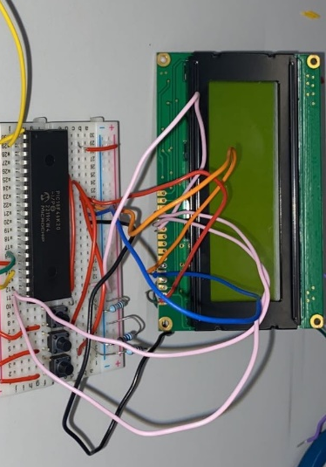
Figure 13
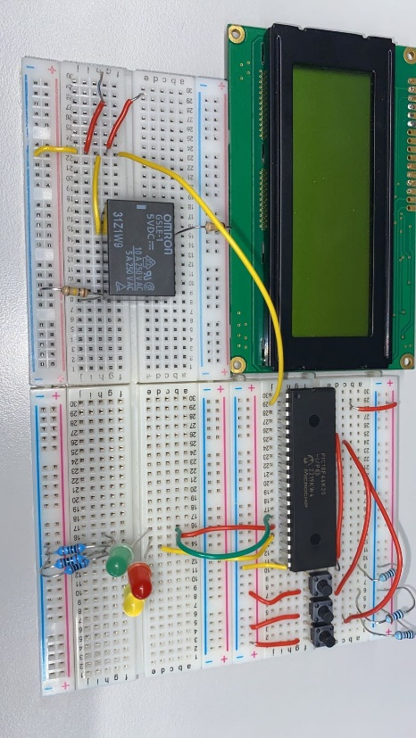
Figure 14

Once the microcontroller had been programmed, the circuit could be physically built using breadboards so that the circuit could be tested. Three breadboards were used to construct the prototype circuit with the LCD screen being temporarily connected to the circuit but not board mounted. In a full manufacture of the circuit, the LCD screen alongside the buttons and LEDs would be the visible part of the circuit for the user. With the microcontroller, wires and other components being hidden, for safety and for an improved aesthetic, however for testing, breadboards were used. The supercapacitors also had been previously constructed so testing could begin. The process of testing the circuit and capacitors required the capacitance of the milk and the lemon juice capacitor to be known to ensure accurate and correct results.
Testing Process
To measure the charge and discharge time of a supercapacitor, we will follow these steps:
Charging setup: We will connect the positive terminal of the supercapacitor to the positive terminal of the power supply and the negative terminal of the supercapacitor to one end of the resistor. We’ll then connect the other end of the resistor to the negative terminal of the power supply.
Charging process: Set the power supply voltage to the desired level for charging the supercapacitor, which will be 5V. Start the stopwatch or timing device and connect the power supply to the circuit. Observe the voltage across the supercapacitor using the digital multimeter and monitor the time it takes for the voltage to reach a specific threshold or stabilize at a certain level.
Discharging setup: Disconnect the power supply from the circuit. Connect the positive terminal of the supercapacitor to one end of the resistor and the other end of the resistor to the negative terminal of the digital multimeter. Set the multimeter to measure voltage.
Discharging process: Start the stopwatch or timing device and record the initial voltage across the supercapacitor using the digital multimeter. Allow the supercapacitor to discharge through the resistor, and monitor the time it takes for the voltage to decrease to a specific threshold or reach a lower stable level.
However during our experiment we will be incorporating the design made on proteus with our pic microcontroller which will be programmed so that a button will charge the supercapacitor, a button will discharge and the time taken as well as the voltage will shown on an LCD display.
It's important to note that the charge and discharge time of a supercapacitor can be influenced by factors such as the capacitance of the supercapacitor, the voltage applied, the resistance of the circuit, and the initial charge or discharge state of the supercapacitor. Therefore, it's essential to ensure consistent conditions for accurate measurements.
Once the microcontroller had been programmed and the circuit had been constructed, the capacitance of both the lemon juice and milk capacitors needed to be calculated. A series of tests using a muti meter was completed on the capacitors, charging them to 5V, timing the time taken to charge, discharge and then finally calculating the capacitance ad confirming this with the multi meters.
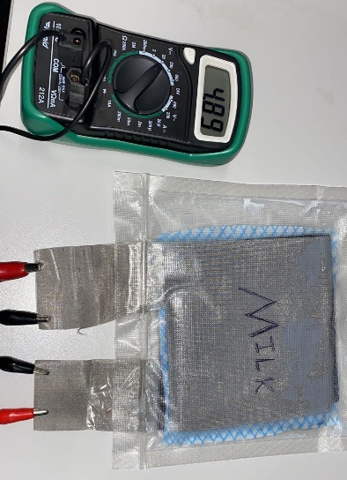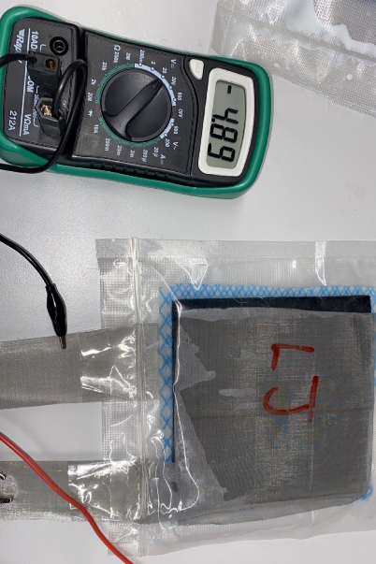
Figure 15 Figure 16
As shown here in figures15 and 16, the supercapacitors have been built and tested, the results yielded stated that;
- The capacitance of the milk supercapacitor – 2744mF = 2.74F
- The capacitance of the lemon juice supercapacitor – 1233mF = 1.23F
From these results, it is clear that the milk supercapacitor was more efficient and had a higher capacitance, both supercapacitors had been manufactured using identical materials, quantities and were tested under the same conditions suggesting that the milk is a more efficient electrolyte as the capacitance is greater.
The next stage of the testing that needed to be completed was to use the physical circuit to test the capacitors, the results yielded from this can then be compared to the multi meter and calculated capacitance, which are known to be sound and accurate readings, to see how accurate and successful the circuit designed is. The test process was as follows;
- Fully discharge the capacitor
- Press button 1 to charge the capacitor
- Record the results on the display
- Repeat this process 3 times to ensure accuracy and repeatability of results
This process was used to test both supercapacitors, with the results being;
Milk supercapacitor – 2.6F
- 2.6F
- 2.6F
- 2.6F
Lemon Juice supercapacitor – 1.2F
- 1.2F
- 1.2F
- 1.2F
The results from the circuit were the same on all three tests of both supercapacitors showing that the results are repeatable, and from the multi meter readings that were obtained, the testing shows that the circuit is fairly accurate in measuring the capacitance. The results obtained by testing the supercapacitors through calculations and a multimeter, compared to the circuit reading are similar with a 0.03F difference for the milk supercapacitor and a 0.12F difference for the lemon juice supercapacitor.
To further test the circuit, the results can then be used in the proteus simulation, this will show the ‘perfect answer’ under ideal conditions as proteus will use perfect conditions to calculate the capacitance. For example a resistor being 9.8Ω rather than 10Ω, or weak connections between the wires and connections in the breadboard where the voltage is being measured.
The first Proteus simulation is for the supercapacitor that uses milk as its electrolyte, the value calculated for this was 2744mF, so this value of capacitor is being used to in the simulation. The capacitor is first fully discharged to 0V before being charged to the 3db point, which is 3.1V. At this point, the capacitance is calculated and displayed on the screen as shown below.
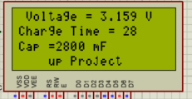
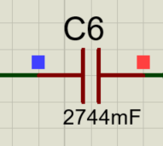
Figure 18
Figure 17
From this simulation, it is clear that the capacitance calculated is 2800mF this figure should be 100% accurate as the simulation is under perfect conditions. Comparing this to the actual reading of 2744mF, it is very close with a minor discrepancy of 56mF, although one downfall and area that could be improved for the circuit design and the program is that the resolution is to the nearest 100mF. With that considered, the result obtained is accurate and shows that the circuit works successfully.
The second proteus simulation is for the supercapacitor that uses lemon juice as the electrolyte, the value calculated for this is 1233uF, so this is used for the capacitor in the simulation. Again, the capacitor is fully discharged to 0V and then charged to its 3db point to calculate the capacitance, which is displayed on the LCD screen and shown below.
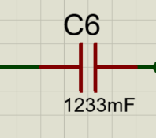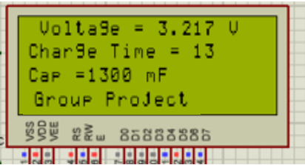
Figure 19 Figure 20

From the simulation using the 1233mF capacitor, the circuit calculates the capacitance to be 1300mF or 1.3F. This again similarly to the milk supercapacitor is close to the actual result being just 67mF out, this is partially due to the resolution of the circuit and program as it will display the result in intervals of 100mF meaning that it is very unlikely to be accurate to more than 50mF. With that taken into account, this again shows that the circuit design is successful and accurate as it backs up the calculated result and the circuit result also.
Analysis
After completing the testing of the circuit, the calculation and testing of the supercapacitors and finally the proteus simulation, the results can be plotted and displayed in the form of graphs to make them easily comparable and readable. The first Graph shown here in figure 21 displays the results from the supercapacitor using milk as its electrolyte;

Figure 21
The graph shows the similarity between the results, as they are spread over a 100mF range, this is because the resolution of the design is 100mF and the proteus and circuit readings differ by 100mF. This is the equivalent of one second difference, with the proteus simulation measuring 27 seconds and the circuit measuring 26. There are a range of factors that could cause this to occur, with the supercapacitors being home-made, there will be imperfections that could cause a results to slightly differ. Additionally, environmental factors like temperature and humidity could make a minor difference that could slightly cause results to differ. The calculated reading however sits between both readings showing that the design is successful and accurate, to 100mF. If the circuit is changed, and resistors are swapped out, the circuit can be accurate to 10uF, however this would take hours to charge and discharge through a 100K resistor making that option less attractive as the user would not have the time to wait. [11]

Figure 22
The overall trend of the lemon juice supercapacitor is similar to the milk supercapacitor, with the proteus reading being above, and the circuit reading being below the actual calculated reading of the supercapacitor with a difference of 100mF. This goes to show that the circuit is successful as the same pattern appears again. The biggest downfall of the circuit is the resolution, as it could never be 100% accurate using this format. In electronics, every component will have a tolerance which is usually +-5% or even +-10%. The furthest reading here is off by 7%, and for the other supercapacitor it is only 5% so the results are not massively inaccurate. [12]
Now that the results have been measured, plotted and analysed, and the circuit has been deemed successful, the difference between the two supercapacitors can be compared to understand why they differ so much despite being made from identical components in an identical way, with the exception of the electrolyte.

Figure 23

Figure 24
Figures 23 and 24 both show the differences between the two supercapacitors capacitance, also showing the three forms of results gathered for each, with the circuit, calculated and simulated capacitances being plotted for each. From the results and the graphs, it is evident that the supercapacitor that used the milk as its electrolyte is far superior to the lemon juice, being almost exactly double. This result is surprising as milk and lemon juice are both good electrolytes and so a difference this large is surprising to see. [13]
One factor to take into account for the results is that the supercapacitors were home made and so they will have some differences despite being made in the same way with identical size materials. One factor that could make a difference is the volume of air that remained within the capacitor after vacuum sealing it, however the factor that would make the largest difference and what probably would cause the large difference in the results is the volume of liquid used for each. The milk supercapacitor likely had a larger volume of liquid that soaked through the activated carbon sheets compared to the lemon juice. This could be the reason that the milk is essentially twice as effective as an electrolyte for the supercapacitor based on the tests conducted using the circuit to measure capacitance and the multi meter to calculate the capacitance of both. The supercapacitors were made and tested one after another so conditions for both were identical for testing and when being made. [14]

Conclusion
In conclusion, this project was an overall success as a circuit has been designed, simulated, manufactured, and tested that successfully charges, discharges, measures and displays the capacitance of a supercapacitor to the user. The Design is compatible with all capacitors and slight changes which are documented including changing the resistors and the code allow to measure capacitors ranging from uF,mF and F accurately and to a precise degree. The design and manufacture of two supercapacitors using alternate electrolytes was also successful and aided the testing process of the circuit proving that it is functional and accurate.
If this project was to be further developed, the changes that would be made are;
- Increased resolution in the capacitance reading
- Choices to measure uf, mF or F in the form of a menu screen
- The ability to measure the capacitance reading for discharging
Overall, the project met the initial criteria set out and could be developed into a product that could be used to measure capacitance for a range of capacitor and supercapacitors accurately and in a timely manner. The circuit design allows the user to charge or discharge the capacitor using a relay and gives them access to information including; [15]
- Real Time Updating Voltage
- Time to Charge
- Real Time Counter
- Capacitance reading
With the circuit being compatible with a range of capacitors taking 1 minute to charge a 60F capacitor. The design could be altered to increase charge time if especially large supercapacitors were being tested, to decrease the waiting time for the user, however the circuit design and program of the PIC18F46K20 overall is a success.

References

[1] | F. P. i. P. Science, "science direct," 2015. [Online]. Available: https://www.sciencedirect.com/topics/materials-science/supercapacitors. [Accessed 14 05 2023].
[2] | P. F. &. V. K. &. S. C.Pillai, "mdpi," 26 8 2020. [Online]. Available: https://www.mdpi.com/2073-4344/10/9/969. [Accessed 2023 05 15].
[3] | "pubs.rsc.org," 10 2019. [Online]. Available: https://pubs.rsc.org/en/content/articlelanding/2019/na/c9na00374f. [Accessed 2023 05 16].
[4] | F. m.-o. f.-b. n. f. e. c. a. storage, "science direct," 2022. [Online]. Available: https://www.sciencedirect.com/topics/materials-science/supercapacitor-material. [Accessed 15 05 2023].
[5] | "kemet," 21 04 2019. [Online]. Available: https://www.kemet.com/en/us/technical-resources/supercapacitors-vs-batteries.html#:~:text=Supercapacitors%20have%20faster%20charge%20and,the%20electrical%20discharge%20in%20supercapacitors.. [Accessed 15 05 2023].
[6] | 04 2022. [Online]. Available: https://www.sciencedirect.com/science/article/abs/pii/S2352152X21015383. [Accessed 16 05 2023].
[7] | "microchip," [Online]. Available: https://www.microchip.com/en-us/product/PIC18F46K20. [Accessed 2023 05 16].
[8] | A. Raj, "circuit digest," 29 05 2019. [Online]. Available: https://circuitdigest.com/electronic-circuits/supercapacitor-charger-circuit-diagram. [Accessed 2023 05 17].
[9] | hkBattousai, "electronics stackexchange," 4 04 2015. [Online]. Available: https://electronics.stackexchange.com/questions/138086/super-capacitor-charge-and-discharge-circuit. [Accessed 2023 05 17].
[10] | [Online]. Available: //ww1.microchip.com/downloads/en/DeviceDoc/PICkit%202%20Programmer-To-Go%20User%20Guide%20b.pdf. [Accessed 18 05 2023].
[11] | "effect of humidty on electronics," [Online]. Available: https://www.iqhome.org/index.php?route=extension/d_blog_module/post&post_id=18#:~:text=Electronics%20are%20sensitive%20to%20extremes,also%20be%20a%20real%20problem. [Accessed 18 05 2023].
[12] | J. SACHS, 31 05 2020. [Online]. Available: https://www.embeddedrelated.com/showarticle/1353.php. [Accessed 18 05 2023].
[13] | T. JOY. [Online]. Available: https://www.livestrong.com/article/512753-electrolytes-in-lemons/. [Accessed 18 05 2023].
[14] | J. BLOM. [Online]. Available: https://learn.sparkfun.com/tutorials/capacitors/all . [Accessed 19 05 2023].
[15] | C. SHEERS, 24 01 2019. [Online]. Available: https://www.eng-tips.com/viewthread.cfm?qid=448520. [Accessed 19 05 2023].

