Networking Assignment

By

Bryn Sutton

Contents
Contents
Networking Assignment 1
Contents 1
Introduction 2
System Specs 2
CEO Computer 2
HR admin, Sales marketing and Finance assistant 3
Film Editors, Media Engineers, Graphics/Animation Engineers, Media Technicians, Interns 3
Web-Designers 3
Wireless Network 4
Servers 4
Printers 4
TV 5
Security 5
Webcams 5
Cabling 5
Software & VoIP 5
Alternative Solutions 6
Practical Task 6
References 12
Appendices 13
Appendix 1 – Specs: CEO 13
Appendix 1.2 – Specs: HR, Sales & Finance 16
Appendix 1.3 – Specs: Film, Media Eng., Graphics, technicians & Inerns 17
Appendix 1.4 – Specs: Web-Design 18
Appendix 2 – Network Specifications 19
Appendix 3 - Servers 20
Appendix 4 – Windows 10 21
Appendix 5.1 - Printers 22
Appendix 5.2 - Printer 23
Appendix 6 – TV 24
Appendix 7 – Security 24
Appendix 8.1 - VOI Webcams 25
Appendix 8.2 - Speakers 25
Appendix 9 – Ethernet Cable, Category 6a 26
Appendix 10 – Office 365 26

Introduction

A small digital firm, called DigiProd, is looking to upgrade from 4 members of staff to 48 members of staff. In addition their computers are out of date, as is their office network. I have been hired as a consultant contractor, with the task of upgrading their current system. As such I will be specking new computers and appliances for all personnel in addition to designing and implementing a modern network that can cope with the requirements of a middling media firm and all that entails. In addition the network should include security features, a VoIP system for easy of communication, new printers, a media, web, print and media servers. The budget is £70,000.
My first task shall be to speck personal computers for each of the companies departments, depending upon their requirements. Obviously the media and graphics users will require superior machines to the admin and web staff. Having researched all the hardware, which will include computers, servers, VoIP equipment and all the software that will need to accompany it, I will then design a network using Cisco packet tracer.

System Specs
The system specifications will cover all the computers for each of the departments. I will give a general overview on what each section requires and give some general specifications. The full specifications will be given in the appendices. In addition to the computers I will include all other hardware and software, such as printers, cabling, routers etc. and give an explanation as to what they do and why I have chosen them. Finally I will give my alternative set up, which will include other items that may be outside of the budget or ideas that may suit future proofing the company.
CEO Computer
Requirements – General use, forms & reports, viewing media. (See Appendix 1.1)
The CEO needs a computer from which they can manage the company. I would imagine that would mostly include admin tasks, however it would also need to view and run the media from the company in order to see how projects are coming along and to check finished projects.

Using a 'Build your own' computer site I have designed a mid-range computer, with a decent network card, mid-range video and sound cards and 8GB of ram. As I would imagine the CEO may wish to view media content from their office, I recommend a desktop computer that view all media content in good definition. In addition to this, a good network card in concert with a fast Wi-Fi set-up, will allow all media to be streamed or downloaded from the office instead of having to travel to the specific workstation(s) where the content is designed and produced. The CEO can then receive updates on projects at a click of a button. In addition, as the CEO would likely have multiple tasks on-going at any one point, it would make sense to have a computer that can do the same. To this extent there is 8GB of DDR4 ram and a decent duel core processor to accommodate for a high degree of multi-tasking. This PC comes with a 23" Monitor, mouse, keyboard and web cam.
A digital copy of Windows 10 Pro 'Software Geeks' website for £19.99 per computer. Note that each digital code will only work on one PC and is not transferable.
The total price of this PC is £692.

HR admin, Sales marketing and Finance assistant
General use, internet and reports. (See Appendix 1.2)
The HR admin, sales marketing and finance assistant computers do not need to be high speck as their task will typically revolve around spread sheets, word documents or web based use. Therefore each of these stations will be equipped with a basic computer.
Each computer will come with a 23" monitor, mouse, keyboard and web-cam.
Price Each: £505
Total Price: x4 £2,020

Film Editors, Media Engineers, Graphics/Animation Engineers, Media Technicians, Interns
Highly Demanding Graphics and Sound Requirements. (See Appendix 1.3)
The Film editors, media engineers, graphics/animation engineers, media technicians and inters will require machines capable of handling graphics heavy programs, such a video editors, animation software and graphics software. As such they will be supplied with high quality computers with a good dose of ram for tackling these heavy duties. To accomplish this each PC is given 16GB of ram in addition to a 4GB graphics card, all of which are VR ready to allow future VR projects. I have included this to help future proof the company as we enter the age of virtual reality, which is becoming prevalent in computer console gaming and this will no doubt be utilized in other media applications in the coming years.
In addition, each computer had been given additional power and cooling capabilities to help cope with the increased processing and heat output.
Price Each: £1,272
Total Price: x23 £25,760

Web-Designers
Moderate Graphics, Sound Requirements (See Appendix 1.4)
The web designers have been given mid-range computers with increased graphics capabilities. While there are some graphics software involved in web design, it is not as acute as other departments, while the majority of the work is web based. As with all the computers in the company there is a good network card to prevent any single computer slowing the system down.
Price Each: £671
Total Price: x10 £6,710

Computer Total: £35,182
MS Word: 38 x£19.99 = £759.62 I would suggest full office 365 rather than just word
Running Total: £35,942

Wireless Network
For the network connection, I have opted to go wireless, to reduce cost. Each floor is equipped with its own router to ensure an adequate wireless signal. The routers I have chosen will be the ASUS RT-AC68U, which operates on a duel-band, at up to 1300-1900Mbs at 5GHz and 450-600Mbs at 2.4GHz. This is matched to the speeds of the network cards installed in all the new computers, which will help prevent network lag now and in the future if the company decides to expand. However obviously at some point these routers will become obsolete as pace of technology expands, they will help to keep the company ahead of the curve for the time being.

The ASUS RP-AC66 Range Repeater allows for comparable high-speed wireless connections.
I have chosen some of the faster wireless routers to accommodate large amounts of data to be transferred smoothly.

Wireless Router Cost: 155+96 = £251
Total Wireless Cost: x4 = £1,004

Servers
I have chosen two 'My Cloud Pro Series PR4100', one to serve as main Web and Media Server and the other as a mail/print server. The mail server will be partitioned from the media server. Each server comes equipped with a 24TB storage, however it is expandable to 40TB if required. The backup system is cloud based, so in a catastrophic event all data will be recoverable. This may be a bit small for this number of users
That said I would advise also using RAID software in the case of corrupted files, however this is optional and shall be suggested in my recommendations.

Individual Server Cost = £1,250
Total server cost = £2,500

Printers
I have chosen to purchase six printers, although the specification was only for four. I have four 'Brother HL-S7000DN A4 Mono Inkjet Printer', which have a 100 page per minute capacity for high capacity printing. In addition there are also 2 'Epson Workforce WF-7710DWF A3+ Colour Multifunction Inkjet Printer' which allow A3 printing if required.
Being a media company that may be designing posters or items on larger sheets of paper, I thought it would be best that the company were able to print them in house, as opposed to having to source another company to print larger items for them.
Brother Printer = £2,185
Epson Printer = £143
Total Printer Price = £9.026

TV
For the conference room I have acquired a 40" TV, a JVC LT-32C672 32" Smart LED TV, should be fit for video conversances. It will be connected to the CEO’s computer for the mater of VoIP in the conference room and will have its own web cam.
TV: £169

Security
To keep the office computers secure I recommend having a popular security software program called ‘Norton Security' which comes with a Firewall, anti-virus and other functions. The standard package can be installed on the server to provide security for the whole firm.

Norton Security Standard Package = £25 PA

Webcams
To allow for VOI for every member of staff, 50 'Logitech C270 HD' Webcams, will be installed along with 50 sets headsets with microphone.
While originally I was going to go with speakers for each PC, I decided that this would create too much noise pollution and so have set with head phones.
Webcam x 50 = 312
Head set with microphone x0 = £750
Total = £1,063

Cabling
I have chosen to connect all the wireless routers and servers via Ethernet cable. I have chosen Category 6a cable has a bandwidth of 10,000 Mb/s compared to 1,000 Mb/s of the cheaper Category 5. In addition the installation of Category 6a cable will ensure that the network does not become obsolete in the near future, helping to save the company from paying an additional cost in a few years to have it updated, and will prevent lag in the case of heavy usage or if the company were to expand further.
I have estimated that 100m of cable will be more than enough to cover the wiring needed for all the routers, servers and printers to be connected into a serviceable network system. Remember to include suitable amount of connectors and boots.
100m Cat6a Cable: £70

Software & VoIP
All the computers will be running windows 10, this is inclusive of Office 365 Personal, which comes included with Skype, with the conclusion of headsets and webcams, for access to a VoIP system. The Office 365 software will be installed on the server.
Office 365 Yearly Subscription: £60 I think you will find this needs to be a “per user” licence.

Total Cost = £49,860
Remaining budget = £20,140

Alternative Solutions

An alternative solution that I can suggest would involve more hardware.
I would firstly suggest twice the number of servers, once for each system (Mail, Web, Media & Print) this would help the flow of traffic, as having multiple server functions may lead to lag as the network routers are overloaded by all the client traffic.
I would also upgrade to larger wall mounted servers as they would be more future proof, however the additional cos of these larger servers would prove too expensive to afford on the current budget.
In addition to this I would use a Switch instead of a router to direct traffic, as this is more efficient.
While the servers come with a cloud based back up system, I would advise partitioning or installing an additional RAID serve. I would recommend this because, were there to be issues with the cloud service server, then all the data and saved records could be lost or users may be denied access while the server is unavailable.

The amount of data and lag shouldn't be too much of an issue, having only 50 or so users, however if the company were to expand further the number of users could definitely cause problems with the print and web server functions being on the same physical server. Another solution to this problem in addition to an extra security measure is to convert from wireless to a wired connection for all computers. While this will have a substantial cost it will increase the amount of data that can flow in addition to preventing wireless data trouble with interference and a closed wired network can is much harder to hack unless the hacker has physical access to the cabling system.

As an additional security measure a more advanced Norton Security Package may be purchased, which gives a greater level of security or a physical fire wall can be installed. (See Appendix 7)
Depending upon the type of media that is produced by the company, I may also recommend larger printers, however this would largely depend upon whether the company is primarily producing digital products or if they are also producing posters and physical products in addition.

Practical Task

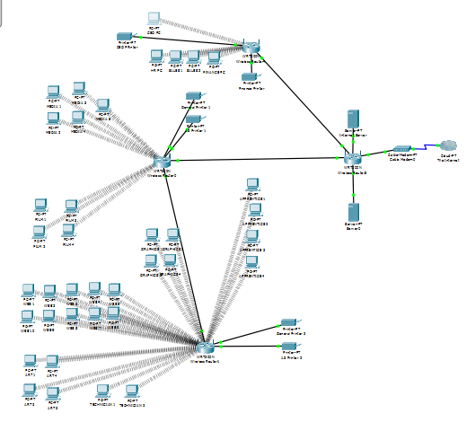
The whole network is displayed here. Each floor of the company has its own wireless network routers. Each of the routers are 'hard wired' to the 'primary' router, which connect the network together and links the network to the internet.
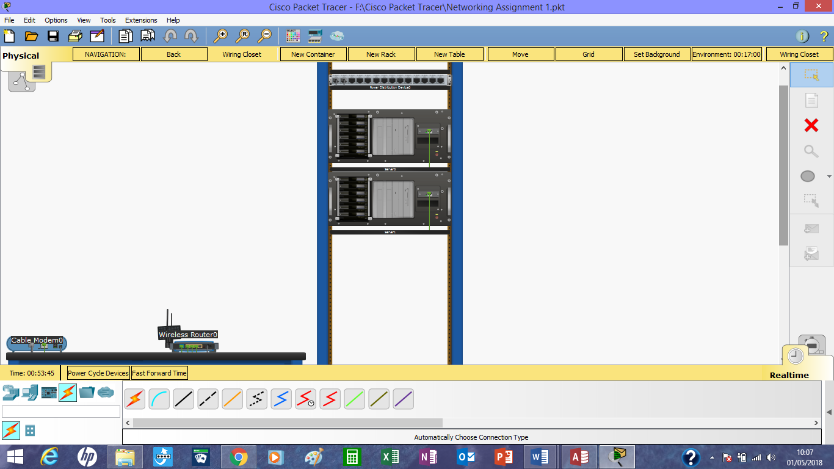
The primary server room is based on the 1st floor, It houses the servers and the primary router, in addition to the 1st floor router. I also have added a router in my program, however this is representative as modern routers have a modem as part of the package.

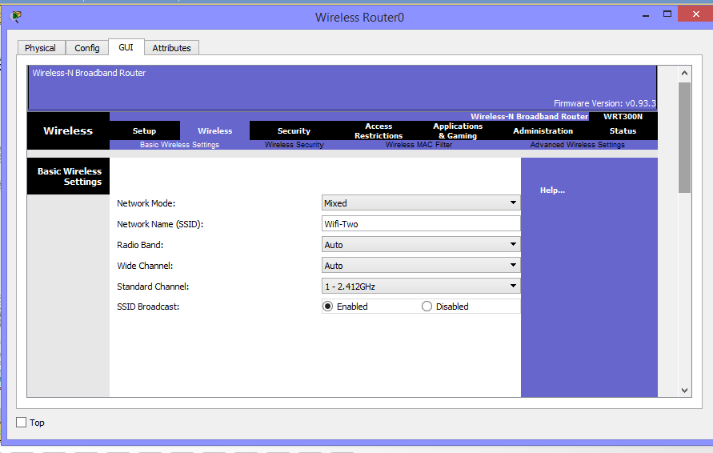
Each of the floor router have been given their own name, this is to provide wireless coverage to each floor.
Each PC and device has been allocated it own IP address.
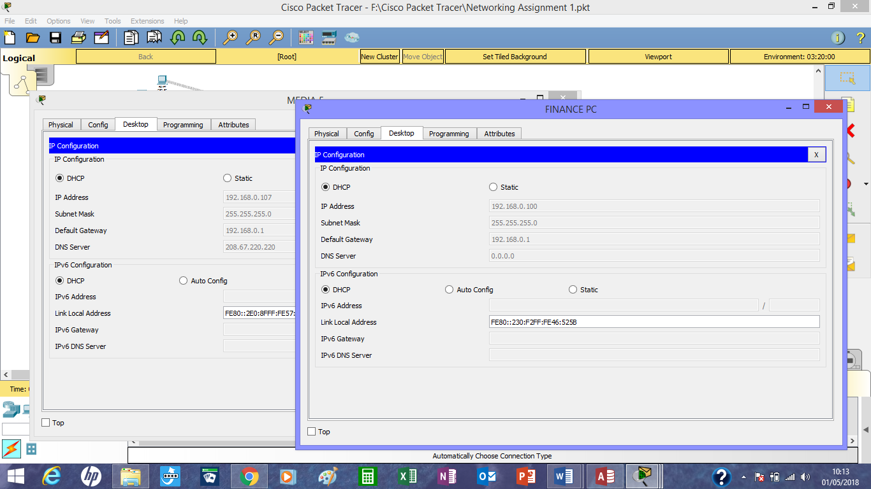
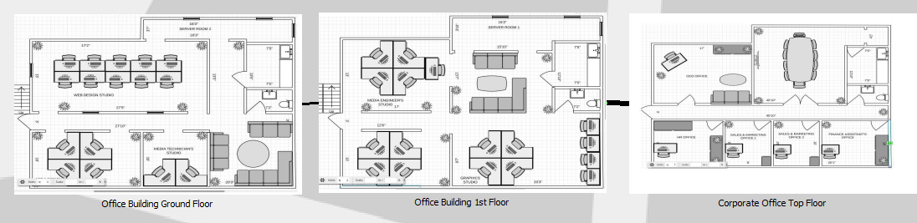
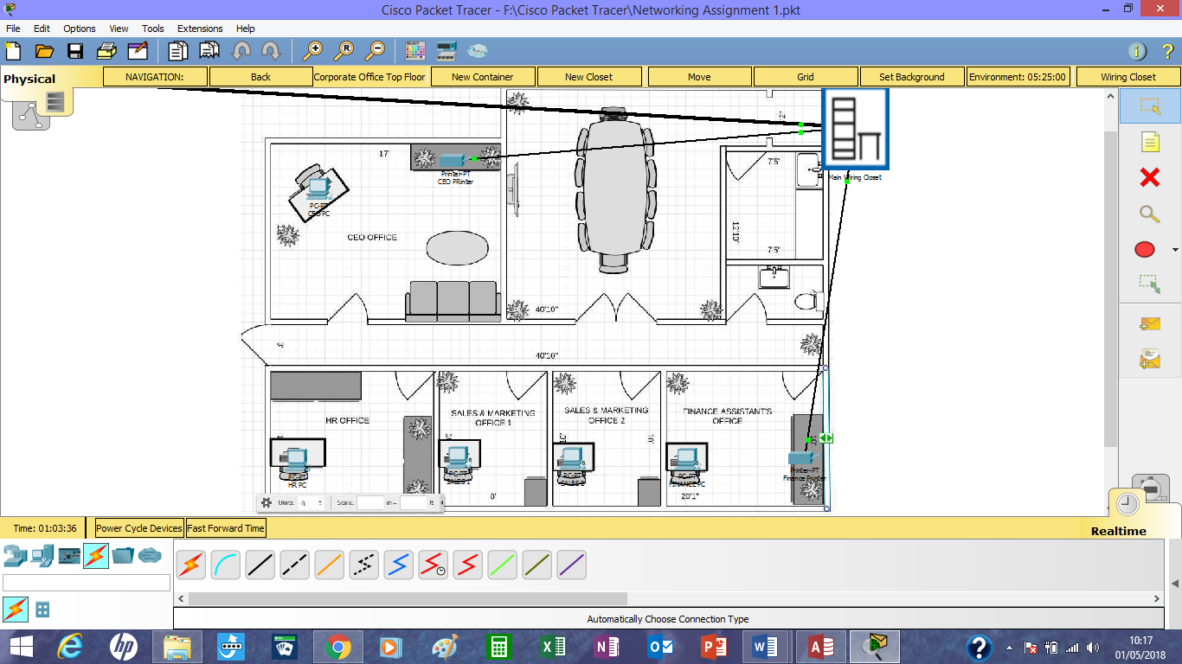
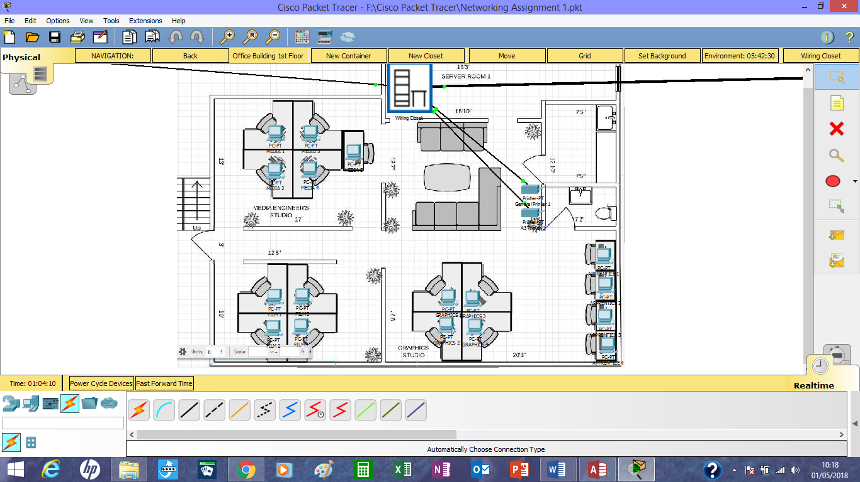
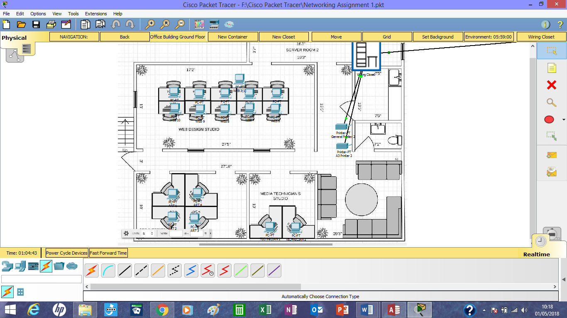

References

- https://www.pcspecialist.co.uk/computers/intel-home-office-pc/
- https://softwaregeeks.co.uk/product/windows-10-pro/?gclid=EAIaIQobChMIi7fwxuul2QIVFhMbCh0W_AU9EAQYASABEgKbofD_BwE
- https://www.wdc.com/en-gb/products/network-attached-storage/my-cloud-pr4100.html?gclid=Cj0KCQiAiKrUBRD6ARIsADS2OLlgMlxXNma6vAm9-Odwj0aqX5NTYKkfLfH69fco9jbfoQ9CpRS5k04aAgSGEALw_wcB#WDBNFA0240KBK-EESN
- Data network installation company - http://thegooditcompany.co.uk/network-installations?gclid=Cj0KCQjw_ODWBRCTARIsAE2_EvX_SQWFl7iAFEMgcd3mazcyfzhZa6oDbcmDM0j0y33NJKVxlnGyYPcaAsBKEALw_wcB
- How business servers work - http://smallbusiness.chron.com/business-server-work-15394.html
- RAID software - https://www.easeus.com/backup-utility/free-raid-backup-software.html
- Storage space - https://docs.microsoft.com/en-us/windows-server/storage/storage-spaces/storage-spaces-direct-hardware-requirements
- Cause of Network Lag - https://www.lifewire.com/lag-on-computer-networks-and-online-817370
- A3 Printer - https://www.printerland.co.uk/Epson-WorkForce-WF-7710DWF-P140023.aspx
- Industrial printer - https://devilprinters.co.uk/brother-print-only-a4-devices-mono-inkjet/349-brother-hl-s7000dn-a4-mono-inkjet-printer-4977766710916.html?utm_campaign=PS_mod&utm_source=DP_shop&utm_medium=G_merchant&gclid=Cj0KCQjw_ODWBRCTARIsAE2_EvUQKDyQW8McmfUrzvQjmYncUl_G6aWigjsOd4ypS6JfEQAheVBhhnkaAuGjEALw_wcB
- TV - https://www.currys.co.uk/gbuk/tv-and-home-entertainment/televisions/televisions/jvc-lt-32c672-32-smart-led-tv-10167269-pdt.html
- Firewalls - https://www.comodo.com/resources/home/how-firewalls-work.php
- Free Firewall Download - https://www.manageengine.com/products/firewall/?gclid=Cj0KCQjw_ODWBRCTARIsAE2_EvVB13GIl0MqLpVP5Mwg8NjsAfaiMaxmH40LNWkHbqgGa1gOCrdLsMYaAgfTEALw_wcB
- Norton Security Package - https://uk.norton.com/products/affiliate-global?SID=adc3fcf9-3b75-4f74-a5a3-c9bf31f56962&API1=100&API2=7555837&cjid=7555837
- Webcams - https://www.onedirect.co.uk/logitech/logitech-c270-hd-webcam?fee=7&fep=97988&gclid=Cj0KCQjw_ODWBRCTARIsAE2_EvU8M4_eFLm2OMr6gcGwyXuu-AFklLNYStiNhf7Jgs4F8teBkG_TVb8aAr87EALw_wcB
- Headsets - https://www.onedirect.co.uk/sennheiser/sennheiser-pc-2-chat-lightweight-headset?fee=7&fep=101124&gclid=Cj0KCQjw_ODWBRCTARIsAE2_EvUpmxQ8SUItk92xoI8UMdYCxeg51-oNvbm2rP6CZc4MMJfOtjtdsCYaAhmKEALw_wcB
- Category 6a Article - http://incovo.com/blog/benefits-using-cat-6-cable-instead-cat-5
- Cat6a Cable supply - https://www.cablemonkey.co.uk/56-cat6a-bulk-cable?gclid=CjwKCAjwoKDXBRAAEiwA4xnqv8HHusA0RK7D7sNBgFZPDqQ9DdeeEFOa42hwSbUiz5gWZhYc0WutBRoC5ksQAvD_BwE
- Office 365 - https://www.microsoft.com/en-gb/store/b/office?invsrc=search&cl_vend=google&cl_ch=sem&cl_camp=973816521&cl_adg=52087093801&cl_crtv=255821491595&cl_kw=office%20365%20buy&cl_pub=google.com&cl_place=&cl_dvt=c&cl_pos=1t1&cl_mt=e&cl_gtid=aud-378135853147:kwd-300769532778&cl_pltr=&cl_dim0=WlYw5QAAAaSh_lCY:20180503162524:s&OCID=AID695748_SEM_WlYw5QAAAaSh_lCY:20180503162524:s&s_kwcid=AL!4249!3!255821491595!e!!g!!office%20365%20buy&ef_id=WlYw5QAAAaSh_lCY:20180503162524:s&activetab=tab:homeorpersonal

Appendices

Appendix 1 – Specs: CEO

Server/PC/MAC Specification identification form

Appendix 1.1
Job Role: | CEO
Location: | CEO Office
Component | Recommendation
Processor:  (Manufacturer, Model, Speed) | Intel Core i3 Duel-Core Processer i3-7300 (4GHz) 4MB Cashe
Memory:  (Type, Amount) | 8GB Corsair Vengeance DDR4
Hard Drive:  (Type, Capacity) | 120GB SSD
CD-ROM/DVD:  (Read, Read/Write, Speed) | 24x Duel Layer DVD Writer (+/-R)(+/-RW)(RAM)
USB Ports:  (Number, Location) | 2x USB 3, 2x USB 2 @ BACK  2x USB 3 @ FRONT
Video Card:  (Manufacturer, Model, Video RAM) | 1GB Nvidia Geforce GT 730-DVI, HDMI, VGA
Sound Card:  (Manufacturer, Model) | Creative Sound Blaster, Audigy XF OEM
Modem:
(Internal/External, Speed, Standard)
Network Card(s):  (Ethernet: speed, Wireless, Standard) | Wireless 802.11 AC1900 1,300Mbps/5GHz 600Mbps/2.4GHz PCI-E
Operating System:  (Manufacturer, Version, Compatibility) | Microsoft Windows 10
Monitor:  (Size, Resolution, Refresh Rate) | 23" Widescreen 1920x1080 DP, HDMI
Printer:  (Manufacturer, Model, Type, Speed) | N/A
Speakers:  (Manufacturer, Model, Type) | N/A
Internet Connection:  (USB, Ethernet, Wireless) | Wireless
Source https://www.pcspecialist.co.uk/computers/intel-home-office-pc/
https://softwaregeeks.co.uk/product/windows-10-pro/?gclid=EAIaIQobChMIi7fwxuul2QIVFhMbCh0W_AU9EAQYASABEgKbofD_BwE
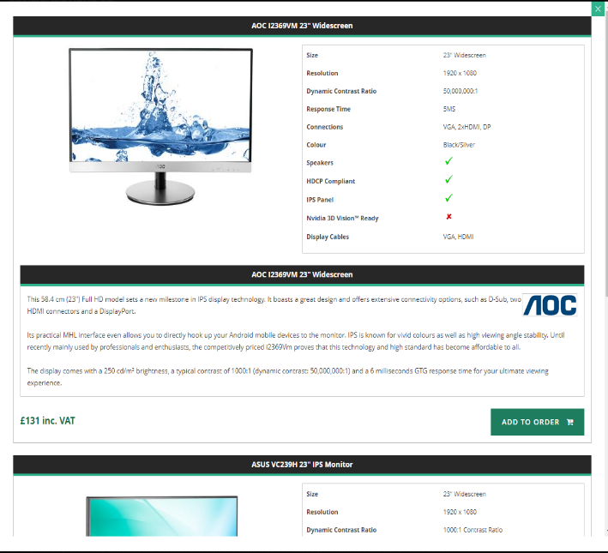
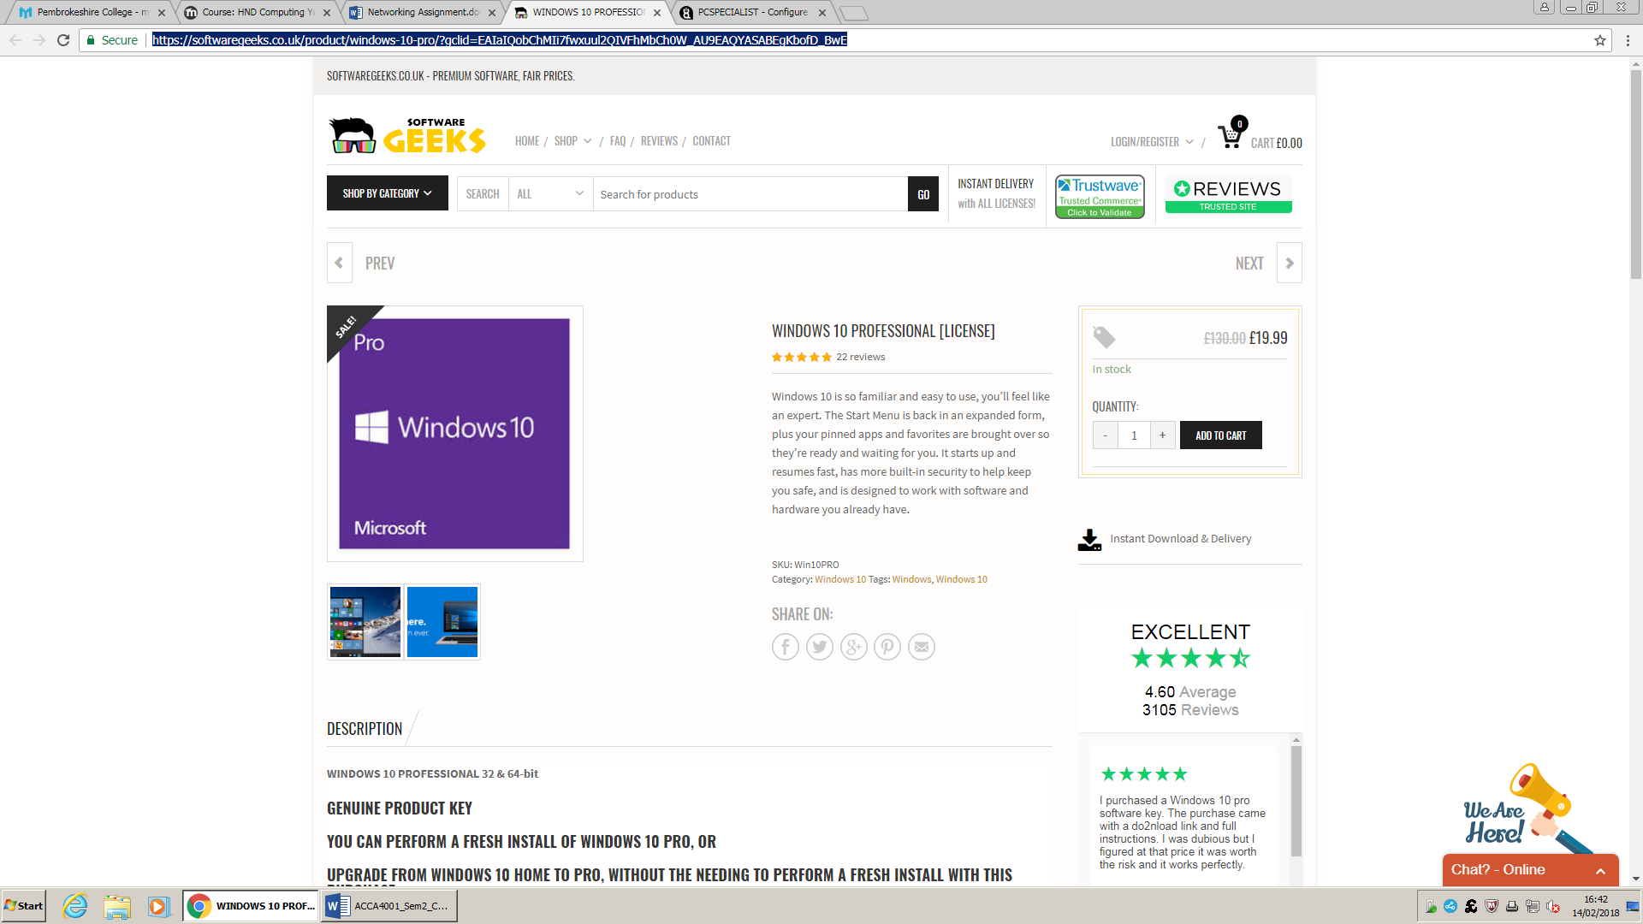

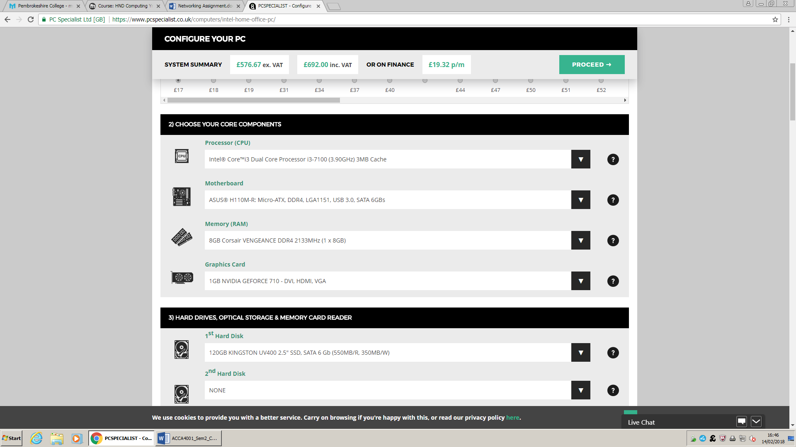

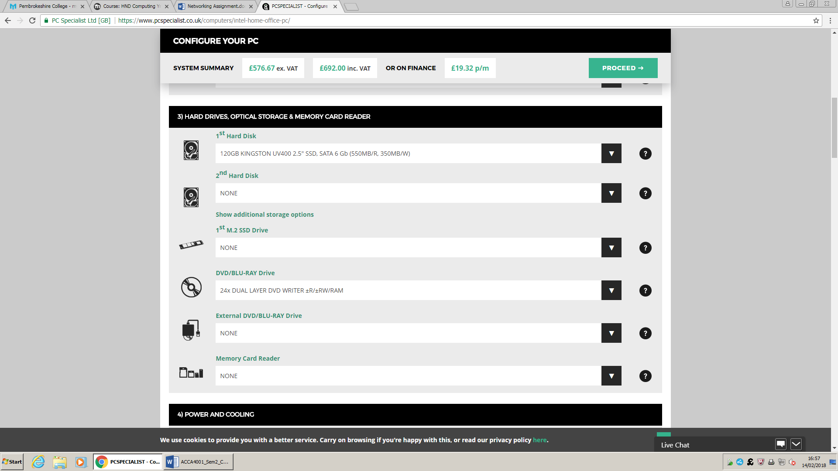

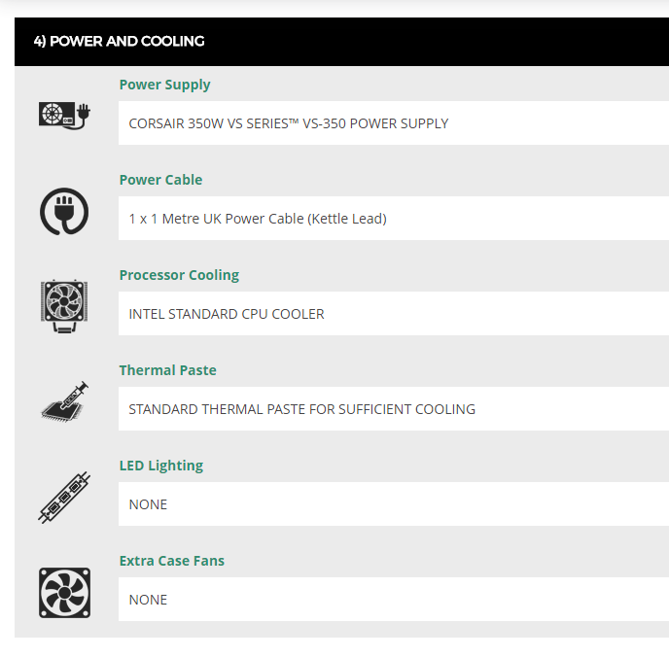
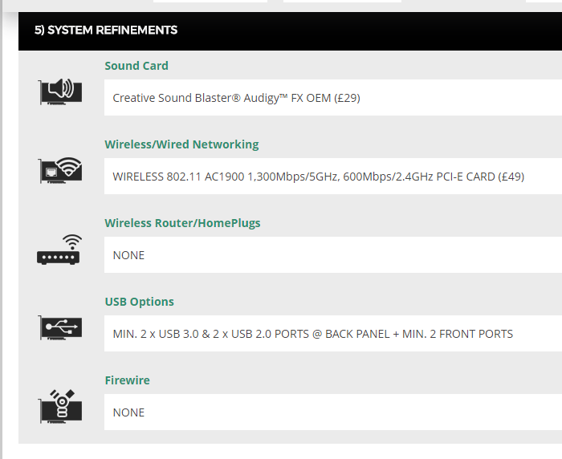
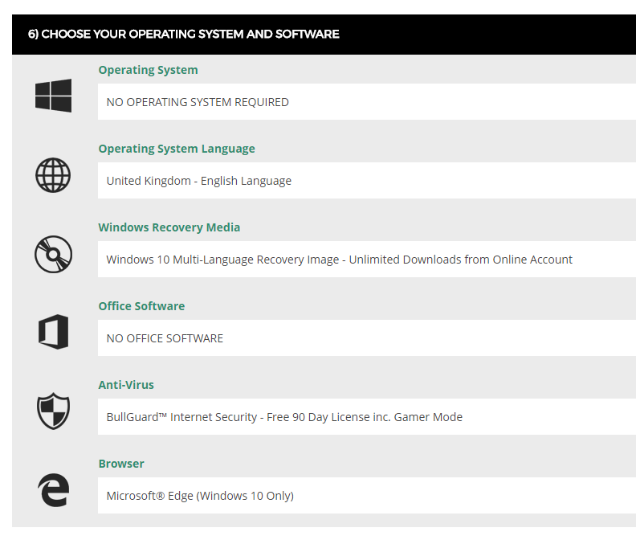
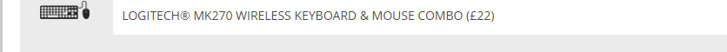
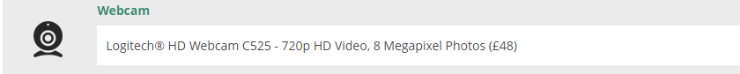

Appendix 1.2 – Specs: HR, Sales & Finance
Job Role: | HR, Finance & Sales
Location: | HR, Finance & Sales Offices
Component | Recommendation
Processor:  (Manufacturer, Model, Speed) | Intel Pentium duel-core G4400 3.30GHz, 3MB Cashe
Memory:  (Type, Amount) | 4GB Corsair Vengeance DDR4
Hard Drive:  (Type, Capacity) | 120GB SSD
CD-ROM/DVD:  (Read, Read/Write, Speed) | None
USB Ports:  (Number, Location) | 2x USB 3, 2x USB 2 @ BACK  2x USB 3 @ FRONT
Video Card:  (Manufacturer, Model, Video RAM) | Intergrated HD Graphics
Sound Card:  (Manufacturer, Model) | Onboard 6Channel (5.1) High Def Audio
Modem:
(Internal/External, Speed, Standard)
Network Card(s):  (Ethernet: speed, Wireless, Standard) | Wireless 802.11 AC1900 1,300Mbps/5GHz 600Mbps/2.4GHz PCI-E
Operating System:  (Manufacturer, Version, Compatibility) | Microsoft Windows 10
Monitor:  (Size, Resolution, Refresh Rate) | 23" Widescreen 1920x1080 DP, HDMI
Printer:  (Manufacturer, Model, Type, Speed) | N/A
Speakers:  (Manufacturer, Model, Type) | N/A
Internet Connection:  (USB, Ethernet, Wireless) | Wireless

Appendix 1.3 – Specs: Film, Media Eng., Graphics, technicians & Inerns
Job Role: | Film, Media, Graphics, Art, Technicians & Interns
Location: | Offices of aforementioned
Component | Recommendation
Processor:  (Manufacturer, Model, Speed) | Intel Core I5 Quad-Core Processer i5-7400 (3GHz) 6MB Cashe
Memory:  (Type, Amount) | 16GB Corsair Vengeance DDR4
Hard Drive:  (Type, Capacity) | 120GB SSD
CD-ROM/DVD:  (Read, Read/Write, Speed) | None
USB Ports:  (Number, Location) | 2x USB 3, 2x USB 2 @ BACK  2x USB 3 @ FRONT
Video Card:  (Manufacturer, Model, Video RAM) | 6GB Nvidia Geforce GT 1060-DVI, HDMI, 3x DP VR Ready
Sound Card:  (Manufacturer, Model) | Asus Xonar DGX 5.1
Modem:
(Internal/External, Speed, Standard)
Network Card(s):  (Ethernet: speed, Wireless, Standard) | Wireless 802.11 AC1900 1,300Mbps/5GHz 600Mbps/2.4GHz PCI-E
Operating System:  (Manufacturer, Version, Compatibility) | Microsoft Windows 10
Monitor:  (Size, Resolution, Refresh Rate) | 23" Widescreen 1920x1080 DP, HDMI
Printer:  (Manufacturer, Model, Type, Speed) | N/A
Speakers:  (Manufacturer, Model, Type) | N/A
Internet Connection:  (USB, Ethernet, Wireless) | Wireless

Appendix 1.4 – Specs: Web-Design
Job Role: | Web Designers
Location: | Web Office
Component | Recommendation
Processor:  (Manufacturer, Model, Speed) | Intel Core i3 Duel-Core Processer i3-7100 (3.90GHz) 3MB Cashe
Memory:  (Type, Amount) | 8GB Corsair Vengeance DDR4
Hard Drive:  (Type, Capacity) | 120GB SSD
CD-ROM/DVD:
(Read, Read/Write, Speed)
USB Ports:  (Number, Location) | 2x USB 3, 2x USB 2 @ BACK  2x USB 3 @ FRONT
Video Card:  (Manufacturer, Model, Video RAM) | 1GB Nvidia Geforce GT 730-DVI, HDMI, VGA
Sound Card:  (Manufacturer, Model) | Creative Sound Blaster, Audigy XF OEM
Modem:
(Internal/External, Speed, Standard)
Network Card(s):  (Ethernet: speed, Wireless, Standard) | Wireless 802.11 AC1900 1,300Mbps/5GHz 600Mbps/2.4GHz PCI-E
Operating System:  (Manufacturer, Version, Compatibility) | Microsoft Windows 10
Monitor:  (Size, Resolution, Refresh Rate) | 23" Widescreen 1920x1080 DP, HDMI
Printer:  (Manufacturer, Model, Type, Speed) | N/A
Speakers:  (Manufacturer, Model, Type) | N/A
Internet Connection:  (USB, Ethernet, Wireless) | Wireless

Appendix 2 – Network Specifications
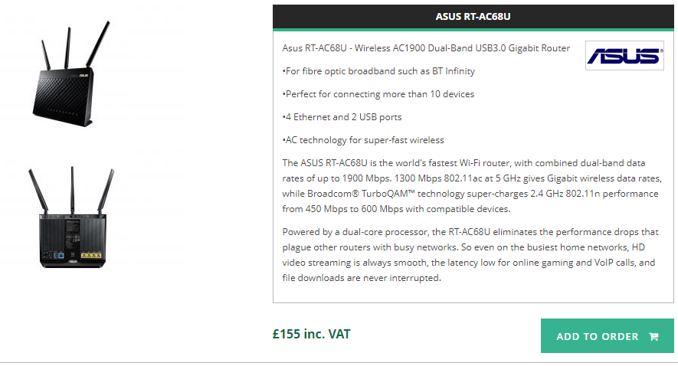
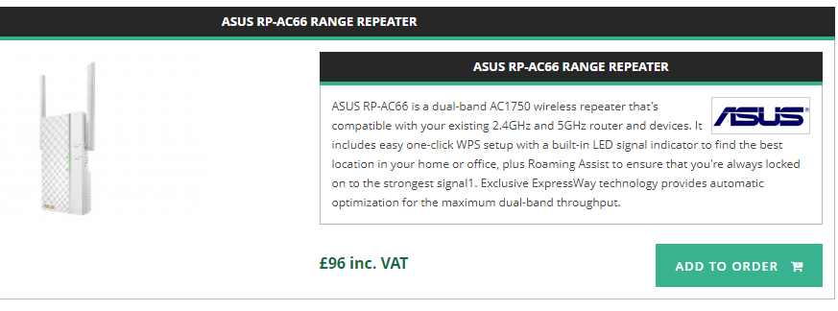

Appendix 3 - Servers
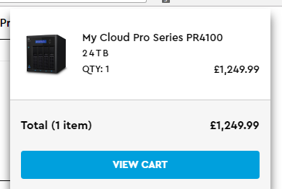

Source https://www.wdc.com/en-gb/products/network-attached-storage/my-cloud-pr4100.html?gclid=Cj0KCQiAiKrUBRD6ARIsADS2OLlgMlxXNma6vAm9-Odwj0aqX5NTYKkfLfH69fco9jbfoQ9CpRS5k04aAgSGEALw_wcB#WDBNFA0240KBK-EESN

Appendix 4 – Windows 10
https://softwaregeeks.co.uk/product/windows-10-pro/?gclid=Cj0KCQjw_ODWBRCTARIsAE2_EvU7s0SKP4519OHYZL8qQgJLcX2s_j-3WIbk_xDyDutexzbnUEo3cTUaAuQoEALw_wcB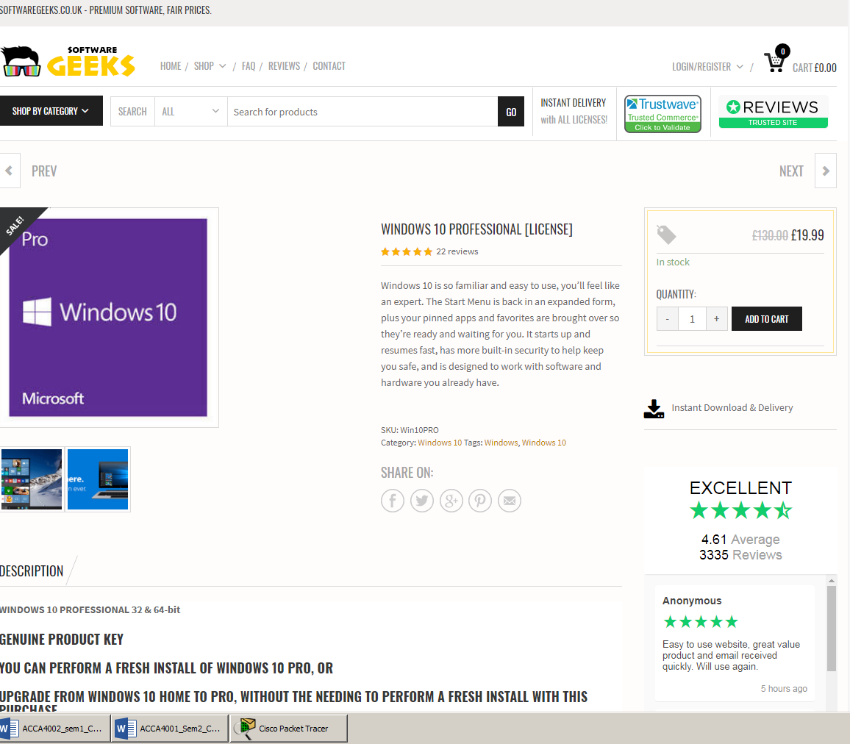

Appendix 5.1 - Printers
https://www.printerland.co.uk/Epson-WorkForce-WF-7710DWF-P140023.aspx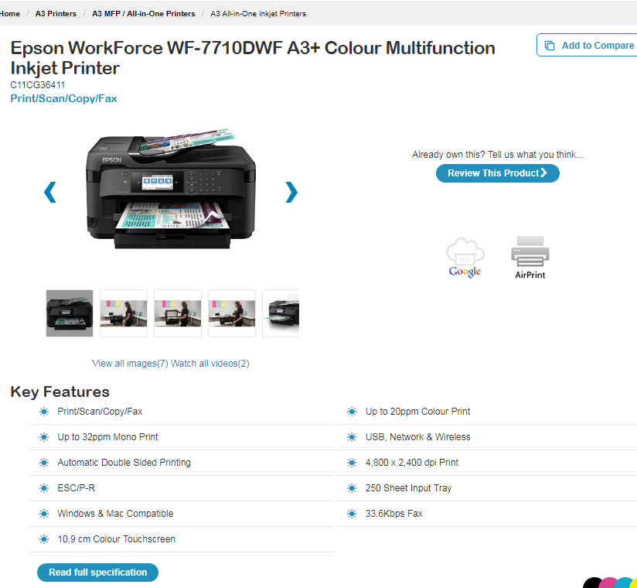

Appendix 5.2 - Printer
https://devilprinters.co.uk/brother-print-only-a4-devices-mono-inkjet/349-brother-hl-s7000dn-a4-mono-inkjet-printer-4977766710916.html?utm_campaign=PS_mod&utm_source=DP_shop&utm_medium=G_merchant&gclid=Cj0KCQjw_ODWBRCTARIsAE2_EvUQKDyQW8McmfUrzvQjmYncUl_G6aWigjsOd4ypS6JfEQAheVBhhnkaAuGjEALw_wcB
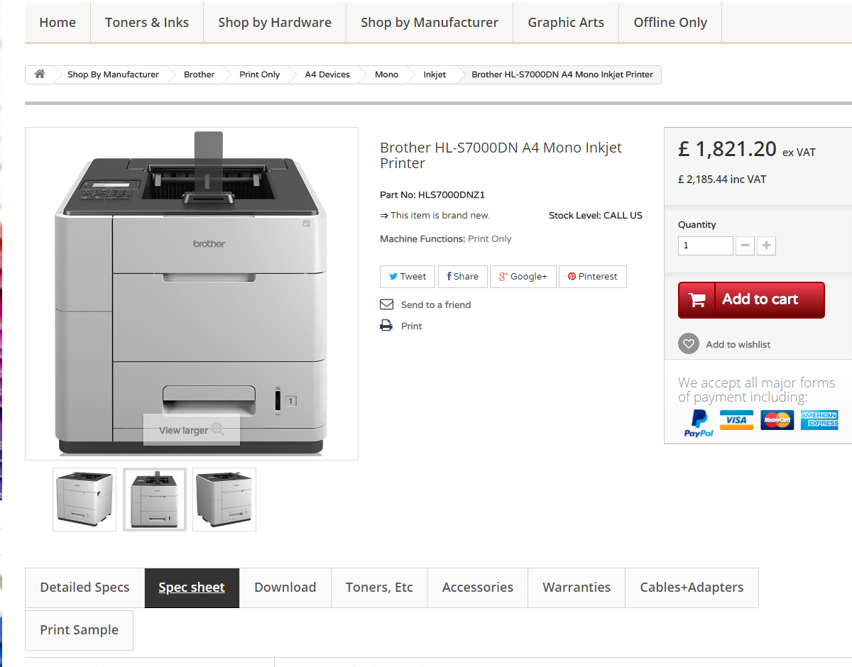

Appendix 6 – TV
https://www.currys.co.uk/gbuk/tv-and-home-entertainment/televisions/televisions/jvc-lt-32c672-32-smart-led-tv-10167269-pdt.html
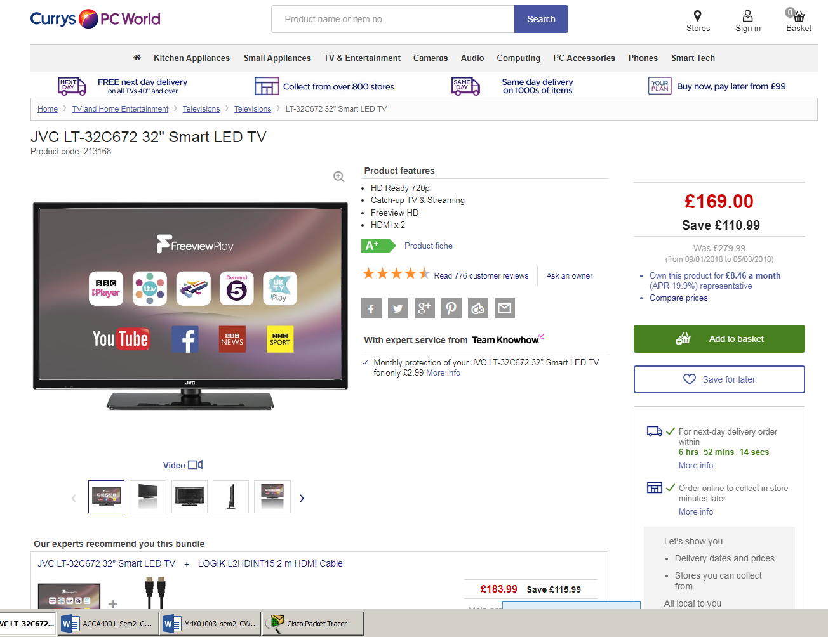

Appendix 7 – Security
https://uk.norton.com/products/affiliate-global?SID=adc3fcf9-3b75-4f74-a5a3-c9bf31f56962&API1=100&API2=7555837&cjid=7555837
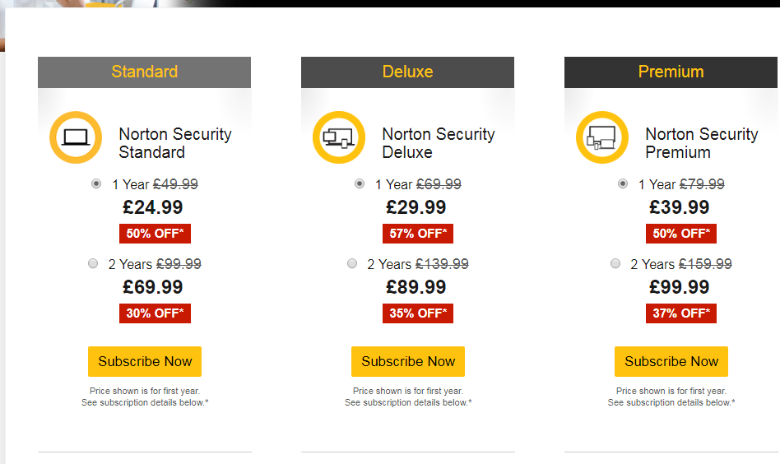

Appendix 8.1 - VOI Webcams
https://www.onedirect.co.uk/logitech/logitech-c270-hd-webcam?fee=7&fep=97988&gclid=Cj0KCQjw_ODWBRCTARIsAE2_EvU8M4_eFLm2OMr6gcGwyXuu-AFklLNYStiNhf7Jgs4F8teBkG_TVb8aAr87EALw_wcB
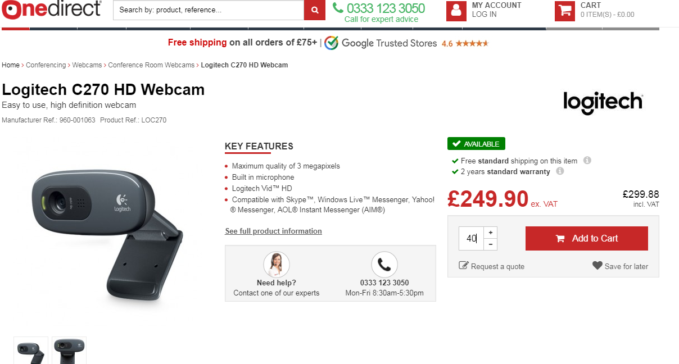

Appendix 8.2 - Speakers
https://www.onedirect.co.uk/sennheiser/sennheiser-pc-2-chat-lightweight-headset?fee=7&fep=101124&gclid=Cj0KCQjw_ODWBRCTARIsAE2_EvUpmxQ8SUItk92xoI8UMdYCxeg51-oNvbm2rP6CZc4MMJfOtjtdsCYaAhmKEALw_wcB
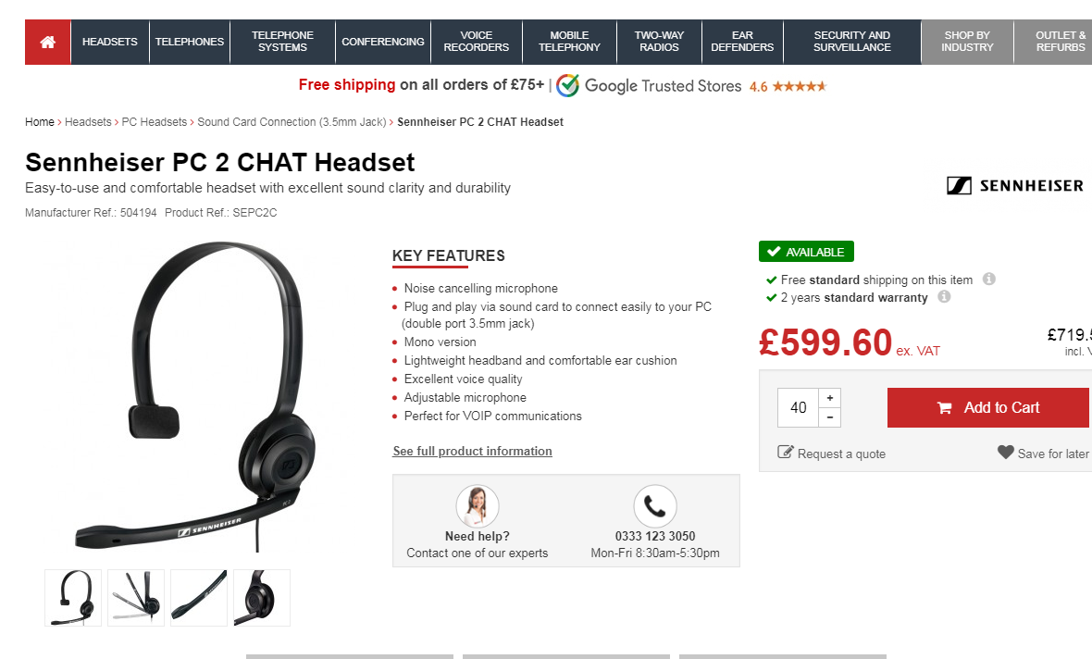

Appendix 9 – Ethernet Cable, Category 6a
https://www.cablemonkey.co.uk/56-cat6a-bulk-cable?gclid=CjwKCAjwoKDXBRAAEiwA4xnqv8HHusA0RK7D7sNBgFZPDqQ9DdeeEFOa42hwSbUiz5gWZhYc0WutBRoC5ksQAvD_BwE

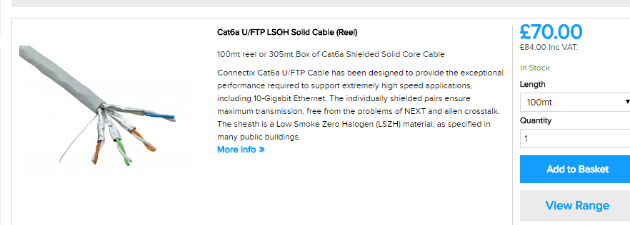

Appendix 10 – Office 365
Source: https://www.microsoft.com/en-gb/store/b/office?invsrc=search&cl_vend=google&cl_ch=sem&cl_camp=973816521&cl_adg=52087093801&cl_crtv=255821491595&cl_kw=office%20365%20buy&cl_pub=google.com&cl_place=&cl_dvt=c&cl_pos=1t1&cl_mt=e&cl_gtid=aud-378135853147:kwd-300769532778&cl_pltr=&cl_dim0=WlYw5QAAAaSh_lCY:20180503162524:s&OCID=AID695748_SEM_WlYw5QAAAaSh_lCY:20180503162524:s&s_kwcid=AL!4249!3!255821491595!e!!g!!office%20365%20buy&ef_id=WlYw5QAAAaSh_lCY:20180503162524:s&activetab=tab:homeorpersonal


