Tyler The Creator and his brands
Golf Wang and Golf Le Fleur

By: Te'shawn Biggs

The University of Wales Trinity Saint David

SID:2222492

Who is Tyler, The Creator?

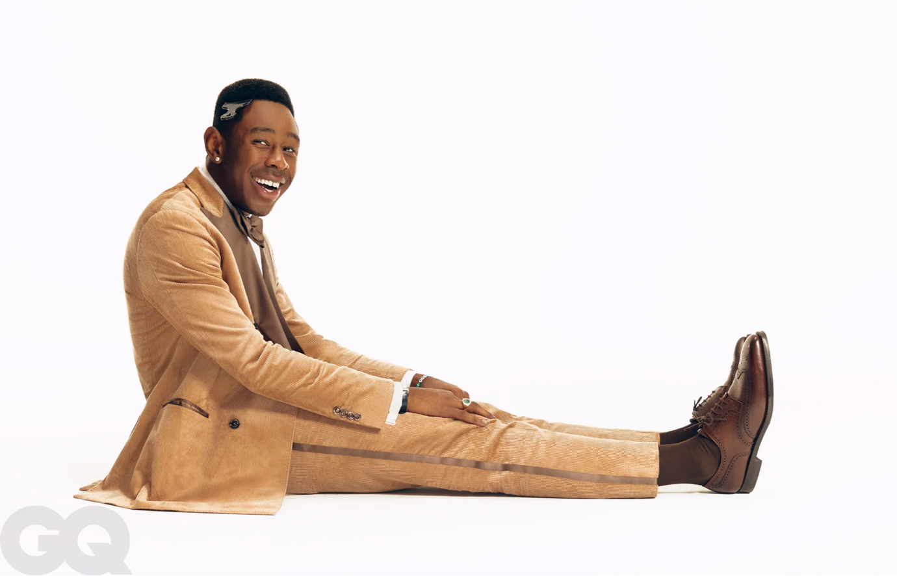
- Tyler the Creator is a rapper, producer, and fashion designer from California, USA. He was born on Mar 6, 1991, and is best known as the founder of the alternative hip-hop collective Odd Future and the clothing brand Golf Wang[ Ref 1.]. Tyler first rose to prominence in the early 2010s with his music and has since become one of the most influential and innovative figures in hip-hop and popular culture(Fig1). Tyler has won two Grammy Awards, three BET Hip Hop Awards, a BRIT Award, and a MTV Video Music Award.

Figure 1. Shows Tyler, The Creator in a photo shoot for GQ Magazine.

As a rapper, Tyler is known for his inventive and often controversial lyrics and innovative production style, incorporating elements of punk, alternative rock, and other genres. He has released multiple critically acclaimed albums, including "Goblin," "Wolf," and "Igor."[Ref 2]

In addition to his work in music, Tyler has also made a significant impact in the fashion world. He founded Golf Wang in 2011 as a clothing brand offering a bold and distinctive alternative to more mainstream fashion brands [Ref 3]. The brand has since grown into a full-fledged lifestyle brand, offering a range of products and accessories, and has become one of the most influential and respected names in the fashion world.

Overall, Tyler the Creator is an artist, designer, and entrepreneur who has significantly impacted popular culture and continues pushing the boundaries of what is possible in music, fashion, and beyond.

What is GOLF WANG?

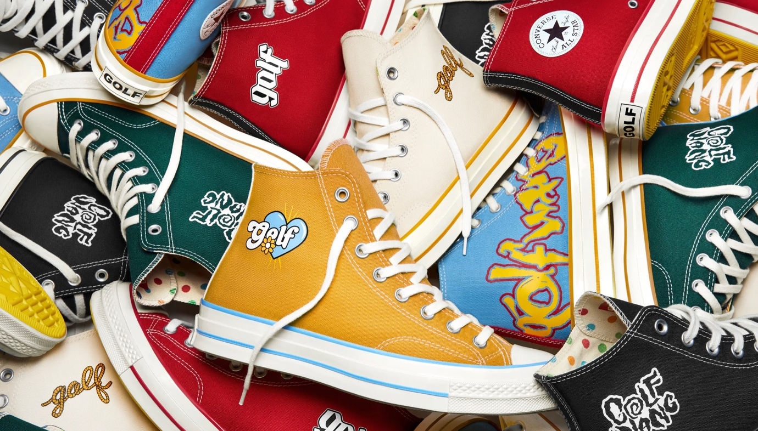
GOLF WANG is a clothing brand founded by American rapper Tyler, The Creator. The brand was first introduced in 2011 and is known for its bold and colourful designs that often feature graphic tees, hoodies, and jackets[Ref 3]. The brand also includes accessories such as sunglasses, hats, and shoes. The name GOLF WANG is a play on the word "wolf", which is Tyler, The Creator's nickname and "GOLF" is derived from his Love for the sport of Golf. The brand is closely associated with Tyler, The Creator's music and has a strong fanbase among his fans. It is not a publicly traded company, but it is possible to purchase products through its website and select retailers.

Figure 2. Golf Wang Collaboration with Sneaker brand Converse

What is Golf Le Fleur?

Golf Le Fleur is a subsidiary brand of the clothing line Golf Wang, created by American rapper Tyler, The Creator. Golf Le Fleur began as a sneaker collaboration between Tyler, The Creator and Converse in 2017. The initial line featured a colourful and playful design with floral motifs and the signature Golf Le Fleur logo on the side of the shoe. The collaboration was successful, and the two companies continued to work together, releasing new sneaker designs in subsequent years.

Following the success of the sneaker line, Golf Le Fleur expanded into a full clothing line, offering luxury T-shirts, hoodies, jackets, luxury Leather luggage, perfumes and nail polish. The clothing line features similar colourful and playful designs, often incorporating floral prints and bold colour combinations. The brand's aesthetic is often described as a mix of skate-wear and high fashion, focusing on bold graphics and unique designs.

Golf Le Fleur has gained a dedicated following among fans of Tyler, The Creator and streetwear enthusiasts. The brand has also become known for its limited-edition releases, which often sell out quickly and have become highly sought after by collectors.

Business analysis Golf Wang/ Golf Le Fleur

A business analysis of Golf Wang/ Golf Le Fleur would involve evaluating various aspects of the company, such as its products, target market, marketing strategy, financial performance, and competition.

In terms of products, Golf Wang/ Golf Le Fleur offers a wide range of clothing and accessories, primarily streetwear and fashion. The brand is known for its bold, colourful designs and often features graphic tees, hoodies, and jackets. The brand is heavily influenced by Tyler, The Creator's style and is strongly associated with his music and fans.

The target market for Golf Wang/ Golf Le Fleur is primarily young adults up to middle aged people from the ages of 18-34(Ref 16) (Fig 3). Who particularly are fans of Tyler, The Creator and his music. The brand has a solid social media presence, which helps it connect with its target market and build a community of fans around its products.

Golf Wang/Golf Le Fleur's marketing strategy is heavily influenced by Tyler, The Creator's personal brand. The company has used various forms of content, such as music videos and social media posts, to market its products. The brand also sponsors events and collaborations to keep its name in the public eye(Fig 3).
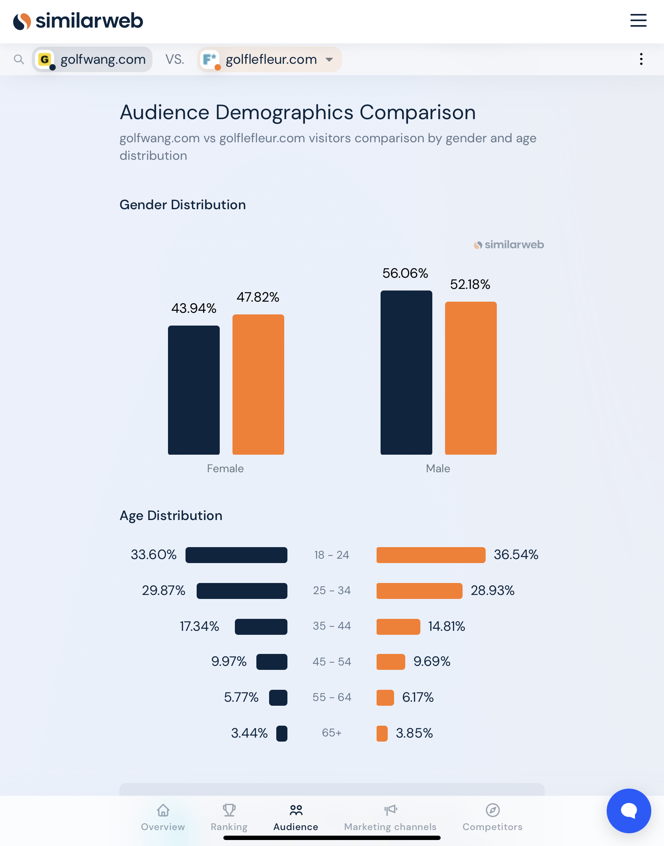
Fig 3. Shows Age Distribution for Golf Wang/Golf Le Fleur

As for financial performance, as it is not a publically traded company, specific financials are not available. Though it is was found that Golf wang grossed anywhere between 25-50 million dollars between September 2019- October 2020(Ref 16). Nevertheless, it is known that the brand gained traction and popularity with its fanbase through Tyler, The Creator's musical journey(we're talking more than one grammy award and other music awards successful), which is why it is easy to assume that the business is doing well.

In terms of competition, Golf Wang/ Golf Le Fleur competes with other streetwear and fashion brands. Some of the notable competitors are Supreme, BAPE, Off-White, and PALACE. The brand differentiates itself by strongly associating with Tyler, The Creator's personal fashion sense/brand, which helps it stand out in the crowded streetwear market. Especially to his cult-like fan base who look up to him.

Swat Analysis – Golf Wang/ Golf Le Fleur

A SWOT (Strengths, Weaknesses, Opportunities, and Threats) analysis of GOLF WANG would involve evaluating the brand's internal and external factors that can impact its performance. Here is a basic overview of the SWOT analysis:

Strengths:
Strong association with Tyler, The Creator's personal brand
Unique and bold designs
Strong social media presence and community of fans
Collaborations with other brands and musicians
Strong reputation among streetwear enthusiasts

Weaknesses:
Limited distribution channels (primarily online and select retailers)
Heavy reliance on Tyler, The Creator's personal brand
Limited international exposure

Opportunities:
Expansion into international markets
Development of an e-commerce platform
Expanding product line to include more fashion items
Sponsorship and collaboration opportunities

Threats:
Growing competition from other streetwear brands
Changes in fashion trends
Economic downturns that could negatively impact consumer spending
Tyler, The Creator's brand could become less popular

This analysis is just a starting point, and it is essential to note that the real-world performance of a company can be affected by multiple factors. This is also based on the limited information available about the company as it is not public.

How are collaborations with other brands good for Tyler the Creator and Golf Wang/ Golf Le Fleur?

Increased exposure: By collaborating with other brands, Golf Wang/ Golf Le Fleur has tapped into new customer bases that may not have otherwise been reached. For example, if Golf Wang/ Golf Le Fleur collaborates with a well-known sportswear brand like adidas, it can reach a new audience of sports enthusiasts and fitness fans. This can help to increase the visibility and popularity of Golf Wang/ Golf Le Fleur products and services. An example of this is Kanye West with his Yeezy collection with adidas or Micheal Jordan with his Air Jordan imprint at Nike.

Access to new resources: Collaborating with other brands can also provide Golf Wang/ Golf Le Fleur with access to new resources, such as production facilities, marketing expertise, and distribution networks. For example, if Golf Wang/ Golf Le Fleur collaborates with a well-established fashion brand, it can benefit from its manufacturing, marketing, and distribution expertise. This can help to improve the quality and reach of Golf Wang/ Golf Le Fleur products and services. For example if Tyler The Creator collaborated with Louis Vuitton or Hermes it could potentially gain access to there leather goods manufacture. Connections like this will save him money on materials, manufacturing costs etc.

Building relationships: Collaborating with other brands can also help to build relationships with key players in the fashion industry. This can be valuable for future business opportunities and partnerships. For example, if Golf Wang/ Golf Le Fleur collaborates with a well-known celebrity, it can benefit from the endorsement and further increase its visibility by tapping into their fanbase. This is crucial because Celebrity endorsements have a direct bearing on customer-based brand equity (Ref 9)

Cross-promotion: Collaborating with other brands can also help to cross-promote each other's products and services. For example, if Golf Wang/ Golf Le Fleur collaborates with a sportswear brand, it can promote Golf Wang/ Golf Le Fleur products to its customer base, and Golf Wang/ Golf Le Fleur can promote the sportswear brand to its customer base. This can help to increase visibility and sales for both brands. An example of this is how Virgil Abloh collaborated with Louis Vuitton for his personal brand off white. Doing this eventually resulted in not only Louis Vuitton buying the brand but people associating Off White with Louis Vuitton itself, thus putting it in the luxury brand category (Ref 10).

Enhanced creativity: Collaborating with other brands can lead to new creative partnerships and ideas. For example, if Golf Wang/ Golf Le Fleur collaborates with an artist like Takashi Murakami (who is famous for creating paintings, sculptures, and films populated by repeated motifs and mutating characters of his own creation. His wide-ranging work embodies an intersection of pop culture, history, and fine art.) (Ref17), it can lead to new designs and creative projects that can help to keep the brand fresh and innovative.

Collaborations with other brands

This section will separate Golf Wang and Golf Le Fleur because they are separate entities. Even though Golf Le Fleur is a subsidiary of Golf Wang, it is classed as the brand's luxury line and is tailored slightly to the top few per cent of Tyler, The Creators supporters.

GOLF WANG

GOLF WANG has done several collaborations/ J.V’s with other brands over the years, including:

GOLF x Vans: A collaboration with Vans for a limited-edition shoe collection that included shoes designed by Tyler, The Creator and other GOLF team members. [Ref 3]

GOLF x Converse: A collaboration with Converse for a limited-edition shoe collection.[Ref 3]

GOLF x HUF: A collaboration with HUF for a limited-edition shoe collection

GOLF x Emotionally Unavailable: A collaboration with streetwear label Emotionally Unavailable for a limited-edition clothing collection.
GOLF x G-Shock: A collaboration with Casio's G-Shock watch brand for a limited-edition watch collection.

GOLF x Sade: Collaborating with singer Sade for a limited-edition T-shirt collection.

GOLF x Ksubi: A collaboration with Australian denim brand Ksubi for a limited-edition clothing collection.

GOLF x Anti Social Social Club: A collaboration with streetwear brand Anti Social Social Club for a limited-edition clothing collection.

GOLF x Santa Cruz Skateboards: A collaboration with Santa Cruz Skateboards for a limited-edition skateboard deck collection

GOLF x The North Face: A collaboration with The North Face for a limited-edition clothing collection.

GOLF x Stüssy: A collaboration with streetwear brand Stüssy for a limited-edition clothing collection.

GOLF x Samuel Ross: Collaborating with designer Samuel Ross for a limited-edition clothing collection under the GOLF le Fleur* name.

These collaborations are a way for GOLF WANG to expand its reach and connect to different communities; by working with other brands, designers or musicians, GOLF WANG can expand its fanbase, which helps its brand awareness, popularity, and revenue. It is always a win-win situation for both parties.

Golf Le Fleur

Golf Le Fleur, a subsidiary of the clothing brand Golf Wang, has collaborated with several other brands and businesses over the years. Some of the notable collaborations include:

Converse: Golf Le Fleur has collaborated with Converse to create a line of Chuck Taylor sneakers featuring the Golf Le Fleur branding and unique colourways.

Vans: Golf Le Fleur has worked with Vans to create a line of shoes featuring the Golf Le Fleur logo and unique designs.

Supreme: Golf Le Fleur has collaborated with Supreme on a limited-edition clothing and accessory collection.

Ferrari: Golf Le Fleur has worked with Ferrari on a limited-edition clothing and accessory line that features the iconic Ferrari logo.

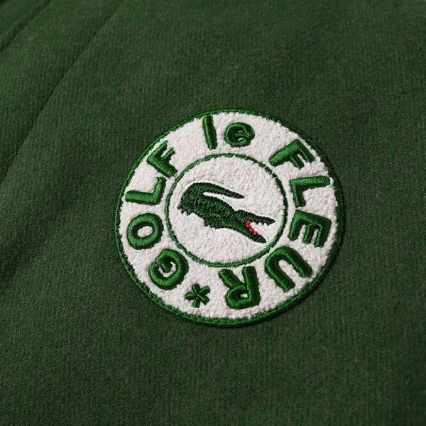
Lacoste: Golf Le Fleur has partnered with Lacoste to create a line of clothing and accessories that combines the classic Lacoste style with the bold and playful aesthetic of Golf Le Fleur.(Fig 7)
Figure 7. Shows the logo for the Golf Le Fleur and Lacoste collaboration

These collaborations have helped Golf Le Fleur reach new audiences, increase brand awareness, and offer its customers a more comprehensive range of products. By collaborating with these brands Tyler has managed to tap into these companies key supporters.

What significance do J.V. have on Tylers brands?

Access to local expertise: Since Tylers brands are relatively young collaborations with more seasoned brands has helped build relationships with local partners. Which helps gain access to local expertise and knowledge of the market. For example, a local partner may better understand local regulations, customer preferences, and cultural differences. By partnering with a local brand, Tylers brands can ensure its products and services are well-suited to the local market.

Shared resources: Through collaborations Tylers brands have access to shared resources, such as production facilities, distribution networks, and marketing expertise. By partnering with a well-established local brand, Tyler's brands can leverage the partner's resources to improve the quality and reach of its products and services. An example of this is his collaboration with Converse. By him collaborating with a major sneaker retailer/manufacturer he doesn’t have to worry about sourcing manufacturing facilities or sneaker designers because they are provided by Converse. This helps drive down costs significantly and leaves more margin for profits.

Joint marketing efforts: J.V.s can also provide opportunities for joint marketing efforts, which can help to increase brand awareness and customer loyalty. For example, a J.V. with a local partner can lead to joint promotions, advertising campaigns, and events that can help to increase visibility for both brands. (Ref 19). This is essential to gaining the most exposure for profits. Especially since Tyler, The Creator is an entertainer, he can literally do interviews promoting not only his brand but the brands he’s collaborating with. This makes his fans want to endorse the brand even more.

Reduced costs: By partnering with bigger brands Tylers brands benefited from reduced costs associated with entering new markets. Especially entering the world of sneaker manufacturing and luxury travel goods. Also by partnering with local brands or distributor, Tylers brands share the costs and risks associated with entering new markets. This can help to minimize the costs associated with launching new products and services in new markets.

Ten-year expansion plan

There are several ways Tyler, The Creator, could potentially expand his businesses Golf Wang/ Golf Le Fleur over the next ten years, such as:

International Expansion: By opening new retail locations, setting up an e-commerce platform, or partnering with local retailers in new markets, Golf Wang/ Golf Le Fleur could increase its customer base and revenue. This could include opening physical stores in major cities worldwide or establishing an online presence in new markets which is something that would help make the brands have a more global footprint. This can be seen with drakes OVO brand and The Brand Supreme. On a regular weekday, the store is packed with young streetwear aficionados who have come not just to purchase products from the label's latest drop, but also to hang out with staff and other like-minded members of the OVO tribe, which is rooted in appreciation for rap music, streetwear and contemporary art. The opening of OVO's London boutique in November 2017 drew a line of 400 people (Ref 20).

Product Line Expansion: By expanding its product line to include new fashion items such as denim, suits, and dress shoes, Golf Wang/ Golf Le Fleur could appeal to a broader range of consumers and increase its market share in the fashion industry. This could also open up new revenue streams and target new customer segments. This is something Tyler, The Creator has already started to implement with the release of his nail polish and fragrance release. This is great for targeting new customer segments because even if his supporters aren’t into or can’t afford his clothing or sneakers, they can still buy something from his line and feel like their supporting him. These non-toxic polishes are available for individual purchase at $20 each or can be purchased together in a collection for $55 (Ref 18.)

Digital Marketing: Digital marketing is becoming increasingly important, and Golf Wang/ Golf Le Fleur could invest in developing an effective digital marketing strategy that utilizes social media, search engine optimization, and other online marketing techniques. This would allow the brand to reach and engage with more customers and understand their preferences, which could help drive sales and increase brand awareness. A perfect example of this is Rhianna halftime performance. During her performance, there was a 3-4 part where she picked up a case of her fenty make up from a back up dancer. Just this small amount of advertisement for her brand drove her social media mentions up by 717%. This pushing her brands profits up by $8.1 million dollars within 12 hours (Ref 8).

Partnership and collaborations: Golf Wang/ Golf Le Fleur has an extensive history of collaborating with other brands, designers and musicians. By continuing to establish partnerships and collaborations with other brands, designers and musicians, Tylers brands could reach new audiences, increase brand awareness, and gain access to new resources, technologies and expertise that could help it to grow its business. This can be proven by simply looking at their businesses webpage analytics(Fig 4). Every time the company announces collaborates or releases collaborations with other brands the websites traffic increases substantially. This is pivotal from a financial standpoint because collaboration between the same fashion categories make up 40.3 percent in profit (Ref 11)
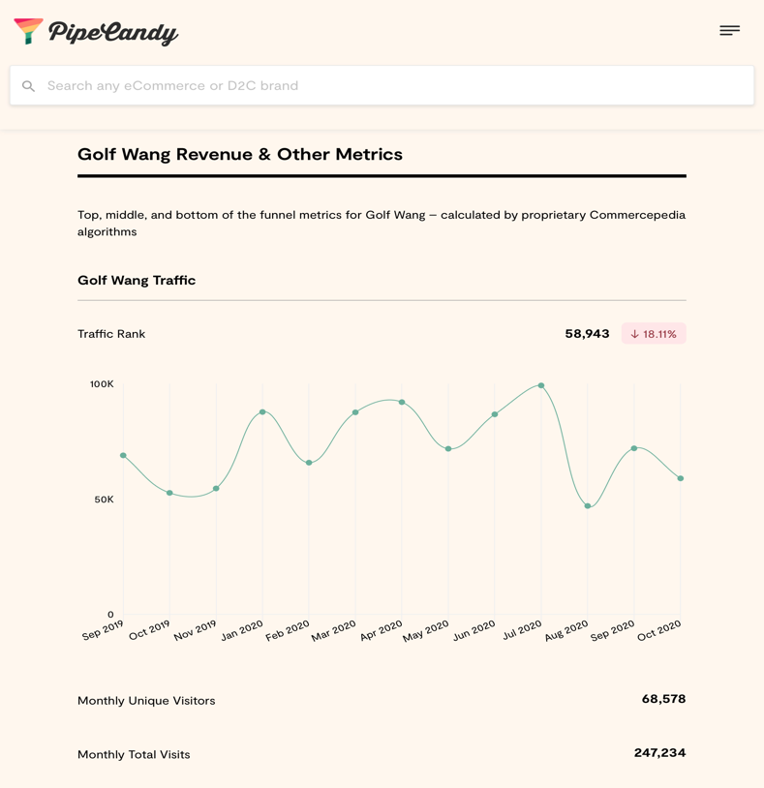
Figure 4. Shows website traffic for Golf Wang

Sustainable practices: Sustainable fashion is becoming more important to consumers and the industry. Golf Wang/ Golf Le Fleur could look at ways to reduce its environmental impact by using more sustainable materials, reducing waste and energy consumption, and promoting sustainable production methods. Several studies have pointed out the serious environmental and social hazards caused by the fashion industry. However, the industry is transitioning toward a new sustainable and ethical fashion paradigm. Sustainable consumption is a recent trend where consumers consider the social and environmental aspects (Ref12). This could help the brand appeal to environmentally conscious consumers, reduce costs and improve efficiency.

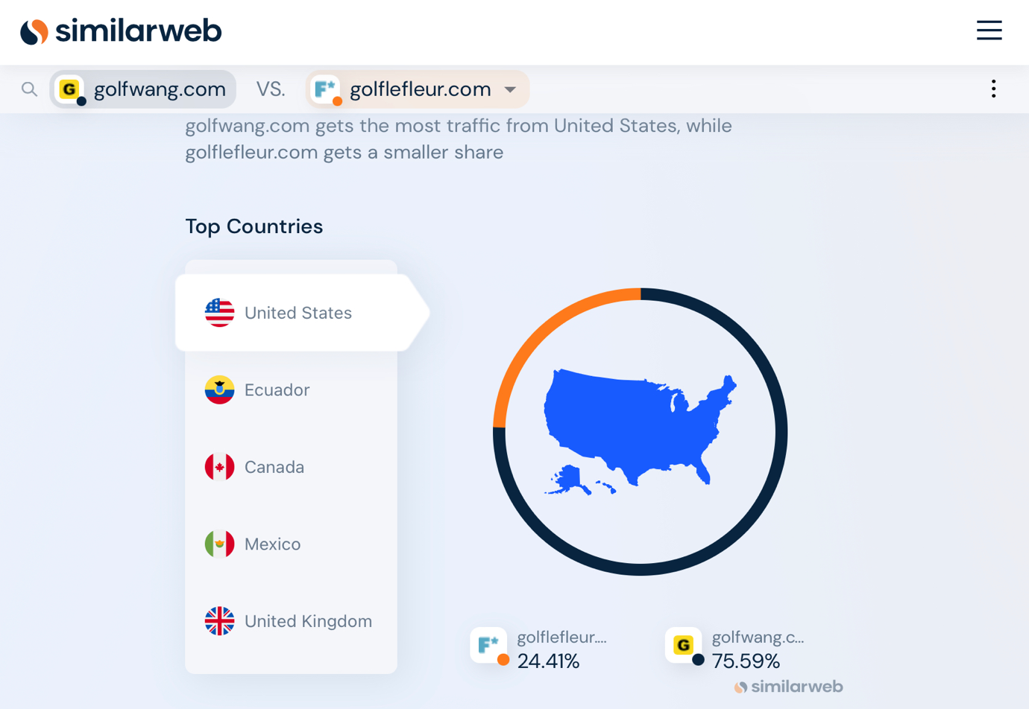
Brick and Mortar Stores: Golf Wang/ Golf Le Fleur could open new retail locations, as well as overhaul existing ones, to create immersive, interactive and innovative shopping experiences that build a deeper connection with the customers. These stores could also showcase new collections and host events. This could help the brand to reach new customers, increase sales, and create a stronger connection with its existing customers. Even though e-commerce is becoming a more used option in retail buying , traditional shoppers prefer to go in shops and see items face to face. Hence why this company should have more locations. These locations can be sorted out simply by checking geographically where people are placing orders the most via the websites (Fig 5)
Figure 5. Shows which countries shop the brands the most.

It is worth noting that as the fashion industry is dynamic and is constantly changing and evolving, Golf Wang/ Golf Le Fleur should be flexible and ready to adapt to new trends, consumer preferences and market conditions. To successfully expand its business, Golf Wang/ Golf Le Fleur should focus on critical elements such as quality, innovation, customer service and sustainability.

How to market better-

There are several ways Golf Wang/ Golf Le Fleur could potentially improve its marketing efforts, such as:

Leverage social media: Golf Wang/ Golf Le Fleur already has a strong presence on social media platforms such as Instagram, Twitter, and TikTok, but it could further leverage these platforms to reach new customers and engage with existing ones. This could include creating and sharing more engaging content, hosting online events and campaigns, and utilizing influencer marketing to reach new audiences.(Ref 14). One way these brands are already leveraging social media is its creator is very famous and has an international following, which helps to drive up sales. Especially if Tyler is seen wearing specific pieces at his performance shows and posts it to his social media platforms.

Develop a mobile app: Golf Wang/ Golf Le Fleur could develop a mobile app that allows customers to browse and purchase products, access exclusive content, and engage with the brand through interactive features such as augmented reality and gamification. This would make their products more accessible for people who do not live close to Golf Wang/ Golf Le Fleur shops. This can be compared to the very successful brand Supreme.

According to Ratcliff @ Econsultancy (2015), there are 7 reasons why retailers should have an app: (Ref 14)
- The competition has one
- Some people just love using apps
- Increased conversion – According to an ABI Research survey 40% of US respondents who had downloaded a retailer app said they bought more of that brand’s products.
- You can communicate with your customers instantly – you can use push notifications to immediately inform users of information updates or relevant news
- Ease of payment – Smartphones in built technology can allow users to pay in-store instantly (Apple are currently doing this)
- Improving in-store experiences
- Extra value

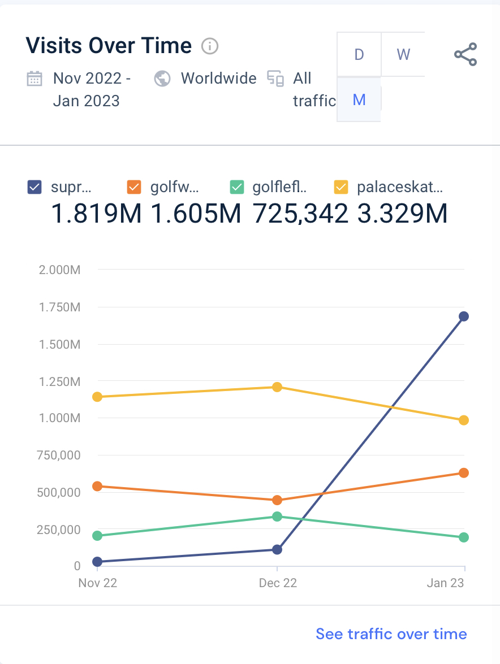
This makes perfect sense when you look at competitors of Tyler’s brands (Supreme, Palace, etc.) All of which have apps unlike Tyler’s brands. The data below shows that web/app traffic alone is way high because of the convince of having an app. (Fig 6.)

Figure 6. Shows the web/app traffic Tyler’s brands compared to his competitors

Build brand storytelling: Golf Wang/ Golf Le Fleur could create a strong brand story that connects with its target audience on an emotional level, to help customers understand the brand's values, mission, and unique positioning in the market. This could include creating content such as videos, articles, and social media posts highlighting the brand's heritage, inspiration, creative process, and the values that the brand represents. This will help customers understand what sets the brand apart and how it aligns with their values.

Create a CRM strategy: Golf Wang/ Golf Le Fleur could create a Customer Relationship Management (CRM) strategy that helps it build stronger customer relationships. This could include personalized marketing campaigns, targeted email and SMS campaigns, and customer loyalty programs. By understanding its customer base, GOLF WANG could provide relevant, personalized offers and content that aligns with their preferences. Examples of this can be found with fashion company Zara. Zara was one of the first to pioneer the use of personal digital assistants (PDAs) to capture customer data in real time – not just on transactions, but on their customer’s preferences and habits. CRM software comes in when it’s time to use this data to sell, sell, sell, re-engaging existing buyers with fresh discounts and campaigns (Ref 21).

Event and Experiences: Golf Wang/ Golf Le Fleur could host more events and experiences such as pop-up shops, fashion shows, concerts, and art exhibitions to showcase its products, create buzz and engage with customers in a fun, interactive way. This can be a great way to connect with customers, build brand awareness and drive sales by creating a memorable and enjoyable brand experience.

Personalized content: Golf Wang/ Golf Le Fleur could use more personalization to create targeted marketing campaigns and email campaigns that resonate with individual customers by considering their demographics, purchase history, and browsing behaviour. This will help the brand increase its chances of conversion by providing customers with offers and content tailored to their preferences, increasing relevance and reducing the chances of them unsubscribing or ignoring the campaign. This is something Tyler, The Creators brands have done before by offering an exclusive offer for fans to be able to customize there own Golf Wang Converse.[Ref 8]

Influencer Marketing: Golf Wang/ Golf Le Fleur could leverage the power of influencer marketing to reach new audiences and gain credibility among specific segments by partnering with key influencers across various platforms. This strategy is particularly effective when the influencer's brand aligns well with the brand values and mission of Golf Wang/ Golf Le Fleur, as they can bring new audiences and drive trust from their followers.

These are just a few examples of how Golf Wang/ Golf Le Fleur could improve its marketing efforts. The key is to stay current and relevant, to understand the target audience and to be able to create personalized, compelling and engaging content that can connect with them.

What entrepreneurial business methods and techniques are applied to Golf Wang/ Golf Le Fleur?

Marketing and Branding: Golf Wang/ Golf Le Fleur's unique and bold designs are crucial to its brand identity. The brand uses various marketing and branding strategies by recognising it’s demography and niche, instilling FOMO, create look books, collab with influencers to post content wearing the merchandise on tik tok, Instagram etc. to promote its products and build its brand. For example, the brand could partner with influencers, bloggers, and social media personalities to promote its products and increase its reach. It could also sponsor events and create engaging content to build brand awareness and connect with its target audience.

Product Development: Golf Wang/ Golf Le Fleur's focus on innovation and quality is evident in its constantly evolving product line. The brand uses market research and customer feedback to inform its product development decisions, ensuring that it meets its target market's needs and wants. By staying ahead of trends and continuously updating its product line, Golf Wang and Golf Le Fleur remains relevant and attractive to customers.

Networking and Collaboration: Golf Wang/ Golf Le Fleur's strong connection to the music and arts communities is vital to its brand identity. The brand uses networking and collaboration strategies to build relationships with other brands, artists, and influencers in these communities.

E-commerce: Golf Wang/ Golf Le Fleur uses e-commerce strategies to sell its products online and reach customers worldwide. The brands have well-designed e-commerce websites that make it easy for customers to browse and purchase products. It also uses email marketing, search engine optimisation, and social media advertising to drive traffic to its website and increase sales.

Limited Edition Releases: As previously mentioned, Golf Wang/ Golf Le Fleur often releases limited edition collections, which creates a sense of scarcity and exclusivity for customers. This strategy helps to build excitement and anticipation for the brand's products and drive sales. By releasing limited edition products, Golf Wang/ Golf Le Fleur can keeps its product lines fresh and appealing to customers and maintains a sense of novelty and excitement around the brand.

These are just a few examples of the entrepreneurial business methods and techniques that Golf Wang/ Golf Le Fleur may use to succeed. The brand uses these methods and others to create a sustainable and prosperous business model.

What are some USPs for Golf Wang/ Golf Le Fleur?

Golf Wang/ Golf Le Fleur are both clothing and lifestyle brands that stand out for their bold and unique designs, playful and irreverent aesthetic, solid cultural connection, high-quality products, and limited edition releases. Here is an elaboration on each of these points:

Bold and Unique Designs: Golf Wang/ Golf Le Fleur is known for its bold and eclectic fashion and style, which sets it apart from other streetwear brands. The brand offers customers a range of unique and eye-catching designs that are not easily found elsewhere. This gives customers a way to express their individuality and personal style in a unique and memorable way.

Playful and Irreverent Aesthetic: Golf Wang/ Golf Le Fleur’s playful and irreverent approach to fashion and style is a crucial part of its brand identity. The brand offers customers a fun and playful way to express their style. This approach to fashion sets Golf Wang apart from other streetwear brands that may take themselves too seriously and helps to make the brand more appealing and accessible to customers.

Strong Cultural Connection: Golf Wang/ Golf Le Fleur strongly connects to the music and arts communities, mainly through its founder, Tyler, The Creator. The brand’s products and aesthetics reflect these communities’ cultural values and interests, making it appealing to customers who share these interests. This strong cultural connection helps to build a sense of community and belonging among fans of the brand.

High-Quality Products: Golf Wang/ Golf Le Fleur is known for producing high-quality products, using premium materials and paying attention to detail. This sets the brand apart from other streetwear brands and helps to establish it as a premium, quality brand. Customers are willing to pay a premium for Golf Wang products because they know they are getting a high-quality product that will last.

Limited Edition Releases: Golf Wang/ Golf Le Fleur often releases limited edition collections, which creates a sense of scarcity and exclusivity for customers. This helps to build excitement and anticipation for the brand’s products and creates a strong sense of community among fans. The limited edition releases also help keep the brand fresh and exciting, as customers always know there is something new and exciting around the corner.

Conclusion

In conclusion Tyler, The Creator has created a cult following which has in turn transitioned into his brands for the better. He has successfully managed to take his own personal style and turn it into successful fashion brands ,which may in fact continue to thrive if he can manage to stay in good social standings. Even though he has been successful thus far his brands still has a ways to go. The sky truly is the limit with his brands and they could be a successful as Kanye Wests Yeezy brand if he continues to apply strategic marketing practices and continue to collaborate with well known brands and celebrities. The shortcomings that could be found for his brands is the lack of international retail stores selling his products. This is a negative because not all consumers like to shop online and would prefer to see the items in person and try them on before purchasing. If Tyler, The Creator can figure out a way to expand his retail stores to over seas locations his lines would be more successful.

Figures
Figure 1. Shows Tyler, The Creator in a photo shoot for GQ Magazine.
Figure 2. Golf Wang Collaboration with Sneaker brand Converse
Figure 3. Shows Age Distribution for Golf Wang/Golf Le Fleur
Figure 4. Shows website traffic for Golf Wang
Figure 5. Shows which countries shop the brands the most.
Figure 6. Shows the web/app traffic Tyler’s brands compared to his competitors
Figure 7. Shows the logo for the Golf Le Fleur and Lacoste collaboration

Links to Golf Wang and Golf Le Fleur

Golf Le Fleur- https://golflefleur.com
Golf Wang- https://golfwang.com

References

1.Wikipedia (2023) https://en.m.wikipedia.org/wiki/Tyler,_the_Creator

2.Marcus Pruitt, (Dec 7 2020) Defining the sound of Tyler, The Creator https://audiblwav.com/defining-the-sound-of-tyler-the-creator/

3.MIKE DESTEFANO, (Apr 7, 20202) How Golf Wang Evolved With Tyler, the Creator's Career, https://www.complex.com/style/how-golf-wang-evolved-with-tyler-the-creators-career

4.DANIELLE BACHER, (JUN, 13 2016) Inside Tyler, The Creator's Colorful Golf Wang World at Made L.A. https://www.hollywoodreporter.com/news/general-news/inside-tyler-creators-colorful-golf-902308/

5.Arian Chopra, (Oct 7 2022) Golf Le Fleur: A Case Study https://440industries.com/golf-le-fleur-a-case-study/?utm_content=cmp-true

6.LIA MCGARRIGLE, (JUN 10 2016) How Tyler, The Creator Became A Runway Designer https://www.thefader.com/2016/06/10/the-evolution-of-tyler-the-designer

7. Zak Maoui, (Apr, 22 2022) You can now make your own trainers with Tyler, The Creator https://www.gq-magazine.co.uk/fashion/article/tyler-the-creator-converse-2022

8. Rebecca Stewart, (Feb, 15 2023) Rihanna and Fenty Beauty Played the Super Bowl Long Game, and

Won https://www.adweek.com/brand-marketing/rihanna-fenty-beauty-advertising-mvp-super-bowl-57

9. Eur. J. Market., 42 (1/2) (2007), pp. 121-134

10. LVMH ( JULY 20, 2021) Virgil Abloh and LVMH announce significant expansion of their successful relationship https://www.lvmh.com/news-documents/news/virgil-abloh-and-lvmh-announce-significant-expansion-of-their-successful-relationship/

11. Jang, Eun-Young, (Sep, 5 2006) An Analysis on Cases of Fashion Collaboration Strategy https://koreascience.kr/article/JAKO200633063796108.pdf

12. Go, E.J.; Lee, H.I.; Jo, M.J. Sustainable Fashion—Gyomunsa; Fashion Marketing Research Lab, Yonsei University: Seoul, Korea, 2021

13. Maria Teresa Romão, Sérgio Moro, Paulo Rita, Pedro Ramos,Leveraging a luxury fashion brand through social media,European Research on Management and Business Economics,Volume 25, Issue 1,2019,
Pages 15-22,
ISSN 2444-8834,
https://doi.org/10.1016/j.iedeen.2018.10.002.

14. Ratcliff, C. (2015). Seven reasons why retailers should have an app and six why they shouldn’t Econsultancy (online) (6th March 2015) Available at: https://econsultancy.com/blog/66133-seven-reasons-why-retailers-should-have-an-app-and-six-why-they-shouldn-t/

15. Similarweb.com (feb, 2023) https://pro.similarweb.com/#/digitalsuite/websiteanalysis/overview/website-performance/*/999/3m?webSource=Total&key=supreme.com,golfwang.com,golflefleur.com,palaceskateboards.com

16.PipeCandy (2023) https://pipecandy.com/companies/golf-wang?__cf_chl_tk=qPGMCAecjx.xAHNa0YknKK8lFzYi.nZtYkv4LgCBflQ-1675910276-0-gaNycGzNCXs

17. Gogasian.com (2023) https://gagosian.com/artists/takashi-murakami/

18. Tracey Williams Cowen ( Jun, 28 2022) Tyler, the Creator’s Golf le Fleur* Launches New Nail Polishes https://www.complex.com/style/tyler-the-creator-golf-le-fleur-new-nail-polishes?utm_campaign=social_widget_share&utm_medium=social&utm_source=link
19. Converse All-Star series, Tyler Talk, Paris ( Jun, 18 2022) https://youtu.be/Z90f1-zWg0c

20. Christopher Morency (Oct, 05 2018) The rise of Drakes OVO label https://www.businessoffashion.com/articles/media/the-rise-of-drake-ovo-oliver-el-khatib/
21. Rob Binns (Apr,21 2021) Big Brand CRM Case Studies https://www.expertmarket.com/uk/crm-systems/customer-relationship-management-case-studies

