

STUDENT NAME: DHRUV KALPESHKUMAR SHUKLA
STUDENT ID: 2210110
Programme: MBA- Masters of Business Administration
Module: Human Resource Management – Assessment 1
Module code: LCMB7000
Contribution to Overall Module Assessment (%): 50%

Human Resource Management

Executive Summary
This report shed light on the changing role of HRM after Covid. Furthermore, this research points out how the organization sector even after covid is heavily depended on this managing of human resource so that they can recruit efficient employees. In order to manage these pandemic situations after covid, sudden recruitments strategies that is needed after covid has been accumulated by HRM. Lots of people due to this global pandemic has lost either their job or become unemployed. HRM’s changing role has also discussed about that issue.

Table of Contents
1.0Introduction 4
2.0 Analysis 4
2.1 Changing roles of HRM after Covid 5
2.2 Virtual recruiting 6
2.5 Implementing new technologies 8
2.6 Social media recruitment 9
2.7 Conducting weekly and daily survey for the employees 10
3.0 Finding 11
4.0 Recommendation 11
5.0 Conclusion 12
Reference List 14
Appendix 1: Global HRM market 16

1.0Introduction
“Human Resource Management (HRM), is one of the most important and strategic recruited and or organizational environmental management strategies that has been there to manage this organizational culture for years. There has been lots of chainages that HRM goes through every day in order to manage the organizational structure. Th organizational structures need improvisation every day and or at least once month. The organization sector even after covid is heavily depended on this managing of human resource so that they can recruit efficient employees in order to manage these sudden recruitments strategies that is needed after covid, as lots of people due to this global pandemic has lost either their job or become unemployed. Therefore, these reports if going to discuss about various strategic response o of HRM and practices that has been implemented through HRM in order to manage this organizational outflow.

2.0 Analysis
The changing role of HRM had been here after pandemic. According to the opinion of Njoku et al (2019), this pandemic has changed almost 85% organizational structure. The organizational structure that 70% depended on the management of HRM. The HRM after the pandemic has happened to get lot more technologically and o9ffucilay advanced for making their business of any organizational structure enact. According to the opinion of Fahim., (2018), more than 270 employee firm a has been shared their focus from technology, policy, procedures to people. Because people after pandemic become the most important staff to fill out the economical gap that Covid has created.
After this pandemic many people were deliberately jobless b due to their safety concern and other people are jobless because the organizational economical hazard is not enough to maintain employees or lots of employees. This long-time pandemic therefore took lots of job from people. Therefore, after pandemic the focus of HRM is to makes sure the employees aka people, economical value and organizational value were the most important values that has been share by the HRM technically and officially. For example, when the pandemic hits the world-famous hotel “Prism Hotels & Resorts” has laid out 45% of their working forcer out of 4500 workers. This affected their efficient employer rate as well as their economical site.
Next thing that most of the HRM professional support is checking the health condition and providing safety and health insurance policies to new employers or existing employees. So that employees are more relaxed when they are taking interest in the respect job posted by the HRM. Furthermore HRM, od different countries are making sure to implement cost manage strategies that is focused through lots of tools a technique that has the further consistency of the effect of Covid.
The local governmental and federal governmental issued guidelines that was affected various areas in various ways. Making sure this time-maintained issue was better maintained through organizational competitiveness Is again maintained well by this improved HRM. The education and the training to the employee has taken more creative turn after Covid. According to the opinion of Lopez-Cabrales and Valle-Cabrera (2020), Before covid 60% training were provider to the employees to manage their organizational structure, IT based training, other technical resource collected training that can gain help by managing the organizations’ structure. According to the opinion of Berber et al (2018), on the other hand after covid 80% of the employer training consisted of making survive with sudden hazard in natural environment, managing work in remote working structure. Economical sustainability issue and education related to managing issues is lot more important than to making sure technological awareness.

2.1 Changing roles of HRM after Covid
The changing role of HRM can be seen more clearly after pandemic mainly because of the pandemic that has change the organizational structure and the organizational structure that included lots of remote work, shift changing work. Work from home and various other technological, field work that has been there to make this working system of HRM change their working motto and recruiting employees. The employed recruiting care and practices is one of the most significant works that has been complicated by thus sudden pandemics. Lots of recruited are wither not available for the job because they are afraid of this new normal situation after covid in the organizational structure.
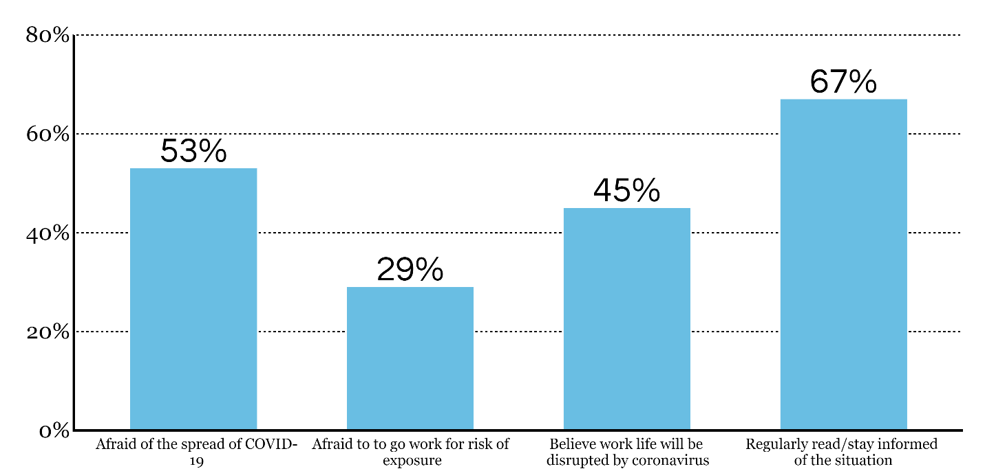
Figure 1: Impact of Covid 19 pandemic over employees
(Source: hrexecutive.com, 2022)
HRM had guide their employer and organizational sector for making through this transition that has happened because of this pandemic. This pandemic has devastated millions of people’s job-related situation and hampered almost 5.36% employment rate worldwide race of employment basic. HRM is responsible for making sure to apply new kinds of resources to make this employment rate decreased days by day. This employment rate has been decreased by 6.18% throughout the world. This is because of the mass employment that has happened because of this pandemic. HRM took this opportunity of unemployment rate and recruit employees. According to the opinion of Azizi et al. (2019), 43 % of the HRM professional think that their role has changed because of this pandemic.

2.2 Virtual recruiting
During the pandemic most of the people are looking for this work from home comfort. This work from home comfort is either beneficial or making lots of problematic situation for the organizational sector. According to the opinion of Paauwe and Boon (2018), many organizational sectors are complaining due to work from home 59.46% of employees are not showing enthusiasm of working therefore organizational structure are suffering because of employee’s lack of enthusiasm. Therefore, HRM is being more critical for this point of view. The new normal situation is not at all enthusiastic for many employees as more and more employees are now adays looking for home based job. According to the opinion of Cuneate al. (2022), most of the HR team is now navigating virtual recruiting and not physical interview process. This virtual interview process is making the interview portion smooth for both the recruiter and the employee. Recruiter from different states or long distance can then join this recruitment process. Therefore, virtual recruiting is giving after this pandemic lots of option to the employer and employee to take a note on to the effective recruitment.
The right audience can be choosing through this recruitment process. This recruitment process is beneficial for making sure lots of people are taking note through this virtual recruiting process before making sure to note their name for any job.
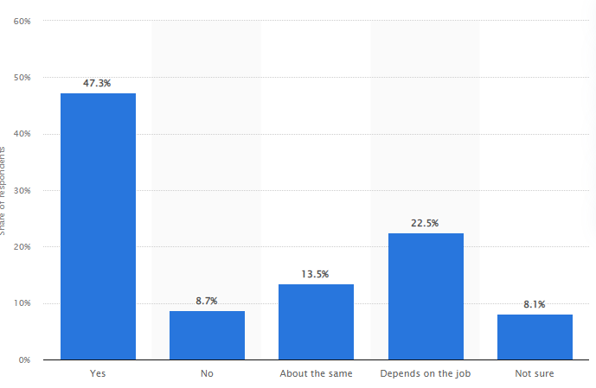
Figure 2: Opinion about online recruiting
(Source: statista.com, 2022)
According to the opinion of Collings et al (2021), this online recruiting process is lot more popular within they HRM than any physical interview process that’s taking lots of time to manage this online recruitment process to make time changing aspect or time management aspect.
2.3 Managing various remote teams
After covid one thing that has been happened because of this work from home is management of hundreds of employees with manuals or with technological resources. The technological resources like technological stool and technologically expert people are expert for managing these kinds of remote working employees. Managing these remote tasks of making sure every employee is doing or every employee is doing their job in a correct way is another thing that there HRM has learned to received. The sudden pandemic situation and technological unprepared situation of the organizations structure has made HR team ready to manage any kind of hazard in this remote managing tasks. According to the word said by Hamadamin and Atan (2019), after pandemics almost 80% of the employer are giving their employees the opportunity to do work from home. The work from home that is connect to manage the remote task is another part so this management of HRM.

2.5 Implementing new technologies
Implementing new kind of technologies that can renege this work from home, virtual recruitment and most important of all managing this virtual recruitment. New kind of technological support are always there to make the work of HRM easy because they manage the most hectic task of managing the employees so that employees can bring further profit to the organizational structure.
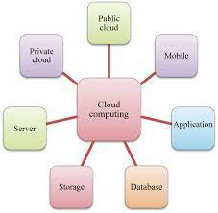

Figure 3: Technologies used by HRM after covid
(Source: hrexecutive.com, 2022)
IT based technologies are the main asset that most of the technologically embraced organizational sector have bene using since the pandemics. Implementing these IT based technological tools and normal t technological tools that can help by managing t all the posts tasks of HRM. The HRM employees who does not know how to work with many IT based tools and technique before pandemic has learned those during their work in the pandemic time. According to the word said by Hauff., 2021), after pandemic HRM implement various technology like multitasking, cloud storage, AI and several another influential technological response that made their job role easier. The multiuse of mobile phone even has been use through r these HRM management system.

2.6 Social media recruitment
At first before covid social media was not at all included in most of the organizations sector. According to the word said by Kaufman., (2020), in addition after pandemic when almost 75% of the people are using social media then organization also using this social media to make business. Social media after pandemic become so popular that most of the business have media this social media marketing’s strategy to reach billion of customer who cannot go outside. Along with that social media is another pretty cost-efficient business marketing strategy. Therefore, this marketing strategy has also been including by many HRM of many organizations structure in order to make their recruitment more strategic and more controlling.
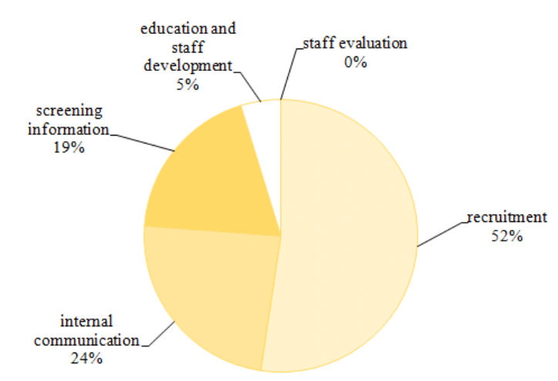
Figure 4: Marketing strategy applied by HRM after Covid
(Source: researchgate.net, 2022)
This social media marketing strategy of HRM for the further growth of any organizations structure has been create and innovative for the organizational structure. HRM, after many organizational changed throughout this covid has made sure that they could use social media forsaking advertisement related enquiry, update regarding the latest technological resources and giving more info to the candidate who are going to apply for their respectable company. After pandemic the economic condition of the employees are not at all a good situation so the HRM produced and practiced social media marketing technology are there to help the business regain control over their business through this cost’s efficient social media recruitment and marketing strategy.

2.7 Conducting weekly and daily survey for the employees
Before the pandemics this survey was not mandatory for most of the offices. But after this pandemic this survey has been led buy most of the organizations structure in order to make this organizational structure which has been weaken by employee or workforce. According to the opinion of Iqbal., (2018), after covid when people become more important for any organizational structure, then 59% of the organizational structure has happened to be conducting weekly or daily basis surveys to know more about the mental health condition of their employee’s. The mental health of the employees is more important than any other thing after Covid, Covid not only devastated the economic condition of people but also devastated the mental health of people. Therefore, to focus more on the human mental condition the HRM made this weekly or daily survey basis in order to know more about their employees.

3.0 Finding
This report has been talked about the changing role of HRM after e Co0vid ion order to gain competitive awareness thorough the organizational competitive structure. The organizational competitive structure has happened to be the important asset after covid. Every business after covid wanted hike as quickly as it can. Therefore, to make the business organization hiked up the HRM support is must. Along with this the accommodating changing role of HRM is also import mat to hike up the organizational structure.
The significance of HRM lies mostly on managing staff within any organizational structure. The organizational structure mostly depended on the HRM practices. Effective HRM practice can made better improvements through the organizational employee managing. 56% Percent employee or workforce for business depended on organizational HRM practices. Therefore, the main focus of HRM after Covid is more on human mental condition. The HRM made sure to change their aspect through the organizational practices. The effective practices of HRM included employee’s satisfaction related organizational improvement. HRM activities are there to that organizational structure can be improved after the sized loss of Covid.

4.0 Recommendation
HR no doubt has made organizational practices improvised through their effective practice. The effective practices of HRM included more and more employees related and organizational improvement related activities so that organizational structure can be improved after the sized loss of Covid. Covid has impacted organizations’ structure by making sure the organization has lost a large sum of their e efficient and active employees, the organization has lost more economical touches’ and lastly the economically devastated organizational structure that are unable to get any kind of resources to make their o organization go through any kind of hazard. Therefore, the recommendation provided on the basis of natural disaster like Covid 19 are:
- Provide employees health related policies more frequent and efficient. According to the opinion of Sareen., (2018), 85% of the employee’s retention has depended on health policies provided by various organizational structure.
- Employee safety is one of the most important assets that any organizational HRM structure should be looking at. After covid most of the employee who could not manage the organizational employment status because of their employment status related issues.
- Taken in to account various social and cultural issue that is affecting the organizational status is another important regulation that HRM should be taken into account. After covid due to the rules and regulation structured by different governments has affected the organizational business in more ways than iota can be hopefully be realized. Therefore, everyday measurement of the organizational area is another important added valued that should be taken into account by HRM.
- According to the opinion of Malik., (2018), Cost management should be taken into account by HRM. After covid when most of the organizational structural response of towards making more investment towards their business. In this situation making profit from organizational economic grasps are more important than any other thing practiced by HRM.
- According to the opinion of Barba-Aragón et al (2018), providing training related to manage the technological hazard, social hazard and natural hazard are another important area that should be the focus of HRM.

5.0 Conclusion
In conclusion it can be said t that the HRM practices has been changed lot since the effect of Covid. Covid has global pandemics has affected lot of life but them more forcefully that has been affect6e by this Covid is economy. Global SCM through which most f o the global business goes one and on has been affected by this SCM. Therefore, when various kind of change has been taken places due to this pandemic then it is sure that those business that has been handled by the organizational workforce should also change their path. therefore, the HRM has changed because of the change culture of this business.

Reference List

Azizi, M.R., Atlasi, R., Ziapour, A., Abbas, J. and Naemi, R., 2021. Innovative human resource management strategies during the COVID-19 pandemic: A systematic narrative review approach. Heliyon, 7(6), p.e07233.
Barba-Aragón, M.I. and Jiménez-Jiménez, D., 2020. HRM and radical innovation: A dual approach with exploration as a mediator. European Management Journal, 38(5), pp.791-803.
Berber, N., Đorđević, B. and Milanović, S., 2018. Electronic human resource management (e-HRM): А new concept for digital age. Strategic Management-International Journal of Strategic Management and Decision Support Systems in Strategic Management, 23(2).
Collings, D.G., McMackin, J., Nyberg, A.J. and Wright, P.M., 2021. Strategic human resource management and COVID‐19: Emerging challenges and research opportunities. Journal of Management Studies.
Cunha, M.P., Gomes, E., Mellahi, K., Miner, A.S. and Rego, A., 2020. Strategic agility through improvisational capabilities: Implications for a paradox-sensitive HRM. Human Resource Management Review, 30(1), p.100695.
Fahim, M.G.A., 2018. Strategic human resource management and public employee retention. Review of Economics and Political Science.
Hamadamin, H.H. and Atan, T., 2019. The impact of strategic human resource management practices on competitive advantage sustainability: The mediation of human capital development and employee commitment. Sustainability, 11(20), p.5782.
Hauff, S., 2021. Analytical strategies in HRM systems research: a comparative analysis and some recommendations. The International Journal of Human Resource Management, 32(9), pp.1923-1952.
Iqbal, A., 2018. The strategic human resource management approaches and organisational performance: The mediating role of creative climate. Journal of Advances in Management Research.
Kaufman, B.E., 2020. The real problem: The deadly combination of psychologisation, scientism, and normative promotionalism takes strategic human resource management down a 30‐year dead end. Human Resource Management Journal, 30(1), pp.49-72.
Lopez-Cabrales, A. and Valle-Cabrera, R., 2020. Sustainable HRM strategies and employment relationships as drivers of the triple bottom line. Human resource management review, 30(3), p.100689.
Malik, A., 2018. Strategic human resource management and employment relations. An International Perspective. Springer, 10, pp.978-981.
Njoku, E., Ruël, H., Rowlands, H., Evans, L. and Murdoch, M., 2019. An analysis of the contribution of e-HRM to sustaining business performance. In HRM 4.0 For Human-Centered Organizations. Emerald Publishing Limited.
Paauwe, J. and Boon, C., 2018. Strategic HRM: A critical review. Human resource management, pp.49-73.
Sareen, D., 2018. Relationship between strategic human resource management and job satisfaction. International Journal of Current Research in Life Sciences, 7(03), pp.1229-1233.

Appendix 1: Global HRM market
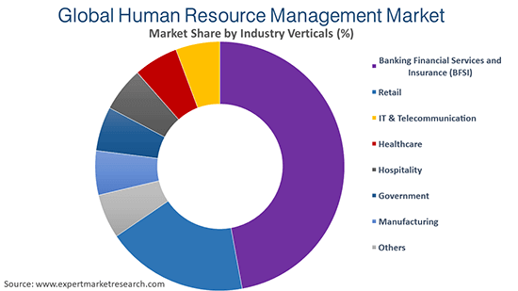
(Source: expertmarketresearch.com, 2022)

