Cash Flow
From January to April our total Income comes to £88,183.28 that includes the owner’s investment of £30,000 pounds in the first month. The total Expenditure is £51,060.46 and the Net Cash Flow total comes to £37,122.82. Also, the Opening Balance totals up to £72,057.24 and the Closing Balance comes to £109,180.06. This is suggested by Bookkeeping Master (2013), Business Victoria (2018) and NCVO (2018).
In the months of May to August our sales have doubled since the last months because of wedding season in which the total Income comes to £116,366.56. The total Expenditure comes to £31,275.80 and the Net Cash Flow total is £85,090.76. Also, the total of Opening Balance adds up to £276,477.42 and the Closing Balance totals up to £361,568.18. This is suggested by Bookkeeping Master (2013), Business Victoria (2018) and NCVO (2018).
The September and October months was a quieter month for sales than other months in which have come down to half and the total Income is £29,091.64. The Expenditure total adds up to £15,787.90 and the Net Cash Flow totals up to £13,303.74. The Opening Balance comes to £251,329.03 and the Closing Balance totals up to £264,632.77. This is suggested by Bookkeeping Master (2013), Business Victoria (2018) and NCVO (2018).
In the months of November and December our sales have doubled again due to Christmas and the total Income is £58,183.64. The total Expenditure comes to £15,287.90 and the Net Cash Flow adds up to £42,895.74. Also, the Opening Balance totals up to £292,482.51 and the Closing Balance comes to £335,378.25. This is suggested by Bookkeeping Master (2013), NCVO (2018) and Business Victoria (2018).

conclusion
In conclusion our business Blush Boutique is a women clothing shop which design, produce and sell product of all different sizes and style. We are promoting our products through the business website and social media. The price of our products is based on market research, Competitive pricing and customers reviews. To ensure our products kept at a lower price the fabric we use is imported from India at a low cost. We have been successful in our sales and have had an increase in profit each term throughout the year.

SWOT

Strength
- We design, produce and make our products with high quality materials.
- Our products are cheaper than competitors.
- We offer custom made clothes where customers can benefit from clothing of their preference. This is suggested by Ritchie and Campbell (2014) and Institute for Manufacturing (2018).

Weaknesses
- We only offer women clothes.
- Our business could decline from lack of popularity. This is suggested by Ritchie and Campbell (2014) and Institute for Manufacturing (2018).
Opportunity
- We promote our business through a website and social media.
- Our business could have a further increase in sales.
- Our business could expand to more branches. This is suggested by Ritchie and Campbell (2014) and Institute for Manufacturing (2018)
Threats
- Our competitor could begin to price their products lower than ours.
- Our competitors could sell products that are more popular than ours. This is suggested by Ritchie and Campbell (2014) and Institute for Manufacturing (2018)

Reference
Bookkeeping Master. (2013) ‘How to Create a Cash Flow Forecast using Microsoft Excel - Basic Cashflow Forecast’ [Online Video) https://www.youtube.com/watch?v=C5PcUSmfOZU Accessed Date 1st December 2018.
Business Victoria. (2018) ‘Cash flow forecasting’ [Online] http://www.business.vic.gov.au, Accessed Date 1st December 2018.
Institute for Manufacturing. (2018) ‘SWOT (Strengths, Weaknesses, Opportunities, Threats)’ [Online] https://www.ifm.eng.cam.ac.uk, Accessed Date 1st December 2018.

NCVO. (2018) ‘How to Set Up a Cash Flow Forecast in a Spreadsheet’ [Online] https://knowhownonprofit.org, Accessed Date 1st December 2018.

Ritchie, A. and Campbell, N. (2014), Starting a Business in 7 Simple Steps, London: Collins.

Business Plan Contribution Audit
Fulmodina Hannan: 1709529
Mehek Sayeed: 1709656
Sultana Islam: 1709614
Papia Russell: 1709533

Friha Nawaz: 1709515

Title: Business Plan - Final

Start date: 14th November 2018

End Date: 5th December 2018

14th November 2018 Week 1:
- Fulmodina Hannan – will cover describing of the Product and how it is being made. Have done researched and completed the speaker’s note on the Products.
- Mehek Sayeed – will cover Introduction, Mission Statement, Aim, Objective, Marketing and Executive Summary.
- Sultana Islam – will cover recapping of Financial Resource.
- Papia Russell – will cover Cash Flow.
- Friha Nawaz – will cover Pricing Strategy.
21st November 2018 Week 2:
- Fulmodina Hannan – group member Papia Russell finding difficult to do Cash Flow, in which I will now cover Cash Flow, Conclusion and SWOT. Researched on how to create a spreadsheet for the Cash Flow and working towards making the spreadsheet. Messaged and called Friha Nawaz to make a start on her work also helped and advised her what to do and how to do her work. I cannot complete my work unless the group member provide me with their works.
- Mehek Sayeed – Introduction, Mission Statement, Aim and Objective completed. After receiving feedback from the lecture made some changes to the work.
- Sultana Islam – have not started to do any work yet and will cover Executive Summary too.
- Papia Russell – will cover describing the Products and it is being made.
- Friha Nawaz – not started to do any work yet.

28th November 2018 Week 3:
- Fulmodina Hannan – completed the Cash Flow spreadsheet. Also made a price list for the products with Mehek Sayeed as Friha Nawaz was unable to. Cannot complete the Conclusion and SWOT as other members have not provided with their work except Mehek Sayeed who has emailed her work to me. Helped Papia Russell on her work as she is struggling a little.
- Mehek Sayeed – completed all her work and help to make a product list with myself (Fulmodina Hannan).
- Sultana Islam – completed recap of Financial Resource and working towards Executive Summary.
- Papia Russell – completed her work.
- Friha Nawaz – working towards completing the work. Supposed to make the product price lists however, did not do it.

5th December 2018 Week 4:
- Fulmodina Hannan – completed conclusion and SWOT also added bulleting onto the slides.
- Mehek Sayeed – checking over the competed work also rehearsing on speaker’s note.
- Sultana Islam – completed Executive Summary.
- Papia Russell – rehearsing on speaker’s note.
- Friha Nawaz – added bulleting onto the Google slide.

Ps: please look for the Cash Flow spreadsheet and Product price lists in the appendices.

Appendices

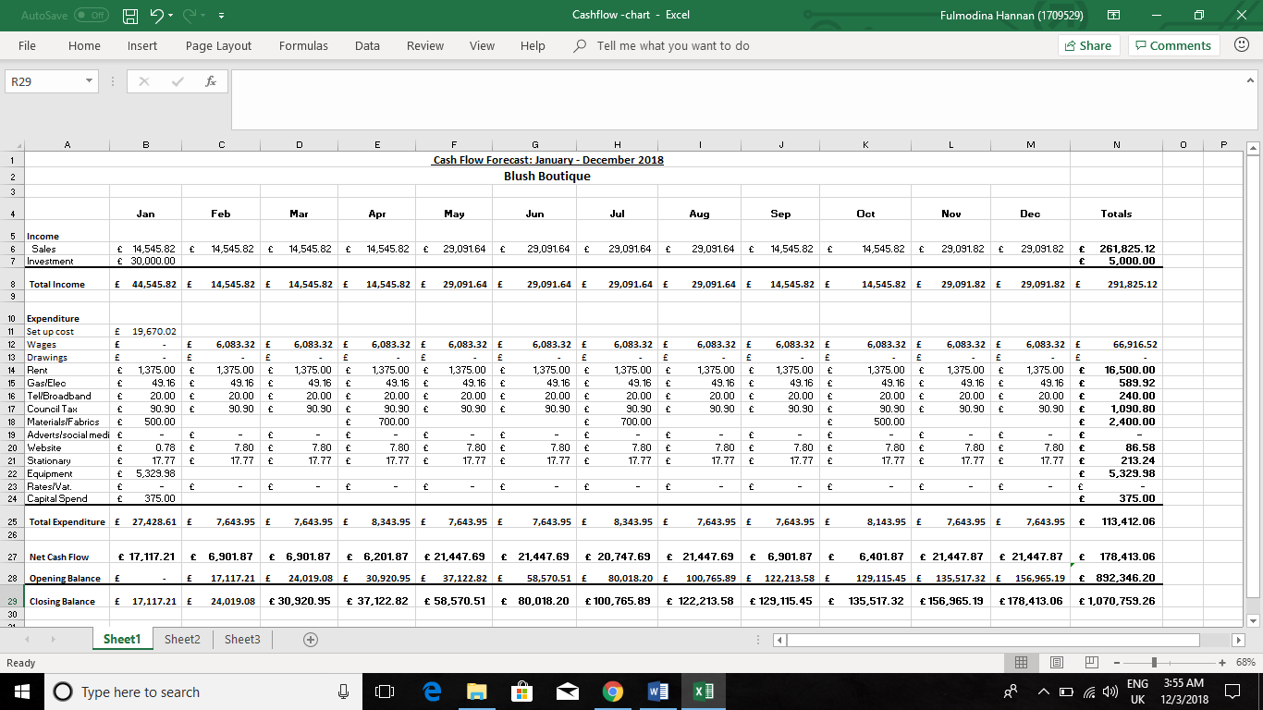

Product Price Lists for Blush Boutique
Casual Abaya - £25.00 - x 10 sold
Dubai Abaya - £45.99 - x 6 sold
Occasional Abaya - £150.00 - x 3 sold
Designer Abaya - £140.00 - x 4 sold
Casual Anarkali dress - £39.99 - x 6 sold
Traditional Anarkai dress - £169.99 - x 3 sold
Designer Anarkali dress - £ 149.00 - x 3 sold
Casual Salwar Kameez - £37.99 - x 10 sold
Traditional Salwar Kameez - £139.99 - x 3 sold
Designer Salwar Kameez - £99.99 - x 3 sold
Occasional/Party dress - £190.00 - x 5 sold
Evening Gown - £249.99 - x 4 sold
Summer dress - £25.99 - x 6 sold
Long Maxi dress - £16.00 - x 7 sold
Slit cut Kurti - £14.99 - x 6 sold
Denim Skirt - £18.99 - x 6 sold
Floral Skirt - £14.99 - x 5 sold
Jersey Skirt - £12.99 - x 5 sold
Long Flared Skirt - £34.99 – x 5 sold
Summer Tops - £9.99 – x 6 sold
Jersey Tops - £8.99 - x 8 sold
Slim Fit Jeans - £19.99 – x 6 sold
Jeggings - £13.99 – x 6 sold
Stretchy Jeans - £24.99 x 6 sold
Flared Palazzo - £25.99 - x 6 sold
Formal Trousers - £ 21.99 - x 6 sold
Casual Trousers - £16.99 - x 7 sold

Custom Made Order:
Casual Abaya - £35.00 - x 12 sold
Designer Abaya - £150.00 x 6 sold
Occasional Abaya - £160.00 - x 6 sold
Casual Anarkali dress - £49.99 - x 4 sold
Designer Anarkali dress - £160 - x 3 sold
Traditional Anarkali dress - £210.00 - x 3 sold
Casual Salwar Kameez - £40.00 - x 8 sold
Designer Salwar Kameez - £120.00 - x 2 sold
Traditional Salwar Kameez - £150.00 - x 2 sold
Occasional/Part dress - £200.00 - x 6 sold
Evening Gown - £260.00 - x 6 sold

