

BA BUSINESS MANAGEMENT
Data Handling and Business Intelligence

Student name: Cristian Stoleru
Student ID: 2215119
Course code name: LCBB5000
Lecturer Name: XAVIER MATIENI
Contents
Introduction 4
Part 1 5
Dataset Overview 5
Data Preprocessing 5
Mean Price 5
Median Price 6
Mode Price 6
Standard Deviation: No. of Bedrooms 7
Largest Variance in Variables 8
Largest Standard Deviation in Variables 9
Interpretation of Last Three Outcomes 9
Using Pivot Tables to Professionally Present Data 10
Correlation Between Prices and Number of Bedrooms 13
Scatter Plot: Price Against Number of Bedrooms 14
Part 2 17
Advantages and Disadvantages of SPSS and Excel 17
The Data Mining Cycle: Meaning and Importance 20
Conclusion 23
References 24

Introduction
This is a data analysis report conducted by a data analyst intern in an established research centre to analyse the "USA Housing Dataset" for uncovering statistical trends and meaningful patterns. A detailed analysis of the dataset based on information about housing prices and number of bedrooms is done using Microsoft Excel and SPSS software. The analysis employs Excel to visualize data and calculations, as well as SPSS for advanced statistical modelling to analyse key metrics like mean, median, mode, standard deviation, and variance. It also addresses the strengths and drawbacks of the tools used on examining the major role of the Data Mining Cycle in creating strong outcomes.

Part 1

Dataset Overview
The ‘USA Housing Dataset’ has 4,140 entries with 18 variables, which describes the details of housing characteristics in the United States. The variables are price, bedrooms, bathrooms, square footage (living area and lot), number of floors, year built and additional fetures such as waterfront presence, quality of view, and condition of renovation. Categorical information like street city, and state zip code is also included as part of the dataset. House prices are extremely wide for very large houses from $0 up to over $26 million. The numerical values of square footage and the number of bedrooms have a lot of statistical meaning, and some temporal data, such as year built and renovation year, have historical value.

Data Preprocessing
The price variable was pre-processed in order to mitigate missing values and provide the accurate input for analysis. To replace missing values in SPSS we used the Median of Nearby Points method. In this approach, the missing values are imputed using the median of the neighbouring data points in the dataset. Overall, 49 missing values were replaced to bring the number of valid cases up to 4140 for the price variable. Keeping the intigrity of the dataset was crucial in this step because missing values can distort statistical results and would make the results and the interpretation less reliable with the given data. Through this method, the structure and variability of the dataset was maintained while the imputed values would coincide with the data in a realistic way.

Mean Price
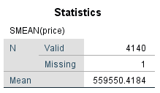
The mean price of the houses in the dataset was found to be $559,550.42 (N = 4140)
The average housing price throughout all the properties is represented by the mean value. This figure means how much it costs to buy a house in the sampled dataset on average ($559,550.42). Black (2019) points out that although the mean is the most often used measure of central tendency, it is sensitive to extreme values or outliers. As property prices in this dataset range greatly from $0 to over $26 million, the mean may not represent the typical property price for many properties. However, it provides a baseline for analysis and for policy make (Field, 2018).

Median Price
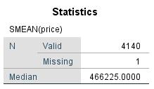
The median price of the houses in the dataset was found to be $466,225.00 (N = 4140).
The median value, in the dataset, of $466,225.00, stands for everything above half of the houses for sale, which means half priced above this value, while the other half is priced below. The median is a less sensitive measure of central tendency in skewed datasets than the mean compared to the mean (Wooldridge, 2016). For use on the housing dataset to indicate a typical price for housing, this value represents a ‘market rate’ or baseline on which to measure the ability to afford housing and to assess whether market conditions are normal (Siegel, 2012).

Mode Price
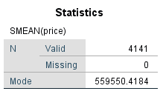
The mode of the house prices in the dataset was found to be $559,550.42 (N = 4141).
Mode is $559,550.42, i.e, the most frequently occurring price in the dataset. Thus, this means that this price point occurs more than any other of the housing dataset. The mode differs from the mean and median; it brings focus to the most common price range, giving an understanding of the most popular housing tiers on the market (Bluman, 2018). Within this dataset, the mode indicates that there is a clustering of houses around this price point so this data suggests that it can serve as an indicator to look for standard pricing patterns in the housing market (Triola, 2021).

Standard Deviation: No. of Bedrooms
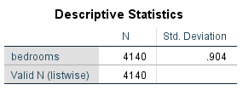
The standard deviation for the number of bedrooms in the dataset was calculated as 0.904 (N = 4140).
The standard deviation of 0.904 shows on average how much the number of bedrooms from the dataset deviates from the mean. Given this relatively small value, most of the properties have number of bedrooms that clusters very close to the mean with limited variability. This means that the number of bedrooms tends to vary a lot less in the housing dataset than it might in, for instance, real estate offerings, which indicate some sort of typical housing preferences or norms in this area (Newbold, Carlson, & Thorne, 2019).

Largest Variance in Variables
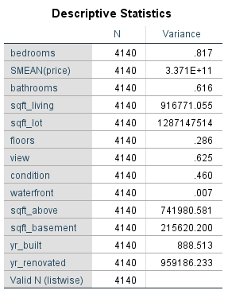
Variance is the average squared deviation from the mean, used to determine how much a dataset is spread out. For price, variance appears to be much higher than for other variables, meaning that housing prices in the dataset vary widely. This is expected, given both the inclusion of low cost properties and high cost luxury properties, leading to greater dispersion. Identifying market dynamics is dependent on understanding this variance, since this variance represents diversity in property values depending on the location, size and features (Gujarati & Porter, 2020).

Largest Standard Deviation in Variables
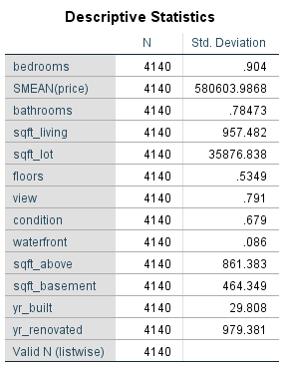
The price range for housing are extremely wide as can be seen with the high standard deviation for this data. It reflects the diversity of the housing market, characterised by factors such as size, location and by features (Moore, McCabe, & Craig, 2017). Understanding this variability is essential for identifying market trends and disparities in property values (Levine, 2021).

Interpretation of Last Three Outcomes
It turns out that the standard deviation of number of bedrooms is quite low (0.904), which means that the house sizes in the dataset are essentially the same. However, at the other end of the spectrum, price has the most variance (3.371×10¹¹) and standard deviation (580603.99), indicating very high volatility in housing prices that include both affordable and high-end homes. This points to the varied nature of the housing market where price goes up with factors such as location, properties’ feature, demand in the market and other parameters which are relatively uniform.

Using Pivot Tables to Professionally Present Data
Pivot Tables are one of Excel’s most powerful tools for summarizing, analyzing and presenting large datasets. By allowing users to dynamically restructure and aggregate data without changing the original dataset, it can therefore help users uncover patterns and trends. Pivot Tables also group, filter, and allow for function applications such as averages or sums to make professional presentations of complex data in an easy to read format. This section will utilize a Pivot Table to help us understand the average housing price by city, showing us regional difference in housing prices.

Objective: Summarizing Average Housing Price by City Using Pivot Tables
The objective is to calculate and present housing price per city based on average using a Pivot Table. This analysis will also highlight regional price variations to help understand how buyers determine affordability of the product and what are some market trends.

Steps to Create a Pivot Table in Excel

Insert a Pivot Table:
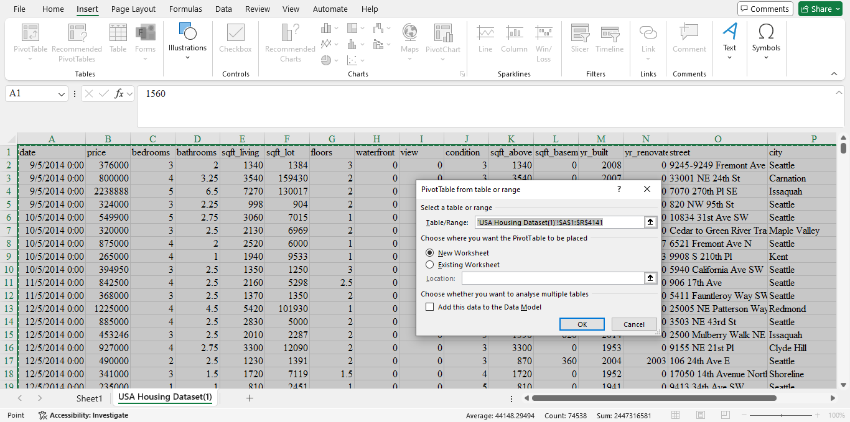
- Open the dataset in Excel and ensure the data is structured with column headers (e.g., price, city, etc.).
- Select the entire dataset (Ctrl + A) and go to the Insert tab on the ribbon.
- Click on PivotTable and, in the dialog box, select New Worksheet as the destination. Click OK.
Set Up the Pivot Table
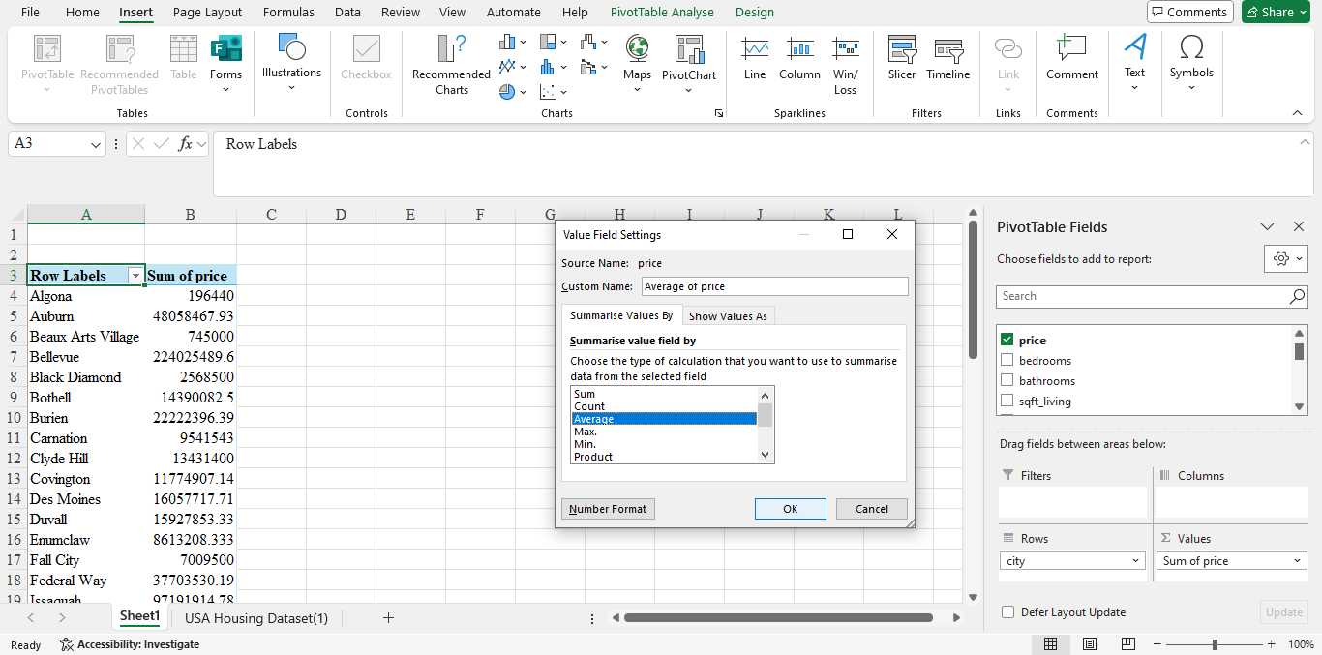
- In the Pivot Table field pane, drag the city column to the Rows area.
- Drag the price column to the Values area.
- Excel will default to summing the prices. Change this to calculate the average:
  - Click the dropdown arrow next to Sum of price in the Values field pane.
  - Select Value Field Settings, choose Average, and click OK.
Format the Data
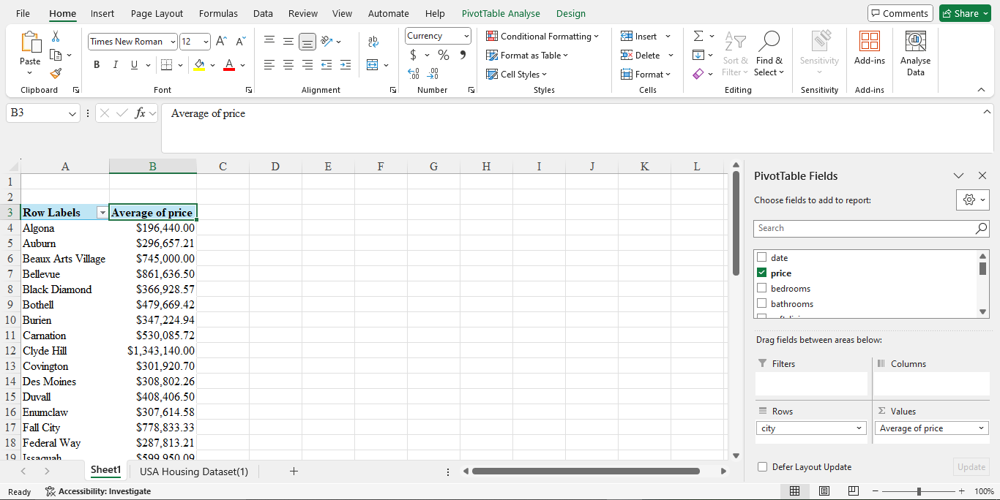
- To make the table more presentable, format the average prices as currency:
  - Right-click the column containing the averages, choose Format Cells, and select Currency.
Professional Presentation
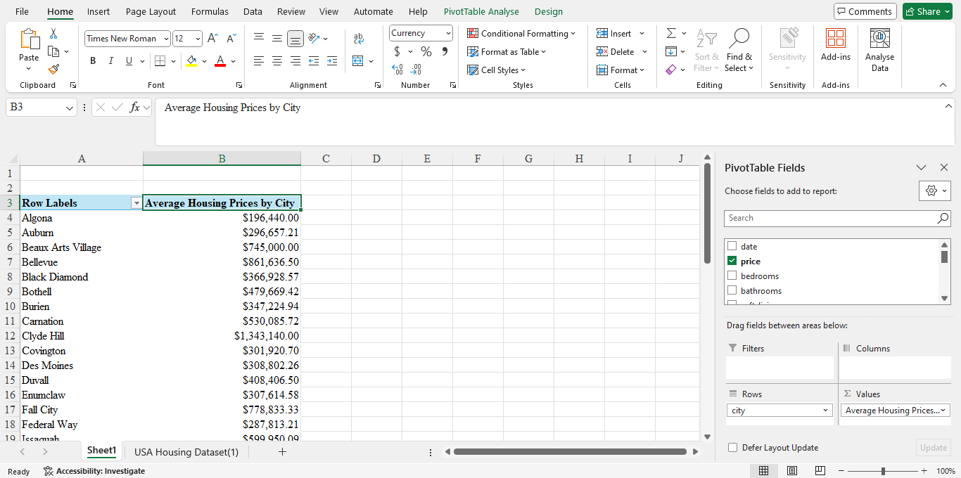
- Rename the Pivot Table to something meaningful, such as "Average Housing Prices by City."
- Adjust column widths for clarity and, if needed, add borders or shading to enhance readability.

Interpretation of the Pivot Table
Each city, with its respective average housing price, will be shown in the Pivot Table. This will give us a picture of how prices change by area, and the maximum and minimum costs in housing terms. This summary assists the stakeholders to grasp market dynamics and take use of the data for informed decisions.

Correlation Between Prices and Number of Bedrooms

Working
Step 1: Import the Dataset
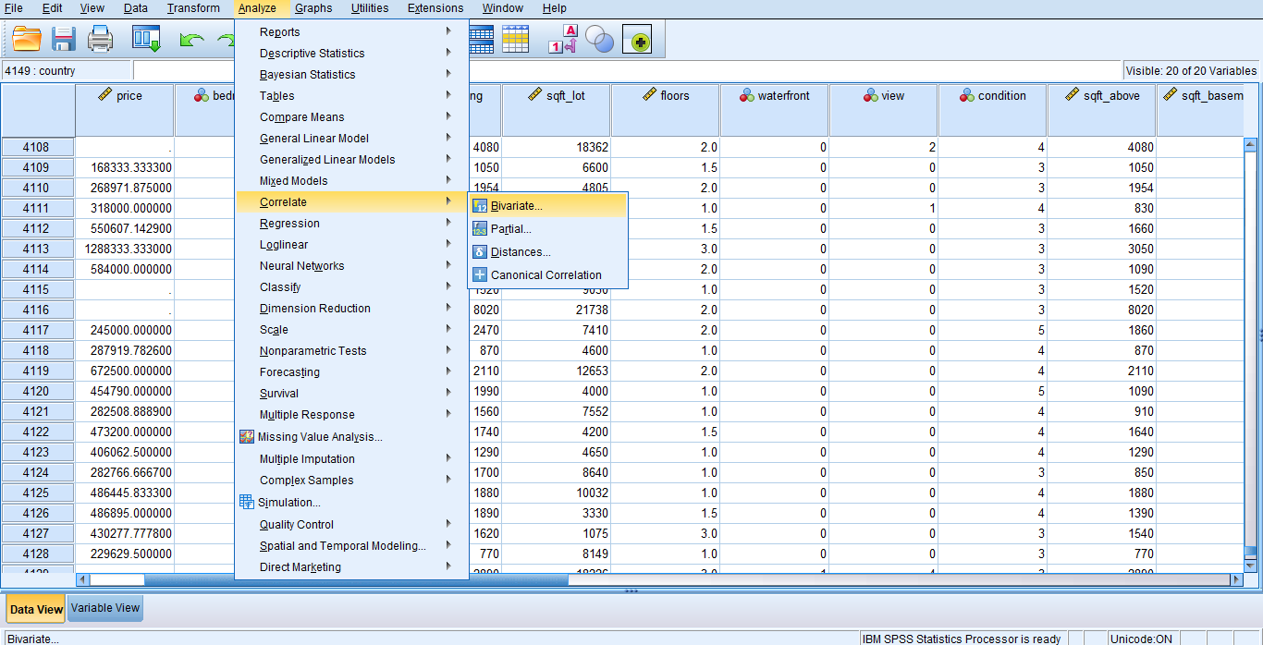
Step 2: On Analyse, go to Correlate and select Bivariate.
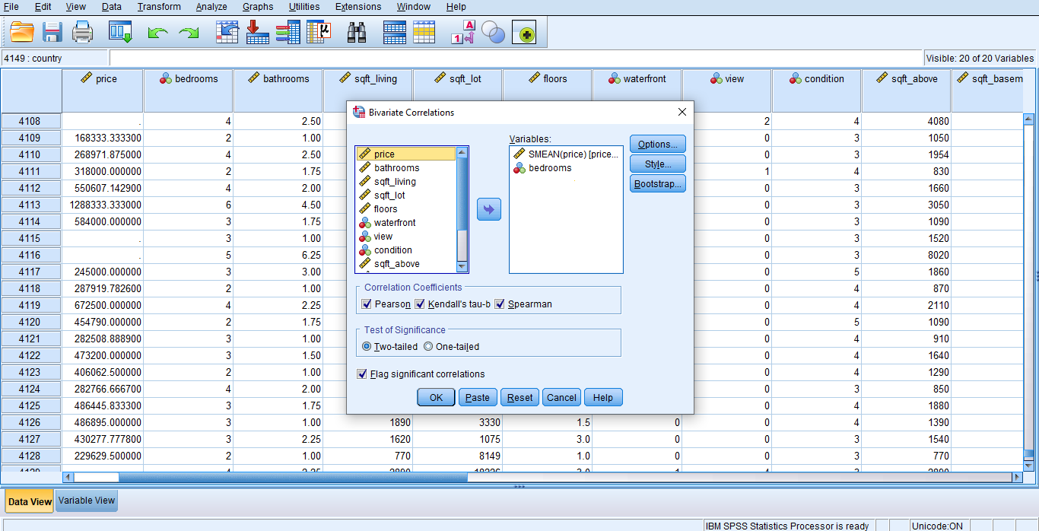
Step 3: Put the Price variable and No. of Bedrooms variable in Variables.
Step 4: Tick the boxes for desired correlation analysis and press OK.

Results
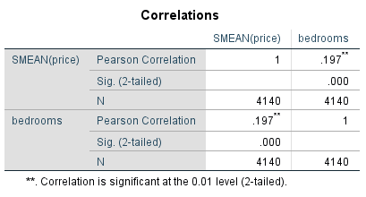
The Pearson correlation between price and the number of bedrooms was found to be 0.197 (p < 0.001, N = 4140).
With 0.197, the Pearson correlation coefficient is weak positive linear relation between the number of bedrooms and the price of a house. This means the relationship is not strong; housing prices rise as the number of bedrooms goes up but not much. The p-value (p < 0.001) confirms that the correlation is statistically significant, meaning the observed relationship is unlikely to have occurred by chance. However, the weak correlation indicates that other factors, such as location, square footage, and amenities, likely play a more substantial role in determining housing prices.

Scatter Plot: Price Against Number of Bedrooms

Steps to Create a Scatterplot in SPSS

Open the Dataset
- Load the dataset into SPSS.

Access the Scatterplot Tool
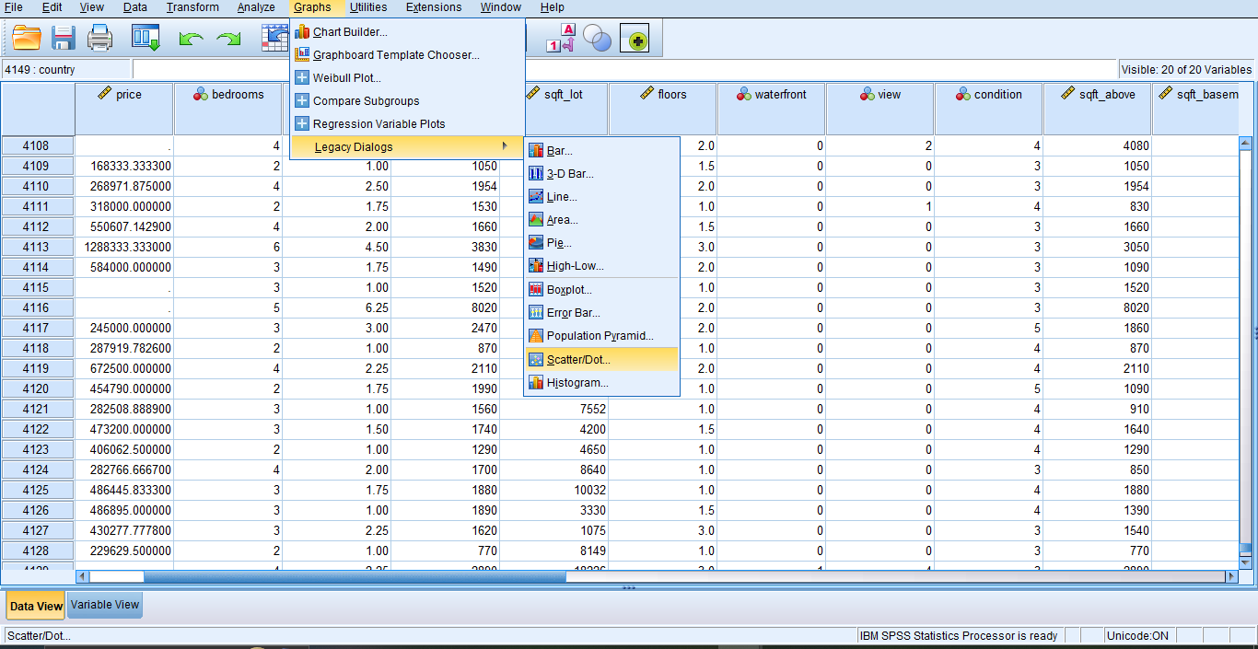
- Go to Graphs > Chart Builder.
- Then go to Chart Builder window, select Scatter/Dot from the window.

Define the Axes
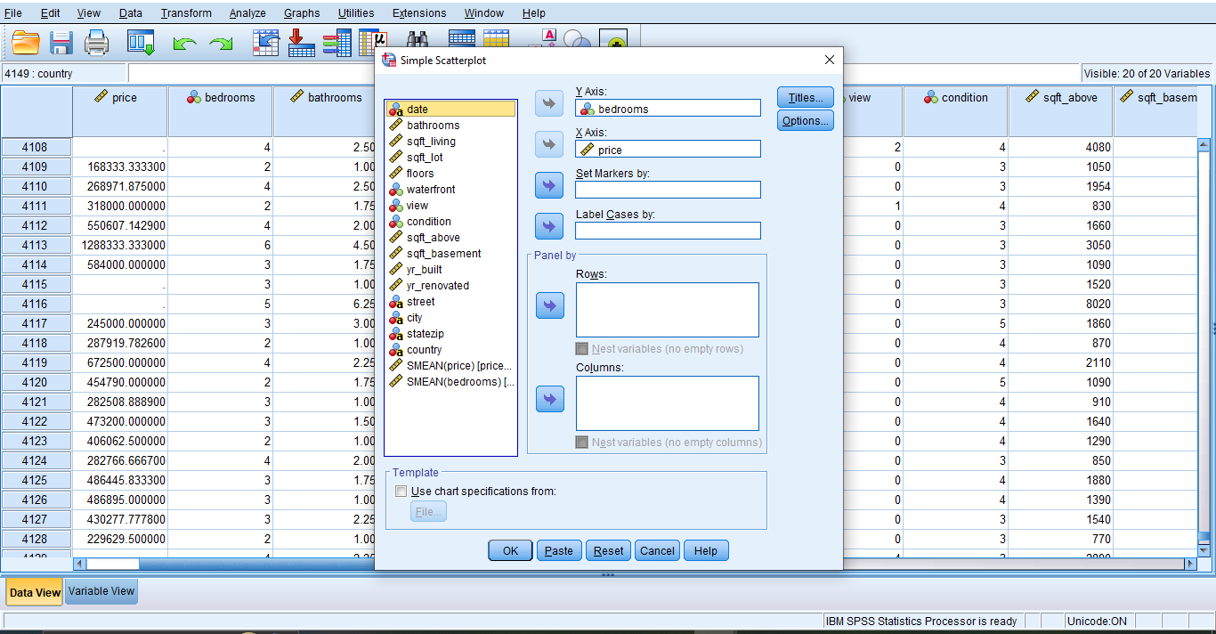
- Drag price to the X-Axis (horizontal axis).
- Drag number of bedrooms to the Y-Axis (vertical axis).

Customize the Scatterplot
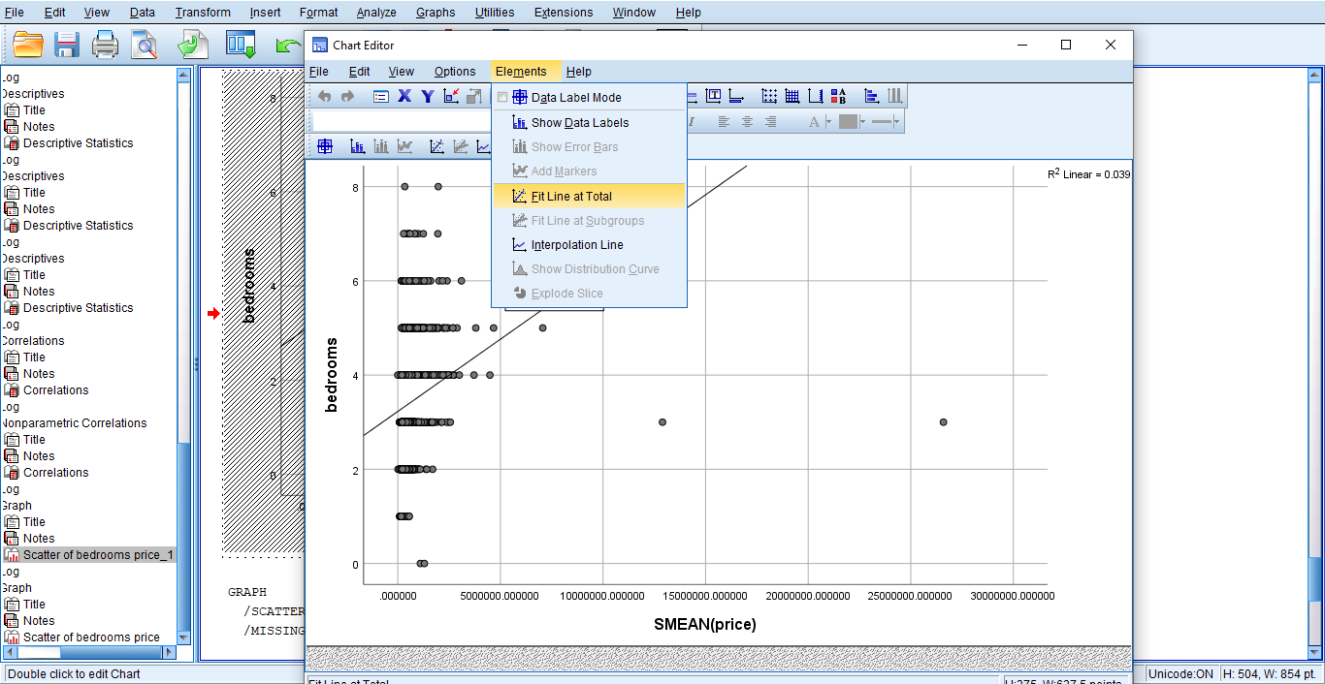
- Click OK to generate the scatterplot.
- Double-click the graph to open the Chart Editor to add a trendline,
- In the Chart Editor, click Elements > Fit Line at Total to add a regression line.

Results
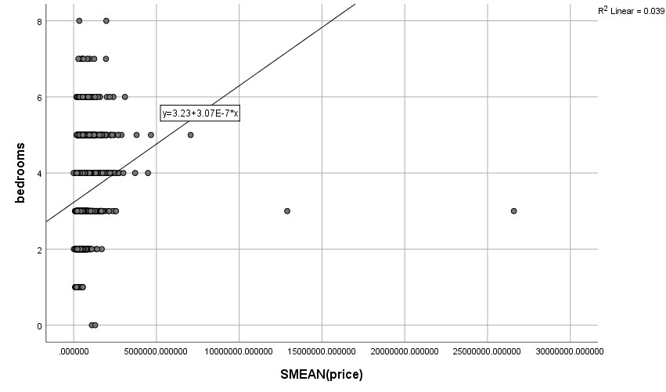
A scatterplot of price (X-axis) and number of bedrooms (Y-axis) was generated, showing a weak positive linear trend. The equation of the trendline is y = 3.23 + 3.07 × 10⁻⁷x, with an R² value of 0.039.
The scatterplot between the housing price and the number of bedrooms in the scatterplot is a weak positive relationship (r=0.0197) consistent with the results of the Pearson correlation coefficient (r). The low R² value (0.039) is an indication of the fact that only 3.9% of the variation of the number of bedrooms can be accounted for through housing price. Many other factors which are very likely to influence both of these variables and associatively relate to one another through a statistically significant and measurable quantity. The point distribution appears highly variable, with several outliers' having a strong effect on the trend. Which reaffirms that housing price isn’t influenced by one factor, one factor alone does not predict housing price.

Part 2

Advantages and Disadvantages of SPSS and Excel
Feature | SPSS Advantage | SPSS Disadvantage | Excel Advantage | Excel Disadvantage
Ease of Use | User-friendly interface for conducting statistical analysis with minimal effort (Field, 2018). | Advanced features, such as multivariate analysis, require a steep learning curve (Pallant, 2020). | Intuitive interface, suitable for basic data analysis and visualization (Winston, 2019). | Limited support for advanced statistical analyses; workarounds are required for many tasks (Benninga, 2014).
Cost | N/A | High licensing fees make it less accessible to individuals or small organizations (Levine, 2021). | Affordable and often included in Microsoft Office subscriptions (Winston, 2019). | N/A
Data Size Capacity | Handles moderate datasets efficiently, suitable for research and academic studies (Pallant, 2020). | Struggles with extremely large datasets; performance issues may arise with millions of rows (Black, 2019). | Can handle moderate-sized datasets for basic operations without significant performance degradation (Winston, 2019). | Poor performance with very large datasets; frequent crashes and slower response time (Benninga, 2014).
Statistical Analysis | Offers a wide range of predefined statistical functions, such as regression and ANOVA (Black, 2019). | Limited flexibility for custom algorithms; lacks programmability compared to Python or R (Levine, 2021). | Supports basic statistical functions such as averages, medians, and standard deviations (Winston, 2019). | Complex statistical tests (e.g., multivariate regression or ANOVA) require external add-ins or manual calculations (Benninga, 2014).
Visualization | Provides built-in visualization tools like scatterplots, boxplots, and histograms (Field, 2018). | Charts lack flexibility and are visually less appealing compared to Excel (Pallant, 2020). | Extensive charting options with high customization, suitable for professional reporting (Winston, 2019). | Limited ability to handle large, complex visualizations; lacks built-in support for statistical overlays (Benninga, 2014).
Data Cleaning and Preprocessing | Efficiently manages missing values, outliers, and categorical data. The Median of Nearby Points method simplifies imputation (Pallant, 2020). | Cannot handle non-numerical or string-heavy datasets as effectively as text-focused tools like Python (Field, 2018). | Supports basic data cleaning with features like filtering, sorting, and conditional formatting (Winston, 2019). | Requires extensive manual intervention for advanced data cleaning tasks, such as handling missing data or outliers (Benninga, 2014).
Integration | N/A | Poor integration with modern data science tools like Python and SQL, limiting workflows (Field, 2018). | Seamlessly integrates with Microsoft Power BI, SQL, and other Office tools, enhancing its utility in professional settings (Benninga, 2014). | Lacks native integration with specialized statistical software like SPSS or advanced machine learning libraries (Levine, 2021).

The Data Mining Cycle: Meaning and Importance
The data mining cycle is a systemical framework used to analyse large datasets to uncover meaningful patterns, trends and relationships. Using techniques from statistics, machine learning, and database management, this cycle works to extract actionable insights out of raw data to help decision making in multiple domains. It provides a structured methodology to ensure repeatable, scalable and reliable process for exploratory and predictive purposes (Witten et al., 2016).

Steps in the Data Mining Cycle

Data Collection
The first step in the Data Mining cycle is doing data gathering from multiple sources. The data could be structured such as database data, semi structured such as web logs or unstructured such as text or images for example. The data collection should also be covered with accurate data that can give you a valuable insight (Larose, 2015). Take real estate as an example, and data such as property prices, sizes, locations and amenities could be collected from different listing services (MLS) or from government archives. The quality and scope of data collected therefore heavily affect success of the steps that follow.

Data Preprocessing
When working with data, it is often the case that the collected data needs to be cleaned and formatted. Data preprocessing deals with cases of missing values, inconsistency, and outliers before that data can be analysed. This step involves tasks such as:
- Handling Missing Values: Filling gaps in datasets like data using the Median of Nearby Points imputation techniques (Mitchell, 1997).
- Normalization: Making comparisons of data standardises the data ranges to make comparisons meaningful (Ghosh & Acharya, 2019).
- Categorical Transformation: Converting text-based data into numerical sets.
For example, when preprocessing a housing dataset, missing price values might be filled in from adjacent data as we did in the earlier analysis.

Exploratory Data Analysis (EDA)
Statistical techniques and visualizations are used to summarize the characteristics of the data in the area of exploratory data analysis. This step will provide the next stages of analysis with some patterns, correlation and anomaly that will provide the next levels of analysis (Heumann, Schomaker & Shalabh (2016)). For example, scatterplots may show positive relation between housing prices and the number of bedrooms, summary statistics such as means and median specify approximate central tendency and dispersion.

Modelling
This step means applying statistical or machine learning models to the data and use the data to predict or predict outcomes. Common models include:
- Regression Analysis: Predicting continuous variables, such as housing prices using features like square footage (Marz & Warren, 2015).
- Classification Models: Classifying, for example, identifying whether a property is "affordable" or "luxury", so you can categorise the data.
- Clustering Algorithms: Similar kinds of data points that can be grouped together like for finding groups of cities that have similar real property trends.
Consider that in a real estate scenario, a regression model might predict housing prices based on built size and location.

Evaluation
As models are applied, those models also need to be evaluated on how accurate and how they perform. This involves comparing model predictions with actual outcomes using metrics such as:
- R² (Coefficient of Determination): It is a measure that tells how good the model fits the data variation (Han, Pei, & Kamber, 2012).
- RMSE (Root Mean Squared Error): It measures the average of the error between predicted and actual values.
For example, for predicting housing prices, one regression model could have an R² of 0.85 which means that the model explains 85 percent of the variability of prices.

Deployment
Finally, insights are implemented into real world applications. This could involve:
- Using a predictive model to set property prices.
- Integrating customer behavior insights into marketing strategies.
- Automating processes based on predictive analytics.
An example of deployment is data driven recommendations that inform property investments decisions in real estate..

Importance of the Data Mining Cycle

Transforming Data into Insights
The role of the Data Mining Cycle is to change raw data into actionable insights. For instance, in retail, analysing customer transaction data would reveal purchasing patterns, allowing promotion to targeted customers to increase revenue (Provost & Fawcett, 2013).

Supporting Data-Driven Decisions
It provides a structured way to make decisions, based on reliable data. Developers in the housing market can therefore find out neighbourhoods with high need and invest wisely according to previous price patterns and predictions (Marz & Warren, 2015).

Predicting Future Trends
The Data Mining Cycle leads to the outcome of Predictive Analytics. Organizations can forecast for the future by analysing historical data. For example, a bank might predict loan default risks with historical data on a set of past customers, or a real estate agency might predict price changes in a certain market (Mitchell, 1997).

Improving Operational Efficiency
Data mining helps find inefficiencies to efficiently use the operations data. For instance, in logistics, it is possible to analyse delivery routes to determine where the transportation costs may be reduced and the delivery time reduced (Ghosh & Acharya, 2019).

Examples of Data Mining in Action

Real Estate
Data mining is used in the housing market because it’s used to predict property prices based on factors such as location, size and features of the neighbourhood. Clustering can also provide insights with respect to areas with similar price trends, which help investors decide on a strategic course of action (Heumann et al., 2016).

Healthcare
Data mining is used traditionally on patient records by hospitals to identify risk factors associated with a disease. Predictive models can help us detect early signs of diabetes or heart disease, and see what kind of treatment a patient will likely need, which helps produce better patient outcomes and reduce healthcare costs (Han et al., 2012).

Retail
Transaction data is analyzed by retailers to develop an understanding of customer preferences and optimise inventory management. For illustration, users can identify seasonal trends and stock inventory for popular items at peak times (Provost & Fawcett, 2013).

Conclusion
This report analyzed the “USA Housing Dataset” and used Excel and SPSS to explore key statistics, visualize the data, and interpret relations. It discusses the variability of housing prices across the country, relative weakness of bedroom data, and the value of preprocessing data to make it meaningful. Discussion on SPSS and Excel along with the data mining cycle showed how structured data analysis can be an enabler to the decision based on informed decision and actionable insight.

References
Benninga, S. (2014). Financial Modeling. 4th ed. Cambridge: MIT Press.
Black, K. (2019). Business Statistics: For Contemporary Decision Making. 9th ed. Hoboken, NJ: Wiley.
Bluman, A.G. (2018). Elementary Statistics: A Step by Step Approach. 10th ed. New York: McGraw-Hill.
Field, A. (2018). Discovering Statistics Using IBM SPSS Statistics. 5th ed. London: Sage Publications.
Ghosh, A., & Acharya, J. (2019). Data Mining Using Python and R. 1st ed. Boca Raton: CRC Press.
Gujarati, D.N., & Porter, D.C. (2020). Basic Econometrics. 6th ed. New York: McGraw-Hill.
Han, J., Pei, J., & Kamber, M. (2012). Data Mining: Concepts and Techniques. 3rd ed. San Francisco: Morgan Kaufmann.
Heumann, C., Schomaker, M., & Shalabh. (2016). Introduction to Statistics and Data Analysis: With Exercises, Solutions, and Applications in R. Cham: Springer.
Larose, D.T. (2015). Discovering Knowledge in Data: An Introduction to Data Mining. 2nd ed. Hoboken, NJ: Wiley.
Levine, D.M. (2021). Statistics for Managers Using Microsoft Excel. 9th ed. Boston: Pearson.
Levine, D.M. (2021). Statistics for Managers Using Microsoft Excel. 9th ed. Boston: Pearson.
Marz, N., & Warren, J. (2015). Big Data: Principles and Best Practices of Scalable Real-Time Data Systems. 1st ed. Manning Publications.
Mitchell, T.M. (1997). Machine Learning. 1st ed. New York: McGraw-Hill.
Moore, D.S., McCabe, G.P., & Craig, B.A. (2017). Introduction to the Practice of Statistics. 9th ed. New York: W.H. Freeman.
Newbold, P., Carlson, W.L., & Thorne, B. (2019). Statistics for Business and Economics. 9th ed. Harlow: Pearson.
Pallant, J. (2020). SPSS Survival Manual: A Step by Step Guide to Data Analysis Using IBM SPSS. 7th ed. Maidenhead: Open University Press.
Provost, F., & Fawcett, T. (2013). Data Science for Business: What You Need to Know About Data Mining and Data-Analytic Thinking. 1st ed. Sebastopol: O'Reilly Media.
Siegel, A.F. (2012). Practical Business Statistics. 6th ed. San Diego: Academic Press.
Triola, M.F. (2021). Essentials of Statistics. 7th ed. Boston: Pearson.
Winston, W.L. (2019). Microsoft Excel 2019: Data Analysis and Business Modeling. 6th ed. Redmond, WA: Microsoft Press.
Witten, I.H., Frank, E., Hall, M.A., & Pal, C.J. (2016). Data Mining: Practical Machine Learning Tools and Techniques. 4th ed. Amsterdam: Morgan Kaufmann.
Wooldridge, J.M. (2016). Introductory Econometrics: A Modern Approach. 6th ed. Mason: Cengage Learning.

