El Mar Noire Business Plan

Name: Iulia Cristina Banu
Student number: 1908796

Name of Host Organization: University of Wales Trinity Saint David
Date of Report Publication: 03.07.2020

Table of contents

- Introduction…………………………………………………………………………………3
- Mission statement……………………………………………………………………….3
- Business Aims……………………………………………………………………………….3
- Business Objectives……………………………………………………………………….4
- Legal Identity…………………………………………………………………………………5
- Business description………………………………………………………………………6
- Marketing and PR plan………………………………………………………………7-11
- Pricing Strategy……………………………………………………………………….12-13
- Human resources………………………………………………………………………….14
- Job Roles and Responsibilities……………………………………………………….14
- Finances………………………………………………………………………………………..15
- Cash Flow Forecast………………………………………………………………………..16
- Conclusion…………………………………………………………………………………….20
- Appendix 1 – SWOT Analysis………………………………………………………….21
- References…………………………………………………………………………………….23

- Introduction

In the present business environment, a detailed business plan is a vital element in order to reach success in business.
This business plan contains our story and the strategies that we’ll adopt in order to make the story come true, and based on the SWOT analysis (Appendix 1) we have all the reasons to believe we will succeed.
The foundation of this plan is a mix between primary and secondary research, based upon which was built our marketing strategy (Abrams, 2003)

- Mission statement
El Mar Noire has finally materialized from dream to reality, finally opening for its future customers in the year of 2021.
‘Life is better by the sea’, so just leave it to us and enjoy your holiday. No effort is too much for us, leave all your worries behind and spend a beautiful time by the sea enjoying all the activities that you love.
- Business Aims
El Mar Noire is a newly built mini-hotel by the sea, offering guests different holiday packages, giving them the option to choose bundle deals which include day trips, water sports, fishing, wine tastings and other activities that will get the whole family excited. Offering spotless accommodation and friendly services, the hotel shall be remembered as ‘a home away from home’ to our guests, and all the activities we’ve set up for them will WOW.
So our main mission will always be to provide quality hospitality services to our guests in a comprehensive and cost competitive manner, providing one of the best accommodation options in the area (De Connie Mok, 2009).

Mamaia Beach
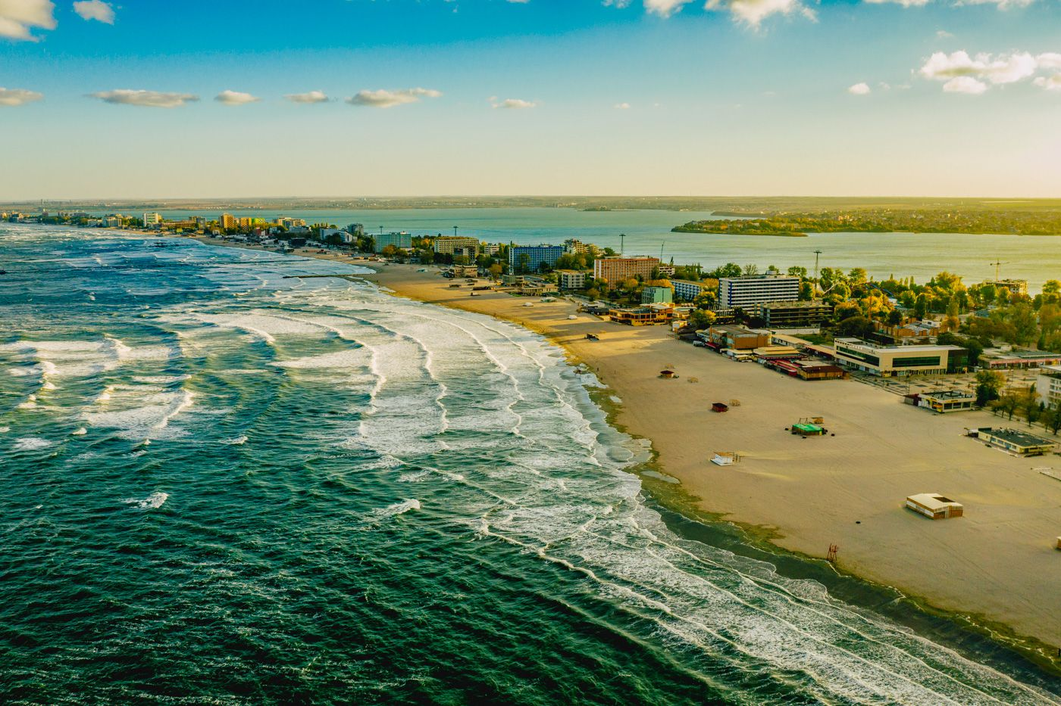
- Business Objectives
Wishing to make our customers’ holidays more than just average, El Mar Noire aims high, and within the first year will establish itself as one of the top independent new businesses in the area. Things won’t be left to chance and every single detail has been mapped out before starting the business.
The business objectives were set from the beginning, as detailed below.
One of the most important stages in setting up the business will definitely be the recruitment of a team of professional people, all already experienced in the trade, who will provide top quality services to our guests. Recruiting a team of housekeepers to handle all aspects regarding the cleanliness of the business will be another aim as well, as the guests need not to worry at any time about the general state of the place, everything looking spotless (Jagmohan, 2008).
Before even opening there has been put in place a PR and marketing plan and all possible aspects of the business have been detailed in there. Advertising the business will be crucial especially at the beginning, as we need to make a name for ourselves. During the summer season, a 90% occupancy rate is expected, and off-season the aim is for a 40% occupancy rate.
In our efforts to entertain all of our guests, business partnerships with other local companies are expected. We have negotiated a contract with the local beach bar (https://www.facebook.com/plajah2o/ ) so our guests can relax on the beach while having a sun bed on the beach provided, and also enjoy great cocktails at discounted prices. Deals with all the relevant businesses in the area have been detailed already, and the guests will be able to explore local vineyards and taste great traditional Romanian food and wines, all in the beautiful countryside setting.

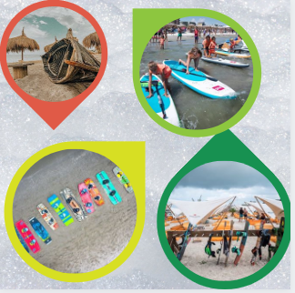
And because we want to emphasize again how important our guests are to us and entertaining them is one of our missions as well, a wide range of nautical sports – jet skiing, kite surfing, boat rides etc. will be available, as gear has been purchased. The use of the equipment will be exclusive to our guests and the fun doesn’t have to stop 24/7.
- Legal Identity
El Mar Noire will be registered as an LTD with two shareholders, Miss Banu being the main shareholder, with 70% of the shares under her name and the other shareholder, Mr. Moisescu, will hold the remaining 30% of the shares.
By registering the company as an LTD, the biggest benefit is limited liability protection. Simply put, should the company run into trouble, the personal assets of the shareholders are secure. A limited company is treated as a separate legal entity; a ‘legal person’ in its own right.
Another advantage of a limited company will be easier access to finance. The separate legal entity of a limited company might make it slightly easier to secure finance deals, rather than as a sole trader. Also, companies can raise capital by issuing new shares to shareholders or placing shares to new investors. (GovUk, 2020).

- Business description
The hotel is newly built and is placed very favorably just 200 meters away from the beach, and has all the necessary amenities in the neighborhood, with a wide range of shops, restaurants, cafes, bars and pubs in the area.
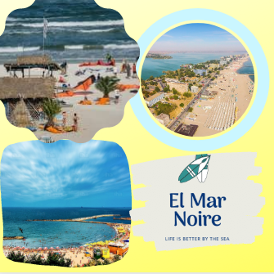
To begin with, the business can offer 10 double rooms to our guests in a traditional Romanian setting, and everything is brand new and has the touch of modern. Everything was designed in order to maximize the comfort of our guests and we do try to accommodate all of our guests’ needs. Two of our rooms are located on the ground floor and provide disabled access, along everything that is required.
We are able to offer bed & breakfast deals to our guests, as the hotel comes with a large dining area where breakfast is prepared using fresh local sourced produce. Wishing to make this business even more attractive to potential customers, every guest can use our dining space and kitchen if they wish to prepare their own food.
Amongst the other facilities provided to our guests, there is a garden area with a built-in barbecue space and a large conservatory, so people can choose to spend their time and relax without even leaving their accommodation premises.
During the summer season, parking has proven to be a real issue in the area, but ELM will provide 10 parking spaces for its guests, 1 for each room the hotel has.
Besides offering spotless accommodation and exceptional service, in the desire to succeed and impress our guests, we are very much aware of the fact that we need to be one step ahead of the competition. The customers’ needs and desires change on a regular basis, so conducting marketing researches constantly will help us be on the same page with the trends. We plan on offering numerous activities to our guests, such as water sports -and equipment for it- and partner with local water sports guides will be part of the deal for us. We can also offer day trips (by bike or by bus) to the surrounding areas so people can get to know the hidden treasures found in Dobrogea (the south-west area of Romania, located on the coast on the Black Sea), and our local guide will help them explore these areas reach in heritage (the region of Dobrogea has heavy Turkish and Greek influences, during medieval times being ‘colonized’ by these nations and in time it has adopted many of their traditions and embedded them in their lifestyle).

- Marketing and PR plan
Mamaia is an area dedicated to our holiday goers by the sea, and most people in the area run businesses created around the hotel & travel industry. The competition is very tough, and as a small business we have to get all the details right from the beginning in order to set a clear line between us and the competition.
Conducting a detailed and successful marketing research will be the key to survive and thrive in this industry. All the needs and desires of potential customers are revealed by the marketing research, and at the same time we are able to get familiar with the competition and their offers, in a bid to be better than them.
The main detail revealed by the conducted marketing research was the fact that other businesses in the area only offer accommodation and no other activities, and potential customers are interested in those ‘extras’ that we’ve able to offer them. As a result, one of our main focuses is creating a holiday package offering guests the chance to relax in our hotel but also carry out different activities every day, all arranged for to maximum satisfaction (Robin J. Birn, 2002).
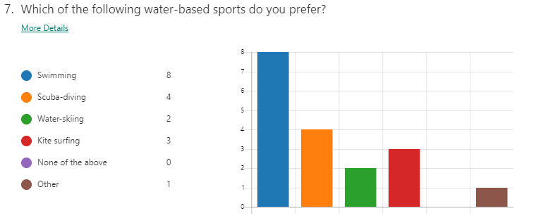
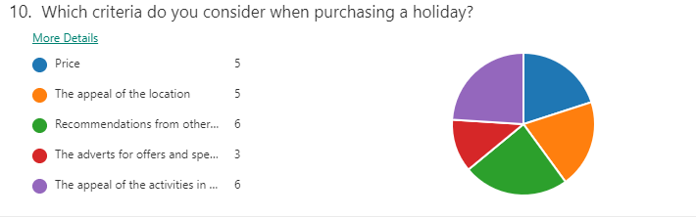
In the coast area that ELM is situated, the occupancy rate in the summer season is around 90%, and this means that our target market is not a certain group of people, but actually all the people looking for adventure, fun and relaxation (Linda Pinson, 1996).

Even though the season officially ends at the beginning of October and starts again in April, ELM aims to stay open throughout the year. In the off-season we plan on attracting guests by organizing trips and activities in nature, team-buildings, wine-tastings (Dobrogea is the area with the most vineyards in Romania), camps for improving the physical condition, with daily training in nature and by the sea, and also camps for students.
Of course our business will be heavily advertised, so that our fellow Romanians can opt to go on a holiday by the seaside and experience all the privileges offered by our business, but a main focus will be trying to attack foreign visitors. Statistics have shown the fact that very few holiday goers in Mamaia come from outside of the country, so offers designed especially for the foreign customers will be emphasized. Given the fact that we aim to offer more than just accommodation but also entertainment as well, our business should become very attractive to all kinds of tourists.
In order to attract all the desired customers from Romania and outside of the country as well, promoting the business in a right manner will be the deciding factor to our success. We have to face it, technology has taken over. Today’s holiday goers have the ability to complete an online comparative research without even leaving their beds. So the hotel needs to be very visible and easily accessible online, and in this way the bookings won’t be few and very far in between. There is a need to advertise everywhere in the relevant online environment for potential bookings, in order for people to find the business at the top of the offers list and be able to book our services for place to stay and have fun (Manish Verma, 2017).

A first step to promote our business the right way is creating partnerships with tourism agencies. Experienced tourism agencies with years of trading by the sea-side in Romania can help us build our image in the eyes of potential customers and they will do much of the promoting the business for us.
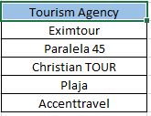
In order to target a large crowd of people and be very visible as a business, social media accounts will be created for the business (Facebook, Instagram, and Twitter) so we can interact in real time with potential guests. Having a good representation on Trip Advisor, Expedia, Hotels and other similar platforms is important as well nowadays, as people want to hear from our other guests and see the ratings given to our business (Minazzi, 2015).
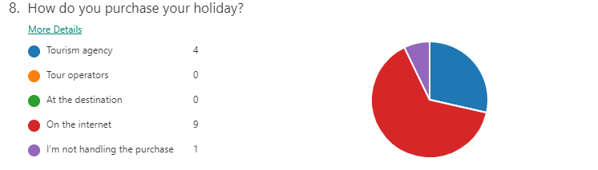
The presence of the online travel agencies (OTAs) is essential because it presents our guests with a wide variety of options to choose from, based on their preferences. One of the disadvantages of using third parties such as travel agencies is the high fees imposed by them for each purchase.
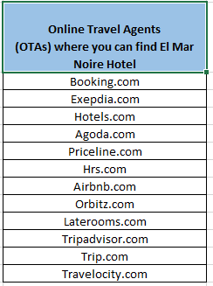
We will conduct direct mail campaigns for existing customers and potential customers, because those are efficient and not costly, in this way being able to communicate directly with the customers through personalized emails, newsletters and marketing polls, informing customers about future offers or events that we are organizing related to the customer’s preferences.

ELM will also have a logo which will easily identify to the hotel and it will be used in publicity campaigns.
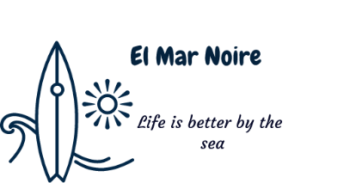

Each customer will receive at checkout a personalized wooden key ring in the shape of a surf board, graved with the ELM logo and the date of their stay with us.
ELM will have a webpage where the business will be presented and customers will be able to book reservations online, but there will also be a blog where we will post information about the hotel and services offered, about the offered activities, nearby attractions and activities offered by partners, and also stories and impressions of other tourists. Our tourists will be able to post pictures and share impressions from the holiday spent at our hotel, on the blog.

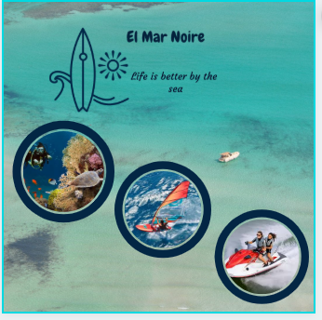
The blog will be directly connected to our YouTube channel, where we shall upload mini documentaries about the nearby attractions, about traditions and habits specific to the area and also anything related to water sports.
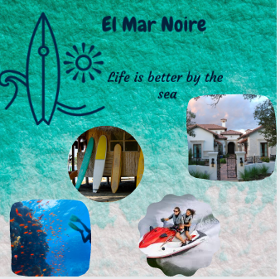
A collaboration with some of the most followed influencers has already been detailed and since the first week of opening our business some of them will be able to enjoy our services and in exchange will promote our business on the social networks where they have millions of followers (Seeler Sabrina, 2017).
Through our marketing campaign we don’t want to promote just our business, location and services, but Dobrogea and Romania at the same time.
By creating a video which presents our facilities and shows the wide range of activities offered, we hope to be able to attract even more adventures, and placing the video advert on online platforms such as YouTube and social media will catch the eyes of many and spark their interest. Considering that people share interesting videos on their social media accounts on a regular basis, our customers will do their part in promoting us as well, spreading the word about our business to their circle of family and friends. Because promoting the business efficiently is so important, all of our staff are constantly trained in order to be the ambassadors of the business. Their friendly and professional services offered at all times will be a major plus, and their extensive knowledge about the surrounding places and the will to go above and beyond their job role will help build the image of a great successful business.
Running a profitable business is what everyone aims for, and in order to gain more profits we have realized that past customers can make the best audience to market to – if they’ve had a positive experience in the past, why wouldn’t they want to return?
Even though we are a new business, we have designed a customer loyalty program to ensure that our guests come back again and again. Considering that everyone wants to see that their custom is being appreciated, by offering returning guests special perks and discounts we will only make the business more attractive to them. In the long run this process will generate steady and reliable income.
- Pricing Strategy
The current pricing strategies used nowadays in the hotel industry is one subject that will forever be discussed by professionals. There is no magic formula that is universally approved for hotels to achieve their goals, but the hotel pricing strategies that we will adopt have steadily proven to be effective for other businesses. A combination of different pricing methods will take us a long way in obtaining success in the hospitality business industry.
The room rent that we will charge for our hotel rooms plays a very important role in our business, especially when we plan on selling more rooms. Rightly pricing the rooms at the right time will help sell more rooms and boost the occupancy, which leads to increased profitability.
The hotel room pricing strategy plays a vital role in the success of our business. If the prices charged are too high, we will lose customers to the local competition that offers more reasonable rates for more or less the same type of accommodation and services. And then, if the rates are not competitive enough and you charge less, you will end up losing money. In this case you can get more guests, but it will be difficult to cover the operational costs, which will increase.
Determining the right hotel room rate is not an easy task, and the whole game of hotel room pricing strategy becomes quite complex as there are several factors that impact the room pricing. Some of those factors are: our room types, value of services offered, occupancy, demand and supply on the local market, competition pricing, seasonality and even the day of the week.
The occupancy based dynamic pricing strategy that we plan to use will be a great way to increase room revenue. The rooms of the hotel will be priced based on supply and demand, and then when the demand exceeds the supply, the room rates have to be increased. For example, if 8 out of the 10 rooms are already occupied and there is a high demand, the prices for the remaining two rooms can be increased.
After understanding at what rates the competitors are selling their rooms we are able to come up with a competitor-based hotel room pricing strategy as well. We have considered the hotels that come into the same segment and star category, and we have analyzed what the competition is offering for the rates charged. Our proposed rates have been compared to their rates and the prices have been set in a way to offer more value to our guests. By keeping on monitoring this properly, we will be able to understand what customers are already paying and how much they are willing to pay. Armed with these insights, our hotel room prices can be set at an attractive rate so we can sell our services at competitive prices.
Offering package deals is one of the most effective pricing strategies in the hotel industry, and we plan to make good use of it. Instead of selling just rooms, we will create specific packages inclusive of additional activities at a reasonable rate. This strategy usually compels people to believe that they are getting more for less. The packages could be as simple as “Bed & Breakfast’ or customers can tailor the offer to include any kind of activities from the ones we have previously mentioned (De Robert Reid, 2009).

Actual analysis of price for the competition
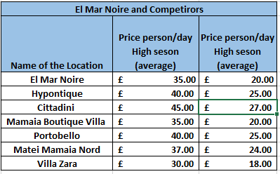
The competitors were chosen considering the following criteria: similar services offered, situated in a close range of our location, the same guest capacity and same facilities offered, similar overall features. The analysis was difficult enough because in the area there are only a few hotels offering the possibility of booking extras such as nautical sports, and the ones do offering it are part of the luxury hospitality sector in Romania.
For the first year of business will adopt a penetration pricing strategy, our price being a bit lower than the one of our competitors, this strategy being chosen because we are new on the market and wish to attract customers from the very beginning. (ManuelSánchez-Pérez, 2020)
At the same time we will use a strategy of differentiating the price, offering small discounts to customers who wish to purchase holidays with at least 3 months in advance.

- Human resources
The business structure we intend to build at EMN:
Iulia Banu, the main shareholder of ELM has over 15 years of experience in the hospitality industry in Romania and Spain as well, knows very well the market, requirement and needs of customers.
The other shareholder is qualified sports coach, mainly focusing on nautical sports, with over 10 years of experience and a large portfolio of potential customers based in Romania and overseas as well.
Both shareholders are born in Constanta and they are familiar with the local attractions and the beautiful landmarks usually known just by locals, which you cannot find in touristic guides.

- Job Roles and Responsibilities
Miss Iulia Banu
- Important decision making related to anything which directly affects the company.
- Employee recruitment.
- Leading the acquisitions department, procuring all the goods necessary for the business.
- Stock audits.
- Signing and negotiating contracts with partners.
- Basic economic accountancy.
- Marketing research and marketing strategy development.
- Accompanying tourists in their trips as a touristic guide.

Mr. Andi Moisescu
- Making sure all of the sports equipment is in a good working condition and responsible for the maintenance of that equipment
- Offering services as a water sports coach, all activities being conducted in a professional manner.
- Supervise the nautical activities carried out by tourists.
Customer Service Executives/Reception
- Answer in a professional way to all the questions and enquiries, face to face or over the phone.
- Be very well documented regarding ELM and able to communicate all of this information to our guests.
- Use efficiently our online booking system.
- Send and accept information from our partners.

Cleaners

- Ensure at all times the cleanliness of the location, including rooms, conservatory, kitchen, dining room and all communal spaces of the hotel, at the highest possible standard.
Actual recruiting process: through web-sites specialized in the job recruitment of qualified people and recruiting agencies.
- Finances
The two shareholders will access the Startup Nation Scheme, which grants £30.000 in funds offered by EU to new businesses, non-repayable, with the purpose of acquiring equipment.
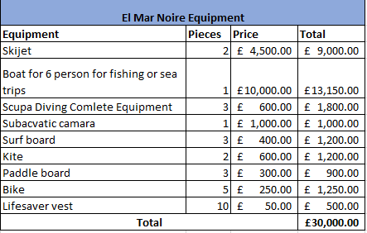

For covering unpredicted costs and in order to ensure the cash-flow, the 2 shareholders will access a £20,000 loan repayable over the course of 3 years, with a monthly pay rate of £641.
- Cash Flow Forecast
Represented below is a prediction of the income and expected expenditure for the first 12 months of business activity.
For estimating the monthly revenue, we have considered a cautious occupancy rate of the hotel and calculated average amounts attributed to the touristic activities offered to customers. All the costs have been adapted for each season by taking into account its particularities, opportunities, threats, and general market trends.
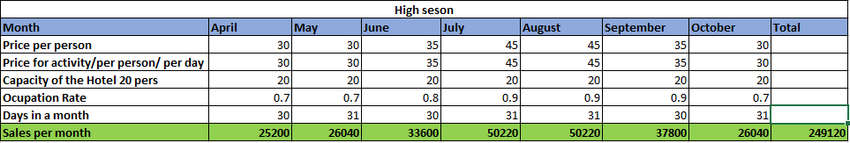

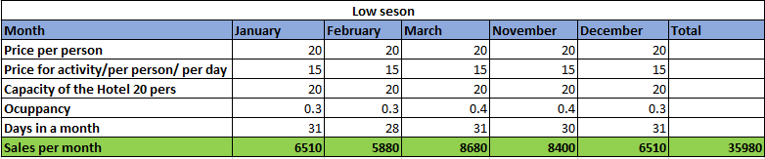

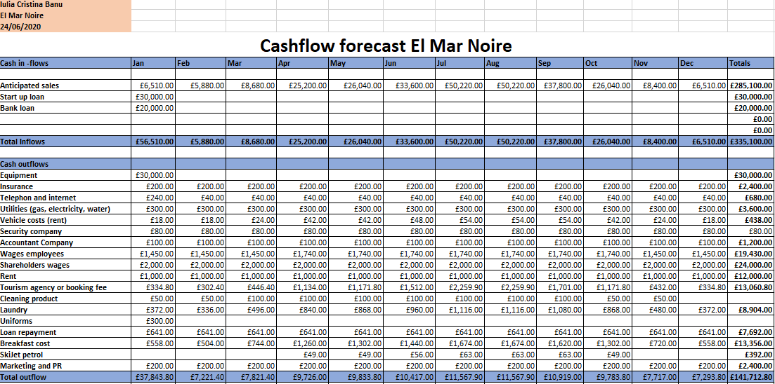

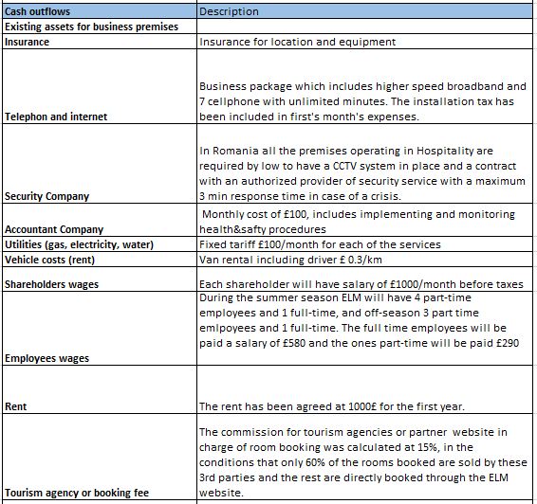
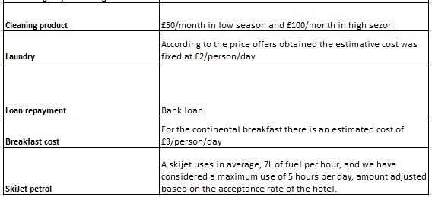

- Conclusion

- Tourism is one of the largest industries in the world, having a huge significance in the development of different countries worldwide. In Romania, even though the tourism industry is not very well represented, in the area which our business operates it represents the main business operating sector, with more than 60% of the population being employed in tourism industry. The tourism in this area is experiencing a boom period which has been in growth for the past 10 years and it’s not showing any signs of slowing down, promising future opportunities for the people of this region and great benefits for both the population and Romania as well.
- Every business needs a written plan, and the above plan detailed by us is the result of a thorough marketing research that we have conducted. Although this plan isn’t necessarily the ground zero when looking to launch a business, its benefits are clear, and there is no question that the plan will come in handy as it’s going to be needed sooner rather than later, especially when launching a business which started with a great economical investment and has forever attributed a great economical responsibility to the business partners.

- The business plan described above is but a starting point, but this project will set ELM on the path to success and growth in the hospitality industry. that our strategies are effective enough to enable us to break off any weakness

Appendix 1
SWOT analysis
STRENGHTS | WEAKNESSES
- Our strength lies in the fact that we are located in one of the most popular tourist destinations in Romania, which means more customers are likely to be headed our way. Also, our competent employees who understand the hospitality business are ready to ensure that we achieve our intended goals.  - The business has an extra chance at succeeding as it will generate profits from the Guest house and extra services offered with our special package deals.  - Finally the two shareholders have vast experience in the hospitality, and they will bring forth their experience to bear on the business. | - Like any other business, we have certain weaknesses in the fact that we are located in an area with plenty of hotels, and this can be taken to mean that the market here is saturated. Our several marketing strategies that we have in place were designed in a way to help us break this weakness and excel amongst other beach resorts. We are positive that our strategies are effective enough to enable us to break off any weakness.  - Also, as a new business on the market it will be harder for us to make a name for our business in the first year.  WEAKNESSES
OPPORTUNITIES | THREATS
- Like any other business, we have certain weaknesses in the fact that we are located in an area with plenty of hotels, and this can be taken to mean that the market here is saturated. Our several marketing strategies that we have in place were designed in a way to help us break this weakness and excel amongst other beach resorts. We are positive that our strategies are effective enough to enable us to break off any weakness.  - Also, as a new business on the market it will be harder for us to make a name for our business in the first year. | - Dealing with threats is not alien to any business and so we expect to deal with a few before we start up the business and also during the course of running the business. Threats such as a downturn in economy or arrival of new competitors in the same area are likely to occur.  - A few other factors worth mentioning are: the declining income of the population, resulting in less people looking to go on holiday, and the reorientation of a good part of holiday goes towards other holiday destinations in different countries.  - The fact that the taxes imposed by the local authorities are always going up will result in diminishing the profit of the company.  - The duration of the summer season throughout the year is of only 7 months, and this is a threat to be considered if we want to run a successful business.

- WEAKNESSES
- Like

- any other business, we have certain weaknesses in the fact that we are located in

References
Abrams, R. M., 2003. The Successful Business Plan: Secrets & Strategies. s.l.:s.n.
De Connie Mok, B. S. J. K., 2009. Service Quality Management in Hospitality, Tourism, and Leisure. s.l.:s.n.
De Robert Reid, D. C. B., 2009. Hospitality Marketing Management. s.l.:s.n.
GovUk, 2020. Limited companies. [Online]
Available at: https://www.gov.uk/limited-company-formation?fbclid=IwAR1mxX1M5plzVOmttMnHBJQCTg-RjN_iEPEnszhfl_cKLjDjK4NPYTZSUBE
[Accessed 24 6 2020].
Jagmohan, D. N., 2008. Hospitality Reception and Front Office (Procedures and Systems). s.l.:s.n.
Linda Pinson, J. J., 1996. Target Marketing: Researching, Reaching, and Retaining Your Target Market. s.l.:s.n.
Manish Verma, K. V., 2017. Social Media a Promotional Tool: Hotel Industry. J o u r n a l o f A d v a n c e s I n H u m a n i t i e s, Volume V o l u m e 5 N u m b e r 1, pp. 221-223.
ManuelSánchez-Pérez, M. D.-M. S.-P., 2020. You’re the Only One, or Simply the Best. Hotels differentiation, competition, agglomeration, and pricing. International Journal of Hospitality Management.
Minazzi, R., 2015. Social Media Marketing in Tourism and Hospitality.
Robin J. Birn, R. B., 2002. The International Handbook of Market Research Techniques. s.l.:s.n.
Seeler Sabrina, L. M. S. H., 2017. The experienced tourist - the role of the social media influencer. s.l.:s.n.

- an area with plenty of hotels, and this can be taken to mean that the market here is saturated. Our several marketing strategies that we have in place were designed in a way to help us break this weakness and excel amongst other beach resorts. We are positive that our strategies are effective enough to enable us to break off any weakness.
- Also, as a new business on the market it will be harder for us to make a name for our business in the
- .
- t WEAKNESSES
- WEAKNESSES
- Like any other business, we have certain weaknesses in the fact that we are located in an area with plenty of hotels, and this can be taken to mean that the market here is saturated. Our several marketing strategies that we have in place were designed in a way to help us break this weakness and excel amongst other beach resorts. We are positive that our strategies are effective enough to enable us to break off any weakness.
- Also, as a new business on the market it will be harder for us to make a name for our business in the first year.
- WECONC

- AKNESSES
Like any other business, we have certain weaknesses in the fact that we are located in an area with plenty of hotels, and this can be taken to mean that the market here is saturated. Our several marketing strategies that we have in place were designed in a way to help us break this weakness and excel amongst other beach resorts. We are
- Like any other business, we have certain weaknesses in the fact that we are located in an area with plenty of hotels, and this can be taken to mean that the market here is saturated. Our several marketing strategies that we have in place were designed in a way to help us break this weakness and excel amongst other beach resorts. We are positive that our strategies are effective enough to enable us to break off any weakness.
- Also, as a new business on the market it will be harder for us to make a name for our bu

