Marketing plan written for
11 Cadogan gardens (relais & chateaux)

Student Name
Abdul miah

Student ID number
2027095

Marketing Essentials BMIH4005

Lecturer
Deborah Lloyd

Introduction.
11 Cadogan gardens part of relais & chateaux hotel. the geographical area is in London the heart of Chelsea minutes away from Kensington and all the designer shops. Reason why marketing plan was chosen because it’s in London the capital of England this hotel is in a very high-class high security rich expensive beautiful. It its location such an high class the most lavish hotel it has 56 rooms and suites with experience its like each room is each different world. The building the structure the foundation of that building dates back in the 19th century when it was built by lord Chelsea.

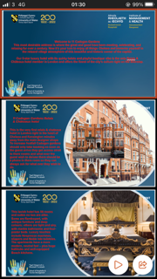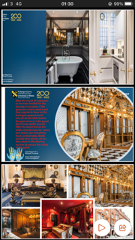

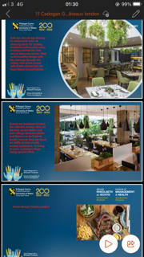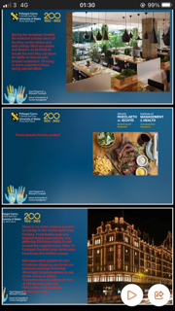

- Marketing Mix

Product – CADOGAN SUITE.
1 king or 2 twin beds average size 45m² (485ft²) with separate living room En-suite bathroom with bathtub and walk-in shower, basin and toilet cimes with a Hairdryer Bathrobes and slippers. Noble Isle toiletries. Complimentary Hi-speed Wi-Fi with Samsung LED Smart TV with satellite channels. Ruark Bluetooth DAB Radio Air conditioning Nespresso machine with Bottled water ironing board Maximum occupancy 3 Person
Price –
£944 per night (including taxes and fees)
Comes with many different styles and prices starting from £400 rising to £1000 a night.
Place –
Based in the heart of Chelsea in a very busy place very expensive buildings with high class designer shops around. This stunning boutique hotel comes with leafy views of Cadogan gardens even the hotel and dinning has leafy views inside. This hotel is near harrods knights bridge where expensive shopper go to eat and stay in hotels.
Promotion –
sometimes when you look online on social media or websites you can find good offers with promotion code even sometimes if someone knows someone that goes to Cadogan quite regularly they can give there promotion code to their friends and family. There are promotion if you book higher rooms and suits Cadogan garden hotels gives promotion discount to shop in Harrods or sometimes if you book online, you can get free dinning at the HANS bar and grill.
- The Marketing Environment (Micro-SWOT)

In the restaurant it’s such an lovely dinning with high quality food served the tables has wine glasses which is great but it can be better if they bring the glasses out when drinks are being served so the glass don’t have any dust. On the website it has pictures of food menu but has no fruits in the pictures which is a healthy option. On the menu website could not find no vegan options on the breakfast which will attract a lot of customers having a vegan option put on for breakfast. Restaurant has a great touch will real plants and flowers stay green great air to breath the menu is great with great choice to choose from but it’s very confusing has no price written on which will confuse the customers from ordering what they want to order.

About the 11 Cadogan hotel the suits bathroom has no skin type product apart from soap an lotions. A lot of people has different skin conditions they should give options to the customers before booking the rooms if customer has skin conditions like rashes on the skin and asthma they should be given options to change the bedding shits and the bathroom products to what is sensitive for there skin which is an very important part.

- The Marketing environment (Macro) PESTEL

Chelsea is a high-end expensive area 11 Cadogan gardens is in such an perfect location. They have to compete the price and wages high rent in the central plus the rate VATS. So, when making decisions they have to look in to all these keys the food quality and service demands has to be high up. Most of the customers are high end peoples like office people staying over for meetings or customers coming over from other countries so it brings in moneys to this country. Hotel is environmentally friendly the restaurant has wooden tables with greens plants across the room fresh food prepared by top quality chefs. They have to compare them self to other hospitality chains. Sometimes the law can often change like the covid 19 lockdown a lot of things have changed in marketing and the finical ways company’s markets and operate like getting hold of suppliers for the beddings products and the restaurant getting hold of meat and veg was hard when exports have stopped during lockdown plus prices went up and staffs where on pay leave. There is a lot of designer shops surrounding Cadogan gardens it’s a busy walking area with lots of cultured peoples.

- Creating Customer Value & Engagement

Keep a database of all customers do monthly surveys keep customers email phone number and home address to they can send promotions and offers and get response back from customers make Facebook page and social media platform ask them what they want what they like how they want there booking or order to be keep customers happy with friendly customer assistance let the customer be in control give them change to pick or choose what they desire. Following covid 19 11 Cadogan garden has funded 250 retail and leisure companies have received £15m of tailored financial supports. Give the customers great offer if there is any promotion sell it to your customers give them benefits be close and friendly to the customers share your torts with them offer them a coffee to start a talk. Cadogan does a offer if you book an full suite, you will get shopping vouchers for Harrods shop and with and welcome glass of champion give the customer the security that there are safe to stay at Cadogan gardens give customer service of their life time so they love and and come back again or recommend there friands and family back to visit the 11 Cadogan gardens.

- Effective Use of digital Marketing

these days with the new technology all the young people use Facebook Using Facebook an Instagram to market 11 Cadogan gardens keep all the customers add on Facebook an send them promotion when customers come if they like they can take pictures and upload it on Facebook or Instagram and tag 11 Cadogan gardens so it can attract and bring in more and more customers. Email is another great way keep in touch with the customers over email take bookings and orders over email. Digital marketing is very important theses days with the new technology all the young people use Facebook. Using Facebook and Instagram to market 11 Cadogan gardens keep all the customers added on Facebook and send the offers and promotion when customers come if they like they can take pictures and upload it on Facebook or Instagram and tag 11 Cadogan gardens so it can attract and bring in more and more customers. Email is another great way keep in touch with the customers over email take bookings and orders over email its great to use email if customer has a booking in 11 Cadogan gardens they can cancel or change there booking via email everything can be done with an laptop desktop or a smart phone.

Conclusion –

At 11 Cadogan gardens the bedding materials should be checked and suitable for all types of skin conditions are the toiletries are upto date and fresh put fresh fruits on every tables give customers great offers give them offers like example book for 4 nights and get 1 night free or maybe like an meal for 2 for free at hans bar and grill. Give customers free glass of wine or champain look for the loyal customer and give them benefits give them VIP pass and treatments let the customers feel comfort and in control if there at 11 Cadogan gardens. Keep the restaurant clean keep the tables open and clean keep fresh flowers on the tables for fresh air make sure the guest are checked on everyday take surveys for every customer that comes in and out or 11 Cadogan gardens so hotel can keep monitor on what customers want.

References –

https://www.11cadogangardens.com
B aresenault. Travel time feb 07 2020.
F Duncan. April 2016.
J buckley. 2019.
J schreier. 2017.
M aronson.
M stevens.
M simon.
N Schuster.
O robins.
S natalie.
S grace.

