DS 1 Template

My Screenshots/Photos
- Please add 4–6 screenshots or photos of your digital life.
- You can use your phone or laptop.
- For each screenshot, write one or two sentences explaining what it shows.

Screenshot/Photo 1
My Digital skills Week 3 notes
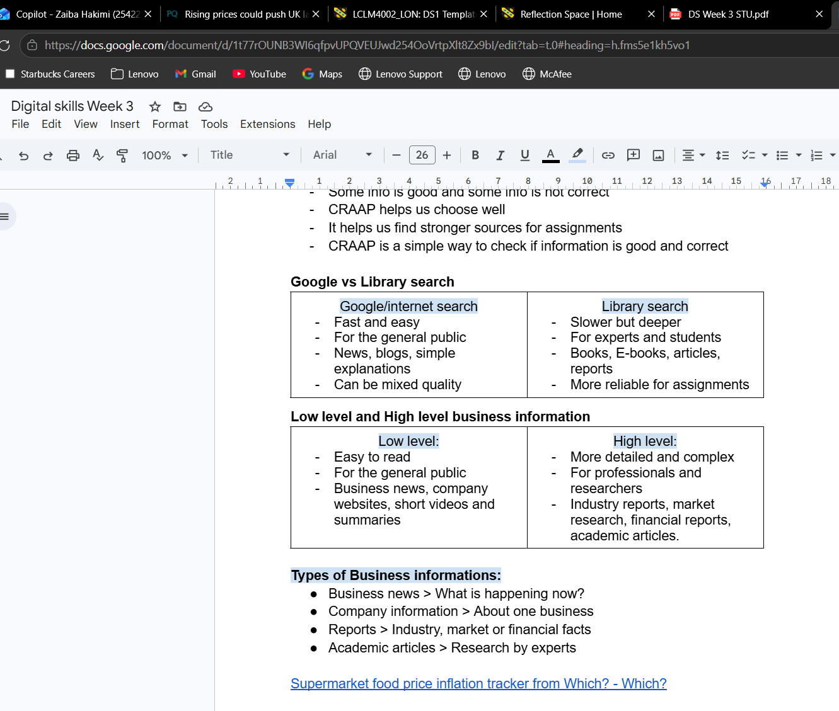
In the image above, I used Google Docs to create clear structured notes to help me memorise and understand the information I learnt in class that day. I inserted a table, as well as hyperlinks to website sources which gives me easier access compared to searching for the information separately. After taking this screenshot, I saved the document into my OneDrive under Digital Skills - Week 3. By taking notes on Google Docs; it keeps my notes more secure. This is because if I exit the tab, I will not lose my work as it saves automatically. There is a risk of losing or damaging physical notes, which strengthens my decision to use online note taking for studying. This also demonstrates my digital note taking skills and file organisation.

Screenshot/Photo 2
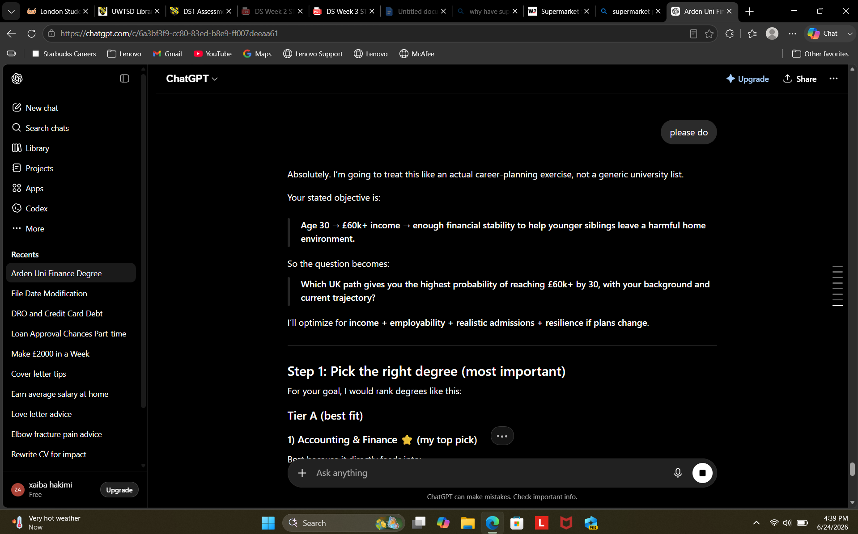
Outside of the course, I also use digital skills to aid other aspects of my life. In the picture above I have used an AI bot to help plan out an education plan for me, which best suits my own personal life. Using AI is a grey area for me, as I know the drawbacks and benefits of using this digital tool. It consumes a lot of water which has recently caused an uproar on the news, as well as the ethics of using artificial intelligence. However, it can be very efficient to the ordinary person and students, as it can skim and sort out information from all over the internet in just a few seconds. Its rapidly advancing features have also allowed AI to now use phrases and descriptions to create images and videos without the need of human labour. Overall, using AI presents my digital skills and the ability to communicate clearly with a non-human assistant to help use my time more efficiently.

Screenshot/Photo 3
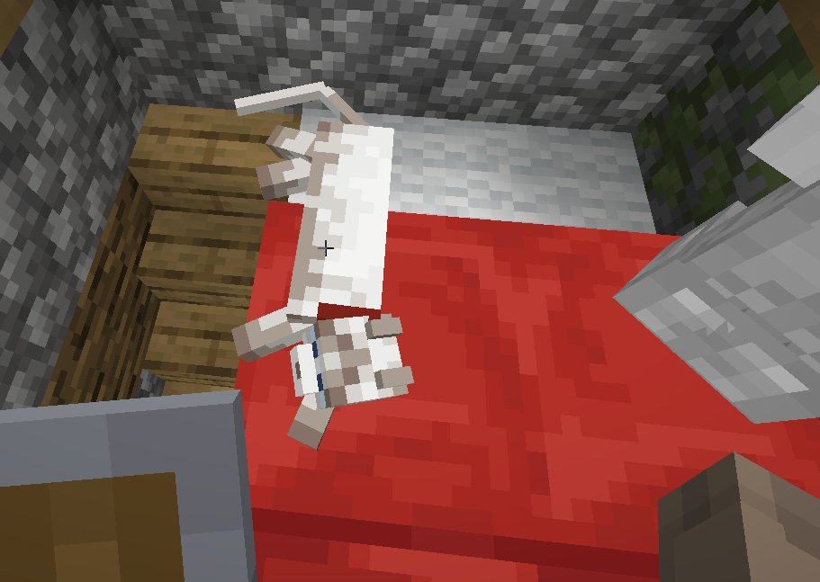 In the image above I have shown a screenshot of myself playing a game on my laptop called Minecraft. In this game, you use the WASD keys on the keyboard to move as well as other keys having particular functions for the game. This showcases my digital skills and how I can use it for leisure activities as well as academic. This game can be quite fast paced which helps my ability to type and use my mousepad with more control. I have noticed that my touch typing skills had improved after playing digital games on a computer as I have to pay more attention to the screen compared to the keyboard.

Screenshot/Photo 4
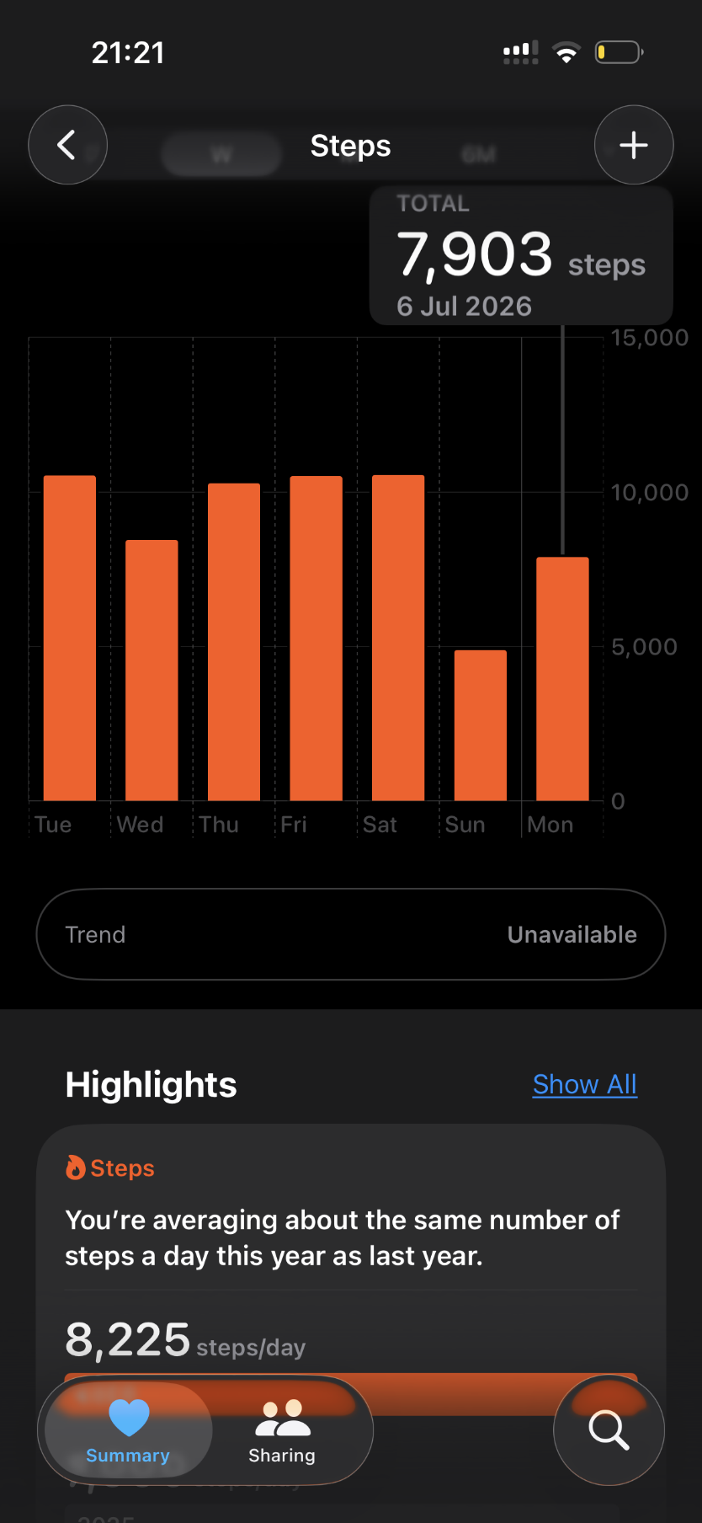
The screenshot above is from my health application on my phone. This demonstrates my use pf digital skills to help keep me on track of my fitness journey and recognise patterns and estimations on calories burnt and steps taken. I find this quite useful as I usually carry my phone with me so it can track my movement throughout the day and present it to me in a bar graph with comparisons to previous weeks/months of data.

Screenshot/Photo 5
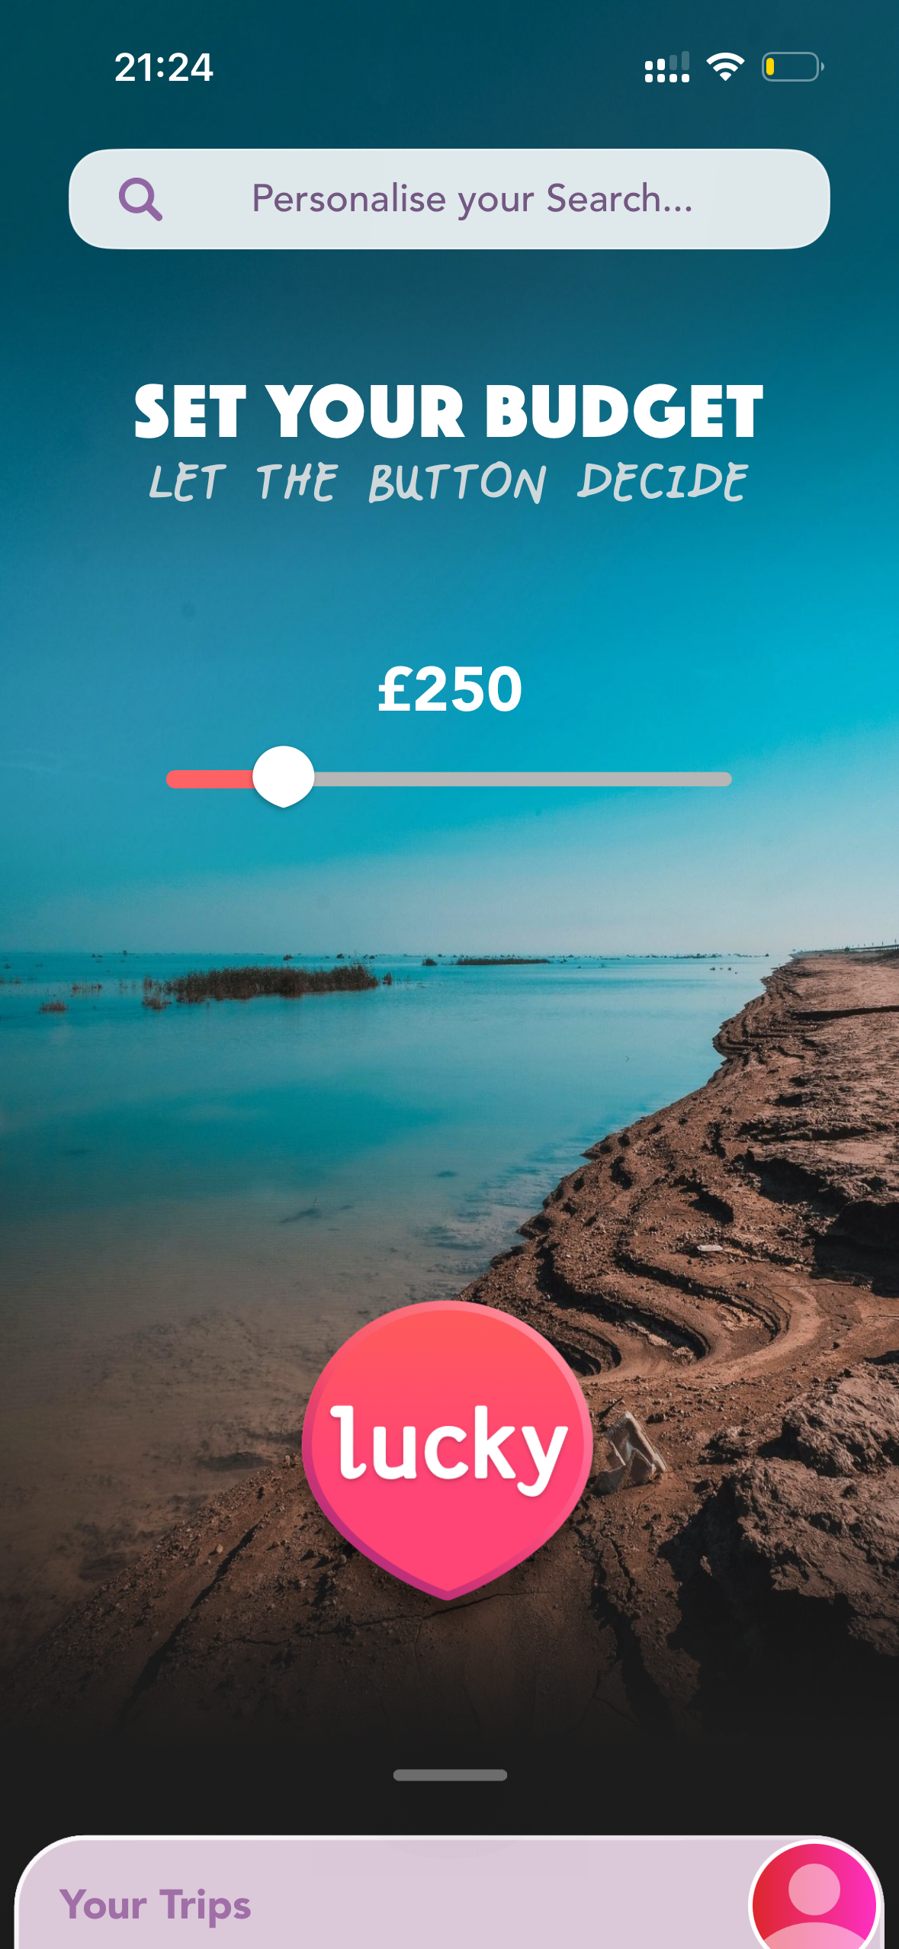
This screenshot above is from an application called Luckytrip taken on my phone. This app allows me to choose a holiday based on my budget and specific preferences without me having to scope multiple different websites for flights, hotels, weather conditions and so on. This makes it incredibly efficient to book holidays and takes up less of my personal time so I can focus more on other aspects of my life and plan the outfits to pack instead.

Screenshot/Photo 6
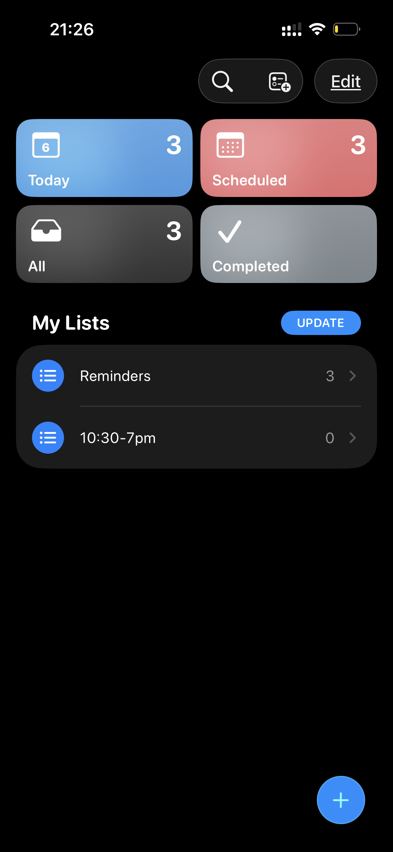
The image above is a screenshot of my reminders application on my phone. I use this digital tool daily to keep me on top of daily tasks, and deadlines. This tool is incredibly helpful to me as it aids in multiple different areas of my life whether it be administrative tasks, bill due dates, appointments, or even sometimes chores. This is almost like a to do list that moves with the time, and I can set up repeat reminders as well as specific timings for them.

My Short Reflection
- Write 5–8 simple sentences about your digital life.
- You can use the sentence starters below if helpful.

Sentence starters
- I use digital tools to …
- I feel confident when I …
- I want to improve …
- I often use these tools: …
- I sometimes feel nervous about …
- I hope this module will help me …
- Digital skills are important for me because …
You can write more if you want.

Submission Checklist
Before you submit, please check:
​​​ ☐ I added 4–6 screenshots
☐ I wrote short sentences for each screenshot
☐ I wrote my short reflection
☐ My work is my own
☐ My file opens correctly
​​☐ My file opens correctly

