A guidance handbook for early years practitioners to support young children through transitions

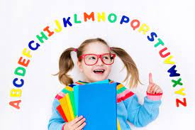

Contents Page

Introduction 3

The needs of the child 4

The role of the ADULT 7

Environments 11

Partnerships 13

Interventions 15

Proposed outcomes 17

REFERENCE LIST 18

Introduction

This handbook's main purpose is to guide practitioners within the early year's workforce in supporting young children through transitions. This handbook will discuss what is meant by a transition, the role of an adult, the needs of the child, the environments in which the children are learning, working partnerships, interventions and proposed transition outcomes.

What is a ‘transition’?

According to Bronfenbrenner (1979; cited in Brooker, 2008), a transition is when a child's place in the environment is adjusted due to a change in role, setting, or sometimes both. Brooker (2008) says that transitions happen frequently throughout life and are usually regarded as developmental changes that mould children's lives through their numerous subsequent adjustments. Young children can learn many new skills and gain knowledge of their surroundings and environment through transitioning. It is said that the shift from home to group care is one of the most significant effects of social change for young children, according to Neuman (2001, cited by Brooker, 2008). The practice of enrolling children in childcare before their first birthday has become standard in many nations as more and more mothers enter full-time work.

The needs of the child

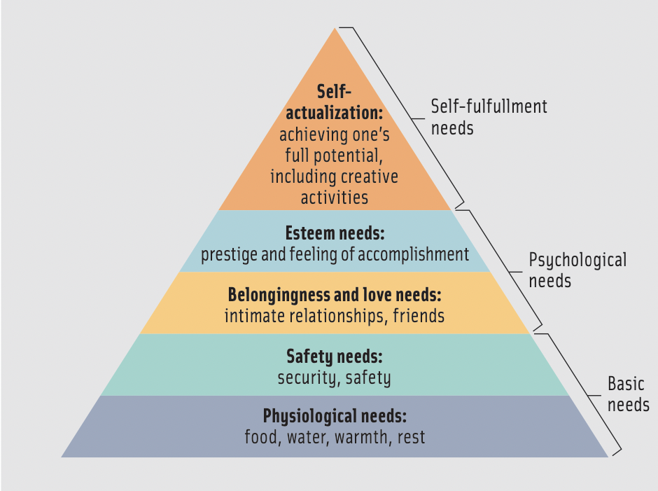
Children in the Early Years have a wide range of needs that should be identified and then addressed by adults and practitioners. According to Maslow (Poston, 2009), the living body is the most special machine in the universe and has many needs that must be satisfied for it to grow and develop to its fullest potential. Maslow thought that a child's physiological needs should be attended to initially as they are still developing in their early years. Necessities including food, water, warmth, and rest are included here. These needs must be satisfied before any additional growth can occur. These physiological requirements are necessary for the human body to function as a whole and carry out the essential function of survival. In general, an individual's appetites have an impact on these demands. As the child grows older, their taste buds will develop, and the child will grow the willingness to try more foods.
(The School of Life, No Date)
(The school of life,
No Date)
Safety needs come next on the hierarchy of needs. The desire to feel safe and secure must be maintained throughout life, just as physiological needs. These needs can vary from person to person, but in the case of children, they may take the form of a need for a secure home environment. In the home, there should be safety, warmth, and affection. when a family is frequently dysfunctional, it can have a significant impact on the child's development, and they may find it difficult to move up and meet their social needs. (Poston, 2009) During a transition such as a nursery to reception, the practitioner has a duty of ensuring the child feels comfortable, safe and looked after within the environment as it may be a new place that the child is unfamiliar with.
The pyramid then moves on to needs for belonging. These requirements reflect the social drive to belong. When a child wants to develop relationships with others, they can have a sense of belonging. Young children may exhibit behaviours that seek approval more frequently. The child may participate in activities to attract the attention of their parents or caregivers, such as exploring or asking numerous questions. Several things can affect a person's yearning to belong. One of these is socioeconomic influences, which include factors like the educational attainment of parents and family members, the neighbourhood where a child is raised, the kind of schools they attend, and the other students who attend those schools. Based on these factors, it is likely that whichever kind of behaviour is learned and approved will be the behaviour that shapes a specific child's character and sense of self-worth. During a transition, a child will encounter many new people whom they may not recognise, which can be quite daunting for the child at first. However, when entering a new environment, every child seeks to make new friends and relationships, and practitioners can support this by using different communication methods and play techniques to spark the interests of the children, bringing them together with things they may have in common. It is also important for a child to create a healthy, positive attachment with their secondary carers, the key workers or practitioners within their school setting. Adults can observe the behaviour and reactions of the children to identify how comfortable they may feel in the environment, and therefore can make any appropriate changes to ensure the transition is as smooth as possible for the child.
After that, Maslow lists self-esteem needs as the following set of needs. When addressing one's self-esteem, a child's development creates a link to awareness. Self-esteem is reported to start developing as early as two years old. Maslow addresses self-respect as the highest level of self-esteem. This desire supports the concept of ability confidence, mastery of a skill, or demonstrated competency in the child's work. This factor is extremely important when a child enters a new transition in their life. Practitioners can promote self-esteem and self-respect by praising the child for their creativity and good work within the classroom. Adults can provide many different activities for the child to help them find their individual skills and abilities and develop these as they explore through play.
Finally, self-actualisation is at the very top of the pyramid. According to Maslow, this need is self-sufficient, thus, to satisfy it, all the other needs in the pyramid must also have been satisfied in some way. To achieve self-actualization, a person must become aware of whom they are while embracing what they learn to be true, without limitations.

The Role of the Adult

Urie Bronfenbrenner developed the bioecological theory, a theory of human development, in 1998. According to this hypothesis, a child's immediate surroundings include their home, family, peers, school, and neighbourhood. Bronfenbrenner believes that a child's development and growth can be widely impacted by the role of an adult in their life.
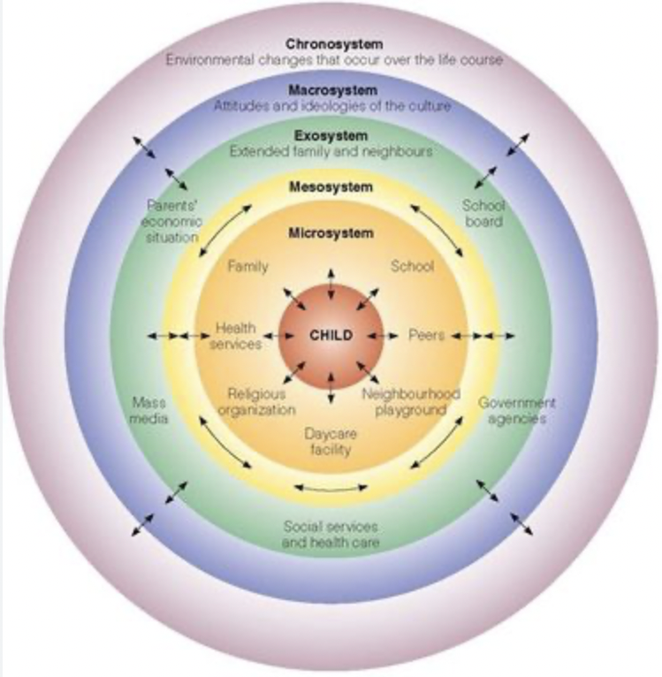

(Simply Psychology, 2020)
Halpenny, O’Toole and Hayes (2017) state that adults can learn a lot about a child's personality and the environment through reflective observation of the child, which will promote healthy growth and learning. Positive, productive attitudes are described by Bronfenbrenner. One is the degree to which the child tends to stick with and participate in more difficult tasks. Children will construct, reorganise, and develop new characteristics in an environment, symbolic changes, as well as physical and social changes when provided with suitable circumstances. Another category of developmentally generative dispositions considers children's growing ability and active inclination to interpret their experiences. This, according to Bronfenbrenner (1998), helps in the development of "directive belief systems" regarding oneself as an active agent both about oneself and the environment. Since these personal belief systems form the basis of self-directed learning, concentration, and problem-solving, it is especially crucial and relevant to the early years of practice. It is important that in early years settings a child is given the freedom and opportunity to explore, and practitioners should provide activities and tasks for the children that are child-led.
Practitioners need to form positive and secure attachments with early years children, especially during nursery to reception transitions. When experiencing these difficult changes, building a positive attachment with a practitioner in the setting can help the process easier for the child. This transition can be difficult for the child and can be frightening going into a bigger setting, surrounded by many new people. Ensuring that a good relationship is formed can help the child to feel more comfortable and at ease during the transition and make them feel as if they have a ‘safe place’ with that person. Children go through many transitions in their life, but the most important and most difficult ones are in the early year's stages. Babies who are separated from their primary caregivers often experience separation anxiety, which is of particular interest to early years practitioners. Most of the time, a child will cry when their parent leaves because they have developed a close, loving bond with them. It will get easier for the child to say goodbye to their parents as they form a relationship inside the environment where they feel protected and cared for as they form a secondary attachment to the practitioner (Bowlby, 2007, quoted in Halpenny, O’Toole and Hayes, 2017). There is a perception that adults have a significant influence on every child's life, particularly during transitions. According to Brooker (2008), early years children have the chance to receive close, individualised attention during their transition to a new setting, when they are cared for by an adult who watches and waits, follows their preferences, and supports their development through careful planning, exhibit many positive outcomes. Recognizing each child's uniqueness enables better support to be given to each child, ensuring that they can achieve their full learning potential. This is the foundation of an early years practitioner's profession. In the early years, practitioners must carefully monitor and assess a child's activity, involvement, and development as this enables the practitioner to gain more knowledge about the kid's skills and, in the future, to recall and take these observations into account when creating a development and care plan for the child to give everyone the greatest support possible.
The way an adult responds to, supports, and directs the growth of a child can influence that child's development in the later stages of life. Bowlby (1982) discusses the theory of attachment. According to Bowlby, a developing child needs to learn to trust and, eventually, to become more independent. Affection, concern, and the reasonably rapid meeting of the child's needs can help with this. Babies cry when they are hungry, in discomfort, tired, or anxious and in Bowlby's opinion, a parent's response in such situations establishes the basis for the child's attachment to them. A baby learns to trust that the parent will always be there for them in times of need if the parent reacts consistently and warmly, and a stable attachment is then created. In some circumstances, like abuse and neglect, if parents don't attend to their child's needs, the baby learns that adults are, at best, untrustworthy and, at worst, frightening and form an unsettled attachment to the parent (Halpenny, O’Toole and Hayes, 2017).

Environments

Children's learning, play, and development surroundings can have a significant impact on their development. Theorist Lev Vygotsky (1962) held the view that children are not egocentric but rather social beings that seek to understand the world through communication. It is suggested that Vygotsky developed theories that concentrated on the social and environmental components of development as a result of the communist environment in which he lived and worked. His theory put a heavy emphasis on play, language, and sociocultural elements. (Pound, 2014).
Children perform better in their play than in other real-life situations, according to Vygotsky. It is crucial to allow time for play and freedom throughout transitions. Children have the chance to learn about rules and find solutions to issues through play. Play may encourage a child to grow in an exploratory zone by allowing them to explore and venture out to acquire new skills. Children are more likely to interact with one another during transitions through play than through focused or isolated tasks, which fosters good connections and positive growth.
Vygotsky also placed a strong emphasis on language and communication in his theories. Any linguistic or communication obstacles that may exist during the transition from nursery to reception should be brought to light to be addressed and minimised. This is important as a child may feel isolated if there is a communication barrier, therefore a practitioner should go to every measure to ensure that the needs of the child are met. The relevance of the labelling process in the creation of concepts was emphasised by Vygotsky. Children's language was social in nature since it developed via interaction with other people. For children in the early years, communication is a vital aspect of being able to understand the needs and wants of the child. Using communication and language techniques, the child can discuss their feelings, emotions and so on about a topic or an activity with then allows the practitioner to appropriately make any changes to ensure maximum support, care and education.
There are additional factors that affect growth, and according to Vygotsky, the zone of proximal development is the best-known part of his theory. The difference between what a child can accomplish on their own and what they can accomplish with the assistance of an adult or other person with greater experience can best be characterised as this. When adults assist a child in learning, they are promoting the growth of understanding and skill. A type of mental conflict that results from social interaction can lead to new learning. Children who are in a new environment will ask lots of questions to learn new things about where they are and what they are doing. Practitioners should allow all children to be curious and adventurous, so they become familiar with the environment in which they are (Pound, 2014).
(Healthline, 2020)
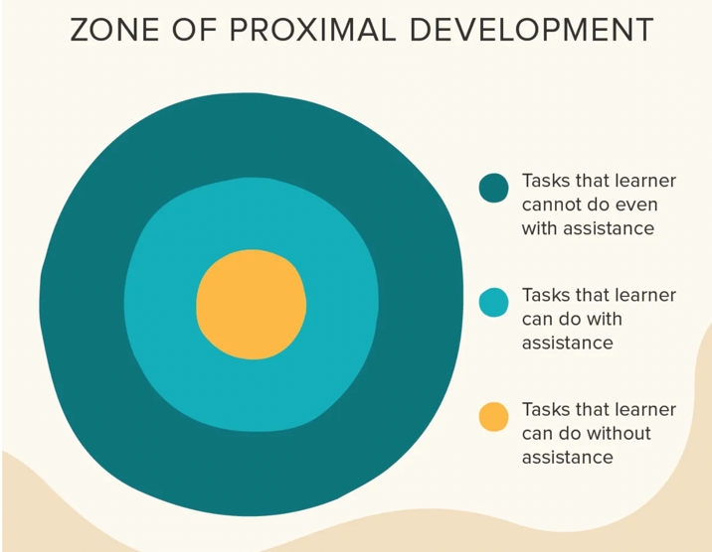

Partnerships

One of the most crucial elements of working with children in the early years is partnership working. Wilson (2016) claims that creating partnerships with parents benefits not just the child in a setting but also the larger society. To obtain help and information, parents and professionals must establish trusting connections. If necessary, this might result in more intense support for families. There are opportunities to help and direct parents to various forms of intervention as professionals who have frequent and intimate contact with all parents who bring their children to settings. Parenting assistance is prioritised, and individuals who experience poor outcomes have access to a variety of interventions. Practitioners can recognize emerging behavioural issues in early childhood settings, and by forming strong, supportive relationships with parents or caregivers, it is feasible to share ideas with them about how to improve behaviour patterns and address potential issues early on. For parents, early childhood settings are a contact point that can provide support and referrals. Additionally, this might minimize any safeguarding concerns.
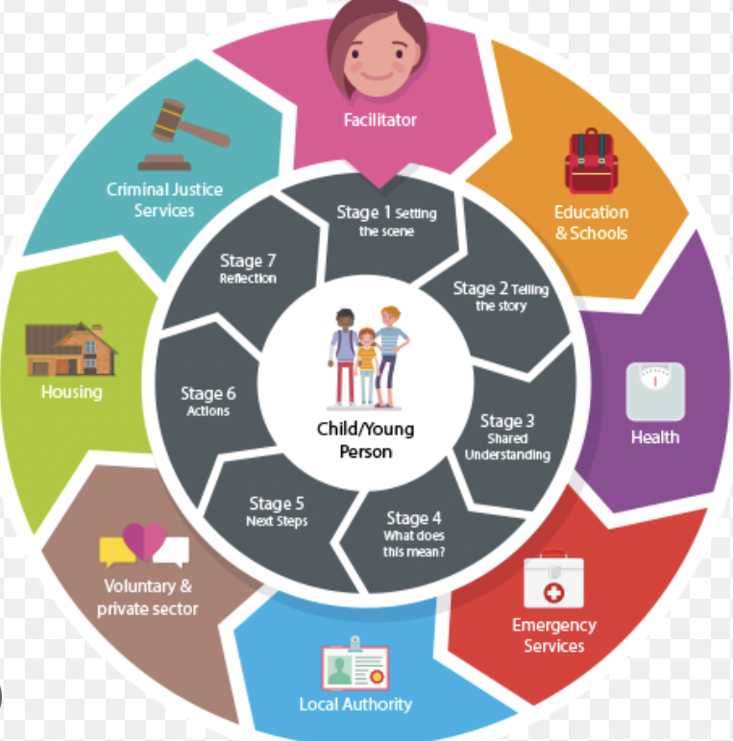
Another type of partnership work that is crucial for children in their early years is multi-agency working. According to Cheminais (2009), a multi-agency partnership working occurs when professionals from different agencies collaborate, sharing goals, information, tasks, and responsibilities to respond quickly to address issues before they have an opportunity to negatively affect children's learning and development. When many agencies cooperate, coordinated services that are sensitive to the changing needs of children are planned and delivered collaboratively. In documentation, a variety of structures, methods, and justifications for multi-agency collaboration are reflected by several related terms and ideas that are frequently used interchangeably. When more than one agency collaborates in a planned and official manner, this is known as inter-agency working. When professionals collaborate and use standard operating procedures to deliver front-line services, this is known as integrated working. Staff members with various professional backgrounds and training join to work in a multidisciplinary environment. Joint working is when experts from many organisations collaborate on a project or initiative. To accomplish goals, partnership working can be used which refers to the procedures that foster connections between various professional groups at various levels. A child transiting through a setting that employs multi-agency working can benefit from a variety of advantages. With a range of shared services, advice, and support being offered and easily accessible, adopting the different techniques of collaborative working can lead to enhanced and improved outcomes for children. (Cheminais, 2009)

(West Cheshire Children’s Trust, No Date)

Interventions

To support young children through the transition from nursery to reception, practitioners can put in place and implement different interventions to make the transition process easier and smoother for the child. Many interventions can be used, these include:
- Home visits
- Welcome packs
- Taster sessions
- Stay-and-play sessions

Home visits are a very popular intervention used in the early years’ settings. A home visit will be conducted by practitioners before a transition. Meyer and Mann (2006) believe that home visitation sessions can improve the bond between the family and the school, and many professionals feel that home visits lead to improved relationships with the children and their families. Home visits can promote parent and child communication and foster a deeper knowledge of the child as well as the relationship between the home environment and academic performance.
Welcome packs are usually given by practitioners to parents or caregivers at home visits. Welcome packs involve the completion of all relevant documents, and it allows parents to provide a written record of everything that the setting may need to know about the child. This gives an insight into the child’s behaviours, capabilities and preferences.
Taster sessions are great for the child to become familiar with the setting they are transitioning to. Such taster sessions include as a key component not only the student learning about the school but also the school learning about the student and family. They can get to know them and aid in determining honestly whether this is the best school for them (Independent School Parent, 2013).
Stay-and-play sessions are probably one of the most popular forms of intervention in the early years. Stay-and-play sessions allow parents or caregivers to accompany their child in the setting before a transition to ensure the child feels comfortable and at ease in the setting. It also allows parents or carers to see the school and the classroom, meet the other children and get to know the staff who work in the school.

Proposed outcomes

A practitioner will be able to tell if a transition for a child has been successful if the child is integrated, content, and happy in the new environment. If the transition has gone well, the child will show pleasant attitudes, good development, and the ability to play and engage without the need for their parents' or caregivers' presence. This demonstrates how their independence is growing and how they will eventually start to interact with other children and adults. A happy and content child will exhibit behaviours and interests that are creative, exploratory, independent, and emotionally mature.

Reference List
Brooker, L. (2008) Supporting Transitions in the Early Years. London: Open University Press
Cheminais, R. (2009) Effective multi-agency partnerships putting every child matters into practice. London: SAGE Publications
Halpenny, A., O’Toole, L. and Hayes, N. (2017) Introducing Bronfenbrenner: A guide for practitioners and students in Early Years education. London: Routledge.
Healthline (2020) What is the zone of proximal development? [image] Available at: https://www.healthline.com/health/zone-of-proximal-development (Accessed: 03/12/2022)
Independent School Parent (2013) The importance of taster days. Available at: https://www.independentschoolparent.com/school/prep/choosing-a-school/ (Accessed: 03/12/2022)
Meyer, J. and Mann, M (2006) ‘Teachers’ perspective of the benefits of home visits for Early Elementary children’, Early Childhood Education Journal, 34, 93-97. Available at: https://link.springer.com/article/10.1007/s10643-006-0113-z (Accessed: 03/12/2022)
Poston, B. (2009) An Exercise in Personal Exploration: Maslow’s Hierarchy of Needs. Colorado: Association of Surgical Technologists
Pound, L (2014) How Children Learn: Educational theories and approaches – From Comenius the father of modern education to giants such as Piaget, Vygotsky and Malaguzzi. London: Practical Pre-School Books
Simply Psychology (2020) Bronfenbrenner’s ecological systems theory. [image] Available at: https://www.simplypsychology.org/Bronfenbrenner.html (Accessed: 03/12/2022)
The School of Life (No Date) The importance of Maslow’s pyramid of needs. [image] Available at: https://www.theschooloflife.com/article/the-importance-of-maslows-pyramid-of-needs/ (Accessed: 03/12/2022)
West Cheshire Children’s Trust (No Date) Multi-agency Group Supervision. [image] Available at: https://westcheshirechildrenstrust.co.uk/our-way-of-working/multi-agency-group-supervision/ (Accessed: 03/12/2022)
Wilson, T. (2016) Working with parents, carers and families in the Early Years: The essential guide. London: Routledge

