AHHI5017 Contesting Conflict: Representations of War, 1789–Present
Week 8: The Second World War
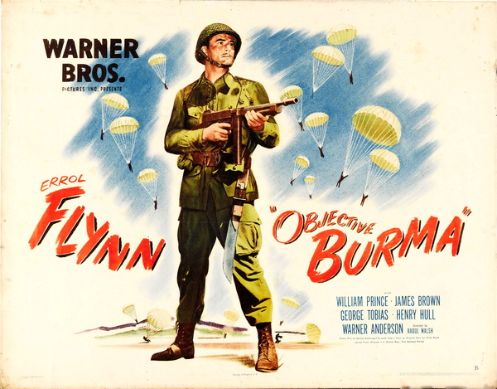
Lectures summary:
This week investigates how the Second World War was propagandised and memorialised by the victorious allies. Using the United States as the main case study, students will examine how Hollywood studios played an active and willing role in the American war effort, familiarising themselves with examples of the wartime combat movie genre via a screening of Objective, Burma! which takes place in Arts 4, 1pm, Monday March 19.
The lecture begins by contemplating the status of World War Two memory in American culture, giving though to the commemorative practices and institutions which were put in place in the decades after the end of the conflict. These discussions service the purpose of establishing how the conflict tends to be culturally remembered as a “good war” in the United States and other allied nations. The solidification of this “good war” image, the lecture posits, owed a partial thanks to the types of narratives and representation which were propagated by the Hollywood wartime combat movie genre. With this premise in mind, the lecture concludes by giving students some background information which will help students interpret Objective, Burma! The lecture then seeks to contextualise Objective, Burma! within the generic tropes and stereotypes of the wartime combat movie, but also as part of broader trends of World War Two memory in the United States and other allied nations. As a counterpoint, we will watch as short film Listen to Britain as a gauge of how film propaganda was used across the Atlantic.

Preparing for the lectures:
In order to interpret Objective, Burma! – or any piece of cinema – in a properly-informed manner, it is essential to view a good-quality version of the film in its duration; hence the arrangement of a film screening. If you are unable to attend the screening, please ensure that you make alternative arrangements to watch the film in advance of the lecture. (A copy will be loanable from myself on request; preference will be given to groups of students rather than individuals).
Before the Wednesday lecture, students should also read the G Kurt Piehler piece ‘The “Good War” and Modern Memory,’ which establishes some of the general contours of World War Two memory which will be a recurrent focus throughout the lectures.

Required reading and other preparation:
- G Kurt Piehler, ‘The “Good War” and Modern Memory’ in Remembering War the American Way (Smithsonian Institution: Washington DC, 1995), pp. 126–153.
Required viewing:
- Objective, Burma! Directed by Raoul Walsh (USA, 1945).
- Listen to Britain. Directed by Humphrey Jennings and Stewart McAllister (UK, 1942).
Background reading:
- Robert L McLaughlin and Sally E Parry, ‘The War in the Pacific’ and ‘Our Enemies,’ We’ll Always Have the Movies: American Cinema during World War II (University of Kentucky: Lexington, 2006), pp. 67–99, 100 and 123–136. Note: the entire chapter is not directly relevant to our themes, although the additional sections on representations of Italians and Germans in the combat genre are not entirely incidental to the lectures.
Recommended further reading:
- Jeffrey Richards, ‘World War Two,’ Films and British National Identity: From Dickens to Dad’s Army (Manchester University: Manchester, 1997), pp. 85–127. This acts as an introduction to wartime movies made in Britain, and complements our in-class focus on American examples.

Questions to consider:
Piehler, ‘The “Good War” and Modern Memory’
- How would you characterise the general trends of World War Two memory in the United States?
  - Are they comparable to those in Britain and other the other allied nations?
  - Or, conversely, are there any attributes which are peculiar to the American memory of World War Two?

- What efforts were made to commemorate World War Two during the conflict and in its immediate aftermath by the United States?
- Is there anything significant about the formal characteristics (artistic, architectural, stylistic, etc.) of American commemorative efforts during/immediately after the war?
- Is there anything significant about the geography of where American commemorative efforts took place during/immediately after the war?

- What efforts were made to commemorate World War Two in the period from the 1950s to the 1990s?
- What different types of commemorations were the American public subjected to in these decades?
- In what ways did memory of the Holocaust impact upon American commemorations of World War Two?
- Did the onset of the Korean War effect how World War Two was commemorated in any way?

Objective Burma!
- What were your impressions of Objective, Burma!?
  - What did you like/dislike about the film, and why?
  - What was effective/ineffective about it, and why?

- What cinematic, dramatic and narrative techniques are used to explain why, where, how and against whom the war was being fought by the United States?

- What cinematic/dramatic/narrative techniques are used to enhance the ‘realism’ of the film’s depiction of historical events and human relationships?
  - Does the film gesture towards historical veracity at all?
  - Does it comment on 1940s US society at all (overtly or otherwise)?

- Is there anything notable about how paratroopers specifically – and the US military more generally – are depicted in the film?

- What function does the war correspondent Williams serve in the drama of the film?
  - Why do you think the director (Raoul Walsh) and screenwriters (Ranald MacDougall and Lester Cole) chose to include this character?

Listen to Britain
- How effective is the film as a piece of propaganda?

- How effective is the film from an aesthetic, artistic and cinematographic standpoint?

- How might the film be used to gauge differences between Britain and the United States with respect to attitudes towards and cultural memory of WWII?

Background readings
The suggested readings will help you interpret the assigned materials. Below are questions to consider in relation to these non-essential texts.
McLaughlin and Parry, American Cinema during World War II
- McLaughlin and Parry begin by explaining the circumstances surrounding the United States’ entry into World War Two. What were some of the key events which occurred in the Pacific theatre in 1942 and 1943, and how were they represented by Hollywood films?
- What was the relationship between the “public record” of the United States’ early involvement in the war (p. 73), and the manner in which the conflict was depicted in Hollywood movies?

- What were some of the outstanding features of the wartime combat movie genre? Is there anything significant about the representation of:
    - The United States’ overseas territorial possessions;
    - The US military;
    - Specific events that occurred during the war;
    - Enemies of the United States?

- What were some of the recurrent narrative tropes/story devices of the wartime combat movie genre?
  - Did the combat genre replicate any existing narrative frameworks from film or literature, and if so which?
  - Was there anything notable about the manner in which wartime combat movies tended to reach their narrative conclusion?

- To what extent does Objective, Burma! conform to the generic features and narrative tropes of the Hollywood wartime combat movie?

