Advanced Processes and Materials
  - Critical Evaluation of Non-Traditional Machining Equipment for the Manufacturing Industry
Liam Gill – P148130
05/03/2018


Abstract
The purpose of this report was to take a look at two different advanced cutting processes that could be implemented within a manufacturing company that produces springs, fixings, and fastenings. The two processes being considered by this report are laser cutting and abrasive water jet cutting.
In this report both processes are investigated into how they operate and are directly compared with each other to see which one would be most suited to the company looking to invest.
It is found in this report that both processes are more than capable of carrying out the cutting operations required by the manufacturing company, however it is recommended that the abrasive water jet cutter be used because although it is less accurate than the laser is does offer a lower running cost and lower cost of initial implementation.

Table of Contents
Abstract 1
Introduction 3
Aims and Objectives of Project 4
Appropriate Materials for Cutting 5
Scientific Principles of Chosen Advanced Processes 7
Laser Cutting 7
Advantages and Disadvantages of Laser Cutting 9
Abrasive Water Jet Cutting 9
Advantages and Disadvantages of Abrasive Water Jet Cutting 11
Direct Comparison of Laser Cutting and Abrasive Water Jet Cutting 11
The Possible Effect That New Technology Could Have on the Company 13
Conclusions 16
Reference List 17

Introduction

This report has been created for a manufacturing company that wishes to modernise its processes, this will involve an upgrade from a traditional process to a non-traditional process. A traditional process uses sharp cutting tools to remove material by shear deformation whereas a non-traditional process is considered an advanced process and so does not use any sharp tools and removes material by thermal, mechanical, electrical or chemical energy.
In this report an investigation will be carried out on two different advanced processes that can be used in the manufacturing industry for cutting various components such as springs, fixings, and fastenings as can be seen in the pictures Fig 1.
TWI Global (2018) Define and advanced manufacturing process as ‘the use of innovative technologies and methodologies for improved competitiveness in the manufacturing sectors.’
The two advanced processes that will be investigated within this article are laser cutting and abrasive water jet cutting. Discussed in this report is a fundamental breakdown and scientific principles of the operation of the two advanced processes, a comparison of the two processes and an outcome of which process is most suited for the applications required by the manufacturing company.

Aims and Objectives of Project
It is the aim of this report to compare the two advanced processes for cutting to establish which process would be most suited for a manufacturing company that produces variety of components that include springs, fixings, and fastenings as can be seen in the pictures Fig 1.
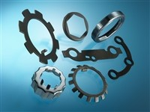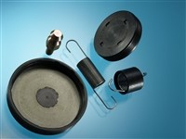
Fig 1.
As can be seen in the pictures Fig 1 the components that are required to be manufactured of a small nature and so the need for a cutting process that can cut large pieces of material is not required. However, the precision of the cutting process will need to be very precise because without a high level of precision then the components being produced such as the fixings and fastenings may not be able to function correctly.
When producing these components due to the nature of their operation it is important that the surface finish of the parts being produced is of a high quality. Although it is not stated the quantity of parts required to be cut it is assumed that the quantity is a high value due to the cheap cost of the components it is assumed that a high volume will need to be produced to ensure the company is profitable.

Appropriate Materials for Cutting

The table in Fig 6 shows that Spring Engineers (2018) state there are seven common materials that are used for the production of springs. Fig 2 outlines these seven common spring materials and the derivatives of those materials. By using this table the cutting processes can be checked to ensure that they have the appropriate cutting ability to easily cut the commonly used spring materials.
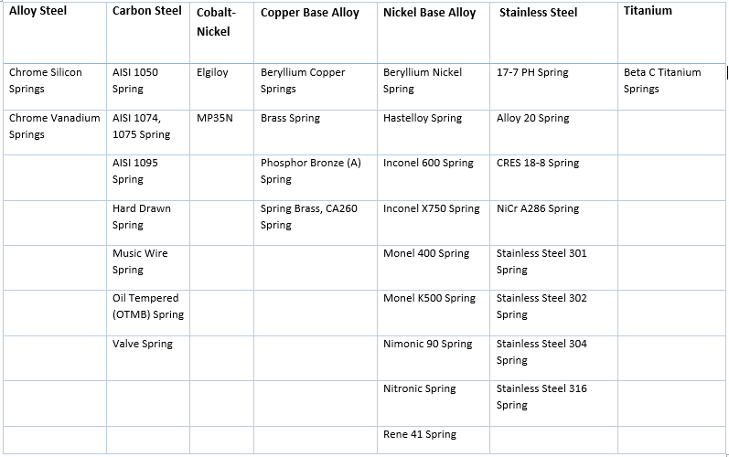
Fig 2. (Spring Engineers, 2018)
By investigating the properties of the hardest material that is commonly used to manufacture springs it was found that according to (He, Setsuhara, Shimizu, & Miyake, 2001) that the hardness of titanium is 22GPa.
After carrying out some investigation into the most commonly used fastenings and which were the strongest is was found that according to Indiana Steel (2017) the most common material for fasteners were Alloy Steel, Silicone Bronze, Aluminum and Chrome. According to Bolt Depot (2018) the strongest fastener was a grade 8 Carbon Alloy Steel Bolt as can be seen in fig 3.
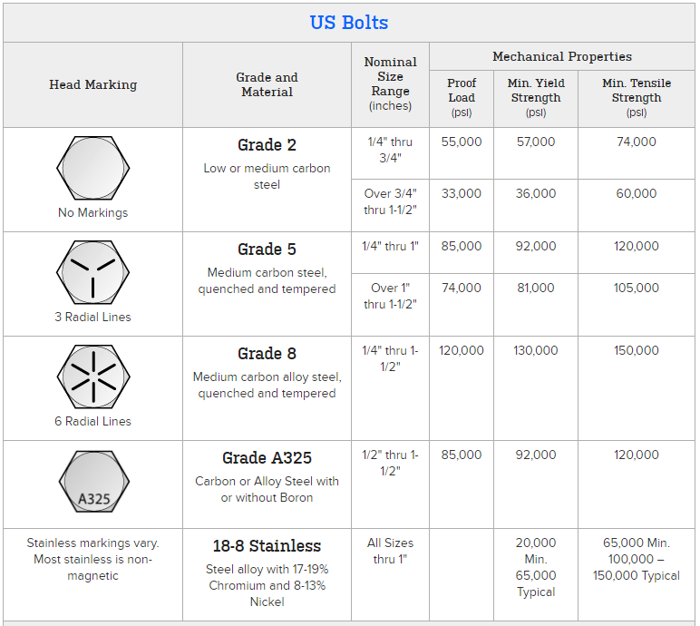
Fig 3. (Bolt Depot, 2018)
Using the information provided in Fig 2 and Fig 3 and investigating the cutting forces involved with both the laser and abrasive water jet cutting it is clear that both processes are a viable option at this point because they both are able to cut through the small components being manufactured with relative ease.

Scientific Principles of Chosen Advanced Processes
In this section the fundamental operation and scientific principles of each process will be investigated to establish how they operate and carry out their cutting functions.

Laser Cutting
The laser cutting process is essentially using extremely high energy light beams to heat up material to a point where the beam breaks the material down and melts it creating a cutting path.
Before photons are created to produce a laser the system must first be pumped, in this pumping process energy is absorbed by atoms in a process known as absorption, the electrons in the atom are raised from a lower energy level closer to the nucleus (E1 in Fig 4) to a higher energy level shown as E2 in Fig 4. Once the atoms are at the specific higher energy level this is known as population inversion.
The laser beam is created by a process called stimulated emission. Stimulated emission occurs when a photon of a specific energy triggers an electron of an atom to drop down from an excited level of orbit (E1 in Fig 4), to the ground level of orbit (E2 in Fig 4). The energy created by the electron dropping to the ground level (hv) releases another photon of the same wavelength and travelling in the same direction as the incident photon. These two photons go on to stimulate more and more electrons in a knock on effect to create a higher and higher energy light beam, a diagram of this can be seen in fig 4 (Wikipedia, 2018).
The materials used to create this can be gas molecules, crystal, glass, and liquid or dye long as it has the ability to be excited in this way. (How Product Are Made, 2018)

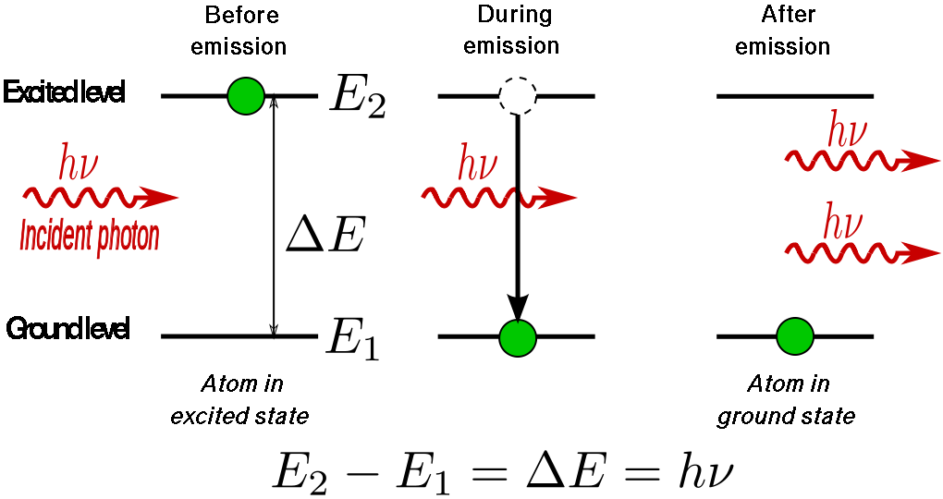
Fig 4. (Wikipedia, 2018)
In the equation ilistrated in Fig 4 the E1 and E2 values represent the the different energy levels of the electron at the ground level of orbit and the excited level of orbit respectively. The v value represents the frequency of the photon and h represents Planck's constant factor.
Once the photons are created they reflect internally through a semi-reflective mirror and a fully reflective mirror (boht of which are concaved), the puropse of these mirrors is to cause the aplification of wavelengths in a process called optical feedback . As the light is reflecting between these two mirrors the intensity of it increases to a point where it will pass through the semi-transparent mirror in a high energy focused beam (Krajcarz, 2014). A diagram of this process can be seen in fig 5.
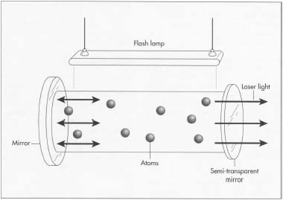
Fig 5. (How Product Are Made, 2018)
The operation of a laser cutting process can be seen in fig 6.
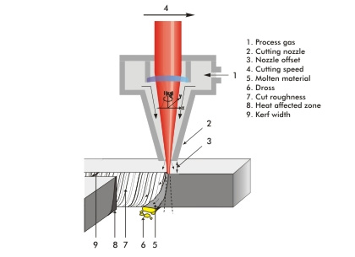
Fig 6. (Kinsman, 2012)
In the cutting process the laser is focused on a point and heats that area up to where is becomes molten metal. Once the entire layer of material becomes molten then the process gas (1) can assist in removing the molten material out through the bottom of the part (5). When making a cut in a materialt the feed rate (4) and nozzle offset (3) must be calculated to suit the material properties, if this is not done correctly then it can affect the quality of the cut such as the material not being cut all the way through if the feed rate is too fast. During laser cutting due the the extremely high temperatures involved some of the material surrounding the cutting path can become affected by the heat (8) and the the properties of the affect material may be altered.

Advantages and Disadvantages of Laser Cutting
To carry out a further in depth investigation of laser cutting a table has been created outlining the advantages and disadvantages of the process. This table can be seen in fig 7.
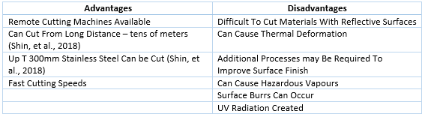
Fig 7.
As can be seen in Fig 7 laser cutting has many advantages such as the ability to create remote cutting machines so the process can be carried out at external locations and not just in a designated workshop. However the process also has many disadvantages that include UV radiation is created during operation and additional processes may be required to improve the surface finish of the cut due to thermal deformation.

Abrasive Water Jet Cutting

Abrasive water jet cutting is a process where a jet of water with ‘velocity of several hundred metres per second’ (Momber & Kovacevic, 1997) is mixed with small abrasive particles and directed at the workpiece that requires cutting (Begic-Hajdarevic, Cekic, Mehmedovic, & Djelmic, 2015). The particles that are mixed with the water can include garnet, aluminium oxide or silica carbide (Momber & Kovacevic, 1997).
During the operation of abrasive water jet cutting the water is first pumped to the high-pressure inlet (1), from here the water passes through the jewel orifice (2) where the water is transformed from high pressure to high velocity (Nambiath, 2016), this occurs because the orifice reduces the pressure of the water obeys the following equation;
$$P1V1=P2V2$$
In the above equation the letters P1 and V1 represent the pressure and velocity at one point of a system and the P2 and V2 values represent the pressure and velocity at a second point in the system, to hold true to the equation as the water passes through the jewel orifice the pressure is reduced and so an increase in velocity must occur to balance out the equation.
The high velocity water passing through the mixing chamber greatly reduces the air pressure within the mixing chamber and so creates a vacuum, this vacuum that draws in the abrasive (3) to fill the space left by the vacuum and so creates an abrasive mixture (Nambiath, 2016). As the water and abrasive pass through the mixing tube (4) they form together and stabilise before being propelled towards the work piece with a velocity of up to 1055m/s (Hydromar, 2018) and at a diameter of between 0.1mm to 0.3mm (Momber & Kovacevic, 1997) where it cuts by means or erosion (Krajcarz, 2014)
A process diagram for abrasive water jet cutting can be seen in fig 8.

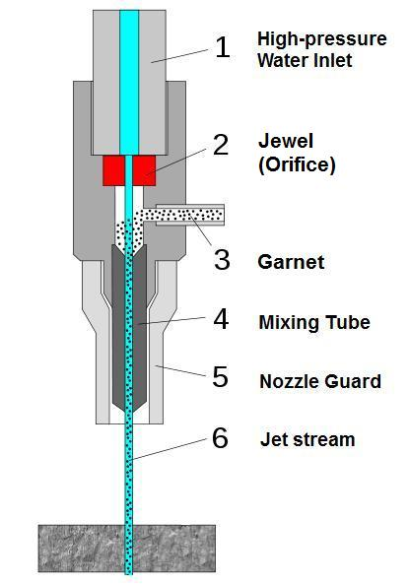
Fig 8. (MultiCam, 2011)
The amount to force carried by the water jet can be calculated by using the following formula;
$$Force=Pressure X Area$$
The cutting force that is applied by the water jet can be calculated by using the following formula;
$$Cutting Force=\left(Mass of water+Mass of particles\right) X Deceleration of Water and Particles$$
In the above equation the mass of water and particles are only considered from the exit of the nozzle to the contact point with the material.

Advantages and Disadvantages of Abrasive Water Jet Cutting
To carry out a further in depth investigation of laser cutting a table has been created outlining the advantages and disadvantages of the process. This table can be seen in fig 9.
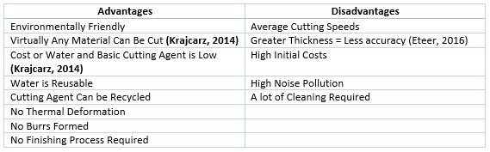
Fig 9
It is shown in Fig 9 that there are more advantages to using abrasive water jet cutting than there are disadvantages. Some of these advantages include the points that the process in environmentally friendly, no burrs are formed and there is no thermal deformation. The disadvantages associated with abrasive water jet cutting include high initial start-up costs and high noise pollution.

Direct Comparison of Laser Cutting and Abrasive Water Jet Cutting

To take a more direct comparison of the Laser Cutting and Abrasive Water Jet Cutting a table has been formed in fig 10 to directly compare some of the features of the processes.
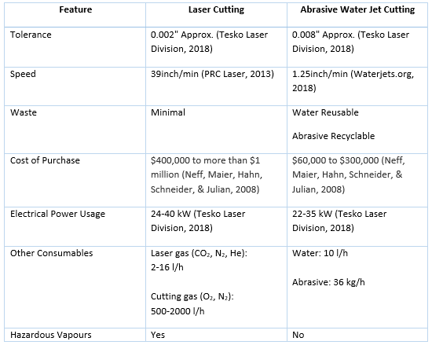
Fig 10
As can be seen in fig 10 the laser cutting process has the ability to cut with a higher tolerance, can cut with a higher speed and creates minimal waste. However the process of abrasive water jet cutting also produces minimal waste as well as being a lower cost of start-up and has a lower running cost. For these reasons as well as needing fewer consumables and not producing any hazardous vapours it is suggested that the company in question select and implement the abrasive water jet as their cutting process. It is noted that the laser cutting has the ability to be created as a remote cutting machine and has the ability to cut at a faster rate, these qualities will not have a huge impact on the company because all the cutting they require will be carried out in-house and because the items that require cutting are only on a small size and so the increased cutting rate will not have a massive impact. It is believed to be far more beneficial for the company to use abrasive water jet cutting due to the potentially huge cost savings that are involved.

The Possible Effect That New Technology Could Have on the Company
Direct diode laser
As the manufacturing company is looking to potentially modernise its processes, there is another emerging technology in the cutting of metals that may be worth considering. This process is called Direct Diode Laser (DDL) Cutting. It was declared by Rodrigues, Vanhove, & Duflou (2014) the Direct Diode Lasers are ‘industrially relevant cutting speeds, with acceptable surface quality’. As well as being a more modern process SAUCEDO, CHANN, SAMSON, & TAYEBATI (2016) state that DDL ‘offers a lower cost of manufacturing.’
Direct Diode Laser cutting produces a laser beam without the need for a doped fibre system and so uses the diodes directly. This allows the DDL to be a more efficient method of laser production as the middle process has now been removed (Bohlen, 2018). DDL have a high quality laser beam and are known for being the most reliable and smallest laser source (Bohlen, 2018).
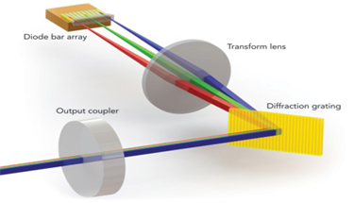
Fig 11. (Bohlen, 2018)
One of the benefits of using DDL is that most metals reflect les of the beam and so have a higher beam absorption than with CO₂ (SAUCEDO, CHANN, SAMSON, & TAYEBATI, 2016) and this results in the ability to cut through materials at a faster rate.
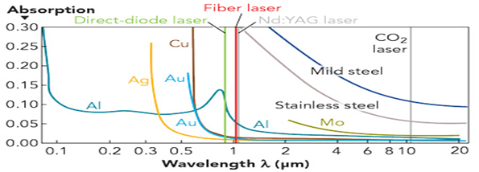
Fig 12. Absorption of various metals at relevant wavelengths for industrial lasers (SAUCEDO, CHANN, SAMSON, & TAYEBATI, 2016)
Fig 12 illustrates the absorption of beam in various metals. This shows us the DDL operating at 970nm which results in a higher absorption than Nd: YAG laser, Fibre lasers and CO₂ lasers.
By the DDL creating a beam that has a higher absorption rate than other laser processes there is less energy wasted by means of reflection and so the material heats at a faster rate and so can be cut at a higher speed.
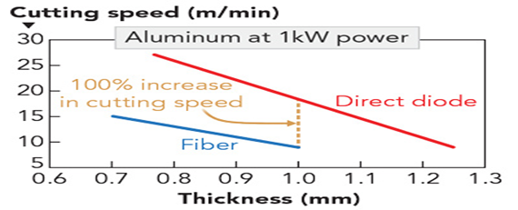
Fig 13. (SAUCEDO, CHANN, SAMSON, & TAYEBATI, 2016)
Typically DDL has the ability to cut through various materials of various thickness 15% faster than with fibre or disk lasers (Bohlen, 2018). In aluminium this increase in cutting speed is greater as can be seen in fig 13.
As a result of the faster cutting speeds the use of DDL will ‘have the potential to decrease operational costs considerably’ (Rodrigues, Vanhove, & Duflou, 2014).
Another benefit of opting to use DDL over other lasers is the quality of the surface finish after cutting. An example of a surface finish comparison can be seen in fig 14.
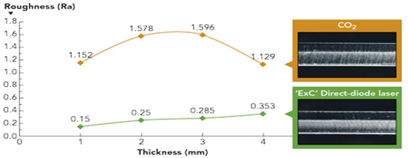
Fig 14. (SAUCEDO, CHANN, SAMSON, & TAYEBATI, 2016)
As can be seen in Fig 11 through all levels of thickness of the material the surface finish of DDL is considerably better than with CO₂. The increase in surface finish could possibly eliminate the need for further processing of the material and the need for further machines. This will all contribute to a decrease in operational costs.
To further reduce the operational costs within the company the DDL is not only more efficient than other laser types but it also requires less maintenance too, as was stated by Rodrigues, Vanhove, & Duflou, (2014) ‘maintenance is low and expected lifetime high for the common diode lasers systems’. An illustration of the increased efficiency can be seen in fig 15.
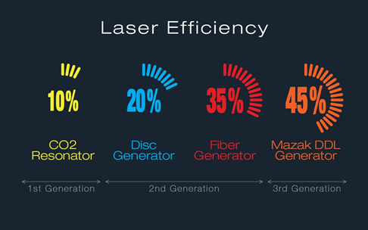
Fig 15. (Bohlen, 2018)
Fig 15 shows that a DDL 10% more efficient than a Fibre laser and a full 35% more efficient than a CO₂ laser.

Conclusions
In conclusion this report finds that although both the laser and abrasive water jet offer a suitable advanced process for the job required by the manufacturing company, the process that is being recommended is the abrasive water jet cutter. The laser cutter did offer many benefits that were more of an advantage than the water jet such as a higher cutting speed and a higher accuracy, however the abrasive water jet had far more beneficial advantages such as being environmentally friendly due to the consumables used are recyclable, a lower operating cost and a lower start-up cost. It is thought that the advantages of the water jet are more beneficial because the cost savings involved with the stat up and operation were so large that to any manufacturing company that would be a viable option.
Furthermore another process was investigated. This process was DDL. It was found that if the company wanted to further improve their cost savings and maintain a high production rate then this process would be more suited than both the laser and abrasive water jet.

Reference List
Begic-Hajdarevic, D., Cekic, A., Mehmedovic, M., & Djelmic, A. (2015). Experimental Study on Surface Roughness in Abrasive Water Jet Cutting. Procedia Engineering, 394-339.
Bekir, S. Y., Mian, M. S., & Farhan, A. (2017). Laser cutting of various materials: Kerf width size analysis and life cycle of cutting processes. Optics and Laser Technology, 2-3.
Bolt Depot. (2018, March 10). Bolt Grade Markings and Strength Chart. Retrieved from Bolt Depot: https://www.boltdepot.com/fastener-information/materials-and-grades/bolt-grade-chart.aspx
Eteer, M. (2016, July 2). The Advantages and Disadvantages of Waterjet Cutting. Retrieved from Ballard Machine Works: http://ballardmachineworks.com/2016/07/02/advantages-disadvantages-waterjet-cutting/
He, J. L., Setsuhara, Y., Shimizu, I., & Miyake, S. (2001). Structure refinement and hardness enhancement of titanium nitride films by addition of copper. Surface and Coatings Technology, 38-42.
How Product Are Made. (2018, March 10). Solid State Laser . Retrieved from How Products Are Made: http://www.madehow.com/Volume-6/Solid-State-Laser.html
Hydromar. (2018, April 6). Waterjet Cutting - How Does It Work? Retrieved from Hydromar: http://www.hydromar.co.uk/waterjet-cutting-how-does-it-work.aspx
Indiana Steel. (2017, May 25). What is the most commonly used material for nuts and bolts? Retrieved from Indiana Steel: http://blog.indanasteel.com/2017/05/material-used-for-nut-and-bolts.html
Kinsman, R. (2012, September 28). Laser cutting! Retrieved from rachelkinsman.wordpress.com: https://rachelkinsman.wordpress.com/2012/09/28/laser-cutting/
Krajcarz, D. (2014). Comparison Metal Water Jet Cutting with Laser and Plasma Cutting. Procedia Engineering, 838-843.
Momber, A. W., & Kovacevic, R. (1997). Test parameter analysis in abrasive water jet cutting of rocklike materials. International Journal of Rock Mechanics and Mining Sciences, 17-25.
MultiCam. (2011, November 28). Nozzle Components. Retrieved from MultiCam: http://multicam.ca/nozzle-components/
Nambiath, P. (2016, November 29). Pressure matters in abrasive waterjet cutting. Retrieved from The FABRICATOR: https://www.thefabricator.com/article/waterjetcutting/pressure-matters-in-abrasive-waterjet-cutting
Neff, R., Maier, C., Hahn, J., Schneider, R., & Julian, A. (2008). Making sense of metal cutting technologies. The FABRICATOR, 50-53.
PRC Laser. (2013, April 4). PRC Laser Cutting Calculator . Retrieved from PRC Laser: http://www.prclaser.com/calculator.html
Shin, J. S., Oh, S. Y., Park, H., Chung, C.-M., Seon, S., Kim, T.-S., . . . Lee, J. (2018). Laser cutting of steel plates up to 100 mm in thickness with a 6-kW fiber laser for application to dismantling of nuclear facilities . Optics and Lasers in Engineering, 98-104.
Spring Engineers. (2018, March 10). Spring Material Types. Retrieved from Spring Engineers: http://www.springhouston.com/materials/
Tesko Laser Division. (2018, April 4). Standard metal cutting processes: laser cutting vs. water jet cutting. Retrieved from Tesko Laser Division: http://www.teskolaser.com/waterjet_cutting.html
TWI Global. (2018, April 5). What is advanced manufacturing? Retrieved from TWI Global: https://www.twi-global.com/technical-knowledge/faqs/faq-what-is-advanced-manufacturing/
Waterjets.org. (2018, April 4). Cutting Speeds. Retrieved from Waterjets.org: https://waterjets.org/archive/waterjet-equipment/general/cutting-speeds/
Wikipedia. (2018, Febuary 18). Laser. Retrieved from Wikipediea: https://en.wikipedia.org/wiki/Laser

