

Employee attrition and retention causes, and recommendations to reduce the leaver rates

Student Name:- Sahil Girishbhai Bhuva
Student Number:- 2127449
Lecturer Name:- Dr. Laila Maazouz
Module Code:- LCBB5004

Abstract
The report aims to analyze the causes and effects of employee attrition in the nursing sector or industry in the United Kingdom. In addition, it also evaluates the existing retention schemes for retaining nursing professionals within the Nursing industry. It is a well-acceptable fact that one of the largest professions in the healthcare sector is nursing. This profession is an integral part of the functioning of the National Health Service (NHS). In addition, it will discuss and evaluate the existing retention schemes.

Table of Contents
Introduction 4
Causes and effects of employee attrition within the Nursing Industry in the United Kingdom 5
Five monetary existing retention schemes for Nursing professionals 8
Five Non-monetary existing retention schemes for Nursing professionals 10
Critical evaluation of monetary and non-monetary retention schemes for nursing professionals 12
Recommendation to improve nurse retention in the short term 13
Recommendation to improve nurse retention in the long term 14
Conclusion 15
References 16

Introduction
The report emphasized the leaver rates of the nurses in the National Health Services. A substantial number of nurses left the National health services in England in June 2022.The nursing staff was encouraged to continue to render their services in the National Health Services and thereby minimizing the leaver rate. As per the study, it was found that the leave rates of nurses were much higher in Scotland. However, the data for Northern Ireland and Wales could not be found. The records witnessed that a substantial number of midwives, nurses, and nursing associates were leaving their nursing jobs. As of March 2022, more than 27, 100 staff left their nursing services.

Causes and effects of employee attrition within the Nursing Industry in the United Kingdom
The most commonly given cause or reason for leaving nursing services is the retirement of the employees. The second most given reason is the complications in balancing work and life together. As per the data collected, it was found that approximately 6900 employees in three months starting from April 2022 till June 2022. In addition, the other cause was the health issues faced by the employees. Approximately 1800 employees left their roles due to health problems. Further, more than 5600 employees left their services due to promotion. Furthermore, nearly 1000 employees left their services to undertake further education and training for their growth and development (Everitt, 2022).
As per the survey conducted for this purpose, it was found that there were many other reasons for the increased leaver rate in National Health Services in the United Kingdom. These reasons include working under too much pressure, feeling negative perceptions, and exhaustion. One of the major reasons for leaving the job was that the employees felt undervalued and did not get the deserved recognition (Nyashanu, et al., 2020).
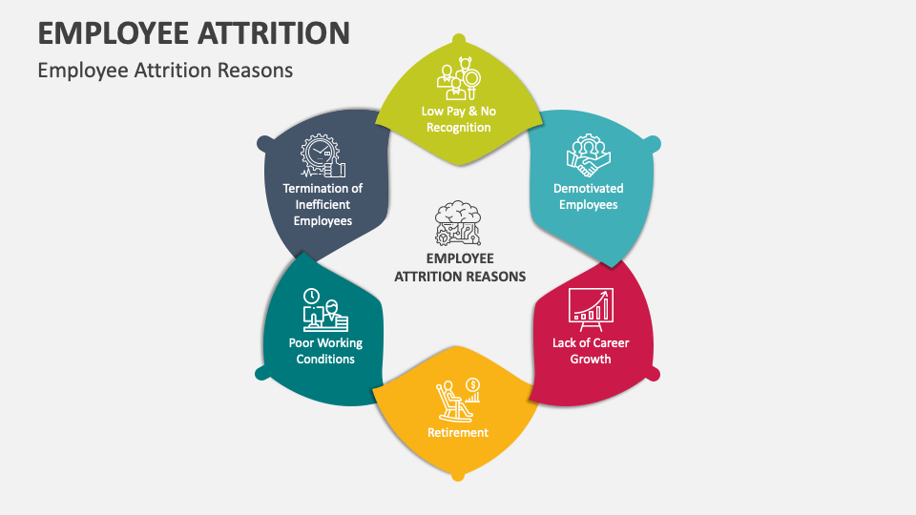
Source: (Collidu, 2023).
As per the survey conducted in December 2021, it was found that the common reasons for leaving the services include personal circumstances, retirement, and a higher amount of workload. Moreover, it was suggested that employee attrition was more due to work-life balance than other reasons. The high staff turnover was due to long working and unsociable hours, toxic and negative work culture, lack of proper communication between the staff and the management, and limited career opportunities (Cloutier, et al., 2015).
Another important cause was a negative and demotivating culture in the workplace. The survey reiterated that the nursing staff was facing discrimination at work. Furthermore, it was also reported that 22% of nurses faced harassment, bullying, and abuse from their colleagues. Other causes for employee attrition were economic conditions and sickness absence. The analysis also suggested that the leaver rates were highly linked to the sickness of the employees.
The working conditions in the National Health Service were very unfavorable to the employees in the NHS were getting worse over time.
The number of nurses leaving the National health service in England is provided hereunder:
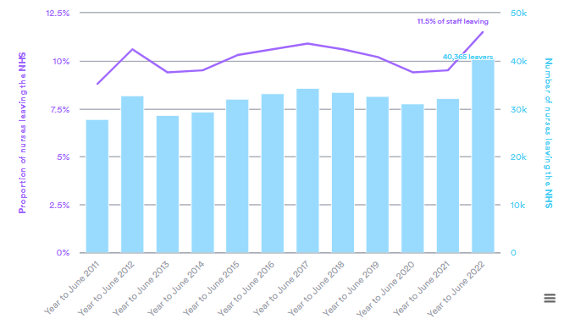
Source: (Nuffield Trust, 2023).
The employee attrition caused several adverse impacts on National health services. As per the research, an increase in 1% regional unemployment resulted in a reduction in the probability of the midwife leaving or nursing. As per various research conducted, the effects of employee attrition included excessive workload on the nurses, poor patient satisfaction, delay in daily procedures, and complaint from patients frequently as the new staff will require sometime to fully understand and learn the daily procedure .store under the services effectively (Onyango, et al., 2017).
It has been found that the younger nurses who are under the age of 45 years are leaving the jobs in higher numbers than the other category. The vacancies so caused will remain constant or may increase due to crisis at the workplace, developing a supply of nurses most sustainably and boosting employee retention will take many years.
Employee attrition not only affects the healthcare sector in the United Kingdom but also affects adversely the quality of life of the diseased, which further increases the risk of their lives. Therefore, it has become a major challenge in the healthcare service sector to increase and maintain employee retention as there is ahuge gap between the demand and supply of the burses in this sector in the United Kingdom (Vantagecircle,2023).

Five monetary existing retention schemes for Nursing professionals
Competitive bonuses and Salaries: Offering a higher amount of salary can be the most effective strategy or scheme to retain employees and reduce the laver rates. National Health Service consider paying salaries and bonuses to its nursing staff. This way it attracts and recruits new nurses and has proved to be most effective. In addition, it endeavors to pay the nursing staff and the professionals more than the competitors, and giving bonuses is also proven to serve the desired purpose. Moreover, it also offers a retention bonus to loyal nurses. It endeavors to retain experienced nurses as this will further ensure safety, which increases the retention of new nurses (Buchan, et al., 2017).
Commissions: Further, the healthcare sector in the United Kingdom consider paying commissions to the nursing staff and the professionals on the completion of the task assigned to them. A sum of money is paid to the nurses based on their performance and is an additional compensation.
Employee stock option: The nursing staff has been offered a specified number of shares that can be used by them only after the vesting period. It develops a feeling of belongingness and ownership and encourages them to work harder with full dedication.

Source: (EDUCBA, 2023).
Performance-based pay: NHS also considers paying more if the performance of the nursing staff exceeds the prescribed benchmarks.
Gain sharing plans: It is increasingly being considered recently and therefore the National Health Service (NHS) offers a financial share to the nursing staff due to the increase in profitability that was the result of employee participation.

Five Non-monetary existing retention schemes for Nursing professionals
Awards: National health service renders awards to its nursing professionals and this is one of the best and most motivating schemes for retaining nursing professionals. This may include accomplishments, plaques, trophies, and certificates. National health service (NHS) render awards to its nursing staff to make them recognize that their efforts are taken into account and noticed by the NHS (Al-Suraihi, et al., 2021).

Source: (Vantagecircle, 2023).
Gifts: Gifts are also given to nursing professionals to motivate the nursing staff to inculcate a feeling of belongingness in the healthcare sector. This enables the nursing staff to work with more appreciation and enthusiasm. This is sometimes more impactful than monetary retention schemes.
Recognition: The efforts and hard work of the nursing staff have been fully recognized and appreciated by the National health service. It recognizes their efforts and praises the nurses and the other staff working in the healthcare sector by way of public praise, handwritten notes, and compliments by way of email or text messages.
Reasonable breaks: The existing retention scheme involves giving reasonable breaks to the nurses. It ensures giving two rest breaks and a break for having meals to ensure that they perform their roles most effectively.
Mentorship Program: National health service undertakes various mentorship programs to increase the rate of retention of the nursing staff and professionals associated with the healthcare sector. Many nurses participate in these programs and are thereby retained in this manner. These programs provide a new opportunity to the nurses and this also leads to enhancement in the confidence level of the nurses. These programs are of very much use in the area of teaching. Moreover, it also gives them a feeling of pride to the nurses and renders an opportunity for an enhanced level of learning and growth and an increase in potential pay. Additionally, this creates extra work o tasks for the nurses who have gained relevant experience as well as expertise (Brophy, et al., 2018).

.

Critical evaluation of monetary and non-monetary retention schemes for nursing professionals
The monetary and non- monetary retention schemes for nurses will prove to be very fruitful the nurses will feel valued and recognized both in monetary and non-monetary terms. The evaluation of the above-mentioned retention schemes provides that offering bonuses, and other forms of incentives will make the staff feel they are taken care of, and their efforts are being taken into account.
These retention schemes pave the way for retention of the old employees as this is very crucial to retain them in the first place, rather than recruiting and hiring new ones.
This will further ensure a reduction in employee attrition in the national health services and eventually an increase in employee retention (Almaaitah, et al., 2017).

Recommendation to improve nurse retention in the short term
It is highly recommended that the National Health Service (NHS) should consider reducing the workload of the nurses. For this, it should develop and implement strategies including hiring support staff, hiring nurses for each unit, and clearly defining their tasks respectively to reduce their burden. This will further ensure the efficient working of the nurses. Moreover, it should consider adapting to the new and enhanced technology up-gradation.
In-saddition, the nurses who are now undercompensated should be compensated fairly as per their performance and efforts otherwise, they will likely switch to other employment. They should be trained further to ensure advancement in their careers through seminars and workshops.
It should be ensured that the nurses are compensated with basic benefits that include dental insurance, health insurance, and flexibility in schedules.
Furthermore, feedback from the nursing staff should be taken every six months and this will certainly help to identify the areas of improvement and concern. This will act as a powerful tool to retain the existing nursing staff as their opinions and views are considered and valued by taking into account their needs and want.

Recommendation to improve nurse retention in the long term
To derive benefits and retain the employees in the long run, it is highly recommended that the interactions between the nursing staff and the leaders should be enhanced and maintained. It should endeavor to foster a relationship between these two to reduce the leave rates of the nurses. This can be ensured by listening to the nursing staff actively and understanding their feelings and addressing their problems before it affects their work adversely.
Furthermore, the recognition of the nursing staff should be paramount in every healthcare sector. This should be ensured by recognizing the achievements of the nursing staff periodically, offering public praise by organizing staff recognition programs, conducting reviews of the performance of the nurses, and congratulating them for their respective achievements and accomplishments.
The mental and emotional well-being of the nursing staff should be promoted by providing them with free access to wellness resources. This will include meditation, therapies, relaxation techniques, and counseling sessions. This will further ensure that they will take care of the patients in an optimal manner.
In addition, experienced nurses should be given a level of autonomy to make them feel recognized and that their experience is valued as a healthcare professionals. The top management should repose some faith in the experienced nurses.

Conclusion
The report concluded that the retention of employees cannot be considered in isolation. The nursing workforce should be managed in the most optimum manner and the National 0health service is required to balance the inflows including overseas recruits and newly qualified clinicians with the outflows including those who are leaving their roles or retiring. Further, the existing retention schemes were reviewed in terms of their efficiency and sufficiency. Further, various monetary and non-monetary retention schemes are hereby discussed that the National Health Service should take into account to reduce employee attrition. Furthermore, the National Health Service should understand the reasons why the employees prefer to live and should act upon the same promptly.

References
Almaaitah, M.F., Harada, Y., Sakdan, M.F. and Almaaitah, A.M., 2017. Integrating Herzberg and social exchange theories to underpin human resource practices, leadership style, and employee retention in the health sector. World Journal of Business and Management, 3(1), pp.16-34 https://www.researchgate.net/profile/Mohammad-Almaaitah-2/publication/316328040_Integrating_Herzberg_and_Social_Exchange_Theories_to_Underpinned_Human_Resource_Practices_Leadership_Style_and_Employee_Retention_in_Health_Sector/links/5a4e1aa1aca2729b7c8c1cbd/Integrating-Herzberg-and-Social-Exchange-Theories-to-Underpinned-Human-Resource-Practices-Leadership-Style-and-Employee-Retention-in-Health-Sector.pdf?_sg%5B0%5D=started_experiment_milestone&origin=journalDetail&_rtd=e30%3D
Al-Suraihi, W.A., Samikon, S.A. and Ibrahim, I., 2021. Employee Turnover Causes, Importance and Retention Strategies. European Journal of Business and Management Research (EJBMR)https://oarep.usim.edu.my/jspui/bitstream/123456789/20529/1/Employee%20Turnover%20Causes%2C%20Importance%20and%20Retention%20Strategies.pdf
Brophy, J.T., Keith, M.M. and Hurley, M., 2018. Assaulted and unheard: violence against healthcare staff. New solutions: a journal of environmental and occupational health policy, 27(4), pp.581-606 https://ochu.on.ca/wp-content/uploads/2019/08/2017-11-27-Assaulted-and-Unheard-Violence-Against-Healthcare-Staff-New-Solutions-Article.pdf
Buchan, J., Charlesworth, A., Gershlick, B. and Seccombe, I., 2017. Rising pressure: the NHS workforce challenge. Health Foundationhttp://allcatsrgrey.org.uk/wp/download/management/human_resources/RisingPressureNHSWorkforceChallenge.pdf
Cloutier, O., Felusiak, L., Hill, C. and Pemberton-Jones, E.J., 2015. The importance of developing strategies for employee retention. Journal of Leadership, Accountability & Ethics, 12(2) http://www.m.www.na-businesspress.com/JLAE/Pemberton-JonesEJ_Web12_2_.pdf
Collidu., 2023. Employee Attrition. [ONLINE]. Available at: https://www.collidu.com/presentation-employee-attrition (Accessed on 22nd July 2023)
EDUCBA., 2023. Employee stock options. [ONLINE]. Available at: https://www.educba.com/employee-stock-options/ [Accessed on 22nd July 2023].
Everitt, J., 2022. Developing a comprehensive understanding of attrition in an NHS weight management service for adults with obesity (Doctoral dissertation, Cardiff Metropolitan University) Thesis.pdf
Nuffieldtrust., 2023. Peak leaving? A spotlight on nurse leaver rates in the UK. [ONLINE]. Available at: Peak leaving? A spotlight on nurse leaver rates in the UK | Nuffield Trust [Accessed on 22nd July 2023].
Nyashanu, M., Pfende, F. and Ekpenyong, M., 2020. Exploring the challenges faced by frontline workers in health and social care amid the COVID-19 pandemic: experiences of frontline workers in the English Midlands region, UK. Journal of Interprofessional Care, 34(5), pp.655-661 https://e-space.mmu.ac.uk/626409/6/Exploring%20the%20challenges%20faced%20by%20frontline%20workers%20in%20health%20and%20social%20care%20amid%20the%20COVID%2019%20pandemic%20experiences%20of%20frontline%20workers%20in%20the%20e.pdf
Onyango, P.O. and Kwena, R.O.N.A.L.D., 2017. Influence of talent management on employee retention in public hospitals in Kenya; a case of Siaya Countyreferral hospital. The Strategic Journal of Business and Change Management, 4(2), pp.70-94 https://d1wqtxts1xzle7.cloudfront.net/92163339/485-libre.pdf?1665255059=&response-content-disposition=inline%3B+filename%3DInfluence_of_Talent_Management_on_Employ.pdf&Expires=1689925860&Signature=X-jPVWhATEYPsjCbrieYoAQRCUmqOGlK00gV4Avsc7yIHKVWgg8pUFRGODFfaTYK2NgPelcZout1G3XPAEJ5yHtzSobRKbrFcl2N817rHa7X74neShzgBOFiXUjc8~yKnUestaxKQiluWbnA8kuvCkgn8bdHn7E8Q-zHjXdLcItRVgYmsBFNXT10wgBBShMSaAQ~lG9GkJWJanmT55lh7~aEQfBHDXEqCJuXZ~8Y75z2yHr8QeB-~fBQu~RQLUWXBEXKCfOg~F3HAiFj3Kb~-4B~BKI2c-YK3zOYKTbCd~EE0~3RpWScY70Dpv1pBdhamddJTTYhwTj3DjSoiigxnQ__&Key-Pair-Id=APKAJLOHF5GGSLRBV4ZA
Vantagecircle., 2023. 60 top creative employee award titles: explained with typesand examples. [ONLINE]. Available at: https://blog.vantagecircle.com/employee-award-titles/[Accessed on 22nd July 2023].

