GreenLeaf Organics: PART B

Student Name:yasir azad
ID:2332328
ACCA5026 Databases and Application Development

SQL Injection
SQL injection can be defined as a cybersecurity threat or attack that is made using the queries that are made on an application. It is the result of the use of data that are not validated. Its action on a database can either modify or retrieve the entire data available at a point in time. In that case, attackers can use command operations remotely for data retrieval. It usually occurs when an application or a database accepts any malicious inputs, making it part of an SQL Statement. The backend database then gets attacked, leading to retrieval or modification.

Identification of Vulnerability in the website
The use of the PHP application, the SQL Injection was mainly identified for the product search feature. To understand the vulnerability of the database for products, the user input was used without any sanitization.
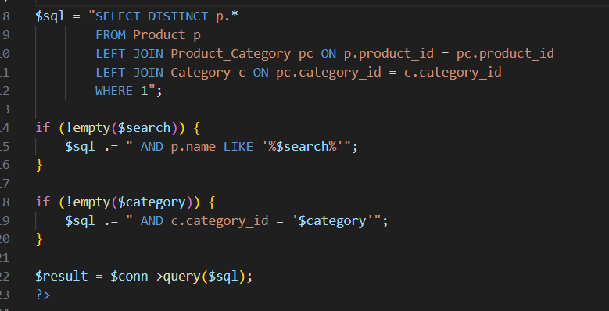
Figure 1: Assessing the vulnerability in the index.php
As shown in Figure 1, the query was structured as WHERE p,name LIKE ‘search’, which helps any attackers to play with the query structure of the system. However, to demonstrate the vulnerability, a different input was used. The condition used was OR ‘1’ =’1 which helped in identifying system vulnerability.
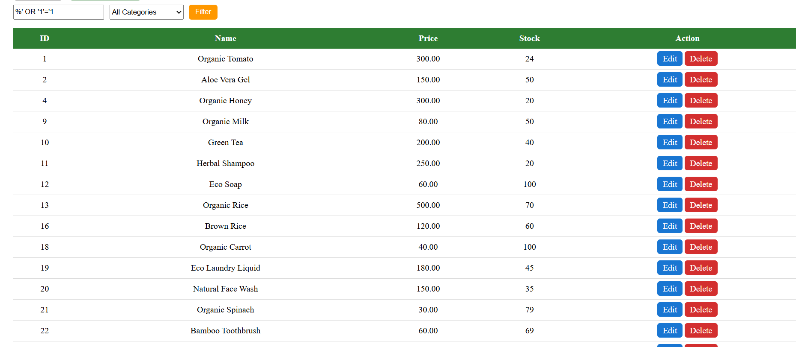
Figure 2: The attacks returned the queries
As shown in Figure 2, the database considers the query as true, which leads to returning of all records. This is how the system vulnerability is detected.

Risks related to SQL Injection
Any SQL attack on Greenleaf’s database can lead to the following impacts:
- Unauthorized Access to the database.
- Breach of sensitive data
- Manipulation of critical data
- Increase in database vulnerability to threats.

Testing for the GreenLeaf: Vulnerability in Web Applications
In the case of GreenLeaf Organics' website and online store creation, it becomes a major constraint largely because the website application contains backend databases that are more vulnerable than any other databases. Most importantly, the customer, product, supplier, and other data stored as part of the online database can be entirely erased, breached, or retrieved. Thus, the online store will become fully functional, leading to huge losses.
A simple real-time example would be a system using a query as follows;
SELECT * FROM Product WHERE name= ‘user input” where an attacker can enter such a number or query that makes the condition true, thereby enabling the attacker to view all the required data. That is why websites need proper authentication, security, and anti-malware systems in place.
Considering the potential risks to the brand, it can help attackers bypass authorization requirements, unless there is a highly innovative cybersecurity framework. Also, the data associated with the business, more importantly, the sensitive and confidential information, can be breached. Sometimes the attacker intends only to modify the data so that the entire transaction or system keeps showing errors.

Implementation after using the security system
In terms of the evidence of using preventive measures, a test was conducted using the same malicious code that an attacker would possibly use.
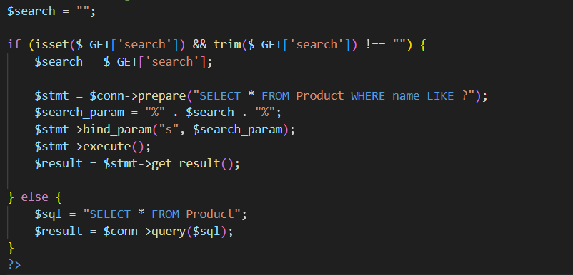
Figure 3: Using different inputs to protect from SQL injection
As illustrate din the figure 1, there are no user inputs used in the query; instead, a different placeholder is used. It helps in keeping the user information safe from being executed as any other code.

Testing the security implementation
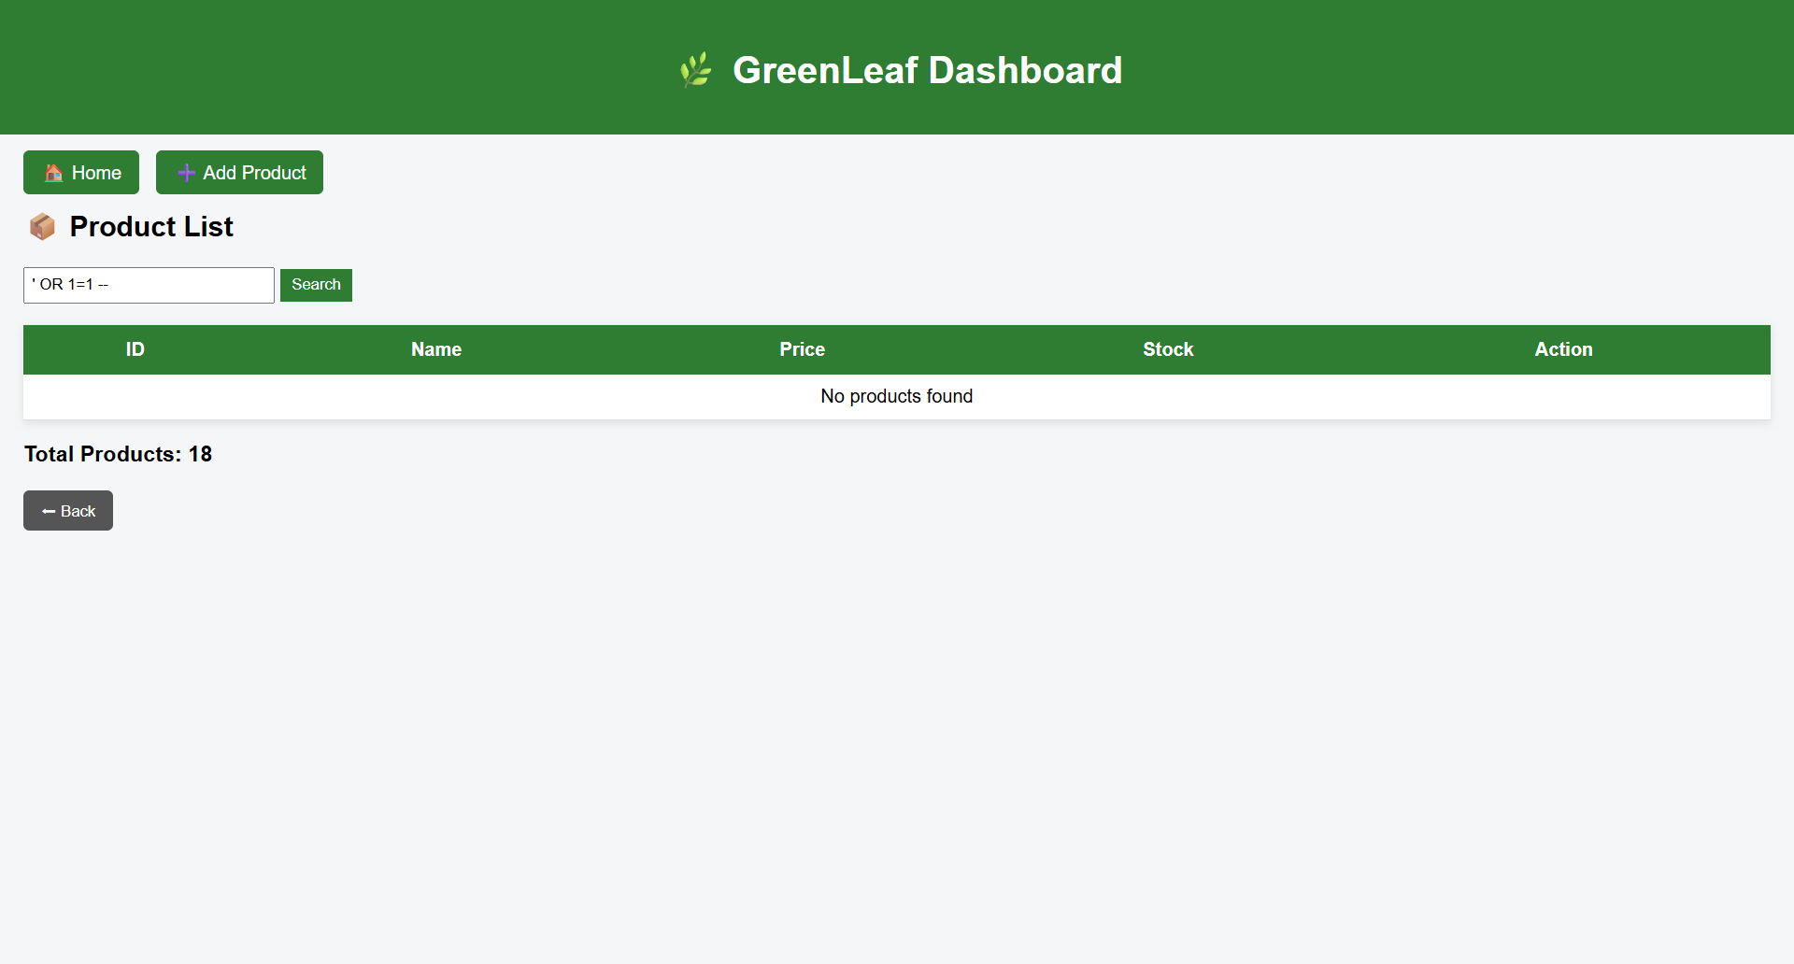
Figure 4: Analysis of SQL injection attacks
Based on the demonstration or the test, we have derived a result where the webpage shows “No products found,” as shown in Figure 2, showing that the separation of the user inputs from the other code prevents the page from being subject to SQL injection.

Evaluation
The use of anti- SQL injection techniques protects not only the sensitive data necessary for the online store to operate, but it also ensures the reliability of every transaction. Duplication is very much possible with such tactics, and it can be largely avoided.

