Marketing plan written for
Hotel Holiday Inn

Student Name: Rohit Patra
Student ID: 2233814

___________________
Marketing Essentials BMIH4005
Lecturer

________________________________
Contents
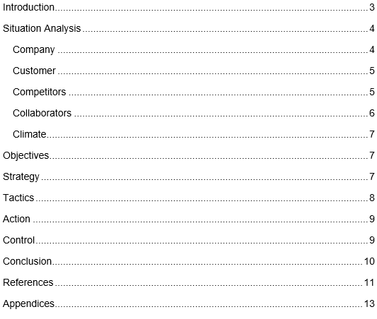

Introduction
This marketing plan report has been prepared with the purpose of providing a comprehensive strategy to promote and sell a product or service. The report outlines a clear roadmap for achieving marketing goals and objectives within a specific timeframe. The marketing plan is essential for any organization to achieve a competitive edge and increase revenue. It helps businesses to identify their target audience, understand their needs, and develop effective marketing campaigns to attract and retain customers (Jobber, et al 2020). The SOSTAC model, which means Situation, Objectives, Strategy, Tactics, Action, and Control, is used in this report (Kotler et al 2020). This model provides a framework for developing a marketing plan that is structured, measurable, and actionable. Additionally, the report includes the 4Ps of marketing. These elements are fundamental in defining the marketing mix for the product or service, and they ensure that the company is providing the appropriate product, at the correct price, through the right channels, and with the right promotion.

Situation Analysis
Hotel Holiday Inn is a global hotel chain that offers comfortable and convenient accommodations to travellers around the world. The hotel chain was established in 1952 and has since launched over 3,000 locations in more than 100 countries (Shuford,et al 2015). Now here are some key elements of the situation analysis of the hotel Holiday Inn.

Company

Customer

Competitors
Five Forces Model of Porter for Hotel Holiday Inn:

Collaborators
Hotel Holiday Inn collaborates with a range of partners and stakeholders to enhance its operations and offer a better experience for customers. Some of its key collaborators include:
- Franchisees: Hotel Holiday Inn operates through a franchise model, partnering with independent hotel owners to operate under the Holiday Inn brand (Clow et al 2013). This allows the hotel chain to expand its reach and offer a consistent brand experience across its locations.
- Technology Providers: Hotel Holiday Inn collaborates with technology providers to enhance its operations and customer experience. This includes the use of online booking platforms, mobile apps, and other digital tools to streamline operations and offer personalized services to customers (Housden 2008).
- Food and Beverage Suppliers: Hotel Holiday Inn partners with food and beverage suppliers to offer quality dining options for its customers. This includes a range of restaurants and bars that cater to different tastes and preferences.
- Corporate Clients: Hotel Holiday Inn collaborates with corporate clients to offer specialized services for business travellers. This includes conference facilities, meeting rooms, and other amenities that cater to the needs of corporate clients.
- Travel Agents: Hotel Holiday Inn partners with travel agents to offer packages and promotions for its customers. This allows the hotel chain to reach a wider audience and offer competitive prices and value-added services to customers.

Climate
- Political factors, such as laws and regulations related to taxation, employment, and health and safety, can impact Holiday Inn's profitability and operations.
- Economic factors such as exchange rates, inflation, and global economic conditions can also impact the demand for hotel services and Holiday Inn's operations.
- Sociocultural factors such as changing consumer preferences and trends can also impact the hotel chain's operations and marketing strategies.
- Technological advancements can provide opportunities for Holiday Inn to improve its operations and enhance customer experience, but it may also require significant investments.
- Environmental factors such as climate change and natural disasters can also impact Holiday Inn's operations and sustainability efforts.

Objectives
The aims of the marketing plan for Hotel Holiday Inn are to increase occupancy rates, improve customer satisfaction, and enhance brand awareness through targeted promotional strategies and personalized customer experiences.

Strategy
The marketing strategy for Hotel Holiday Inn focuses on providing a high-quality customer experience that emphasizes personalized service and value for money. The hotel chain's value proposition is centred on offering a comfortable and convenient stay that meets the needs of both leisure and business travellers. To achieve this, the marketing plan includes targeted promotional strategies such as loyalty programs, online marketing, and partnerships with travel agents. In terms of pricing strategy, Hotel Holiday Inn uses Bowman's Strategy Clock to position itself as a quality mid-market hotel chain that offers competitive prices (Smith PR 2020). The hotel chain leverages economies of scale to keep costs low while still providing a high-quality service. This approach enables Hotel Holiday Inn to differentiate itself from both luxury and budget hotels and appeal to a wide range of customers seeking value for money. Overall, the marketing strategy for Hotel Holiday Inn is focused on delivering a quality customer experience at a competitive price point.

Tactics
The marketing mix for Hotel Holiday Inn includes the following components:
- Product: The hotel Holiday Inn offers a range of accommodation options to meet the needs of both leisure and business travellers, including standard rooms, suites, and executive rooms. The hotel chain also provides amenities such as restaurants, bars, fitness centres, and meeting rooms.
- Price: Hotel Holiday Inn uses a competitive pricing strategy to appeal to a wide range of customers seeking value for money. The hotel chain also offers promotional discounts and loyalty programs to incentivize repeat business and encourage customer loyalty.
- Place: Hotel Holiday Inn has a global presence with properties located in key destinations around the world. The hotel chain also utilizes various distribution channels such as online travel agents, direct bookings, and partnerships with airlines and other travel companies.
- Promotion: The hotel chain uses a mix of traditional and digital marketing strategies to promote its services and enhance brand awareness. This includes targeted advertising campaigns, social media marketing, email marketing, and partnerships with travel bloggers and influencers.

Action
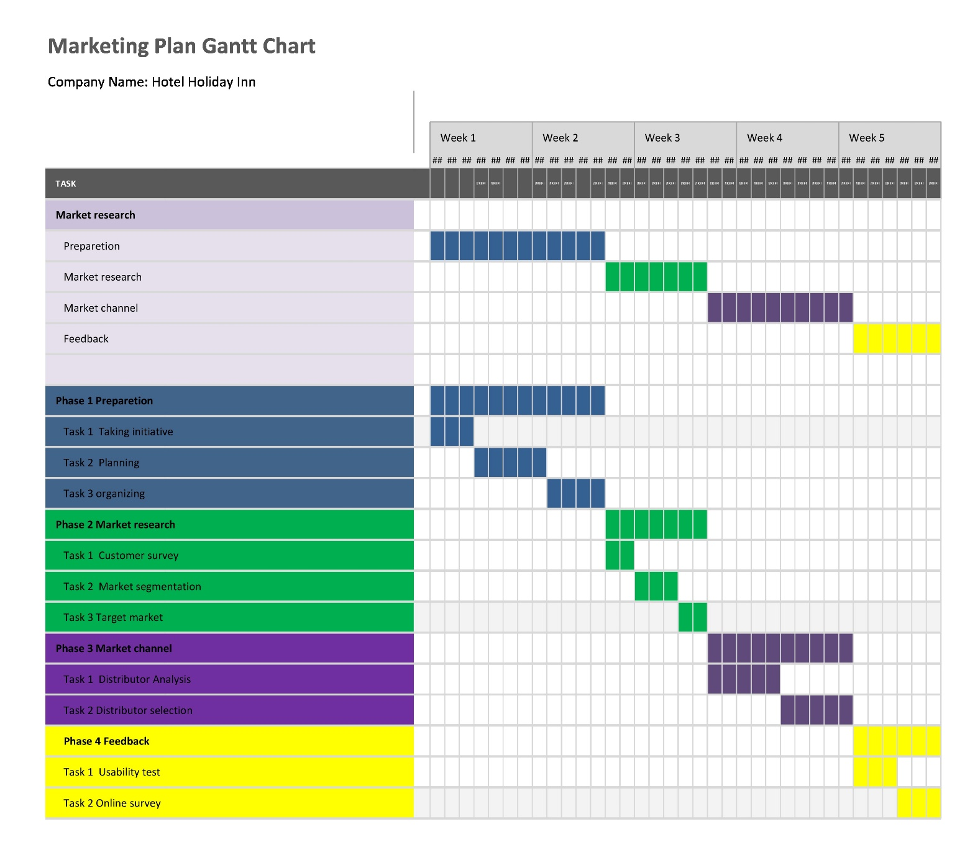

Control
The success of Hotel Holiday Inn's marketing plan will be measured by metrics such as occupancy rates, revenue per available room, and customer satisfaction scores. The hotel chain will also track the number of new customers, positive attitudes towards the brand, and revenue growth to determine the effectiveness of its marketing strategies and initiatives. The Unique Selling Proposition (USP) for Hotel Holiday Inn is its commitment to providing a comfortable and convenient stay that meets the needs of both leisure and business travellers at a competitive price point (Ryan 2012). The hotel chain places a strong emphasis on delivering personalized and high-quality customer service while also offering a range of amenities such as restaurants, bars, fitness centres, and meeting rooms. Additionally, Hotel Holiday Inn has a global presence with properties located in key destinations around the world, making it a convenient and reliable choice for travellers seeking a consistent experience wherever they go.

Conclusion
The marketing plan for Hotel Holiday Inn aims to increase occupancy rates, improve customer satisfaction, and enhance brand awareness through targeted promotional strategies and personalized customer experiences. The product, price, place, promotion, people, procedure, and physical evidence are all part of the hotel chain's marketing mix (Chaff 2019). Recommendations include expanding the hotel chain's online presence, leveraging data analytics to personalize customer experiences, and investing in sustainable initiatives to appeal to environmentally conscious travellers.

References
- Bowie,D. Buttle,F. Brookes,M & Mariussen,A (2017), Hospitality Marketing. 3rd ed, Routledge, London
- Chaffey, D and Ellis- Chadwick, F. (2019) Digital Marketing. 7th ed, Pearsons, London. Ghauri, P N (2014) International Marketing, 4th Ed, McGraw Hill, London
- Christopher, A.O., 2021. E-marketing and the hotel business promotion: Prospect and challenges in selected hotels in Ado-Ekiti, Nigeria. E3 Journal of Business Management and Economics, 11(1), pp.020-026.
- Clow, K & Baack, D (2013), Integrated Advertising, Promotion and Marketing Communications. 6th ed, Pearson, London
- de Roos, J.A. and Wiseheart, M., 2016. Agency tests in hotel management agreements. Available at SSRN 2754217.
- Hargreaves, C.A., 2015. Analysis of hotel guest satisfaction ratings and reviews: An application in Singapore. American Journal of Marketing Research, 1(4), pp.208-214
- Henschel, U.K., Gruner, A. and Von Freyberg, B., 2018. Hotelmanagement. Walter de Gruyter GmbH & Co KG.
- Housden M (2008), Marketing Research & Information, Butterworth Heinemann, Oxford. Kotler,P and Kartajaya, H. Marketing 4.0 Moving from Traditional to Digital (2017) Wiley. New York.
- Jobber, D. and Ellis-Chadwick, F (2020), Principles and practice of marketing. 9th ed. London.
- Kotler, P., Armstrong, G., Harris, L. and He, H., 2020. Principles of marketing. 8th European ed, London: Pearson Education Limited.
- Migdal, N.F., Shapiro, S. and Gorman, T., 2015. Hotel Law: Transactions, management and franchising. Routledge.
- Rutherford, D.G., 2021. Hotel management and operations.
- Ryan, D. (2012) Understanding Digital marketing: Marketing Strategies for Engaging The Digital Generation. Kogan Page, London.
- Shuford, J., 2015. Hotel, motel, Holiday Inn and peer-to-peer rentals: the sharing economy, North Carolina, and the constitution. North Carolina Journal of Law & Technology, 16(5), p.301.
- Smith PR & Zook ZE (2020) Marketing Communications. 7th ed, Kogan Page, London

Appendices
Slide 1
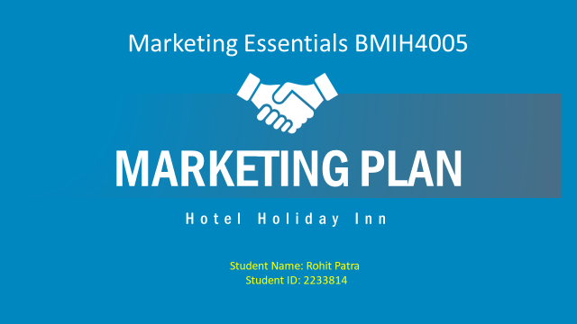

Slide 2
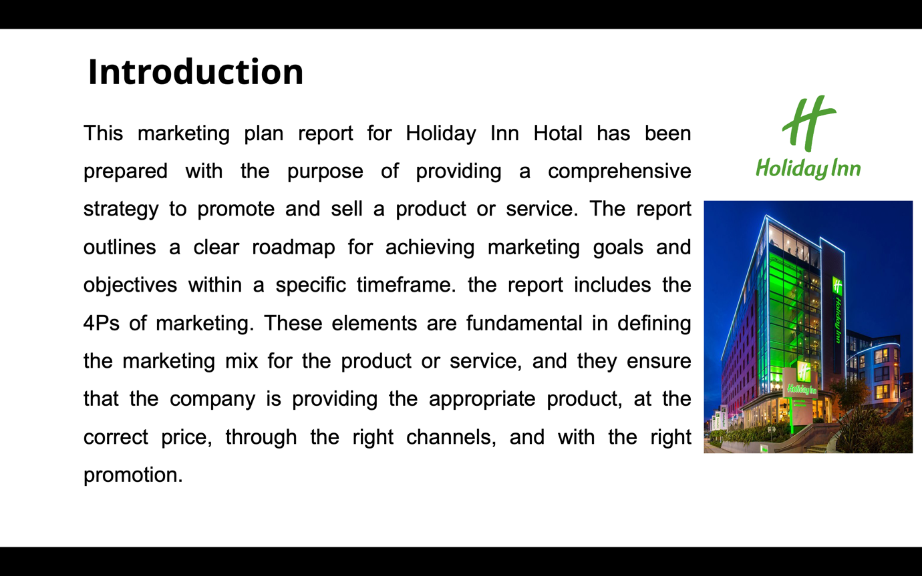

This marketing plan report has been prepared with the purpose of providing a comprehensive strategy to promote and sell a product or service. The report outlines a clear roadmap for achieving marketing goals and objectives within a specific timeframe. The marketing plan is essential for any organization to achieve a competitive edge and increase revenue. It helps businesses to identify their target audience, understand their needs, and develop effective marketing campaigns to attract and retain customers (Jobber, et al 2020). The SOSTAC model, which means Situation, Objectives, Strategy, Tactics, Action, and Control, is used in this report (Kotler et al 2020). This model provides a framework for developing a marketing plan that is structured, measurable, and actionable. Additionally, the report includes the 4Ps of marketing. These elements are fundamental in defining the marketing mix for the product or service, and they ensure that the company is providing the appropriate product, at the correct price, through the right channels, and with the right promotion.

Slide 3
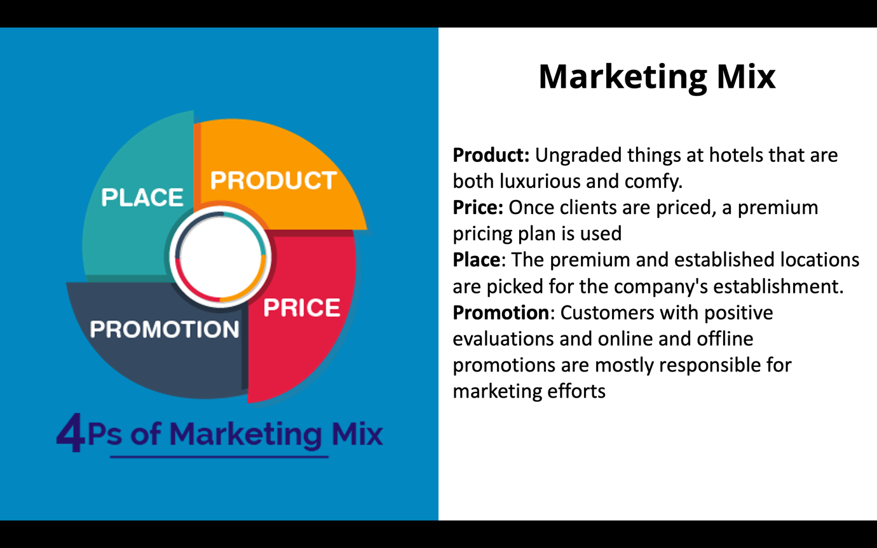

Marketing Mix

- Product: Ungraded things at hotels that are both luxurious and comfy.
- Price: Once clients are priced, a premium pricing plan is used
- Place: The premium and established locations are picked for the company's establishment.
- Promotion: Customers with positive evaluations and online and offline promotions are mostly responsible for marketing efforts
Slide 4

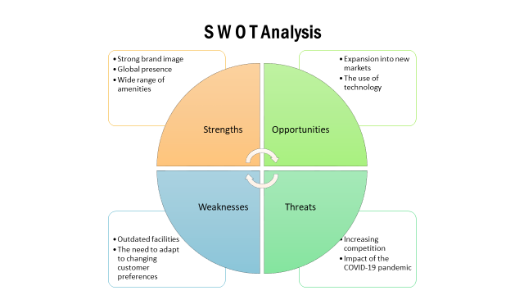
SWOT Analysis
Strengths: Strong brand image, Global presence, Wide range of amenities are pushing the brand ahead.
Weaknesses: Outdated facilities and The need to adapt to changing customer preferences would be crucial
Opportunities: Expansion into new markets and The use of technology would be handful for the brand
Threats: Increasing competition and Impact of the COVID-19 pandemic gave the hotel a good level of threat

Slide 5
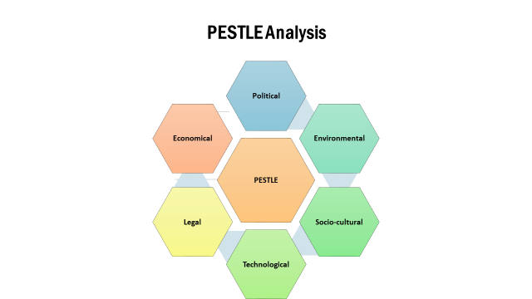

- Political factors, such as laws and regulations related to taxation, employment, and health and safety, can impact Holiday Inn's profitability and operations.
- Economic factors such as exchange rates, inflation, and global economic conditions can also impact the demand for hotel services and Holiday Inn's operations.
- Sociocultural factors such as changing consumer preferences and trends can also impact the hotel chain's operations and marketing strategies.
- Technological advancements can provide opportunities for Holiday Inn to improve its operations and enhance customer experience, but it may also require significant investments.
- Environmental factors such as climate change and natural disasters can also impact Holiday Inn's operations and sustainability efforts.

Slide 6
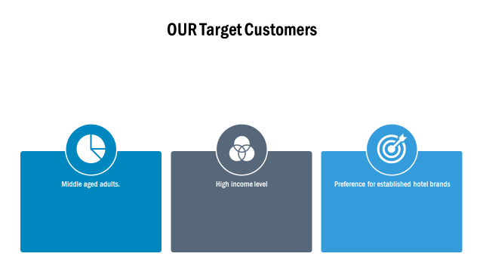

Market Segmentation
- Business and leisure travellers seeking comfortable and convenient accommodation with quality amenities
Target Customer Profile
- Middle-aged adults with a moderate to high-income level and a preference for established hotel brands

Slide 7
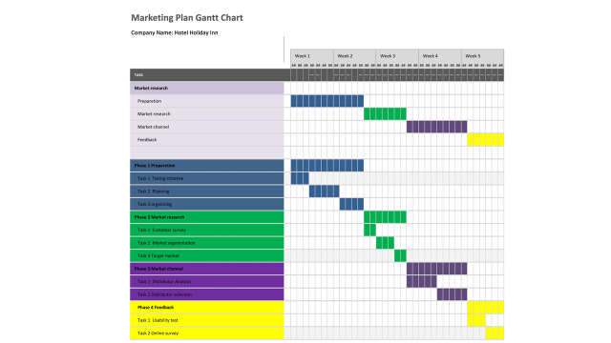

Slide 8
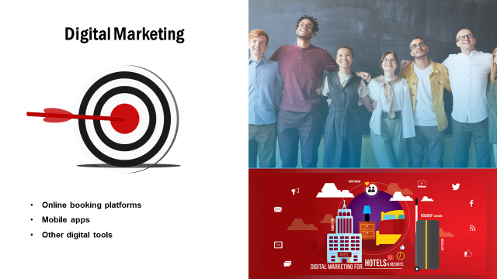
Hotel Holiday Inn collaborates with technology providers to enhance its operations and customer experience. This includes the use of online booking platforms, mobile apps, and other digital tools to streamline operations and offer personalized services to customers.

Slide 9
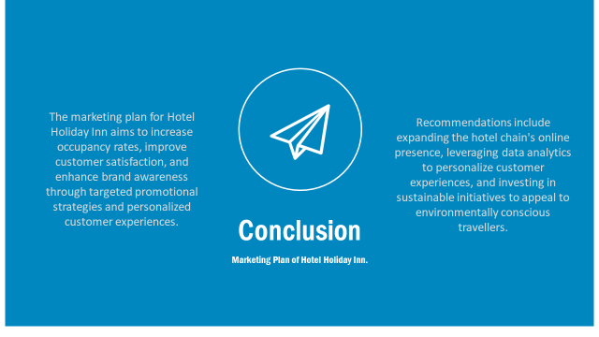
The marketing plan for Hotel Holiday Inn aims to increase occupancy rates, improve customer satisfaction, and enhance brand awareness through targeted promotional strategies and personalized customer experiences. The product, price, place, promotion, people, procedure, and physical evidence are all part of the hotel chain's marketing mix (Chaff 2019). Recommendations include expanding the hotel chain's online presence, leveraging data analytics to personalize customer experiences, and investing in sustainable initiatives to appeal to environmentally conscious travellers.

Slide 10
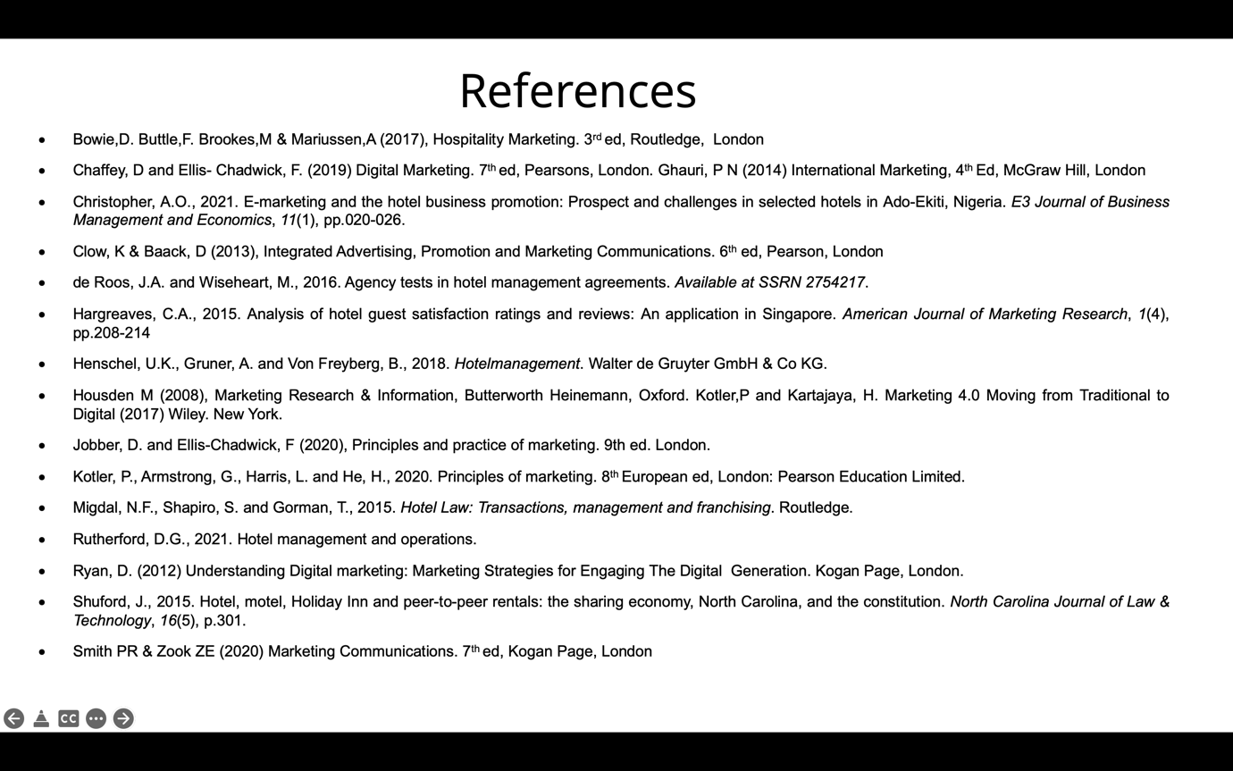
- Bowie,D. Buttle,F. Brookes,M & Mariussen,A (2017), Hospitality Marketing. 3rd ed, Routledge, London
- Chaffey, D and Ellis- Chadwick, F. (2019) Digital Marketing. 7th ed, Pearsons, London. Ghauri, P N (2014) International Marketing, 4th Ed, McGraw Hill, London
- Christopher, A.O., 2021. E-marketing and the hotel business promotion: Prospect and challenges in selected hotels in Ado-Ekiti, Nigeria. E3 Journal of Business Management and Economics, 11(1), pp.020-026.
- Clow, K & Baack, D (2013), Integrated Advertising, Promotion and Marketing Communications. 6th ed, Pearson, London
- de Roos, J.A. and Wiseheart, M., 2016. Agency tests in hotel management agreements. Available at SSRN 2754217.
- Hargreaves, C.A., 2015. Analysis of hotel guest satisfaction ratings and reviews: An application in Singapore. American Journal of Marketing Research, 1(4), pp.208-214
- Henschel, U.K., Gruner, A. and Von Freyberg, B., 2018. Hotelmanagement. Walter de Gruyter GmbH & Co KG.
- Housden M (2008), Marketing Research & Information, Butterworth Heinemann, Oxford. Kotler,P and Kartajaya, H. Marketing 4.0 Moving from Traditional to Digital (2017) Wiley. New York.
- Jobber, D. and Ellis-Chadwick, F (2020), Principles and practice of marketing. 9th ed. London.
- Kotler, P., Armstrong, G., Harris, L. and He, H., 2020. Principles of marketing. 8th European ed, London: Pearson Education Limited.
- Migdal, N.F., Shapiro, S. and Gorman, T., 2015. Hotel Law: Transactions, management and franchising. Routledge.
- Rutherford, D.G., 2021. Hotel management and operations.
- Ryan, D. (2012) Understanding Digital marketing: Marketing Strategies for Engaging The Digital Generation. Kogan Page, London.
- Shuford, J., 2015. Hotel, motel, Holiday Inn and peer-to-peer rentals: the sharing economy, North Carolina, and the constitution. North Carolina Journal of Law & Technology, 16(5), p.301.
- Smith PR & Zook ZE (2020) Marketing Communications. 7th ed, Kogan Page, London



