
The purpose of this report is to focus on the aspect of Samsung’s customer experience (CX) and
to also discuss the CX strategy used by Samsung to sell their mobile phone. The report will also
aim at meeting the general motive of the company using practical insights. In the course of this
report, various areas of customer experience will be focused on, which includes the importance
of CX, omnichannel marketing, etc. and they will be linked to Samsung mobil
The purpose of this report is to focus on the aspect of Samsung’s customer experience (CX) and
to also discuss the CX strategy used by Samsung to sell their mobile phone. The report will also
aim at meeting the general motive of the company using practical insights. In the course of this
report, various areas of customer experience will be focused on, which includes the importance
of CX, omnichannel marketing, etc. and they will be linked to Samsung mobil

Quality and Customer Relationship Management of Samsung Mobile

Student Name: Roxana-Ioana Ciubotariu

Module Name: Understanding and Engaging in the Customer Experience

Modul cod: BMSW5103

Lecturer Name: Nishi Ramsurrun

University of Wales Trinity Saint David

Summary

This report focuses on Samsung mobile and how it can improve its customers management (CRM)processes by implementing an appropriate CRM model. The report begins with an introduction to the importance of quality processes and CRM efforts for Samsung Mobile, highlighting the potential core benefits of an excellent customer experience. The company background sections provide a brief overview of Samsung Mobile’s current positions, its CRM problem, and the expected benefits of addressing this problem. In the model review sections, tow CRM models are critically reviewed, outlining their relevance, strengths, and weaknesses. The selections and application of model will then be discussed, with the justification of the chosen model followed by its applications to the Samsung Mobile CRM problem. Finally, the report assesses the application benefits and challenges and discusses the effectiveness of AI and marketing theories that can improve the CRM process.

Introduction
Quality processes and CRM efforts are crucial for businesses to achieve sustainable success in today highly competitive marketplace. Total Quality Management (TQM)and SERVQUAl are two such processes that help organizations improve their product and service quality. A well-executed CRM strategy also improves the customers experience, which leads to increased loyalty and advocacy, which translates into financial benefits for the company. This report aims to provide a road map for Samsung Mobile to improve its CRM process by Implementing an appropriate CRM mode.

Company Introduction
Samsung is a South Korean multinational company that produces a wide range of electronic devices, including mobile phones, televisions, and home appliances. Samsung has become one of the world's leading smartphone manufacturers, offering a range of Android-based devices for consumers with different budgets and preferences.
Samsung's flagship phones like the Galaxy S and Note series are known for their advanced features and high-end specs, while their mid-range phones like the Galaxy A series strike a balance between affordability and quality. Samsung also offers budget-friendly phones, such as the Galaxy M series, for those who want a basic smartphone experience without breaking the bank.
Samsung mobile devices are known for their innovative features, including high-quality cameras, large screens, powerful processors, and long-lasting batteries. The company has also been at the forefront of developing new technologies such as foldable screens, 5G connectivity and artificial intelligence functions. Samsung has a strong presence in the mobile phone market and continues to innovate and improve its devices to meet changing consumer needs and demands. Despite its success, Samsung Mobile struggles with the CRM process, which has led to low levels of customer satisfaction. Online reviews indicate that customers are dissatisfied with Samsung Mobile customer service and after sales support. The company CRM problem stems from Both internal and external factors such as poor communication channels, inadequate employee training and increased competition. Addressing this problem could lead to increased customer loyalty improved brand reputation, and increased revenue.

Samsung's Total Quality Management
Total quality management (TQM) is a management philosophy that emphasizes continuous improvement in all aspects of an organization's operations. Samsung, the South Korean multinational conglomerate, is known for successfully implementing TQM in its operations.
Samsung's TQM approach involves a strong focus on customer satisfaction, employee involvement and empowerment, and a commitment to continuous improvement. The company uses several TQM tools and techniques to ensure the quality of its products and services, such as statistical process control, Six Sigma and Kaizen methodology.
One of the key elements of Samsung's TQM strategy is its focus on innovation. The company encourages its employees to generate new ideas and improve processes through an open communication culture where feedback is valued and acted upon. Samsung also invests heavily in research and development to stay ahead of the competition and bring new products and services to market.
Another important aspect of Samsung's TQM approach is its focus on quality control. The company uses several methods, such as statistical analysis and quality circles, to ensure that its products and services meet or exceed customer expectations.
Samsung's total quality management approach has helped the company become a leader in the consumer electronics and mobile phone markets and has contributed to its reputation for high quality products and services.
Preventive quality management of Samsung Organisation
Preventive quality management is an approach to quality management that focuses on identifying and addressing potential quality problems before they occur, rather than simply reacting to problems after they occur. Samsung, the South Korean multinational conglomerate, has implemented several strategies of preventive quality management.
One of the key strategies Samsung uses for preventive quality management is product design. The company invests heavily in research and development to ensure that its products are designed with quality in mind from the very beginning. This includes using advanced materials, rigorous component testing and designing products to be easy to use and reliable.
Another important aspect of Samsung's preventive quality management approach is the management of its supply chain. The company works closely with suppliers to ensure that they meet Samsung's high-quality standards and uses quality control processes such as Six Sigma to ensure that products meet specifications and are delivered on time.
Samsung also uses Statistical Process Control (SPC) to monitor and control the quality of its production processes. SPC involves the collection and analysis of process performance data to identify potential quality problems and to prevent them from occurring. This approach helps Samsung ensure its products are consistently of high quality and reduces the risk of defects and recalls.
Samsung's preventive quality management approach has helped the company achieve high levels of quality in its products and services and contributed to its reputation for innovation and reliability.
Customer satisfaction of Samsung Company
Samsung, the South Korean multinational conglomerate, places a strong emphasis on customer satisfaction in its operations. The company has implemented several strategies to ensure that its products and services meet or exceed customer expectations. One of the keyways Samsung measures customer satisfactions is through customer feedback. The Company regularly solicits feedback from its customers through surveys, online forums and social media and uses this feedback to identify areas for improvement in its products and services. Samsung also places a strong emphasis on product quality as a key driver of customer satisfaction. The company invests heavily in research and development to ensure that its products are innovative, reliable, and easy to use, and uses quality control processes such as Six Sigma to
ensure that products meet specifications and are delivered on time. In addition to product quality, Samsung also focuses on customer service as a key element of customer satisfaction. The company offers a wide range of customer support services, including telephone and online support, repair and maintenance services, and warranty programs. Samsung’s emphasis on customer satisfaction has contributed to the company's success in the consumer electronics and mobile phone markets. By focusing on product quality, innovation and customer service, Samsung has built a loyal customer base and a reputation for high-quality products and service.
Samsung Customer Support
Samsung, the South Korean multinational conglomerate, provides a wide range of customer support services to its customers worldwide. These services include phone and online support, repair and maintenance services and warranty programs.
Samsung's telephone support service provides customers with access to trained support representatives who can assist with technical issues and answer questions about Samsung products and services. The company also offers online support through its website and social media channels where customers can find answers to frequently asked questions and troubleshoot problems with their devices.
In addition to telephone and online support, Samsung provides repair and maintenance services for its products. The company has service centres located all over the world where customers can bring their devices for repair and maintenance services. Samsung also offers remote support services, allowing technicians to diagnose and fix problems with devices from afar.
Samsung's warranty program is another key element of its customer care offerings. The company offers a range of warranties on its products, including standard manufacturer's warranties and extended warranties that provide additional coverage for repairs and replacements. Samsung's warranty program is designed to give customers peace of mind and protect them from defects and other issues with their devices.
Samsung Customer Support Services are designed to provide customers with the help and support they need to use their Samsung products with confidence. By offering a wide range of support services, including phone and online support, repair and maintenance services and warranty programs, Samsung has built a loyal customer base and a reputation for providing high quality products and services.

Customer Relationship Management of Samsung Organisation
CRM is very important for Samsung mobile phones as CRM can be a determining factor in their success in the UK. It interprets the behaviour, satisfaction and attitude of their customers and the quality relationship their brand has with its customers. When it comes to Samsung's competitive advantage in the UK telecom market, Samsung can proudly say that its success relationship between its clients.

Samsung organization positive and negative review
The company uses customer data to personalize its marketing and communication efforts, tailoring its messages to individual customers based on their preferences and past brand interactions. Samsung also provides personalized product recommendations and customer support services based on their needs and usage patterns. In addition to customization, Samsung places a strong focus on customer support as a key element of its CRM efforts. The company offers a wide range of support services to customers, including telephone and online support, repair and maintenance services and warranty programs. Samsung Support Services are designed to provide customers with the help and support they need to use their Samsung products with confidence and to address any issues or concerns they may have in a timely and efficient manner. Samsung is also using customer feedback to inform their CRM efforts. The Company regularly solicits feedback from its customers through surveys, online forums and social media and uses this feedback to identify areas for improvement of its products and services. Samsung's CRM team works closely with other departments across the company, such as product development and marketing, to ensure that customer feedback is incorporated into all aspects of the business. Samsung CRM's efforts are designed to build and maintain strong, long-term relationships with its customers by providing high-quality products and services, personalized communication, and superior customer support. By focusing on the needs and preferences of its customers and using customer feedback to inform its strategy, Samsung has built a loyal customer base and a reputation for delivering high-quality, innovative products and services.
Positive Review

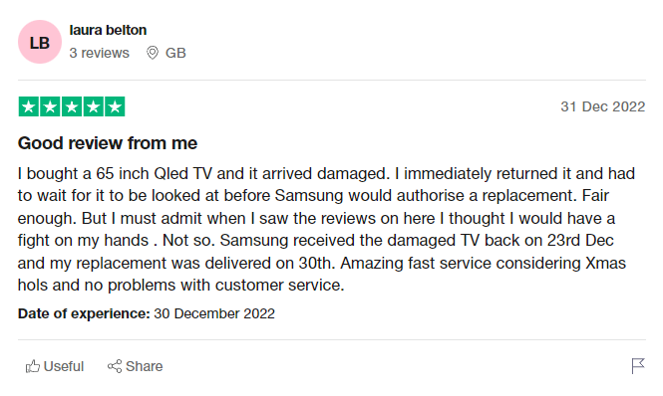

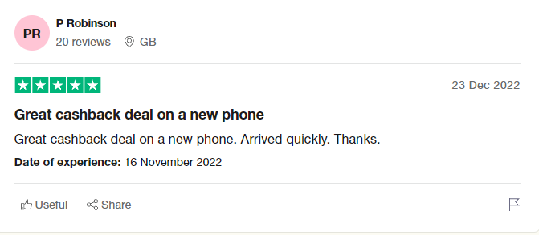

Negative Review
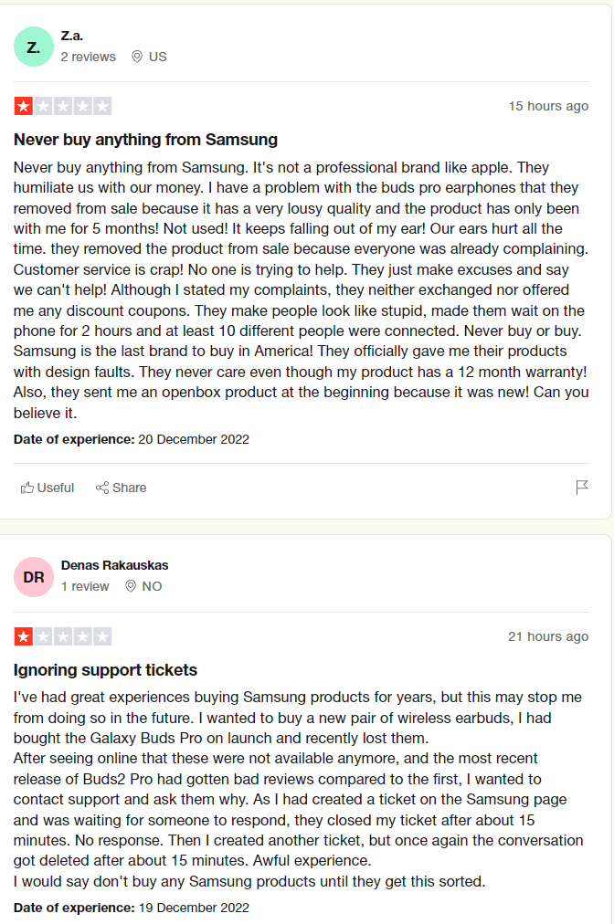

Response to positive review
For the positive reviews, as a manager with experience with clients, I can thank the client for trusting in our company. For the mistake that happened with the product, let us apologize for the unpleasant incident and solve the problem as urgently as possible so that the client is satisfied with our services. Let's replace the product with a new one. And in the future, give the staff good training to know how to deliver our products safely. So that they know how to follow the procedures to stop destroying the products before reaching the customer. Experienced manager, we always need to come up with different deals for our clients. And to offer them the best opportunities in which to make their own customized plan so that it is easier for them to buy the best products from us. quality.

Response to negative reviews
When receiving negative reviews, the company usually responds with empathy, a willingness to address the issue, and a commitment to improving the customer experience. Samsung should appreciate all feedback from its customers, including negative feedback, as it provides an opportunity to identify areas for improvement and make necessary changes to improve the overall customer experience.
The negative reviews should be taken very seriously because they help us to improve the quality of our products. But it also helps us with the development of customer services to see what their experience is with the staff. And for this we must find solutions how to We are developing the services provided by the staff for clients. Let's give the staff more motivation and more training. Let's try to make our products better than the other products on the market. And let's try to be more careful with the new products when we launch them on the market, let's do a more careful expertise on the products. So that customers are no longer dissatisfied in the future.

Samsung SWOT analysis Company
Samsung is a technology conglomerate popularly known for its consumer electronics products, which in this SWOT analysis refers to the competitive strengths of the business that keep the enterprise a major player in the international market. A corporate SWOT analysis indicates the most relevant strengths, weaknesses, opportunities and threats in the field of technology and its operating environment.

Samsung strengths Internal Strategic factors
- Strong Brand Image: Samsung is one of the most well-known and respected brands in the world and has a reputation for producing high-quality products.
- Diversified product portfolio: Samsung manufactures a wide range of products including smartphones, TVs, home appliances and more.
- Strong Research and Development Capabilities: Samsung invests heavily in research and development, which enables the company to create innovative products and stay ahead of the competition.

Weaknesses Samsung of Internal strategic factors
- Dependence on the smartphone market: Samsung's smartphone division contributes significantly to the company's revenue, which can be a weakness if the smartphone market faces a downturn.
- Lack of differentiation: Some of Samsung's products, such as its smartphones, may not have significant differentiation compared to its competitors.
- Supplier Dependence: Samsung relies on a network of suppliers for its components and materials, which can lead to supply chain disruptions and other issues.
Opportunities for Samsung External Strategic Factors
- Expand into new markets: Samsung can expand its product offerings into new markets, such as wearable technology and virtual reality.
- Growth in emerging markets: As emerging markets continue to develop; Samsung has significant potential to expand its customer base and increase revenues.
- Increased focus on sustainability: As consumers become more environmentally conscious, Samsung has an opportunity to differentiate itself by focusing on sustainability and environmentally friendly products.

Threats Samsung Faces External Strategic Factors
- Competition: Samsung is facing intense competition from other tech companies like Apple and Huawei.
- Economic downturns: Economic downturns can lead to lower consumer spending, which can have a negative impact on Samsung's revenue.
- Technological changes: Rapid technological changes can make some of Samsung's products obsolete and require the company to invest heavily in research and development to remain competitive.

PESTLE Analysis of Samsung
There are many ways to analyse the operation of the company for the purpose of tracking growth. To track the growth of a company, you can easily choose from external factors, internal factors, competitors, markets and more. All these factors are chosen to chart the growth and success of the company.

Political factors of Samsung
- Regulations: Samsung operates in different countries with different regulations that may affect the company's operations and profitability.
- Trade policies: Trade policies such as tariffs and trade agreements may affect Samsung's ability to import and export products.
- Political Instability: Political instability, such as civil unrest or changes in government, may negatively impact Samsung's operations in affected countries. They employ thousands of employees.
Economic factors of the Samsung Company
- Global Economic Conditions: Economic conditions, such as recessions or booms, can affect Samsung's revenue and profitability.
- Exchange Rates: Fluctuations in exchange rates can affect Samsung's international sale and revenue.
- Income levels: Consumers' income levels may affect Samsung's sales, as consumers with higher incomes may be more likely to buy higher end products.
Social factors of the Samsung Company
- Demographic changes: Demographic changes, such as an aging population or changing consumer preferences, may affect Samsung product offerings and sales.
- Consumer Behaviour: Changes in consumer behaviour, such as increased demand for durable products, may affect Samsung's product development and marketing strategies.
- Culture: Cultural differences between regions may affect Samsung's ability to effectively market and sell its products

Technology factors of Samsung company
- Rapid technological changes: Rapid technological changes may make some of Samsung's products obsolete and may require the company to invest heavily in research and development to remain competitive.
- Intellectual Property: Intellectual property protection is critical in the technology industry, and Samsung may face legal challenges related to intellectual property.
Legal factors of the Samsung Company
- Patent and copyright laws: Samsung may face legal challenges related to patent and copyright infringement, which can be costly and time consuming.
- Consumer protection laws: Consumer protection laws may affect Samsung's marketing and sales practices, and the company must ensure compliance with these regulations.
- Labour laws: Samsung must comply with labour laws and regulations, which can affect the company's operations and profitability.
The environmental factor of the Samsung Company
- Climate change: Climate change and environmental issues can affect Samsung's operations and supply chain, as the company may need to address issues such as resource depletion and carbon emissions.
- Sustainable Business Practices: As consumers become more environmentally conscious, Samsung may need to focus on sustainable business practices to differentiate itself from competitors and appeal to environmentally conscious consumers.
- Waste Management: Samsung needs to address the issue of waste management related to its products such as e-waste and packaging materials.

Samsung the problem with the customer experience

Samsung has faced some customer experience challenges in the past. One issue was related to customer support, with some customers reporting difficulty in resolving their issues or getting adequate support. This has resulted in frustration and negative experiences for some customers.
Another problem was related to the quality and safety of the product. Samsung has faced several incidents where its products, such as smartphones and washing machines, have been recalled due to safety concerns. These incidents caused inconvenience and dissatisfaction for customers, who might have to be without their devices for long periods of time or worry about security issues.
In addition, some customers have reported dissatisfaction with Samsung's software updates and lack of timely updates for older devices. This has led to frustration among users who may not be able to access the latest features or security updates.
In recent years, Samsung has worked to improve its customer experience by investing in customer service, implementing quality control measures, and focusing on product innovation. The company has also introduced initiatives such as the Samsung Members program, which provides customized support and benefits to customers. However, there is still room for improvement and Samsung continues to work to provide a better overall experience for customers.

Acting to alleviate a global crisis for Samsung mobile.

Samsung Mobile has faced a global crisis such as a pandemic or natural disaster, there are several actions the company could take to mitigate the situation.
First, Samsung could focus on providing essential products and services to help people cope with the crisis. For example, during a pandemic, Samsung could focus on producing and delivering medical equipment like ventilators, or donating smartphones and tablets to help people stay connected and informed.
Second, Samsung could implement measures to support its employees and communities impacted by the crisis. This could include providing financial assistance or mental health support to employees or donating funds and resources to local organizations and relief efforts.
Third, Samsung could leverage its technology and innovation capabilities to develop solutions to address the crisis. For example, Samsung might develop new products or software applications that help people work or study from home or collaborate with other companies and organizations to develop new treatments or vaccines for a pandemic.
By taking a proactive and responsible approach to a global crisis, Samsung mobile can help mitigate the impact of the crisis and contribute to the well-being of its employees, customers, and communities.

Closing the loop at every level of the Samsung organization
Closing the loop is an important concept in every organization, and Samsung is no exception. It means ensuring that feedback and information is collected, analysed, and considered at every level of the organization, from senior management to front-line employees. This helps ensure that issues are identified and resolved quickly, and that the organization continuously improves its products, services, and operations.
At Samsung, closing the loop can be achieved by implementing a feedback system that allows customers, employees, and other stakeholders to provide feedback and suggestions, and by ensuring that this feedback is collected, analysed, and considered in a timely manner. This can be done through various channels, such as customer surveys, employee suggestion boxes, and social media monitoring.
Once feedback has been collected, it should be analysed to identify common themes and trends, and action plans should be developed to address any issues that arise. These action plans should be communicated to relevant stakeholders and progress should be tracked to ensure that issues are resolved, and improvements are made.
Closing the loop also involves making sure all employees are aware of the feedback system and the importance of collecting and acting on feedback. Training and communication initiatives can be put in place to ensure employees understand the process and are equipped to collect and respond to feedback effectively.
By implementing a robust feedback system and closing the loop at every level of the organization, Samsung can improve its products, services, and operations, and ultimately provide a better experience to customers and stakeholders.
market. Today, Samsung's Net Promoter Score stands at 47. That's three points higher and slightly below the consumer electronics industry average of 55.

Conclusion
Based on the analysis of Samsung's mobile market performance, it can be concluded that the company has maintained a strong position in the global smartphone market through consistent innovation, a diverse product portfolio and effective marketing strategies. The report highlights increased competition in the industry, particularly from Chinese brands, and suggests that Samsung must continue to prioritize technological advancements and customer satisfaction to sustain its growth going forward. The report also identifies opportunities for Samsung to expand its presence in emerging markets and capitalize on the growing demand for 5G and foldable smartphones. In Samsung's mobile phone division, it has demonstrated resilience and adaptability in a rapidly evolving industry.

Recommendation

Quality Control: Samsung Mobile should continue to prioritize quality control processes in their production lines to ensure that their devices meet high standards of performance and reliability. This could involve investing in more robust testing procedures, leveraging data analytics to identify potential problems early on, and implementing strict quality control checks throughout the manufacturing process.
Product Innovation: Samsung Mobile should continue to invest in research and development to create new and innovative products to meet the changing needs of customers. This could include exploring new features and technologies such as foldable screens and 5G connectivity, as well as investing in sustainability initiatives and green materials.
Customer Feedback: Samsung Mobile should actively seek customer feedback to identify areas where they can improve their products and services. This could involve soliciting feedback through surveys, focus groups and online reviews, as well as leveraging social media to engage with customers and respond to their concerns in a timely manner.
Customer Service: Samsung Mobile should prioritize customer service and support to build strong relationships with their customers. This could involve investing in training programs for customer service representatives, implementing a comprehensive customer service portal, and offering incentives to keep customers loyal to the brand.
Customer Loyalty Programs: Samsung Mobile should consider implementing customer loyalty programs to encourage customers to purchase more Samsung products and services. This could involve offering exclusive discounts, early access to new products and personalized recommendations based on the customer's purchase history.
By prioritizing quality control, product innovation, customer feedback, customer service and loyalty programs, Samsung Mobile can build stronger relationships with their customers and maintain a competitive edge in the global smartphone market.

Reference
Our business:About Us.Samsung us.(2021,December1).Retrieved April 19,2023,from
https://www.samsung.com/us/about-us/our-business/
Mobile: Home Electronics: Home Appliances:Mobile. Samsung uk. (2022, April 19). Retrieved April 19, 2023, from https://www,samsung.com/uk/
Ltd, A. A. (2022, July 27). Effectiveness of Total Quality Management (TQM) at Samsung. UKDiss.com. Retrieved April 19, 2023, from https://ukdiss.com/proposal/total-quality-management-samsung-8352.php
Quality Handbook - Samsung Semiconductor Global. (n.d.). Retrieved April 19, 2023, from https://semiconductor.samsung.com/resources/others/Quality_Handbook_Web_Rev.05.pdf

Consumer satisfaction towards Samsung mobile phones with ... - JETIR. (n.d.). Retrieved April 19, 2023, from https://www.jetir.org/papers/JETIR1812504.pdf
Help &amp; Contact: Samsung United Kingdom. Samsung uk. (2023, March 29). Retrieved April 19, 2023, from https://www.samsung.com/uk/support/contact/
Newsroom, S. U. S. (2022, September 20). Samsung earns highest ranks in product and service quality for TV and Home Appliances by ACSI®. Samsung US Newsroom. Retrieved April 19, 2023, from https://news.samsung.com/us/samsung-ranks-highest-acsi-2022-product-service-quality-tv-home-appliances/
Mobile: Home Electronics: Home Appliances: TV. Samsung uk. (2023, April 19). Retrieved April 19, 2023, from https://www.samsung.com/uk/
Frue, K. (2020, November 24). Pest analysis of Samsung. PESTLE Analysis. Retrieved April 19, 2023, from https://pestleanalysis.com/pest-analysis-of-samsung/
Marketing strategy and SWOT analysis of Samsung. (n.d.). Retrieved April 19, 2023, from https://thesocialgrabber.com/marketing-strategy-and-swot-analysis-of-samsung/
Darbinyan, M., &amp; Galstian, K. (2023, March 30). Marketing strategy and SWOT analysis of Samsung. The Social Grabber. Retrieved April 19, 2023, from https://thesocialgrabber.com/marketing-strategy-and-swot-analysis-of-samsung/
Marketing strategy and SWOT analysis of Samsung. (n.d.). Retrieved April 19, 2023, from https://thesocialgrabber.com/marketing-strategy-and-swot-analysis-of-samsung/

