Exploring Gender Disparities in Attitudes Toward Feminism: A Quantitative Research Study

Abstract

Gender equality and feminism remain central to societal discourse, yet persistent inequalities underscore the need to understand attitudes toward feminism. This study explored gender disparities in attitudes toward feminism among 27 undergraduate students (18 females and 9 males) using the Social Roles Questionnaire (SRQ; Baber & Jenkins Tucker, 2006). An independent sample t-test results reveal no significant difference in attitudes between male and female participants (t (25) = .958, p > .05), rejecting the initial hypothesis. However, limitations of the SRQ may suggest the need for alternative measures like the Feminist Identity Development Scale (Bargad & Hyde, 1991) for nuanced exploration of feminist attitudes. Additionally, geographic biases in existing research and participant sample size may limit generalisability. Future studies should employ diverse samples to understand gender attitudes towards feminism comprehensively. While this study did not find significant differences, further research with refined measures and diverse cohorts could be crucial for advancing a more significant global understanding of gender attitudes towards feminism.

Introduction

Gender equality and women's rights have long been central topics in societal discussions, with feminism playing a pivotal role in advocating equality (Srivastava et al., 2017). Despite notable progress towards gender parity, inequalities remain evident (Lwamba et al., 2022; Srivastava et al., 2017). According to The World Health Organisation (2021), about one out of every three women across the globe faces physical or sexual violence from partners or non-partners at some point in their lives, a rate of gender-based violence that has not changed in over a decade. To fully grasp ongoing efforts for fair treatment and opportunities, it is essential to understand attitudes towards feminism, which reflect societal perceptions of gender equality (Cislaghi & Heise, 2020; Weis et al., 2018). This understanding is pivotal for advancing inclusive policies and encouraging a culture of equality and respect for all genders (Belingheri et al., 2011; Weis et al., 2018).

Feminism is a movement dedicated to achieving equality between women and men in various spheres, such as politics, economics, and social status (Bettencourt et al., 2011). It challenges structural inequalities and gender-based stereotypes perpetuating gender disparities (Cislaghi & Heise, 2020; Stewart et al., 2021). Feminism also emphasises the significance of confronting intersecting forms of oppression and discrimination, including race, class, sexuality, and disability (Crenshaw, 2006; Díez-Bedmar, 2022). Feminism has also become a focal point in academic discussions and broader societal debates surrounding civil rights movements, economic equality initiatives, and social justice advocacy (Fitzpatrick Bettencourt et al., 2011).

Martin and Smith (2020) highlighted increased hostility and intolerance within some classrooms towards discussions about social justice, underscoring the importance of addressing issues related to gender equality and social justice within academic settings. Fitzpatrick Bettencourt et al. (2011) found that younger adults, regardless of gender, tend to hold more progressive views on politics, religion, and women's issues. Notably, however, both younger and older women exhibited significantly more favourable attitudes toward feminism compared to men. Attitudes toward feminism vary among individuals and are influenced by many factors, including gender, cultural background, education, and personal experiences (Davis & Greenstein, 2009).

Research suggests that women are more likely to perceive gender inequality as a significant issue despite developing advancements, especially in education (Belingheri, 2021). Personal experiences with gender discrimination and oppression significantly influence attitudes towards feminism and promote a greater alignment with feminist goals and identity (DeFelice & Diller, 2019; Leaper & Arias, 2011). Leaper and Arias (2011) suggest that women who have experienced gender-based discrimination or harassment, such as sexism, are more likely to identify with feminist ideologies, sometimes as a form of support. These experiences, often painful and challenging, can shape individuals’ perceptions of gender inequality and their engagement with feminist activism (DeFelice & Diller, 2019; Leaper & Arias, 2011).

Some individuals may hold negative perceptions or misconceptions about feminism, often fuelled by misinformation or negative information from the media, stereotypes, or a lack of understanding about its principles and goals (Hopkins-Doyl et al., 2024; Santoniccolo, 2023). A prevalent misconception is the belief that feminism is anti-men and aims to elevate women above men (Hopkins-Doyl et al., 2024). These negative connotations associated with the term feminism deter individuals, particularly men, from identifying as feminists (Hopkins-Doyl et al., 2024). Rivera-Rodriguez et al. (2020) found that men's opposition to feminist movements can be motivated by feelings of threat, such as the perceived erosion of traditional masculinity's significance. Men may also perceive feminism as a threat to traditional gender roles and societal power structures, with studies such as (Chen et al., 2009) indicating that men who strongly identify with traditional gender roles are more likely to express hostility towards feminism.

The Social Roles Questionnaire (SRQ; Baber & Jenkins Tucker, 2006) measures individuals' perceptions of gender role attitudes (Baber & Jenkins Tucker, 2006). Studies such as Naz et al. (2022) and Grigoropoulos (2024) have corroborated the utility and reliability of the SRQ in assessing and evaluating individuals' perceptions and attitudes toward social and gender roles. The SRQ items are crafted to detect attitudes or behaviours that may indirectly contribute to maintaining or supporting gender disparities rather than overtly endorsing them (Grigoropoulos, 2024). The SRQ has demonstrated its effectiveness in capturing diverse aspects of social attitudes and behaviour, supporting its suitability for measuring attitudes towards gender roles (Baber & Jenkins Tucker, 2006; Grigoropoulos, 2024; Naz et al., 2022). Therefore, the SRQ will be utilised in this study to measure male and female attitudes towards feminism.

This study aims to explore the differences between male and female attitudes towards feminism. Drawing from the literature presented, it is hypothesised that females will have stronger attitudes towards feminism than males.

Method

Participants

There were twenty-seven participants in total, all undergraduate students: 18 females and nine males. The participants' ages ranged between 18 and 58 (M = 26.46, SD = 10.79). Participants were recruited via the Experimental Management System (EMS).

Design

The design was a between-subjects design. Gender was the categorical independent variable (IV) and was put into two groups: female (group 1) and male (group 2). Attitudes towards feminism scores were the continuous dependent variable (DV) and were measured using the SRQ.

The analysis conducted to compare the difference in attitudes towards feminism between males and females was an independent sample t-test appropriate for comparing the means of the two independent groups.

Materials
Age and gender were collected using a demographic provided on Qualtrics. The SRQ was used to collect participant data in the laboratory and online. The questionnaire was put onto Qualtrics for administration. The questionnaire contained 13 items (e.g. “Tasks around the house should not be assigned by sex.”) and were all used. Each item was scored on a 5-point Likert scale between 1 = Strongly Disagree to 5 = Strongly Agree. Total scores on the scale ranged between 13 and 65, with higher scores indicating stronger attitudes towards feminism. Participants were categorised into male and female for analysis. Eight items required reverse scoring prior to analysis. The internal reliability was indicated to be Cronbach’s alpha at .77, like the internal reliability reported by Baber and Jenkins Tucker (2006) at .72 and .77 for study one and .73 for study two. Data collection occurred in a controlled laboratory and an online database environment using Qualtrics.
Procedure

Participants in the study were recruited through the Experiment Management System (EMS). A computer with a pre-loaded Qualtrics link was ready within the laboratory. A link was provided to direct participants who signed up online to the study. Upon accessing this, participants were provided with an information sheet (see Appendix A) detailing the study's purpose and procedures. The information sheet was also provided as a downloadable version for online participants. This was followed by a consent procedure (see Appendix B) in which they were asked to agree to participate. Once consent had been provided, demographic data (age and gender) was collected before participants completed The SRQ (see Appendix D). After completing the questionnaire, participants received a debrief (see Appendix C) about the study's aims and objectives. A downloadable debrief was also available for those who participated online. Participants were reminded about their right to withdraw, were thanked for participating, and were credited 1 EMS credit.

Results

An independent sample t-test was employed to investigate potential disparities in attitudes toward feminism between male and female participants. Group statistics for attitudes toward feminism were calculated for male and female participants, with the female group (N = 18) scoring M = 53.06, SD = 7.02, and the male group (N = 9) scoring M = 50.4, SD = 5.85. The findings reveal no significant difference in attitudes between the two genders (t (25) = .958, p > .05).

Given that the p-value (.17) exceeds the conventional significance threshold (α = .05), the hypothesis that females will have stronger attitudes towards feminism than males must be rejected.

Discussion

This result shows that the hypothesis, which posited that females would have stronger attitudes toward feminism than males, must be rejected based on the observed data. The evidence does not support the idea that females, on average, hold stronger attitudes toward feminism compared to males. The observed findings could result from a combination of factors. Firstly, it is essential to consider the limitations of the study. The sample size, particularly the relatively small number of male participants, affected the statistical power of the analysis. A larger and more balanced sample size could provide more robust results and reveal subtle differences in gender attitudes.

It is also worth considering that the sample used in the study needed to fully represent the broader population, which could have influenced the observed lack of significance between genders. Research suggests that women of colour may offer unique perspectives on feminism compared to their white counterparts, stemming from diverse experiences and cultural contexts, perspectives that may often go unrecognised in contemporary research (Crenshaw, 2006; DeFelice & Diller, 2019; Simien, 2004). Similarly, men from different racial or socioeconomic backgrounds may hold distinct attitudes toward feminist movements (Robnett & Anderson, 2017). Given the diverse views on economics, social status, and politics across various cultures, it is imperative to cultivate a comprehensive understanding by conducting studies that encompass diverse cohorts (Reohr et al., 2022). Therefore, a broader sampling across different demographics could have altered the overall outcome of the study.

Common misconceptions about feminism are becoming less common as attitudes change (Hopkins-Doyle et al., 2024). Fitzpatrick Bettencourt et al. (2011) discovered that younger adults, regardless of gender, tend to espouse more progressive viewpoints on politics, religion, and women's issues. This suggests a shift towards more inclusive and egalitarian perspectives regarding feminism among younger generations. Hopkins-Doyl et al.'s (2024) study challenges the misconception that feminism is anti-men. It highlights the nuanced focus of feminism on gender equality and the dismantling of oppressive systems affecting individuals of all genders. Anderson (2014) found that feminists generally hold more positive attitudes toward men than non-feminists. This challenges the misconception that feminists harbour resentment or hostility towards men. Instead, it highlights the complexity of gender dynamics and the impact of traditional gender roles on perceptions of feminism.

Valsechhi et al. (2023) show that masculinity could be changing, with less adherence to traditional norms correlating to lower support for gender discrimination and exposure to evolving norms or lack of information, further reducing backing for gender hierarchy. This shift may stem from greater exposure to diverse perspectives through social media, education, and feminist activism (Borah et al., 2023; Jackson, 2018). Individuals raised in an era of readily accessible information encounter a broad spectrum of feminist ideas and discussions on platforms like Twitter and YouTube (Borah et al., 2023; Majumdar et al., 2022). These platforms serve as forums for learning, sharing personal experiences, and global connections, contributing to a greater embrace of feminist values and ideologies among young people of all genders (Cortés-Ramos et al., 2021; Jackson, 2018). This may highlight the evolving nature of gender perceptions alongside contemporary attitudes towards feminism. Considering the study's participant average age (M = 26.46), these factors might have influenced the outcomes.

There seems to be a geographic bias in research that undermines the comprehensive understanding of feminist attitudes and experiences across different societies and demographic groups. For example, Fitzpatrick Bettencourt et al. (2011) suggested that younger and older women exhibited significantly more favourable attitudes toward feminism than men. However, this research was conducted over a decade ago in the Westernised regions of the United States. Its findings may not comprehensively reflect attitudes toward feminism, thereby constraining the applicability of findings to diverse cultural contexts and regions globally. Similarly, Martin and Smith's (2020) and Leaper and Arias's (2011) research have both been based on American participants, adding to the limitations in the generalisability of findings to broader populations. Therefore, while the study found no significant difference in attitudes towards feminism between male and female participants, this conclusion may not apply universally due to the limited diversity in the sample and the geographic focus of existing research. Future research should aim to incorporate more diverse samples from various cultural backgrounds or include a directive ethnic demographic to provide a more comprehensive understanding of gender attitudes towards feminism on a global scale.

When examining male and female attitudes toward feminism, the SRQ has limitations due to its reliance on self-reporting, which is potentially influenced by demand characteristics (McCambridge et al., 2012). This could impact the accuracy of responses, especially in the online version. While adhering to a controlled laboratory-only setting might mitigate some concerns (Gross, 2020), the SRQ's lack of specificity in capturing nuanced attitudes related to feminism could lead to inconclusive results. The Feminist Identity Development Scale (Bargad & Hyde, 1991) may offer a more practical alternative for exploring gender disparities in attitudes toward feminism, as it measures identification with feminist values, activism, and awareness of gender inequality, providing potential for nuanced understanding towards feminist attitudes in future research.

In conclusion, while the study's findings did not support the hypothesis that females would exhibit stronger attitudes towards feminism than males, several factors may have contributed to this outcome. Further research with larger, more diverse samples and refined measurement tools could be necessary to understand better the complexities of gender attitudes towards feminism.

References
Anderson, K. J. (2014). Manufacturing man-hating feminism. Modern Misogyny, 50–73. https://doi.org/10.1093/acprof:oso/9780199328178.003.0003
Baber, K. M., & Jenkins Tucker, C. (2006). The social roles questionnaire : A new approach to measuring attitudes toward gender. Sex Roles, 54(7–8), 459–467. https://doi.org/10.1007/s11199-006-9018-y
Bargad, A., & Hyde, J. S. (1991). Women’s Studies: A Study of feminist identity development in women. Psychology of Women Quarterly, 15(2), 181–201. https://doi.org/10.1111/j.1471-6402.1991.tb00791.x
Belingheri, P., Chiarello, F., Fronzetti Colladon, A., & Rovelli, P. (2021). Twenty years of gender equality research: A scoping review based on a new semantic indicator. PloS One, 16(9), e0256474–e0256474. https://doi.org/10.1371/journal.pone.0256474

Borah, P., Ghosh, S., Suk, J., Mini, D. S., & Sun, L. (2023). Feminism not for all? The discourse around white feminism across five social media platforms. Social Media + Society, 9(3). https://doi.org/10.1177/20563051231186862

Chen, Z., Fiske, S. T., & Lee, T. L. (2009). Ambivalent sexism and power-related gender-role ideology in marriage. Sex Roles, 60(11–12), 765–778. https://doi.org/10.1007/s11199-009-9585-9

Cislaghi, B., & Heise, L. (2020). Gender norms and social norms: differences, similarities and why they matter in prevention science. Sociology of Health & Illness, 42(2), 407–422. https://doi.org/10.1111/1467-9566.13008

Cortés-Ramos, A., Torrecilla García, J. A., Landa-Blanco, M., Poleo Gutiérrez, F. J., & Castilla Mesa, M. T. (2021). Activism and social media: Youth participation and communication. Sustainability (Basel, Switzerland), 13(18), 10485-. https://doi.org/10.3390/su131810485

Crenshaw, K. (2006). Intersectionality, Identity Politics and Violence Against Women of Color. Kvinder, køn & forskning (Online), 2–3. https://doi.org/10.7146/kkf.v0i2-3.28090

Davis, S. N., & Greenstein, T. N. (2009). Gender Ideology: Components, Predictors, and Consequences. Annual Review of Sociology, 35(1), 87–105. https://doi.org/10.1146/annurev-soc-070308-115920

DeFelice, K. A., & Diller, J. W. (2019). Intersectional feminism and behavior analysis. Behavior Analysis in Practice, 12(4), 831–838. https://doi.org/10.1007/s40617-019-00341-w

Díez-Bedmar, M. del. (2022). Feminism, intersectionality, and gender category: Essential contributions for historical thinking development. Frontiers in Education, 7. https://doi.org/10.3389/feduc.2022.842580

Fitzpatrick Bettencourt, K. E., Vacha-Haase, T., & Byrne, Z. S. (2011). Older and younger adults’ attitudes toward feminism: The influence of religiosity, political orientation, gender, education, and family. Sex Roles, 64(11–12), 863–874. https://doi.org/10.1007/s11199-011-9946-z
Grigoropoulos, I. (2024). Women’s Sexist Attitudes and Their Self-Silencing Tendency to Sexismthe Buffering Role of Personal Belief in a Just World and Gender Role-Related Attitudes. https://doi.org/10.32388/paia39
Gross, R. J. (2020). Psychology: the science of mind and behaviour (8th ed.). Hodder Education.
Jackson, S. (2018). Young feminists, feminism and digital media. Feminism & Psychology, 28(1), 32–49. https://doi.org/10.1177/0959353517716952
Leaper, C., & Arias, D. M. (2011). College women’s feminist identity: A multidimensional analysis with implications for coping with sexism. Sex Roles, 64(7–8), 475–490. https://doi.org/10.1007/s11199-011-9936-1

Lwamba, E., Shisler, S., Ridlehoover, W., Kupfer, M., Tshabalala, N., Nduku, P., Langer, L., Grant, S., Sonnenfeld, A., Anda, D., Eyers, J., & Snilstveit, B. (2022). Strengthening women’s empowerment and gender equality in fragile contexts towards peaceful and inclusive societies: A systematic review and meta‐analysis. Campbell Systematic Review, 18(1), e1214-n/a. https://doi.org/10.1002/cl2.1214
Majumdar, S., Tewatia, M., Jamkhedkar, D., & Bhatia, K. (2022). “you don’t know me so don’t try to judge me”: Gender and identity performance on social media among young Indian users. Frontiers in Psychology, 13. https://doi.org/10.3389/fpsyg.2022.855947
Martin, J. L., & Smith, J. (2020). Why we march! Feminist activism in critical times: Lessons from the women’s march on Washington. Women’s Studies International Forum, 81, 102375–102375. https://doi.org/10.1016/j.wsif.2020.102375

McCambridge, J., de Bruin, M., & Witton, J. (2012). The effects of demand characteristics on research participant behaviours in non-laboratory settings: a systematic review. PloS One, 7(6), e39116–e39116. https://doi.org/10.1371/journal.pone.0039116

Naz, F., de Visser, R. O., & Mushtaq, M. (2022). Gender social roles: A cross-cultural comparison. Journal of Human Behavior in the Social Environment, 32(2), 189–200. https://doi.org/10.1080/10911359.2021.1878971

Reohr, P., Irrgang, M., Watari, H., & Kelsey, C. (2022). Considering the whole person: A guide to culturally responsive psychosocial research. Methods in Psychology (Online), 6, 100089-. https://doi.org/10.1016/j.metip.2021.100089

Rivera-Rodriguez, A., Larsen, G., & Dasgupta, N. (2022). Changing public opinion about gender activates group threat and opposition to feminist social movements among men. Group Processes & Intergroup Relations, 25(3), 811–829. https://doi.org/10.1177/13684302211048885

Robnett, R. D., & Anderson, K. J. (2017). Feminist identity among women and men from four ethnic groups. Cultural Diversity & Ethnic Minority Psychology, 23(1), 134–142. https://doi.org/10.1037/cdp0000095

Santoniccolo, F., Trombetta, T., Paradiso, M. N., & Rollè, L. (2023). Gender and media representations: A review of the literature on gender stereotypes, objectification and sexualization. International Journal of Environmental Research and Public Health, 20(10), 5770-. https://doi.org/10.3390/ijerph20105770

Simien, E. M. (2004). Gender differences in attitudes toward Black Feminism among African Americans. Political Science Quarterly, 119(2), 315–338. https://doi.org/10.2307/20202348

Srivastava, K., Chaudhury, S., Bhat, P., & Sahu, S. (2017). Misogyny, feminism, and sexual harassment. Industrial Psychiatry Journal, 26(2), 111–113. https://doi.org/10.4103/ipj.ipj_32_18

Stewart, R., Wright, B., Smith, L., Roberts, S., & Russell, N. (2021). Gendered stereotypes and norms: A systematic review of interventions designed to shift attitudes and behaviour. Heliyon, 7(4), e06660–e06660. https://doi.org/10.1016/j.heliyon.2021.e06660

Valsecchi, G., Iacoviello, V., Berent, J., Borinca, I., & Falomir-Pichastor, J. M. (2023). Men’s gender norms and gender-hierarchy-legitimizing ideologies: The effect of priming traditional masculinity versus a feminization of men’s norms. Gender Issues, 40(2–4), 145–167. https://doi.org/10.1007/s12147-022-09308-8

Weis, A. S., Redford, L., Zucker, A. N., & Ratliff, K. A. (2018). Feminist identity, attitudes toward feminist prototypes, and willingness to intervene in everyday sexist events. Psychology of Women Quarterly, 42(3), 279–290. https://doi.org/10.1177/0361684318764694
World Health Organization. (2021, March 9). Devastatingly pervasive: 1 in 3 women globally experience violence. World Health Organization. https://www.who.int/news/item/09-03-2021-devastatingly-pervasive-1-in-3-women-globally-experience-violence

\

Appendix A

Information sheet.

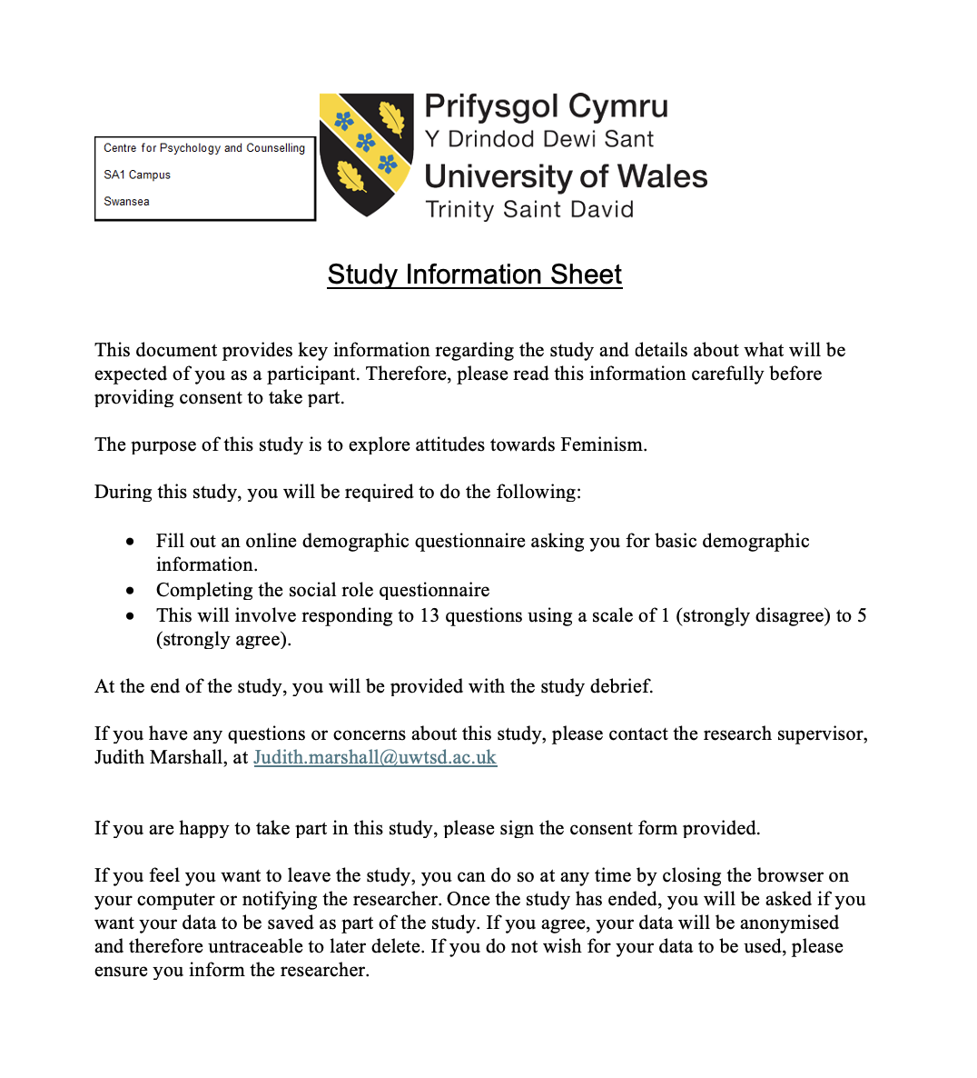

Appendix B

Consent form.
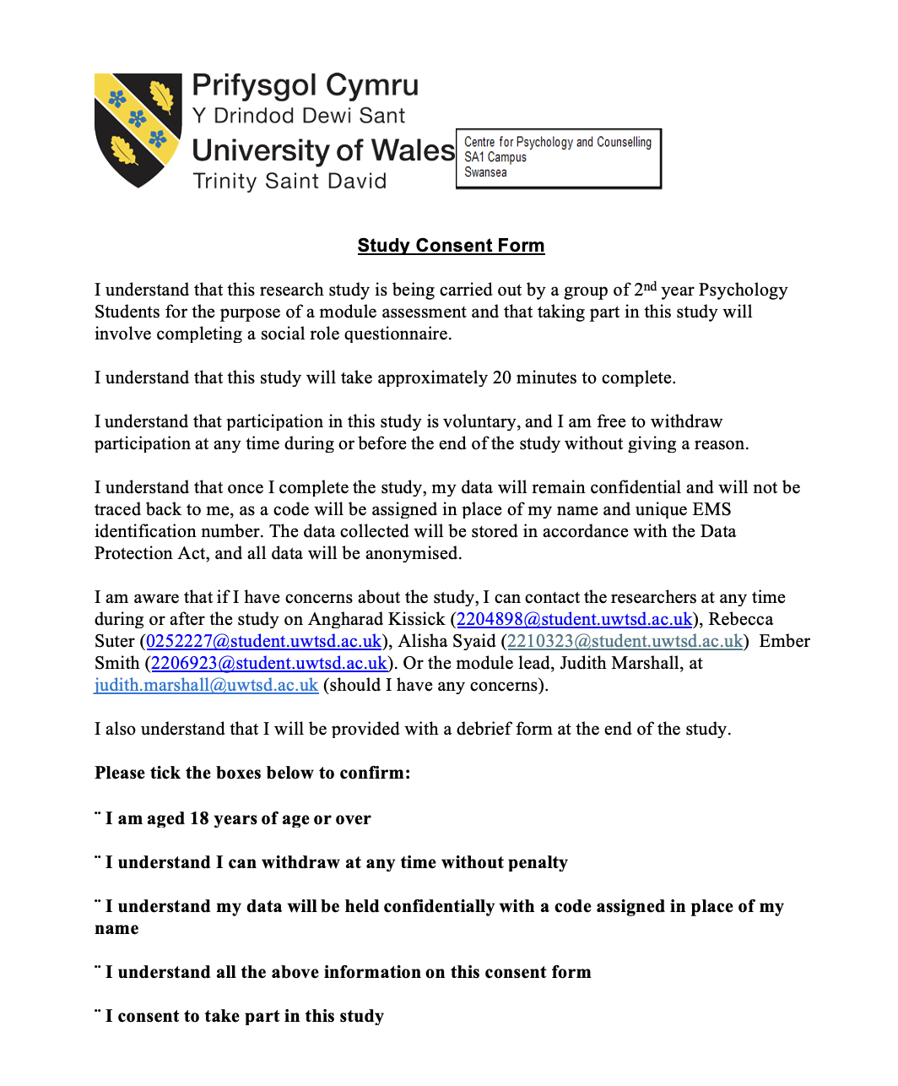

Appendix C

Debrief Sheet

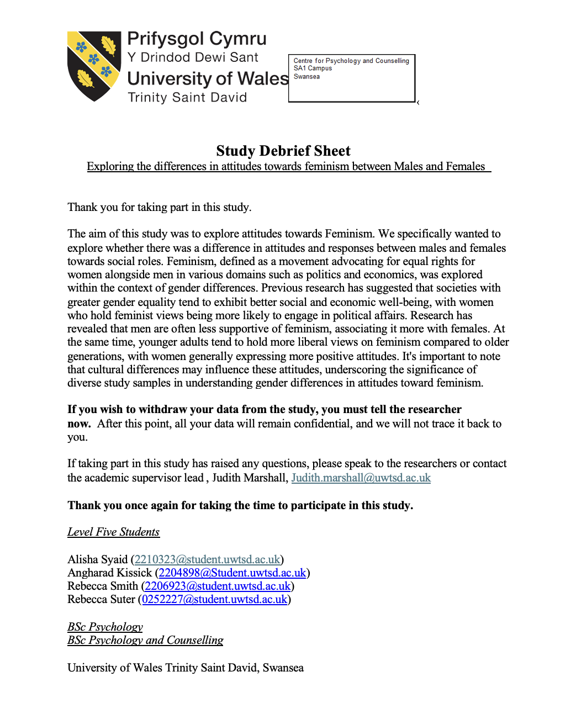

Appendix D

The Social Roles Questionnaire (Baber & Jenkins Tucker, 2006).

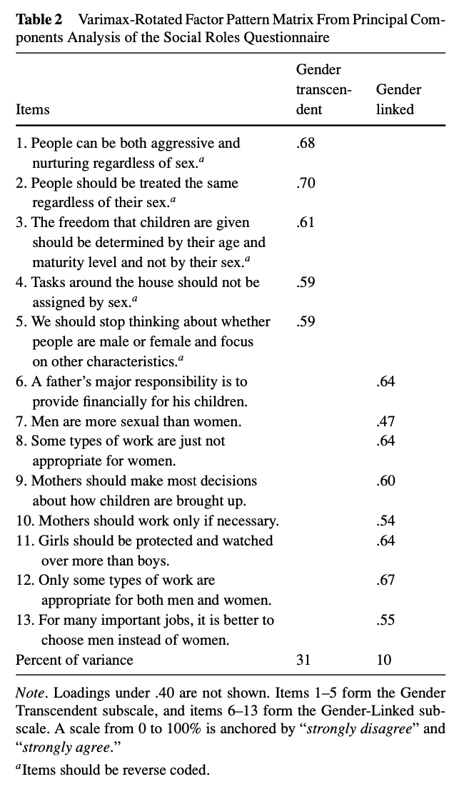

Appendix E

Full SPSS output.



