

To what extent do current physical fitness standards used in policing reflect the physical demands of operational policing duties?
Corey Miller
BSc (Hons) Professional Policing

Word Count: 6595
(Excluding Research Proposal and Ethical Form)

Declaration
This work has not previously been accepted in substance for any degree and is not being concurrently submitted in candidature for any degree.
Signed: C. Miller
Date: 04/01/2026
Statement 1:
This dissertation is being submitted in partial fulfilment of the requirements for the degree of BSc (Hons) Professional Policing

Signed: C. Miller
Date: 04/001/2026
Statement 2:
This dissertation is the result of my own independent work/investigation, except where otherwise stated.
Other sources are acknowledged by footnotes giving explicit references. A bibliography is appended.
Signed: C. Miller
Date: 04/01/2026

Statement 3:
I hereby give consent for my dissertation, if accepted, to be available for photocopying and for interlibrary loan, and for the title and summary to be made available to outside organisations.
Signed: C. Miller
Date: 04/01/2026
Statement 4:
I hereby give consent for my dissertation, if accepted, to be available on the university’s IT system to those who have consent to use the system.
Signed: C. Miller
Date: 04/01/2026
Acknowledgments

I want to express my sincere gratitude to my family, whose support has been the backbone of this entire journey. Their patience, understanding, and belief in me have carried me through long shifts, late nights of study, and the pressure of balancing work, training, and academic commitments. They have given me the space to focus when I needed it, the encouragement to keep going when things felt overwhelming, and the grounding that only family can provide. Everything I have achieved throughout this dissertation has been built on the strength, stability, and loyalty they’ve shown me, and I am genuinely grateful for the foundation they continue to give me every day.

Abstract
This dissertation critically evaluates the validity of the bleep test as the sole measure of police fitness within Gwent Police and Uk policing. The Job-Related Fitness Test is designed to ensure a minimum level of aerobic capacity, questions remain about whether this standard reflects the multidimensional physical demands of frontline policing.
To explore this, a structured questionnaire was distributed to serving officers, gathering data on test performance, perceived operational relevance, preparedness and attitudes toward reform. The findings reveal that although almost most officers comfortably achieve the required 5.4 many do not believe the test represents the realities of policing, particularly tasks requiring strength, agility and functional movement.
Over half respondents reported feeling operationally unprepared despite passing the test, and a significant majority expressed support for adapting or supplementing the current standard. These highlighting the limitations of aerobic only assessments and the need for more comprehensive, occupation-specific fitness measures.
The study concludes that the bleep test provides a baseline indicator of aerobic endurance but lacks the scale required to assess true operational readiness. Recommendations include supplementing the Job-Related Fitness Test with strength based and scenario based driven assessments, developing role-specific standards, and implementing ongoing review processes to ensue fitness testing remains relevant, credible, and aligned with the demands of modern policing.

Table of Contents
__________________________________________________________________________________
Introduction……………………………………………………………………………….10
__________________________________________________________________________________
Chapter 2 - Literature Review…………………………………………………………12
2.0 Introduction 12
2.1 Current Fitness Standards 13
2.2 Physical Demands of Policing 16
2.3 Gaps Between Standards and Practice 19
2.4 Conclusion 21
__________________________________________________________________________________
Chapter 3 - Methodology 22
3.0 Introduction 22
3.1 Research Philosophy and Approach 23
3.2 Population and Sampling 23
3.3 Instument Development 24
3.4 Pilot Study 24
3.5 Data Collection Procedure 25
3.6 Data Analysis 25
3.7 Ethical Considerations 26
3.8 Reliability and Validity 26
3.9 Limitations 27
3.10 Conclusoion 27
__________________________________________________________________________________
Chapter 4 – Analysis and Results 27
4.0 Introduction 27
4.1 Frequency and Familiarity with the Bleep Test………………………………….28
4.2 Performance Levels and Physical Demand 29
4.3 Relevence to Operational Policing 31
4.4 Operational Policing and Real-World Gaps 32
4..5 Attitudes Toward Adaption 33
4.6 Injury and Recovery 33
4.7 Confidence in Physcial Readiness 34
4.8 Summary of Key Findings 35
4.9 Implications and Reccommendations 35
4.10 Conclusion 36
__________________________________________________________________________________
Chapter 5 - Conclusion and Recommendations 37
5.0 Introduction 37
5.1 Restating the Aim 37
5.2 Summary of Key Findings 38
5.3 Standards and Performance in the Sample 38
5.4 Officer Perceptions 39
5.5 Implications for Standards 40
5.6 Recommendations Grounded in Research 41
5.7.Limitations of the Study 41
5.8 Concluson 42
__________________________________________________________________________________
Bibliography 43
__________________________________________________________________________________
Appendices 48
Appendix A – Application For Ethitical Approval 48
Appendix B – Blank Questionaire 70
Appendix C - Questionaire Results 74
Appendix D – Further Bar Charts and Pie Charts 78
__________________________________________________________________________________

List of Figures
Figure 4.1 - Frequency of Bleep test ………………………………………………… 28
Figure 4.2 – Typical Level Reached……………………………………………………29
Figure 4.3 – Perceived Physical Demand……………………………………………..30
Figure 4.4 – Accuracy of Bleep Test vs Role………………………………………....31
Figure 4.5 – Felt Unprepared Despite Passing……………………………………… 32
Figure 4.6 – Should Bleep Test be Adapted?..........................................................33
Figure 4.7 - Confidence in Their Physical Readiness for Operational Demands….34

1. Introduction

The role of a police officer in society is both multidimensional and dynamic, requiring officers to perform a wide range of tasks that frequently demand significant physical exertion (Anderson et al., 2001; Orr et al., 2016). From responding rapidly to emergency calls, engaging if foot pursuits and restraining individuals to providing assistance with other agencies, the physical demands placed on police officers are substantial and varied (Lockie et al., 2020). Against this back drop the establishment and maintenance of physical fitness standards for police officers have become critical components in ensuring public safety and effective service delivery (Hoffman and Collingwood, 2017). However, the degree to which these standards accurately reflect the real-world operational demands of policing remains a subject of considerable debate amongst academics, practitioners, police officers and members of the public (Soderstrom and Cummings, 2022).
Traditionally, physical fitness standards in policing have been designed to assess general attributes such as cardiovascular endurance, muscular strength, flexibility and overall stamina (Anderson et al., 2001; College of Policing, 2021). This benchmark is often evaluated through standardises testing of the 15 metre shuttle run (Bleep Test). While this assessment provides a baseline measure of fitness, questions have risen about their relevancy and adequacy in preparing officers for their unpredictable situation specific challenges encountered during duty (Lonsway, 2003). For example, the ability to sprint short distances, exert force to restrain a non-compliant individual or carry heavy equipment over uneven terrain may not be fully captured by fitness testing (Orr et al., 2016).
The changing trends of crime and public expectations have further complicated the issue. Modern policing now encompasses a wide spectrum of activities from community engagement and crime prevention to counter terrorism and emergency response. The physical profile required for effective performance in these areas may differ significantly, raising concerns about the appropriateness of a one size fits all approach to fitness standards (Soderstrom and Cummings, 2022). Moreover, the increasing emphasis on inclusivity and diversity within police forces has promoted a re-examination of fitness requirements to ensure they do not inadvertently exclude capable individuals or perpetrate bias (Lonsway, 2003: Soderstrom and Cummings, 2022).
Research exploring the relationship between physical fitness and operation performance in policing has produced mixed findings. Some studies suggest a strong correlation between higher fitness levels and improved job performance and resilience (Ramey et al., 2009; Lockie et al., 2020). Others argue that certain aspects of operational policing such as communication skills and decision making and emotional intelligence are equally or more critical than physical endurance (Hoffman and Collingwood, 2017). This divergence highlights the complexity of defining and measuring what constitutes “fitness for duty” in a modern policing context.
This dissertation aims to critically evaluate the extent to which current physical fitness standards in policing and how it reflects the physical demand officers face in their line of duty. By examining the current standards comparing them with documented operational requirements and considering the perspectives of current serving police officers and subject matter experts, the research seeks to identify potential gaps and areas for improvement. Ultimately providing evidence based recommendations for aligning fitness standards more closely with the realities of operational policing, thereby enhancing officers’ safety, effectiveness and public trust.

2. Literature Review

2.0 Introduction
This chapter analyses relevant legal authorities and respected academic literature concerning current physical standards and testing in policing, and whether these adequately address the role's physical demands.
Being a police officer requires more than just procedural expertise about making decisions under duress, it frequently entails extreme physical exertion, physical demands and unanticipated situations. Operation responsibilities put a lot of physical strain on officers, whether they are conducting foot pursuits, responding to violent incidents, or conducting rescues and taking part in crowd control. Police forces across the UK have responded by enforcing physical fitness requirements to make sure personnel meet these demands.
Still, there are concerns regarding these standards. Do they accurately represent the physical demands of the job? Or are they more influenced by custom, legal justification, and hiring objectives done by actual data? This chapter will also analyse how well current fitness standards in policing align with the practical daily physicality needed for operational tasks.
Furthermore, this chapter will highlight important topics, arguments, and gaps in a body of knowledge about police fitness requirements and job demands. This creates the research scholarly underpinnings and ensures that the study is based on up to date information and makes a significant contribution to continuing research.
This literature review will be accomplished through the analysis of literature obtained from the UWTSD e-learning online library database and an Internet search engine called Google Scholar, which gathers information and navigates the Internet to present data from verified academic and scholar resources. These sources include government publications, expert unprofessional textbooks, academic journals, research development publications, and other sources that are authorised and qualified to publish information about operational policing duties and police fitness standards.
2.1 Current Fitness Standards
Physical fitness in policing was mainly under standardised and unstructured in the early 20th century. Although there were no official evaluations, officers would need to maintain their own general fitness (Thielgen & Schade, 2024). Back then the emphasis was on endurance and strength, reflecting the actual physical nature and practicality of early policing roles. By the 1970s the Law Enforcement Assistant Administration (LEAA) Introduced the first ever structured fitness standards, mainly focusing on cardiovascular endurance and muscular strength (Bryan, 2024).
Police fitness standards marked a turning point in in 2012 after the Windsor review (Part II). The introduction of the job related fitness test (JRFT) which became mandatory for all police officers undertaking personal safety training which is what officers complete at the application phase of recruitment. It is also Important to note that is a requirement for all police officers to complete the personal safety training annually in order for them to be operationally compatible and up to date with the current training standards (College of Policing, 2021). The job related fitness test involves a 15m metre shuttle run to a level of 5.4 equating to an aerobic capacity of 35ML/KG/MIN (Kent Police, 2024).
The standard for the job related fitness test was introduced based on research by Brewer et al., (2004), who analysed the physicality of police training. Brewer et al., (2004) used 35 serving police officers aged 22 to 45 years of age. His method was to get the participants to complete the six core Psychological Skills Training (PST) modules while wearing gas analysis and heart rate monitors. During the research Brewer et al., (2004) collected samples from all the attendees and participants breath to measure VO2 Max. Brewer et al., (2004) found that level 5.4 on the job related fitness test should be the minimum standard for all the officers undertaking personal safety training. These findings were agreed by the Police Advisory Board and incorporated into national policy (College of Policing, 2021).
There have been studies to suggest that the job related fitness test may exceed the actual aerobic demands of modern training (NPCC, 2023). Saunder (2003) has made an argument that a joint role fitness test does not compliment or reflect the actual physical demands that police officers have to carry out in their role. “The bleep test is not a measure of general fitness or health, but simply a measure of physical capability to undertake Public & Personal Safety Training (PPST)” (Saunders, 2023). Brown v Mod (2023) found that the test disproportionately affected older officers down to the physiological differences such as them having a lower VO2 2 Max and less muscle mass. Statistics showed in 2024 that 1,200 police officers failed the fitness test which raises concerns about its fairness and its effectiveness in relation to the job role (Liberal Democrats, 2024).
There be many platforms like Reddit and police community where officers who are currently serving or who have served in a frontline position and role have expressed frustration with the fitness test and its relevance to the job role itself (Reddit, 2025; Police community 2025). There have been many officers who have argued that the bleep test can be stressful, and it does not reflect current policing demands which often involves short bursts of an anaerobic effort and not sustained aerobic activity, which is what the joint role fitness test aims to assess (Reddit, 2025). There are many officers who believe that the fitness should be measured through scenario based training rather than running tests (Careers in Blue, 2025). Fitness should be measured by performance in training, not arbitrary running tests” (Pilgrim, 2025).
Research by Miller, Sharp & Bracket (2018) highlights modern day police officers to regularly undertake grappling, repeated sprints, load carriage and rapid directional change when they are conducting foot pursuits and carrying out crowd control on public order deployments. Many of these actions demand an anaerobic power, muscular strength and agility, which the joint role fitness test does not assess. Bishop and Payne (2017) have stated that an assessment involving high intensity interval runs, strength tasks and job specific drills such as a load drag obstacle courses, would better ensure that all police officers acquire the resilience and capability to perform their roles effectively and safely.
The national police council in 2023, endorsed the research highlighting that the aerobic demands of public on personal safety training align more closely with 3.7 on the bleep test rather than the 5.4 (Saunders, 2023). In 2024 Kent Police updated their job related fitness test standard to adopt level 3.7 from offices conducting personal safety training following recruitment training (Kent Police, 2024). It is important to note that the entry level is still 5.4 during the application process and initial recruitment, and 3.7 for any testing following this in the police officers career for response officer. The Police Federation welcomed the new aerobic cut off as it implements the Equality Act 2010 noting that older female and male officers previously struggled to meet level 5.4 (Saunders, 2023).
Thielgan and Schade (2024) conducted a study and measured police officers heart rate and their response is doing live role training, and found that peak intensities often exceed 5.4. This suggested that an aerobic only test, even at 3.7 does not capture anaerobic power, muscular strength, and agility demands. Thielgen and Schade, (2024) has suggested without either strength and high intensity interval components, a shift to level 3.7 will heavily under prepare officers carrying out foot pursuits or physical interventions while carrying out their role.
Some officers and commentators argued that lowering the standards could compromise public safety, calling the new level “pathetic” and “something an unfit tortoise could pass” (GB News, 2023). Critics have feared that the reduced standards might erode confidence in police capability, especially in high risk roles (Geoghegan, 2025). “This now so-called fitness standard puts the lives of police officers and the public at risk” (Anonymous Met Officer, 2023).
2.2 Physical Demands of Policing
Police officers in the UK face diverse physical challenges that extend beyond routine patrols, encompassing load carriage, foot pursuits, grappling during arrests, crowd control and prolonged periods of standing or walking in full kit. These tasks impose significant physiological strain, affecting operation effectiveness and long-term health (Rayson, 2011). Understanding these demands is critical for developing targeted fitness standards and training interventions that reflect the realities of modern policing (Spiteri et al., 2016).
Load carriage remains one of the most taxing for police officers at the moment, carrying body armour, utility belts and communication devices which can often total a weight of 10 to 15 kilogrammes. Knapik et al (2004) metabolic study has shown that for every additional kilogramme that a police officer is carrying, it increases energy expenditure by approximately 1 to 2% during walking and running. There has been UK based simulations whereby officers carrying 12 kilogrammes have experienced a 20% rise in heart rate and 15% decrease in minimal auction uptake performance (Pirnes et al., 2014). These shifts can compromise endurance and speed during critical interventions.
Foot pursuits have been characterised by sudden acceleration, changing direction and maximal sprint efforts over even or uneven terrain. Research by Rayson (2011) has indicated that 80% of foot pursuits involve at least one sprint exceeding 100 metres, whereby officers have reached 90 to 95% of the age predicted maximum heart rate. It has been shown that prolonged foot chases can often attract cumulative fatigue and substantially heightening the risk of musculoskeletal injuries (Spiteri et al., 2016).
Routine foot patrols often entail prolonged walking and standing, with average shift distances of 12-15km at 4-5km/h while wearing 10-16kg of equipment. Even at moderate speeds, officers’ energy expenditure can exceed 6kcal a min leading to early onset fatigue and a 25% reduction in alertness over an eight-hour shift (Murphy et a., 2011). According to Murphy et al., (2011) the best type of training to improve officers sprint recovery and a sustained boost of high power output is high intensity interval training which is not tested on the job related fitness test.
On many occasions police officers get into physical confrontations which require them to grapple. This demands explosive strength, muscular endurance and core stability. Studies measuring force output during takedowns have shown to report a peak ground reaction force have up to three times the body weight (McLean & Gill, 2012). Studies suggest that police officers with poor upper body strength exhibit longer rush times and increase chance of injury to both of them and the suspect (O’Neill et al., 2013). Resistance training protocols focussing on compound posterior-chain movements can reduce these incidents and improve arrest efficiency (Siddle et al., 2019)
Noaked et al., (2010) has reported that crowd control operations introduced sustained static and dynamic loads through baton work, shield handling and coordination along with keeping in riot formation. Monitoring has revealed that officers in protective kit weighing up to 18 kilogrammes sustain a 60 to 70% of VO2 max for durations exceeding 2 hours, elevating core temperature and risking heat strain. Research shows police officers conducting tactical drills, incorporating multidirectional marching carrying a load whilst conducting baton strikes have effectively enhanced both tolerances to movement and heat stress (Prines et al., 2014).
A case study at The Metropolitan Police Service by Christie (2020) was conducted which analysed 3 years of pursuit data (2016-2018) on custody and incident logs, supplemented by semi-structured interviews with 24 pursuit trained officers and the control room.
The data showed:
- Data sample: 2,099 authorised vehicle pursuits and foot pursuits
- Injury outcomes: 4.2% of officers reported musculoskeletal strains, 28% abrasions and 8% head knocks as most common.
- Pursuit characteristics: average pursuit lasted 75 seconds over 320 metres of urban terrain with sudden direction changes and sprint bouts exceeding 90% max heart rate.
- Officer insights: interviewees cited rapid fatigue, tunnel vision and reduced reactionary gap when sprinting in full kit. Several described “cardiac like” chest pain on deceleration and extended recovery of 8-12 minutes before regaining full operational capacity.
The recommendations from the case findings that implementing high-intensity interval training (HIIT) replicating 30-90 seconds of sprinting/rest patterns and including change of direction drills in kit to improve agility under load.

2.3 Gaps Between Standards and Practice
Despite the recognised importance of operational fitness to police effectiveness on demands, and officer well- being, several substantial gaps persist in the research on UK police physical fitness and standards. Firstly, there is a lack of evidence tracking how police officers’ fitness levels evolve throughout their careers. Although the College of policing have collated the job related fitness test to the 15 metres multi stage fitness test, it remains unclear how fitness declines or improves with age, time served and changing duties. (College of policing, 2021). Cross-sectional pass rates offer limited insight into individual fitness trajectories, recovery following injury, or the impact of career breaks, shift patterns and promotions.
Relationship between Joint-Role Fitness Test performance and real world operational tasks have received insufficient experimental attention in a UK setting. International Studies demonstrate moderate correlations between physical test scores and task performance. For example, Canettiet al (2021) found the sprint and shuttle run times, predicted fence jumps, drugs and get up tasks in US officers. Yet no UK based research has systematically validified the multistage fitness test protocols against the common physical demands of arrest pursuit and restraints. This leaves the police force reliant on benchmarks from overseas or outdated physiological data (Brewer et al., 2004), without robust UK researched specific criteria.
There is too much focus on aerobic capacity that lacks crucial attributes like strength power and agility. Functional movement tests and tactical load tests that have shown superior predictive validity in military organisations (Cook, Burton & Kiesel, 2016), these have not been integrated or evaluated within UK policing. This narrow fitness concept risks overlooking officers’ holistic readiness full unpredictable, physically demanding scenarios.
Reliability of high intensity tasks is also under researched. Police work often involves successive bouts of exertion with limited recovery, detainee restraint followed by pursuit of additional suspects. For example, recruit data from Massachusetts show the sit-up and push up performance alongside 1.5 mile run times independently predicted academy graduation (Shusko et al., 2017). These findings highlight the importance of muscle endurance and recovery kinetics, yet UK protocols focus almost exclusively on annual aerobic testing.
The current UK fitness programme for testing police recruits’ centres almost entirely on aerobic capacity yet several critical domains of operational performance remain unassessed. Firstly, maximum explosive strength in the upper part and lower limbs is not formally measured, despite evidence that officers regularly engage in grappling, baton strikes and dynamic lifting tasks. Muscular profiling studies have revealed that up to 30% of officers demonstrate below average power outputs during simulated arrests. Davey (2018), list factors for both performance failure and muscular skeletal injury.
Load carriage capacity receive only cursory attention. Officers routinely carry 12 to 20 kilogrammes of kit for extended periods, yet no standard test evaluates the combined effects of endurance load bearing and postural control under stress (Brewer, Begg & Woods 2004). Equally, chronic tightness in the hips and thoracic spine, documented in 40% of officers goes unchecked, contributing to lower back pain and reduced reach in defensive interventions (Welbourne 2017).
Bridging these gaps demands a holistic fitness approach encompassing strength, power, agility, flexibility and occupationally relevant load carriage tests. Only through a multi-dimensional approach can you ensure officers are truly prepared for the full spectrum of frontline challenges.
2.4 Conclusion
This literature review examining physical standards within UK operational policing reveals a concerning disparity between the current fitness levels and standards between actual officer capabilities and requirements for frontline policing. It has shown that the current physical demands of policing aren't being tested, and this is concerning as not only does it undermine officer safety during confrontations and pursuits but also pose risk to public trust and operational efficiency.
Training protocols and fitness assessments have not evolved alongside the demands of modern policing, leaving a gap between real world expectations and institutional practise. Furthermore, a lack of consistent monitoring and support systems amplifies the problem. The revealed literature signals a pressing need for standardised enforceable benchmarks and proactive interventions especially amid increasing physical demands.
In conclusion, current findings strongly suggest that UK police fitness testing does not meet the physical standards necessary for optimal operational performance. To ensure public and officer safety there's an urgent need to reform fitness policies and embed a culture of physical preparedness within policing institutions. The next chapter of this dissertation will seek to identify the methodology that will be the most appropriate and suitable to conduct primary research surrounding the observed gaps witnessed within the literature review.

3. Methodology
3.0 Introduction
This chapter outlines the methodological framework that I used to investigate the extent to which current physical fitness standards in Uk policing reflect the operational demands of front line duties. It describes the research philosophy, design, population and sampling, instrument, development, data collection procedures, analytical techniques, ethical considerations, and measures to ensure reliability and validity.
3.1 Research Philosophy and Approach
A positivist philosophy underpins this study, as it seeks objectively measure an officer’s perceptions of fitness standards against the operational demands (Saunders, Lewis & Thornhill, 2012). A quantitative approach facilitates systematic comparison of questionnaire responses across a representative officer sample (Creswell, 2014). While a positive stance guides the overarching framework, this study also acknowledges the nuanced realties of policing. Operational duties often involve unpredictable and high-stress scenarios that may not be fully captured through quantitative metrics alone. Therefore, while the primary approach is deductive, the questionnaire includes open-ended prompts to allow officers to elaborate on specific experiences where fitness standards either supported or hindered performance. This hybrid element introduces subtle interpretivist lens, enhancing contextual understanding (Silverman, 2013).
3.2 Population and Sampling
The target population compromises of uniformed, frontline deployable officers within Gwent Police that are required to undertake the fitness assessment.
- Sampling frame: All active-duty, deployable officers within Gwent Police.
- Sampling technique: Purposive sampling to ensure diversity in rank, years’ service, gender, roles and force area, supplemented by convenience sampling via professional networks (Etikan, Musa & Alkassim, 2016).
- Sample Size: A minimum of 20 officers within Gwent Police.
To reduce sampling bias, the sample was restricted to front line officers, who were most directly relevant to the research questions. The choice to only use frontline officers was because they are best positioned to provide relevant, experienced based insights into both operational physical demands of policing and the rationale and implementation of fitness standards.
3.3 Instrument Development
A structured questionnaire was developed drawing on the College of Policing’s Physical competence assessment framework (College of Police, 2020) and operational task analysis in the literature (Anderson et al., 2018)
- Section:
- Demographics and service Background
- Awareness of current fitness standards
- Perceived relevance of the fitness test to operational tasks and demands
- Self-reported fitness levels
Questionnaire validity was enhanced through expert review by two force fitness trainers (Oppenheim, 1992). To ensure the questionnaire captured the full spectrum of operation demands, items were mapped against documented task categories such as foot pursuits, manual restraint and prolonged standing during crown control (Anderson et at., 2018).
3.4 Pilot study
A pilot study was conducted with ten officers from three different areas of Gwent Police force to assess clarity, length and face validity. Minor wording revisions were implemented based on feedback. Pilot data were excluded from the main analysis (Joshi et al., 2015).
3.5 Data Collection Procedure
The questionnaire within Appendix B was converted to an online survey using a secure platform.
- Invitations via emails and WhatsApp was sent to participants containing a survey link and participation information sheet.
- Participation was voluntary, with implied consent indicated by questionnaire submission.
- Data were collected over a four-week window, with one reminder sent to boosts response rate (Dillman, 2000).
3.6 Data Analysis
Quantitative data collected through the structured questionnaire was analysed using descriptive statistics to identify patterns in officers’ responses. Frequency distributions and percentage breaks downs were used to summarise categorical variables such as role, years of service and bleep test performance. Likert-scale items were treated as ordinal data and visualised using bar and pie charts to illustrate trends in perceived physical demand, and confidence readiness. The analysis focused on identifying discrepancies between fitness test outcomes, real world preparedness and views on the adequacy of the bleep test. Visualisations were generated to support interpretation and enhance clarity, enabling a direct comparison between institutional standards and frontline experiences (Bryman, 2016).
3.7 Ethical Considerations
This study received approval from the University from the University Ethics Committee. Key ethical Safeguards include.
- Information sheet outlining aims, voluntary participation, and withdrawal rights.
- Anonymity via-non identifying codes.
- Data stored only on the researcher’s laptop, only accessible by me.
- Compliance with the British Psychological Society Code of Ethics (BPS, 2021).
Given the sensitive nature of discussing national standards, particular care was taken to ensure psychological safety for participants. Officers were reassured that responses would not be shared with any line managers or used for performance evaluation. The questionnaire introduction sheet explicitly stated that participation would not affect employment status or fitness assessment outcomes. Furthermore, officers were given the option to skip any question they felt uncomfortable answering and contact details for support services were provided. As mentioned, these measures align with ethical best practices in oocupational research and fostered a higher degree of trust and openness in responses (BPS, 2018).
3.8 Reliability and Validity
Construct validity will be supported through factor analysis to confirm underlying dimensions of relevance perceptions. Content validity was ensured via literature alignment and expert review (Haynes, Richard & Kubany, 1995).
3.9 Limitations
Potential limitations include self-report bias and limited generalisability within different force areas. These will be acknowledged in the discussion, and recommendations for triangulation with physical performance data will be proposed which would strengthen the validity of the findings (Creswell & Plano Clark, 2017). The reliance on self-reported data introduces potential biases, including social desirability and recall insecurities. Officers may overstate their fitness levels or underreport challenges due to perceived professional expectations (Podsakoff et at., 2003). Although anonymity was assured, the occupational culture of policing may still influence response openness. To add, the study does not incorporate objective performance data, such as actual fitness test scores from the training team or operational incident logs.
3.10 Conclusion
This chapter has detailed the positivist, quantitative survey methodology designed to assess the alignment between policing fitness standards and operational tasks and demands. Subsequent chapters will present the survey results and interpret the findings in the context of existing fitness and policing literature.
4. Analysis and Results
4.0 Introduction
This section presents the findings from a quantitative questionnaire completed by 25 police officer’s frontline serving within Gwent Police. A blank questionnaire can be found in Appendix B, answers can be found in Appendix C. The aim of this research and questionnaire was to assess whether officers believe if the current fitness standards reflect the physical demand of operational policing. The results are presented thematically, supported by descriptive statistics and visualised through bar and pie charts which will be shown in this chapter. The data that is not shown in this chapter will be found in Appendix D.
4.1 Frequency and Familiarity with the Bleep Test
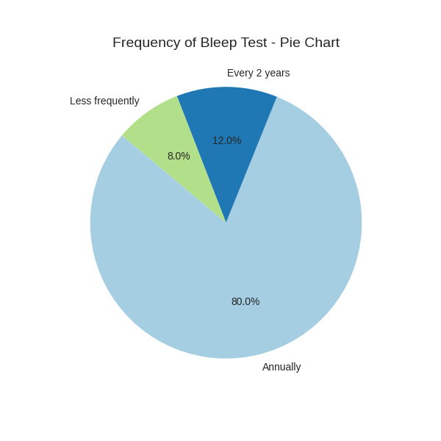
The majority of responders (80%) reported being required to complete the bleep test annually, with a smaller proportion completing it biannually (12%) or less frequently (8%) (See Figure 4.1). This suggests that the bleep test remains a routine and institutionalised component of fitness assessment across the force. The consistency of its administration aligns with national policing guidelines in the UK, where the 15m-metre shuttle run (Bleep test) is the standard for annual fitness testing (College of Policing, 2021).
Figure 4.1
4.2 Performance Levels and Physical Demand
When the officers were asked about their standard performance, 40% of officers reported reaching levels between 7.0 and 8.9 while 24% reached between 5.4 and 6.9, the minimum standards for most roles (Figure 4.2). Only 8% exceeded level 11.0, suggesting that while most officers meet the bassline, few surpass it substantially.
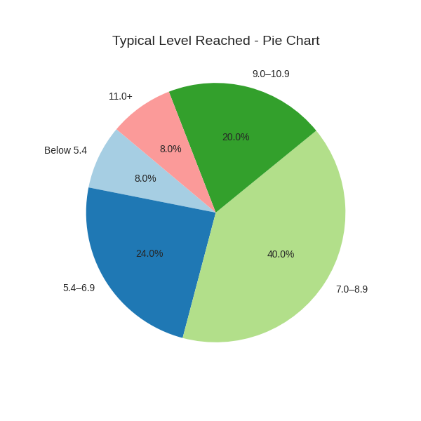
Figure 4.2
Regarding the perceived physical demand of the test, responses were varied. 36% rated the bleep test as moderately demanding (Score of 3), while 44% rated it as either 4 or 5, suggesting high physical exertion (Figure 4.3). This reflects the aerobic nature of the test, which emphasizes cardiovascular endurance (Aerobic) over muscular strength and agility.
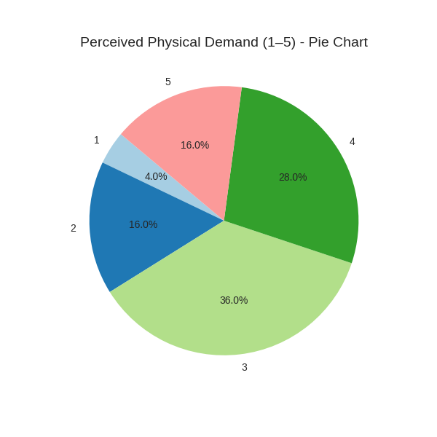
Figure 4.3
Officers rated the physical demand of the bleep test on a scale from 1 (Not demanding) to 5 (Extremely demanding) with most responses clustering around moderate to high demand

4.3 Relevance to Operational Policing.
A key focus was whether officers believed the bleep test accurately reflects the physical demands of their role. Only 8% of people have voted it as “completely reflective” (Score of 5), while 52% rated it 1 or 2, suggesting low perceived relevance (Figure 4.4). This supports existing critiques that the bleep test, while easy to administer, does not capture the multidimensional physicality of frontline policing (Anderson et al., 2001; Orr et al., 2019).
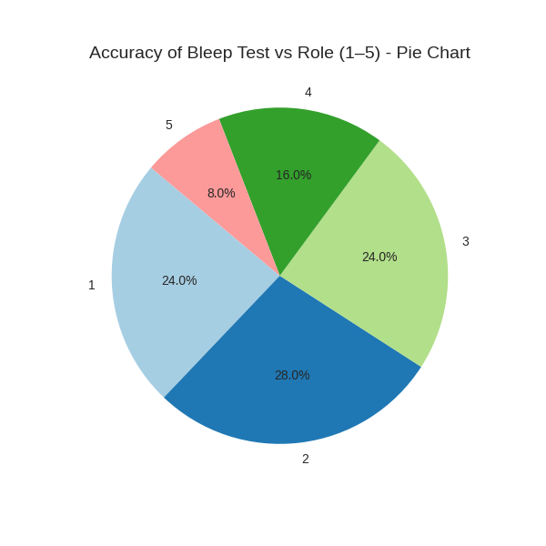
Figure 4.4

This chart presents officers perception of how accurately the bleep test reflects the physical requirements of their operational roles.
4.4 Operational Readiness and Real-World Gaps
Over half of the respondents (56%) reported feeling physically unprepared for real-world tasks regardless of passing the bleep test (Figure 4.5). This disconnect suggests that the test may not sufficiently prepare officers for unpredictable, high intensity scenarios such as foot pursuits, suspect restraint, or navigating complex environments, tasks which require strength, agility, and anaerobic bursts (Dawes et al., 2016).
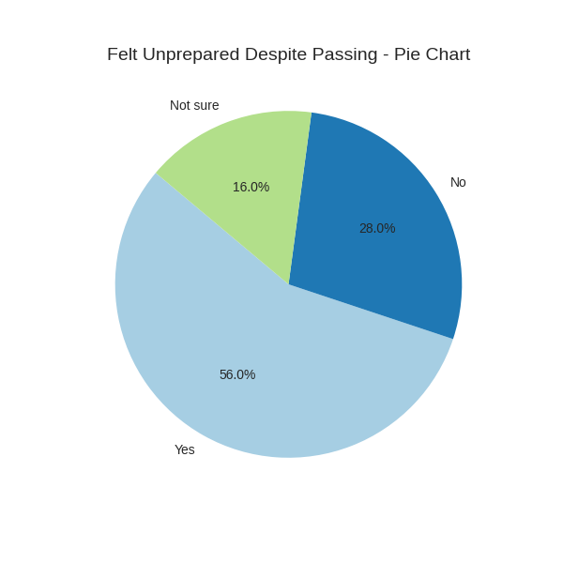
Figure 4.5

4.5 Attitudes toward Adaption
When asked whether the bleep test should be adapted or supplemented, 72% responded affirmatively (Chart 4.6). Open ended responses highlighted a desire for role specific assessments, inclusion of strength based tasks (e.g., push/pull), and scenario based simulations. These suggestions align with research advocating for job specific physical assessments that mirror job-related tasks (Lockie et al., 2020).
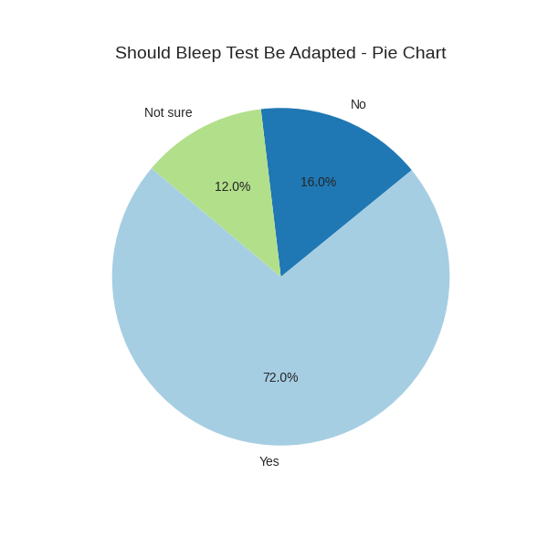
Figure 4.6.
4.6 Injury and Recovery
Nine officers (36%) reported suffering a physical injury in the past two years. Among them, four believed their fitness level (As measured by the bleep test), positively influenced their recovery, while three felt it had a negative impact. This mixed feedback highlights the limitations of using a single aerobic test as a proxy for overall physical preparedness, particularly when strength, mobility, and injury prevention are critical (Roberts et al., 2015).
4.7 Confidence in Physical Readiness
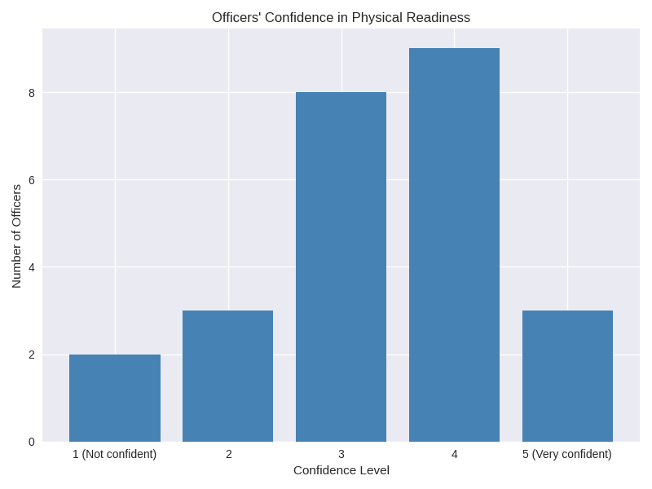
Confidence in operational readiness was moderate overall. Most officers rated themselves between 3 and 4 out of 5 with only three officers expressing full confidence (Figure 4.7). This suggest while officers may meet the fitness standard, they may not feel fully prepared for the physical unpredictability of frontline duties. This is also confirmed in findings from Dawes et al. (2016), who argue that confidence in physical performance are closely tied to the specificity of training and assessment.
Figure 4.7

This is a bar chart showing the confidence in their physical readiness for operational demands. Most officers rated themselves moderately confident (levels 3 and 4), with fewer expressing low or full confidence.
4.8 Summary of Key findings
- 72% of officers believe that the bleep test should be adapted or supplemented.
- 56% felt physically unprepared for real-world tasks despite passing the test.
- 52% rated the test as poorly reflective of operational demand.
- Only 8% rated the test as fully representative of the role.
These findings suggest a significant gap between the current fitness standards and the physical experiences of frontline policing. While the bleep test offers a standardised, cost effective measure of aerobic capacity, it fails to account for areas such as strength, agility and task specific demands that officers routinely face. This misalignment may have implications for both officer safety and public protection.
4.9 Implications and Recommendations
The data supports a growing body of literature advocating for more thorough and role-specific fitness assessments in policing. Studies by Orr et al. (2019) and Lockie et al. (2020) emphasize the need for tests that simulate occupational tasks, such as body drags, stair climbs, and dynamic movement under load. Incorporating such elements could enhance both the ecological validity of assessments and officers’ confidence in their physical readiness.
Furthermore, the perception of irrelevance may reduce motivation to train or take the tests seriously, potentially undermining its intended purpose. A more holistic approach combining aerobic, strength, and functional movement assessments could facilitate a culture of fitness that is both meaningful and sustainable.
4.10 Conclusion
The analysis of the questionnaire data provides a clear and consistent picture of how serving officers perceive the current police fitness standard and how effectively the bleep test reflects the physical realities of front line policing. Across all sections of the questionnaire, the results have demonstrated that while officers routinely complete the JRFT and generally meet the or exceed the minimum recruitment, this does not translate into to confidence in the test as a meaningful measure of operational readiness. The majority of officers achieved levels between 7.0 and 8.9, indicating that aerobic capacity is not a limiting factor for most officers. However, this performance pattern also highlights the narrow scope of the test as it measures stamina, but not the broader physical capabilities required in policing.
The results also reveal a strong appetite for reform. A significant majority of officers expressed the view that the current test should be adapted or supplemented, with many recommending the inclusion of strength-based assessments, functional movement tasks, or scenario driven simulations. This desire for change is not rooted in resistance to fitness testing, but in a belief that the current standards does not align with the realities of the job. Officers appear to value fitness and recognise its importance, but they want a system that measures the right things not simply the easiest or most convenient.
Overall, the findings from this chapter highlight a clear gap between the JRFT as it currently exists, and the operational demands experienced by officers on the ground. The data, shows that while the bleep test ensures a baseline level of aerobic fitness, it does not provide a comprehensive or credible assessment of policing capability.
5. Conclusion and Findings
5.0 Introduction
This chapter brings together the key insights from the research and evaluates what the findings reveal about the effectiveness of the JRFT (Bleep Test) standards as a measure of police fitness. By drawing directly on the questionnaire results and aligning them with relevant literature, the chapter clarifies how well current standards reflect operational demands and where clear gaps exist. The aim here is to consolidate the evidence, highlight the most significant patterns, and outline what these findings means for the future of police fitness testing.
5.1 Restating the Aim
This dissertation set out to critically evaluate the extent to which the bleep test reflects the physical demands of frontline policing. The study focused on officer perceptions, operational relevance, and the adequacy of current standards. By analysing questionnaire data from 25 officers and integrating it with UK policy and academic literature, the research assessed whether the JRFT provides a valid measure of readiness and explored areas for reform (College of Policing, 2021).

5.2 Summary of Key Findings
The questionnaire revealed several consistent themes:
• Routine completion: 80% of officers reported completing the bleep test annually, confirming its institutionalisation.
• Performance levels: Most officers achieved between 7.0–8.9, comfortably above the minimum 5.4 requirement but rarely exceeding higher thresholds.
• Perceived demand: Officers acknowledged the test as physically demanding, yet many questioned its relevance to operational duties.
• Preparedness gap: 56% of respondents reported feeling unprepared for real-world tasks despite passing the test.
• Desire for reform: 72% expressed support for adapting or supplementing the test, with suggestions including strength measures and scenario-based assessments.
• Injury experience: 36% reported injuries in the past two years, though perceptions of fitness impact varied.
These findings suggest that while the bleep test ensures a baseline of aerobic capacity, it does not adequately reflect the multidimensional demands of policing.
5,3 Standards and Performance in the Sample
The JRFT was designed to match the aerobic demands of Personal Safety Training, with the minimum standard set at level 5.4 (College of Policing, 2021). In practice, the majority of officers in this study exceeded that threshold, with performance clustering around 7.0–8.9. This indicates that most officers possess sufficient aerobic capacity to meet institutional requirements.
However, the clustering of results also highlights a ceiling effect: few officers achieved higher levels, suggesting the test does not incentivise or measure elite fitness. Officers themselves recognised this limitation, with many noting that passing the test did not equate to feeling operationally prepared. This perception aligns with critiques in the literature that aerobic endurance alone is not predictive of occupational performance (Manser, 2019; Dawes et al., 2016).
The preparedness gap identified in the questionnaire is particularly significant. More than half of respondents reported feeling unprepared for operational tasks despite passing the test. This suggests that the JRFT, while ensuring minimum aerobic capacity, fails to capture the broader fitness attributes required for policing, such as strength, agility, and functional movement (Morris et al., 2019).
5.4 Officer Perceptions
Officer perceptions provide critical insight into the validity of fitness standards. While most respondents acknowledged the physical demand of the bleep test, they did not believe it reflected the realities of policing. Tasks such as suspect restraint, equipment carriage, and navigating obstacles were frequently cited as areas not captured by the test.
This perception undermines the credibility of the JRFT. If officers view the test as irrelevant, motivation to train and prepare may diminish. The finding that 72% of respondents support reform demonstrates a clear appetite for change. Officers suggested incorporating strength measures, agility drills, and scenario-based simulations, reflecting a desire for standards that align more closely with operational demands.
These perceptions are consistent with critiques in UK policing literature. McLoughlin (2019) argued that fitness tests must be occupationally relevant and non-discriminatory, while Morris et al. (2019) highlighted the limitations of shuttle runs compared to treadmill-based alternatives. The questionnaire results reinforce these arguments, providing empirical evidence that officers themselves recognise the inadequacy of current standards.
5.5 Implications for Standards
The findings have several implications for UK fitness standards. First, the JRFT ensures a baseline of aerobic capacity but fails to measure other critical components of performance. Second, officer perceptions highlight a disconnect between institutional standards and occupational realities, undermining motivation and credibility. Third, the clustering of performance results suggests the test does not incentivise higher levels of fitness, potentially limiting the development of elite capability.
These implications suggest that reform is necessary. Supplementing the bleep test with additional measures would enhance validity, improve officer preparedness, and foster a culture of meaningful fitness. Importantly, reform should be guided by officers feedback, ensuring that standards are both operationally relevant and institutionally credible.

5.6 Recommendations Grounded in Research
Based on the questionnaire findings and supporting literature, the following recommendations are proposed:
1. Supplement the bleep test: Introduce strength-based measures (e.g., push/pull), agility drills, and scenario-based simulations to capture the multidimensional demands of policing (Morris et al., 2019).
2. Role-specific standards: Develop differentiated fitness requirements for specialist units, reflecting varied operational demands (College of Policing, 2021).
3. Holistic training programs: Encourage officers to engage in strength, mobility, and functional conditioning alongside aerobic training (Dawes et al., 2016).
4. Continuous review: Establish a framework for regular evaluation of fitness standards, incorporating officer feedback and emerging evidence (McLoughlin, 2019).
5. Cultural change: Promote fitness as a meaningful component of professional identity, aligning standards with operational realities to enhance motivation and credibility (Manser, 2019).
5.7 Limitations of the Study
While the study provides valuable insights, several limitations must be acknowledged. The sample size of 25 officers’ limits generalisability, and the reliance on self-reported data introduces potential bias. Future research should employ larger samples and mixed methods, including observational studies and physiological testing, to provide a more comprehensive understanding. Nevertheless, the findings offer a robust snapshot of officer perceptions and performance within Gwent Police, providing a strong foundation for further research and policy development.
5.8 Conclusion
This dissertation concludes that the bleep test, while effective in measuring aerobic capacity, is insufficient as the sole measure of police fitness. The test fails to reflect the multidimensional demands of frontline policing, leaving officers underprepared for real-world tasks. The majority of officers surveyed expressed a desire for adaptation, highlighting the need for more comprehensive and role-specific assessments.
By supplementing the bleep test with strength, agility, and scenario-based measures, UK police forces can enhance the validity of fitness standards, improve officer effectiveness, and foster a culture of meaningful fitness. Such reforms would ensure that fitness testing serves its intended purpose: preparing officers for the realities of policing.

Bibliography
Anderson, G.S., Plecas, D., & Segger, T. (2001) Police officer physical ability testing – Re-validating a selection criterion. Policing: An international Journal of Police Strategies & Management, 24(1), 8-31.
Anderson, J.T., Stephenson, E., Langfort, J. & Richards, J (2018) ‘Operational task analysis in Policing: A systematic review’, Journal of Law Enforcement Fitness, 5(2), pp. 45-60.
Bishop, P. &Payne, F. (2017) ‘Anaerobic demands of law-enforcement foot pursuits,’ Policing: An International Journal of Police Strength & Management, 40(3), pp. 520-533.
Brewer, J., Begg, M. and Woods, K. (2004) ‘An investigation into fitness requirements of personal safety training. University of Sunderland.
Brewer, K., Harrison, B., Loos, T. & Mathews. J. (2004) ‘Psychological demands of Officers Safety Training; Journal of Police Science, 18(3), pp45-58.
British Psychological Society (BPS) (2021) Code of Human Research Ethics. Leicester: BPS. Available at BPS Code of Human Research Ethics | BPS (Accessed 1st September 2025).
Bryan, B (2024) A history of physical fitness in law enforcement. DMAA Research. Available at: https://dmaaresearch.com/a-history-of-physical-fitness-in-law-enforcement/. (Accessed: 17th July 2025)
Bryman, A. (2016) Social Research Methods. 5th edn. Oxford: Oxford University Press, pp. 338-360.
Canetti, E.F.D Dawes, J.J., Drysdale, P.H, Lockie, R.G., Kornhauser, C., Holmes, R., Schram, B. and ORR, R.M (2021) ‘Relationship between metabolic fitness on performance in police occupational tasks’, Journal of science and sport and exercise, 3, pp. 179-185.
Careers in Blue (2025) Police Fitness Test – What is it like? Available at: https://careersinblue.co.uk/police-fitness-test-how-to-improve-your-fitness-best-ways-to-train/ /(Accessed: 2nd July 2025)
Christie, M., (2020) ‘managing the safety of police pursuits: a mixed method case study of the Metropolitan Police service, London’s social Science Journal. University College London. Available at: https://discovery.ucl.ac.uk/id/eprint/10098929/ (Accessed: 26th of July 2025)
College of Policing (2020) Physical Competence Assessments for Police Officers. London: College of Policing. Available at: https//www.college.police.uk (Accessed 25th August 2025).
College of Policing (2021) Job-related fitness standards. Available at: https://www.college.police.uk/support-forces/health-safety-welfare/job-related-fitness-standards- /(Accessed: 14th July 2025)
College of Policing. (201). Job-related fitness test. Retrieved from https://www.college.police.uk (Accessed: 16 October 2025)
Cook, G., Burton, L. and Kiesal, K. (2016) ‘Functional movement screening in tactical athletes: criterion validity and reliability’, Military medicine, 181(10), pp.1312-1319.
Cresswell, J.W. (2014) Research Design: Qualitative, Quantitative, and Mixed Methods. 4th edn. Oxford: Oxford University Press.
Creswell, J.W. and Plano Clark, V.L. (2017). Designing and Conducting Mixed Methods Research. 3rd edn. Thousand Oaks, CA: Sage
Davey, A.R. (2018) ‘Neuromuscular characteristics of UK police officers’ Journal of Human Kinetics, 62, pp.125-135.
Dawes, J.J., Orr, R. M., Siekaniec, C.L., Vanderwoude, A.A., & Pope, R. (2016). Associations between anthropometric characteristics and physical performance in male law enforcement officers. Journal Strength and Conditioning Research, 30(6), 1723-1728
Dillman, D.A (2000) Mail and Internet Surveys: Tailored Design Method. 2nd edn. New York: Wiley.
Etikan, I., Musa, S.A. & Alkassim, R.S. (2016) ‘Comparison of Convenience Sampling and Purposive Sampling’, American Journal of Theoretical and Applied Statistics, 5(1), pp1-4.
GB News (2023) Officers furious at ‘woke’ demand to cut police fitness test – ‘an unfit tortoise could pass it’. Available at: https://www.gbnews.com/news/police-fitness-test-woke-officers (Accessed: 20 July 2025)
Geoghegan, R. (2023) Public Safety Foundation commentary. Quoted in GB News. Available at: https://www.gbnews.com/news/police-fitness-test-woke-officers (Accessed: 08th July 2025)
Gilem, J.A. & GLIEM, R.R.(2003) ‘Calculating, Interpreting, and Reporting Cronbach’s Alpha Reliability Coefficient for Likert-Type Scales’ Midwest Research-to-Practice Conference in Adult, Continuing and community Education, pp.82-88
Haynes , S.N., Richard, D. & Kubany, E.S (1995) ‘Content Validity in Psychological Assessment: A Functional Approach to Concepts and Methods’. Psychological Assessment, 7(3) pp. 238-247.
Hoofman, J.R & Collingwood, T.R, (2017) Fit for duty: Police physical fitness training; on NSCA’s Essentials of Tactical Strength and Conditioning. Human Kinetics, pp.613-634
Joshi, A. et al. (2015) ‘Likert Scale: Explored and Explained’, British Journal of Applied Science & Technology, 7(4), pp. 396-403.
Kent Police (2024) Job related fitness test SOP (043I). Available at: https://www.kent.police.uk/foi-ai/kent-police/Policy/operational-partnerships/job-related-fitness-test-sop-o43l// (Accessed: 15th July 2025)
Knapik, J.J., Reynolds, K.L & Harman, E. A., (2004). Solider load carriage: Historical, psychological, biomechanical and medical aspects. Military Medicine, 169(1), pp.45-56.
Liberal Democrats (2024) Revealed: Over 1,200 police officers fail fitness test. Available at: https://www.libdems.org.uk/news/article/revealed-over-1200-police-officers-fail-fitness-test/ (Accessed: 24th July 2025)
Lockie, R.G., Dawes, J.J., Kornhauser, C.L., & Holmes, R.J. (2020). Cross-sectional and retrospective cohort analysis of the effects of age and sex on physical fitness of law enforcement officers. Journal Strength and Conditioning Research, 34(4), 934-941.
Lockie, R.G., Lyons, K., Cunningham, D.J. & Moore, J. (2019) ‘Physical Determinants of Occupational Performance in Law Enforcement’, International Journal of Police Science & Management, 21(1), pp. 5-12.
Lonsway, K.A. (2003) ‘Tearing Down the Wall: Problems with Consistency, Validity, and Adverse Impact of Physical Ability Testing in Police Selection; Police Quarterly, 6(3), pp. 237-277.
McGill, A. & Welbourn, H. (2017) ‘Flexibility deficits un UK policing’, Police Journal, 90(3), pp.50-65.
Manser, A. (2019). Physiological responses during performance of the 15-metre Multistage Shuttle Run Test (15mMSFT), with reference to the Police Fitness Standards. University of Chester Repository, pp. 1-85.
McLean, B., & Gill, N., (2012). The biomechanical demands pf physical restraint techniques. Jornal of Law Enforcement, 3(2), pp.12-19.
McLoughlin, F. (2019). Pre-entry physical fitness tests of the Irish and UK police. EC Nutrition, Vol. 14, Issue 10, pp. 668-676
Miller, A., Sharp, S. and Backett, A. (2018) ‘Strength and load-carriage requirements in policing’, Journal of Occupational and Environment Medicine, 60(2), pp. e85-e91.
Murphy, J. Nevill, A., Holder, R. & Richards, J., (2011). The impact of occupational load carriage on police officer performance. Ergonomics, 54(2), pp.90-98.
Morris, M., Deery, E., & Sykes, K. (2019). Chester treadmill police tests as alternatives to 15-m shuttle running. Occupational Medicine, 69(2), 133–138.
Noakes, T., Carter, R & Hew-Butler, T., (2010). Heat stress and Thermoregulatory response in protective clothing. Sports medicine., 40(8), pp. 681-701.
NPCC (2023) Fitness Testing Working Group - JRFT Results and Recommendation. Available at: https://www.npcc.police.uk/SysSiteAssets/media/downloads/publications/disclosure-logs/npcc-central-office/2023/228-2023-session-02-jrft-app-a.pdf/(Accessed: 25th July 2025)
O’Neill, J., Latour, M., & Brown, H., (2013). Muscular strength correlates with arrest performance in law enforcement. Journal of occupational health and safety, 29(4), pp.238-245.
Oppenheim, A.N (1992) Questionnaire Design, Interviewing and Attitude Measurement. London: Printer Publishers.
Orr, R.M., Pope, R., Stierli, M. & Hinton, B. (2016) ‘Operational loads carried by law enforcement officers and the resultant psychological and biomechanical efforts; Ergonomics, 59(5), pp. 781-791.
Orr, R., Canetti, E. F. D., Gough, S., Macdonald, K., Dulla, J., Lockie, R., Dawes, J., Blacker, S., Milligan, G., & Schram, B. (2025). Police fitness: An international perspective on current and future challenges. Sports, 13(7), 219.
Pilgrim (2025) Commet on ‘Fitness Test Changes’, Reddit, 2 May. Available at: http://www.reddit.com/r/policeuk/comments/1bk4f86/fitness_test_changes/ (Accessed: 20 July 2025)
Pirnes, S., Tammelin, T. & Heinonen, A., (2014). Energy expenditure of riot police officers during crowd control. European Jornal of Applied Physiology, 114(5), pp.1039-1047.
Podsakoff, P.M., MacKenzie, S.B., Lee, J.Y. & Podsakoff, N.P. (2013) ‘Common method biased in behavioural research: A critical review of the literature and recommended remedies’ Journal of Applied Psychology, 88(5), pp. 879-903.
Rayson, M., (2011). Psychological demands policing: a UK perspective. Policing: An International Journal, 34(3), pp.409-422.
Reddit (2025) Fitness test changes discussion. Available at: https://www.reddit.com/r/policeuk/comments/1bk4f86/fitness_test_changes/ /(Accessed: 20 July 2025)
Roberts, M.A., O’Dea, J., Boyce, A., & Mannix, E.T. (2015). Fitness levels of firefighter recruits before and after a supervised exercise training programme. Journal of Strength and Conditioning Research, 29(3), 644-651.
Rammey, S.L., Downing, N.R. & Franke, W.D (2009) ‘ Milwaukee police department retirees: cardiovascular disease risk and morbidity among law enforcement officers; AAOHN Journel, 57(11), pp. 448-453.
Saunders, I. (2023) Why are chiefs disregarding the new scientifically proven 3.7 fitness test level? Police Federation. Available at: https://www.polfed.org/wiltshire/news/2023/why-are-chiefs-disregarding-the-new-scientifically-proven-37-fitness-test-level/ /(Accessed: 20 July 2025)
Saunders, M., Lewis, P. & Thornhill, A. (2012) Research Methods for Business Students. 6th edn. Harlow: Pearson Education.
Shusko, M. et al., (2017). Recruit Fitness as a predictor of police academy graduation. Occupational Medicine, 67(3), pp. 235-242.
Siddle, J., Thomas, P & Garner, P., (2019). Resistant training interventions for arrest related violence reduction. Journal of Strength and Conditioning Research, 33(7), pp.1950-1958
Soderstrom, M. & Cummings, D.R. (2022) ‘Physical fitness standards and the diversity challenge in policing: A case study; Policing: A Journal of Policy and Practice, 16(1), pp. 243-259.
Spiteri, T., Coetzee, B. & Dawson, B., (2016). High- intensity interval training for foot pursuit readiness. Journal of Sports Sciences, 34 (20), pp1949-1956.
Teddlie, C. & Yu, F. (2007) ‘Mixed Methods Sampling: A Typology with Examples’ , Journal of Mixed Methods Research, 1(1), pp. 77-100.
Thielgen, M.M. & Schade, S. (2024) ‘Psychological demands of modern Uk policing’ Journal of Police and Criminal Psychological, 39, pp.660-670.
Zhang, Z., He, J., Zhang, X., Zhao, L., & Deng, Y. (2025). Analysis of physical fitness tests for police officers in various countries: a scoping review. Frontiers in Physiology, 16, Article 1703389, pp.1-12.

Appendices
Appendix A: Application for Ethical Approval
RESEARCH STUDENTS
This form is to be completed by the student within SIX months for full-time students and TWELVE months for part time students, after the commencement of the research degree or following progression to Part Two of your course.

Once complete, submit this form via the MyTSD Doctoral College Portal at (https://mytsd.uwtsd.ac.uk).

This document is also available in Welsh.

RESEARCH STAFF ONLY
All communications relating to this application during its processing must be in writing and emailed to pgresearch@uwtsd.ac.uk , with the title ‘Ethical Approval’ followed by your name.

STUDENTS ON UNDERGRADUATE OR TAUGHT MASTERS PROGRAMMES should submit this form (and receive the outcome) via systems explained to you by the supervisor/module leader.

In order for research to result in benefit and minimise risk of harm, it must be conducted ethically. A researcher may not be covered by the University’s insurance if ethical approval has not been obtained prior to commencement.

The University follows the OECD Frascati manual definition of research activity: “creative work undertaken on a systematic basis in order to increase the stock of knowledge, including knowledge of man, culture and society, and the use of this stock of knowledge to devise new applications”. As such this covers activities undertaken by members of staff, postgraduate research students, and both taught postgraduate and undergraduate students working on dissertations/projects.

The individual undertaking the research activity is known as the “principal researcher”.

Ethical approval is not required for routine audits, performance reviews, quality assurance studies, testing within normal educational requirements, and literary or artistic criticism.

Please read the notes for guidance before completing ALL sections of the form.

This form must be completed and approved prior to undertaking any research activity. Please see Checklist for details of process for different categories of application.

SECTION A: About You (Principal Researcher)
1 | Full Name: |  | Corey Miller
2 | Tick all boxes that apply: |  | Member of staff: | ☐ | Honorary research fellow: | ☐
 | Undergraduate Student | ☒ | Taught Postgraduate Student | ☐ | Postgraduate Research Student | ☐

3 | Institute/Academic Discipline/Centre: | University of Wales Trinity Saint David
4 | Campus: | Swansea
5 | E-mail address: | 2245849@student.uwtsd.ac.uk
6 | Contact Telephone Number: | 07919890128
 | For students:
7 | Student Number: | 2245849
8 | Programme of Study: | BA (Hons) Professional Policing
9 | Director of Studies/Supervisor: | Jane Thomas

SECTION B: Approval for Research Activity
1 | Has the research activity received approval in principle?  (please check the Guidance Notes as to the appropriate approval process for different levels of research by different categories of individual) |  | YES | ☒ | NO | ☐
 |  |  |  |  | Date
2 | If Yes, please indicate source of approval (and date where known): Approval in principle must be obtained from the relevant source prior to seeking ethical approval | Research Degrees Committee |  | ☐
2 |  | Institute Research Committee |  | ☐
2 |  | Other (write in) |  | ☒ | Jane Thomas

SECTION C: Internal and External Ethical Guidance Materials
 | Please list the core ethical guidance documents that have been referred to during the completion of this form (including any discipline-specific codes of research ethics, location-specific codes of research ethics, and also any specific ethical guidance relating to the proposed methodology). Please tick to confirm that your research proposal adheres to these codes and guidelines. You may add rows to this table if needed.
1 | UWTSD Research Ethics & Integrity Code of Practice | ☒
2 | UWTSD Research Data Management Policy | ☒
3 | [List any other relevant documents here] | ☐

SECTION D: External Collaborative Research Activity
If there are external collaborators then you should gain consent from the contact persons to share their personal data with the university. If there are no external collaborators then leave this section blank and continue to section E.
1 | Institution
2 | Contact person name
3 | Contact person e-mail address
4 | Is your research externally funded? |  | YES | ☐ | NO |  | ☐
5 | Are you in receipt of a KESS scholarship? |  | YES | ☐ | NO |  | ☐
6 | Are you specifically employed to undertake this research in either a paid or voluntary capacity? | Voluntary | YES | ☐ | NO | ☐
7 |  | Employed | YES | ☐ | NO | ☐
8 | Is the research being undertaken within an existing UWTSD Athrofa Professional Learning Partnership (APLP)? | If YES then the permission question below does not need to be answered. | YES | ☐ | NO |  | ☐
9 | Has permission to undertake the research has been provided by the partner organisation? | (If YES attach copy)  If NO the application cannot continue | YES | ☐ | NO |  | ☐

Where research activity is carried out in collaboration with an external organisation
10 | Does this organisation have its own ethics approval system? | YES | ☐ | NO | ☐
 | If Yes, please attach a copy of any final approval (or interim approval) from the organisation (this may be a copy of an email if appropriate).

SECTION E: Details of Research Activity
1 | Indicative title: | To what extent do currently Physical fitness standards used in police recruitment reflect the physical demands of operational policing duties?
2 | Proposed start date: | 19th of MAY 2025 | Proposed end date: | 02nd of MARCH 2025
Introduction to the Research (maximum 300 words per section)
Ensure that you write for a Non-Specialist Audience when outlining your response to the points below:
- Purpose of Research Activity
- Proposed Research Question
- Aims of Research Activity
- Objectives of Research Activity
Demonstrate, briefly, how Existing Research has informed the proposed activity and explain
- What the research activity will add to the body of knowledge
- How it addresses an area of importance.
3 | Purpose of Research Activity  The purpose of this research is to critically examine the physical fitness standards employed in police recruitment and assess their relevance to the actual physical demands encountered in the role. This study aims to identify whether current fitness testing accurately predicts an officer’s ability to perform key operational tasks, such as pursuits, restraint techniques and emergency response. Additionally, the research seeks to explore potential discrepancies between recruitment requirements and long-term fitness expectations, and how these standards influence recruitment outcomes, workforce diversity, and operational reediness.  (this box should expand as you type)
4 | Research Question  To what extent do currently Physical fitness standards used in police recruitment reflect the physical demands of operational policing duties?  (this box should expand as you type)
5 | Aims of Research Activity  - To examine the physical fitness standards currently used in police recruitment process.  - To evaluate the extent to which these standards align with the physical demands of day to day policing duties.  - To assess whether current fitness standards effectively predict an officer’s ability to perform key operational tasks.  - To explore perceptions among officers regarding the relevance and fairness of these standards.  - To identify gaps or limitations in existing fitness testing protocols and suggest improvements for recruitment and training practices.  (this box should expand as you type)
6 | Objectives of Research Activity  - To review and compare the physical fitness standards use in policing across selected police forces in the UK focussing on Gwent Police.  - To analyse the physical recruitment of common policing tasks, such as foot pursuits, suspect restraint and emergency response.  - To determine whether current fitness tests are valid predictors of operational performance.  - To explore the perceptions of serving officers regarding adequacy and fairness of fitness standards.  - To identify potential improvements or alternatives to current recruitment fitness standards.  (this box should expand as you type)
Proposed methods (maximum 600 words)
Provide a brief summary of all the methods that may be used in the research activity, making it clear what specific techniques may be used. If methods other than those listed in this section are deemed appropriate later, additional ethical approval for those methods will be needed. You do not need to justify the methods here, but should instead describe how you intend to collect the data necessary for you to complete your project.
7 | This study will adopt a quantitative method approach to provide a comprehensive understanding of the relationship between recruitment fitness and standards and real-world policing demands.  Quantitative research will be collected through questionnaires distributed to police officers, recruits and training staff, aimed at measuring perceptions of fitness recruitments and their relevance to operational duties. This allows data collection from a larger and more diverse sample. Anonymity may encourage more honest and reflective responses.  .  (this box should expand as you type)
Location of research activity
Identify all locations where research activity will take place.
8 | The research will be conducted within selected police forces within the UK mainly focussing on Gwent police.  (this box should expand as you type)
Research activity outside of the UK
If research activity will take place overseas, you are responsible for ensuring that local ethical considerations are complied with and that the relevant permissions are sought. Specify any local guidelines (e.g. from local professional associations/learned societies/universities) that exist and whether these involve any ethical stipulations beyond those usual in the UK (provide details of any licenses or permissions required). Also specify whether there are any specific ethical issues raised by the local context in which the research activity is taking place, for example, particular cultural and/or legal sensitivities or vulnerabilities of participants. If you live in the country where you will do the research then please state this.
9 | N/A  (this box should expand as you type)

10 | Use of documentation not in the public domain: Are any documents NOT publicly available? | NO | ☒
10 |  | YES | ☐
11 | If Yes, please provide details here of how you will gain access to specific documentation that is not in the public domain and that this is in accordance with the current data protection law of the country in question and that of England and Wales.  (this box should expand as you type)

 | Does your research relate to one or more of the seven aims of the Well-being of Future Generations (Wales) Act 2015? | YES | NO
12 | A prosperous Wales | ☐ | ☒
13 | A resilient Wales | ☐ | ☒
14 | A healthier Wales | ☐ | ☒
15 | A more equal Wales | ☐ | ☒
16 | A Wales of cohesive communities | ☐ | ☒
17 | A Wales of vibrant culture and thriving Welsh language | ☐ | ☒
18 | A globally responsible Wales | ☐ | ☒
19 | If YES to any of the above, please give details:
 | (this box should expand as you type)

SECTION F: Scope of Research Activity
 | Will the research activity include: | YES | NO
1 | Use of a questionnaire or similar research instrument? | ☒ | ☐
2 | Use of interviews? | ☒ | ☐
3 | Use of focus groups? | ☐ | ☒
4 | Use of participant diaries? | ☐ | ☒
5 | Use of video or audio recording? | ☐ | ☒
6 | Use of computer-generated log files? | ☐ | ☒
7 | Participant observation with their knowledge? | ☐ | ☒
8 | Participant observation without their knowledge? | ☐ | ☒
9 | Access to personal or confidential information without the participants’ specific consent? | ☐ | ☒
10 | Administration of any questions, test stimuli, presentation that may be experienced as physically, mentally or emotionally harmful / offensive? | ☐ | ☒
11 | Performance of any acts which may cause embarrassment or affect self-esteem? | ☐ | ☒
12 | Investigation of participants involved in illegal activities? | ☐ | ☒
13 | Use of procedures that involve deception? | ☐ | ☒
14 | Administration of any substance, agent or placebo? | ☐ | ☒
15 | Working with live vertebrate animals? | ☐ | ☒
16 | Procedures that may have a negative impact on the environment? | ☐ | ☒
17 | Other primary data collection methods. Please indicate the type of data collection method(s) below. | ☐ | ☒
 | Details of any other primary data collection method:  (this box should expand as you type) | ☐ | ☒
If NO to every question, then the research activity is (ethically) low risk and may be exempt from some of the following sections (please refer to Guidance Notes).

If YES to any question, then no research activity should be undertaken until full ethical approval has been obtained.

SECTION G: Intended Participants
If there are no participants then do not complete this section, but go directly to section H.

 | Who are the intended participants: | YES | NO
1 | Students or staff at the University? | ☒ | ☐
2 | Adults (over the age of 18 and competent to give consent)? | ☒ | ☐
3 | Vulnerable adults? | ☐ | ☒
4 | Children and Young People under the age of 18? (Consent from Parent, Carer or Guardian will be required) | ☐ | ☒
5 | Prisoners? | ☐ | ☒
6 | Young offenders? | ☐ | ☒
7 | Those who could be considered to have a particularly dependent relationship with the investigator or a gatekeeper? | ☐ | ☒
8 | People engaged in illegal activities? | ☐ | ☒
9 | Others. Please indicate the participants below, and specifically any group who may be unable to give consent. | ☐ | ☒
 | Details of any other participant groups:  (this box should expand as you type) | ☐ | ☒

Participant numbers and source
Provide an estimate of the expected number of participants. How will you identify participants and how will they be recruited?
10 | How many participants are expected? | 25- 50.  (this box should expand as you type)
11 | Who will the participants be? | Police Officers and staff serving within Gwent Police.  (this box should expand as you type)
12 | How will you identify the participants? | They will be Police Officers serving within Gwent Police.  (this box should expand as you type)

 | Information for participants: | YES | NO | N/A
13 | Will you describe the main research procedures to participants in advance, so that they are informed about what to expect? | ☒ | ☐ | ☐
14 | Will you tell participants that their participation is voluntary? | ☒ | ☐ | ☐
15 | Will you obtain written consent for participation? | ☒ | ☐ | ☐
16 | Will you explain to participants that refusal to participate in the research will not affect their treatment or education (if relevant)? | ☐ | ☐ | ☒
17 | If the research is observational, will you ask participants for their consent to being observed? | ☐ | ☐ | ☒
18 | Will you tell participants that they may withdraw from the research at any time and for any reason? | ☒ | ☐ | ☐
19 | With questionnaires, will you give participants the option of omitting questions they do not want to answer? | ☒ | ☐ | ☐
20 | Will you tell participants that their data will be treated with full confidentiality and that, if published, it will not be identifiable as theirs? | ☒ | ☐ | ☐
21 | Will you debrief participants at the end of their participation, in a way appropriate to the type of research undertaken? | ☒ | ☐ | ☐
22 | If NO to any of above questions, please give an explanation
 | (this box should expand as you type)

 | Information for participants: | YES | NO | N/A
24 | Will participants be paid? | ☐ | ☒ | ☐
25 | Is specialist electrical or other equipment to be used with participants? | ☐ | ☒ | ☐
26 | Are there any financial or other interests to the investigator or University arising from this study? | ☐ | ☒ | ☐
27 | Will the research activity involve deliberately misleading participants in any way, or the partial or full concealment of the specific study aims? | ☐ | ☒ | ☐
28 | If YES to any question, please provide full details
 | (this box should expand as you type)

SECTION H: Anticipated Risks

Outline any anticipated risks that may adversely affect any of the participants, the researchers and/or the University, and the steps that will be taken to address them.

If you have completed a full risk assessment (for example as required by a laboratory, or external research collaborator) you may append that to this form.
1 | Full risk assessment completed and appended? |  | Yes | ☐
1 |  |  | No | ☐
2 | Risks to participants  For example: sector-specific health & safety, emotional distress, financial disclosure, physical harm, transfer of personal data, sensitive organisational information
 | Risk to participants:  - Participants may disclose personal or sensitive information about their health, performance, or experiences.  - Discussion of fitness standards may cause discomfort, particularly for those who have failed tests or experienced physical or mental challenges.  - Officers may provide biased or guarded responses, fearing negative repercussions.  (this box should expand as you type) | How you will mitigate the risk to participants:  - Obtain informed consent forms. Anonymize all data by removing identifying details. Store data secularly.  - Use sensitive language in questionnaires. Offer the option to decline any questions. Provide support contact information if needed.  - Guarantee anonymity. Use neutral, non-leading questions on interviews and questionnaires. Allow participants to skip questions or withdraw and any opportunity.  (this box should expand as you type)
3 | If research activity may include sensitive, embarrassing or upsetting topics (e.g. sexual activity, drug use) or issues likely to disclose information requiring further action (e.g. criminal activity), give details of the procedures to deal with these issues, including any support/advice (e.g. helpline numbers) to be offered to participants. Note that where applicable, consent procedures should make it clear that if something potentially or actually illegal is discovered in the course of a project, it may need to be disclosed to the proper authorities
Exploring physical fitness standards may involve discussions that touch on personal health, physical ability, test performance, perceived inadequacy, or discrimination. These topics can be emotionally or professionally sensitive, especially for recruits who may fear judgement for serving officers who feel pressure to maintain standards.

How to deal with it:

- Inform consent and voluntary participation.
- Anonymity and confidentially.
- Nonjudgmental language and questions.
- Offer phycological support resources.
- Minimize power dynamics.
- Debrief participants.

(this box should expand as you type)
4 | Risks to the investigator  For example: personal health & safety, physical harm, emotional distress, risk of accusation of harm/impropriety, conflict of interest
 | Risk to the investigator:  - Some officers may feel defensive of hostile toward the research, especially if they perceive it as questioning their fitness or performance.  - Might encounter challenges related to professional boundaries, particularly when conducting interviews with police officers and recruits.  - If asking participants who have faced physical or mental challenges, stress or failure the investigator may be affected emotionally or may encounter distressing information.  (this box should expand as you type) | How you will mitigate the risk to the investigator:  - Build rapport and emphasize the aim of the research aims of improvement and support rather than criticism. Use neutral and nonjudgmental language  - Be transparent about the role as a researcher and the independent from policing and operations. Conduct interviews and questionnaires in neutral environments to reduce power imbalances. Remind participants they can stop participating at any time.  - Offer support resources and ensure that participants have the option to decline any questions they find difficult.  (this box should expand as you type)
5 | University/institutional risks  For example: adverse publicity, financial loss, data protection
 | Risk to the University:  - If research is perceived as critical or controversial, it may reflect poorly on Gwent police and the university  - If the study involves human participants and handles sensitive personal data, mishandling could breach data protection laws.  - If a student researcher encounters conflict with a police organisation, the university may be drawn to a dispute.  (this box should expand as you type) | How you will mitigate the risk to the University:  - Ensure the research is framed as constructive, evidence based and aimed at improving practices. Follow all university ethical guidelines and secure ethics committee approval. Maintain transparency and academic integrity.  - Adhere to university’s research ethics and data handling policies. Store data securely. Obtain informed consent and provide clear privacy notices to participants.  - Keep open communication. Document all permissions and communications formally.  (this box should expand as you type)
6 | Environmental risks  For example: accidental spillage of pollutants, damage to local ecosystems
 | Risk to the environment:  - If the research involves observing or taking part in physical activity, there is a risk of injury to the researcher and participants.  - Conducting research in site grounds, may expose the researcher and participants to environmental hazards such as wet floors, heavy equipment or crowded situations.  - Fire safety and emergency evacuation risks.  (this box should expand as you type) | How you will mitigate the risk to environment:  - Do not physically participate in any fitness testing unless trained to do so and cleared to do so. Complete health and safety risk assessments. Ensure any observed activities are supervised by qualified training staff.  - Receive a safety briefing form the hosting person. Be alert of signage and environmental conditions.  - Identify fire exits and emergency procedures. Comply with all site-specific safety protocols.  (this box should expand as you type)

 | Disclosure and Barring Service
 | If the research activity involves children or vulnerable adults, a Disclosure and Barring Service (DBS) certificate must be obtained before any contact with such participants. | YES | NO | N/A
7 | Does your research require you to hold a current DBS Certificate? | ☐ | ☐ | ☒
8 | If YES, please give the certificate number. If the certificate number is not available please write “Pending”; in this case any ethical approval will be subject to providing the appropriate certificate number.

SECTION I: Feedback, Consent and Confidentiality

1 | Feedback  What de-briefing and feedback will be provided to participants, how will this be done and when?
Participants with receive a standardized debrief and the end of their participation which will include:

- A brief summary of the research aims and their role in the study.
- Reassurance that their responses are anonymous and confidential.
- A reminder of their right to withdraw their data within a defined period.
- Contact details for the researcher and academic supervisor.
- As list of support services.

It will be provided by:

- For questionnaires: the debriefing text will appear at the end of the form.

(this box should expand as you type)
2 | Informed consent  Describe the arrangements to inform potential participants, before providing consent, of what is involved in participating. Describe the arrangements for participants to provide full consent before data collection begins. If gaining consent in this way is inappropriate, explain how consent will be obtained and recorded in accordance with prevailing data protection legislation.
Before any participation takes place, all participants will be provided with a detailed participant information sheet that outlines exactly what is involved in the study. This will ensure that the participants are giving fully informed consent.
It will cover:

- Purpose of the study.
- What participation involves.
- Voluntary participation.
- Anonymity and confidentially
- Risks and benefits.
- Contact information.

(this box should expand as you type)
3 | Confidentiality / Anonymity  Set out how anonymity of participants and confidentiality will be ensured in any outputs. If anonymity is not being offered, explain why this is the case.
- Anonymity of participants:
- No personal identifiers will be collected or linked.
- Each participant will be assigned a unique ID code to label their response.
- Any ID information will used will be edited or generalised using transcription.

- Confidentiality of data:
- Questionnaire responses will be stored on a password protected device.
- Consent forms will be stored separately from research data and kept securely.

- Data sharing and use:
- Participants will be informed of their right to withdraw from the study at any time and to.
- Request that their data be deleted up to a specific cut off point.

(this box should expand as you type)

SECTION J: Data Protection and Storage

 | Does the research activity involve personal data (as defined by the General Data Protection Regulation 2016 “GDPR” and the Data Protection Act 2018 “DPA”)? | YES | NO
1 | “Personal data” means any information relating to an identified or identifiable natural person (‘data subject’). An identifiable natural person is one who can be identified, directly or indirectly, in particular by reference to an identifier such as a name, an identification number, location data, an online identifier or to one or more factors specific to the physical, physiological, genetic, mental, economic, cultural or social identity of that natural person. Any video or audio recordings of participants is considered to be personal data. | ☐ | x
 | If YES, provide a description of the data and explain why this data needs to be collected:
2 | (this box should expand as you type)
 | Does it involve special category data (as defined by the GDPR)? | YES | NO
3 | “Special category data” means sensitive personal data consisting of information as to the data subjects’ –  (a) racial or ethnic origin,  (b) political opinions,  (c ) religious beliefs or other beliefs of a similar nature,  (d) membership of a trade union (within the meaning of the Trade Union and Labour Relations (Consolidation) Act 1992),  (e) physical or mental health or condition,  (f) sexual life,  (g) genetics,  (h) biometric data (as used for ID purposes), | ☐ | x
 | If YES, provide a description of the special category data and explain why this data needs to be collected:
4 | (this box should expand as you type)

 | Will data from the research activity (collected data, drafts of the thesis, or materials for publication) be stored in any of the following ways? | YES | NO
5 | Manual files (i.e. in paper form)? | ☐ | ☒
6 | University computers? | ☐ | ☒
7 | Private company computers? | ☐ | ☒
8 | Home or other personal computers? | ☒ | ☐
9 | Laptop computers/ CDs/ Portable disk-drives/ memory sticks? | ☒ | ☐
10 | “Cloud” storage or websites? | ☐ | ☒
11 | Other – specify: | ☐ | ☒
12 | For all stored data, explain the measures in place to ensure the security of the data collected, data confidentiality, including details of backup procedures, password protection, encryption, anonymisation and pseudonymisation:
Confidentiality of data:
.
- Questionnaire responses will be stored on a password protected device.
- Consent forms will be stored separately from research data and kept securely.

(this box should expand as you type)

 | Data Protection
 | Will the research activity involve any of the following activities: | YES | NO
13 | Electronic transfer of data in any form? | ☐ | ☒
14 | Sharing of data with others at the University outside of the immediate research team? | ☐ | ☒
15 | Sharing of data with other organisations? | ☐ | ☒
16 | Export of data outside the UK or importing of data from outside the UK? | ☐ | ☒
17 | Use of personal addresses, postcodes, faxes, emails or telephone numbers? | ☐ | ☒
18 | Publication of data that might allow identification of individuals? | ☐ | ☒
19 | Use of data management system? | ☐ | ☒
20 | Data archiving? | ☐ | ☒
21 | If YES to any question, please provide full details, explaining how this will be conducted in accordance with the GDPR and Data Protection Act (2018) (and any international equivalents, where appropriate):
Confidentiality of data:

- Questionnaire responses will be stored on a password protected device.
- Consent forms will be stored separately from research data and kept securely.

(this box should expand as you type)
22 | List all who will have access to the data generated by the research activity:
The researcher only.

(this box should expand as you type)
23 | List who will have control of, and act as custodian(s) for, data generated by the research activity:
The researcher only.

(this box should expand as you type)
24 | Give details of data storage arrangements, including security measures in place to protect the data, where data will be stored, how long for, and in what form. Will data be archived – if so how and if not why not.
Confidentiality of data:
- Questionnaire responses will be stored on a password protected device.
- Consent forms will be stored separately from research data and kept securely on a password protected device.

(this box should expand as you type)
25 | Please indicate if your data will be stored in the UWTSD Research Data Repository (see https://researchdata.uwtsd.ac.uk/ ). If so please explain. (Most relevant to academic staff)
It will not.

(this box should expand as you type)
26 | Confirm that you have read the UWTSD guidance on data management (see https://www.uwtsd.ac.uk/library/research-data-management/) | YES | ☒
27 | Confirm that you are aware that you need to keep all data until after your research has completed or the end of your funding | YES | ☒

SECTION K: Declaration
The information which I have provided is correct and complete to the best of my knowledge. I have attempted to identify any risks and issues related to the research activity and acknowledge my obligations and the rights of the participants.

In submitting this application I hereby confirm that I undertake to ensure that the above named research activity will meet the University’s Research Ethics and Integrity Code of Practice which is published on the website: https://www.uwtsd.ac.uk/research/research-ethics/
1 | Signature of applicant: | Corey Miller | Date:  16/05/2025

For STUDENT Submissions:
2 | Director of Studies/Supervisor: |  | Date:
3 | Signature: |  | Date:

For STAFF Submissions:
4 | Academic Director/ Assistant Dean: |  | Date:
5 | Signature: |  | Date:

Checklist: Please complete the checklist below to ensure that you have completed the form according to the guidelines and attached any required documentation:
☒ | I have read the guidance notes supplied before completing the form.
☒ | I have completed ALL RELEVANT sections of the form in full.
☒ | I confirm that the research activity has received approval in principle
☒ | I have attached a copy of final/interim approval from external organisation (where appropriate)
☐ | I have attached a full risk assessment (where appropriate) ONLY TICK IF YOU HAVE ATTACHED A FULL RISK ASSESSMENT
☒ | I understand that it is my responsibility to ensure that the above named research activity will meet the University’s Research Ethics and Integrity Code of Practice.
☒ | I understand that before commencing data collection all documents aimed at respondents (including information sheets, consent forms, questionnaires, interview schedules etc.) must be confirmed by the DoS/Supervisor, module tutor or Academic Director.

RESEARCH STUDENTS ONLY
Once complete, submit this form via the MyTSD Doctoral College Portal at (https://mytsd.uwtsd.ac.uk).

RESEARCH STAFF ONLY
All communications relating to this application during its processing must be in writing and emailed to pgresearch@uwtsd.ac.uk , with the title ‘Ethical Approval’ followed by your name.

STUDENTS ON UNDERGRADUATE OR TAUGHT MASTERS PROGRAMMES should submit this form (and receive the outcome) via systems explained to you by the supervisor/module leader.

Appendix B Blank Questionnaire

Introduction
Greetings, my name is Corey Miller, and I am a third year Professional Policing student with the University of Wales Trinity Saint David (UWTSD). If you are reading and have access to this document, it means I have previously been in contact with you regarding the potential and incredibly useful contribution you may provide for my dissertation, and I am very grateful for your time.

This questionnaire is part of a research study exploring the extent to which the current physical fitness standards reflects the demand of operational policing duties. your response assess the relevance of current fitness standards and identify any areas for improvement.
Finally, it cannot be understated how useful and impactful any information you provide will be for my research project, you may answer or skip any and all questions and provide as much or as little detail as you wish, any contribution is greatly appreciated, and I can only thank you for your generosity and your time.

This section simply seeks to frame a brief context to gauge the background of participants, all answers relating to personal information will be anonymised and not included in any submitted or published works.

You reserve the right to not answer any questions within the document, including the first 3 which will not be recorded outside of professional correspondence, however, job role at the very least would provide great insight and assist when analysing data.

Participant Name:

Participant Age:

*Participant Current Occupational Experience or Job Title:

Section 1: Demographics
- What is your current role within the police force?
- Frontline Response
- Neighbourhood policing
- Tactical support unit
- Custody
- Other (Please Specify):
- How many years have you served in the police force?
- Less than 2 years
- 2-5 years
- 6-10 years
- 11-15 years
- More than 15 years
- What is your age group?
- Under 25
- 25-34
- 35-44
- 45-54
- 55+

Section 2: Bleep Test Experience
- How often are you required to complete the bleep test?
- Annually
- Every 2 years
- Less Frequently
- Not required
- What level do you typically reach on the bleep test?
- Below 5.4
- 5.4 – 6.9
- 7.0 – 8.9
- 9.0 – 10.9
- 11+
- On a scale of 1-5 how physically demanding do you find the test?
(1 = Not demanding, 5 = Completely)
- 1
- 2
- 3
- 4
- 5
- Do you believe the bleep test accurately reflects the demands of your operational role?
(1 = Not demanding, 5 = Completely)
- 1
- 2
- 3
- 4
- 5
- Which of the following tasks do you regularly perform the are not reflected in the bleep test?
- Physical restraint of suspects
- Carrying heavy equipment
- Navigating obstacles
- Long-duration foot patrols
- Climbing or lifting
- Other (Please specify):

Section 3: Operational Readiness and Injury
- Have you ever felt physically unprepared for a task despite passing the bleep test?
- Yes
- No
- Not sure
- Have you experienced a physical injury in the line of duty in the past years?
- Yes
- No
- If yes, do you believe your fitness level (As measured by the bleep test) impacted your injury or recovery?
- Yes, negatively
- Yes, positively
- No impact
- Not applicable
- How confident are you in your physical readiness to respond to high-intensity incidents?
(1 = Not at all, 5 = Completely)
- 1
- 2
- 3
- 4

Section 4: Feedback and Suggestions
- Do you believe the bleep test should be adapted or supplemented to better reflect operational demands?
- Yes
- No
- Not sure
- What changes or additions would you suggest to improve the relevance of fitness testing for frontline policing?

Open ended response:

- Any additional comments or experiences you would like to share regarding the bleep test and operational readiness?

Open ended response:

Appendix C Questionnaire Results
Section 1: Demographics
Role | Count
Frontline response | 17
Neighbourhood policing | 5
Tactical support unit | 3

Years of service | Count 2
2 years | 3
2- 5 years | 6
6-10 years | 8
11-15 years | 5
15+ years | 3

Age group | Count
Under 25 | 2
25-34 | 9
35-44 | 7
45-54 | 5
55+ | 2

Section 2: Bleep Test Experience
Frequency of Bleep test | Count
Annually | 20
Every 2 years | 3
Less frequently | 2
Typical level reached | Count
Below 5.4 | 2
5.4-6.9 | 6
7.0-8.9 | 10
9.0-10.9 | 5
11.0+ | 2

Perceived physical demand | Count
1 (Not demanding) | 1
2 | 4
3 | 9
4 | 7
5 (Extremely demanding) | 4

Accuracy of Bleep test | Count
1 (Not at all) | 6
2 | 7
3 | 6
4 | 4
5 (Extremely accurate) | 2

Section 3: Operational Readiness and Injury
Felt Unprepared | Count
Yes | 14
No | 7
Not sure | 4

Injury in the past 2 years | Count
Yes | 9
No | 16

Impact of Fitness on Injury/Recovery | Count
Yes, negatively | 3
Yes, positively | 4
No impact | 2
Not applicable | 16

Confidence in Readiness
1 (Not confident) | 2
2 | 3
3 | 8
4 | 9
5 (Very confident) | 3

Section 4: Suggestions
Should Bleep Test be Adapted | Count
Yes | 18
No | 4
Not sure | 3

Common suggestions
Add strength based components
Include scenario based assessments
Tailor standards to role intensity
Replace bleep test with more dynamic obstacle based testing

Appendix D Further Bar charts and Pie charts
Figure D.1
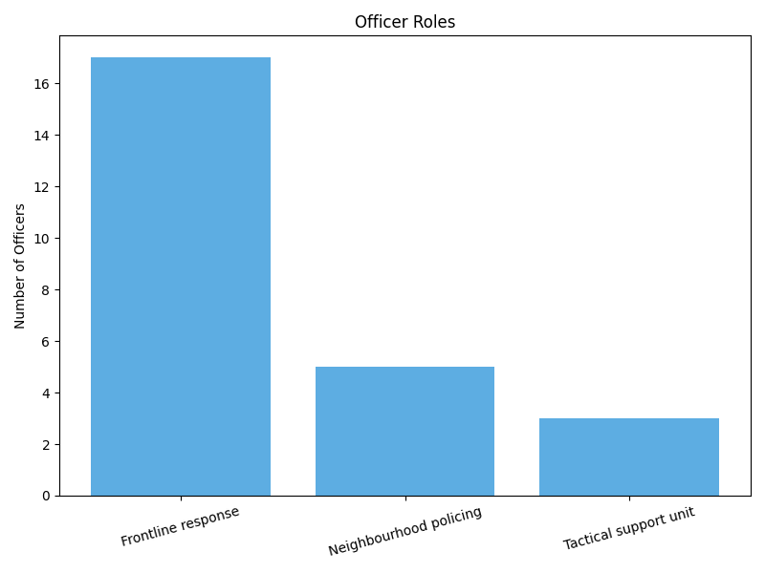

A bar chart showing the distribution of respondents by role. The majority (68%) were in frontline response roles, with smaller groups in neighbourhood policing (20%) and tactical support units (12%).

Figure D.2
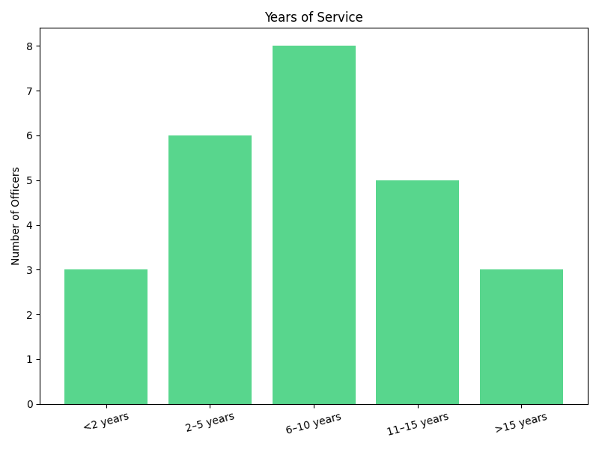
A bar chart illustrating officers’ length of service. Most respondents had between 6-10 years’ experience, with balanced spread across other service brackets.

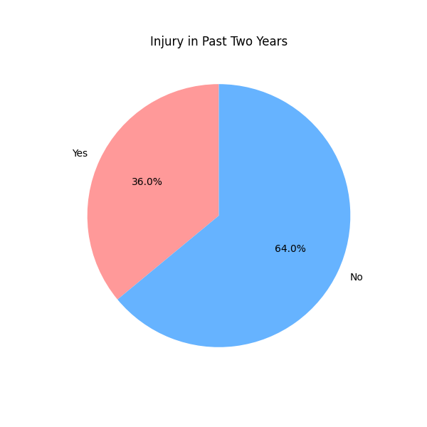
Figure D.3

A pie chart showing that 36% of officers reported experiencing a physical injury in the past two years, while 64% did not.

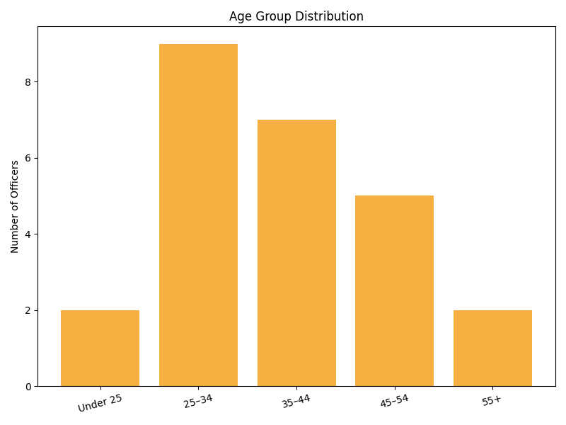
Figure D.4

A bar chart showing the age profile of respondents. The largest group was aged 25-34, followed by 35-44 and 45-54, with fewer officers under 25 over 55.

Chart 12
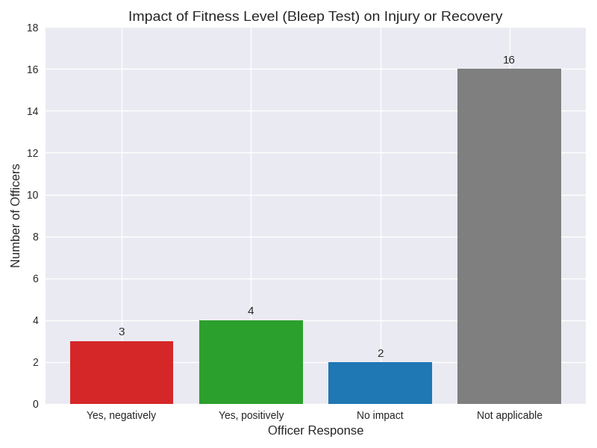

A bar chart illustrating officers views on how their fitness level (as measured by the bleep test) affected injury or recovery. Most responses indicated no impact or that the question was not applicable.

