


An investigation into the effects of material properties Vs physical changes when modelling shaped charges.
by
Olly Overton

Supervisor: Dave Holley

Project submitted as part of the requirements for the award of BEng (Hons) OME

March 2024

Declaration of Originality

I, Olly Overton declare that I am the sole author of this Project; that all references cited have been consulted; that I have conducted all work of which this is a record, and that the finished work lies within the prescribed word limits.

This work has not previously been accepted as part of any other degree submission.

Signed :

Date :

FORM OF CONSENT

I, Olly Overton hereby consent that my Project, submitted in candidature for the BEng (Hons) OME degree, if successful, may be made available for inter-library loan or photocopying (subject to the law of copyright), and that the title and abstract may be made available to outside organisations.

Signed :

Date :

Copyright Acknowledgement

I acknowledge that the copyright of this project report, and any product developed as part of the project, belong to University of Wales Trinity Saint David, Swansea.

ABSTRACT

The calculations involved when modelling shaped charges in a hydrocode, implement many complex equations. These equations cover the likes of; shock interactions, particle interactions, fluid dynamics and temperature changes. The ways these equations interact influence the output of a simulation. It is not common knowledge amongst users of a hydrocode, how these equations and resulting interactions are affected, by changing a singular variable such as the poisson ratio of a shaped charge liner. A singular change to just one variable i.e. the poisson ratio of the liner, may subject a simulation to produce a different output. This output can be measured in many ways such as; the change in the velocity of the jet, the change in length of the jet, the change in breakup of the jet and the change in temperature of the jet. Each variable will play a part in influencing the different outputs, with varying significance depending on said variable and the output being assessed.

This report will cover the most significant variables and how they work holistically to alter the output of a simulation. The rationale behind this, is the fact that tolerances when manufacturing shaped charges and their impact on jet performance is not properly understood. The manufacture of shaped charges uses the highest quality copper possible (cost being the limiting factor). However, there will still be discrepancies and defects across different batches and manufacturers.

This work will explore the effect those discrepancies/defects play in changing the performance of a shaped charge; by producing models with pre-defined parameters on certain variables. These parameters will simulate manufacturing tolerances, with the resulting data analysed to see if they play a significant part in the overall performance of a shaped charge.

Table of Content
Abstract
Table of Content
List of Figures
Acknowledgements

Copyright Acknowledgement ii
Chapter 1 – Setting the scene 7
1.1 Introduction 7
1.2 Aim 8
1.3 Objectives 9
1.4 Structure Of The Project 9
Chapter 2 - RESEARCH & REVIEW OF LITERATURE 10
2.1 Introduction 10
2.2 Physical Parameters 10
2.3 Material parameters 19

Chapter 3 – METHODOLOGY for this study………………………………21
3.1 Producing a replicant shaped charge simulation 21
3.2 Validating a simulated device 23
3.3 Comparing simulated vs trialed data using vjm plots 25
3.4 Creating a new simulation 28

CHAPTER 4 DATA COLLECTION AND RESULTS………………………………..30

CHAPTER 5 RESULTING DISCUSSION……………………………………………40
5.1 Conclusion 40
5.2 Recommendations 42
5.3 Further Research 43
5.4 Reflection 45
APPENDICES 47
Ethics form 50

LIST OF FIGURES
Figure 1 - The collapse of a shaped charge liner illustrated by Pugh [4]. 11
Figure 2 - A diagram of a shaped charge and its fundamental components [3]. 14
Figure 3 - A diagram of a shaped charge with a boat-tail rear [3]. 15
Figure 4 - Hierarchy of components that affect the jet formation of a shaped charge [14]. 16
Figure 5 - A graph illustrating the relationship between penetration and standoff [21]. 17
Figure 6 - The breakup time of fragment n is determined by considering the overlap, d1 and d2, of its neighbouring fragments in the jet. The effective length, leff, is determined from the overlap of the fragment n + 1. In this case, the breakup time for fragment n is calculated as t_{br} = max ( (d1/(v_{n}-v_{n}+1)), (d2/v_{n}-1-v_{n}) ). [18] 20
Figure 7 - The generic shaped charge modelled……………………………………………..22
Figure 8 - An enlarged section of Figure 7 [30]……………………………………………….22
Figure 9 - Modelled shaped charge Vs flash x-ray still. [23]…………………………………23
Figure 10 - Two flash x-ray stills of a new device, at different time stamps. [25]………….26
Figure 11 - VJM plot of the device in Figure 10, assuming the fragments as cylinders…………………………………………………………………………………………..27
Figure 12 - VJM plot of the device in figure 10 using the ellipsoid assumption…………..28
Figure 13 - Simplified shaped charge simulation, material vs pressure [31]………………29
Figure 14 - Propagation of the liner collapsing uniformly [31]……………………………….29
Figure 15 - Matrix of scheduled simulations to be run when altering fracture pressures [32]…………………………………………………………………………………………………30
Figure 16 – Results from altering the Pfrac of both the liner and casing [21] ………..…. 31
Figure 17 – Still image at 12 microseconds liner deforming before the casing [32].…….31
Figure 18 – VJM Plot of Run 1 [33].…………………………………………………………..32
Figure 19 – VJM Plot of Run 4 [33]..…………………………...……………………………..33
Figure 20 – VJM Plot of Run 1 Vs Run 4 [33].…………………………………………….…33
Figure 21 – VJM Plot of Run 1 Vs Run 4 Zoomed [33]……………………………………..34
Figure 22 – VJM Plot of Run 1 Vs 4 Vs 7 [33].…………………………...………………....35
Figure 23 – Simulations with 10% intervals in Pfrac differences [21]..............................35
Figure 24 – VJM Plot of Runs 1 Vs 27 Vs 29 [33]…………………………..…………..….36
Figure 25 – VJM Plots of Runs 1 Vs 27 Vs 29 Zoomed [33]………………..…………..…36
Figure 26 – VJM Plot of Runs 1 Vs 27 Vs 29 with error bars [23]…………..………….…37
Figure 27 – Simulations altering the yield stress and Poisson ratio [21]……..…………..38
Figure 28 – VJM Plot of altering Poisson ratio and yield stress [23]…………..………….38
Figure 29 – VJM Plot of altering Poisson ratio and yield stress zoomed [23]….………..39
Figure 30 – Hierarchy of material factors affecting shaped charge jet formation [34]….41
Figure 31 – Example of the potential liner spread of real device Vs simulated [35]……43
Figure 32 – SESAME's 3 equations that contribute to their EOS [18]……………………44
Figure 33 – Highest velocity recorded when changing out the EOS [21]………………..44
ACKNOWLEDGEMENTS

Chapter 1 – Setting the scene

Introduction
A shaped charge is a device whereby a liner, often made from a malleable material such as copper, is inverted when subject to elevated temperatures and extreme pressures. These extreme conditions are produced by an explosive event under confinement. This results in the liner being exposed to such a temperature that it becomes a plasma (a state whereby it does not obey the rules of the 3 known states; solid, liquid or a gas [1]). Because of this plasma state, the liner can elongate up to 3-5 times its original diameter. This elongation forms a molten plasma jet. Which when explosively driven, speeds in excess of 7kms⁻¹ can be achieved. Thus, making it a perfect formula for enhanced penetration. This phenomenon is known as the Munroe effect, and is widely adopted by the majority of defence companies who produce shaped charge devices.

It is important to highlight, a shaped charge is a device and not defined solely as a weapon. Despite having the capability to be used as a weapon itself, and in weapons such as tandem warheads (a two-stage detonation device, used to penetrate within a target). A shaped charge can also be used as a render safe tool, to disrupt Improvised Explosive Devices (IEDs). Furthermore, shaped charges can also be used in the mining industry to break apart rock formations to reach precious metal ores.

These shaped charge devices, can be replicated in a virtual environment, using a hydrocode. A hydrocode is a computer program that can be used to simulate numerically highly strain dynamic events, specifically those that include shocks [2]. Due to the explosive nature of a shaped charge, the malleable liner is exposed to a shockwave (a propagating wave of air that travels faster than air in the medium). Therefore, a hydrocode is ideal for simulating this shockwave and the interaction it has between the many components within a shaped charge.

When modelling shaped charges, many virtual components must be considered. These components include; specific variables (yield stresses, fracture pressures etc.), equations that utilise these variables, and the mesh in which the calculations are performed by the hydrocode. All of which work holistically and contribute a defined significance to the end output of the simulation. When delving into the many components that affect the performance of a shaped charge, the components can be categorised as either, material properties or physical changes in the setup of the simulation. It is unknown what components carry the most significance in altering the end output of a simulation. Therefore, a study into the magnitude of each individual component is required to determine its importance in the model.

Aim
The aim of modelling these individual components is to produce a hierarchy of controls, with the idea being it can be referred to when other users attempt to model a shaped charge. Currently, extensive research has been carried out for around 80 years in perfecting the shaped charge. However, this research has mainly had a focus on physical testing. It is only within the last 20 years that Hydrocodes have been simulating these devices in a virtual environment.

Therefore, there has been less of a focus on the modelling of shaped charges. Which is why I have concluded, that the smaller variables such as; fracture pressures, temperature melts and type of data used in the models have been overlooked. This conclusion is backed up by an in-depth literature review that has been conducted.

Objectives
The aim for this project is to develop a hierarchy-based dataset, which will be able to help inform the larger community when modelling experimental setups.
Objectives to achieve this include:
- Attempt to validate a shaped charge simulation, from data collected on trial testing a specific shaped charge device.
- Determine a list of major components that affect a shaped charges performance.
- Alter these components within a pre-defined range, and record the output.
- Analyse the new velocities observed, once a component has been altered.
- Produce a Velocity, Jet, Mass (VJM) plot to further analyse the jet breakup of each simulation.
- Produce a hierarchy of the components and analyse their significance into affecting the models output.
- Create a guide to aid users in the larger community to also make VJM plots.
These objectives are an initial prediction of how the overall aim will be achieved. They are subject to change. This is because the work that will be carried out is relatively new. It may be the objectives are not met due to encountering; unexpected hurdles, discovering certain limitations and ultimately failing to find existing research to help aid the progress of the project.

All difficulties experienced throughout this project will be documented, with the solution to each explained.

Structure Of The Project
The project itself is broken up into three parts. Firstly, the background of the project and an introduction into the shaped charge device. The second part is focussed on the theoretical work which already exists, and how it forms the foundations for this project. The theoretical work associates to the research and experimental approaches both in the physical and virtual experimentation of the development of shaped charges. The third part delves into the initial simulation that will be altered, in the attempt to create a simulation that replicates that of existing trials data. This simulation will then be further altered, to see the affect that changing certain components has on the output. The final part will compose of the data extracted from all the simulations that are due to be executed. This data will be analysed thoroughly in order to draw the conclusions that link back to the original project title.

Chapter one illustrates an overview of the report. Briefly explains the shaped charge device. Details the aims and objectives that are planned and how these contribute to the overall project title.

Chapter two focusses on the pre-existing literature that will help to build the foundations that this project is based upon.

Chapter three details the construction of the shaped charge simulation and how it is validated against existing trials data. The focus will then change to how this simulation is altered to capture new outputs by changing components.

Chapter four will address the conclusion with the claims made backed up from extensive data analysis.

Chapter 2 - RESEARCH & REVIEW OF LITERATURE

Introduction
This chapter will look to present existing information on shaped charges and their lethality effects. The review of existing information will be separated into two major aspects; the first focussing on the trials and testing of shape charges; the second delving in on the modelling of shaped charges. Both will cover the fundamental theories that underpin some of the crucial components of the shaped charge. After all, these components will be altered in the simulations, so it is important to understand how they interact in affecting the performance of a shaped charge. This will progress into a conversation on the construction of a shaped charge and some of the parameters that they typically follow.

2.2 Physical Parameters
A particular parameter that should be of interest is the liner of a shaped charge and its role in affecting the jet formation. The conceptual mechanics on how a jet elongates was first explored by Birkhoff and other in 1948 [3], however this initial concept was expanded on by Pugh, Eichelberger and Rostocker [4]. The major change between the two opinions refers to the non-uniform collapse of the liner.

The line assigned ‘A through Q’ symbolises where that of the conical liner sits. The shockwave assigned line is V_{d}. As the shockwave propagates along the conical liner, the velocity of collapse V_{o} decreases from the apex to the base as the mass of the liner decreases. Taking two points P and P1, it takes an identical time for point P to reach J, as it does for P1 to reach the curve M. If the velocity of collapse were to be uniform then P1 would reach the dashed line N in the time taken for P to reach J. It is from this that a shaped charge jet has a varying velocity. The tip of the jet will always be faster than that of the rear slug; this is because there is simply more mass (of the liner) at the rear. This varied velocity theory was not touched on by the research from Birkhoff. Nowadays it is common knowledge amongst the wider user group (of shaped charges) that the tip has a higher velocity.

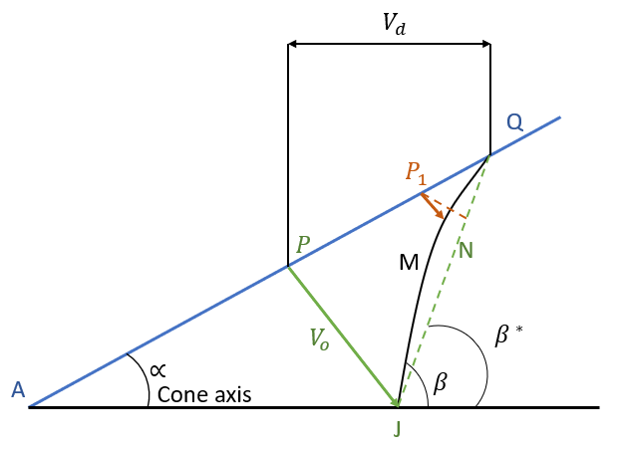
Figure 1 - The collapse of a shaped charge liner illustrated by Pugh [4].

A limitation to the work carried out by both Birkhoff and Pugh, is that if following their concepts the collapse of the liner will be repeatable. Thus providing the same result each firing. However, a shaped charge will have a different result that varies within a certain bandwidth after each firing. This bandwidth is caused by manufacturing defects, inconsistent explosive reactions, temperature of the environment and the way certain reactions interfere with one another. If you were to fire 100 shaped charges from the same manufacturer, and same batch; you would witness a range of outputs that would produce a bell curve. In fact the varying velocity will also produce a bell shape curve if you were to plot 100 firings.

This varied velocity will need to be captured in any simulations ran. To do this multiple tracer points will need to be inserted along the firing axis of the jet. To successfully do this, a combination of both fixed and fluid tracers will be required. A fixed tracer remains in its original assigned co-ordinate, whereas a fluid tracer will travel through the mesh with the first piece of material to make contact with it. The purpose of a tracer is to record velocity. A tracer is not a physical piece of material in the simulations, so it will not affect the results. It is rather a given point in which calculations are conducted.

Another parameter affecting the physical performance of a shaped charge, is the shockwave and its tendency to shear/deform materials. The fundamentals behind shockwaves and their utilisation in shaped charges has been researched extensively. An explosive material will exert a shockwave through a medium. When a shockwave passes through a medium, it exposes the medium to a harsh change in pressure. The point before the shockwave and point after, differ due to the Rankine Hugoniot relations [5]. This overall change in pressure experienced by the medium in which the shockwave passed through can be very significant. This is because the scaling is nonlinear. When the shockwave interacts on a shaped charge liner, the large magnitude of pressure exerted on the liner makes it behave like that of a plasma. This is due to the liner yield stress being overmatched [6]. In fact, if you use too much explosive or an explosive with a high brisance, the pressure becomes too intense for the material and results in vaporisation. The Bernoulli equation for the flow of the material can be applied and it is assumed an inviscid fluid [3].
Having looked at the liner and shockwave interaction, it is then important to look at the geometry and layout of all the components in a shaped charge. All shaped charges follow the concept of the Munroe effect, however they will all differentiate on their physical makeup as a result of their intended use [3]. Certain shaped charges are altered to maximise penetration, whereas others are altered to maximise reliability and use in harsh environments (deserts/underwater).

The result of World War 2 produced numerous iterations of different shaped charges. This was due to the requirement of successfully penetrating thick armours such as steel and concrete bunkers [3] [7]. Within the mining industry, the blasting of rock with the use of shaped charges is thoroughly researched [7] [8]. These mining shaped chagres are much larger as they cover such a wide area target such as a cliff face. Shaped charges used within the defence industry are smaller in size. This is because they have to be more precise; this is to target small specific targets such as a power source located within an IED. Because of this, there will always be a variation of shaped charge devices [3].

Even with differences in the application and intended use of a shaped charge, they all still follow similar principles. In the diagram below, the liner diameter is LD, the charge diameter is CD, and the explosive and the warhead diameter is WD [3]. The head height is the distance between the apex of the liner material and the point of detonation [3].
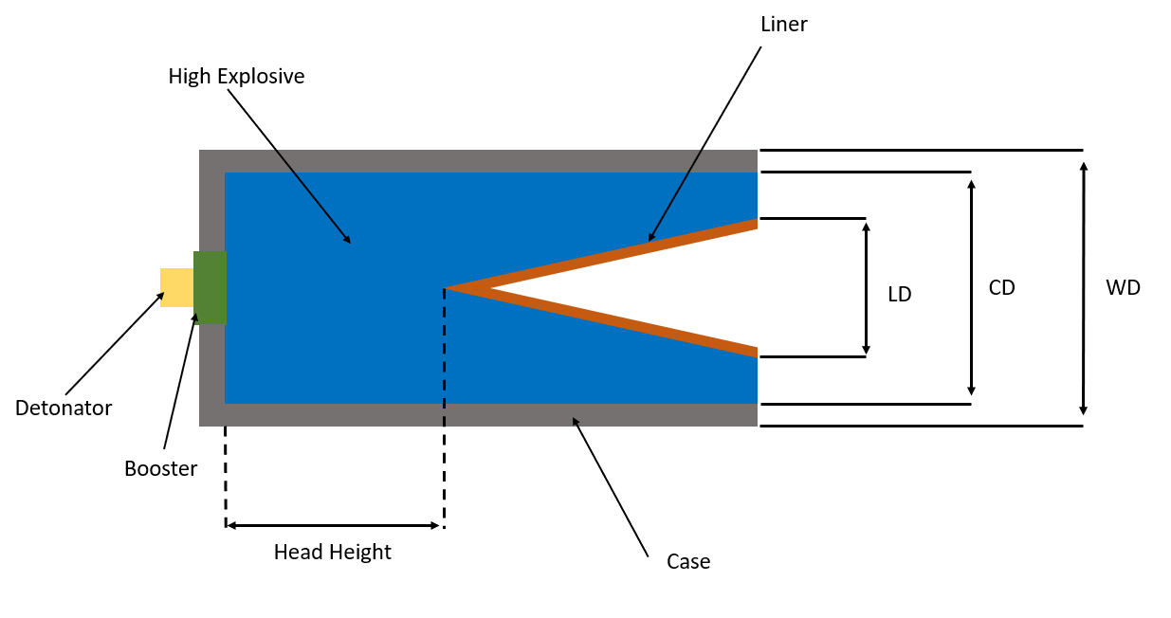
Figure 2 - A diagram of a shaped charge and its fundamental components [3].
The major output of a shaped charge is its penetration capability. This is heavily affected by the standoff. The standoff is the distance between the target and liner. The connection involving the standoff and the design is also heavily researched [9] [10]. However, the following investigation is going to focus more on the jet formation, and the components that affect this. Therefore, the standoff will not be investigated. The only consideration needed which relates to standoff, is that the simulations scheduled to be ran; will have to have enough standoff to a target, in order to allow the jet time and space to form.

There are other considerations to evaluate when designing a shaped charge. These are the weight of the shaped charge, as well as the overall cost. The weight of the shaped charge will be heavily influenced by its intended use. Shaped charges can vary in size drastically, depending on the target set. For example, a shaped charge such as VulcanTM can be filled with just 10g of Plastic Explosive (PE) to defeat small IEDs with little protection [11]. Whereas, Saab’ SM-EOD 130 uses 2540g of PE to defeat buried Unexploded Ordnance (UXO) [12]. The other consideration was the cost, this includes; the materials, assembly/manufacturing, shipping and marketing. The common trend amongst the defence industry is to increase performance but save money and materials.

Applying this to shaped charges, a way in which you can reduce both weight and cost per individual unit is to exploit boat-tailing. This is where the charge is tapered, so that sections of the explosive are removed and the overall cost and weight are reduced [3]. The diagram below alters the design previously seen to incorporate boat-tailing. The effect boat-tailing has on the performance is minor. However, if implemented properly the boat-tail can act as a wave guide in order to produce a more uniform shockwave on the liner. This results in a more even collapse of the liner.
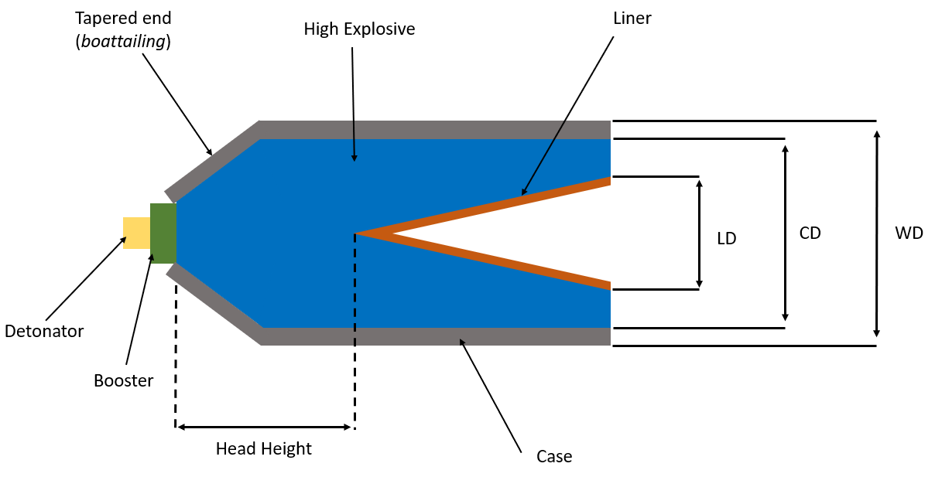
Figure 3 - A diagram of a shaped charge with a boat-tail rear [3].

Although there are ways to promote an increase in performance of a shaped charge, there is no set defined script as per say to achieve this [3]. However, one example of increasing performance is to optimise the relationship between the apex angle of the liner and the penetrative power of the jet. This relationship has been studied since World War 2 and continues to be a hot topic of modern research, especially when analysed with different combinations of liner material and thicknesses [3] [13]. Studies have shown it is possible to see that the liner thickness, angle and shape all have an effect on the jet velocity and formation. However, these factors do not have defined a construction nor relationship that can be applied to all shaped charges [9] [13]. It is therefore vital, that caution is taken when trying to conclude that any one characteristic of the shape charge geometry is responsible for the change in performance. For example you could have a steel liner with a small cone angle; and then a copper liner with a larger cone angle. Research would suggest the copper liner with the larger cone angle will observe a better jet formation. However, this may not be the case and may impose a problem when it comes to modelling the shaped charge in question. If there are so many relationships, between such a vast list of components; the dataset in order to capture all this will be unachievably large. This experiment needs to remain realistic, therefore more literature needs to be studied to find out what components alter the jet formation the most. Furthermore, research into the software intended to be used, and how it calculates these components will also be required.
It will also be crucial to ensure that this experiment does not step on the toes of work done on EFPs (explosively formed projectile). EFPs are of similar nature to shaped charges, however they do not undergo the Munroe effect. EFPs have a larger cone diameter, but experience a much shallower angle of this liner. They are used in scenarios that require a greater standoff, sometimes which is 100 times its charge diameter. Therefore, although similar, research on EFPs will not provide any greater benefit in understanding jet formation than the research on shaped charges. This is to document it has been considered, but actively avoided for the previous rationale; the fact they do not undergo the Munroe effect, which is the main principle of a shaped charge device.
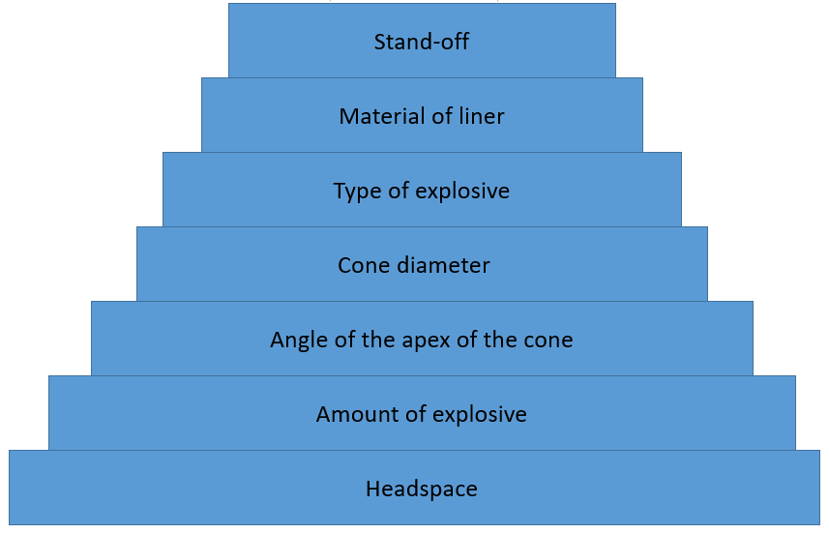
As previously mentioned, the components that carry the most significance in altering the jet formation will need to be researched. However, after multiple discussions amongst SMEs (subject matter experts) those components have been identified and listed below:
Figure 4 - Hierarchy of components that affect the jet formation of a shaped charge [14].
A description of each component and how it affects jet formation:
Stand-off – the stand-off is the distance between the liner of the charge, and the intended target. A stand-off too small results in less penetration, this is because the jet needs time and space to elongate to its full length. On the other hand, a stand-off too large, and the jet will break apart. This occurs because the mass separates out depending on its velocities. Heavier parts of the jet move more slowly and are typically located at the rear of the jet. The tip of the jet is the fastest, because it has the least material. If the jet does break-up, the penetration decreases.
Material of the liner – the choice of the liner material is vital to the performance of a shape charge. Malleable materials such as copper elongate better than those of non-malleable materials. Gold has been trialled and tested, however it is too expensive to manufacturer. The more malleable a material, the more the jet can elongate. This results in better penetration.
Type of explosive – explosives have varying VODs (velocities of detonation). A higher VOD results in a faster jet and better penetration. Another measurable of an explosive is its brisance. This is the shattering effect of the explosive. A high brisance will promote the liner to elongate, however if it is too high the pressures will overmatch the casing too early, resulting in a loss of pressure to invert the liner. A fine balance of pressure production is required to optimise performance.
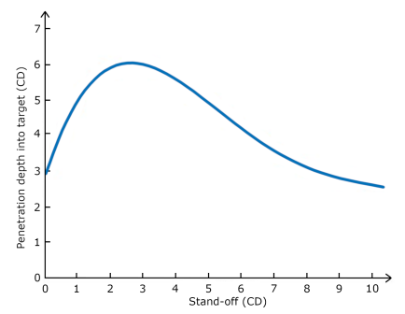
Cone diameter – the cone diameter as illustrated in figure 2, is the overall diameter of the liner. The general rule of thumb, is that penetration of a shaped charge is 3-5 times its cone diameter [15].
Figure 5 - A graph illustrating the relationship between penetration and standoff [21].

Angle of the apex of the cone – the apex of the cone is the sharpness of the angle that the liner folds. The apex of the liner heavily influences the liners relationship with the shockwave. An obtuse angle means the shockwave is exposed to a flatter liner, this means more surface area is exposed to the shockwave at the same time. Therefore, the liner is pushed away from the casing, rather than be inverted on itself. The liner will still invert, just not to the same elongation as that of an acute angle. An obtuse angle replicates that more of an EFP.
Amount of explosive – the net explosive quantity (NEQ), is the amount of explosive within the housing of the shaped charge. This housing is often made of steel, this allows immense pressures to build up inside, which results in the liner inverting on itself. However, in special operations shaped charges are made of plastics and even carbon fibre. The pressure still builds up enough to invert the liner successfully, however the casing then fragments into small pieces that look like cloth. This allows the special operations units to be discreet and quick, whilst leaving little to no evidence behind. This technique is also used in EOD tools such as disruptors [16]. As for the amount of explosive, it is a delicate balance between too much and too little. Too much explosive ruptures the casing before the liner starts to invert. On the other hand, too little explosive does not produce enough pressure to invert the liner.
Headspace – the headspace of a shaped charge is the distance between the apex of the liner and the initiation point of the explosive (often the booster). Similar to the NEQ, the headspace can be too long or too short. A long headspace means the shockwave loses its momentum resulting in less elongation of the liner. Whereas, a short headspace means the shockwave doesn’t have a nice uniform front [3].

There are many other factors that affect the performance of shaped charge, the above list is does not contain them all; it only lists those that are disputed to be the most significant in altering the appearance of the jet.

From the above literature research, some conclusions can be made. Firstly, it is near on impossible to determine the relationship between all the components within a shaped charge. With each shaped charge being purpose built to fulfil a specific role/duty, it is not right to assume that the same rules apply to each and every one. They will all obey the fundamentals such as the Munroe effect, however they will all achieve this differently. Secondly, not all shaped charges are designed for maximum penetration. Many are designed for EOD tools, in which you don’t want maximum penetration. This is because the target will be completely destroyed and limit forensics on the IED parts recovered. Therefore, they won’t have the optimised conditions seen in figure 4 to produce an elongated jet. Finally, there is such a variation in the manufacture of shaped charges, which may cause the jets elongation to vary.

A limit to the current research conducted is that it does not focus on the modelling of shaped charges, but rather physical devices tested and trialled. To aid the structure of the shaped charge simulations due to be ran in this investigation, a further literature review on the modelling of shaped charge devices is required.

2.3 Material parameters
When researching existing work on the modelling of shaped charges, it is worthy of keeping in the mind that it does not directly translate across to the work of others. This is because the modelling of shaped charges carried out by others, is difficult to apply to work carried out by one’s self. This is due to the nature of modelling and the numerous variables within it. This is because many different software’s exist, all of which implement varying ways of carrying out the basics. The basics of modelling a shaped charge includes: the mesh, the units, the material inputs, the strength model, equations of states and if it is Lagrangian or Eulerian. All of these basics help produce a model, but they do it in different ways. For example, a Lagrangian software follows all the particles and describes the variations around each particle along its trajectory [17], the mesh essentially moves with the particles. Whereas, an Eulerian software describes the particles and their interactions in a fixed area as a function of time [17]. As a result, the Eulerian software’s require more computational strain. The software chosen to model shaped charges in this investigation will be Eulerian.

Before starting the simulations, it is important to look at the work of others to see what lessons they learnt. Specifically lessons relating to the modelling of jet breakup. A recent report from February 2023 highlighted how a jet breaks up. It stated the breakup time is calculated as soon as the original slug deforms into two new individual fragments. An assumption made is that each fragment has a constant velocity and that each fragment is axially aligned with the firing axis. Before the separation of the slug, each individual fragment is assumed to have the shape of a circular cylinder of known length and radius. A limitation to this assumption, is that fragments of a shaped charge jet actually look more like an ellipsoid. However, it is difficult to determine the specific time point of when the ellipsoid forms. Taking the readings of when they are cylinders will produce more consistent results. Assuming the fragments overlap that is. Figure 6 shows how the cylinders overlap.
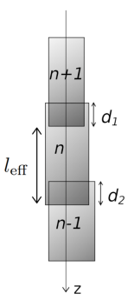
Figure 6 - The breakup time of fragment n is determined by considering the overlap, d1 and d2, of its neighbouring fragments in the jet. The effective length, leff, is determined from the overlap of the fragment n + 1. In this case, the breakup time for fragment n is calculated as t_{br} = max ( (d1/(v_{n}-v_{n}+1)), (d2/v_{n}-1-v_{n}) ). [18]

Because the overlapping of the fragments occurs before the separation, the effective length of a fragment is only the non-overlapping length with the following fragment. Because of this, the radius of the fragment is assumed to scale with the effective length in such a way that conserves the volume of the fragment [18]. When it comes to analyse the simulations in this investigation, it will be crucial to use a VJM (Velocity, Jet, Mass) plot to compare the jet breakup of cumulative mass. Many experiments have been done, where solely the velocity has been compared. This does not elude to the bigger picture of the jet breaks up, merely just records the fragments speed.

Another important lesson when modelling shaped charges is to understand how the code uses material properties. A hydrocode will use fracture pressures, melting temperatures, poisson ratios, yield stresses and more to determine how the individual materials obey the laws of physics and chemistry. Different datasets can be used in certain software’s. For example, some may use the SESAME Tabular format, and others may use the Mie–Grüneisen format [18] [19]. They differ in the way they represent a material using different equations of states.
A more extensive literature review has been conducted on material properties and their sensitivity to changes. This can be found in Appendix 1.

Chapter 3 – METHODOLOGY for this study

3.1 Producing a replicant shaped charge simulation
First, in order to obtain any valid data, a shaped charge simulation has to be constructed. In order for the data produced from the simulation to be valid, the shaped charge modelled, should try to replicate that of an existing off the shelf product. Therefore, conclusions can be drawn on how certain manufacturing tolerances affect the jet formation and performance i.e. “If the manufacture were to produce a new batch of shaped charge ‘x’ with a new copper that is 2% more malleable, the resulting change in performance would be…” In order to set up a shaped charge simulation that replicates an existing product pre-existing trials data is to be used.

In October 2019, a trial took place firing a shaped charge at a 10cm x 10cm x 10cm aluminium block. Flash x-ray systems were used to capture still images of the jet mid-flight. Because the geometry and dimensions of the shaped charge are known, and images of the jet formation are available. This data can aid the set-up of an initial shaped charge simulation.

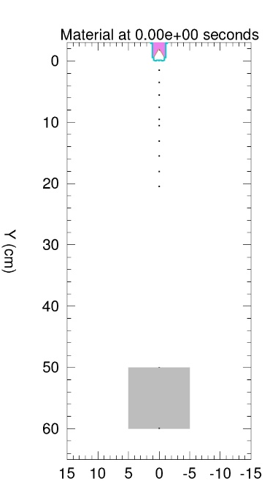

Figure 7 - The generic shaped charge modelled [30].

Figure 7 shows the shaped charge that will be firing in the y-axis at the aluminium block. The ten black dots between the shaped charge and target are tracers. These are not physical material in the simulation. They are merely co-ordinates that record the velocity of material passing through them. Some of these tracers have been fixed, with others being fluid. The idea being the fluid tracers are caught with the jet tip, thus recording the highest velocity observed by the jet. Whereas, those fixed tracers record the velocity of the rear of the jet.
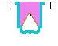

Figure 8 - An enlarged section of Figure 7 [30].

Figure 8 illustrates an enlarged image of the shaped charge from figure 7. The blue/teal material is the casing, the brown/orange material is the liner, and the pink material is the explosive.

In order to produce this set-up, many draft simulations were completed. This involved learning how to implement a ‘user defined shaped (UDS)’ to produce the correct dimensions for the charge. A UDS is a series of co-ordinates, where the software then draws a line between them; similar to that of children’s dot to dot books. Because this simulation is 2D, it had to replicate a cut through image of the 3D real life trials. Therefore, the UDS had to be scaled to use the correct amount of explosive. This was calculated using a simple technique of drawing the device on graph paper, and working out the area within the UDS. As a result, this meant the geometry of the model replicated that of the real life device. However, the performance of the charge still needed validating.

3.2 VALIDATING A SIMULATED DEVICE
The validation of a simulated device can be done in a variety of ways. However, the two most common methods are to compare the images of the simulated device against trials images of the same device. The other method is to analyse the data from both. This latter method is heavily dependent on the type of data recorded on the trial.
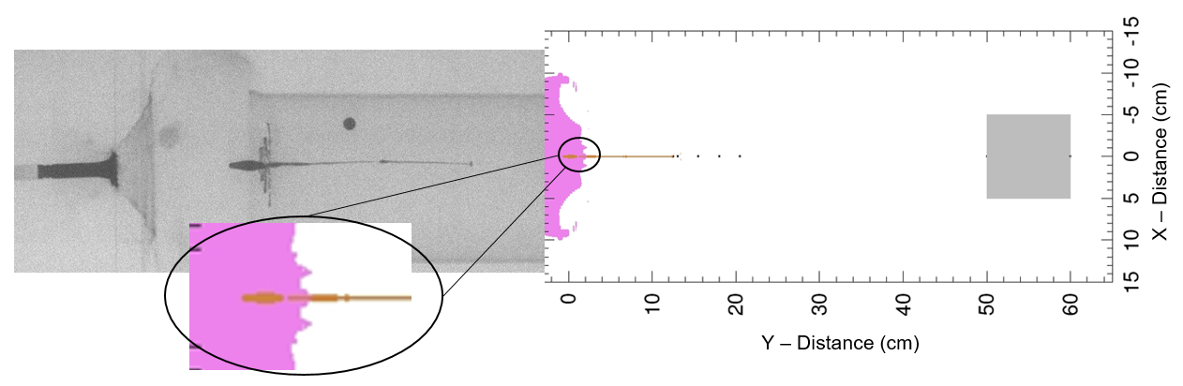
Figure 9 - Modelled shaped charge Vs flash x-ray still. [23]

Figure 9 shows the modelled device from figures 7 and 8 (right hand side) and a flash x-ray still image form a trial in which the modelled device was tested. A flash x-ray image is produced using a backscatter plate and x-ray generator. The two are set-up opposite one another with a large enough gap to allow the jet to pass through. Flash x-rays are preferred over high-speed cameras for two reasons; 1) the event occurs so quickly, that a specialist slow motion camera is required of which is very costly. 2) The event produces a lot of intense light, smoke and heat, which obscures the cameras line of sight to capture the early stages of the jet formation.

To compare the two images, the same exact timeframe is required. The flash x-ray system from the trial was initiated once the jet had passed through two light gates. These light gates were setup with a known distance, and incorporated a timer between when the jet hit the first and second light trap. This allowed the velocity of the jet to be calculated. The recorded velocity from this trial is unable to be shared. Because the flash x-ray system used a timer, a known time was recorded of when the image in figure 9 was taken. To obtain the same time from our simulation the time step needed to be carefully altered. The time step affects the frequency that calculations take place in the simulation. A small time step can increase the run time and computational strain on a simulation, to the point it can take weeks to complete. On the other hand, a time step too large can mean vital data is missed from calculations not taking place regularly enough. The time step used in the simulation shown in figure 9 was designed to record at every 2 microseconds. By looking at the image in figure 9, a few conclusions can observed.

The first conclusion is that the device tested on the trial from figure 9 suffers from co-axial drift. Co-axial drift is the shift of fragments produced by a shaped charge away from the normal. This normal is the intended firing axis. Because the liner may not collapse perfectly uniform, the fragments may have a varied velocity. The air travelling around the left part of a fragment could be greater or smaller than that of the velocity of air travelling around the right part of the fragment, and vice-versa. This is caused by the shockwave not propagating perfectly [20]. This is the consequence of minor defects in the explosive called voids. A void is a very small hole in which air or a contaminant has been trapped in the explosive during manufacturing. This most commonly occurs in the filling process of a shaped charge. Technology is improving to fill the charges using a technique called RAM (Resonant Acoustic Mixing). These voids mean the shockwave is slightly bent off course. In an ideal world, the shockwave would reach the liner at the same time as one continuous plane detonation front. Because the voids bend the shockwave, the liner collapses wherever the shockwave strikes it first. This causes tumbling of fragments which can be observed in the trials data from figure 9. The simulated device does not suffer from co-axial drift. This is because the model does not incorporate voids or crystals within the explosive. Instead, the explosive behaves as a uniform plane detonation front, which strikes all parts of the liner simultaneously. Thus resulting in a uniform collapse of the liner, which resultantly produces a jet that is perfectly straight in the y axis.

A second conclusion can also be made between the flash x-ray and simulation image. The simulation does not seem to include the rings around the bulk of the jet. This is because a discard function was implemented into the simulation. The discard function eliminates material when it drops below a user defined density. Both the liner and explosive was discarded when it became so minute it was not worth calculating. Ultimately, this sped up the run time for the simulation. It was also determined the low density material would have negligible effect on the end result.

3.3 COMPARING SIMULATED VS TRIALED DATA USING VJM PLOTS
Comparing the results from just looks is it not a valid way to draw any conclusions, instead some data analysis is required. A technique used in the work carried out by Pelfalt [18] analyses the material spread of a shaped charge jet. The technique involves producing a VJM (Velocity Jet Mass) graph. The graph shows the cumulative mass against velocity. There are many different ways to produce a VJM. However, it is not stated in Pelfalt’ work which method is best. Pelfalt assumes the individual fragments are cylinders, whereas from trials data it can be said with certainty they actually take the form as an ellipsoid shape.

To produce a VJM from trial data, a flash x-ray still of the jet formation much later on than that of the image in figure 9 is required. A later timeframe will show the fragments are clear individual masses. These can be easily distinguished and analysed. The data captured from the trial in 2019 did not produce an x-ray still with clear fragments. However, a second trial testing a different shaped charge produced this x-ray still:
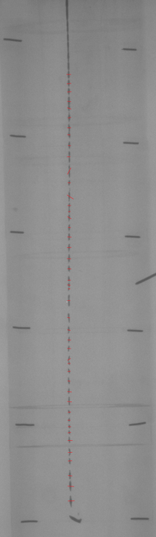
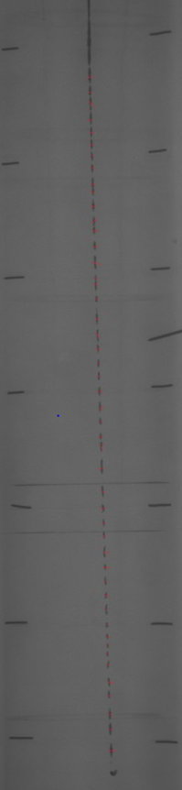

Figure 10 - Two flash x-ray stills of a new device, at different time stamps. [25]

The fragments are much clearer and can be analysed. Because the time stamps of both stills are known, the velocity can be calculated by taking the difference of y-axis co-ordinates between the two images for the same fragment. A calibration is required, which is why the two images have pins spaced exactly 100mm apart. The full calculation process for the VJM can be found in Annex A. It was previously mentioned that the fragments can be assumed as either cylinders or ellipsoids. The actual mass of the liner from the device used in figure 10 weighs 75.95g. This was weighed on precision scales with a thorough cleaning process taking place on the liner beforehand.
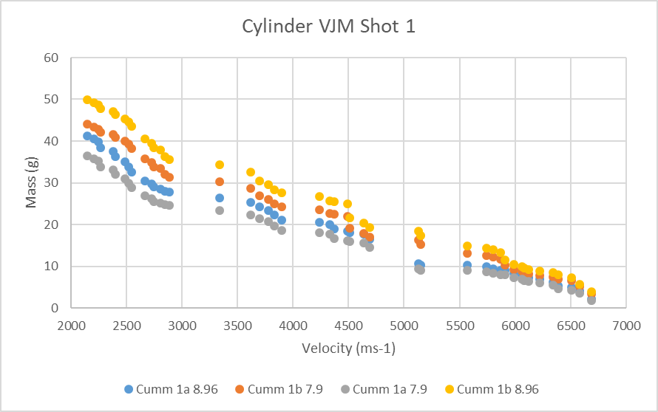
Figure 11 - VJM plot of the device in Figure 10, assuming the fragments as cylinders.
From figure 11, it can be observed that the total mass of the fragments accumulates to 50g. Although this is not the 75.95g, it is expected that not all the mass is captured in the fragments. A portion of mass remains as one large slug with no distinct shape towards the rear of the jet. This is not incorporated in the VJM, as the level of certainty in determining its shape is reduced. The 4 colours in figure 11 represent the mass of copper at different densities depending on temperature. As previously discovered the event of a shaped charge produces intense heat, which produces plasma. It is not known exactly what temperature the copper in this firing reaches, so a range of densities at different temperatures is covered.

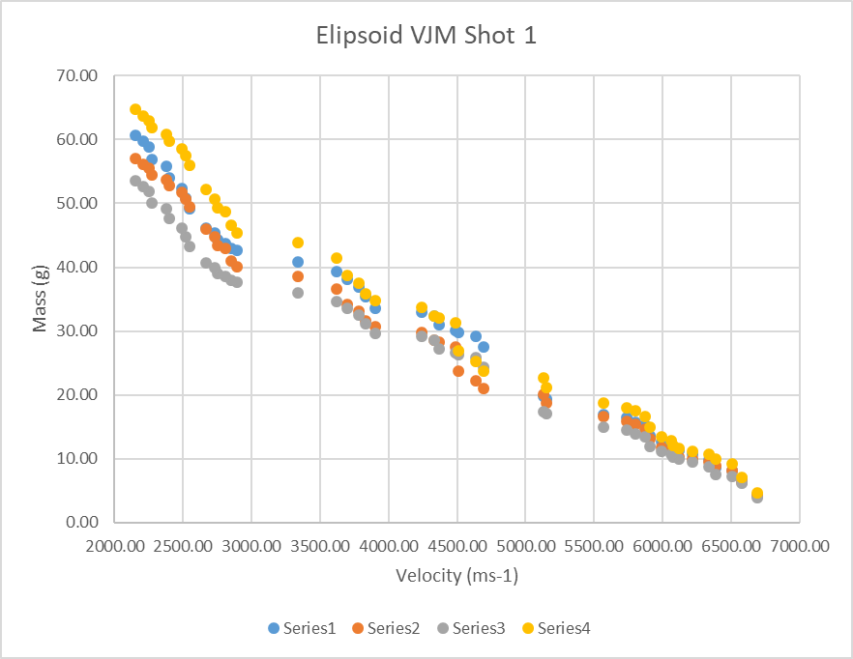
Figure 12 - VJM plot of the device in figure 10 using the ellipsoid assumption.
Comparing figure 11 to figure 12 the total mass observed using the ellipsoid assumption is truer to that of the actual mass of the measured 75.95g. This means the VJM method using the ellipsoid assumption produces data of higher accuracy.

Because a VJM cannot be produced for the simulation against the trials data found in figure 9. It is near on impossible to say the simulation is representative. It could be argued that changes in the velocity and jet formation are not from modifying the parameters of the simulation. To rectify this, a standard shaped charge script needs to be produced. This script will not attempt to recreate an off the shelf product, but instead replicate the fundamental processes within a shaped charge, such as the Munroe effect. Once the script is setup and functional, any change in the output will be due to a parameter modification.

3.4 CREATING A NEW SIMULATION

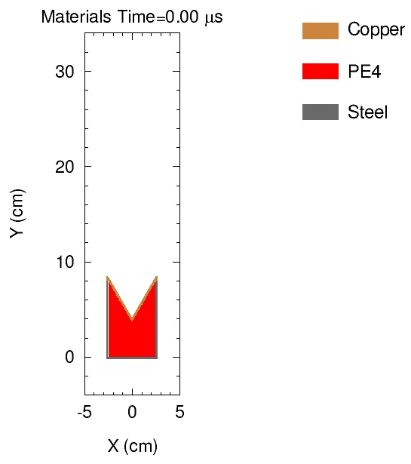
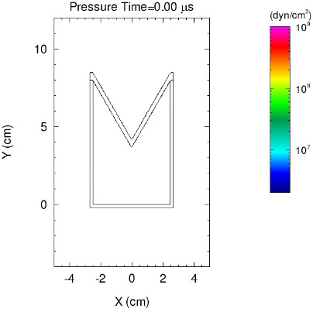

Figure 13 - Simplified shaped charge simulation, material vs pressure [31].

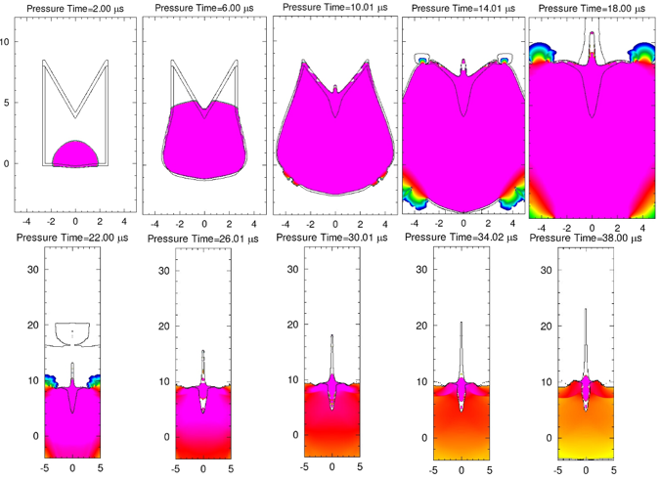
The simulation in figure 13 has been heavily simplified when comparing it to that of figure 7. The reason for this is to reduce computational strain and run time. Existing research depicts the generic shaped charge to look like that of figure 2, which was inspiration for the simulation in figure 13. Starting with a simple simulation means that less errors will be encountered when modifying the parameters. If you modify a more complex simulation, the results can be skewed by the numerous calculations and interactions ongoing in the software.
Figure 14 - Propagation of the liner collapsing uniformly [31].

CHAPTER 4 DATA COLLECTION AND RESULTS
The first modifications to the script involve the fracture pressures of the liner. The fracture pressure is the point at which a materials formation alters under pressure. The fracture pressure is a significant property of a material, and from previous research it would suggest the higher the fracture pressure, the less ductile the liner would be. This would result in reduced elongation.
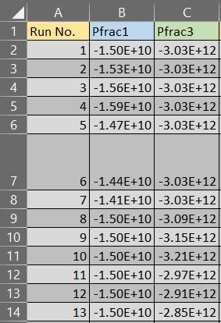

Figure 15 - Matrix of scheduled simulations to be run when altering fracture pressures [32].
Figure 15 highlights the scheduled simulations to be run when testing the affect that altering the fracture pressure (Pfrac) has on the jet formation. Initially a 2% increment would be tested, with this increment considering both upper and lower bounds of a Pfrac alteration. Both the Pfrac of the liner (Pfrac 1) and casing (Pfrac 2) would be altered. The explosive does not have a Pfrac. Physically observing the output images from the simulation will not provide conclusive evidence. This is because the resolution of the output images is not refined to capture such small changes. This reduces computational strain. To analyse the jet formation, the highest velocity observed in the simulation will be recorded. It is expected the jet will have a higher velocity with an increased Pfrac. The rationale being that more pressure can build up before it transitions into a plasma, resulting in more pushing force.
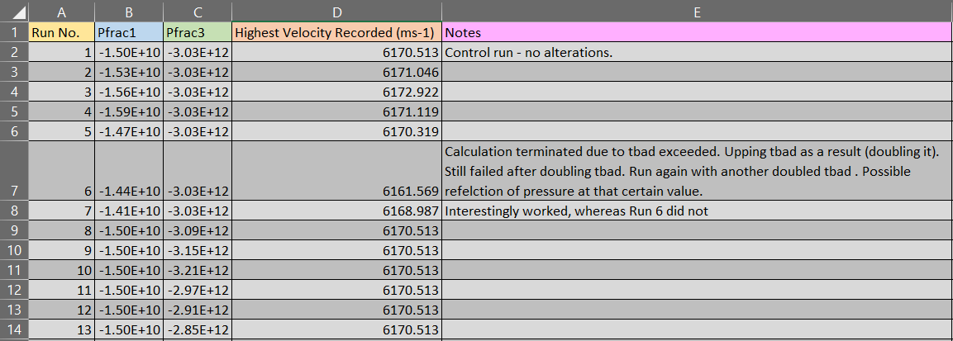
Figure 16 - Results from altering the Pfrac of both the liner and casing [21].
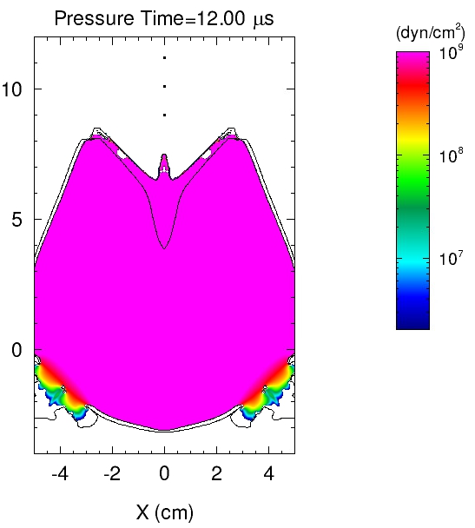
Figure 16 shows the highest velocity observed from the simulations ran. The first obvious conclusion is that there is negligible difference in the highest velocity observed when altering the liners Pfrac. The second obvious conclusion is that altering the Pfrac of the casing has no effect on the highest velocity observed. This second conclusion is expected, because the casing is not the material being deformed into a jet. It is solely building up pressure to invert the liner. Another reason it has no effect is because the liner is transitioning into a plasma before the Pfrac of the casing has been reached. In simpler terms, the pressure build up within the casing ruptures the liners Pfrac before the casings, which is expected as it is 2 magnitudes of order greater.

Figure 17 - Still image at 12 microseconds showing the liner deforming before the casing [32].

In Figure 17, it can be observed that the liner has already started its process in elongating. Whereas, the side walls of the casing has not deformed, it has only been pushed outwards.

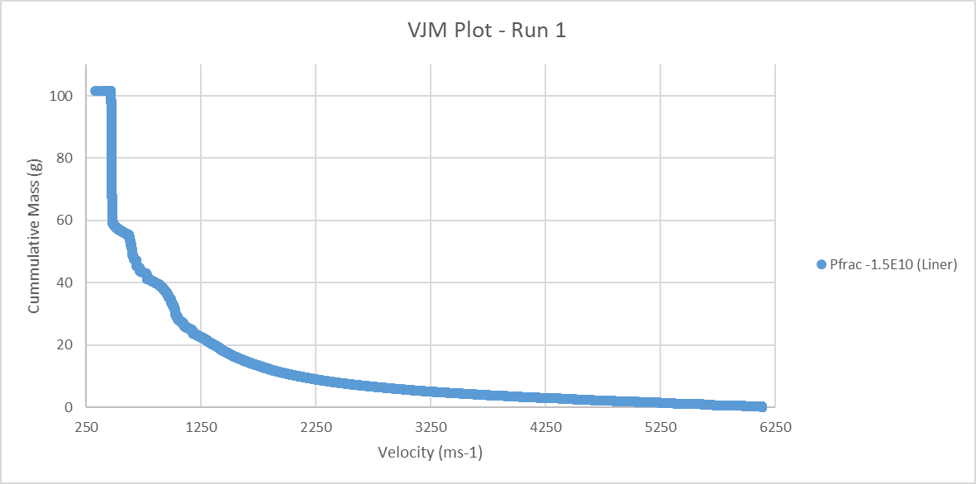
To understand why there is only a 0.0098% increase in velocity between runs 1 and 4, further analysis is required. Although the highest velocity recorded, has negligible difference across the different runs, the overall spread of material and thus spread of its corresponding velocity may have differed. A VJM plot will show the cumulative mass and its velocity, which represents the spread of material through the jet.
Figure 18 - VJM Plot of Run 1 [33].

In Figure 18, there are 4750 data points. These data points correspond to the recording rate of the simulation i.e. how many calculations it takes throughout the 100 micro second simulation. It can be seen that the smaller fragments within the jet travel the fastest, whereas the larger fragments travel much more slower. When comparing Figure 18 to Figure 19, two things should remain constant; 1) the total cumulative mass, this is because the liner dimensions are not changing, so should have the same mass. 2) The highest velocity observed. From the previous results in Figure 16, the velocity change is negligible and this is further reflected in the plots.
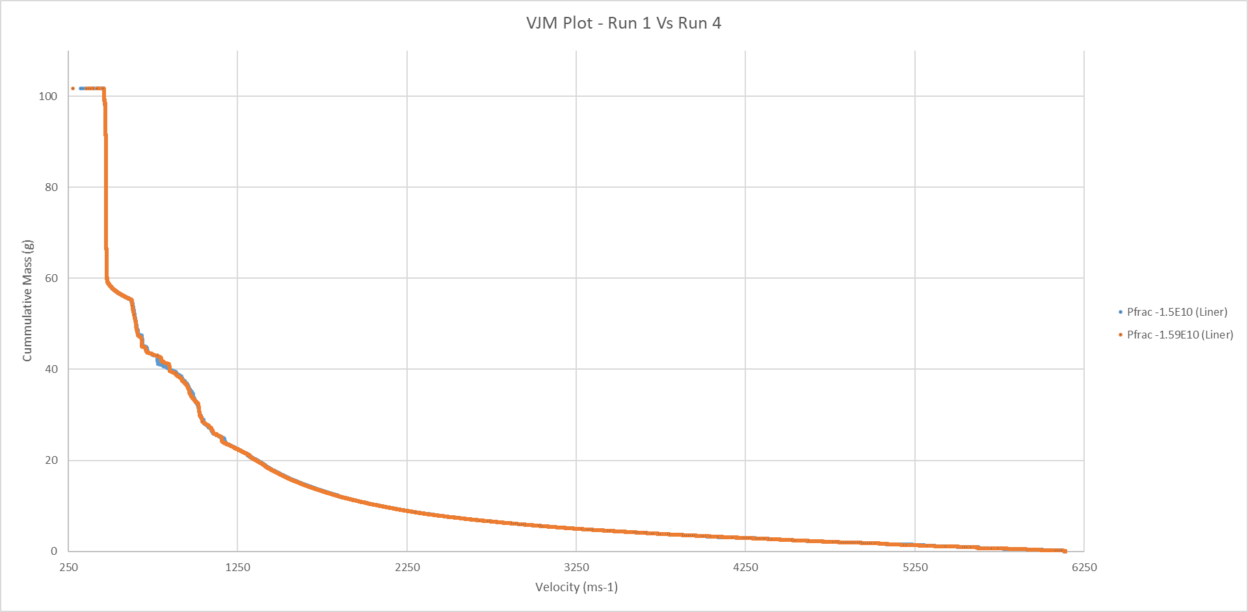
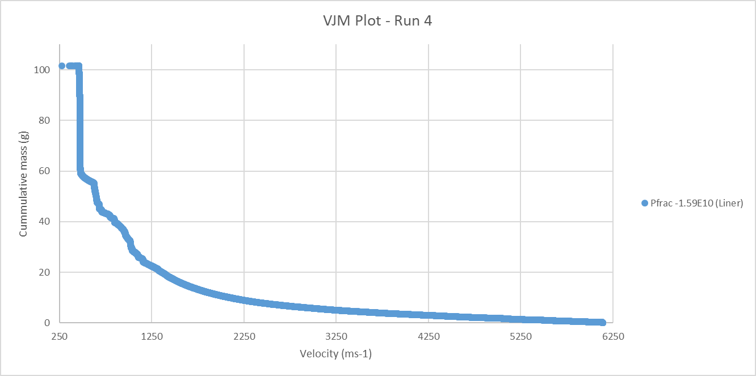
Figure 20 - VJM Plot of Run 1 Vs Run 4 [33].
Figure 19 - VJM Plot of Run 4 [33].

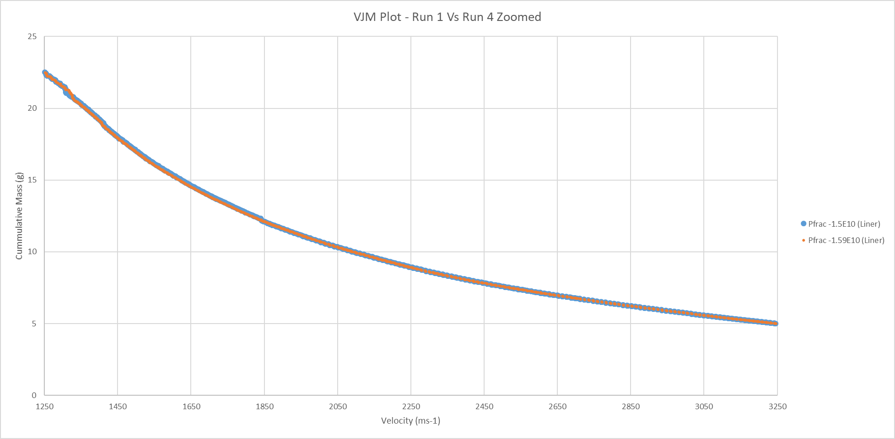
Figure 21 - VJM Plot of Run 1 Vs Run 4 Zoomed [33].
Overlaying the plots of the two runs allows for easier comparison. Although a change in the spread of material was expected, the figures show negligible difference. There is a small difference at approximately 750ms⁻¹/40g, however any differences in this region would not be significant in real life. Figure 21 shows a zoomed in section from figure 20. This zoomed in section identifies the section of the jet that contributes to most penetration. For example, 90% of penetration is covered in the first 30% of the jets mass [21]. It is this section that therefore contributes most to change in the performance of a shaped charge. Because figure 21 shows little to no change in the two runs despite having an altered Pfrac. It can be concluded that increasing the Pfrac by up to 6% from its original value does not affect the performance of a shaped charge. Thus, meaning manufacturing tolerances within 6% do not affect performance. However, it is important to look at the lower bound Pfrac change too.

Figure 22 shows there is still no difference in performance even when using lower Pfrac values.
Figure 22 - VJM Plot of Run 1 Vs 4 Vs 7 [33].

The effect fracture pressures play in the jet formation within the simulation may be affected if the intervals are increased from 2% to 10%.
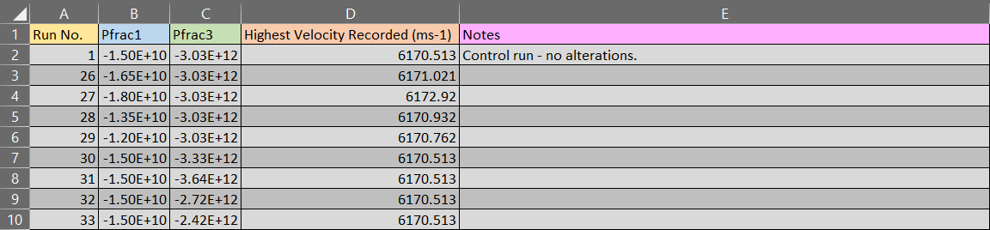
Figure 23 - Simulations with 10% intervals in Pfrac differences [21].
The highest velocity recorded still remains negligible, however the VJMs may highlight a difference not yet seen.
Figure 25 - VJM Plots of Runs 1 Vs 27 Vs 29 Zoomed [33].
Figure 24 - VJM Plot of Runs 1 Vs 27 Vs 29 [33].

Figure 24 - VJM Plot of Runs 1 Vs 27 Vs 29.
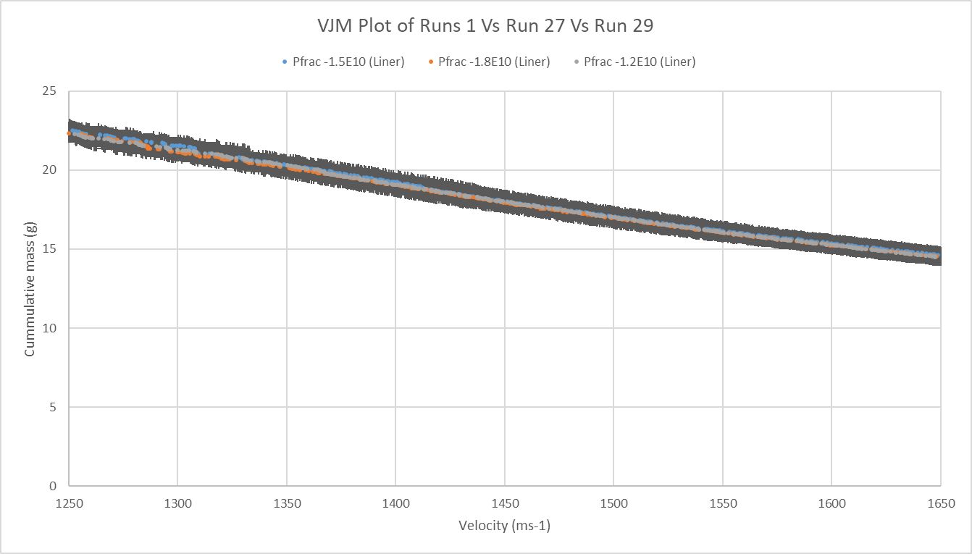
Despite upping the intervals from 2% to 10%, there is still no negligible difference. Figure 25 shows the VJM plot for a ± 20% increase/decrease, where there is still no observed difference. However, this is some small separation of mass at 1250ms⁻¹ across the 3 runs. This difference was not observed in figure 22, but when adding error bars to the data, it is deemed not to be a significant difference.
Figure 26 - VJM Plot of Runs 1 Vs 27 Vs 29 with error bars [23].
This negligible change would suggest that the fracture pressure of a material is not important when producing shaped charge devices, both in the real world and virtual world. It can be concluded that changing the fracture pressure of a copper liner by up to 20% from its original value does not significantly affect the performance of a simulated shaped charge in this specific hydrocode. This conclusion was not predicted, and was a surprise. To understand why, the way the hydrocode uses the fracture pressure needs to be studied. The hydrocode manufacture sadly does not show how the fracture pressures are used and in what equations. However, using existing equations, the fracture pressure is not squared and plays a small role on small objects. Because the liner is so small (millimetres thick) the cross sectional area is insignificant when it comes to the force per unit area. Thus meaning the fracture pressure of the liner will not contribute much output.

Other material properties that may change the way a jet forms include the yield stress and Poisson ratio.
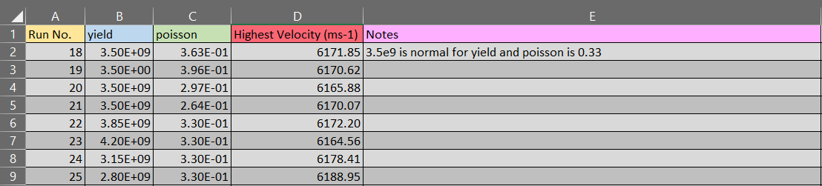
Figure 27 - Simulations altering the yield stress and Poisson ratio [21].

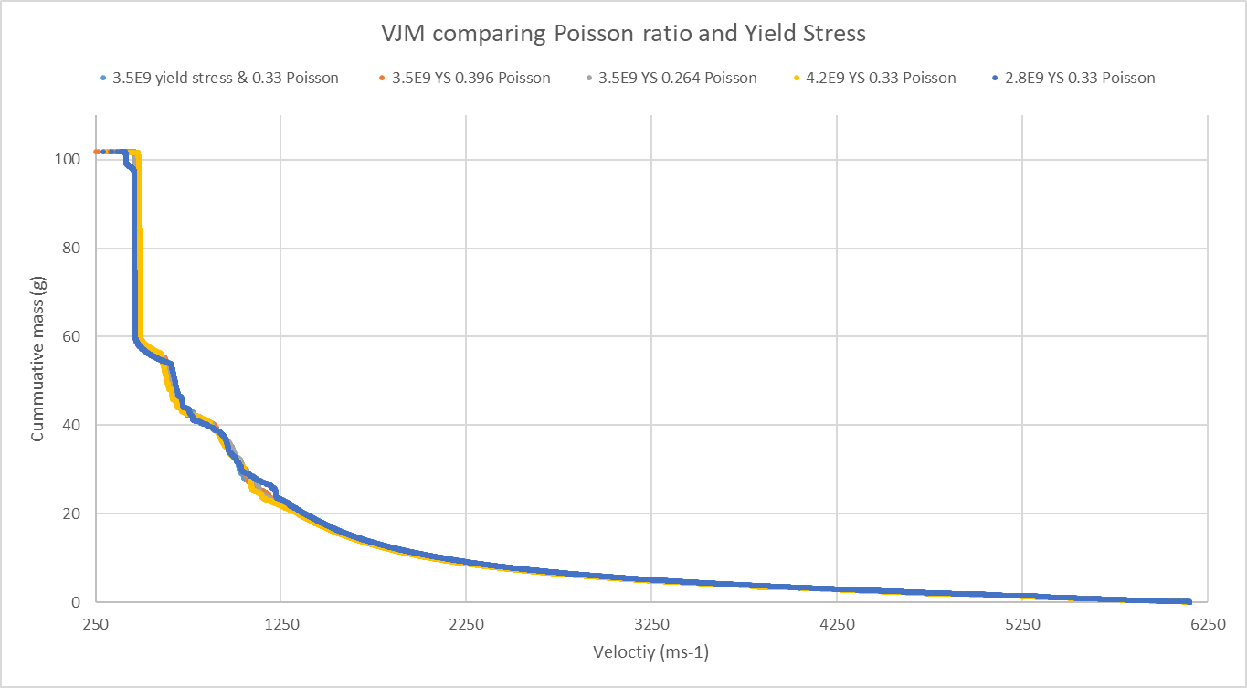
It can be observed that the highest recorded velocity is differing more than when the fracture pressure was changed. However, it is still just a 0.07% change when increasing the yield stress by +20%.
Figure 28 - VJM Plot of altering Poisson ratio and yield stress [23].

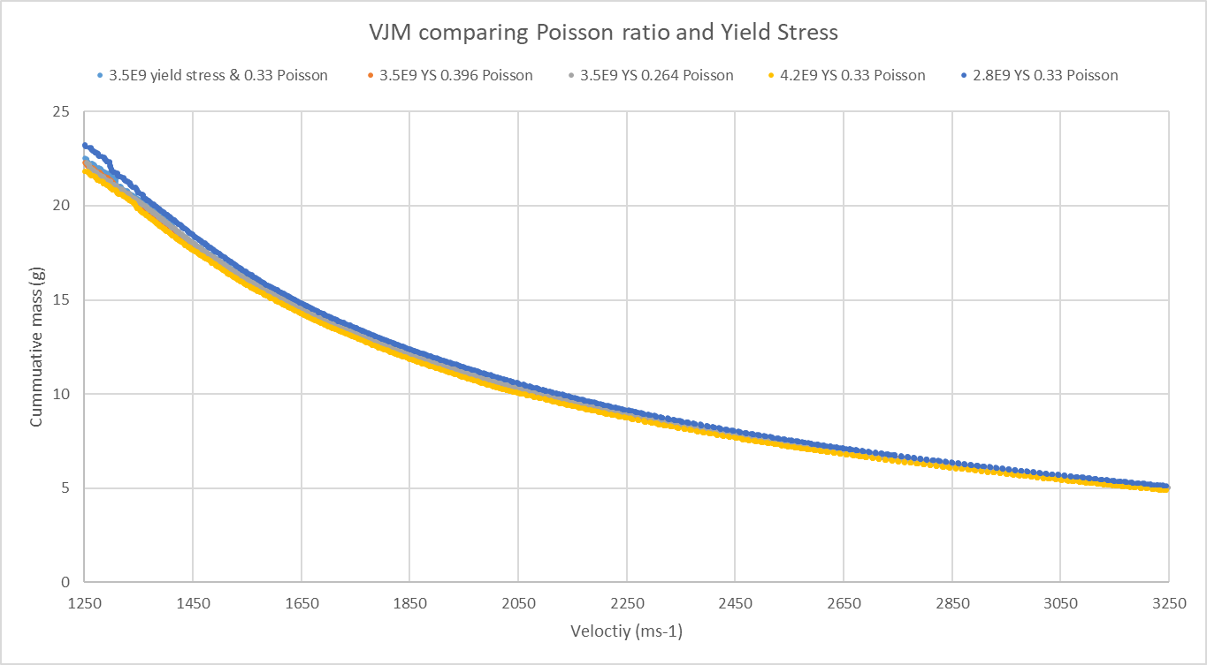
Multiple conclusions can be drawn from Figure 29, the first being that altering the yield stress of the liner has a greater effect on the jet formation than altering the poisson ratio. The mustard yellow and navy blue lines illustrate the largest drift from the normal control run coloured light blue. These two runs are ±20% from the normal yield stress. It can be said a larger yield stress reduces the spread of mass, whereas a decreased yield stress promotes further elongation of mass. This is expected as in real life the yield stress determines the point at which a material transitions from elastic to plastic behaviour. Yield stress is a test of tensile strength. However, the tensile strength of a material acts differently in a shaped charge event. Typically, it determines how much a material can endure when elongated before breaking. However, due to extreme pressures and temperatures in a jet formation the tensile strength becomes somewhat obsolete. The elongation of a material in a jet formation is considerably more than under normal conditions such as a material being loaded in a pull tester [22]. The yield stress and poisson ratio have an increased factor in determining how a material behaves in a jet formation. Within the simulation, calculations take place every 2 microseconds. When the software determines a materials limits are beyond the normal ranges, it replaces tensile strengths with yield stresses. Thus meaning the yield stress in the model has greater influence.
Figure 29 - VJM Plot of altering Poisson ratio and yield stress zoomed [23].
The second conclusion is that the yield stress has a greater impact on the spread of mass than the Pfrac. This is also expected because the yield stress directly influences how much a material stretches, whereas a fracture pressure looks at the point at which is fails i.e. snaps. Because the material is so hot in a jet formation the ions are more loosely spread apart, which in turn reduces the brittleness of the material. These loosely spread ions promote the elongation of a material and allow it to bend/stretch more easily. Within the simulation the software uses the yield stress to determine at which point the jet separates into different fragments. This is dependent on the velocity as essentially the material runs away from itself. This is most commonly at the jet tip where the material is lighter fragments and travelling faster than the rear slug. In figure 29 it can be observed an average of 2.1g of extra mass is present in the jet from the 1250ms⁻¹ to 3250ms⁻¹. Obviously mass cannot be created out of thin air, so it raises the question where does the gain in mass come from. It comes from the rear slug, the lower yield stress means more mass from the rear slug elongates off that large slug into the fragments travelling faster.

CHAPTER 5 RESULTING DISCUSSION

5.1 Conclusion
Numerous studies have been conducted on the physical setup of a shaped charges to assess their change in performance. The performance of a shaped charge is directly affected by the way in which the liner is inverted and elongated. The elongation of the liner forms the jet which is the end payload/delivery system of a shaped charge device; and is responsible for penetration and end effect. The hierarchy previously seen in figure 4 summarised the different physical factors that affect the jet formation of a shaped charge, and thus its performance.

There are not as many studies in deciphering what material factors affect the jet formation and performance of a shaped charge in a simulation within a hydrocode. This study has aimed at assessing the influence of 3 material factors and how they alter the end result when their parameters are tweaked. These 3 material factors have been the fracture pressures, yield stresses and poisson ratio. The following hierarchy of the 3 factors details which holds more influence in affecting a shaped charge jet formation.
Yield Stress

Yield Stress
Poisson Ratio

Poisson Ratio
Fracture Pressure

Fracture Pressure

Figure 30 - Hierarchy of material factors affecting shaped charge jet formation [34].

It is not possible to say by what extent these factors have an influence on the end result for other users in the community. This is because any other simulation will differentiate from the one used in this study because the following will not be the same:
Dimensions – of all components from the liner to casing.
NEQ – the amount of explosive being modelled.
Mesh – the mesh will have a significant affect in any results as it refines calculations.
Software – different software’s use different standard material properties.

Therefore, a conclusion, which can be translated across the user community, cannot be stated. It can be said that for the one simulation in this one study, the yield stress holds the most significance, followed by Poisson ratio and fracture pressure. However, the margins are so negligible that the differences are not significant. This has opened up a new strand of work within the organisation to carry out an extensive study on VJMs and parameter studies.

From a scientific background, the simulations will be capturing a fine resolution of the particle interactions. However, all the material will be perfect. As in there will not be voids in the crystalline structure. A real device will contain voids in the explosive on the microscopic level, of which is not captured in the simulated device. Likewise, defects in the coppers surface will not be captured. If a copper liner was examined using synchrotron x-ray fluorescence microscopy, it would reveal the topography of the surface [23]. Specifically it would show how it is not perfectly flat, nor is it a continuous material (it will contain air gaps differing in size). A hydrocode will not pick this up as it assumes certain equations for its particle interactions.

5.2 Recommendations
There are many limitations to this study. Especially when trying to draw conclusions from the simulated results and applying them to real life firings. This is because modelling in general has many limitations. To touch on some of the major limitations;

1) Firing a shaped charge device in real life will not produce the same results each time. Even if the devices are from the same manufacture and batch, it will not produce the same result if fired numerous times. This is because the breakdown of the explosive is somewhat random. Yes, the results will follow a trend to that of a bell curve, but the results will vary from the normal. Meaning a varied dataset. Whereas, a simulated device will produce the same result over numerous repeats. This is because it does not contain variations, voids, discrepancies in any material. So like for like, the model will never perfectly replicate the device. It is possible to integrate probabilistic modelling, however you then have to repeat your simulations. And it begs the question how many times? To get that varied range, it takes many runs. These simulations are already a computational strain, repeating them would require a lot of free space on a drive. Another question is how you obtain the ranges to include in the models variability to make it relevant.

2) A simulated shaped charge will have perfect asymmetric conditions. This means the material is revolved about a specified axis to create a perfect material. This results in a perfectly directional charge, where all the material is in one narrow plain. Furthermore, this also means all the momentum is directed perfectly into that same plain. A real life firing has a spread of mass. The below shows how the material spread of a jet penetrating a target looks from a directional point of view. The left target shows how a real life firing does not direct all its mass in one direction, there is a spread around the central penetration. The right target shows the modelled material spread with no material being lost outside the centre.

Figure 31 - An example of the potential liner spread of a real device Vs simulated device [35].

With these two limitations, it is recommended that any conclusions made from this study are not applied to that of real devices.

5.3 Further Research
It has been said the conclusions should not be applied to real life devices. However, could the conclusions apply to other simulated devices? To assess this, it is important to acknowledge other software’s are used in the wider community. These different software’s use different inputs for their material properties. For example, software’s typically use one of two equations of state. These are SESAME and Mie–Grüneisen. The Mie–Grüneisen relates the volume and pressure of a solid at a given temperature, and is most commonly used to calculate the pressure in a shock induced solid [24]. Software’s use the Mie–Grüneisen model to further calculate the volume of the crystal lattice and how its vibrational properties differ when exposed to shock. The Mie–Grüneisen model can be expressed as:
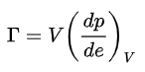

Where V is the volume, p is the pressure, e is the internal energy, and Γ is the Grüneisen parameter which represents the thermal pressure from a set of vibrating atoms. When comparing this SESAME’s equation of state, it can be observed that they use 3 different equations to express the materials temperature, pressure and energy.
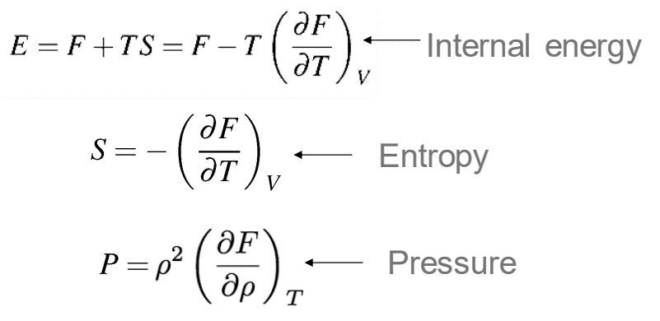
Figure 32 - SESAME's 3 equations that contribute to their EOS [18].
To properly understand how these equations differentiate from one another, they need to be added into the software. This would involve re-writing the scripts and coding them to use different datasets. The hydrocode in which this study was performed in, automatically discards data that it does not ‘agree’ with. Therefore, further changes deep into the software would have to be re-written. These changes were successfully implemented and the following results were observed when altering the equations of state.
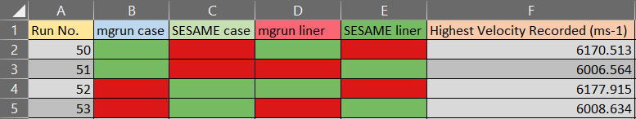
Figure 33 - Highest velocity recorded when changing out the EOS [21].
From figure 32, it can be seen that these alterations to the model have had the most significant changes so far to the highest velocity observed. Further research in assessing the VJM plots these 4 runs would produce could provide of use. The most valuable conclusions, which could be relevant to the wider community, could be drawn from the VJMs of these 4 runs. It could be stated that depending on what EOS (equation of state) is used, the jet formation of the shaped charge will change significantly. If implementing an element of penetration into a target within the simulation, these EOS’s would play a significant role in the performance.

5.4 ReflectioN

Throughout my journey on this project, I was faced with many unplanned limitations. Which at times has made me feel as though nothing went to plan. I expected a couple of unplanned setbacks; which is why when starting this study I conducted a thorough literature review in order to make scientific assumptions, which in turn would help me direct the study to obtain relevant results. I originally expected the fracture pressures, Poisson ratios and yield stresses to play a significant part in altering the jet velocity. When I ran the Python scripts to obtain the highest velocity in each simulation I was let down with the lack of change observed. I actually went back and played around with the simulation by altering my tracers to ensure they were recording the velocity of the jet and not the shock front produced by the explosive detonating. I confirmed the tracers were working as planned by changing the liner material to a plastic . This directly affected the velocity and proved the tracers were working as expected.

After observing little to no change in the highest velocity, I seeked guidance from SME’s. They suggested the idea of running a VJM plot to see if the mass at independent velocities was changing. After running these for my multiple runs, I was starting to get let down. I was assured the data was still useful within the organisation, because it did show that we do not need to be so stringent with our material parameters; and should instead focus on the mesh and physical setup of a simulated device when trying to model a real life product.

When trying to validate a model against an actual product as seen in figure 9, I was bound by the lack of trials data. I was on this trial back in 2019 of which the x-ray still came from. On this trial, I learnt a lot of fundamental trials/safety processes. However, I was early on in my career and was not thinking about the way data was being captured. If I could go back in time, I would request further instrumentation to be setup; to further capture x-ray stills at later timestamps when the jet begins to separate. This would mean I could produce a VJM from the simulated device and actual product. Thus meaning the model could be validated and proven representative. This in turn would mean any conclusions from the data could be transferred from the virtual environment into the real world scenarios

APPENDICES

1) Sensitivity literature review

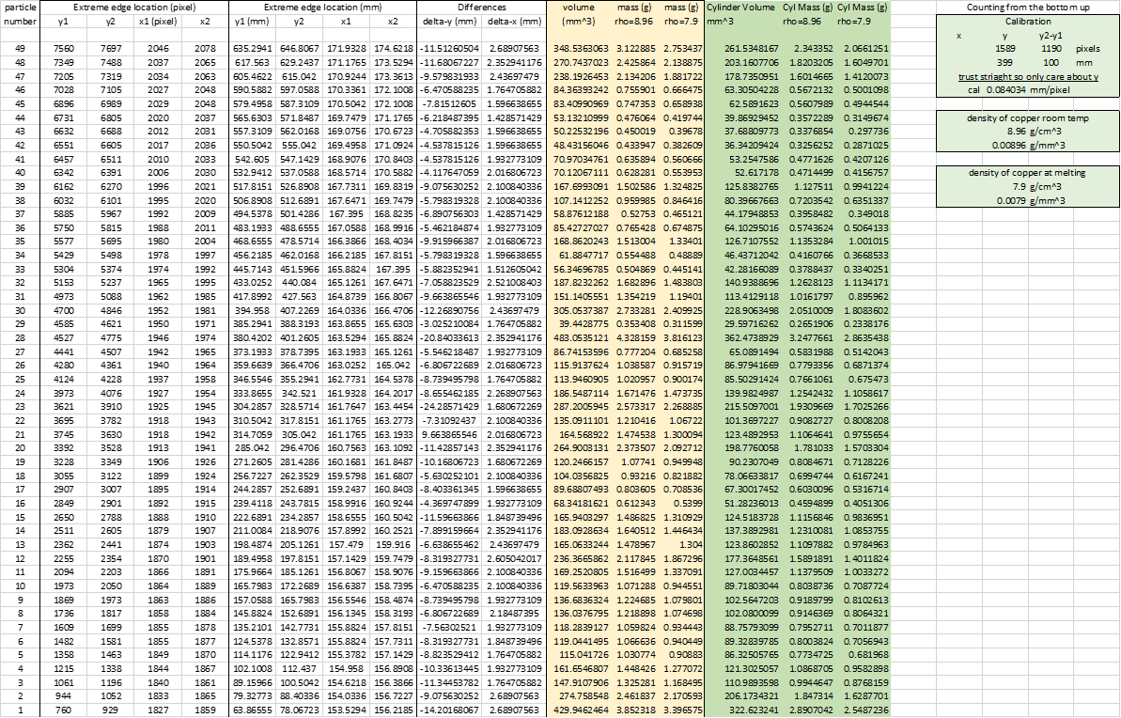
2) Excel data for VJM plotting the left image in figure 11
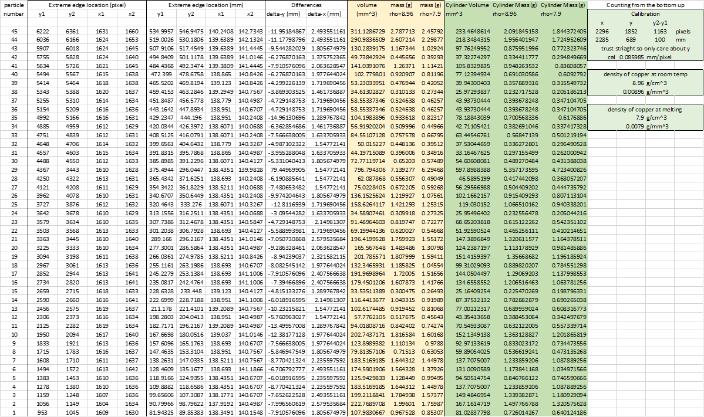
3) Excel data for VJM Plotting the right image in figure 11

4) Gantt chart of planned project progress and how it was tracked
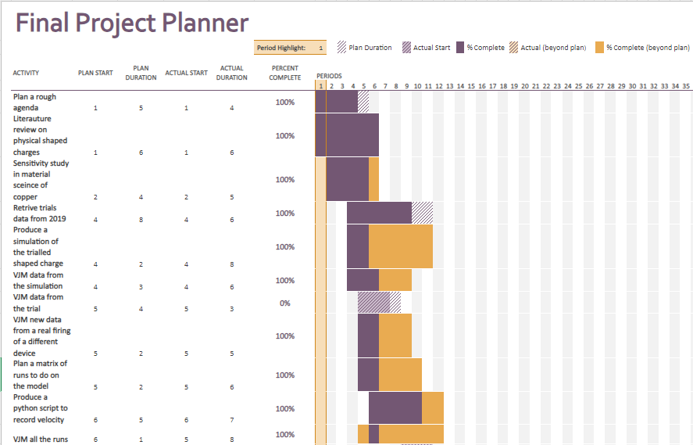

5) Original Gantt chart
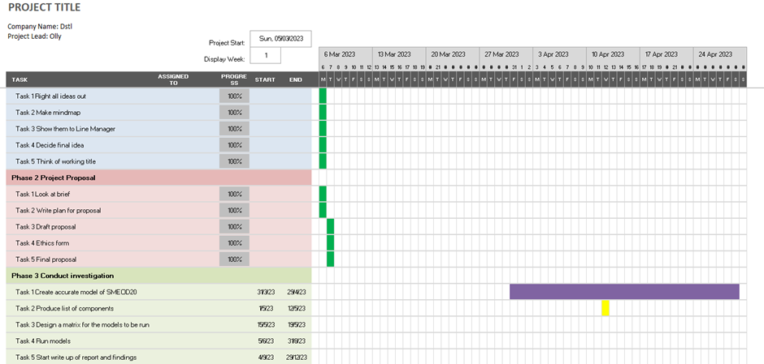

Ethics form

SECTION A: About You (Principal Researcher)
1 | Full Name: | Oliver (Olly) Overton
2 | Student Number: | 1910610
3 | Email address: | 1910610@student.uwtsd.ac.uk
4 | Programme of Study: | OME Apprenticeship Degree
5 | Director of Studies/Supervisor: | Kapilan

SECTION B: Internal and External Ethical Guidance Materials
 | Please list the core ethical guidance documents that have been referred to during the completion of this form (including any discipline-specific codes of research ethics, location-specific dodes of research ethics, and also any specific ethical guidance relating to the proposed methodology). Please tick to confirm that your research proposal adheres to these codes and guidelines. You may add rows to this table if needed.
1 | UWTSD Research Ethics & Integrity Code of Practice | ☒
2 | UWTSD Research Data Management Policy | ☒
3 | Dstl Permission To Publish | ☒

SECTION C: Details of Research Activity
1 | Indicative title: | An investigation into the effects of material properties Vs physical changes when modelling shaped charges
2 | Proposed start date: | 31/03/2023 | Proposed end date: | 22/03/2024
Introduction to the Research (maximum 300 words in each section)
Ensure that you write for a Non-Specialist Audience when outlining your response to the three points below:
- Purpose of Research Activity
- Proposed Research Question
- Aims of Research Activity
- Objectives of Research Activity
Demonstrate, briefly, how Existing Research has informed the proposed activity and explain
- What the research activity will add to the body of knowledge
- How it addresses an area of importance.
3 | Purpose of Research Activity  To find what components in a simulation contribute the greatest significance to the end result, when modelling a shaped charge.
4 | Research Question  What components affect the penetration of a shaped charge the most?
5 | Aims of Research Activity  The aim of this work is to validate a model from previous data, then run a series of models from a matrix that will be pre-defined by myself.
6 | Objectives of Research Activity  • Produce an accurate simulation of the SMEOD20 charge.  • Produce a list of all components affecting penetration of a charge.  • Run simulations and capture the velocity, jet break-up, penetration  • Produce an end report with supporting hierarchy.
 | Proposed data collection methods (maximum 600 words)
7 | Using hydrocode software and tracers in the models. Using trials data from previous trials I have partook in.

SECTION D: Scope of Research Activity
 | Will the research activity include: | YES | NO
1 | Use of a questionnaire or similar research instrument? | ☐ | ☒
2 | Use of interviews? | ☐ | ☒
3 | Use of focus groups? | ☐ | ☒
4 | Use of participant diaries? | ☐ | ☒
5 | Use of video or audio recording? | ☐ | ☒
6 | Use of computer-generated log files? | ☒ | ☐
7 | Participant observation with their knowledge? | ☐ | ☒
8 | Participant observation without their knowledge? | ☐ | ☒
9 | Access to personal or confidential information without the participants’ specific consent? | ☐ | ☒
10 | Administration of any questions, test stimuli, presentation that may be experienced as physically, mentally or emotionally harmful / offensive? | ☐ | ☒
11 | Performance of any acts which may cause embarrassment or affect self-esteem? | ☐ | ☒
12 | Investigation of participants involved in illegal activities? | ☐ | ☒
13 | Use of procedures that involve deception? | ☐ | ☒
14 | Administration of any substance, agent or placebo? | ☐ | ☒
15 | Working with live vertebrate animals? | ☐ | ☒
16 | Procedures that may have a negative impact on the environment? | ☐ | ☒
17 | Other primary data collection methods. Please indicate the type of data collection method(s) below. | ☒ | ☐
 | Flash x-ray images of shaped charges. | ☒ | ☐

If you have ticked NO to every question then the research activity is (ethically) low risk and you may skip section E and continue to section F.

If YES to any question, then no research activity should be undertaken until full ethical approval has been obtained.

SECTION E: Intended Participants
 | Who are the intended participants: | YES | NO
1 | Students or staff at the University? | ☐ | ☒
2 | Adults (over the age of 18 and competent to give consent)? | ☐ | ☒
3 | Vulnerable adults? | ☐ | ☒
4 | Children and Young People under the age of 18? (Consent from Parent, Carer or Guardian will be required) | ☐ | ☒
5 | Prisoners? | ☐ | ☒
6 | Young offenders? | ☐ | ☒
7 | Those who could be considered to have a particularly dependent relationship with the investigator or a gatekeeper? | ☐ | ☒
8 | People engaged in illegal activities? | ☐ | ☒
9 | Others. Please indicate the participants below, and specifically any group who may be unable to give consent. | ☐ | ☒
 | Details of any other participant groups:  (this box should expand as you type) | ☐ | ☒

Participant numbers and source
Provide an estimate of the expected number of participants. How will you identify participants and how will they be recruited?
10 | How many participants are expected? | N/A
11 | Who will the participants be? | N/A
12 | How will you identify the participants? | N/A

 | Information for participants: | YES | NO | N/A
13 | Will you describe the main research procedures to participants in advance, so that they are informed about what to expect? | ☐ | ☐ | ☒
14 | Will you tell participants that their participation is voluntary? | ☐ | ☐ | ☒
15 | Will you obtain written consent for participation? | ☐ | ☐ | ☒
16 | Will you explain to participants that refusal to participate in the research will not affect their treatment or education (if relevant)? | ☐ | ☐ | ☒
17 | If the research is observational, will you ask participants for their consent to being observed? | ☐ | ☐ | ☒
18 | Will you tell participants that they may withdraw from the research at any time and for any reason? | ☐ | ☐ | ☒
19 | With questionnaires, will you give participants the option of omitting questions they do not want to answer? | ☐ | ☐ | ☒
20 | Will you tell participants that their data will be treated with full confidentiality and that, if published, it will not be identifiable as theirs? | ☐ | ☐ | ☒
21 | Will you debrief participants at the end of their participation, in a way appropriate to the type of research undertaken? | ☐ | ☐ | ☒
22 | If NO to any of above questions, please give an explanation
 | (this box should expand as you type)

 | Information for participants: | YES | NO | N/A
24 | Will participants be paid? | ☐ | ☐ | ☒
25 | Is specialist electrical or other equipment to be used with participants? | ☐ | ☐ | ☒
26 | Are there any financial or other interests to the investigator or University arising from this study? | ☐ | ☐ | ☒
27 | Will the research activity involve deliberately misleading participants in any way, or the partial or full concealment of the specific study aims? | ☐ | ☐ | ☒
28 | If YES to any question, please provide full details
 | (this box should expand as you type)

SECTION F: Anticipated Risks

 | Outline any anticipated risks that may adversely affect any of the participants, the researchers and/or the University, and the steps that will be taken to address them.
1 | Risks to participants  For example: sector-specific health & safety, emotional distress, financial disclosure, physical harm, transfer of personal data, sensitive organisational information. If you have identified in section D that there are no participants then enter N/A and go skip to question 3.
 | Risk to participants:  N/A | N/A
2 | If research activity may include sensitive, embarrassing or upsetting topics (e.g. sexual activity, drug use) or issues likely to disclose information requiring further action (e.g. criminal activity), give details of the procedures to deal with these issues, including any support/advice (e.g. helpline numbers) to be offered to participants. Note that where applicable, consent procedures should make it clear that if something potentially or actually illegal is discovered in the course of a project, it may need to be disclosed to the proper authorities
 | N/A
3 | Risks to the investigator  For example: personal health & safety, physical harm, emotional distress, risk of accusation of harm/impropriety, conflict of interest
 | Risk to the investigator:  Risk of physical harm from electronics, energetic materials, slips, trips, manual handling and adverse weather conditions. | How you will mitigate the risk to the investigator:  Risk assessments will be undertaken prior to any work.  Only trained personnel, as defined by ESA NOS, will be allowed to handle energetic materials. I am competently signed off for the ESA/NOS process.
4 | University/institutional risks  For example: adverse publicity, financial loss, data protection
 | Risk to the University: | How you will mitigate the risk to the University:
5 | Environmental risks  For example: accidental spillage of pollutants, damage to local ecosystems
 |  | How you will mitigate the risk to environment

SECTION G: Feedback, Consent and Confidentiality

If you have identified in section D that there are no participants then enter skip this section and continue to section H.

1 | Feedback  What de-briefing and feedback will be provided to participants, how will this be done and when?
 | N/A
2 | Informed consent  Describe the arrangements to inform potential participants, before providing consent, of what is involved in participating. Describe the arrangements for participants to provide full consent before data collection begins. If gaining consent in this way is inappropriate, explain how consent will be obtained and recorded in accordance with prevailing data protection legislation.
 | N/A
3 | Confidentiality / Anonymity  Set out how anonymity of participants and confidentiality will be ensured in any outputs. If anonymity is not being offered, explain why this is the case.
 | N/A

SECTION H: Data Protection and Storage

 | Does the research activity involve personal data (as defined by the General Data Protection Regulation 2016 “GDPR” and the Data Protection Act 2018 “DPA”)? | YES | NO
1 | “Personal data” means any information relating to an identified or identifiable natural person (‘data subject’). An identifiable natural person is one who can be identified, directly or indirectly, in particular by reference to an identifier such as a name, an identification number, location data, an online identifier or to one or more factors specific to the physical, physiological, genetic, mental, economic, cultural or social identity of that natural person. Any video or audio recordings of participants is considered to be personal data. | ☐ | ☒
 | If YES, provide a description of the data and explain why this data needs to be collected:
2 | (this box should expand as you type)
 | Does it involve special category data (as defined by the GDPR)? | YES | NO
3 | “Special category data” means sensitive personal data consisting of information as to the data subjects’ –  (a) racial or ethnic origin,  (b) political opinions,  (c ) religious beliefs or other beliefs of a similar nature,  (d) membership of a trade union (within the meaning of the Trade Union and Labour Relations (Consolidation) Act 1992),  (e) physical or mental health or condition,  (f) sexual life,  (g) genetics,  (h) biometric data (as used for ID purposes), | ☐ | ☒
 | If YES, provide a description of the special category data and explain why this data needs to be collected:
4 | (this box should expand as you type)

 | Will data from the research activity (collected data, drafts of the thesis, or materials for publication) be stored in any of the following ways? | YES | NO
5 | Manual files (i.e. in paper form)? | ☒ | ☐
6 | University computers? | ☐ | ☒
7 | Private company computers? | ☒ | ☐
8 | Home or other personal computers? | ☐ | ☒
9 | Laptop computers/ CDs/ Portable disk-drives/ memory sticks? | ☒ | ☐
10 | “Cloud” storage or websites? | ☒ | ☐
11 | Other – specify: | ☐ | ☒
12 | For all stored data, explain the measures in place to ensure the security of the data collected, data confidentiality, including details of backup procedures, password protection, encryption, anonymisation and pseudonymisation:
All data will be captured using encrypted “standalone machines” on a closed network.

(this box should expand as you type)

 | Data Protection
 | Will the research activity involve any of the following activities: | YES | NO
13 | Electronic transfer of data in any form? | ☒ | ☐
14 | Sharing of data with others at the University outside of the immediate research team? | ☐ | ☒
15 | Sharing of data with other organisations? | ☐ | ☒
16 | Export of data outside the UK or importing of data from outside the UK? | ☐ | ☒
17 | Use of personal addresses, postcodes, faxes, emails or telephone numbers? | ☐ | ☒
18 | Publication of data that might allow identification of individuals? | ☐ | ☒
19 | If YES to any question, please provide full details, explaining how this will be conducted in accordance with the GDPR and Data Protection Act (2018) (and/or any international equivalent):
All data will be captured using encrypted “standalone machines” on a closed network.
(this box should expand as you type)
20 | List all who will have access to the data generated by the research activity:
Principal researcher: Oliver Overton
Lead Technical Reviewer
University Supervisor
21 | List who will have control of, and act as custodian(s) for, data generated by the research activity:
 | Principal researcher
22 | Give details of data storage arrangements, including security measures in place to protect the data, where data will be stored, how long for, and in what form.
All data will be captured using encrypted “standalone machines” on a closed network.
(this box should expand as you type)
22 | Confirm that you have read the UWTSD guidance on data management (see https://www.uwtsd.ac.uk/library/research-data-management/) | ☒
23 | Confirm that you are aware that you need to keep all data until after your research has completed or the end of your funding | ☒

SECTION I: Declaration
The information which I have provided is correct and complete to the best of my knowledge. I have attempted to identify any risks and issues related to the research activity and acknowledge my obligations and the rights of the participants.

In submitting this application I hereby confirm that I undertake to ensure that the above named research activity will meet the University’s Research Ethics and Integrity Code of Practice which is published on the website: https://www.uwtsd.ac.uk/research/research-ethics/
 | 1 | Signature of applicant: |  | Date:  05/03/2023
2 |  | Director of Studies/Supervisor: |  |  | Date:
3 |  | Signature: |  |  | Date:

FOR INTERNAL USE ONLY:
 | Ethical approval given
1 | Signature of assessor: |  | Date:
2 | Name:
3 | Role:

