My name is Joshua Meakins, and I use digital tools in many different areas of my day-to-day life. I use a range of digital tools in both formal and informal situations to help me manage tasks, stay organised, and make everyday activities easier.
I have developed a good knowledge of computer-related skills and applications over the years, particularly through studying Game Development and IT in college. I also grew up using a laptop regularly to play video games, which helped me develop my general understanding and confidence with computers and technology.
As I have grown older, I have come to realise that digital skills are not limited to one specific area. Instead, they involve a wide range of skills and technologies that can benefit me both personally and academically. This has helped me understand that digital skills are not simply about knowing how to use different applications, but also about understanding how to approach and use these tools effectively to make tasks easier, more efficient, and better organised.
Screenshot/Photo 1
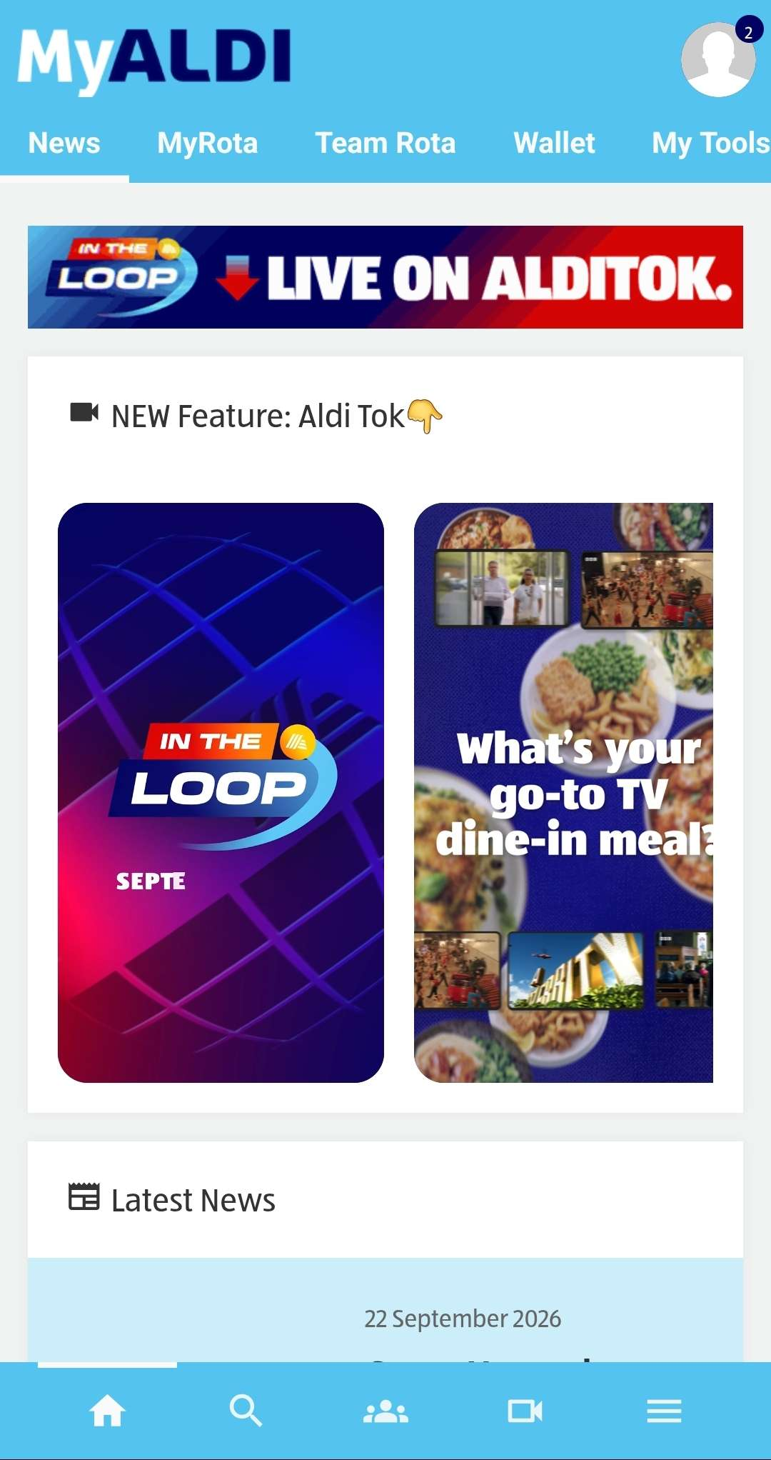
This application is called MyAldi App, which I use daily for my full-time job at Aldi. This allows staff members to access their 4 weekly rotas, so you are aware what upcoming shifts you are required to complete. Allows you too view the Team Rota so you can see who you are exactly working with on that day, from Store Assistants to Deputy Managers. The app also can let staff members access their Gift Cards, update any personal information needed for the business from your full legal name, home address, emergency contact details, and phone number. Also allows everyone to view their payslips and their vital information based on the hours worked for that month.
It also has an external application built-in within the main app that allows all staff members to view and complete/finish any e-learning they have outstanding, from reading new store policy changes to training videos or just overall updates the company as a whole are implementing so every store, every colleague, every person is always up-to-date and organized.

Screenshot/Photo 2
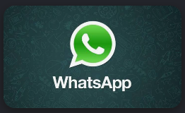
I use WhatsApp on a day-to-day basis as an informal and formal way of communicating with my friends and family. It allows me to quickly send messages, share photos and videos, make voice and video calls, and communicate through group chats. I also use WhatsApp formally for my job role as we have a group chat for all staff members, so we have constant communication between one another when trying to arrange shift changes, time off, or non-work-related emergencies. Using WhatsApp has helped me develop my digital communication skills by allowing me to understand and use different features within the application effectively. It also helps me stay organised when communicating with multiple people and has improved my confidence when using digital communication tools.

Screenshot/Photo 3
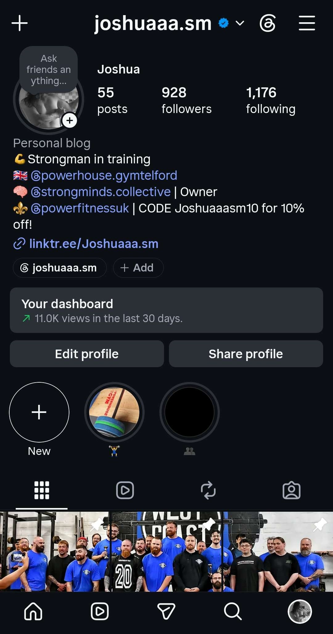
I use Instagram regularly as a public profile to showcase my progress throughout my weight-loss journey and strength training. It allows users from around the world to view my posts and reels, interact with my content by commenting and liking, and share my posts with others. I post content daily, which helps me keep my profile organised and up to date. My Instagram bio also contains additional links for followers to access the products and platforms I promote. For example, I have a personalised discount code for a clothing brand, as well as a Linkr.ee link that allows followers to connect with my other social media platforms, such as TikTok. Overall, Instagram allows me to manage, organise and promote my content while developing my digital communication and social media skills.

Screenshot/Photo 4
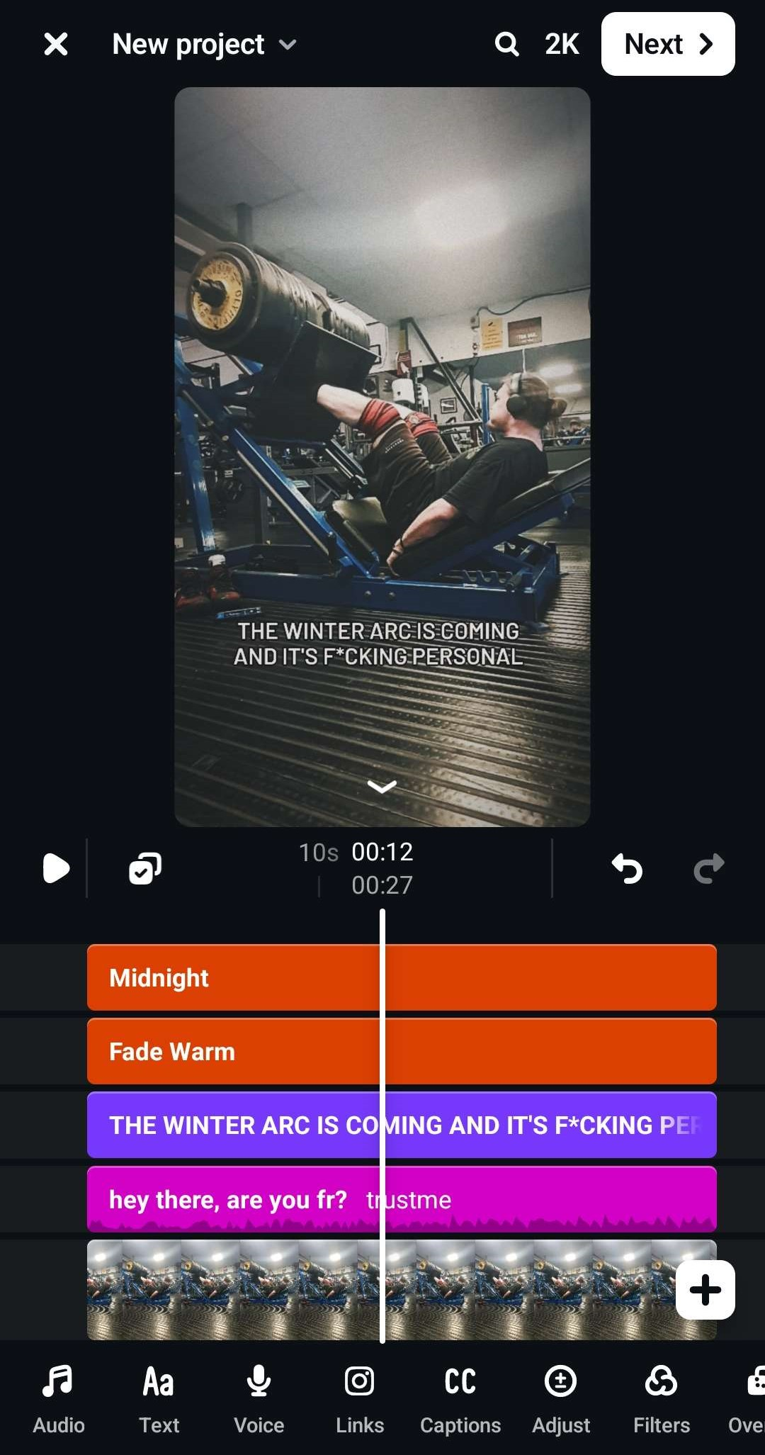
The applications I typically use to create and post my content, as mentioned previously, are Instagram’s built-in editing tools and CapCut. Both applications help me edit and improve recordings from previous training sessions. I use these tools to trim and merge videos, adjust filters, add creative text, and include audio to make my reels and videos more engaging. These editing features allow me to present my content in a clear and appealing way while developing my digital editing skills.

Screenshot/Photo 5
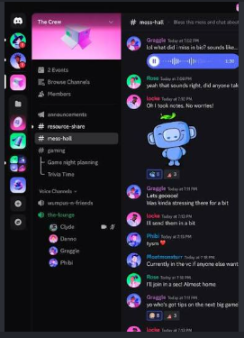
I use Discord as a communication platform to interact with other people who share similar interests in fitness, gaming and online communities. I use Discord servers to communicate through text messages, voice calls and video calls, as well as sharing images, videos and other files. I can also organise conversations into different channels, making it easier to find specific information. Using Discord has helped me develop my digital communication, collaboration and online community management skills. I also have my own personalized discord server so all my friends can join and play games together and chat occasionally.

My Short Reflection
- Write 5–8 simple sentences about your digital life.
- You can use the sentence starters below if helpful.
I use digital tools to create, edit and share content online.
I often use Instagram, CapCut and Discord in my everyday life.
I feel confident when I am editing videos and creating content for social media.
I use Instagram to share my fitness journey and communicate with my followers.
I sometimes feel nervous about learning new digital tools or features that I have not used before.
I want to improve my digital editing, communication and social media skills.
Digital skills are important to me because they help me communicate with others and create content more effectively.

Submission Checklist
Before you submit, please check:
​​​ ☒ I added 4–6 screenshots
☒ I wrote short sentences for each screenshot
☒ I wrote my short reflection
☒ My work is my own
☒ My file opens correctly
​​☒ My file opens correctly

