Question 1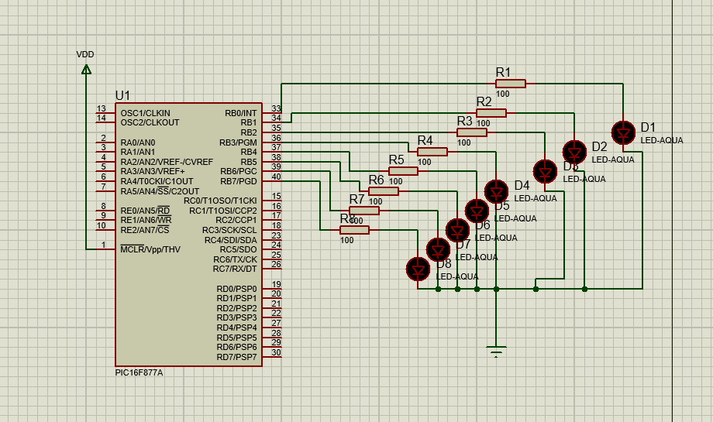
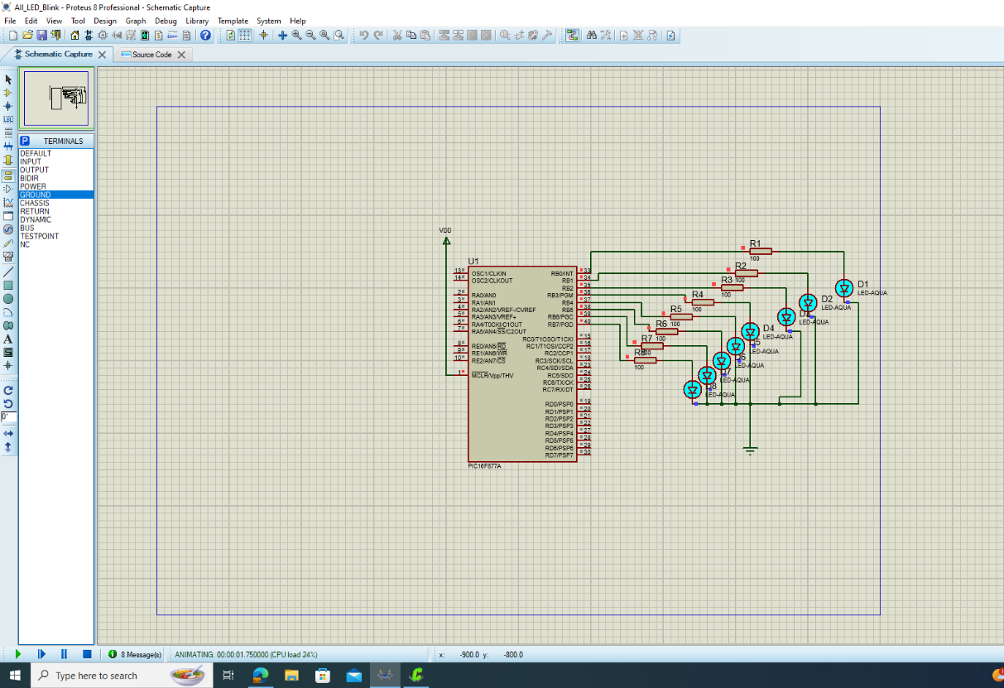
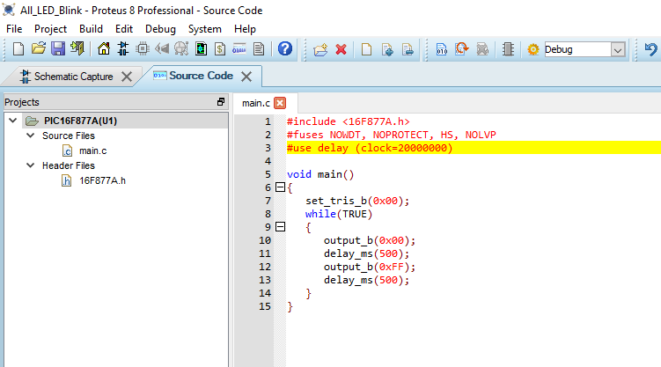
Question 2
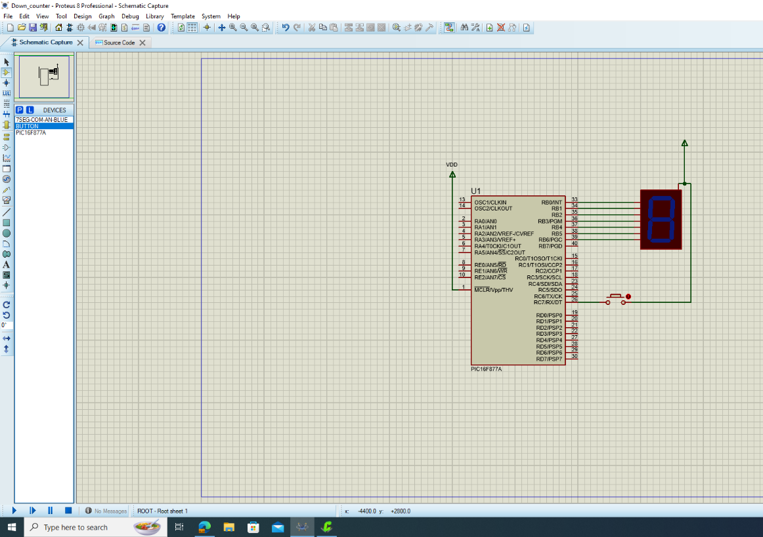
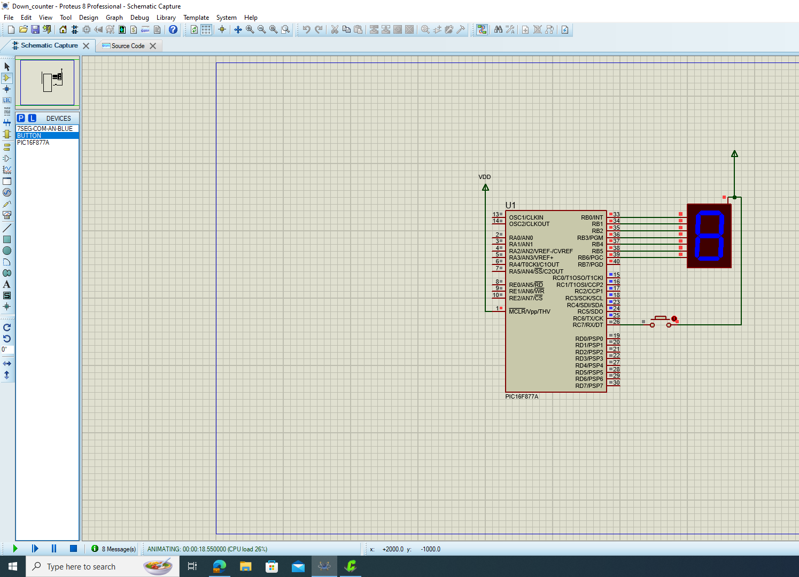
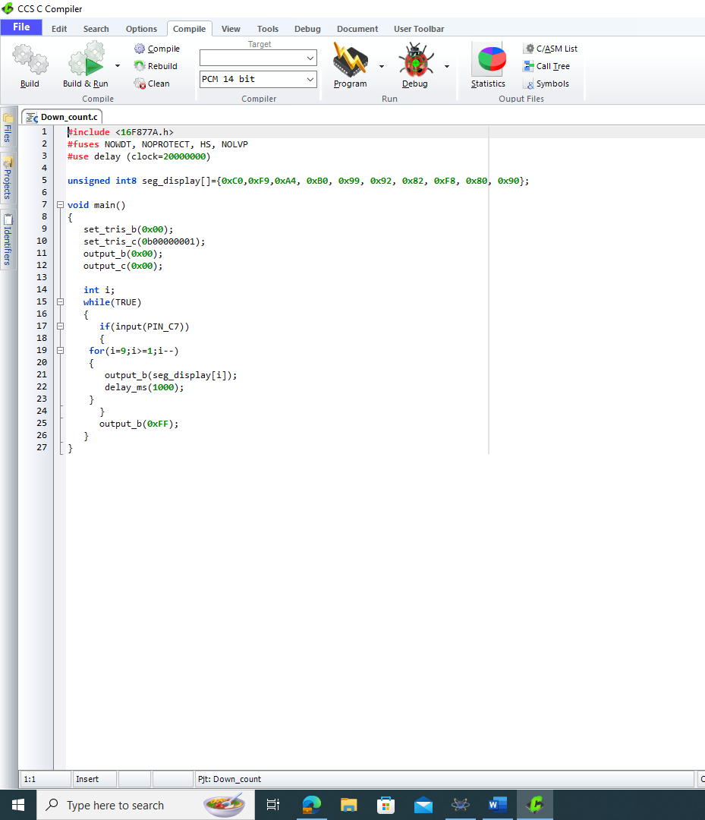

Question 3
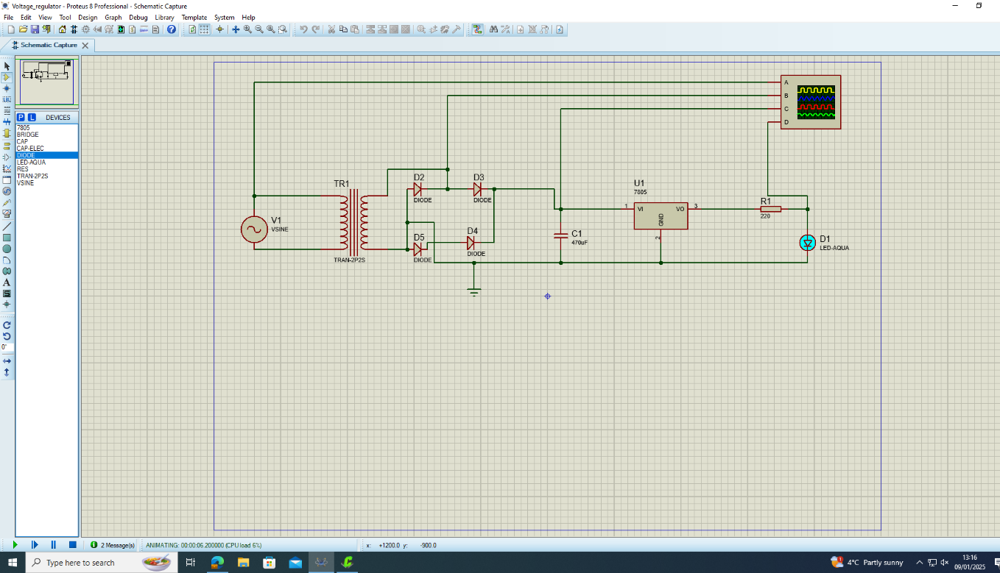
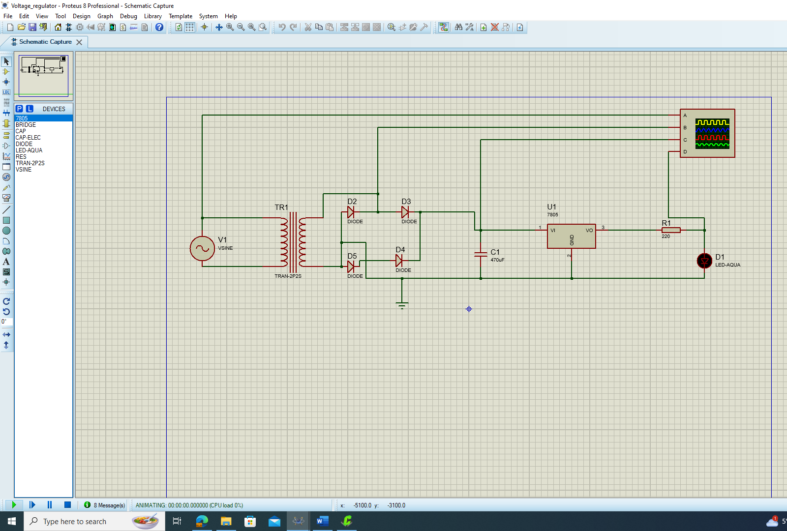

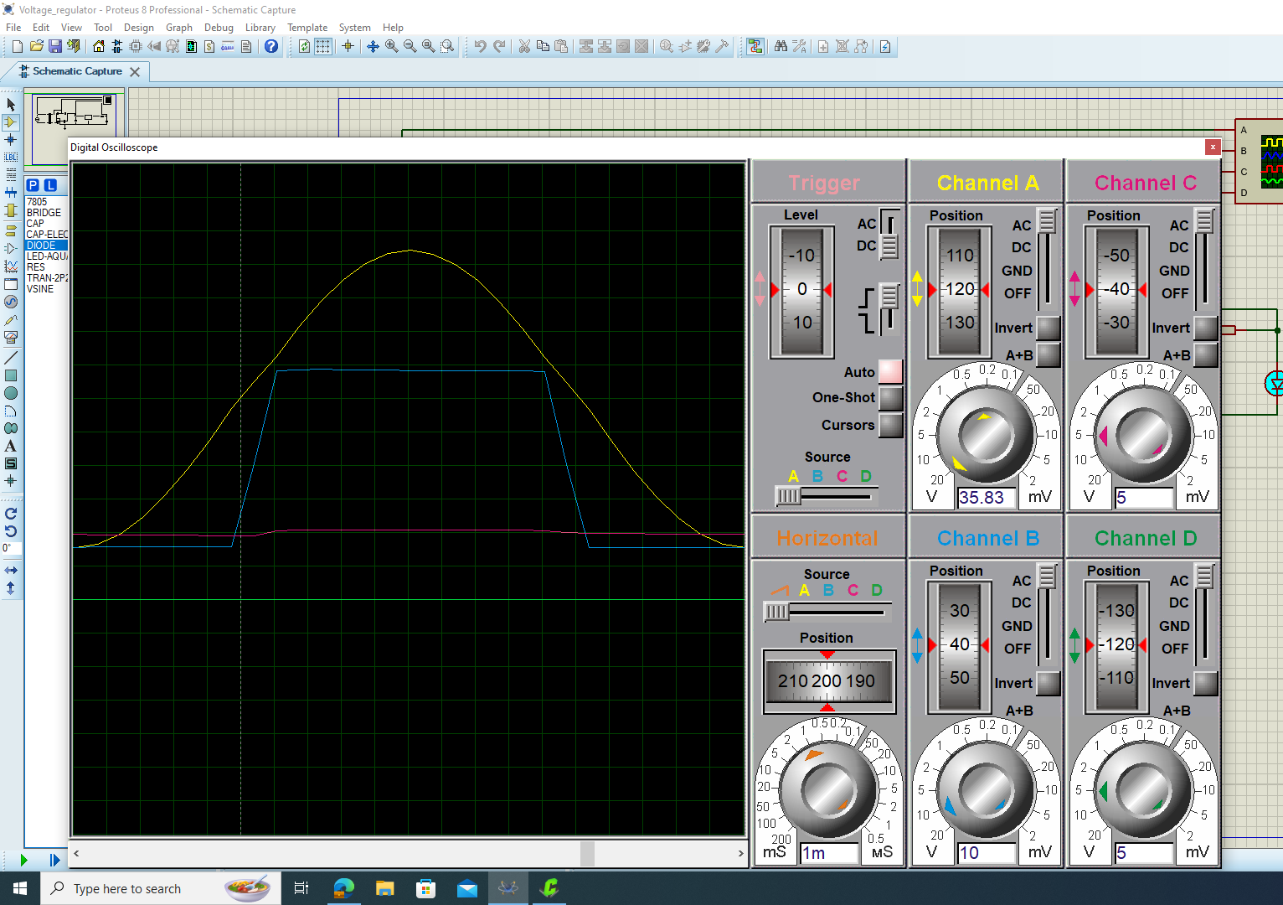

Question 4


