Angur Ali (1805335)
1805335@student.uwtsd.ac.uk
UWTSD
Published on 29th March 2019
Report on the current situation of Tesco
Problem Solving and Decision Making (BMSK4004)

Executive Summary

This report is based on the current situation of Tesco with problems having on its stakeholders. By finding out the nature, scope and impact of those are being affected and analysing using models like SWOT, PESTLE to explain the cause of the problem at Tesco.
The report will also contain details of who the stakeholders are and the impact that is causing to its stakeholders. This report will provide who Stakeholders are using a diagram and also using Mendelow’s matrix to show what level of power and interest stakeholders have on Tesco.

At the end of the report, it contains the conclusion explaining what has been covered and, in the recommendation, it contains suggestions to solve the problems.

Table of Contents
Executive Summary 1
1.0 Introduction 3
2.1 Tesco Problems 4
2.1.1 Accounting Scandal 4
2.1.2 Tesco Direct 4
2.1.3 ClubCard Scandal 4
2.1.4 Horsemeat Scandal 4
2.1.5 Food Waste Scandal 4
2.2 Tesco Nature, Scope and Impact 5
2.3 Analysis of Tesco 6
2.3.1 SWOT Analysis 6
2.3.2 PESTLE 6
2.3.3 Stakeholder Analysis 8
2.3.4 Mendelow’s Matrix 9
3.0 Conclusion 10
4.0 Recommendations 11
5.0 Reference Lists 12

Introduction

Jack Cohen, founder of Tesco has idea believed putting affordable food in reach of everyone. He started selling surplus groceries from a stall in 1919, Jack made profit of £1 on sales from £4. The first store opened in 1929 and now there are 6,966 stores in nine countries across Europe and Asia. (MarketLine). Selling all kind of products from groceries, beverages, fresh food, bakery, clothing, fuel, baby products, flowers and plants, toys, home furnishings, technology and gaming, household appliances, health and beauty products, sports and leisure, consumer electronics and electrical goods. Tesco has become one of the leading supermarkets in the UK. The reason for this is Tesco selling products at really good value for money, which built its reputation.
Tesco core purpose is to “serve shoppers a little better every day” by providing better value, so their customers can enjoy better quality way of living. (tescoplc.com). Tesco has all kind of stores to provide to local communities with jobs ranging from Tesco Extra, Tesco Metro, Tesco Express, one-stop shop and now expanding newly Jacks store, which will compete with discounter stores. Tesco also cover online shopping, mobile network, insurance and banking services.

2.1 Tesco Problems

2.1.1 Accounting Scandal
The executives have wrongly stated their profits figure was incorrect, this error cause huge problems. Soon as it been announced the share prices drop dramatically causing loss of millions of pounds and angered the shareholders.
Accounting scandal sent shockwaves by overstating profits in 2014 by £250m. This caused £2billions of share prices to wipe out in one day. Tesco did act by suspending eight directors. This scandal did affect their financial loss following year of £6.4billions the largest in the history. (UK news, 2018).

2.1.2 Tesco Direct
Tesco direct was their non-food website selling from clothes, furniture’s, electrical goods to toys to attempt to take on likes of Amazon and Argos, which launched in 2006. Tesco had two online websites one for groceries and the other for non-foods, which became a problem due to high cost of fulfilling orders. Tesco eventually decided to close one of the websites due to not making much profits and high cost of maintenance and there were job losses. (Z, Wood).

2.1.3 ClubCard Scandal
Tesco Clubcard had been very successful kind of business due to getting points for every pound you spent in shop then converted to vouchers that can be used to have money off from the store or online. With everything is stored in a system, fraudsters found a loophole to scam customers from their vouchers. Stealing their vouchers from their accounts and spending it without them realising until later. According to Tesco, fraudsters stole people’s online IDs and passwords through phishing emails to use on their Clubcard website. (S.Hawkes). Most people tend to use same passwords for online which made easier for fraud.

2.1.4 Horsemeat Scandal
The horsemeat scandal became “the biggest food fraud of the 21st century”. (F, Lawrence). This led to getting rid of millions of burgers and beef products across Europe. This had affected almost all food chain that had the same suppliers. The action Tesco has taken in the shadow of horsemeat scandal was change of suppliers and promise to get all fresh chicken within the UK they also hired an agriculture director. (C,Mercer).

2.1.5 Food Waste Scandal
The products that are being thrown away due to expiry date was being sent to landfill waste. Since the recession people been struggling to make ends meet and charities group appeal a lot people are looking to food banks. They have asked to provide help to all supermarket chains to keep up with demands not to send to waste. This has become successful due to cooperation by supermarkets. Tesco unveiled new service to minimize food supply chain waste, by launching online food waste hotline. Tesco asked suppliers and growers to pinpoint food waste hotspots and work how to tackle them. (FoodLogistics.com, 2017)

2.2 Tesco Nature, Scope and Impact
The nature of the problem Tesco is facing is competitors are cutting into their share of profits made from supermarket. Aldi and Lidl reporting rises year on year of their financial figures, also there is announcement of plan for rival merger with Sainsbury and Asda, will cause big problems for Tesco.
Tesco announced they will make adjustment to maintain minimal loss by cutting and reshuffling positions and jobs. They have decided to close fresh counters due to less people using it. Customer tend to be in a rush which leading those buying ready pack items than fresh on the counter.

The scope of the problems will affect are shown below with the impact that will have:
Affected by the problems | Impact
Shareholders | Share prices will plummet of the announced of changes to be made.
Management | More work for directors due to cutting middle management team
Suppliers | Getting rid of counters instore will make suppliers look elsewhere
Employees | job cuts and redeploy will affect employees going to working in different fields
Customers | Less interactive with staff will drive them away
Community | Loss of jobs will cause unemployment to rise

2.3 Analysis of Tesco

2.3.1 SWOT Analysis
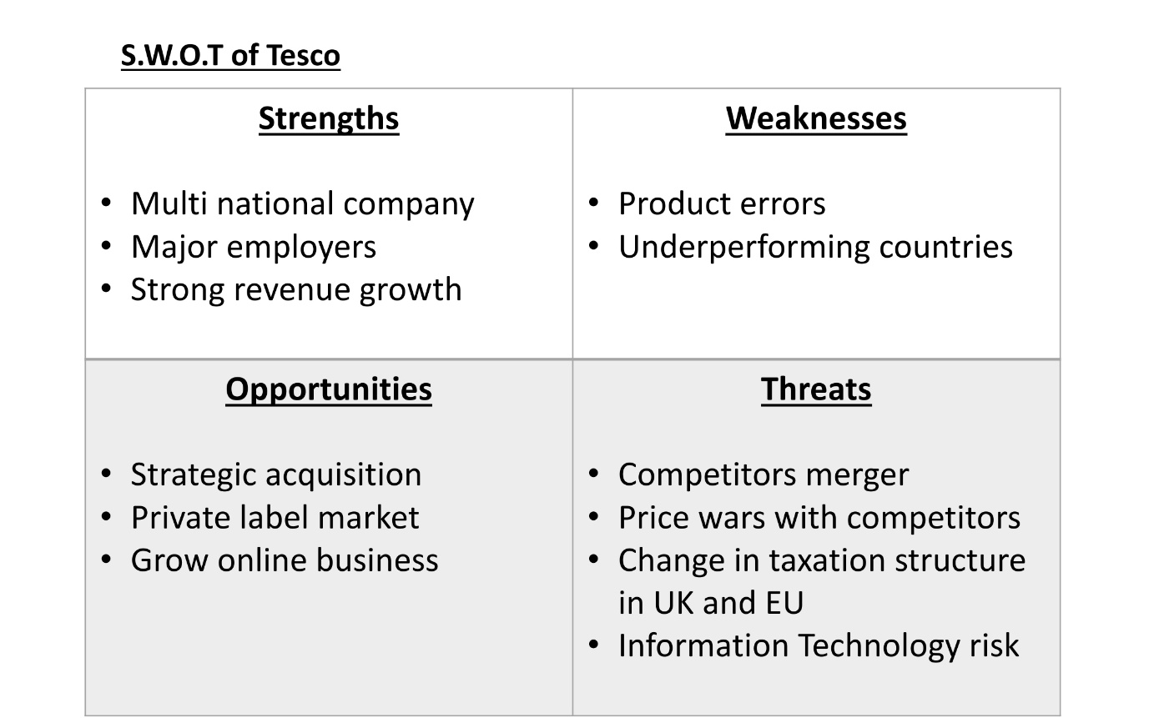

By completing the SWOT analysis, it is identified that the strengths of the Tesco are that they multinational company and major employer all over major cities in the UK. They also have strong revenue growth in UK than anywhere else which makes it more attractive. The weaknesses are that product packaging errors can occurring with missing or not labelling right ingredients. This can cost huge loss for all recalled products. Other weakness is underperforming stores around the world rely on UK. The opportunities they have is acquiring Bookers cash and carry can pass on better offers to customers, promote their own brands and grow online business, by providing easy to use app on mobile for quick slot for delivery. The threats for Tesco will be if Sainsbury’s and Asda merge probably causing price wars, change in taxation structure in UK and EU due to Brexit. Also Tesco lack in I.T skills for moving forward after pervious problems they had with Clubcard.

2.3.2 PESTLE
Using the PESTLE analysis will discover the problems having at the Tesco. PESTLE analysis is a useful tool to identify the external factor that affects the organisations (Newton and Bristoll, 2013). Pettinger (2012) stated that it helps the organisation to understand the environment and the strategic situation. PESTLE analysis lets the organisation understand the political, economic, social, technological, legal and environmental situation. The Researcher will cover three of the PESTLE below:

Political
This company is operating in 12 countries including Asia and Europe. It is exposed to many political factors that can affect the operations of Tesco. These factors include Tax rates, current and impending legislation, political instability, unemployment rate, economic condition of the countries where it is operating.
For example, import duty on goods can affect Tesco because it imports some inventory from outside UK like China and East Asia.
EU referendum is greatly creating a risk factor for investors and the British economy is passing through hard times. The tax on large supermarkets known as “Tesco Tax” was proposed by the local council but UK government refused this initiative mainly to avoid price hike. Similar initiatives in the future can affect Tesco negatively.

Economical
Labour cost is an important economic factor that can affect UK supermarkets. For example, its annual wage bill is amounting GBP 4.5 billion. In 2018 UK Minimum Wage Rate is increased by 4.4% for 25 years old and onward. This upward shift has cost Tesco millions of pounds in UK.
There are many other factors that affect Tesco i.e. cost, prices and profits. The company should focus on the increasing borrowing cost in UK. It can increase the costs and prices and decrease its profits. It can affect the brand reputation and cost leadership strategy.
Merger of Sainsbury’s and Asda if approved will create the biggest supermarket group in the UK, even more dominant than Tesco. The impact on Tesco may be even more squeeze on margins and loss of market share in an all-out price.

Social
The changes to lifestyle and shopping trend has changed by consumers over time. People have tough schedules and want same day and fast delivery with a flexible goods return policy. They prefer one-stop shopping. Tesco is relying on UK customers and must understand and provide the services to meet these issues.
The demand for goods and services is related to the consumer beliefs and attitudes which is another focused issue.
Obesity is another issue in the in society and customers are more concern about their health. Tesco must consider changing behaviour and demand for organic and vegan food by bringing in more choice.
According to PWC report suggests that 65% UK shoppers are loyal shoppers. Tesco should avail this opportunity by developing close ties and one to one connection with customers.

2.3.3 Stakeholder Analysis

Stakeholders are the most important and significant part of any company. It is the support of stakeholders due to which the company operates. All the strategies will have a direct impact on the stakeholders and hence it is very important to keep them in consideration while formulating the new strategies.
The list of Tesco stakeholders are:
Shareholders: the profits and loss to business have big impact to these stakeholders.
Management: the business are run by them in decision making on creating, cutting jobs or expanding if situation need to do.
Employees: need to be happy supporting the business to run in good working environment and providing their service.
Suppliers: key to supplying goods to businesses to make money and loyalty of providing.
Competitors: will provide motivation to grow or improve the style of running the business by having challengers around.
Community: play vital part for growth and support to the business.
Bank: needed if business need any financial lending or services.
Customers: These are the key stakeholders. The company's profit and loss dependson them.
Government: The Government make various policies and rules which needs to be followed by the companies. Also, if the company will perform well, they would pay the taxes on time.

2.3.4 Mendelow’s Matrix

Now, it is required to work out how important the stakeholders are to the Tesco. Mendelow's Matrix is an implement that might be utilized by a business to consider the state of mind of their stakeholders toward the beginning of a task or when they are setting out vital goals. Mendelow’s (1991) matrix is used in most organisations to identify their stakeholders.
The diagram below is the Mendelow’s matrix which will be used to identify the power and interest of the stakeholders.
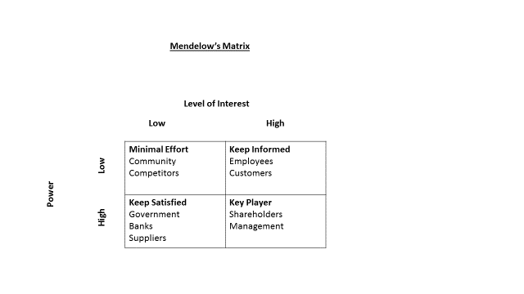
By completing the Mendelow’s matrix it is identified that shareholders and management are the main key players without them the Tesco will not run properly, they are the most important stakeholders. Customers have high interest to see what Tesco can give discount on items comparing to other competitors. Employees have high interest from management for expectations of Tesco doing well leading to promotion or changes to jobs with higher pay. Government expect better success for Tesco will lead to higher taxes coming in, also any changes to law by government can lead to problems having to change things around to stick to new legislation. Banks and suppliers have high power they can expect Tesco coming to them for borrowing/ supplying of services which leads to extra money coming in with payment plan. Competitors and the community has low power and low interest.

3.0 Conclusion
1. Sainsbury and Asda merger can have huge effect on Tesco shareholders. They will become the leading supermarket and it will create price wars pushing prices down on goods to get as many customers buying from them.
2. Discounter retailers like Aldi and Lidl are growing year on year with no slow down, this is affecting Tesco profits which is declining. Customers are looking to spend what they really need and not bulk buying, so they will be shopping around for quality with good reviews and less on price tags.

4.0 Recommendations
1. Tesco will need to be competitive when it will come to battle with competitors over price war. To keep on to loyal customers will need to at least match the competitors, they will need to reward customers with ClubCard that will give huge discount initiative.
2. To compete with discounter retailers like Aldi and Lidl, they will to improve quality of their own brand products by promoting sample packs to attract customers and have better advertising promotions on media.

5.0 Reference Lists
Anon, 2019. Tesco to introduce major cost-cutting measures in UK. Checkout, 45(2), p.22.

Vizard, S. (2013) ‘Charities slam Tesco over food waste “scandal”’, Marketing Week (Online Edition), p. 3. Available at: https://ezproxy.uwtsd.ac.uk/login?url=https://search.ebscohost.com/login.aspx?direct=true&db=bth&AN=91701407&site=ehost-live (Accessed: 19 March 2019).
https://www.tescoplc.com/about-us/history/(Accessed: 19 March 2019).
Food Logistics. Apr2017, Issue 185, p8-8. 1/6p.

Wood, Z (2018), Tesco shuts its non-food website, Tesco Direct, Guardian News & media Limited, London.

Felicity Lawrence (journalist)Tue 22 Oct 2013 06.56 BST First published on Tue 22 Oct 2013 06.56 BST. [online] https://www.theguardian.com/uk-news/2013/oct/22/horsemeat-scandal-guardian-investigation-public-secrecy. (Accessed: 24 March 2019).

https://www.telegraph.co.uk/foodanddrink/foodanddrinknews/9874854/Tesco-pledges-to-open-up-supply-chain-after-horse-meat-scandal.html(Accessed: 24 March 2019).

https://www.mirror.co.uk/news/uk-news/horse-meat-burger-scandal-tesco-1565151(Accessed: 24 March 2019).

https://www.theguardian.com/business/2019/jan/28/tesco-jobs-fresh-food-counters-supermarket--staff (Accessed: 24 March 2019).

https://www.shropshirestar.com/news/uk-news/2018/12/06/how-did-the-tesco-accounting-scandal-unfold/ (Accessed: 24 March 2019).

https://www.theguardian.com/business/2019/mar/05/long-read-aldi-discount-supermarket-changed-britain-shopping (Accessed: 24 March 2019).

https://www.theguardian.com/business/2014/dec/09/tesco-timeline-the-retail-giants-rise-and-fall (Accessed: 24 March 2019).

Rupert Jones (2013) https://www.theguardian.com/money/2013/nov/30/tesco-clubcard-fraud-stolen-vouchers (Accessed: 24 March 2019).

Newton, P. and Bristoll, H. (2013). PESTLE Analysis. [eBook] Available at: http://www.free-management-ebooks.com/dldebk-pdf/fme-pestle-analysis.pdf [Accessed: 26nd March, 2019].
Newton, P. and Bristoll, H. (2013). SWOT Analysis. [eBook] Available at: http://www.free-management-ebooks.com/dldebk-pdf/fme-swot-analysis.pdf [Accessed: 26th March, 2019].

Pettinger, R. (2012), Management a concise introduction, Hampshire: Palgrave Macmillan.

