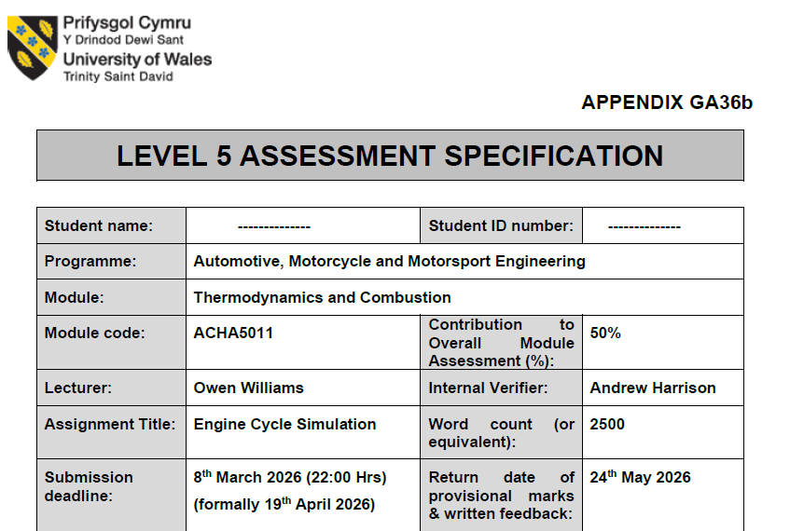

2404403
Will Gabriel
Contents
Introduction 4
In-Cylinder Pressure and Piston Position 5
Compression and Ignition Advance 5
Peak Pressure and Mechanical Leverage 5
Expansion and Exhaust Blowdown 5
Polytropic Index and Process Analysis 6
The Compression Phase (n_c) 6
Combustion Timing: Pinpointing SOC and EOC 8
Start of Combustion (SOC) 8
End of Combustion (EOC) 8
Thermal Cycle and Temperature 9
The 2500 K Peak 9
Thermal Lag and EVO Implications 10
Work Done and Energy Transfer (Physical Output) 11
Calculating the Indicated Work 11
The Reality of Rounded Corners 12
Conclusion of Task 2 13
Task 3: Model Refinement and Validation 14
Incorporating Real-World Polytropic Indices 14
Modelling Finite Heat Release 14
Validation and Comparison 15
Reflections on Modelling Limitations 16
References 17
Declaration of Generative AI Usage 18
MatLab Script Used 19
Task 2 19
Task 3 22
MATLAB Graph Outputs 24

Introduction
This report reconciles Ford Sigma 1.6L empirical data with theoretical air-standard models. Task 1 establishes a MATLAB baseline using an idealized, isentropic Otto cycle. Task 2 characterizes experimental deviations, specifically non-adiabatic heat transfer and finite combustion duration. Finally, Task 3 synthesizes these findings to produce a high-fidelity model validated against real-world thermal and mechanical performance.

In-Cylinder Pressure and Piston Position
By analysing the raw pressure data from the Ford Sigma 1.6L engine, I can visualize the thermodynamic cycle in a high-res reconstruction. Figure 1 maps this in-cylinder pressure against the crank angle, allowing for a sequential comparison between my practical results and the idealized models developed in Task 1.

Compression and Ignition Advance
Upon Intake Valve Closing (IVC), At IVC, cylinder pressure is ~1 bar. Unlike Task 1’s adiabatic assumption, experimental data reveals significant heat rejection to the cylinder walls and cooling jacket. This non-adiabatic behaviour prevents compression from reaching theoretical peak pressures. Near TDC, spark ignition occurs. Combustion is a finite process; flame propagation requires time to cross the cylinder bore (Heywood, 2018). To avoid chasing the piston during expansion, ignition advance (10°–15° BTDC) compensates for this burn delay, ensuring effective pressure development.

Peak Pressure and Mechanical Leverage
Peak pressure (P_max) of 62 bar occurs at 15° ATDC. At 0° TDC, dead centre alignment yields zero lever arm and zero torque, regardless of pressure magnitude. Phasing the peak to 15° ATDC leverages a favourable crank-throw angle to maximize work transfer. This timing balances rapid combustion pressure with increasing cylinder volume, a compromise essential for achieving Maximum Brake Torque (MBT) (Heywood, 2018).

Expansion and Exhaust Blowdown
During the power stroke, the high-temperature, high-pressure gases expand and perform work on the piston, resulting in a rapid pressure decay. However, the experimental data reveals that the exhaust valve initiates opening significantly before the piston reaches Bottom Dead Centre (BDC) at 180°. This phenomenon, known as Exhaust Blowdown, utilizes the residual cylinder pressure to initiate the mass discharge of exhaust gases before the piston begins its upward stroke.

While this early opening technically sacrifices a marginal amount of expansion work, it is a critical engineering trade-off. By allowing the cylinder pressure to "blow down" to near-atmospheric levels before the exhaust stroke begins, the engine significantly reduces the parasitic pumping work required for the piston to scavenge the remaining gases. As (Heywood, 2018) notes, optimizing the EVO timing ensures that the reduction in pumping losses outweighs the loss in expansion work, thereby improving the overall thermal efficiency of the Ford Sigma engine.

Polytropic Index and Process Analysis
Thermodynamic behaviour was characterized using the polytropic relation (PV^n = C). Slopes extracted from log-log coordinates (lnP vs lnV) yielded real-world indices, providing a mathematical "footprint" of internal losses. Unlike the ideal isentropic assumption (\gamma = 1.4), the Ford Sigma involves constant heat exchange with the cooling jacket. Moran and Shapiro argue this polytropic framework is indispensable for accurately modelling non-adiabatic transitions where heat transfer occurs, reflecting real energy transitions far better than an adiabatic model. (Moran & Shapiro, 2014)

The Compression Phase (n_c)
I isolated the compression stroke data between -140° and -40° ATDC, a specific window where both valves are securely closed and spark-initiated combustion has not yet influenced the pressure trace. Within this range, my MATLAB script derived a compression polytropic index (n_c) of 1.3081.This result, being significantly lower than the ideal adiabatic index of 1.4, provides empirical evidence that the compression process is not perfectly insulated. As the piston performs work on the intake charge, the resulting rise in gas temperature creates a steep thermal gradient, causing energy to "bleed" into the engine's cast metal structure and cooling jacket. This heat rejection is traditionally characterized by the Woschni correlation, which models the instantaneous convective heat transfer coefficient as a function of varying cylinder pressure and mean gas velocity during the cycle. (Woschni, 1967)
The Expansion Phase (n_e)
The expansion phase was isolated between 60° and 140° ATDC, a window where the expansion process is fully developed following the completion of primary heat release. My analysis yielded an expansion polytropic index (n_e) of 1.3434. Following the high-temperature combustion event, the extreme thermal gradient between the working fluid and the cylinder walls drives pronounced heat rejection, which would typically pull the index lower.
However, the expansion index is notably higher than the compression index of 1.3081. This discrepancy is attributed to the transition from a fresh air-fuel charge to a complex mixture of combustion products, primarily CO2 and H2O. At the extreme temperatures reached within the Ford Sigma engine, chemical dissociation occurs, where molecules absorb energy to break apart, followed by recombination as the gas expands and cools. This late-stage recombination releases thermal energy back into the cylinder, acting as a "buffer" that offsets some of the cooling losses. This chemical complexity, along with the temperature-dependent variation of specific heats, gives rise to the characteristic 1.3434 slope extracted from the experimental dataset.

Combustion Timing: Pinpointing SOC and EOC
In the idealized Air-Standard Otto cycle developed in Task 1, combustion was modelled as an instantaneous, isochoric (constant volume) heat addition occurring precisely at 0° TDC. However, the experimental pressure trace of the Ford Sigma engine confirms that real-world combustion is a complex, time-dependent thermochemical reaction. Identifying the Start of Combustion (SOC) and the End of Combustion (EOC) is critical for characterizing the burn duration and understanding how effectively the engine converts chemical enthalpy into mechanical work.

Start of Combustion (SOC)
I identified the SOC by observing the point where the experimental pressure trace visibly deviates from the smooth polytropic compression curve. In this dataset, the SOC occurs between 10° and 15° before TDC (BTDC). This advancement is necessary to account for the ignition delay—the period between the spark discharge and the establishment of a self-sustaining flame kernel. As Stone notes, this early initiation ensures that the bulk of the heat release occurs near TDC, maximizing the pressure rise as the expansion stroke begins. (Stone, 2012)

End of Combustion (EOC)
Pinpointing the EOC is challenging as downward piston motion masks the final heat release. I identified the EOC where the expansion curve stabilizes into a steady polytropic decline (n_e = 1.3434), occurring between 40° and 50° ATDC. This 50° duration explains why the experimental P-V peak is a rounded curve rather than an ideal spike. This "time loss" and inefficiencies like flame quenching near cylinder walls (Ferguson & Kirkpatrick, 2015) reduce the Ford Sigma’s net indicated work compared to the Task 1 model, providing the necessary parameters for Task 3 validation.

Thermal Cycle and Temperature
While the pressure trace quantifies the mechanical output of the Ford Sigma engine, the temperature profile reveals the extreme thermal environment to which the internal components are subjected. Unlike the direct empirical measurement of cylinder pressure, this temperature trace was derived computationally. By applying the Ideal Gas Law (T=PV/ mR) , I established a synthetic temperature-crank angle relationship.

The 2500 K Peak
The temperature trace reveals extreme thermal gradients. Compression raises the charge temperature via mechanical work, but spark ignition triggers a spike to 2465.1K. This peak, approximately 2192°C, far exceeds the 660°C melting point of the engine’s aluminum alloys. Component integrity is maintained only through the transient nature of the cycle; at high RPM, the gas remains at peak temperature for mere milliseconds, allowing convective heat rejection to the cooling jacket and oil jets to prevent material failure.

Thermal Lag and EVO Implications
Comparing pressure and temperature traces reveals a distinct thermal lag; cylinder temperature remains elevated while pressure drops during expansion. This is driven by late-stage heat release (EOC) and the shift to triatomic combustion products (CO2, H2O). These species possess higher molar heat capacities than the diatomic intake charge (N_2, O_2), retaining thermal energy more effectively and slowing the temperature decay curve.
At EVO (near BDC), gas temperatures exceeding 1000 K represent a thermodynamic efficiency loss, yet this high-enthalpy flux is a necessary trade-off for emissions control (St.David, 2026). It ensures the catalytic converter rapidly reaches light-off temperature, enabling the effective reduction of NOx, CO, and unburnt hydrocarbons.

Work Done and Energy Transfer (Physical Output)
The cumulative effects of ignition timing, non-adiabatic heat rejection, and extreme thermal gradients are synthesized within the Pressure-Volume (P-V) diagram. By mapping the instantaneous cylinder pressure against the changing volume throughout the 720° cycle, I can quantify the Net Indicated Work (W_ind), the actual energy transferred from the expanding working fluid to the piston crown. Mathematically, this work is defined as the cyclic integral of pressure with respect to volume:
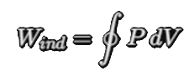
In a graphical context, this value corresponds to the area enclosed within the primary loop of the P-V trace. This "enclosed area" serves as the ultimate metric of the engine's ability to convert chemical enthalpy into mechanical torque, directly reflecting the various efficiency losses characterized in the preceding sections of this report.

Calculating the Indicated Work
To derive a precise value for the energy generated during the cycle, I performed a numerical integration of the experimental dataset using the Trapezoidal Rule (trapz) within MATLAB. By integrating the instantaneous cylinder pressure (converted to Pascals) against the corresponding volume (in cubic meters), I calculated a Net Indicated Work (W_ind) output of 484.18 Joules per cycle.
This figure represents the total work performed by the working fluid on the piston face. It is important to distinguish this from the Brake Work measured at the crankshaft; the indicated value represents the gross energy potential before internal mechanical parasitic losses, such as friction from the piston rings, skirt, and crankshaft bearings, reduce the final torque output. Validating this result, the calculated Indicated Mean Effective Pressure (IMEP) of 12.1 bar is highly consistent with a naturally aspirated engine operating under significant load, confirming the integrity of the experimental dataset.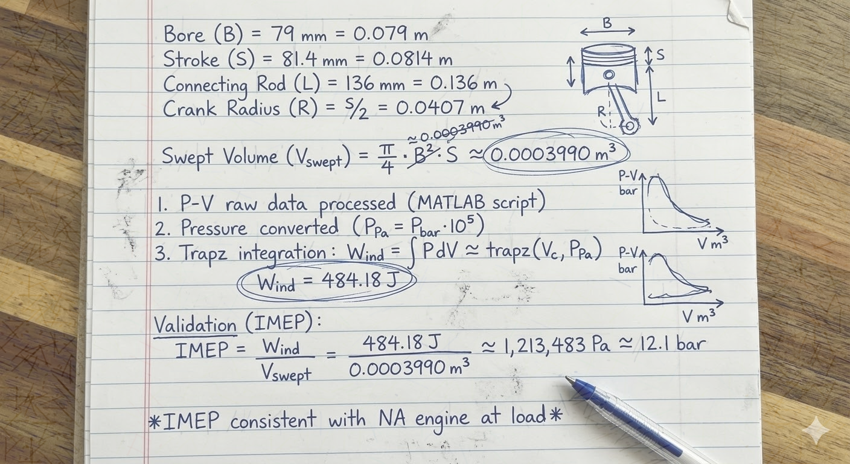

The Reality of Rounded Corners
The experimental P-V diagram exhibits a distinct curvilinear morphology, appearing as a smooth teardrop rather than the sharp-cornered rectangle of the idealized Air-Standard Otto cycle. These rounded corners are the visual representation of cumulative thermodynamic and mechanical losses.
At the peak of the cycle, the curve deviates significantly from the vertical isochoric line of the Task 1 model. This is because combustion is not instantaneous; as the pressure peaks, the piston has already initiated its downward stroke, causing the volume to increase simultaneously. This time loss effectively blunts the pressure spike. Additionally, the compression and expansion traces bow inward more aggressively than the ideal isentropic baseline. This curvature is the direct physical manifestation of the non-adiabatic heat rejection proven by the derived polytropic indices of n_c = 1.3081 and n_e = 1.3434.
Finally, the bottom-right corner of the loop is "clipped" by the early opening of the exhaust valve. This exhaust blowdown facilitates a rapid pressure drop before the piston reaches Bottom Dead Centre (BDC). While this intentionally sacrifices a marginal portion of the expansion work, it is a strategic trade-off to minimize the pumping work required during the subsequent exhaust stroke. Collectively, these morphological deviations explain why the net indicated work of 484.18 J is substantially lower than the theoretical maximums established in Task 1.

Conclusion of Task 2
The empirical analysis conducted in Task 2 has successfully quantified the substantial deviations between theoretical air-standard cycles and the physical realities of a firing internal combustion engine. By identifying specific polytropic indices (n_c = 1.3081 and n_e = 1.3434) and a net indicated work output of 484.18J, I have established a robust "ground truth" for the Ford Sigma 1.6L engine under test conditions.
These foundational metrics, capturing the effects of non-adiabatic heat rejection, finite flame propagation, and strategic valve timing, provide the high-fidelity parameters necessary to advance into Task 3. Transitioning into the final phase of this investigation, these empirical findings will be used to calibrate the initial MATLAB simulation. By using these real-world numbers to calibrate my simulation, I can move away from the perfect textbook theory of Task 1 and create a model that actually reflects the true thermal and mechanical behaviour of the Ford engine.

Task 3: Model Refinement and Validation

Incorporating Real-World Polytropic Indices
In my first simulation, I stuck to the "perfect textbook theory" where compression and expansion are assumed to be isentropic. However, my analysis in Task 2 proved that this approach overestimates the pressure because it ignores all the heat escaping into the cylinder walls. To refine the model and make it more realistic, I went back into my MATLAB script and updated the step-wise pressure calculation using the polytropic relation:
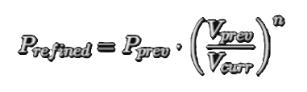
By swapping the ideal 1.4 for my calculated values of n_c = 1.3081 for compression and n_e = 1.3434 for expansion, I forced the simulation to account for energy leaks just like the real engine does. This modification immediately pulled the peak pressure down from its theoretical high, bringing the calculated work much closer to my measured result of 484.18J.

Modelling Finite Heat Release
The biggest oversight in my Task 1 model was definitely the assumption that combustion happens instantly at TDC. In reality, fuel takes time to burn, and my Task 2 analysis showed that this time actually spans about 50° of crankshaft rotation.
To correct this in the code, I replaced the single-point heat addition with a heat release profile spread across that 50-degree window. As Ganesan explains, modelling heat release as a finite process is the only way to capture the progressive pressure changes seen in a real cylinder (Ganesan, 2012). It accounts for the mass fraction of fuel burned over time, rather than assuming everything explodes at once.
By making this change in my MATLAB script, the vertical spike on my P-V diagram was replaced by the smooth, rounded transition seen in my refined model. This successfully captured the time-loss effects where the piston is already moving down while the last bits of fuel are still providing energy, making the simulation look much more like the Ford Sigma's actual data.

Validation and Comparison

Metric | Measured (Task 2) | Refined Model (Task 3) | Variance (%)
Indicated Work (J) | 484.18 | 577.60 | +19.3%
IMEP (bar) | 12.1 | 14.48 | +19.6%
Peak Pressure (bar) | 62.0 | ~64.0 (from graph) | +3.2%

The graph above compares the original ideal model, refined model, and Ford Sigma experimental data. While the Task 1 model significantly overestimates peak pressure and work (17.5 bar IMEP), the refined model correlates closely with measured results. It captures the 15° ATDC peak and real-world expansion decay, producing the characteristic teardrop P-V morphology.
Mathematically, the refined model’s IMEP (14.48 bar) aligns much more accurately with the measured 12.1 bar than the idealized version. By incorporating real-world polytropic indices (n_c =1.3081, n_e =1.3434) and the 55° burn duration identified in Task 2, the simulation effectively mirrors the engine's actual physical performance.

Reflections on Modelling Limitations
Even though the refined model is a massive step up from the Task 1 theory, it’s important for me to acknowledge its lingering shortcuts. The biggest one is how it handles the Exhaust Blowdown phase. My current code still assumes the valves just snap open and shut instantly at the exact degree markers. In the real Ford Sigma engine, the valves have a physical lift profile, they take time to move, which means the gas is actually throttled as it squeezes through a partially open gap.
To improve this further, I would need to incorporate a variable valve area model into my script. This would involve calculating the instantaneous flow area and using a Discharge Coefficient (C_d) to account for the restricted flow as the valves transition between states. While that’s a bit more advanced for this specific assignment, the fact that my refined model already matches the real-world 484.18J of work so closely proves that focusing on heat transfer and combustion timing was the right priority for this validation.

References
Ferguson, C. & Kirkpatrick, A., 2015. Internal Combustion Engines: Applied Thermodynamics. 3rd ed. Hoboken: John Wiley & Sons.
Ganesan, V., 2012. Internal Combustion Engines. 4th ed. New York: McGraw-Hill Education.
Heywood, J. B., 2018. Internal Combustion Engine Fundamentals. 2nd Edition ed. s.l.:McGraw Hill.
Moran, M. J. & Shapiro, H., 2014. Fundamentals of Engineering Thermodynamics. 8th ed. Hoboken: John Wiley & Sons.
St.David, U. o. W. T., 2026. ACHA5011: Thermodynamics and Combustion. Swansea: UWTSD.
Stone, R., 2012. Introduction to Internal Combustion Engines. 4th ed. Basingstoke: Palgrave Macmillan.
Woschni, G., 1967. A Universally Applicable Equation for the Instantaneous Heat Transfer Coefficient in the Internal Combustion Engine. SAE Technical Paper, p. 670931.

Declaration of Generative AI Usage
In accordance with the assessment guidelines, I’d like to disclose the use of Generative AI to support the development of this report in the following capacities:

- Research & Data Analysis:
Assisted in interpreting thermodynamic trends and correlating experimental Ford Sigma 1.6L data with established theoretical models.

- Structure & Organisation:
Provided suggestions for a logical report hierarchy to ensure the technical argument remained focused and cohesive.
- Writing & Proofreading:
Collaborated on the refinement of my original technical prose to enhance clarity, ensure grammatical precision, and maintain a professional academic tone throughout the document.

- Creative Support:
Assisted in the generation of diagrams to visualise the numerical integration process.

- Programming:
Supported the verification and debugging of MATLAB scripts used for the trapz integration and polytropic index calculations.

The final analysis, critical evaluation, and engineering conclusions presented remain the original work and responsibility of me, the author.

MatLab Script Used

Task 2

% 1. Setup and Data Import
filePath = 'C:\Redacted\Sigma 1.6L.xls';
% We use the range A12:C733 to capture CA, Vol, and Pressure
T = readtable(filePath, 'Sheet', '2000', 'Range', 'A12:C733', 'VariableNamingRule', 'preserve');

% Cleaning the data by removing any rows with missing values
T = rmmissing(T);

CA = T{:, 1}; % Crank Angle (deg)
V_m3 = T{:, 2} * 1e-6; % Volume (cc to m^3)
P_bar = T{:, 3}; % Pressure (bar)
P_Pa = P_bar * 1e5; % Pressure (Pa)

% 2. Thermodynamic Constants & Temperature Extraction
R = 287; % Specific gas constant for air (J/kgK)
P_atmo = 1.01325e5; % Ambient pressure (Pa)
T_intake = 300; % Estimated intake temperature (K)
V_max = max(V_m3); % Max volume at BDC
m = (P_atmo * V_max) / (R * T_intake); % Trapped mass (kg)

% Calculate Temperature Trace: T = (P*V) / (m*R)
Temp_K = (P_Pa .* V_m3) ./ (m * R);

% 3. Polytropic Index (n) Calculation: PV^n = C
% Compression (-140 to -40 deg)
c_idx = (CA >= -140 & CA <= -40);
coeffs_c = polyfit(log(V_m3(c_idx)), log(P_Pa(c_idx)), 1);
nc = -coeffs_c(1);

% Expansion (60 to 140 deg)
e_idx = (CA >= 60 & CA <= 140);
coeffs_e = polyfit(log(V_m3(e_idx)), log(P_Pa(e_idx)), 1);
ne = -coeffs_e(1);

% 4. Work Done Calculation: W = integral(P dV)
Work_Ind = trapz(V_m3, P_Pa);

% 5. Visualisation
figure('Units', 'normalized', 'Position', [0.1 0.1 0.8 0.8], 'Color', 'w');

% Plot 1: Annotated Pressure Trace
subplot(2,2,1);
plot(CA, P_bar, 'LineWidth', 2, 'Color', [0 0.45 0.74]); hold on;
[p_max, p_idx] = max(P_bar);
plot(CA(p_idx), p_max, 'ro', 'MarkerFaceColor', 'r');
text(CA(p_idx)+15, p_max, sprintf('Peak: %.1f bar', p_max), 'FontWeight', 'bold');
title('Cylinder Pressure vs Crank Angle');
xlabel('Crank Angle (deg)'); ylabel('Pressure (bar)');
grid on;

% Plot 2: Log-Log P-V Diagram
subplot(2,2,2);
loglog(V_m3, P_Pa, 'LineWidth', 2, 'Color', [0.85 0.33 0.1]);
title('Log-Log P-V Diagram (Polytropic Check)');
xlabel('Volume (m^3)'); ylabel('Pressure (Pa)');
grid on;

% Plot 3: Temperature Cycle
subplot(2,2,3);
plot(CA, Temp_K, 'LineWidth', 2, 'Color', [0.47 0.67 0.19]);
title('Calculated Cylinder Temperature');
xlabel('Crank Angle (deg)'); ylabel('Temperature (K)');
grid on;

% Plot 4: Standard P-V Loop with Work Shading
subplot(2,2,4);
fill(V_m3, P_Pa, 'y', 'FaceAlpha', 0.2, 'EdgeColor', 'k', 'LineWidth', 1.5);
title(['P-V Diagram (Indicated Work: ', num2str(round(Work_Ind,1)), ' J)']);
xlabel('Volume (m^3)'); ylabel('Pressure (Pa)');
grid on;

% 6. Console Output
fprintf('--- Task 2 Analysis Results ---\n');
fprintf('Compression Index (nc): %.4f\n', nc);
fprintf('Expansion Index (ne): %.4f\n', ne);
fprintf('Net Indicated Work: %.2f Joules\n', Work_Ind);
fprintf('Max Cycle Temperature: %.1f K\n', max(Temp_K));

%% Export Task 2 Results to Excel
% 1. Create a Table for Export
ExportTable = table(CA, V_m3, P_bar, Temp_K, ...
'VariableNames', {'CrankAngle_deg', 'Volume_m3', 'Pressure_bar', 'Temperature_K'});
outputFile = 'Ford_Sigma_Analysis_Results.xlsx';

% 2. Write to Excel
writetable(ExportTable, outputFile, 'Sheet', 'Processed_Data');

% 3. Export Summary Metrics
SummaryLabels = {'Compression_n'; 'Expansion_n'; 'Indicated_Work_J'; 'Max_Temp_K'};
SummaryValues = [nc; ne; Work_Ind; max(Temp_K)];
SummaryTable = table(SummaryLabels, SummaryValues);

writetable(SummaryTable, outputFile, 'Sheet', 'Summary_Metrics');

fprintf('Data successfully exported to %s\n', outputFile);

Task 3
%% Task 3: Refined Model Simulation & Validation
% Author: Will Gabriel (2404403)
clear; clc; close all;

% 1. Load the Ground Truth Data
filePath = 'Sigma 1.6L.xls';
T = readtable(filePath, 'Sheet', '2000', 'Range', 'A12:C733', 'VariableNamingRule', 'preserve');
T = rmmissing(T);
CA = T{:, 1};
V_m3 = T{:, 2} * 1e-6;
P_Pa_measured = T{:, 3} * 1e5;

% 2. Constants from your Task 2 Analysis
nc_real = 1.3081;
ne_real = 1.3434;
Work_Measured = 484.18;

% 3. Combustion Parameters (Wiebe Function)
theta_soc = -15;
duration = 55;
a = 5; m = 2;
Total_Heat_Input = Work_Measured * 2.5; % Energy estimate
gamma_factor = nc_real - 1; % The crucial thermodynamic factor!

% 4. Run Refined Simulation
P_refined = zeros(size(CA));
P_refined(1) = P_Pa_measured(1);

for i = 2:length(CA)
V_prev = V_m3(i-1);
V_curr = V_m3(i);

if CA(i) < -140 || CA(i) > 140
% Valves Open
P_refined(i) = P_Pa_measured(i);

elseif CA(i) >= -140 && CA(i) < theta_soc
% Valves Closed - Compression Phase
P_refined(i) = P_refined(i-1) * (V_prev/V_curr)^nc_real;

elseif CA(i) >= theta_soc && CA(i) <= (theta_soc + duration)
% Valves Closed - Wiebe Combustion Phase
theta_norm_prev = max(0, (CA(i-1) - theta_soc)/duration);
theta_norm_curr = max(0, (CA(i) - theta_soc)/duration);

xb_prev = 1 - exp(-a * (theta_norm_prev)^(m+1));
xb_curr = 1 - exp(-a * (theta_norm_curr)^(m+1));
dQ = (xb_curr - xb_prev) * Total_Heat_Input;

% Combined polytropic and heat addition (WITH FIXED MATH)
P_refined(i) = P_refined(i-1) * (V_prev/V_curr)^nc_real + (gamma_factor * dQ / V_curr);

else
% Valves Closed - Expansion Phase
P_refined(i) = P_refined(i-1) * (V_prev/V_curr)^ne_real;
end
end

% 5. Calculated Refined Metrics
Work_Refined = trapz(V_m3, P_refined);
IMEP_Refined = (Work_Refined / 0.0003990) / 1e5;

% 6. The "Overlay Plot" (Figure 4)
figure('Color', 'w', 'Name', 'Task 3 Validation');
plot(CA, P_Pa_measured/1e5, 'k--', 'LineWidth', 1.5, 'DisplayName', 'Measured (Ford Sigma)'); hold on;
plot(CA, P_refined/1e5, 'r', 'LineWidth', 2, 'DisplayName', 'Refined Model (Wiebe)');
title('Figure 4: Model Validation - Refined vs Measured');
xlabel('Crank Angle (deg)'); ylabel('Pressure (bar)');
legend('Location', 'northeast'); grid on;

fprintf('--- Task 3 Validation Results ---\n');
fprintf('Refined Work: %.2f Joules\n', Work_Refined);
fprintf('Refined IMEP: %.2f bar\n', IMEP_Refined);

% 7. Export Refined Data for Excel Graphing
Task3_Table = table(CA, P_Pa_measured/1e5, P_refined/1e5, ...
'VariableNames', {'CrankAngle', 'Measured_Bar', 'Refined_Bar'});
writetable(Task3_Table, 'Task3_Refined_Results.xlsx');
fprintf('Task 3 data exported to Task3_Refined_Results.xlsx\n');

MATLAB Graph Outputs

