Daniel Carlson (2001079)
Introduction to Web and Database Concepts ACCA4023 – Due Date – 05/05/21
Database Analysis and Design Assignment

Table of Contents
Introduction 2
Guidelines 2
Diagrams 2
Context Diagram 2
Level 0 DFD Diagram 3
Entity Relationship Diagram (ERD) 4
Using Access for Database Creation 6
Forms 6
Main Menu 6
Booking 6
Customer Information 7
Stock Check 7
Tables 8
Booking 8
Customer Info 8
Stock Check 9
Reports 9
Booking 9
Customer Info 9
Stock Check 10
Macros 10
Conclusion 10
References 11

Introduction
This report will outline and explain the diagrams that will show the solution to the scenario given. The scenario asks for 3 conditions in which will be represented in different diagrams using Microsoft Azure. I will use a suitable design layout and will use tables to show all data provided and how they link together successfully. By using Visio, I can create a numerous number of tables to show all the relationships and statistics that are needed within this scenario. This report will show a structured, easy to read and detailed explanation of all the different tables and methods used.

Guidelines
There were 3 guidelines/requirements of the scenario that I needed to follow in creating this report. The first was they wanted an on screen designed invoice that they can view, or they can send to print. The second was a record of transactions from the supplier after a successful purchase was made. And the final guideline was they wanted to be able to query information about the booked catering event.

Diagrams
Below I have created 3 diagrams based on the scenario provided. I created a Context Diagram, a DFD Level 0 and an Entity Relationship Diagram.

Context Diagram
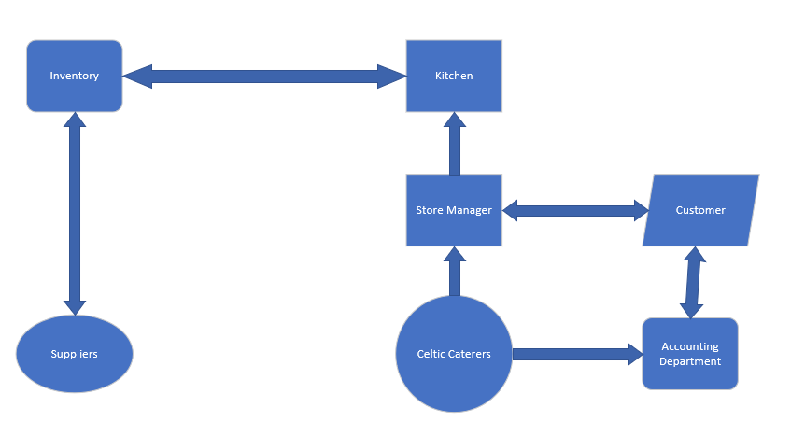
This is the basic context diagram I created regarding this scenario. Above I put the Celtic Caterers as the main shape and then connected all relevant departments to it. As the orders were going through the store manager, I connected the customer entity to the store manager, also I connected the Accounting Department to the Customer as the Invoicing for the bookings would be directly sent via this department. Next, I added the kitchen connected to the store manager as after the order was received the kitchen would be updated on this to identify what they needed. Referring to the items needed, I connected the inventory to the kitchen in which they would be able to check what items were available but also what would need to be ordered. Finally, I connected the Suppliers to the inventory, due to when items are needed the inventory will submit a request to that specific supplier.

Level 0 DFD Diagram
Next, I created a Level 0 DFD based on the overlook of the context diagram. The definition of A DFD diagram is stated clearly by A. Swati when he states that:
A data flow diagram (DFD) is a graphical representation of the "flow" of data through an information system, modelling its process aspects. A DFD is often used as a preliminary step to create an overview of the system without going into detail, which can later be elaborated. [1]
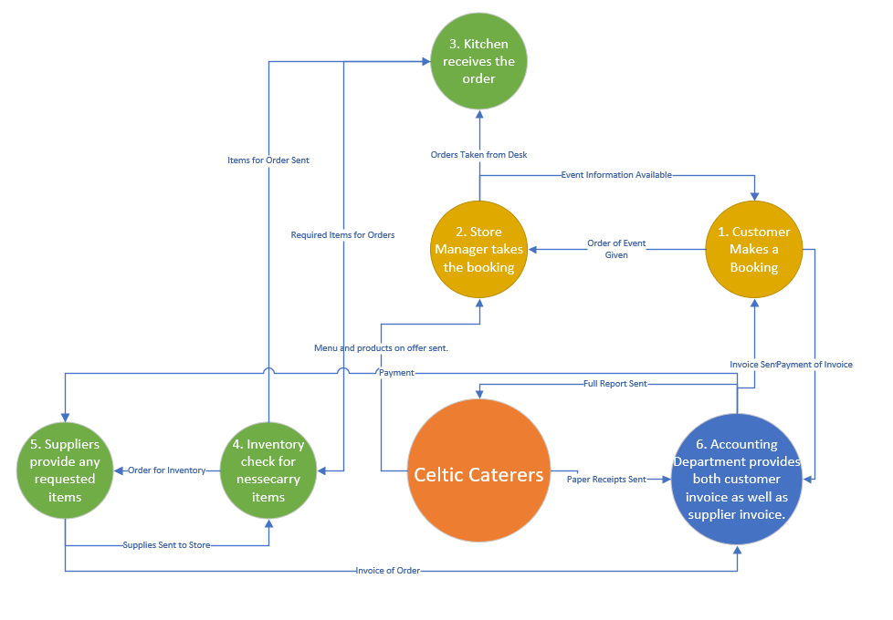
This DFD shows the basic operation of the scenario. First, the customer makes a booking, which is then sent electronically to the store manager who takes the booking and passes it onto the kitchen, while also updating the on-site event information page for the customer to view the details. Next, the kitchen verifies the order with the inventory to identify what items are currently available but also what items are needed to complete the order, which then the inventory submits a request to the supplier for the required items based on the kitchens order. After the supplier receives the order the send both the items to the inventory but also the invoice to the Accounting department for the necessary payment. Next, after the items are received in the inventory, they are noted in the stock report and then sent to the kitchen for preparation of the order, which would then allow the order to be completed. Finally, the accounting department creates the necessary invoices for the customer regarding the price for the event and send it to them.
By using this DFD I can clearly see what processes I needed to do for this scenario but also what entities and relationships I would have to include within the ERD and the database creation.

Entity Relationship Diagram (ERD)
The final diagram I created was an Entity Relationship Diagram or an ERD. An ERD is used as a basic database diagram and shows what characteristics have relationships with each other. The true definition of an ERD is stated by Lucid Chart with:
An Entity Relationship (ER) Diagram is a type of flowchart that illustrates how “entities” such as people, objects or concepts relate to each other within a system. ER Diagrams are most often used to design or debug relational databases in the fields of software engineering, business information systems, education, and research. [2]
Below I have demonstrated my ERD I created to correspond with this scenario:
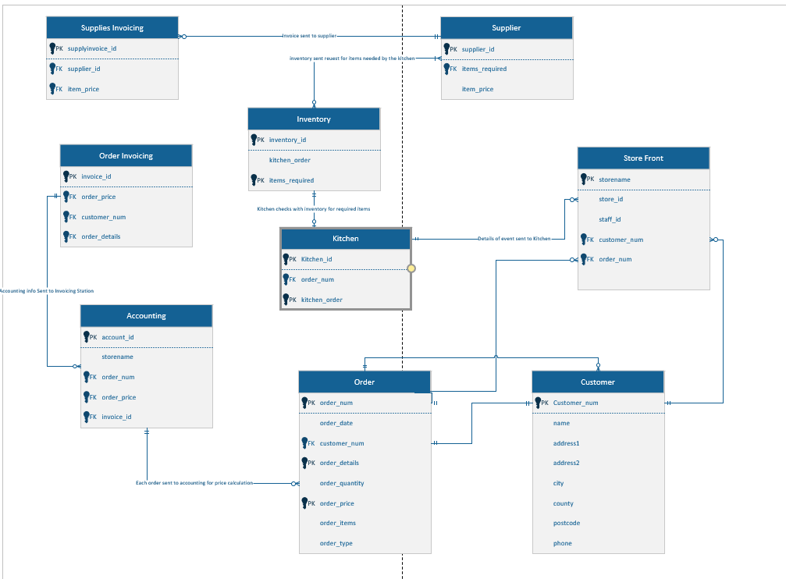
This ERD I used to show a rough overview of the flow chart that a database would use and how they relate to each other. The explanation of the use would be quite like that of the DFD but with an ERD I used the variable value instead of just showing what place is what. Each able within each entity shows what types of data will be inputted into each section and which attribute of that data will be referred as Primary or Foreign Keys. I used the Crow’s Foot Entity Relationship Diagram as this notation of an ERD is the best way to convey detailed entities to people who are not very good with technology. In other words, it is a very simple and detailed way to create a sophisticated but easy to understand ERD.
Within this ERD I used each heading displayed in the DFD and adding a few extras. Firstly, I had the store front entity which asks for 4 separate attributes and 2 of which are FK which are created within the Order and Customer Entities. The Customer Entity was first to be create where I ask for all the necessary information of the customer e.g. First and Last name, Postcode etc. Then categorises them within a CustomerNum and makes it a Primary Key (PK). The relationship between this and the store front is on a 1 to 1 basis. The relationship is connected between the Customer Entity Primary Key with the Foreign Key of the Store Front Entity.
Next was the Orders, Here I classified the Primary Key as OrderNum and then asked for the customer number and then allowed the customer to enter their order details. By using foreign keys, I can easily access the data stored within the primary key of that attribute specified. Also, within the Order Entity There was 2 other Primary Keys specified which were Order Details and Order Price. Finally, the relationships within this entity are as follows, 1. Between the customer and order entities is 1 to 1 as it is based per customer and not multiple, 2. Order and Accounting is a 0 or more relationship as multiple orders can be sent at the same time.
The next entities were the Accounting Department which included Order and Supply Invoicing. These Invoicing entities did not require any user input and pulls data from already created reports i.e. It asks for the Customer Number and Order Details for the Order Invoicing and the Supplier ID and Item Prices for the Supply Invoicing. The relationship between these is simple they are both a 1 to 1 relationship as there can only be 1 invoice per order.
Next was the Kitchen and Inventory Entities. The kitchen asks for the order Number and then creates the Kitchen Order PK for the inventory entity to use. This allows the kitchen to identify what needs to be ordered an specifies within the Kitchen Order Attribute, which is then accepted by the Kitchen Order FK within the Inventory entity which calculates what will need to be purchased and what is already available. The relationship between the Kitchen and Inventory Entities is 1 and only 1.
The final entity was Suppliers, within this entity it asks for the items requires attribute which was created within the Inventory entity and then creates the item price PK which is then used by the Supplier Invoice to Create and pay the supplier the desired amount. The items_required attribute is a Foreign Key and the Item_price attribute is a Primary Key. There are 2 relationships with the supplier entity which are 1. Between Inventory and Supplier which is a 0 or more to a 1 or more relationship as there will only be 1 order from the inventory but there could be multiple deliveries from the suppliers. 2. Supplier Invoice and Suppliers, this relationship is 1 to 1 as there will only be 1 invoice given per order of supplies.

Using Access for Database Creation
To show a basic solution to the scenario I used Microsoft Access to demonstrate what a possibility of the system might look like.

Forms
The main part of the Access database was the forms. I created 4 forms which were Main Menu, Booking, Customer Info and Stock Check.

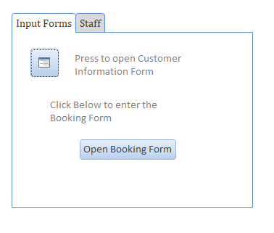
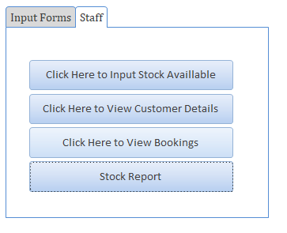
Main Menu

I create 2 separate pages one for the customer use and the other for the staff to use. Thee first form had buttons to open both the customer information input forms and the booking forms. I used tis a s a quick access for the customer to make a booking. I also created a staff section for the staff to have the ability to mange stock levels, view current bookings, customer information and the full stock report. This would be the main menu of the scenario solution.

Booking
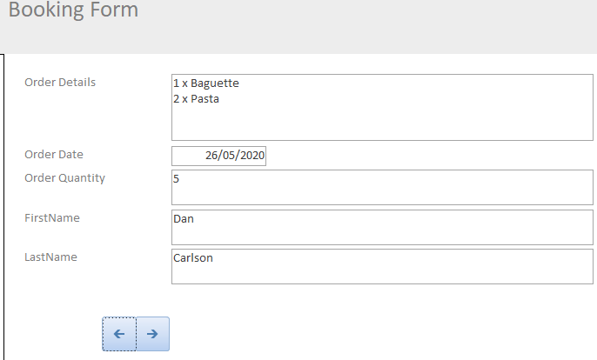
Next was the booking form which allowed the user to input all the booking information of the items they wanted with all the details etc. I added the relevant buttons at the bottom to add multiple orders and view previous inputted orders. This form links to the Booking Table where the entries are stored.

Customer Information
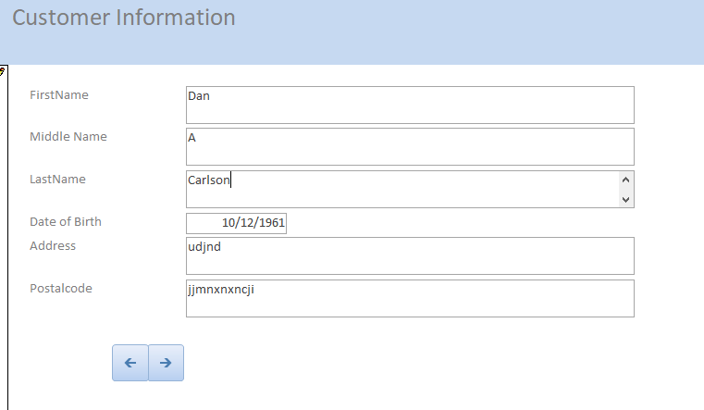
Next was the Customer Information page. This page is displayed when the customer info button on the main menu is clicked, the form will then display the relevant fields for the user to enter all the required details that are asked. There are buttons at the bottom to view the customer inputs. All the data inputted will be added to the Customer Info table which I will show below.

Stock Check
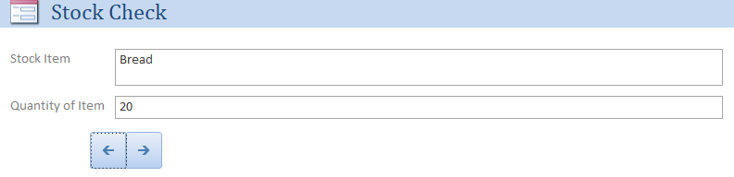
The final form created was dedicated for stock. I created this form to give the staff a quick was to enter the stock numbers for them to be displayed on the monthly stock report. There are buttons at the bottom to navigate between stock items. These will be displayed on a report further on in this document.

Tables
Next, I will explain the tables that are linked to the specific form. There are 3 tables which are Booking, Customer Info and Stock.

Booking
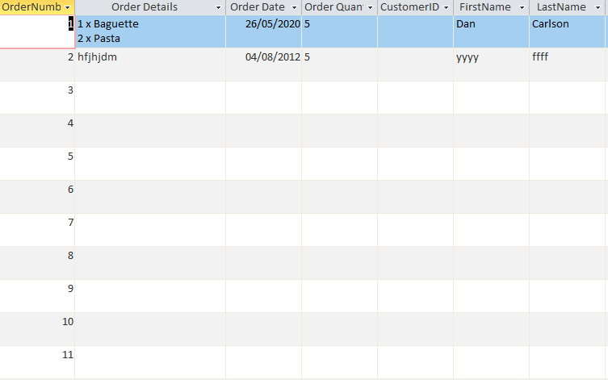
The table above is where the info entered within the booking form will be displayed. When the user enters the order details the table will auto update the relevant field with the inputted information. These tables are an easy way to use forms.

Customer Info
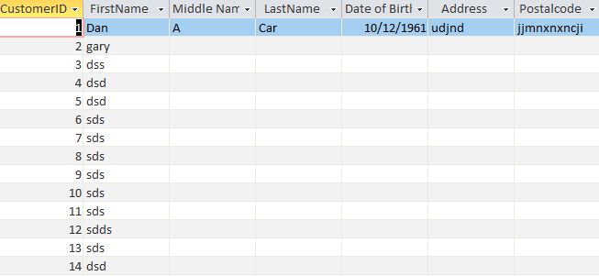
This table is linked to the Customer Info Form where the user will enter their personal information in the selected sections within the form. Each column apart from Date of birth uses the Short Text format where date of birth uses the Date/Time format.

Stock Check
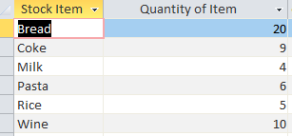
The final table was the stock check table, which is linked to the stock check form. As above the user inputs the stock item and its quantity and then the table will update with the inputted values. The formats in this are Short Text for Stock Item and Number for Quantity.

Reports
Finally, I created reports which would display the forms contents in a clear and detailed manner. By using the data within the tables, it can create a report to show the data clearly. There were 3 reports created, 1 for each table.

Booking
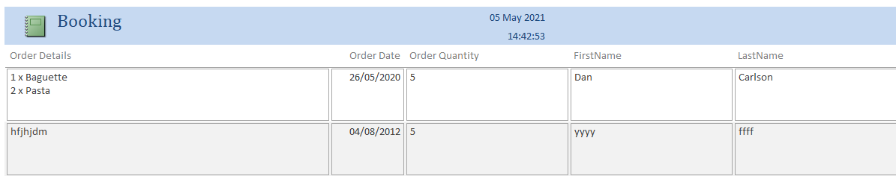
The booking report above displayed what I inputted into the form. The report is a clearer version of the table which also has the option to print out that report. This report can be accessed by clicking the Check Customer Information button on the staff page in Main Menu.

Customer Info
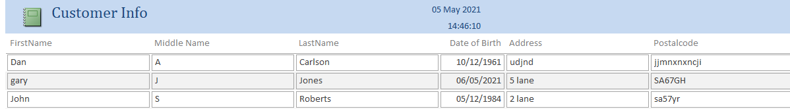
This is the report on the customer Information form. As inputted within the form each section has been displayed with the correct information. This report can be accessed by clicking the Check Booking button on the staff page in Main Menu.

Stock Check
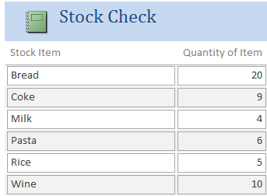
The final report was the Stock Report. This report is linked to the Stock Check form and can be accessed by clicking the Stock Report button on the Staff page of the Main Menu.

Macros
Finally, I created a Macros where the Main Menu would open immediately after the database was opened as demonstrated below.
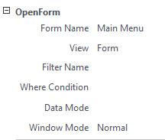
This always opens the Main Menu form automatically whenever the database is opened, and the Enable Editing button has been clicked on opening. This command will allow the Main Menu form to appear without the user having to click on it.

Conclusion
This is how I believe the scenario would be solved. There were a few improvements I could have made in which I will consider in future but overall, the design for this database is what was requested by the company regarding the guidelines. The Diagrams helped the user to show what was happening in the overall database and what requirements are still needed to improve the overall solution.

References

[1] | A. Swati, “What is DFD? Explain level 0 and level1 DFD with suitable example.,” Ques10, [Online]. Available: https://www.ques10.com/p/24848/what-is-dfd-explain-level-0-and-level1-dfd-with-su/#:~:text=DFD%20Level%200%20is%20also,its%20relationship%20to%20external%20entities.. [Accessed 5 May 2021].
[2] | LucidChart.com, “What is an ER Diagram?,” [Online]. Available: https://www.lucidchart.com/pages/er-diagrams/#section_0. [Accessed 04 May 2021].

