Dummy Report for Academic Skills Assignment 1 2017 – Include the title of the Report Here



OCTOBER 2017

MODULE NAME: INCLUDE MODULE NAME AND CODE HERE
Project Name: INCLUDE THE NAME OF YOUR PROJECT HERE
Name: INCLUDE ALL OF YOUR TEAM MEMBER NAMES HERE
Student Number: INCLUDE ALL YOUR STUDENT NUMBERS HERE

Table of Contents

1. eXECUTIVE sUMMARY 1
2. Introduction 2
2.1 Report Remit 2
2.2 Background of the organisation 2
2.3 Aim and Objectives 2
2.4 Project Team 3
2.5 Project implementation 4
2.6 Conclusion 5
3. References 6

List of Figures
IF YOU INCLUDE ANY IMAGES / MODELS /GRAPHS – MAke sure that you include them in a list of figures, even if there is only one of them
FIGURE 2-1 - PROJECT TEAM CHART 3
FIGURE 2-2 - DUMMY GANTT CHART 4

LIST OF TABLES
IF YOU INCLUDE ANY tables – MAke sure that you include them in a list of tables, even if there is only one of them

No table of figures entries found.
APPENDICES
APPENDICES ARE ANYTHING THAT IS INFORMATIVE TO THE REPORT, BUT IS NOT REQUIRED IN THE MAIN BODY OF THE REPORT. FOR EXAMPLE, IF YOU HAD COMPLETED QUESTIONNAIRES, YOU MIGHT INCLUDE THEM IN THE APPENDICES

APPENDIX A –
APPENDIX B –

jUST LIST OUT YOUR APPENDICES, THERE IS NO NEED TO INCLUDE PAGE NUMBERS FOR YOUR APPENDICES

eXECUTIVE sUMMARY

An executive summary is a one page overview of what is contained within your document. This should be the last part of the document that you write.

The executive summary is more than just a sign post of what is contained within the document. i.e. it is not sufficient to say that you will discuss certain things within the report, you need to provide an actual summary of what the report has found.

Typically, the following would be expected in the executive summary:

- Outline of the purpose / remit of the report
- Brief Background information
- What are the findings of the report
- What are the conclusions
- What are the recommendations

For this report, I expect to see the following in the exec summary

- Outline of the purpose / remit of the report
- Brief Background information on the project organisation
- Summary of the aims and objectives of your
- Time Frames and Major Milestones of the project
- Any important information that it would be essential for the reader to know.

Please note, executive summary’s are not included in your overall word count

Introduction

Make good use of heading and subheadings to enhance the fluency and structure of your report.

Report Remit

You need to imagine that the person who is reading this report is not the lecturer, but that it is written for an uninitiated (yet professional) audience. Therefore you need to state what the report is seeking to achieve here.

Background of the organisation

Fairly self-explanatory. This section needs to give a brief background into the organisation in which your project is being carried out. The sort of information that would be expected here is a brief high level history of the company, what the company does, any information on its mission, number of staff, any interesting financial information, any recent news worth mentioning, particularly if there is something interesting about the company that is related to the project. Remember, if you use the company’s website, or any other websites, make sure to include the references. This goes for any information you read, make sure you credit the source with proper citations

Aim and Objectives

This section should outline what the project is trying to achieve. This will largely be centred around what the organisation has asked you to do. Try and make these objectives as SMART as possible (Specific, Measurable, Agreed Upon, Realistic, Timebound). This will help give you a clearer idea of the direction of the project and will help you stay on course during the project delivery.

Project Team

This section should give a brief overview of the project team, including very brief biographies, roles within the team etc. Rough example below.

 | Dave Jones – Project Team Leader  Dave is the Project Team leader, his responsibilities include making the coffee and making sure we don’t run out of paperclips. He has two years’ experience in project management and is a qualified Egyptologist.

If you have set yourself up with any structure of hierarchy, you could include a project team chart here as well, something like the one below: (please note, all these job roles are entirely fictitious, just included below as a place holder

Figure 2-1 - Project Team Chart

If you include any charts or images, make sure to include a caption (as above) so the reader knows what it is.

Project implementation

This section of the report will address with exactly what it is you intend to do for your project. This is the part where you can work together to be a little creative in terms of how you achieve the original aims and objectives. This would also be a good part of the report to try and look at some credible literature to support what you are planning on doing, make sure to cite appropriately.

You will also need to include a high level implementation plan. So this will include key milestones in the project, any resources you require and who is responsible for what. You could include a simple gantt chart to show the project timeline, this is essentially a “timetable” for your project, which you can pull together in excel. A simple example is shown below.

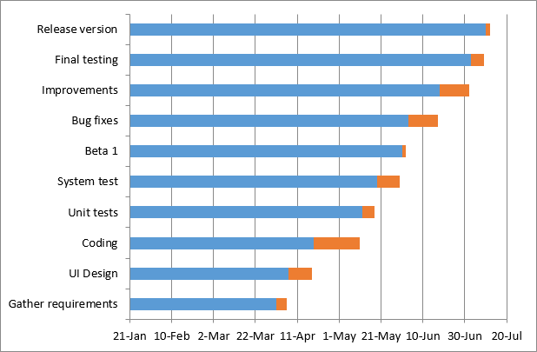
FIGURE 2-2 - DUMMY GANTT CHART

This will be especially useful if you find you are running over the word count. It is advisable to schedule project meetings as part of your project, include them in your plan, and stick to them to make sure the project is staying on course.

Make sure to include measures of success for the project that you will ultimately measure the success of the project on. Schedule a debrief for the close of the project to assess the successes and failures.

Conclusion

This can be a very brief summation of your document – as the document itself is very short

GENERAL NOTES

Once you have a report template you are happy with, keep a copy of it, it will make things a lot easier in the future (I have no problem with you using this one)

Make sure that your presentation is in line with this document.

GET FEEDBACK BEFORE SUBMISSION – ASK QUESTIONS

Make sure that one of the group is responsible for collating the parts of the document and they need to make sure it reads as though it is one cohesive document, not six peoples work stuck together.

Don’t stress, it is only a 1000 word report, just to give you an idea, from page 2 to page 5 is around 750 words. You are more likely to run over Try and keep it concise, as long as it is good quality and not excessive, I am not to worries about it running over.

References

Make sure you include a reference section, this will be using the Harvard referencing system, which we will go through in next week’s lecture. Below are a small number of examples, just to give you a flavour of what the referencing format looks like.

Acemoglu, D., Ticchi, D. and Vindigni, A., (2011). Emergence and persistence of inefficient states. Journal of the European Economic Association, 9(2), pp.177-208.

Adams, J., Young, A. and Zhihong, W., (2006). Public private partnerships in China: System, constraints and future prospects. International Journal of Public Sector Management, 19(4), pp.384-396.

Aharoni, Y. (2014) Coalitions and competition: the globalization of professional business services. Routledge,

Al-Khatib, J.A., Vollmers, S.M. and Liu, Y., (2007). Business-to-business negotiating in China: the role of morality. Journal of Business & Industrial Marketing, 22(2), pp.84-96.

Alford, W.P., (1995). To steal a book is an elegant offense: Intellectual property law in Chinese civilization. Stanford University Press.

Allen, G and Skinner, C. (1991) Handbook for Research Students in the Social Sciences. The Falmer Press. London.

Alvesson, M. (2003), “Beyond Neopositivisits, Romantics and Localists: A reflective approach to interviews in organizational research.” Academy of Management Review, Vol 28 No 1, pp. 13-33.

