Reflective Log

The Research in Action (RIA) module was a highly anticipated module for me. There is usually little opportunity to utilise qualitative format and experimental designs due to constraints in time for lecturers to supervise the preparation. Hence, I was excited for the opportunity to lean in a researcher role. Zoe explained in the first week that the format of this class was to be carried out in 2 groups of 5 and 1 group of 4 and we were expected to conduct a study on the topic of student well-being. We were allowed to choose a quantitative or qualitative format while in discussion of the topic our study would be on. Upon finalising that, Zoe tasked us with the systematic literature search (SLS) to incur more information on our respective chosen topics and ascertain what our study would measure based on past findings and methodologies. Once this was settled, we submitted a proposal form, complete with objectives, procedures, and ethical considerations, followed up with the Ethics Approval Form to identify any areas of concern.

While I was aware of the independent learning format this class would take, it took some time for me to adjust to weekly discussion sessions with my team mates and collaborative work that would be presented to Zoe. I often found myself struggling to manage time between working and breaks. This was due to my own tendency to micromanage and doubt many details out of worry. I built trust in group members over time and learnt to manage workloads quickly to avoid becoming overwhelmed. This built collective efficacy (Bandura, 1997), as I held people responsible to organise and complete their respective tasks that add towards the study. Despite the difference, Zoe was always around to clarify questions, suggest amendments as well as point out gaps and inconsistencies in our work. I feel growth in myself as a student, contributing to confidence as a researcher when it comes to working effectively by facilitating session in the form of presentation and discussion (Kingsbury, 2015).

The process of conducting a SLS was daunting initially as I was unfamiliar with the library system but Zoe had explained it and linked a video to add on. I was grateful for my group members who were actively contributing and eager to try different methods and functions until we were able to curate what was required. Writing down data for each search and change seemed menial and difficult to remember but the group effort in learning and reminding one another eased the process. In comparison to my usual method of just using Google Scholar, I found this tool to be useful in filtering out articles that held little relevance to my search. Having everything laid out methodically and in an organised manner also allowed me to easily visualise what components to could include or exclude (Cooper et al., 2018). Upon completing the first SLS, my group and I realised we had significant errors and were able to perform better in our next attempt, where I felt more confident in keywords and filters, I could use.

The proposal form was more familiar as I had done it multiple times before, the only addition was a new format in UWTSD. I had worked together with my teammates on the title and objectives, but did decide materials and procedure on my own. The materials were revised multiple times as the medium of an online video was required and we had not decided to use YouTube or upload a video on OneDrive. I had searched for and picked out the video via the NHS website on chair-based exercises (NHS, 2022) while Hazim edited the video. Overall, it was a positive experience.

Completing the ethical considerations form was a major learning curve. I was exposed to the laws, goals and complications that influenced the importance and viability that studies hold. This was the document that garnered the most editing and took up majority of the time. My team and I worked together on some sections that we deemed required group agreement, like a section on alignment with the 2015 Wales Act. I wrote on the risks that participants, researchers, and the university could face and how to mitigate them. Multiple revision notes were left by Zoe and Lymarie on what needed to be changed and it gave me perspective on why it can be difficult to plan out studies. I learnt how vital planning for extreme scenarios and being accommodating for participants lessens the likelihood of biased or chaotic studies.

When it came to preparing documents for data collection itself, I was involved in the process of picking out the scale used to measure student’s well-being. The back-and-forth with group mates was useful in finalising a scale that fit the needs of the study. I later carried on creating the debrief form on my own, to gauge what participants may need to hear or read after they had completed their exercises (Leeds Trinity University, 2019). I considered things I learnt from the anticipated risks to weave into specific areas and was sensitive to the participants well-being. The form I had drafted did require changes, especially with contact details and First Aid but I was guided by Zoe and was able to collaborate with my group mate Calvin for proofreading.

This was my first time conducting a live experimental design and I was excited yet nervous to see how it would go. My group member, Myura and I went through the pilot study together and were able to test how the session was meant to go and what we needed to allocate and expect. I learnt how to improve designs and sequences down to minor details from observing the pilot study and working in the feedback (In, 2017). For the actual intervention, there some issues with the numbering of forms and spacing but, the overall study went by smoothly and it felt very rewarding to have seen this study up to data collection. One major lesson was to not overlook smaller details as our forms were all hardcopies yet we had forgotten pens and Zoe had to secure some for the experiment. It was a tangible measure of growth as I could look back on the 8 weeks of planning and studying to see what it amounted to.

At the end of this module, I feel less intimidated to step into the role of a researcher and find the prospect exciting. I am still working on balancing my time between work and rest but I do manage better now. I have learnt more on considering ethics, sensitivities and preparing for experiments. I am confident these skills will aid in my Level 6 modules particularly.

Competency one: Research in Action-
Identifying appropriate research materials (Pilot study)

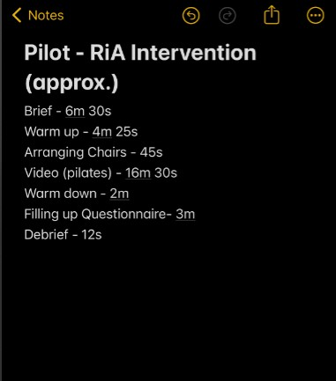
I conducted the pilot study along with Myura on 3 participants. I handled the briefing, explanation on questionnaires and debrief. Only a laptop and TV screen were required for the video, so we both took turns handling that. This pilot study gave us insight into the time it would take to complete the intervention and the breaks that would be required. Hearing feedback and seeing the issues participants faced also made me conscious of changes to make for the main study.

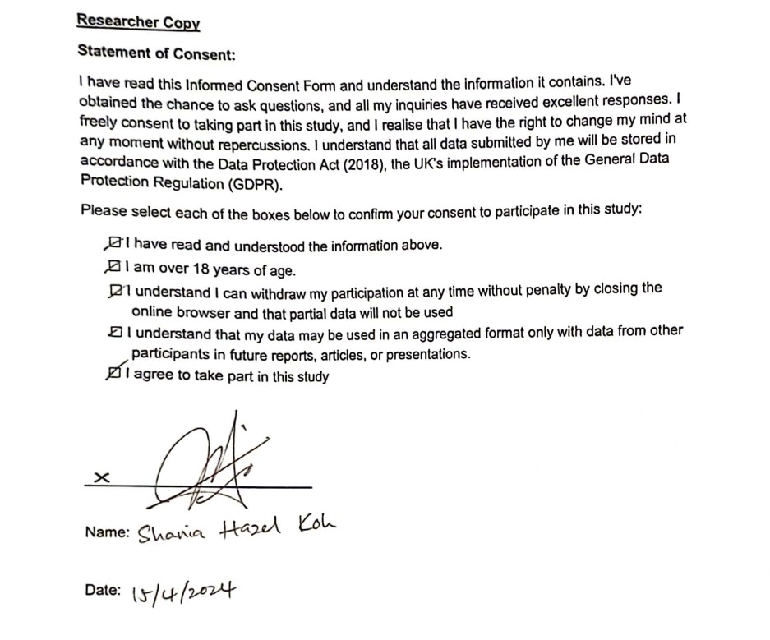

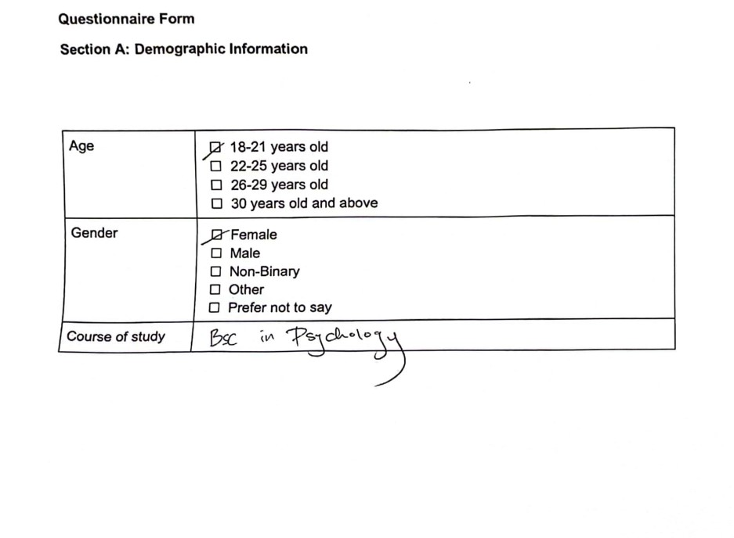

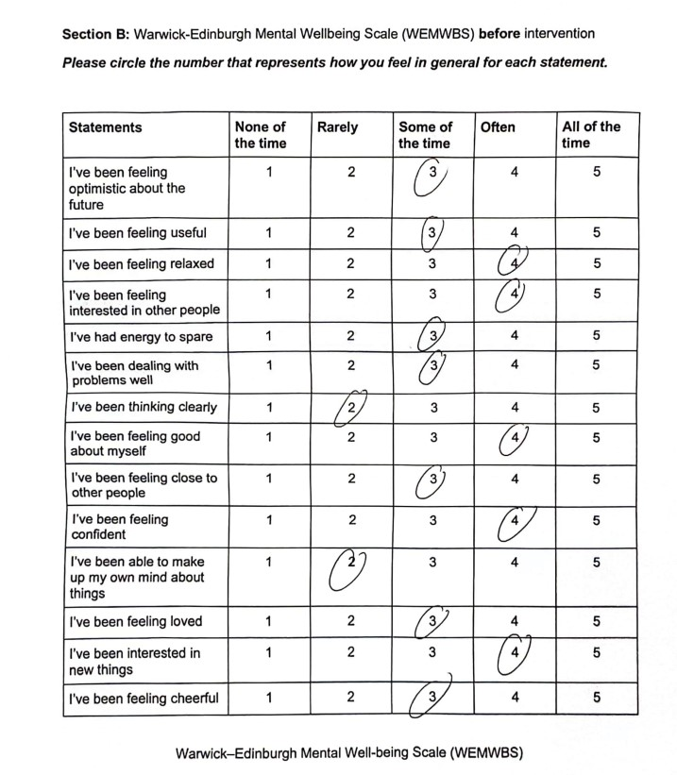

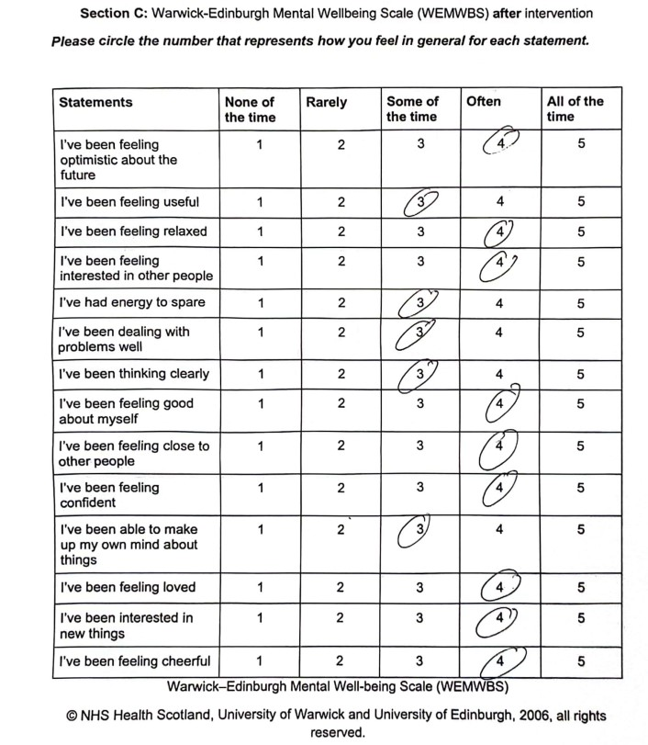

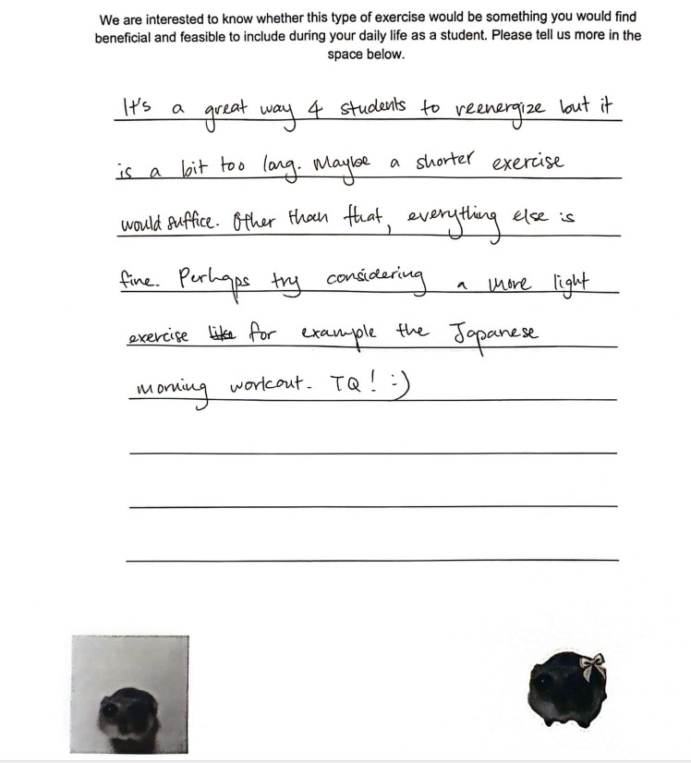

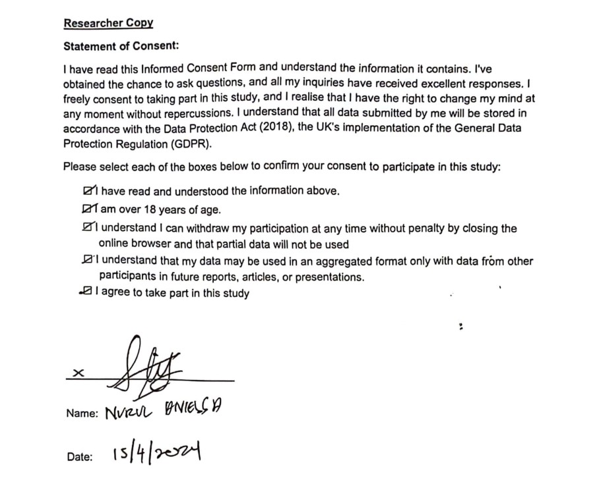

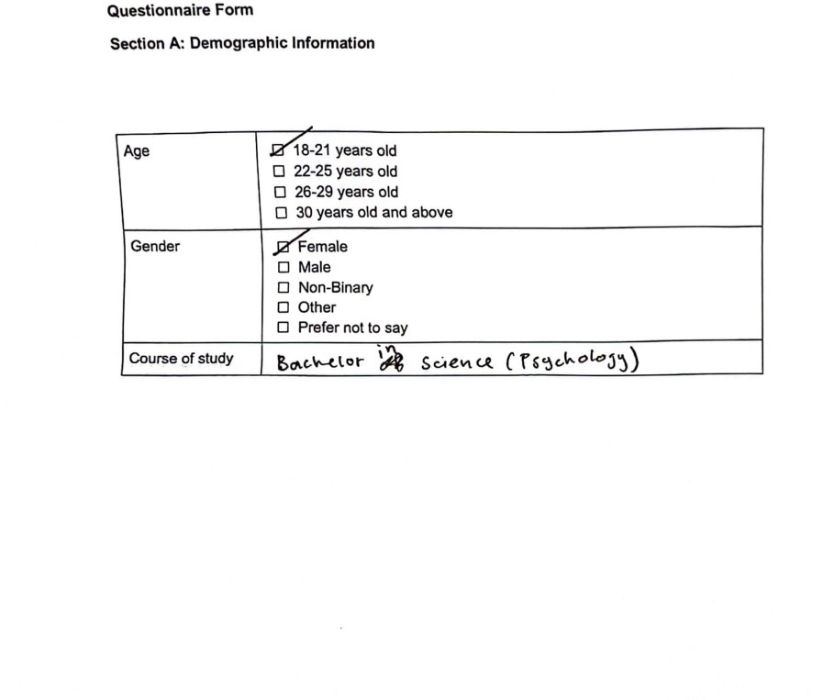

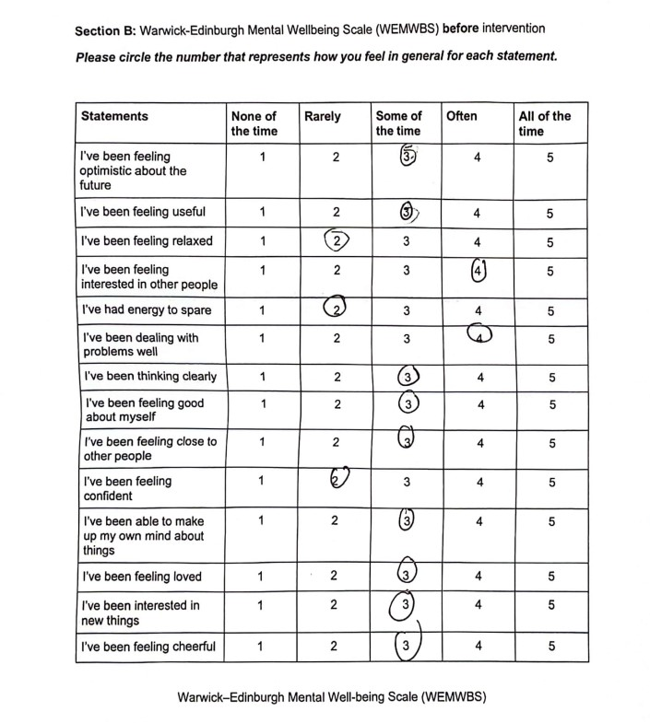

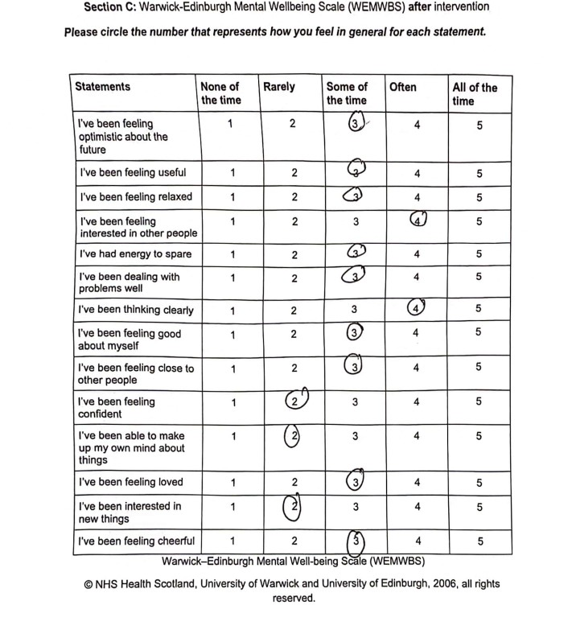



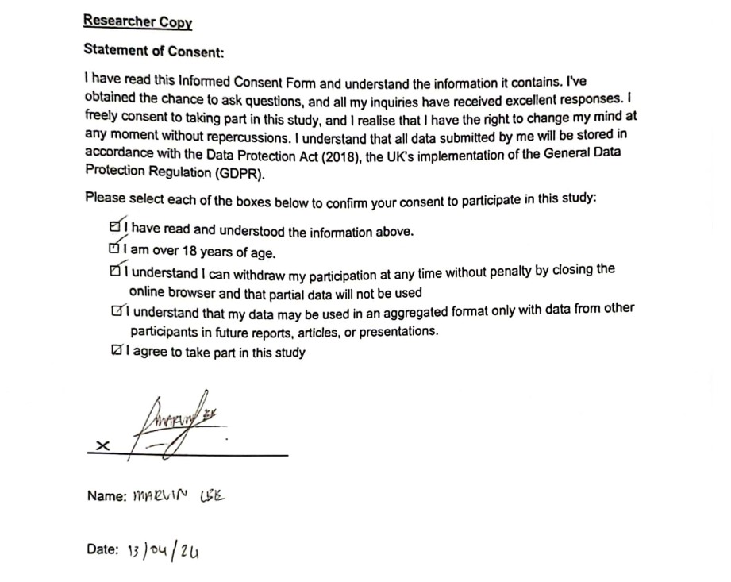

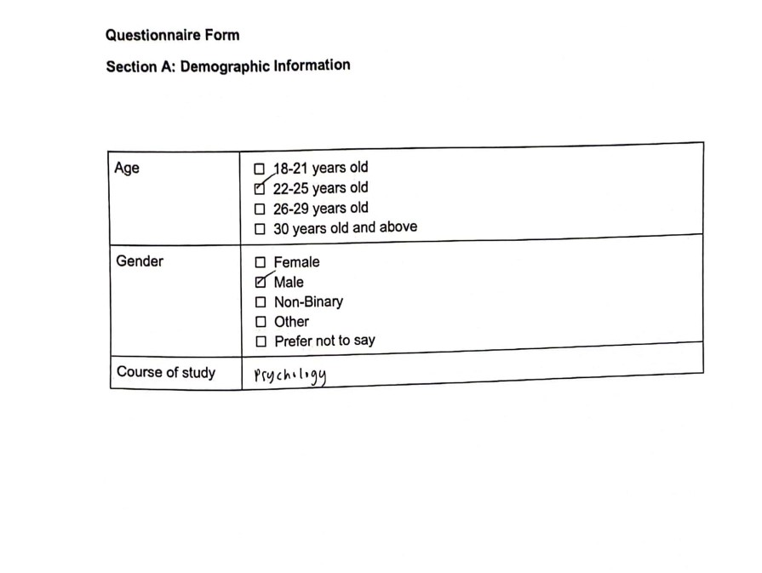

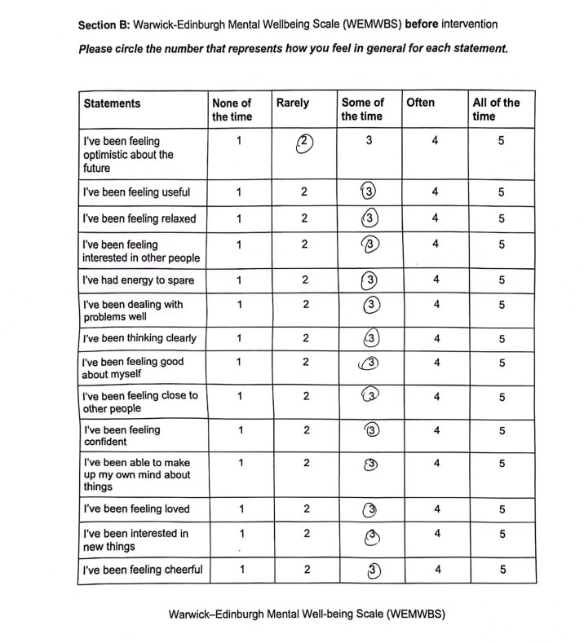

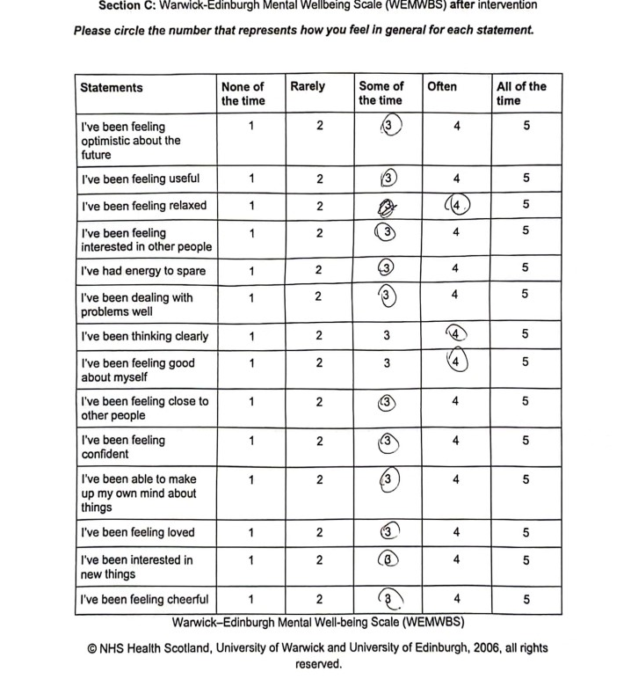

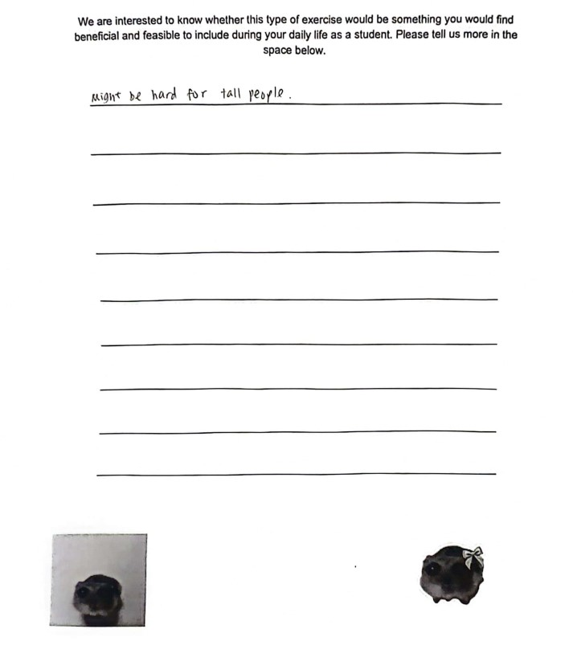

Competency two: Research in Action–
Ethical considerations

APPLICATION FOR ETHICAL APPROVAL

In order for research to result in benefit and minimise risk of harm, it must be conducted ethically. A researcher may not be covered by the University’s insurance if ethical approval has not been obtained prior to commencement.

The University follows the OECD Frascati manual definition of research activity: “creative work undertaken on a systematic basis in order to increase the stock of knowledge, including knowledge of man, culture and society, and the use of this stock of knowledge to devise new applications”. As such this covers activities undertaken by members of staff, postgraduate research students, and both taught postgraduate and undergraduate students working on dissertations/projects.

The individual undertaking the research activity is known as the “principal researcher”.

Ethical approval is not required for routine audits, performance reviews, quality assurance studies, testing within normal educational requirements, and literary or artistic criticism.

Please read the notes for guidance before completing ALL sections of the form.

This form must be completed and approved prior to undertaking any research activity. Please see Checklist for details of process for different categories of application.

SECTION A: About You (Principal Researcher)
1 | Full Name: |  | Ahmad Hazim Bin Mizaiyusri  Abiraami Sundararajan  Calvin Phang Wah Hong  Myura Kiirthansai Arree Chandran  Avinaash Muniandy
2 | Tick all boxes that apply: |  | Member of staff: | ☐ | Honorary research fellow: | ☐
 | Undergraduate Student | ☒ | Taught Postgraduate Student | ☐ | Postgraduate  Research Student | ☐

3 | Institute/Academic Discipline/Centre: | University of Wales Trinity Saint David
4 | Campus: | IQ SA1 Campus
5 | E-mail address: | 2226250@student.uwtsd.ac.uk  2226257@student.uwtsd.ac.uk  2226265@student.uwtsd.ac.uk  2226249@student.uwtsd.ac.uk  2244751@student.uwtsd.ac.uk
6 | Contact Telephone Number: | +447949341546
 | For students:
7 | Student Number: | 2226250  2226257  2226265  2226249  2244751
8 | Programme of Study: | B.Sc. (Hon.) Psychology
9 | Director of Studies/Supervisor: | Zoe Cooke

SECTION B: Approval for Research Activity
1 | Has the research activity received approval in principle? (please check the Guidance Notes as to the appropriate approval process for different levels of research by different categories of individual) |  | YES | ☐ | NO | ☒
 |  |  |  |  | Date
2 | If Yes, please indicate source of approval (and date where known): Approval in principle must be obtained from the relevant source prior to seeking ethical approval | Research Degrees Committee |  | ☐
2 |  | Institute Research Committee |  | ☐
2 |  | Other (write in)  Zoe Cooke |  | ☒ | 4th March 2024

SECTION C: Internal and External Ethical Guidance Materials
 | Please list the core ethical guidance documents that have been referred to during the completion of this form (including any discipline-specific codes of research ethics, location-specific codes of research ethics, and also any specific ethical guidance relating to the proposed methodology). Please tick to confirm that your research proposal adheres to these codes and guidelines. You may add rows to this table if needed.
1 | UWTSD Research Ethics & Integrity Code of Practice | ☒
2 | UWTSD Research Data Management Policy | ☒
3 | UWTSD Student Code of Conduct | ☒
4 | UWTSD Data Protection and Storage Protocol | ☒
5 | BPS Code of Human Research Ethics (April 2021) | ☒
6 | BPS Code of Ethics and Conduct (July 2018) | ☒
7 | BPS Data Protection Regulation – Guidance for Researchers (2018) | ☒

SECTION D: External Collaborative Research Activity
If there are external collaborators then you should gain consent from the contact persons to share their personal data with the university. If there are no external collaborators then leave this section blank and continue to section E.
1 | Institution
2 | Contact person name
3 | Contact person e-mail address
4 | Is your research externally funded? |  | YES | ☐ | NO | ☐
5 | Are you in receipt of a KESS scholarship? |  | YES | ☐ | NO | ☐
6 | Are you specifically employed to undertake this research in either a paid or voluntary capacity? | Voluntary | YES | ☐ | NO | ☐
7 |  | Employed | YES | ☐ | NO | ☐
8 | Is the research being undertaken within an existing UWTSD Athrofa Professional Learning Partnership (APLP)? | If YES then the permission question below does not need to be answered. | YES | ☐ | NO | ☐
9 | Has permission to undertake the research has been provided by the partner organisation? | (If YES attach copy) If NO the application cannot continue | YES | ☐ | NO | ☐

Where research activity is carried out in collaboration with an external organisation
10 | Does this organisation have its own ethics approval system? | YES | ☐ | NO | ☐
 | If Yes, please attach a copy of any final approval (or interim approval) from the organisation (this may be a copy of an email if appropriate).

SECTION E: Details of Research Activity
1 | Indicative title: | The Effects of a Physical Activity Intervention on Student Mental Wellbeing in UWTSD, Swansea: A Quantitative Study using the WEMWBS.
2 | Proposed start date: | 4 March 2024 | Proposed end date: | 6 March 2024
Introduction to the Research (maximum 300 words per section)
Ensure that you write for a Non-Specialist Audience when outlining your response to the points below:
Purpose of Research Activity
Proposed Research Question
Aims of Research Activity
Objectives of Research Activity
Demonstrate, briefly, how Existing Research has informed the proposed activity and explain
What the research activity will add to the body of knowledge How it addresses an area of importance.
3 | Purpose of Research Activity  Based on relevant and contemporary literature, it is well-documented that physical activity improves mental well-being (Siefken et al., 2019; Pressman et al., 2020; Kim et al., 2020). Research has demonstrated the potential of physical activity interventions to significantly improve mental health in a variety of population groups (Lock et al., 2018; Zusková, 2021). Therefore, it is critical to look into how physical activity interventions affect students' mental health in order to impact educational practices that aim to improve student outcomes. Self-Determination Theory (SDT) presents a relevant framework to examine the probable mechanisms that underlie the association between physical activity and mental well-being. SDT holds that people have basic psychological needs for relatedness, competence, and autonomy; engaging in behaviours that meet these needs is linked to improved physical and mental well-being (Lock et al., 2018). Studies have also shown correlations between leisure time physical activity and improved symptoms of anxiety and depression (Siefken et al., 2019), as well as enhanced mental health perception in cancer patients (Kim et al., 2020). Caregivers who stay physically active while looking after those with mental illnesses tend to experience better mental well-being (Zacharis et al., 2020). Despite the mounting evidence, further research is required to focus on these impacts in student populations. Establishing supportive and productive classrooms requires an understanding of how physical activity interventions can be customised to meet the specific requirements of students and enhance their mental health. Thus, the purpose of this research is to investigate how physical activity intervention affects the mental well-being of students at the University of Wales Trinity Saint David (UWTSD).  References:  Kim, J., Kim, J., & Han, A. (2020). The impact of leisure time physical activity on mental health and health perception among people with cancer. Health Promotion Perspectives, 10(2), 116–122. https://doi.org/10.34172/hpp.2020.19

Lock, M., Post, D., Dollman, J., & Parfitt, G. (2018). Development of a self-determination theorybased physical activity intervention for Aged Care Workers: Protocol for the activity for well-being program. Frontiers in Public Health, 6. https://doi.org/10.3389/fpubh.2018.00341

Pressman, S. D., Petrie, K. J., & Sivertsen, B. (2020). How strongly connected are positive affect and physical exercise? Results from a large general population study of young adults. Clinical Psychology in Europe, 2(4). https://doi.org/10.32872/cpe.v2i4.3103

Siefken, K., Junge, A., & Laemmle, L. (2019). How does sport affect mental health? an investigation into the relationship of leisure-time physical activity with depression and anxiety. Human Movement, 20(1), 62–74. https://doi.org/10.5114/hm.2019.78539

Zusková, K. (2021). Some beneficial psychological aspects of physical activity in nature – questions arising from the Narrative Review. Health Problems of Civilization.
https://doi.org/10.5114/hpc.2021.104859

Zacharis, T., Lyrakos, G., & Zisi, V. Z. (2020). Physical activity and mental health in caregivers of mental ill patients in Greece. Journal of Human Sport and Exercise - 2020 - Spring Conferences of Sports Science. https://doi.org/10.14198/jhse.2020.15.proc3.36

(this box should expand as you type)
4 | Research Question  How does engaging in physical activity intervention affect students’ mental well-being?
5 | Aims of Research Activity  The aim of this study is to investigate the effects of engaging in physical activity intervention on students’ mental well-being  (this box should expand as you type)
6 | Objectives of Research Activity  To investigate the effects of engaging in physical activity intervention on students’ mental well-being  (this box should expand as you type)
Proposed methods (maximum 600 words)
Provide a brief summary of all the methods that may be used in the research activity, making it clear what specific techniques may be used. If methods other than those listed in this section are deemed appropriate later, additional ethical approval for those methods will be needed. You do not need to justify the methods here, but should instead describe how you intend to collect the data necessary for you to complete your project.
7 | The study will novelly gauge the effectiveness of students engaging in physical activity intervention in their daily life on their mental well-being. By incorporating such physical activities into breaks during regular lectures, both accessibility and routine is effectively achieved. It is hypothesised that the intervention will encourage students to engage with simple physical activities consistently in daily life and that will improve students’ mental well-being.  ● Participants: Participants will include undergraduate students over the age of 18 studying at  UWTSD, Swansea who sign up using the department’s Experimental Management System

(EMS) in exchange for course credit. The study will target one participant group, reporting a questionnaire before their engagement in the physical activity intervention offered and after engaging in it. The study will require approximately 20 participants.

- Design: A quantitative experimental design. The independent variable will be the engagement of the students in the physical activities. The dependent variable will be the mental well-being of the students based on Warwick-Edinburgh Mental Wellbeing Scale (WEMWBS). WEMWBS
consists of 14 questions measured in 5-scale response categories: satisfaction, affect, competence, relatedness and autonomy. The values obtained from these subscales are used to derive a single mean score. The mean score of each of the 2 sets of WEMWBS is compared to understand the perceived range of students’ mental well-being. Paired t-test is used to analyse the statistical difference between the two sets.

- Materials:
  - Warwick-Edinburgh Mental Well-being scale, printed booklet (demographic questions, WEMWB scale x2, feedback form), pens, 16-minute edited YouTube exercise video [link] , empty room/exercise room, consent forms, supervisor
  - The YouTube exercise video that will be shown is a “Pilates-Standing & Chair based exercises” video uploaded by the NHS and is 30 minutes long. However, only a 16-minute streamlined version with selected sections of the video edited by the researchers will be shown to the participants.
  - Link to video trailer:
https://drive.google.com/file/d/1ERitv_FlALS8ORcZ3UEa3rgvJiPaSaSD/view?usp=drivesdk

- Procedure:
  - After a time and date is set for the study to take place, students from UWTSD will be recruited via EMS to participate in the study.
  - Upon signing up, students will be given an introductory statement form and what they may expect from participating in the study.
  - On the day of the study, students will be given an informed consent form and briefed through the purpose of the study and possible risks before signing the form.
  - Printed booklets containing a demographic questionnaire, the WEMWB scale and the feedback form will be distributed for the participants to fill in the first two sections and then collected back.
  - A short warm-up session of 5-minutes with the supervisor would be carried out to reduce risk of injury.
  - Participants will be shown a 16-minute edited Youtube exercise video focused on stretching with the supervisor mirroring the exercises to follow along.
  - Each stretch will be held for around 1 minute, with revisions for the physical capacity of the participants.
  - Upon completing the session, there will be a 5-minute warm down session and debriefing with the supervisor to ensure participants do not injure themselves after stretching.
  - The distributed booklets will then be returned to participants to fill in the WEMWB scale post-exercise and the feedback form.
  - Upon completing and returning the booklet, participants may leave in their own time.
  - Mean scores of the WEMWBS pre and post intervention will be recorded.
  - Statistics will be analysed using paired t-test via Statistical Package for the Social Sciences (SPSS) and then reported.

(this box should expand as you type)
Location of research activity
Identify all locations where research activity will take place.
8 | Lecture rooms of UWTSD, Swansea
Research activity outside of the UK
If research activity will take place overseas, you are responsible for ensuring that local ethical considerations are complied with and that the relevant permissions are sought. Specify any local guidelines (e.g. from local professional associations/learned societies/universities) that exist and whether these involve any ethical stipulations beyond those usual in the UK (provide details of any licenses or permissions required). Also specify whether there are any specific ethical issues raised by the local context in which the research activity is taking place, for example, particular cultural and/or legal sensitivities or vulnerabilities of participants. If you live in the country where you will do the research then please state this.
9 | (this box should expand as you type)

10 | Use of documentation not in the public domain: Are any documents NOT publicly available? | NO | ☒
10 |  | YES | ☐
11 | If Yes, please provide details here of how you will gain access to specific documentation that is not in the public domain and that this is in accordance with the current data protection law of the country in question and that of England and Wales.  (this box should expand as you type)

 | Does your research relate to one or more of the seven aims of the Well-being of Future Generations (Wales) Act 2015? | YES | NO
12 | A prosperous Wales | ☐ | ☒
13 | A resilient Wales | ☐ | ☒
14 | A healthier Wales | ☒ | ☐
15 | A more equal Wales | ☐ | ☒
16 | A Wales of cohesive communities | ☐ | ☒
17 | A Wales of vibrant culture and thriving Welsh language | ☐ | ☒
18 | A globally responsible Wales | ☐ | ☒
19 | If YES to any of the above, please give details:
Encourages physical activity and a healthier body by incorporating low intensity stretches and exercises into daily life.

(this box should expand as you type)
My group members and I worked on this section together as we were all unfamiliar with this ACT. We were guided by Zoe during revisions but spent some time reflecting the purpose of our intervention based on these aims

SECTION F: Scope of Research Activity
 | Will the research activity include: | YES | NO
1 | Use of a questionnaire or similar research instrument? | ☒ | ☐
2 | Use of interviews? | ☐ | ☒
3 | Use of focus groups? | ☐ | ☒
4 | Use of participant diaries? | ☐ | ☒
5 | Use of video or audio recording? | ☒ | ☐
6 | Use of computer-generated log files? | ☐ | ☒
7 | Participant observation with their knowledge? | ☒ | ☐
8 | Participant observation without their knowledge? | ☐ | ☒
9 | Access to personal or confidential information without the participants’ specific consent? | ☐ | ☒
10 | Administration of any questions, test stimuli, presentation that may be experienced as physically, mentally or emotionally harmful / offensive? | ☒ | ☐
11 | Performance of any acts which may cause embarrassment or affect self-esteem? | ☒ | ☐
12 | Investigation of participants involved in illegal activities? | ☐ | ☒
13 | Use of procedures that involve deception? | ☐ | ☒
14 | Administration of any substance, agent or placebo? | ☐ | ☒
15 | Working with live vertebrate animals? | ☐ | ☒
16 | Procedures that may have a negative impact on the environment? | ☐ | ☒
17 | Other primary data collection methods. Please indicate the type of data collection method(s) below. | ☐ | ☒
 | Details of any other primary data collection method:  (this box should expand as you type) | ☐ | ☒
If NO to every question, then the research activity is (ethically) low risk and may be exempt from some of the following sections (please refer to Guidance Notes).

If YES to any question, then no research activity should be undertaken until full ethical approval has been obtained.

SECTION G: Intended Participants
If there are no participants then do not complete this section, but go directly to section H.

 | Who are the intended participants: | YES | NO
1 | Students or staff at the University? | ☒ | ☐
2 | Adults (over the age of 18 and competent to give consent)? | ☐ | ☒
3 | Vulnerable adults? | ☐ | ☒
4 | Children and Young People under the age of 18? (Consent from Parent, Carer or Guardian will be required) | ☐ | ☒
5 | Prisoners? | ☐ | ☒
6 | Young offenders? | ☐ | ☒
7 | Those who could be considered to have a particularly dependent relationship with the investigator or a gatekeeper? | ☐ | ☒
8 | People engaged in illegal activities? | ☐ | ☒
9 | Others. Please indicate the participants below, and specifically any group who may be unable to give consent. | ☐ | ☒
Details of any other participant groups:

(this box should expand as you type)

Participant numbers and source
Provide an estimate of the expected number of participants. How will you identify participants and how will they be recruited?
10 | How many participants are expected? | 20 undergraduate students are required for the research to gain a substantial amount of data for the paired t-test analysis.  (this box should expand as you type)
11 | Who will the participants be? | Undergraduate students over the age of 18 studying the course of psychology in UWTSD, Swansea.  (this box should expand as you type)
12 | How will you identify the participants? | Participants recruited will be those who signed up using the department’s Experimental Management System (EMS) in exchange for course credit.  (this box should expand as you type)

 | Information for participants: | YES | NO | N/A
13 | Will you describe the main research procedures to participants in advance, so that they are informed about what to expect? | ☒ | ☐ | ☐
14 | Will you tell participants that their participation is voluntary? | ☒ | ☐ | ☐
15 | Will you obtain written consent for participation? | ☒ | ☐ | ☐
16 | Will you explain to participants that refusal to participate in the research will not affect their treatment or education (if relevant)? | ☒ | ☐ | ☐
17 | If the research is observational, will you ask participants for their consent to being observed? | ☒ | ☐ | ☐
18 | Will you tell participants that they may withdraw from the research at any time and for any reason? | ☒ | ☐ | ☐
19 | With questionnaires, will you give participants the option of omitting questions they do not want to answer? | ☒ | ☐ | ☐
20 | Will you tell participants that their data will be treated with full confidentiality and that, if published, it will not be identifiable as theirs? | ☒ | ☐ | ☐
21 | Will you debrief participants at the end of their participation, in a way appropriate to the type of research undertaken? | ☒ | ☐ | ☐
22 | If NO to any of above questions, please give an explanation
 | (this box should expand as you type)

 | Information for participants: | YES | NO | N/A
24 | Will participants be paid? | ☐ | ☒ | ☐
25 | Is specialist electrical or other equipment to be used with participants? | ☐ | ☒ | ☐
26 | Are there any financial or other interests to the investigator or University arising from this study? | ☐ | ☒ | ☐
27 | Will the research activity involve deliberately misleading participants in any way, or the partial or full concealment of the specific study aims? | ☐ | ☒ | ☐
28 | If YES to any question, please provide full details
 | (this box should expand as you type)

SECTION H: Anticipated Risks
I worked on this section to discuss the risks that participants, researchers and the university could face. These risks cover self-esteem, personal social status, privacy, personal values & beliefs, and personal relationship (Oates et al., 2021). The red highlighted text were revisions from Lymarie and Zoe on what needed o be added for the safety of everyone involved. I was able to details proper steps to avoid injuries, prevent misunderstandings and avoid damage to the university reputation while writing on risk mitigation.
Outline any anticipated risks that may adversely affect any of the participants, the researchers and/or the University, and the steps that will be taken to address them.

If you have completed a full risk assessment (for example as required by a laboratory, or external research collaborator) you may append that to this form.
1 | Full risk assessment completed and appended? |  | Yes | ☐
1 |  |  | No | ☒
2 | Risks to participants  For example: sector-specific health & safety, emotional distress, financial disclosure, physical harm, transfer of personal data, sensitive organisational information
 | Risk to participants:  As participants will be asked to partake in physical exercise, there could be a risk of injuries like muscle pulls & soreness or more severe injuries like ankle sprains from incorrectly stretching.  There is additional risk for participants who have prior health condition like pregnancy.  There also exists a risk for coercion as students will be concerned about withdrawal from the study affecting their education.  There is also a minor risk for emotional distress where participants may feel upset if they are unable to follow the exercises as demonstrated. | How you will mitigate the risk to participants:  Participants will be fully informed of the activity, they will be given a full description and advised as to what activity levels it is appropriate for. Participants can decide at ANY point to stop participation. Participants will be encouraged to stay within their capabilities when presented with an exercise.  Participants with health conditions will be properly informed to the risks and warned to not participate in the study. Someone with First Aid Training will be present during the intervention as per UWTSD requirement for insurance.  Participants will be assured that withdrawal from the study will not affect their education.  Participants will be instructed to follow a short warm-up session to ensure their bodies have time to adjust. Additionally, the physical capacity of the participants will be observed and considered when it comes to adjusting transition time between exercises.  A debrief will be held after the session to explain the purpose of the exercises, the benefits as well as assurance to the participants that it is normal to have different paces in progress of what they are able to do.
3 | If research activity may include sensitive, embarrassing or upsetting topics (e.g. sexual activity, drug use) or issues likely to disclose information requiring further action (e.g. criminal activity), give details of the procedures to deal with these issues, including any support/advice (e.g. helpline numbers) to be offered to participants. Note that where applicable, consent procedures should make it clear that if something potentially or actually illegal is discovered in the course of a project, it may need to be disclosed to the proper authorities
4 | Risks to the investigator  For example: personal health & safety, physical harm, emotional distress, risk of accusation of harm/impropriety, conflict of interest
 | Risk to the investigator:  Investigators may be at risk of accusation of causing harm when conducting the physical exercises. | How you will mitigate the risk to the investigator:  This is mitigated by giving the participants a briefing of the study and what it will entail before the sign up and giving out informed consent forms detailing relevant information. Prior
 |  | research into making the study as accessible and safe would contribute to the information given to the participants during the brief as well as debrief to reassure them as well.
5 | University/institutional risks  For example: adverse publicity, financial loss, data protection
 | Risk to the University:  Adverse publicity due to possibility of physical injury and emotional distress or embarrassment among participants | How you will mitigate the risk to the University:  The brief, consent forms talk about to potential risk of injury to the participants and procedures have been set to minimise the risk via warmups.  Additionally, the UWTSD Student Assistance Programme helpline number will be included for students to contact professionals in the event they experience emotional distress.
6 | Environmental risks  For example: accidental spillage of pollutants, damage to local ecosystems
 | Risk to the environment: NIL | How you will mitigate the risk to environment: NIL

 | Disclosure and Barring Service
 | If the research activity involves children or vulnerable adults, a Disclosure and Barring Service (DBS) certificate must be obtained before any contact with such participants. | YES | NO | N/A
7 | Does your research require you to hold a current DBS Certificate? | ☐ | ☒ | ☐
8 | If YES, please give the certificate number. If the certificate number is not available please write “Pending”; in this case any ethical approval will be subject to providing the appropriate certificate number.

SECTION I: Feedback, Consent and Confidentiality

1 | Feedback  What de-briefing and feedback will be provided to participants, how will this be done and when?
The participants will receive a debrief after collection of completed booklets to explain the benefits of the exercises as well as reassurance to the participants that it is normal to have different paces in progress of what they are able to do.

(this box should expand as you type)
2 | Informed consent  Describe the arrangements to inform potential participants, before providing consent, of what is involved in participating. Describe the arrangements for participants to provide full consent before data collection begins. If gaining consent in this way is inappropriate, explain how consent will be obtained and recorded in accordance with prevailing data protection legislation.
Before consenting:

Participants will be briefed on the specific type of physical activity intervention they will be expected to participate in (Pilates stretching and exercise). They will be shown a short 2-minute trailer of the video they will be following on the day of the study. Participants will also be briefed on the risks that are posed to their physical health and mental well-being. All participants will be informed on how their sensitive information on their mental well-being (participants’ responses on the WEMWBS scale in the printed booklet) will be used according to the Section 4: Valid Consent of BPS Code of
Human Research Ethics retrieved from https://explore.bps.org.uk/content/reporthttps://explore.bps.org.uk/content/report-guideline/bpsrep.2021.inf180guideline/bpsrep.2021.inf180

Before activity:

Research participants will be briefed on the physical activities required, along with the cautionary measures that will be taken to avoid any harm to their health throughout the programme which will be a 5-minute warm-up session. Supervisors will be present for the entirety of the physical activity intervention programme to assist participants in any way. If at any point of the intervention the participants feel uncomfortable, they may choose to leave. All post-intervention forms will be stored in a designated folder to uphold confidentiality as per the BPS Code of Human Research Ethics retrieved from https://explore.bps.org.uk/content/report-guideline/bpsrep.2021.inf180 and UWTSD Data Protection and Storage Protocol published on
https://www.uwtsd.ac.uk/about/governance-and-management/corporate-governance/datahttps://www.uwtsd.ac.uk/about/governance-and-management/corporate-governance/data-protectionprotection

(this box should expand as you type)
3 | Confidentiality / Anonymity  Set out how anonymity of participants and confidentiality will be ensured in any outputs. If anonymity is not being offered, explain why this is the case.
To provide anonymity to the participants, no identification information such as names or ID numbers will be taken. Each participant’s booklet and consent form will be given a unique code to distinguish between responses. Throughout the study, only the researchers and their supervisor (if requested) will have access to the data.

(this box should expand as you type)

SECTION J: Data Protection and Storage

 | Does the research activity involve personal data (as defined by the General Data Protection Regulation 2016 “GDPR” and the Data Protection Act 2018 “DPA”)? | YES | NO
1 | “Personal data” means any information relating to an identified or identifiable natural person (‘data subject’). An identifiable natural person is one who can be identified, directly or indirectly, in particular by reference to an identifier such as a name, an identification number, location data, an online identifier or to one or more factors specific to the physical, physiological, genetic, mental, economic, cultural or social identity of that natural person. Any video or audio recordings of participants is considered to be personal data. | ☒ | ☐
 | If YES, provide a description of the data and explain why this data needs to be collected:
2 | The data collection process entails gathering participants’ demographics such as age, gender, and education level alongside insights into participants’ mental well-being. Demographic data helps us understand the characteristics of our target population as well as provide descriptive statistics, which is commonly used in psychology research. Furthermore, the WEMWBS scale will be employed to measure participants’ mental well-being. Upon completion of data collection, the data will then be analysed and interpreted by the researchers to draw conclusions.
 | Does it involve special category data (as defined by the GDPR)? | YES | NO
3 | “Special category data” means sensitive personal data consisting of information as to the data subjects’ – (a) racial or ethnic origin,  (b) political opinions,  (c ) religious beliefs or other beliefs of a similar nature,  - membership of a trade union (within the meaning of the Trade Union and Labour  Relations (Consolidation) Act 1992),  - physical or mental health or condition,  - sexual life,  - genetics,  - biometric data (as used for ID purposes), | ☐ | ☒
 | If YES, provide a description of the special category data and explain why this data needs to be collected:
4
 | N/A

 | Will data from the research activity (collected data, drafts of the thesis, or materials for publication) be stored in any of the following ways? | YES | NO
5 | Manual files (i.e. in paper form)? | ☒ | ☐
6 | University computers? | ☐ | ☒
7 | Private company computers? | ☐ | ☒
8 | Home or other personal computers? | ☒ | ☐
9 | Laptop computers/ CDs/ Portable disk-drives/ memory sticks? | ☒ | ☐
10 | “Cloud” storage or websites? | ☒ | ☐
11 | Other – specify: | ☐ | ☒
12 | For all stored data, explain the measures in place to ensure the security of the data collected, data confidentiality, including details of backup procedures, password protection, encryption, anonymisation and pseudonymisation:
 | To safeguard the security and privacy of stored data from the research, multiple measures will be implemented. Manual materials will be securely stored in locked cabinets in the university lab. OneDrive will be used as a cloud storage to ensure encrypted password security. Portable devices are encrypted, and password-protected, and routine backups are carried out to avoid data loss. Strong password policies along with access controls will be enforced to restrict access to authorized personnel only, guaranteeing the integrity of the data and protecting against unauthorized access.

 | Data Protection
 | Will the research activity involve any of the following activities: | YES | NO
13 | Electronic transfer of data in any form? | ☐ | ☒
14 | Sharing of data with others at the University outside of the immediate research team? | ☐ | ☒
15 | Sharing of data with other organisations? | ☐ | ☒
16 | Export of data outside the UK or importing of data from outside the UK? | ☐ | ☒
17 | Use of personal addresses, postcodes, faxes, emails or telephone numbers? | ☐ | ☒
18 | Publication of data that might allow identification of individuals? | ☐ | ☒
19 | Use of data management system? | ☐ | ☒
20 | Data archiving? | ☐ | ☒
21 | If YES to any question, please provide full details, explaining how this will be conducted in accordance with the GDPR and Data Protection Act (2018) (and any international equivalents, where appropriate):
22 | List all who will have access to the data generated by the research activity:
Ahmad Hazim Bin Mizaiyusri (Researcher)
Abiraami Sundararajan (Researcher)
Calvin Phang Wah Hong (Researcher)
Myura Kiirthansai Arree Chandran (Researcher)
Avinaash Muniandy (Researcher)
Zoe Cooke (Supervisor)

23 | List who will have control of, and act as custodian(s) for, data generated by the research activity:
Ahmad Hazim Bin Mizaiyusri (Researcher)
Abiraami Sundararajan (Researcher)
Calvin Phang Wah Hong (Researcher)
Myura Kiirthansai Arree Chandran (Researcher)
Avinaash Muniandy (Researcher)

*24 | Give details of data storage arrangements, including security measures in place to protect the data, where data will be stored, how long for, and in what form. Will data be archived – if so how and if not why not.
 | This study will collect data manually. The manual data will then be stored in locked storage cabinets in the university lab for security measures and to ensure that the data is not accessible by unauthorized personnel.
25 | Please indicate if your data will be stored in the UWTSD Research Data Repository (see https://researchdata.uwtsd.ac.uk/ ). If so please explain. (Most relevant to academic staff)
 | The data generated will not be stored in the UWTSD Research Data Repository.
26 | Confirm that you have read the UWTSD guidance on data management (see https://www.uwtsd.ac.uk/library/research-data-management/) | YES | ☒
27 | Confirm that you are aware that you need to keep all data until after your research has completed or the end of your funding | YES | ☒

SECTION K: Declaration
The information which I have provided is correct and complete to the best of my knowledge. I have attempted to identify any risks and issues related to the research activity and acknowledge my obligations and the rights of the participants.

In submitting this application I hereby confirm that I undertake to ensure that the above named research activity will meet the University’s Research Ethics and Integrity Code of Practice which is published on the website: https://www.uwtsd.ac.uk/research/research-ethics/
1 | Signature of applicant: | Ahmad Hazim Bin Mizaiyusri (Researcher)  Abiraami Sundararajan (Researcher)  Calvin Phang Wah Hong (Researcher)  Myura Kiirthansai Arree Chandran  (Researcher)  Avinaash Muniandy (Researcher) | Date: 7th March  2024

For STUDENT Submissions:
2 | Director of  Studies/Supervisor: | Zoe Cooke | Date: 8th March
3 | Signature: |  | Date: 8th March

For STAFF Submissions:
4 | Academic Director/ Assistant Dean: |  | Date:
5 | Signature: |  | Date:

Checklist: Please complete the checklist below to ensure that you have completed the form according to the guidelines and attached any required documentation:
☒ | I have read the guidance notes supplied before completing the form.
☒ | I have completed ALL RELEVANT sections of the form in full.
☒ | I confirm that the research activity has received approval in principle
☐ | I have attached a copy of final/interim approval from external organisation (where appropriate)
☐ | I have attached a full risk assessment (where appropriate) ONLY TICK IF YOU HAVE ATTACHED A FULL RISK ASSESSMENT
☒ | I understand that it is my responsibility to ensure that the above named research activity will meet the University’s Research Ethics and Integrity Code of Practice.
☒ | I understand that before commencing data collection all documents aimed at respondents (including information sheets, consent forms, questionnaires, interview schedules etc.) must be confirmed by the DoS/Supervisor, module tutor or Academic Director.

RESEARCH STUDENTS AND STAFF ONLY
All communications relating to this application during its processing must be in writing and emailed to pgresearch@uwtsd.ac.uk , with the title ‘Ethical Approval’ followed by your name.
You will be informed of the outcome of your claim by email; therefore it is important that you check your University and personal email accounts regularly.
STUDENTS ON UNDERGRADUATE OR TAUGHT MASTERS PROGRAMMES should submit this form
(and receive the outcome) via systems explained to you by the supervisor/module leader.

This form is available electronically from the Academic Office web pages:
https://www.uwtsd.ac.uk/academic-office/appendices-and-forms/

Competency three: Research in Action- Data Collection (Debrief Forms)

Debrief Form
I wrote the debrief form and focused on reflecting on the purpose of the study, clarifying benefits of the exercises as well as reassurance to the students of their progress. There were revisions to make the form less formal & contact details.
Thank you for your participation in this study.

Purpose of the study
We were interested in whether taking part in chair-based exercise had an impact on mental wellbeing in a student population.
The exercises and stretches were specifically picked because they can be performed while sitting down and do not require a separate space and could be done during class time or breaks This is to accommodate busy and unfixed schedules that students often hold and what exercise they can incorporate into daily life with that.

Benefits of chair-based pilates:
Firstly, as a baseline, it is important to stay active throughout the day to avoid stiffness or other aches. Dedicating at least 30 minutes to exercising 4 days a week is the recommended exercise routine. However, it is understandable that not everyone is able to achieve that line but should still prioritise movement especially students. Hence, here are some benefits, as outlined by the NHS:
- These exercises and pilates in general can aid in improving posture as it is chair-based and requires specific stances. This would be beneficial to students as they are often found hunched over while immersed in long periods of research and writing.
- Other benefits include refining muscle tone, which is beneficial in regulating movement and speed to ensure a smooth function of the body without facing difficulties in walking or running.
- These exercises and stretches can also assist in building balance and joint mobility, both important in executing daily functions like walking.
- Finally, practising these stretches at various points of the day can help relieve stress and tension as it can relax parts of the body like shoulders, jaw, back and legs.

Further information:
The video, exercises and stretches shown today are a suggestion and starting guide that can be followed. It is important to note that it is normal to have different capacities of completing the stretches since all bodies are different. With proper stretching and continued practice, progress in completing this routine or a modified version may increase. It is important to understand your individual physical ability and capacity to not overstretch or injure oneself.

If you have any questions, please contact the researchers or project supervisor as listed in the information sheet.

I learnt, debriefs were crucial in reducing stress and misinformation participants post-test (Greenspan & Loftus, 2022)

References:
Bandura, A. (1997). Self-efficacy: The exercise of control. Macmillan.
Chair-based pilates video workout. (2022, September 26). NHS.
https://www.nhs.uk/conditions/nhs-fitness-studio/pilates-and-yoga/chair-based-pilates-exercise-video/
Cooper, C., Booth, A., Varley-Campbell, J., Britten, N., & Garside, R. (2018). Defining the process to literature searching in systematic reviews: A literature review of guidance and supporting studies. BMC Medical Research Methodology, 18(1). https://doi.org/10.1186/s12874-018-0545-3
Greenspan, R. L., & Loftus, E. F. (2022). What happens after debriefing? The effectiveness and benefits of postexperimental debriefing. Memory & Cognition, 50(4), 696-709. https://doi.org/10.3758/s13421-021-01223-9
In, J. (2017). Introduction of a pilot study. Korean Journal of Anesthesiology, 70(6), 601. https://doi.org/10.4097/kjae.2017.70.6.601
Kingsbury, M. (2015). Encouraging independent learning. In H. Fry, S. Ketteridge & S. Marshall (Eds.) A handbook for teaching and learning in higher education; Enhancing academic practice (4th ed., pp. 169-179). Routledge.
Leeds Trinity University. (2019, July 12). Research Ethics Debrief Form. https://www.leedstrinity.ac.uk/media/site-assets/documents/key-documents/pdfs/research-ethics-debrief-form.pdf
Oates, J., Carpenter, D., Fisher, M., Goodson, S., Hannah, B., Kwiatkowski, R., Prutton, K., Reeves, D., & Wainwright, T. (2021). BPS Code of Human Research Ethics: Guidance. British Psychological Society.

