Understanding the Importance of Stakeholder Engagement
in the Successful Commencement and Completion of Project

Module: Understanding and Engaging Stakeholders (LCLM5001)
Programme: BA (Hons) Leadership and Management Skills for the Workplace
Submission deadline: 23 March 2026 (14:00)
Student name: Winston Hall
Student ID: 2422871
Lecturer Name: Aso Abdullah
Word count: 3918

Contents
Executive Summary 3
1. Introduction 4
2. Situational analysis 5
2.1. SWOT analysis for StaySmart 5
2.2. PESTLE analysis 6
2.3. SMART Objectives 7
3. Identification and categorisation of key stakeholders 7
3.1. Stakeholder Register 8
3.2. Stakeholder Map 9
4. Roles, responsibilities, benefits and challenges for key stakeholders 10
4.1. Executive sponsors and Regional Leadership 10
4.2. Hotel General Managers and Department Heads 11
4.3. Owners and Asset managers 11
External Stakeholders 12
5. Frameworks, Models and Tools to Engage Stakeholders 12
5.1. RACI Matrix 13
5.2. Stakeholder Engagement Plan 14
5.3. Communication plan 14
6. Stakeholder engagement process and conflict management using the 4Cs model 16
7. Impact of stakeholder engagement on business performance and recommendations 19
8. Conclusion 22
References 24

Executive Summary
StaySmart+ is a premium proposed guest experience service, comprised of AI-guided communication with the guests, a personalised travel planning and sustainability-oriented services, to be rolled out across a chosen number of IHG Hotels and Resorts in six months. The success of the project is not entirely based on technology but rather a cooperation among the stakeholders in a global, franchise-intensive operating model. The report recognises and classifies the principal internal and external stakeholders in both local and international markets and uses well-known standards of stakeholder engagement and project management advice to create fit-purpose engagement mechanisms.
Based on the analysis, (1) hotel owners and general managers are highly influential in operations adoption, whereas frontline colleagues and guests are highly interested and affect the quality of services; (2) AI features enlarge the salience of privacy, cybersecurity and ethical design stakeholders; and (3) cultural and market differences need two-way, flexible engagement instead of a unitary global communications template. A workable toolkit is suggested, and they would be power-interest mapping, stakeholder register, engagement plan, communication plan and RACI matrix, aligned to a six-month delivery roadmap.
The process suggested is based on a 4Cs engagement approach, which includes Communication, Consultation, Collaboration and Commitment implemented through the initiation, design, build, pilot and launch phases. This will minimize resistance, enhance trust and shorten learning cycles when pilots are occurring. Lastly, the report assesses the effectiveness of strong stakeholder engagement in improving performance areas (e.g., adoption rates, Net Promoter Score, service consistency, data-privacy compliance and sustainability metrics) and gives recommendations on how to institutionalise engagement capability to future global service rollouts.

1. Introduction
InterContinental Hotels Group (IHG Hotels and Resorts) is a multinationals hospitality company that runs a family of brands in the luxury, high-end, essentials and extended-stay market segments. The company has an asset-light business model: according to IHG, all but 16 of its nearly 6,700 hotels are operated or franchised, so the corporate functions only establish the brand standards and platforms, and the owners and hotel teams determine how to implement the standards and adapt them to the local context (InterContinental Hotels Group, 2025c). This operating model establishes unique stakeholder relations in the context of any roll out of the service.
In this frame, IHG will introduce a new premium customer experience service, which is called StaySmart+ that will be implemented in some of the hotels worldwide within six months. StaySmart+ combines (a) AI-based guest care features (e.g. multilingual concierge chat and service recovery triage), (b) personalized travel planning integrated into digital channels, and (c) sustainability-conscious features and meeting/event solutions with eliminated single-use objects and waste. The idea aligns with the industry patterns: hotels are more and more implementing digital media and AI to transform the guest experience, and they are under stricter demands regarding the safety of their data, transparency and responsible innovations (Canton, 2021; European Union, 2016).
Stakeholder engagement is not a delivery activity, but a relationship strategy: it develops the quality of relationships on which adoption and long-term value creation is based. A relational approach underlines the role of trust and perceived fairness to motivate stakeholders to give resources and cooperate in change (Ashcroft, et al. 2016). The aim of the project is to achieve differentiated, stable and sociable guest experience in various markets and protect the trust in the brand. IHG has a responsible business agenda as well, which is supported by the project, such as the IHG “Meeting for Good” programme where guidance is offered on how to eliminate single use plastics and donate excess items by partnering with local charities (InterContinental Hotels Group, 2025c). Since the changes in StaySmart+ involve altering the processes facing the guests, technology architecture and supplier relationships, the project must actively engage stakeholders of both the governance and design functions, as well as operations and assurance functions.
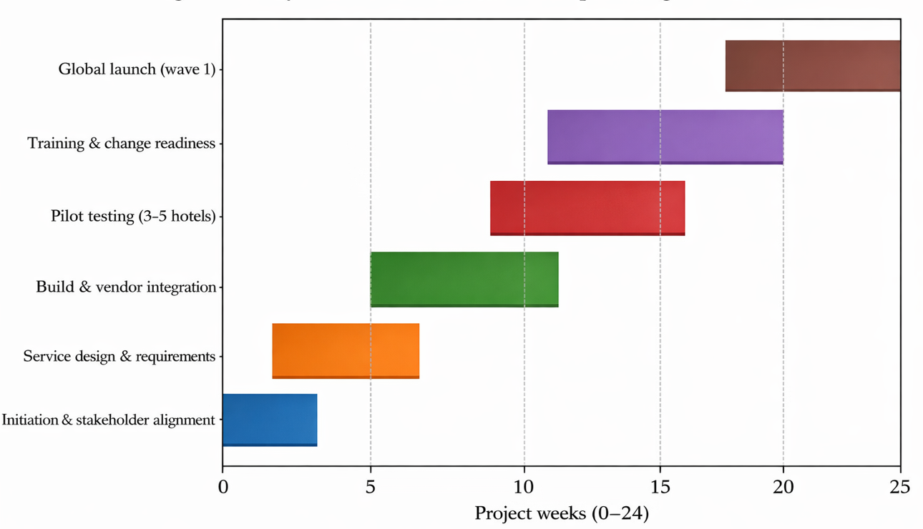
Figure 1: StaySmart+ six-month rollout plan (high-level)

2. Situational analysis

2.1. SWOT analysis for StaySmart
The following table is a summary of a SWOT analysis of the StaySmart+ initiative as it is positioned within the current IHG position.

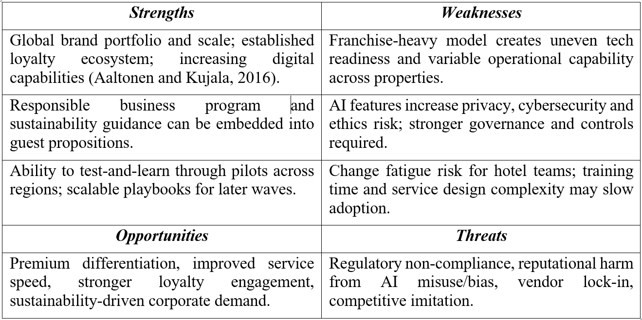

2.2. PESTLE analysis
The following table is a PESTLE analysis with areas of external drivers influencing adoption and strategic implication of stakeholder engagement in both local and international markets.
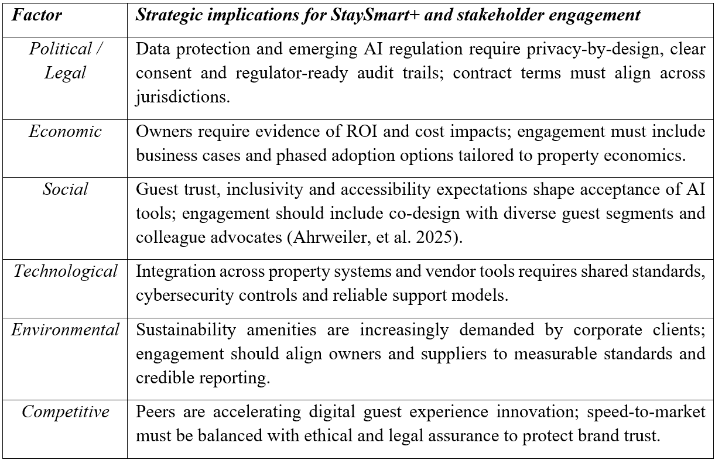

2.3. SMART Objectives
SMART goals demystify the objectives people would want to see and base stakeholder alignment. In the case of the six-month delivery window, the objectives are proposed as follows:
- Specific: Implement StaySmart+ in 50 pilot and wave-1 hotels in no less than 10 markets, spanning between the different brands and levels.
- Measurable: Around 60% adoption of digital services by all eligible guests, +5 point Net Promoter Score increase in pilot hotels, and 15 percent decrease in individual, single-use amenities compared to the baseline in participating hotels.
- Achievable: Use a modular rollout (core AI concierge + travel planning + sustainability menu) with local configuration within defined guardrails.
- Relevant: Enhance customer satisfaction, business excellence and brand distinction and uphold responsible business needs.
- Time-bound: Within 24 weeks: Finish the design, build, pilot, training and wave-1 launch, and hypercare, and lessons-learned review.

3. Identification and categorisation of key stakeholders
Stakeholders are people or groups that may influence or be influenced by the project decision, activities and result. The stakeholders in a worldwide hotel rollout include corporate governance, hotel operations, owners, guests, suppliers, regulators and local communities. Formalized identification process will minimize the likelihood of overlooking any concealed influences (e.g., owner asset managers, works councils or local authorities) and will assist in customizing engagement based on stakeholder anticipations and strength (Aaltonen and Kujala, 2016; Gorman, & Ward, 2023).
There are two complementary ways of categorizing the stakeholders. To start with, internal and external stakeholders: those internal are the corporate leadership, PMO, IT/data, hotel operations and colleagues, whereas the external ones are the owners, guests, corporate clients, vendors, communities and regulators. Second, global and local stakeholders: global stakeholders define policy and platform (e.g., AI governance), and local ones determine how adoption and operational implementation will take place in each market. Such two-fold classification is necessary since the same stakeholder group (e.g., the owners) may have various interests in different regions based on asset strategy, labour cost and competitiveness.

3.1. Stakeholder Register
The table below gives a condensed stakeholder register of StaySmart+.
Stakeholder | Type | Primary interest | Influence | Engagement need
Executive sponsor (C-suite) | Internal | Strategic alignment, risk appetite, funding | High | Governance, decisions, escalation
Global PMO / project team | Internal | Delivery, integration, benefits tracking | High | Daily coordination
Brand, marketing & loyalty | Internal | Guest value proposition, brand standards | Medium–High | Co-design messaging and offers
IT, data, cybersecurity & DPO | Internal | Architecture, privacy, security, data governance | High | Design authority and assurance
Hotel GMs (pilot and wave-1) | Internal | Operational feasibility, service KPIs | High | Operational co-design and readiness
Frontline colleagues | Internal | Workload, training, service quality, fairness | Medium | Training, feedback loops
Franchise owners / asset managers | External (owners) | ROI, capex/opex, brand compliance | High | Business case and adoption options
Technology vendors | External | Delivery obligations, SLAs, data processing | Medium | Contractual + agile delivery rituals
Guests (leisure & business) | External | Convenience, trust, accessibility, value | Medium | User research and consent design
Corporate clients / MICE | External | Sustainable meetings, reporting, experience consistency | Medium | Joint planning and reporting
Regulators (data/privacy, consumer) | External | Compliance, transparency, harms prevention | High | Pre-launch assurance and audit readiness
Local communities/NGOs | External | Local impacts, sustainability and jobs | Low–Medium | Transparent reporting and partnership
OTAs / travel agents | External | Distribution, accuracy of offers | Low–Medium | Integration and comms

3.2. Stakeholder Map
The following figure positions stakeholders through power-interest lens to prioritize engagement effort, and eliminate under-engagement of high risk stakeholders, like privacy regulators and cybersecurity teams.
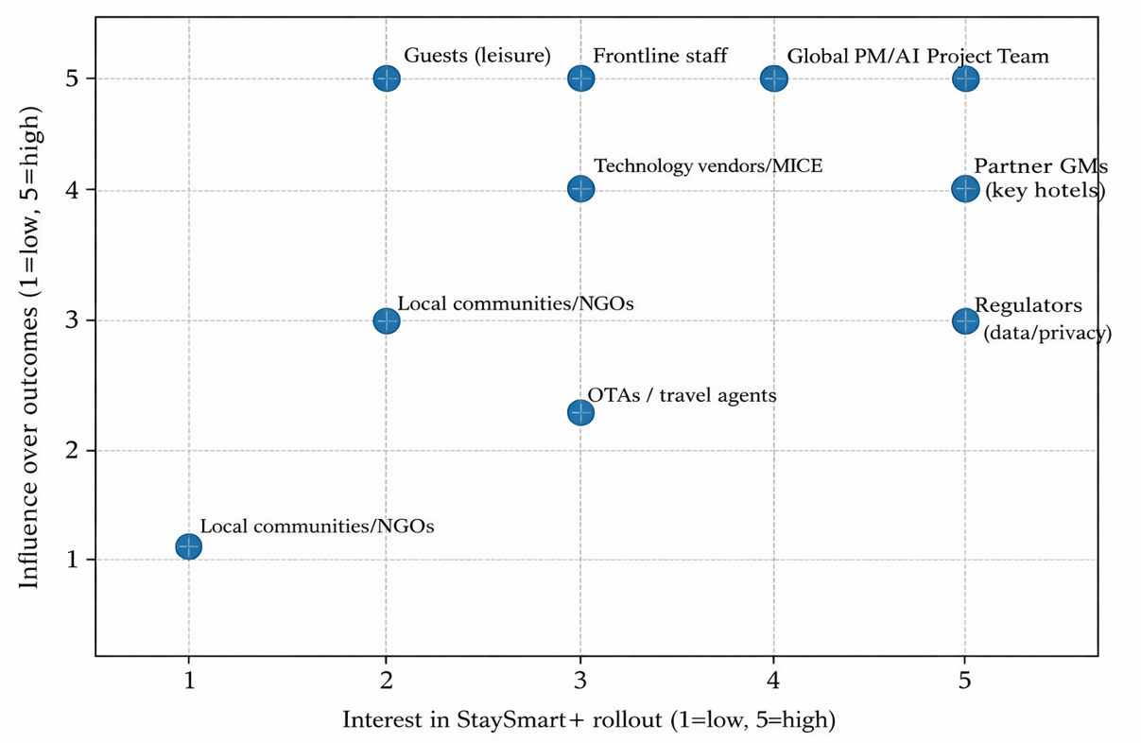
Figure 2: Stakeholder power–interest mapping (planned scores)

4. Roles, responsibilities, benefits and challenges for key stakeholders
Defining the roles and responsibilities of the stakeholders facilitates accountability and minimizes conflict during delivery. In franchise-based hospitality, the decision making of operations like staffing, change in process and local suppliers are normally controlled by the owners and the hotel management with the corporate functions supplying brand standards, platforms, marketing and assurance. This division may lead to a lack of congruence where stakeholders fail to hold a similar perception of value, risk and effort. To demonstrate proper engagement, it should be effective with a clear role design and transparent benefit narratives and early address concerns mechanisms (Bourne, 2016; Rabechini Jr and Monteiro, 2022).

4.1. Executive sponsors and Regional Leadership
Executive sponsors and regional leadership are strategic in their direction, as well as resource allocation and trade-offs (e.g., speed vs. assurance). They have the advantage of having greater brand differentiation and enhanced performance; their weakness is the competing priorities between regions and owners. The programme team (PMO) takes strategy and turns it into a deliverable plan, manages dependencies and scope; the issues that it faces is how to coordinate activities across multiple functions, vendors, and time zones.

4.2. Hotel General Managers and Department Heads
The key stakeholders in the adoption process are the hotel general managers and the heads of departments: they integrate StaySmart+ into daily operational habits, monitor service performance and influence behaviours of colleagues. They have the advantage of being more responsive and can be more productive; the problems involve training time, replacement of fatigue and service levels throughout the peak. The frontrunner colleagues provide the guest experience; their advantages may involve more transparent workflow and improved information to address problems, but the perceived surveillance concerns fairness and skill shortages as AI reassigns tasks can be encountered. It is necessary to engage therefore in psychological safety, training pathways, and feedback loops that can be seen to enhance day-to-day work.

4.3. Owners and Asset managers
Asset value and property economics are considered by the owners and asset managers. They gain when StaySmart+ boosts occupancy, ancillary spend and loyalty; they might oppose when the costs are obscure or when technology limits flexibility of the properties. It is therefore necessary to have transparent business cases, flexibility in adoption as well as the co-created implementation plans. Engagement should also include switching costs and integration with existing property systems where the owners have several brands.

External Stakeholders
The external stakeholders are also material. Affirmations of value are affected by guests and corporate clients; issues they care about are consent, transparency, accessibility and fairness in AI-enabled personalisation. Hospitality AI studies indicate that the core values of adoption are trust and perceived usefulness, and cultural values could affect readiness to use AI services (Rasheed et al., 2023). Investigations and penalties can have a material impact on the project risk due to regulators and data protection authorities. Mutually dependent and potentially risky in terms of data-processing convergence, vendor partners provide technical elements, yet they demand effective contracts, common standards and governance. Valences of reputation are affected by local communities and NGOs, particularly in situations where the sustainability claims are to be demonstrated and when labour conditions are questioned.

5. Frameworks, Models and Tools to Engage Stakeholders
The stakeholder involvement must be organized, supported with evidence and in accordance with the level of stakeholder influence and risk. The AA1000 Stakeholder Engagement Standard focuses on inclusiveness, materiality and responsiveness, suggesting organizations to incorporate engagement framework through governance and decision-making instead of acting as unilateral communications (Gorman, & Ward, 2023). Relationship-management-wise, the long-term value of stakeholder relations is also safeguarded through good engagement because it results in the growth of trust and a decrease of the costs of conflict (Ashcroft, et al. 2016). Project management advice also formulates engagement as an ongoing process throughout the lifecycle, integrating the analysis, planning, communications and monitoring (PMI, 2021).
(1) Power–interest mapping to prioritise effort.
(2) A stakeholder registers to record needs, benefits and risks.
(3) An engagement plan specifying objectives, methods and cadence.
(4) A communication plan clarifying channels, owners and feedback methods.
(5) A RACI matrix to make decisions explicit and reduce duplication.
Of critical importance is the fact that these tools should be seen as a living document. The stakeholder power may also change over the course of the project- such as, a vendor may gain more power in case of integration problems, and regulators may get very salient after a high profile breach in the industry. Thus, the project manager is to arrange regular stakeholder reviews at the end of every stage of a project (end of design, end of build, end of pilot, pre-launch) and revise engagement strategies respectively.

5.1. RACI Matrix
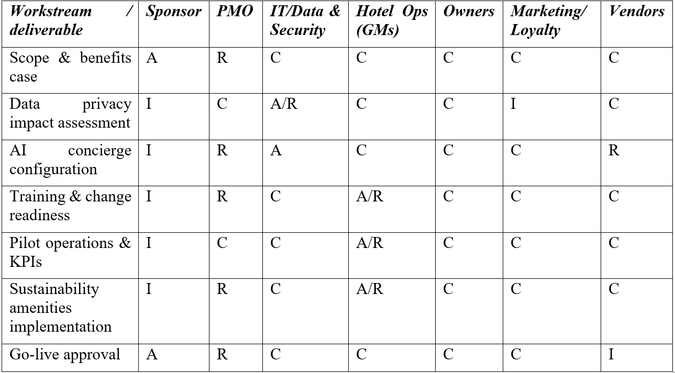
Key: R=Responsible; A=Accountable; C=Consulted; I=Informed (Brower et al., 2020).

5.2. Stakeholder Engagement Plan
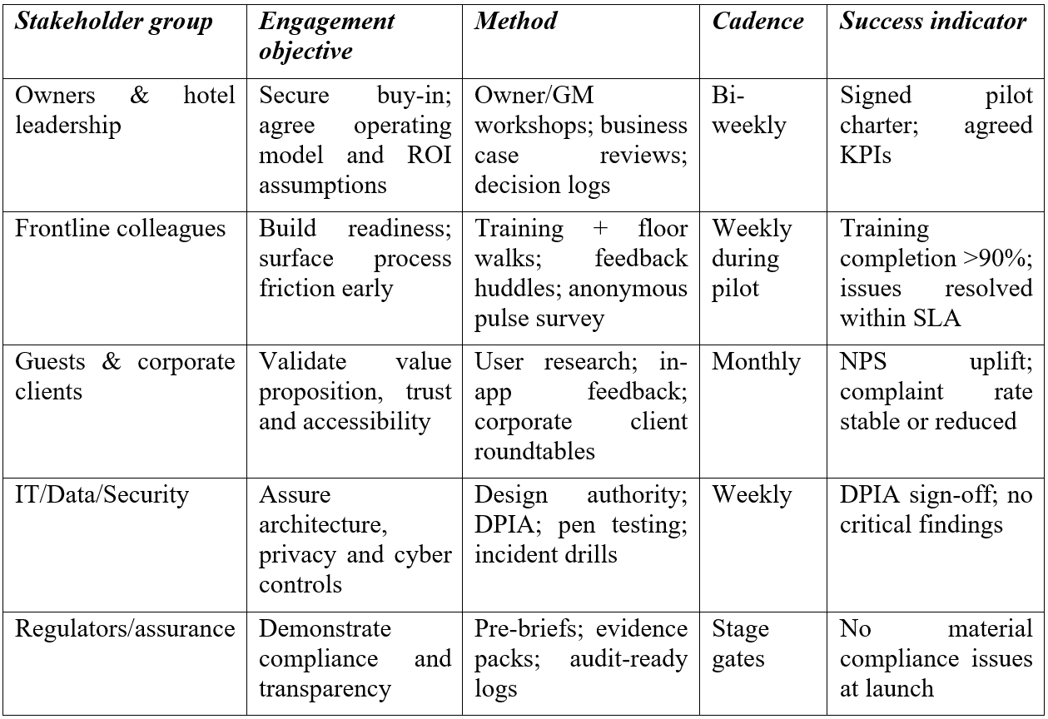

5.3. Communication plan
Audience | Key message | Channel | Owner | Frequency | Feedback / escalation
Hotel colleagues | What is changing, why it helps, how to use tools, where to report issues | Briefings; training; posters; intranet; shift huddles | Hotel GM + Change Lead | Weekly | Huddle feedback; anonymous form; ticketing system
Owners | Benefits case, cost profile, compliance assurances, timeline and decision points | Webinars; dashboards; owner forums | Sponsor + PMO | Bi-weekly | Q&A log; escalation to steering group
Guests | Value, transparency, consent and control options, sustainability choices | App prompts; website FAQs; front desk scripts | Marketing + Hotel Ops | Always-on | In-app rating; complaints tracking
Vendors | Integration priorities, SLAs, data-processing rules, test schedule | Agile ceremonies; technical forums | IT Delivery Lead | Weekly | Issue tracker; contract governance
Regulators/assurance | Evidence of compliance and risk controls | Assurance pack; stage-gate meetings | DPO/Legal | At gates | Findings log; remediation plan

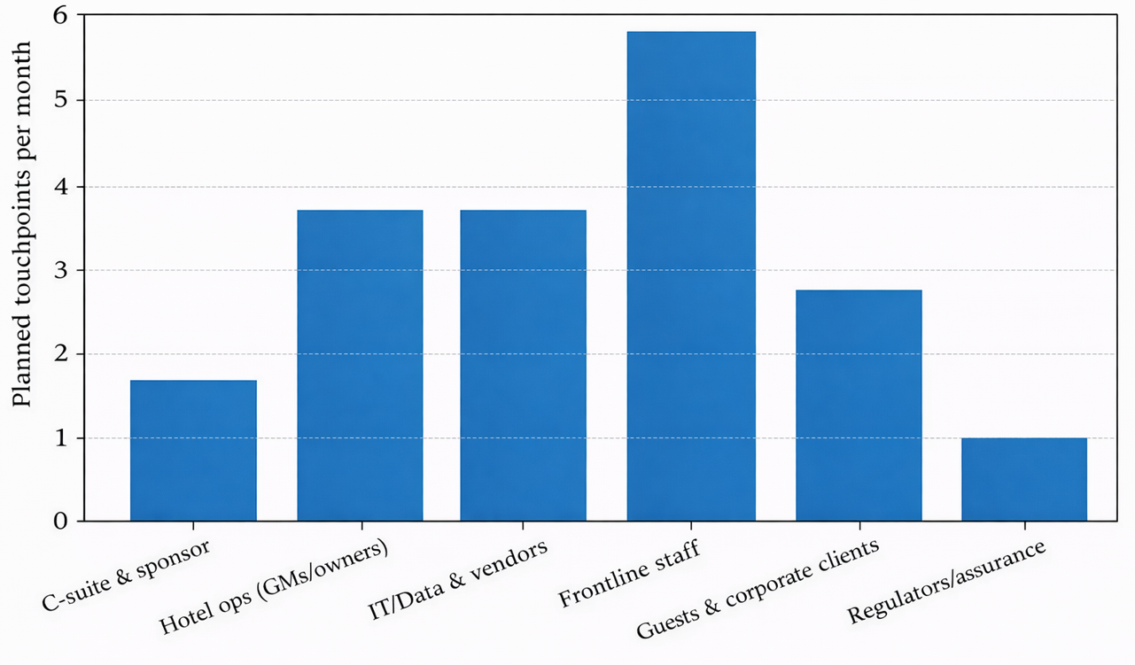
Figure 3: Communication cadence by stakeholder group

6. Stakeholder engagement process and conflict management using the 4Cs model
The main role of the project manager will be to create an environment that allows the stakeholders to work well together by matching expectations, developing trust, minimizing uncertainty and motivating early issue escalation that can impact the design decisions. When it comes to a global hospitality roll out like StaySmart+ this is challenging due to the cultural diversity, the structure of franchising and the space between the technological maturity across the regions. It has been found that stakeholder relationships change over time in a project lifecycle, i.e. engagement strategies should be constantly adjusted to the behavior of stakeholders and the situation at hand (Aaltonen, Kujala and Havela, 2015; Aaltonen and Kujala, 2016).
To operationalized engagement, this report uses the 4C model, which is Communication, Consultation, Collaboration and Commitment, as a behavioral pattern that can be repeated within the project rituals and stage gates. The model does not replace such standards of formal governance like AA1000; instead, it supplements them (Gorman and Ward, 2023).
Clarity and transparency are created by communication (weeks 0 -4). The project will start with a stakeholder discovery sprint to refresh registers, clarify review the decision rights and announce a succinct case of change on what the project is about, why it is important and how operations will change. This communication has to be two-way: leadership establishes direction and risk appetite by controlling groups and sponsors, and local stakeholders express issues of workload, guest experience, data usage, and property economics. Local briefings and service walkthroughs will put strategy into operational context and culturally adapted messaging will make sure that it is relevant in every region.
Evidence-based design is supported by consultation (weeks 210). The owner and general manager workshops, frontline focus groups and guest co-design sessions provide inputs that are used to develop features in the system. In the case of AI-enabled tools, consultation makes it clear what data is being gathered, its purpose, and its point of human control. The use of privacy-by-design approaches, such as Data Protection Impact Assessments, access controls, and data minimization, will help to respond to the concerns of the stakeholders and minimize the risk of redesigning (European Union, 2016). Other stakeholders such as legal, cybersecurity, and compliance stakeholders are consulted at an early stage to ensure delivery timelines are maintained.
The input is then translated into action by collaboration (weeks 6-18). It includes cross-functional teams of operations, IT specialists and vendors in the development of pilots and service scripts to eliminate tensions between corporate and property teams and transform pilot hotels into learning partners. The coordination is enhanced by shared artefacts like decision logs, backlogs and service blueprints. In the case where silence is confused with agreement (where cultural norms discourage open feedback), anonymous channels ensure silence is not confusing by agreement.
Sustainable adoption is achieved through commitment (weeks 1424). Organisational commitment is manifested in signed go-live criteria, negotiated KPIs and structured training. The support of the owner is solidified in pilot charters and cost-benefit agreements, and the employees demand development opportunities, which indicate that they invest in their skills and not automation to replace judgement. Commitment is observed by the guests due to open consent choices, the explanation of the features of AI being transparent, and the availability of opt-outs. On the outside, auditing-ready reports show accountability and enhance the level of governance (Canton, 2021; European Union, 2024).
Stakeholder engagement is problematic despite its value. It is time-consuming, there is a threat of and even stakeholder burnout when the feedback is not considered, and that conflicts are exposed like cost limits and marketing ambitions. Project managers should thus make sure that there is transparency regarding the decisions that can be influenced and the method of trade-offs (PMI, 2021). Voice may also be constrained by cross-cultural dynamics and therefore, mixed methods, anonymous channels and neutral facilitation assists to balance voices. The international guidance also highlights the importance of local ownership and stakeholder inclusion as the key to maintaining the results in cases when a project has an impact on a community or an environment (UNDP and UNWTO, 2018).
The aspect of ethics is critical since StaySmart+ depends on personalisation based on the AI. Adoption requires the impression of usefulness, confidence, and access to human assistance in case technology malfunctions (Ivanov et al., 2019; Lu et al., 2020). The acceptance of AI services is also affected by cultural values and emotions (Rasheed et al., 2023). Such risks as algorithmic bias, manipulative design, excessive data collection can be reduced by the help of many testing groups, auditing of fairness, transparency of disclosure and design reviews that are led by stakeholders, responsible innovation can be promoted in the way the stakeholders expect.
Ethical issue | Stakeholders affected | Risk to project/brand | Mitigation through engagement and controls
Privacy and consent in personalised AI features | Guests; corporate clients; regulators | Loss of trust; regulatory penalties | DPIA, clear opt-in/opt-out, data minimisation, transparent FAQs and staff scripts (European Union, 2016).
Bias and inclusion | Guests; frontline staff | Reputational harm; discrimination claims | Diverse testing panels, bias checks, human override, complaint pathways (Canton, 2021).
Transparency and explainability | Guests; regulators; hotel staff | Complaints and mistrust | Clear disclosures that AI is used, plain-language explanations, escalation to human support.
Workforce impact and surveillance perceptions | Colleagues; unions/works councils | Resistance, industrial relations risk | Co-design workflows, consult employee reps, limit monitoring to necessary metrics, training and job enrichment.
Greenwashing risk in sustainability claims | Guests; NGOs; corporate clients | Credibility loss; client churn | Measurable standards, evidence-based reporting, supplier assurance, alignment to responsible business commitments (InterContinental Hotels Group, 2025c).

7. Impact of stakeholder engagement on business performance and recommendations
Participation by the stakeholders impacts the business performance in three ways; (1) enhancing design quality by integrating operational insight and customer insight; (2) improving adoption by minimizing uncertainty and resistance; (3) minimizing downside risk by compliance, ethical assurance and reputational protection. The latter mechanisms are particularly applicable to the situation of digital service launch where value is conditioned by the stable utilization of touchpoints, and the failure can propagate quite rapidly.
To start with, involvement enhances the service design. Process knowledge, such as the bottlenecks of check-in at its peak time, local language requirements, or accessibility, which could be unseen by the corporate teams, is given by frontline colleagues and hotel leaders. The co-design of the stakeholders boosts perceived usefulness and decreases workarounds that spoil the experience. The guest and corporate client engagement also makes sure that the aspects of personalisation are viewed as useful but not intrusive. The recent studies in the areas of hospitality and tourism show that the application of AI and levels of trust depend on the perceived benefits and the context-specific aspects like culture, customer expectations and transparency (Kim et al., 2024; Rasheed et al., 2023).
Second, participation results in adoption and realisation of benefits. The decision to make a new service to be included in the operating system or a superficial brand requirement is mostly dictated by the owners and GMs in a franchise context. Formal involvement (business cases, pilots, mutual KPIs and local modification on guardrails) will raise commitment. To colleagues, engagement can help in capability building or psychological safety, which will decrease the chances of technology rejection. In the case of guests, involvement enhances transparency, mastery and satisfaction, a factor that fosters loyalty and repetition. This aligns with industry trends of integrating AI into travel planning and digital journeys with the guest-IHG has officially collaborated to develop an AI-based travel planner, using Google Cloud AI (Google Cloud, 2024). The scholarly literature on generative AI in the tourism sector also indicates that personalisation combined with transparency and control by the user enhances value, which supports a stakeholder-based design (Abdalla, et al. 2026).
Third, interactivity lessens risk and safeguards brand loyalty. The protection of data and AI governance is a fast-evolving concept. The timely and sustained consultation with privacy, security and legal stakeholders permits compliant design within the delivery schedule instead of the expensive re-work at the end of the delivery schedule. Community and NGOs interactions also assist in making sure that sustainability amenities and communications are not exposed to greenwashing and concur to plausible keyboards. Initiatives of global industry also tend to focus more on quantifiable hotel sustainability fundamentals (WTTC, 2023). Thus, it is recommended that suppliers and owners should be involved in agreeing on measurable sustainability results and documenting the evidence which should be presented by corporate clients.
The quality of relationship also impacts the revenue based on the stakeholder engagement. Corporate customers are more demanding sustainability-related reporting in events and stays; the alignment of owners, procurement and operations based on plausible sustainability facilities has the capacity to enhance the MICE business win rates and to decrease churn.
Table 1: KPI scorecard for StaySmart+
KPI dimension | Metric | Target (pilot) | Stakeholder owner
Adoption & experience | Digital service usage among eligible guests | ≥60% | Marketing/Loyalty + Hotel Ops
Adoption & experience | Net Promoter Score (NPS) change vs baseline | +5 points | Hotel Ops
Operations | Average response time to common guest requests | −10% vs baseline | Hotel Ops + IT
People | Training completion for impacted colleagues | ≥90% | HR/Change lead + Hotel Ops
Compliance & ethics | Number of material privacy/security incidents | 0 | IT/Security + DPO
Compliance & ethics | AI governance gate completion (DPIA + fairness check) | 100% pre-launch | IT/Data + DPO
Sustainability | Reduction in selected single-use amenity items | −15% vs baseline | Sustainability + Procurement + Hotel Ops
Commercial | Incremental loyalty engagement (active users in pilot hotels) | +10% vs baseline | Marketing/Loyalty
Recommendations to strengthen future stakeholder engagement:
- Globalize a digital rollout stakeholder engagement playbook. Turn case the artefacts of StaySmart+ (register, engagement plan, communication plan and RACI) into templates enabled by training of regional and hotel teams, oriented on the AA1000 principles of inclusivity and responsiveness (Gorman, & Ward, 2023).
- Enhance AI and data control as a company guarantee feature. Implement a standard privacy/ethics gate (DPIA, vendor due diligence, transparency scripts and monitoring) in order to ensure the speed of the innovation does not negatively affect the trust or compliance (European Union, 2016; European Union, 2024).
- Establish value alignment using incentives and value cases that are owner-aligned. Give segmented business cases by hotel and region and think about both shared funding or performance-based incentives to promote adoption in the franchise system.
- Embed colleague voice and change readiness into delivery cadence. Use regular pulse checks, local champions and continuous improvement loops during pilots, and demonstrate visible action on feedback to sustain commitment and reduce change fatigue.

8. Conclusion
StaySmart+ is a strategically topical project that could enhance the experience of the premium guests of IHG with the help of AI-enabled communication, customisation planning, and sustainability-related services. The success of the project is however hinged on the involvement of stakeholders in the complex worldwide ecosystem of owners, hotel operations, colleagues, guests, regulators and technology partners. This report has defined and classified the key stakeholders, identified their roles and concerns and used the well-known stakeholder engagement criteria and the project management guidelines to suggest the feasible engagement mechanisms.
The offered toolkit, which includes stakeholder mapping, register, engagement and communication plans, and a RACI matrix, ensures the use of uniform governance and local adaptation in the markets. The 4Cs engagement strategy offers a successively repeatable method to establish trust, uncover problems at an early stage, work together through delivery and achieve buy-in at launch. Most importantly, both ethical and legal implication of AI and data utilization entails preemptive action and fact-based curbs to guard brand confidence.
Finally, through the stakeholder engagement of high quality the business performance is enhanced due to the enhanced adoption which leads to better service quality and less risk. Through the institutionalization of the suggested playbooks, assurance gates and engagement metrics, IHG will be able to increase its ability to bring forth future global service innovations in a much more aligned, faster learning and more sustainable fashion.

References
Aaltonen, K., & Kujala, J. (2016). Towards an improved understanding of project stakeholder landscapes. International journal of project management, 34(8), 1537-1552.
Aaltonen, K., Kujala, J., Havela, L., & Savage, G. (2015). Stakeholder dynamics during the project front-end: the case of nuclear waste repository projects. Project management journal, 46(6), 15-41.
Abdalla, S., Liu, Y. L., Temerak, M. S., & Jiang, H. L. (2026). Generative AI Applications in the Tourism Industry: Opportunities and Challenges. Unleashing User Innovation, 241-253.
Ahrweiler, P., Späth, E., Siqueiros García, J. M., Capellas, B. L., & Wurster, D. (2025). Inclusive technology co-design for participatory AI. Participatory Artificial Intelligence in public social services: From Bias to fairness in assessing beneficiaries, 35-62.
Ashcroft, J., Childs, R., Myers, A., & Schluter, M. (2016). The relational lens: Understanding, managing and measuring stakeholder relationships. Cambridge University Press.
Bourne, L. (2016). Stakeholder relationship management: a maturity model for organisational implementation. Routledge.
Brower, H. H., Nicklas, B. J., Nader, M. A., Trost, L. M., & Miller, D. P. (2021). Creating effective academic research teams: Two tools borrowed from business practice. Journal of clinical and translational science, 5(1), e74.
Canton, H. (2021). Organisation for economic co-operation and development—OECD. In The Europa directory of international organizations 2021 (pp. 677-687). Routledge.
European Union (2016) Regulation (EU) 2016/679 (General Data Protection Regulation). Official Journal of the European Union. Available at: https://eur-lex.europa.eu/eli/reg/2016/679/oj
European Union (2024) Regulation (EU) 2024/1689 (Artificial Intelligence Act). Official Journal of the European Union. Available at: https://eur-lex.europa.eu/eli/reg/2024/1689/oj/eng
Farooq, M. B., Zaman, R., & Nadeem, M. (2021). AccountAbility’s AA1000AP standard: a framework for integrating sustainability into organisations. Sustainability Accounting, Management and Policy Journal, 12(5), 1108-1139.
Google Cloud (2024) IHG Hotels & Resorts builds a new travel planner powered by Google Cloud AI. Press release, 9 April. Available at: https://www.googlecloudpresscorner.com/2024-04-09-IHG-Hotels-Resorts-Builds-a-New-Travel-Planner-Powered-by-Google-Cloud-AI
Gorman, L., & Ward, A. M. (2023). Accountability. In Encyclopedia of Sustainable Management (pp. 22-28). Cham: Springer International Publishing.
InterContinental Hotels Group (2025b) Responsible Business Report 2024 and performance data. Windsor: IHG PLC. Available at: https://www.ihgplc.com/~/media/Files/I/Ihg-Plc/investors/annual-report/2024/ihg_rbr_24-25_interactive.pdf
InterContinental Hotels Group (2025c) Update on Carbon & Energy – transcript (18 February 2025). Windsor: IHG PLC. Available at: https://www.ihgplc.com/~/media/Files/I/Ihg-Plc/results/2025/full-year-2024/update-on-carbon-energy-transcript.pdf
ISO (2018) ISO 31000:2018 Risk Management—Guidelines. Geneva: International Organization for Standardization. Available at: https://www.mastercontrol.com/uk/compliance/iso14971/?utm_campaign=7013x00000248QtAAI&utm_medium=Online-Ads&utm_source=GO&utm_campaign=7013x00000248QtAAI&utm_medium=Online-Ads&utm_source=GO&gad_source=1&gad_campaignid=14638849800&gbraid=0AAAAAD8-olYF50TZMizvvCh4HfRfDPgNr&gclid=CjwKCAiA-sXMBhAOEiwAGGw6LMFfjCOemwSpIBp0z9qjXeH0W7qDqpsN02xgSn7ozfiRL58d7Rrc9xoCQcAQAvD_BwE
Ivanov, S., Gretzel, U., Berezina, K., Sigala, M., & Webster, C. (2019). Progress on robotics in hospitality and tourism: a review of the literature. Journal of Hospitality and Tourism Technology, 10(4), 489-521.
Kim, H., So, K. K. F., Shin, S., & Li, J. (2025). Artificial intelligence in hospitality and tourism: Insights from industry practices, research literature, and expert opinions. Journal of Hospitality & Tourism Research, 49(2), 366-385.
Kukanja, M., & Planinc, T. (2025). Adoption of Artificial Intelligence in Micro and Small Hospitality Enterprises: The Role of Organisational Characteristics and Managers’ Attitudes Toward AI in Relation to Operating Revenues. Tourism and Hospitality, 6(5), 268.
Lew, S., Tan, G. W. H., Loh, X. M., Hew, J. J., & Ooi, K. B. (2020). The disruptive mobile wallet in the hospitality industry: An extended mobile technology acceptance model. Technology in society, 63, 101430.
Lu, V. N., Wirtz, J., Kunz, W. H., Paluch, S., Gruber, T., Martins, A., & Patterson, P. G. (2020). Service robots, customers and service employees: what can we learn from the academic literature and where are the gaps?. Journal of Service Theory and Practice, 30(3), 361-391.
PMI (Project Management Institute) (2017) A Guide to the Project Management Body of Knowledge (PMBOK Guide) – Sixth Edition. Newtown Square, PA: PMI.
PMI (Project Management Institute) (2019) The Standard for Risk Management in Portfolios, Programs, and Projects. Newtown Square, PA: PMI.
PMI (Project Management Institute) (2021) A Guide to the Project Management Body of Knowledge (PMBOK Guide) – Seventh Edition. Newtown Square, PA: PMI.
Rasheed, H. M. W., Chen, Y., Khizar, H. M. U., & Safeer, A. A. (2023). Understanding the factors affecting AI services adoption in hospitality: The role of behavioral reasons and emotional intelligence. Heliyon, 9(6).
Rodríguez-García, R., Ferrero-Ferrero, I., & Fernández-Izquierdo, M. Á. (2023). Analysis of integration of sustainability in sustainability certifications in the hotel industry. Frontiers in Sustainability, 4, 1116359.
Tussyadiah, I. (2020). A review of research into automation in tourism: Launching the Annals of Tourism Research Curated Collection on Artificial Intelligence and Robotics in Tourism. Annals of tourism research, 81, 102883.
UNDP and UNWTO (2018) Tourism and Sustainable Development Goals—Journey to 2030: Guidelines for Project Planning. New York/Madrid: UNDP and UNWTO. Available at: https://www.undp.org/sites/g/files/zskgke326/files/publications/UNWTO_UNDP_Tourism%20and%20the%20SDGs.pdf

