University of Wales Trinity Saint David
Managing people
Assessment 1

STUDENT NAME: Aygyul Shakirova, ID 1818045

Ze Zook

2020

CONTENT
Introduction..............................................................................................................3
1. What does it mean to be a human resources specialist according to CIPD - the new profession map?.…………………………………………………………………………………………3
2. Explanation, analyzes and evaluates the HR processes- workforce planning, recruitment and selection………………………………………………………………………………….7
3. An overview of how these processes (planning, recruiting and selecting employees) are executed at Sainsbury’s..……………………………………………………………11
Conclusion………………………………………………………………………………………………………….12
References………………………………………………………………………………………………………….13

Introduction
This report includes the following main aspects:
- What does it mean to be a human resources specialist according to CIPD - the new profession map?;
- Explanation, analyzes and evaluates the HR processes- workforce planning, recruitment and selection;
- An overview of how these processes (planning, recruiting and selecting employees) are executed at Sainsbury’s.

- What does it mean to be a human resources specialist according to CIPD - the new profession map?

Armstrong and Taylor (2017, p.4) state that “Human resource management (HRM) is concerned with all aspects of how people are employed and managed in organizations.”
Employees play a key role in the successful implementation of the organizational strategy, on the other hand, the HR strategy plays the main role in supporting them in the process of successful perform to this organizational strategy (Torrington et al., 2014).
From the above information it is clear that the most valuable asset of any organization are its employees, i.e. human resources, and therefore human resources specialists are essential for all organizations, as the work of these specialists covers all aspects related to the employment and to the way in which these employees are managed in this organization.
And these facts show the importance and significance of describing, analyzing, and evaluating what it really means to be human resources professional.
Baczor (2015) states that: “HR professionals must build their trust and credibility by showing capability and courage to challenge accepted practice, and offer business leaders a range of critical perspectives on how to create sustainable organisational value through people.”
An important aspect of what it is like to be a human resources specialist can be emphasized from her speech - the ability to create value for the organization through its workforce.
All human resources professionals, in order to build their ability to support the success of employees in the implementation of organizational strategy, must acquire and practice basic standards related to the main purpose, to the categories of professional values and to core knowledge, core behavior and specialist knowledge that are included in “the new professional map” (LJMU, 2020).
CIPD provides to us "profession map" for better understand the “international benchmark” for the HR professionals (LJMU, 2020).

“The new profession map" image, shown below, demonstrates the structure of this map:
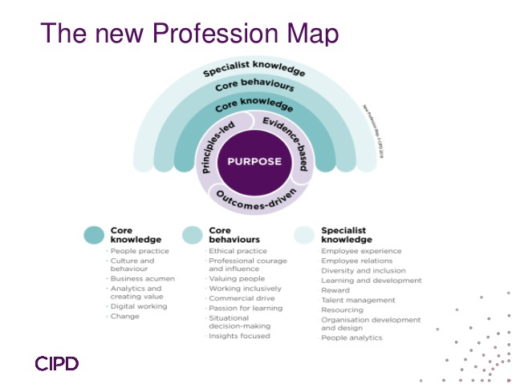
(LJMU, 2020)

For a better description and assessment of what it means to be an HR specialist, the elements of the structure of this new profession map should be analyzed.
In the center of this map is purpose and it describes what the main purpose of the human resources specialist is -to promote “better work” and “a better working life” ( LJMY, 2020).

Next cycle in this map shows the three main categories of professional values (Mac Court, 2020):
- “Principles -led” - There are “three key principles” that aim to determine “good decision-making, regardless of the context”:
- First principle – “Work matters”;
- Second principle – “People matter”;
- Third principle – “Professionalism matters”.
- “Evidence – based” - This category emphasizes the importance of “evidence-based” decision-making in order to achieve better professional judgment, this “professional opinion” must be combined with the following:
- “Behavioural science and academic research” –“independent research”, “reviews” and “benchmarks” are tools to better understand organizations;
- “Organisational data” - By analyzing people, professionals can better understand the workforce related to these aspects: “skills gaps, areas of unique experience, and employee engagement levels”;
- “Practitioner expertise”- basic skills must be formed through which the professional can process his insights into practically effective solutions.
- “Outcomes-driven” - the results of the professionals must be focused on the main purpose-“better work” and “a better working life”.

The other cycle of this map describes the “core knowledge” that an hr specialist must has (Mac Court, 2020).
Mac Court (2020) states that: “Core knowledge - the map outlines six core areas of knowledge to help drive change, create value and positively impact the world of work, these areas are relevant to all HR and people professionals and set out everything you need to be an effective practitioner — whatever your role or specialism:”
- “People practice;”
- “Culture and behaviour;”
- “Business acumen;”
- “Analytics and creating value;”
- “Digital working;”
- “Change.”

The next cycle of the map indicates the “core behaviors” that every human resources professional should practice.
“Core behaviors” - these core behaviors provide universal and standard “ways of thinking and acting”, even in frequently changing situations, that help the HR professional to be a more effective professional, these behaviors are related to the following aspects (Mac Court, 2020):
- “Ethical practice;”
- “Professional courage and influence;”
- “Valuing people;”
- “Working inclusively;”
- “Commercial drive;”
- “Passion for learning;”
- “Insights focused;”
- “Situational decision-making;”

The last cycle of this map is about “specialist knowledge” of hr specialist.
“Specialist knowledge”- this includes specialized areas in which human resources professionals have the opportunity to develop at any level they occupy, these areas are related to the following (Mac Court, 2020):
- “Employee experience;”
- “Employee relations;”
- “Diversity and inclusion;”
- “Learning and development;”
- “Organisation development and design;”
- “People analytics;”
- “Resourcing;”
- “Reward;”
- “Talent management.”

- Explanation, analyzes and evaluates the HR processes- workforce planning, recruitment and selection

For each organization there are several important “human resources processes” such as: workforce planning, recruitment and selection of staff and talent management - as the successful management of these processes by the resource specialist determines whether the organization will have capable employees, who have the necessary skills and in the right moment for the successful implementation of the organizational strategy ( CIPD, 2020).

  - Workforce planning

Armstrong and Taylor (2017, p.238) shares this definition by CIPD: “Workforce planning is a core process of human resource management that is shaped by the organizational strategy and ensures the right number of people with the right skills, in the right place at right time to deliver short – and long – term organizational objectives”.
From the above information it is clear that human resources professionals must devote the necessary time and attention to process of workforce planning to ensure the most accurate and comprehensive implementation of the organizational strategy on the way to achieving the organization’s goals. That is why it is important for the human resources specialist to perform professionally and completely all stages of the workforce planning process.

The image below demonstrates the stages of workforce planning:
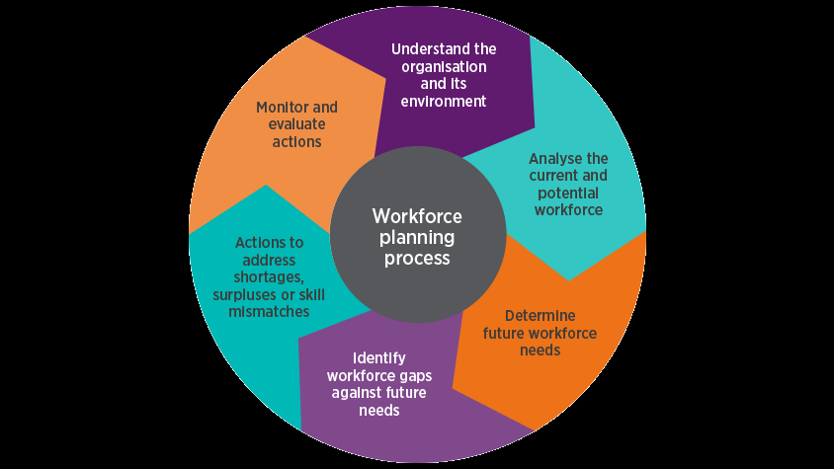
(Weeks, 2020)
The business environment is quite variable and organizations quite often adapt their strategies and practices in accordance with the relevant changes (Armstrong and Taylor, 2017).
Therefore, it is very important to know and implement the "key points of action" for the successful implementation of the human resources planning process.
Weeks (2020) indicate the “key points of action in workforce planning”:
- it must be future-oriented in order for the organization to implement its strategy;
- it must be able to cope with constant changes by being quite flexible and adaptable;
When drawing up a workforce plan, professionals should keep in mind (Weeks,2020):
- “Inputs to the plan” - to analyze whether the data in the organization are of good quality and to highlight the important information;
- “Communication” – to helping managers to follow the plan and “using appropriate language and data”;
- “Measurement and evaluation” –to define the criteria and tools for measuring the level of success of the plan and to answer questions about how this plan will be considered and updated;

  - Recruitment
Armstrong and Taylor (2017, p.248) state that:” Recruitment is the process of finding and engaging the people the organization needs. Selection is that part of recruitment process concerned with deciding which applicants or candidates should be appointed to jobs”.
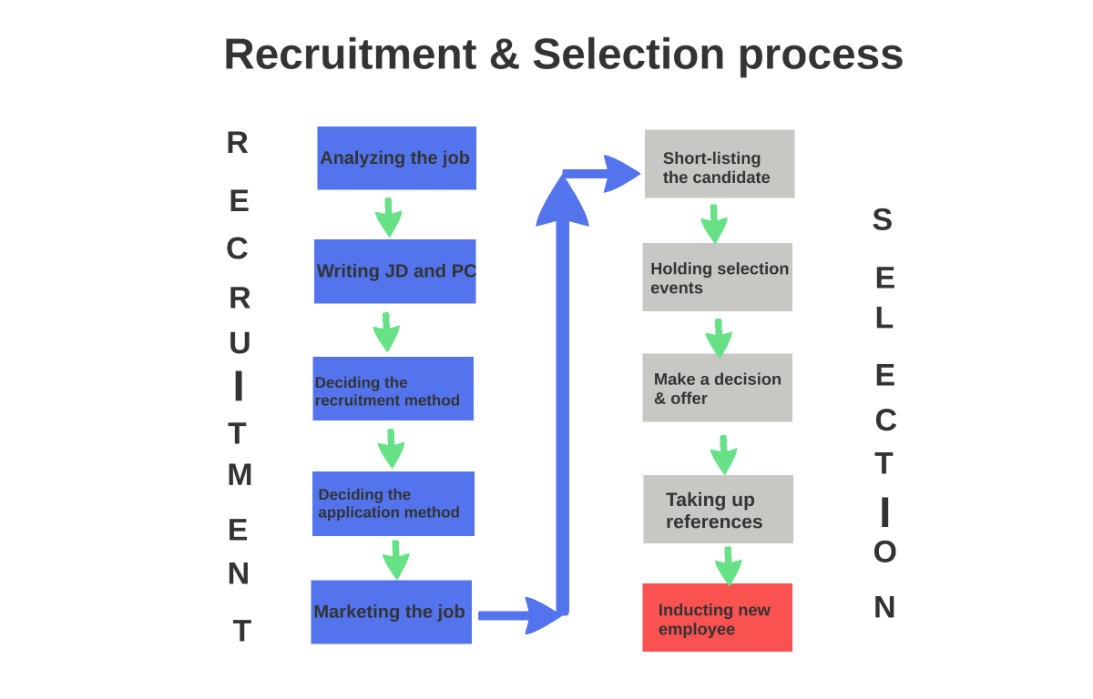
(Prezi, 2020)
“Job analysis” – in this first stage should be collected the information related to the following pain points: (Green, 2020):
- “The job’s purpose and what duties are involved”;
- “How and where it could be carried out”;
- “What outputs would be expected of the jobholder”;
- “How it fits into the organisations’ structure”.
“Writing JD and PC” – in this stage after collecting and analyzing the information above, it will be applied in the job description and the person specification (Green, 2020).
“Deciding the recruitment method and deciding the application method” – in those next stages job postings should provide detailed information on the following (Green, 2020):
- “Job description and person specification”;
- “Job location”;
- “Type of employment offered - for example, is it a fixed-term role?;”
- “The organisation’s activities and values”;
- “Reward and benefits package”;
- “Flexible working opportunities, where available”;
- “Details of how to apply and the deadline”.
Two types of recruitment method (Green, 2020):
- “External recruitment” - when the candidate is sought outside the organization;
- “Internal recruitment” - when it is possible for employees who have already been employed in the organization to be reassigned to other positions;
“Marketing Job” - in this last stage of recruitment process the hr specialist is identifying “common ways of attracting candidates including the employer’s website, commercial job boards, recruitment agencies, professional networking sites such as LinkedIn, local jobcentre and using local networks” (Green, 2020).
  - Selection
“Short -listing the candidate” – In this stage of selection process after reviewing the applicant's CVs and “applications forms” the hr specialist decides who has the necessary qualities to move to the next level of assessment (Green, 2020).
“Holding selection events”- this stage include the implementation of “assessment using interviews, psychometric testing and assessment centres” (Green, 2020).
“Make a decision & offer and taking up references” - before the applicant is formally employed, he must be subject to checks related to “recommendations from the applicant's previous employer, the reports must contain factual information such as: duration of past employment, position, brief details of responsibilities, overall presentation, time retention and reason for leaving”. But the final decision should not be based solely on references (Green, 2020).

The image below shows the “internal and external factors that influence the recruitment process” (HR, help board, 2017):
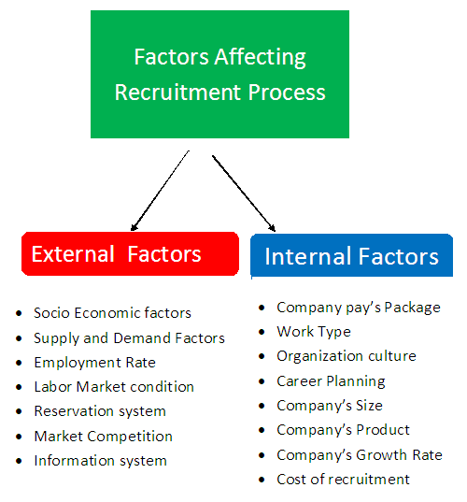
(HR, help board, 2017)

- An overview of how these processes (planning, recruiting and selecting employees) are executed at Sainsbury’s

  - Workforce planning process in Sainsbury’s
Angie Risley, who is Group HR Director in Sainsbury’s, in Annual report from 2019 states that:
“We want to be a place where people love to work and shop. That means harnessing the talent, creativity and diversity of our colleagues to ensure that customers receive great service every time they shop with us”.
Through various apprenticeship programs, Sainsbury’s prepares its talents with the necessary skills and knowledge to implement its business strategy. In these programs, employees acquire knowledge related to “traditional food crafts such as bakeries, butchers and fish, for retail sale and skills such as hospitality and merchandising, business skills such as analytics, cyber security, finance, risk, software and supplies chain management. 120 Argos at Sainsbury’s apprentices develop skills in areas of management of the data analysis team and 15 employees from Sainsbury’s Complete Bank modern apprenticeship with Microcom” ( Annual report, 2019).
  - Recruitment and selection process in Sainsbury’s
Recruitment - Sainsbury’s advertises their vacancies on its website and candidates can send their CVs and fill out an online application (Sainsbury’s, 2020)
Selection
Applying online is followed by an “online assessment” that includes “a verbal or numerical reasoning test, a personality questionnaire or a situational judgement test” (Sainsbury’s, 2020).
The next step in selection process is related to choose whose candidates will continue in interview stage and to sending e-mail for those candidates (Sainsbury’s, 2020).
The fourth and fifth part of the selection process is related to conducting an online interview and to announcing the results in a few days (Sainsbury’s, 2020).
The sixth part of the selection process is: “Final stage assessment – Recruiters may invite the candidate to a second interview or evaluation phase (this is usually only for roles in the store support center). This may include an exercise such as a presentation or case study - something that is relevant to the role candidate is applying” (Sainsbury’s, 2020).
The last part of the selection process is: “Decision time!” -The Sainsbury’s recruitment team selects the successful candidates and notifies them by email of the result (Sainsbury’s, 2020).
Conclusion
“CIPD - The new profession map” provides a standard for the nature of all human resources professionals, regardless of the level and type of organization in which they operate.
The successful performing by the human resources specialist of the three processes - planning, recruitment and selection of labor is a key factor for the successful implementation of the business strategy on the way to achieving the main goals of the organization.
Sunbury’s is an example of successfully implementing a strategy on the way to achieving its goals thanks to the well-executed processes of planning, recruitment and selection of labor.
References
- Armstrong, M., Taylor, S. (2017) Armstrong's Handbook of Human Resource Management Practice. 14th edn. Kogan Page.
- Annual report (2019) Sainsbury’s - Live well for less. Online. Available at: https://www.about.sainsburys.co.uk/~/media/Files/S/Sainsburys/documents/reports-and-presentations/annual-reports/sainsburys-ar2019.pdf
- Baczor, L. (2015) How do you define professionalism in HR? , CIPD – Community. Online. Available at: https://www.cipd.co.uk/Community/blogs/b/research-blog/posts/how-do-you-define-professionalism-in-hr#:~:text=HR%20professionals%20must%20build%20their,on%20Profession%20for%20the%20Future
- CIPD (2020) Resourcing-roles. Online. Available at: https://www.cipd.co.uk/careers/career-options/resourcing-roles
- Green, M. (2020) Recruitment. CIPD. Online. Available at: https://www.cipd.co.uk/knowledge/fundamentals/people/recruitment/factsheet#:~:text=It%20describes%20the%20stages%20of,the%20appointment%20and%20employment%20offer.
- HR, help board (2017) Factors affecting recruitment. Online. Available at: https://www.hrhelpboard.com/recruitment/factors-affecting-recruitment.htm
- LJMU (2020) The New professional map, CIPD. HR- network. Online. Available at: https://ljmuhr.wordpress.com/2019/11/14/the-new-professional-map/
- Mac Court, S. (2020) CIPD –Professional map. The DPG blog. Online.Available at: https://www.dpgplc.co.uk/cipd-professions-for-the-future-profession-map/
- Prezi (2020) Recruitment- selection process. Online. Available at: https://prezi.com/ox1azl-c85qp/recruitment-selection-process/?frame=0722ea50c0580f6379e98598b3e631102e81832d
- Sainsbury’s, 2020 Assessment process. Online available at: https://sainsburys.jobs/working-at-sainsburys/assessment-process/
- Torrington, D., Hall, L., Taylor, S., Atkinson, C. (2014) Human Resource Management. 9th edn. Pearson.
- Weeks, A. (2020) Workforce planning. CIPD. Online. Available at: https://www.cipd.co.uk/knowledge/strategy/organisational-development/workforce-planning-factsheet

