

Fundamentals of Construction Technology (ACBA4001)

Rhydian Jones: 1910142

Lecturer: Mr Allan Nantell

Rhydian Jones – 1910142
Fundamentals of Construction Technology

Introduction
In this report, I will initiate a full site investigation of the proposed plans from the City and County of Swansea to build a new restaurant and ice-cream parlour along with a manager’s apartment. This will be located on Swansea foreshore and will share parts of the car park belonging to Marriot Hotel and County Hall. Through a desktop study I will be describing the historical background of the site by providing plans and photographs from archival material. There will be recommendations given for a detailed site investigation which will be undertaken by others and ensuring findings from the historical background are considered to be the most significant. The Building regulations and Codes of Practise will be covered from the recommendations I provide along with the best type of foundations required for this building given its purpose and location.

Historical background of the site
For centuries Swansea has been an integral part of the Welsh economy. The import and export of goods have provided Swansea with a rich industrial history. In 1881 the Swansea Harbour Trust decided that they needed to begin the construction of the docks due to the increase in sea trade. This was fully completed in 1882.
During the Second World War Swansea docks were targeted by the German Luftwaffe. It was known as the ‘Blitz’ starting from February 19th -21st and carrying a total of 230 deaths and 397 injuries. The docks were heavily bombed for three nights and the Germans targeted the docks due to its importance of exporting coal from the mines in Wales along with tinplate, copper, zinc and iron. This would have had a detrimental effect of the Welsh economy as a whole. The below image of the D
Shed Wharf in the docks illustrates the damage occurred during the ‘Blitz’.
Figure 1 – D Shed Wharf A picture from (Swanseadocks.co.uk, 2019)
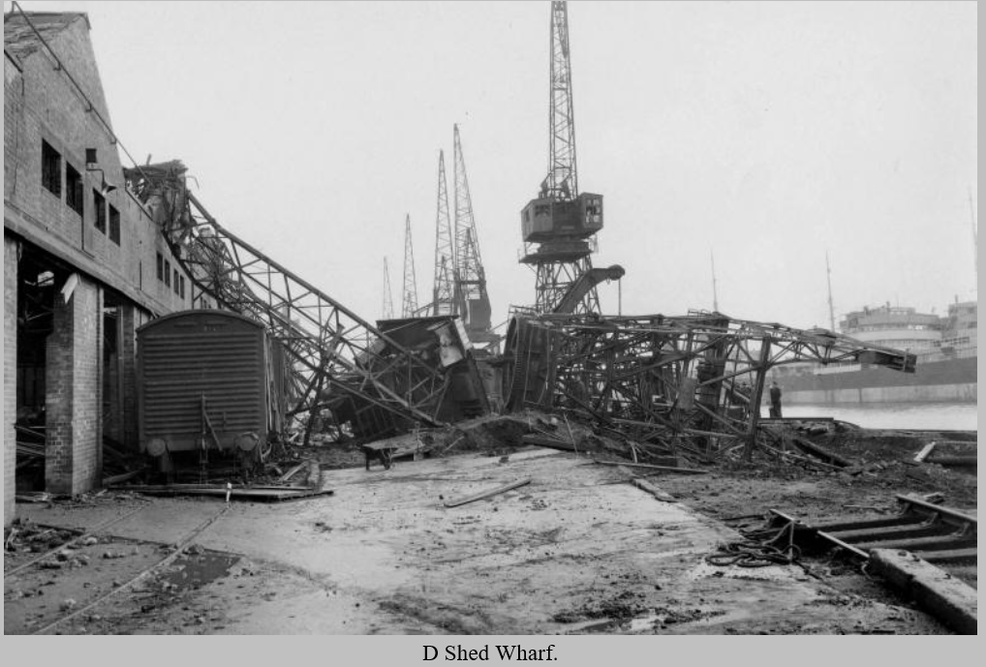

There were many warehouses built down the docks that kept all the exported good before being loaded on the ships for deployment. The image below is of the ´J Shed’ this was a loading point for trains along with horse and cart collecting the good.
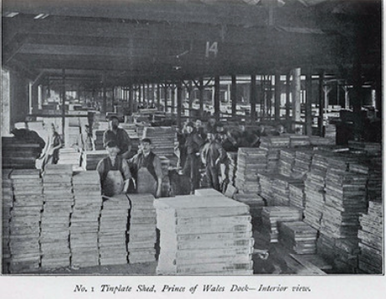
Figure2. J Shed Swansea docks. Picture taken from Flickr.com

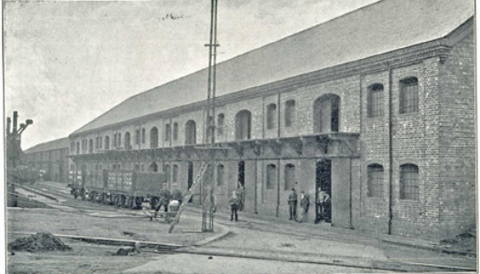
Figure3.J shed Swansea docks. Picture taken from ‘Flickr.com’
Built in 1895.

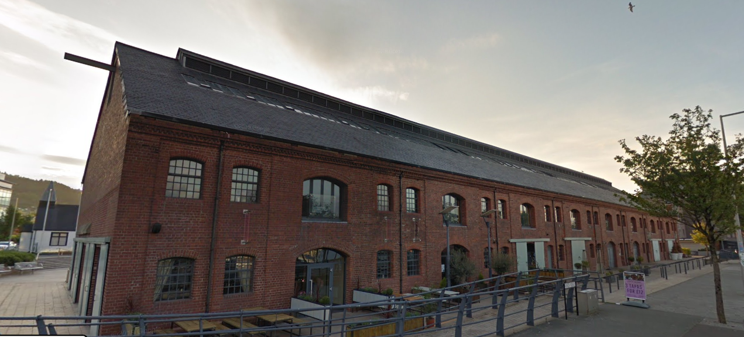
Figure4. J Shed Picture taken from google.com/streetview
It has now been redeveloped into office blocks, restaurants and apartment accommodation.

Bestengineeringarticles.com (2013) notes that by the 1960s, the entire industrial area around Swansea was also in decline and several schemes were put in place to try and make use of the now waste land, much of which was polluted. Some of these schemes were successful, for example, in the case of the Enterprise Zone, Llansamlet, which made use of some of this land. The old South Dock became home to the central leisure centre and marina, although the development was piecemeal at best, until recently.
Now the Swansea docks has been given regeneration over the last two decades and has been renamed at SA1 following its local postal code. In 1999 the Swansea West AM Andrew Davies had a vision for the docklands and in 2002 was appointed as Minister for Economics Development. Youle, R. (2019) development plans stated that it will be “Set around a new marina in the imposing Prince of Wales Dock, the area is set to become Wales’ premier waterfront development, acting as a magnet to new investment and jobs for Swansea and a catalyst for the regeneration of the city’s docklands.

Recommendations for a detailed site investigation
Through looking at the history of the docklands in Swansea and the proposed location on where this development is due to take place, its apparent that there are several considerations to the site investigation that are significant to the impact it could have on the build and most importantly the health and safety of the construction workers in such a historical part of the city. Below I am going to evaluate and advise on which elements of the site investigation that I consider to be the most significant and applicable to this particular site given the research I have gained from the history of the area.
Having been down a visited the site first hand I could see how close it is to the Marriott hotel and the County Hall. There are several structural constraints to be taken up for consideration when planning and investigation near to buildings especially ones of this stature. Ones I am looking out for are
- Buildings immediately adjacent to the site that’s being investigated
- Overhanging structural elements or basements that extend beyond the apparent footprint of the existing building.
- Access between and around existing structures in relations to width and height.
- The stability of existing structures such as retaining walls, pipes, and shallow tunnels should all be adequately assessed prior to the undertaking of round investigations, with particular attention paid to the ability of the existing structure to cope with pressures exerted by a drilling rig or other plant that will be on site.
Review of all available geological, geomorphological and hydrogeological maps and memoirs, reports and other documents including digital data; exploratory hole record sheets and well records; past ground investigations in the vicinity. The depth of exploration naturally depends on the type of work that is proposed on site. In this case it isn’t a substantial building being built so depth of the exploratory hole should go down to the depth of the sand. As you can see from the image below (Figure 8.) the beach is approximately 4m below ground level.
Utility constraints are to be carried out such as water, electric or any other utility that might run within the vicinity. Below is an image from GeoField and application that is used by Welsh Water to locate waste and clean water pipes.
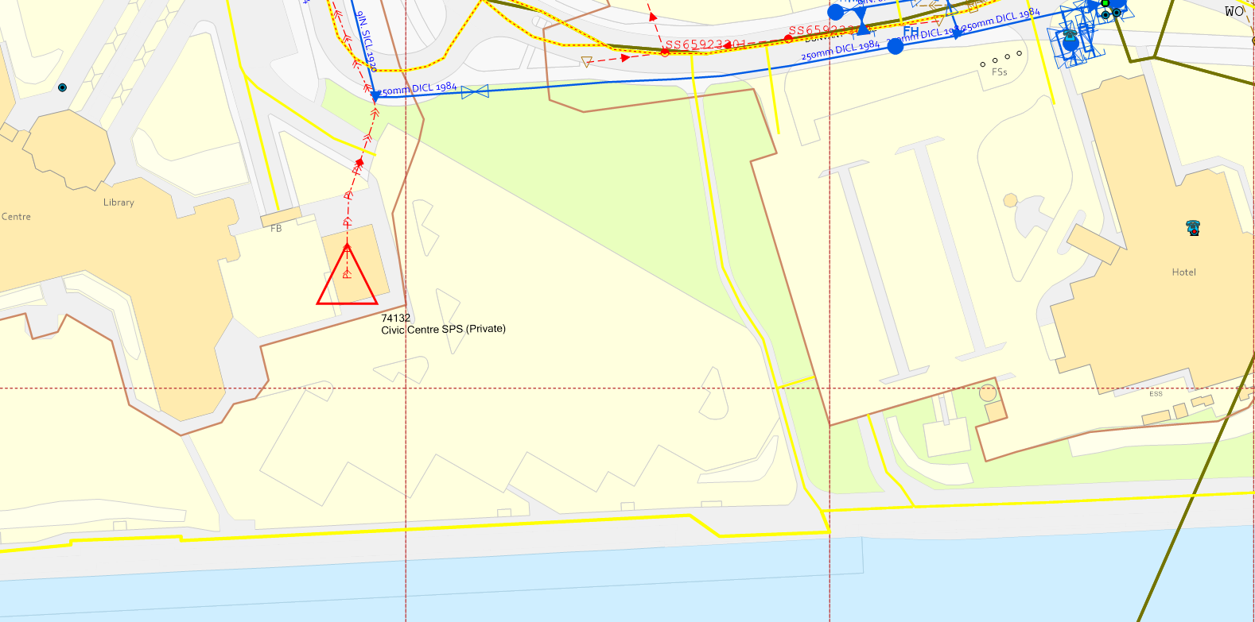
The outline of this box is where the proposed restaurant, Ice Cream Parlour and Managers Apartment will be.
Figure 5. Outlining where the services are located from Welsh Water. The blue line represents a 9”St water main and the red dashed line represents the waste pipe.
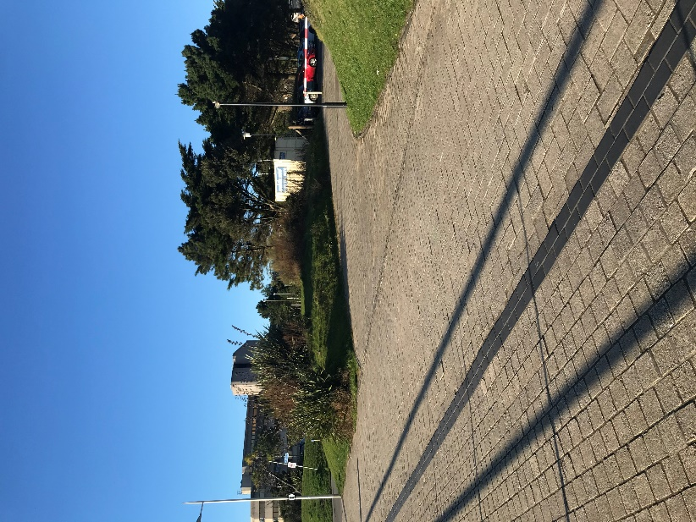
Figure 6. Taken from my site visit.
This is the exact location on where the building will be placed. In the background you can see the County Hall and the picture was taken from the promenade.
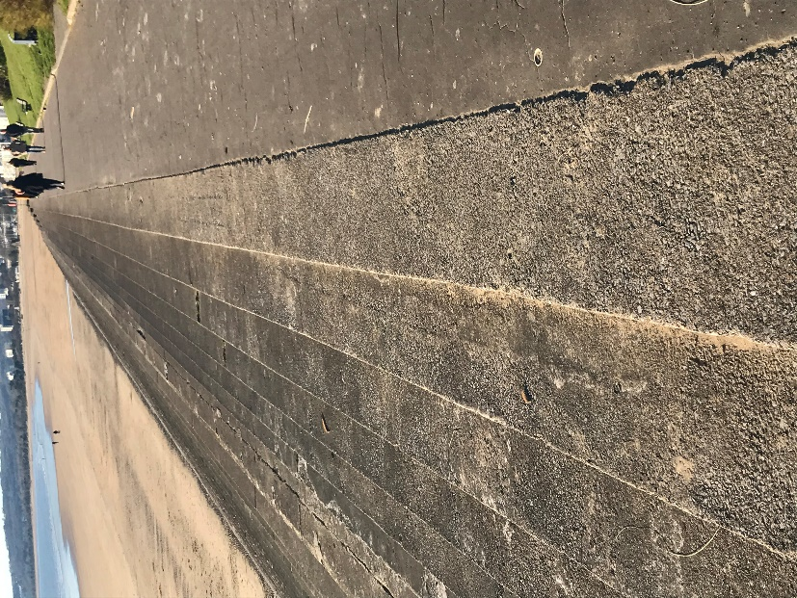
Figure8. Taken from the site visit I did recently. This promenade is within 20m of the proposed building. Essential planning must be taken into consideration to gather information from the soil samples gathered from the investigation into the steps leading down to the beach. Approximately a 4m drop down to the beach so our bore holes must be a minimum of 6m to ensure we gather all evidence of the soils.

As this sight has had two very large buildings built within 100mm of the proposed development we must take in consideration of previous heavy industry uses below ground level. There might be foundation in place from previous buildings which might include piles, and sheet piled walls, engine beds, pits, chambers and even underground storage tanks. There are often of massive construction which can be major obstacles for redevelopment. The ground has a high chance of contamination from chemicals, the spread of burial waste or contaminated material. It’s recommended that we carry out contamination testing by following the code practise which conforms to the (BS-10175)
From a water perspective there aren’t any mains running within the site however it is essential to have access to plans from the electricity and gas board before contemplating any ground investigations. By not doing this we are running a risk of working above ground and not knowing what’s buried. This can pose a massive risk to health and safety
Environmental, Seasonal and Ecological constraints need to be considered. As noted by (Sabbatical and 2019, 2019) about a wind turbine being erected in the Queens dock in Swansea which is considered as a brownfield site they say ‘In conjunction with nearby sparsely-vegetated ground, the patchwork of grassland types present corresponded to Open Mosaic Habitats (OMH) of Brownfield Land, a habitat of principal importance for the conservation of biodiversity in Wales (under Section 42 of the Natural Environment and Rural Communities Act, 2006). It was considered that invertebrates including brown-banded carder bee, dingy skipper, small blue and grayling, which are all of conservation priority in Wales and/or the Swansea area were likely to be present based on local knowledge and desk study information.
As previously stated this site in considered to be a brownfield site. This confirms that there could be potential substances in the ground that could be harmful to humans from the industrial past it has. Further investigating needs to be carried out on the site due to its rich history of the docks being bombed during World War 2. (Usborne, 2019) Stats show that ‘Figures are scant, but in 2009 the Construction Industry Research and Information Association estimated that, between 2006 and 2009, about 15,000 devices, including grenades, had been removed from construction sites. Five per cent were live, equivalent to roughly 250 devices a year.
Codes of Practice and Building Regulations
Due to the site being so close to the foreshore it’s vital that we obtain soil samples. There are two types of samples we can take which are disturbed and undisturbed. The quality of an undisturbed sample can vary between soil laboratories. As the site is so close to the foreshore, there is a high chance of water being present during the exploratory hole. This can have a significant influence on the geotechnical properties and the shear strength. Immediately after taking the sample the qualified operator of the plant or the site supervisor must assess the following:
- Soil particle size in relation to sampler in use
- Voiding the undisturbed samples
- Particle core recovery
- Mixing of strata types7Breaking up of cobbles or boulders unto smaller particles using sampling tools/chiselling
- Condition of sample tube
- Over drilling of previous cored ground to recover sample or core
- Recover of collapsed or squeezing ground.
When setting out the points of interest on the ground prior to making the excavations or bore holes we must comply with the common methods of setting out such as using survey equipment such as GPS (Global Positioning) to establish the exact location from the planning investigation and Using sight lines and distances from local features where these are present or on the ground where you can identify from plans of the proposed locations. Ordnance Datum will be used from the location and elevation coordinates provided from planning.
Open hollow stem auger method as it leaves a casing in the ground for unsupported soil and sand. In this case from a desk stop study this would be the best suited drilling system for this particular site.
Inspection pits are one method of recommendation from the historical background of this site. From a desk stop study and finding out further information on the sites location these inspection pits are usually small and very precisely located. They must be excavated using hand tools only or vacuum excavations techniques. There will be a site log kept to record of any findings within the trenches or a null record if the dig team didn’t encounter anything. Considerations are as follows when excavating:
- Location of excavator in relation to surrounding structures or utilities
- Location of excavator in relation to excavation
- Positioning of spoil heap
- Safe exclusion zone for third party.
The whole site will be fenced off with signing and guarding as the county hall car park and the Marriott hotel car park along with the promenade are within close proximity of the site. Excavation are dangerous and all safety precautions should be followed from the (BS8008).
Foundations
From my preliminary observations the suitable foundations for this particular site given its location and history would certainly be a Raft Foundation. (DIY Doctor, 2019) states A raft foundation is usually preferred under a number of circumstances:
- it is used for large loads, which is why they are so common in commercial building which tend to be much larger, and therefore heavier, than domestic homes
- The soil has a low bearing capacity so the weight of the building needs to be spread out over a large area to create a stable foundation
- The ratio of individual footings to total floor space is high. Typically if the footings would cover over half of the construction area then raft foundation would be used
- If the walls of the building are so close that it would cause the individual footings to overlap, then raft foundations should be used
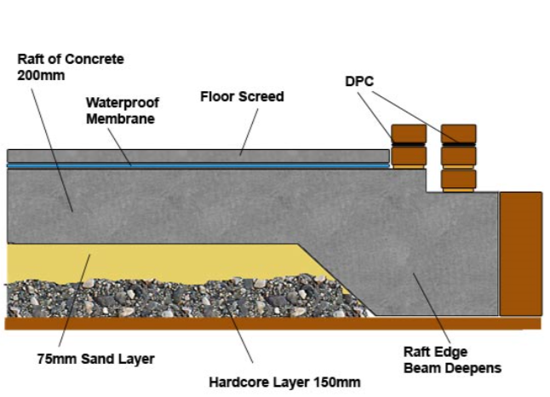
Figure 9. (DIY Doctor, 2019)
This is a typical cross section a raft foundation.

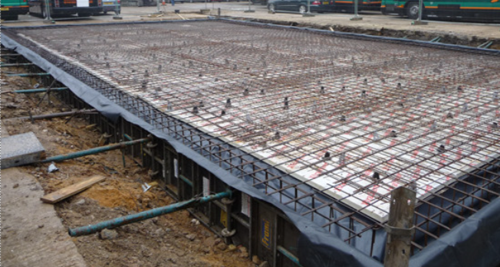
Figure10. (Chess Structural Consultants, 2019)

Due to the nature of the site being close to the foreshore the soil capacity could be low. By using a raft foundation we will be distributing the load across the entire area and the load that is transmitted down to the soil is reduced considerably. In areas where there will be wall columns it is suggested to dig deeper trenches to minimise settlement.

Word count excluding Reference List – 2200

Referencing
Bestengineeringarticles.blogspot.com. (2013). History to the SA1 Development. [online] Available at: https://bestengineeringarticles.blogspot.com/2013/12/history-to-sa1-development.html [Accessed 4 Dec. 2019].
Youle, R. (2019). The success and failure of rebuilding Swansea's docklands. [online] walesonline. Available at: https://www.walesonline.co.uk/news/wales-news/ambition-growth-crisis-success-failure-14226471 [Accessed 6 Dec. 2019].
Flickr. (2019). J-Shed in 1898. [online] Available at: https://www.flickr.com/photos/swansea-events/5384142432 [Accessed 6 Dec. 2019].
Instant Google Street View. (2019). 15 Kings Rd, Wales, United Kingdom | Instant Street View. [online] Available at: https://www.instantstreetview.com/@51.619551,-3.931403,50.68h,5p,1z [Accessed 6 Dec. 2019].
Sabbatical, S. and 2019, W. (2019). Queen’s Dock Wind Turbine, Swansea Port: Ecological Survey and Assessment - BSG Ecology. [online] BSG Ecology. Available at: https://www.bsg-ecology.com/portfolio_page/queens-dock-wind-turbine-swansea-port-ecological-survey-and-assessment/ [Accessed 6 Dec. 2019].
Usborne, S. (2019). Why unexploded bombs keep turning up on building sites. [online] the Guardian. Available at: https://www.theguardian.com/world/shortcuts/2017/mar/05/why-unexploded-bombs-keep-turning-up-on-building-sites [Accessed 6 Dec. 2019].

