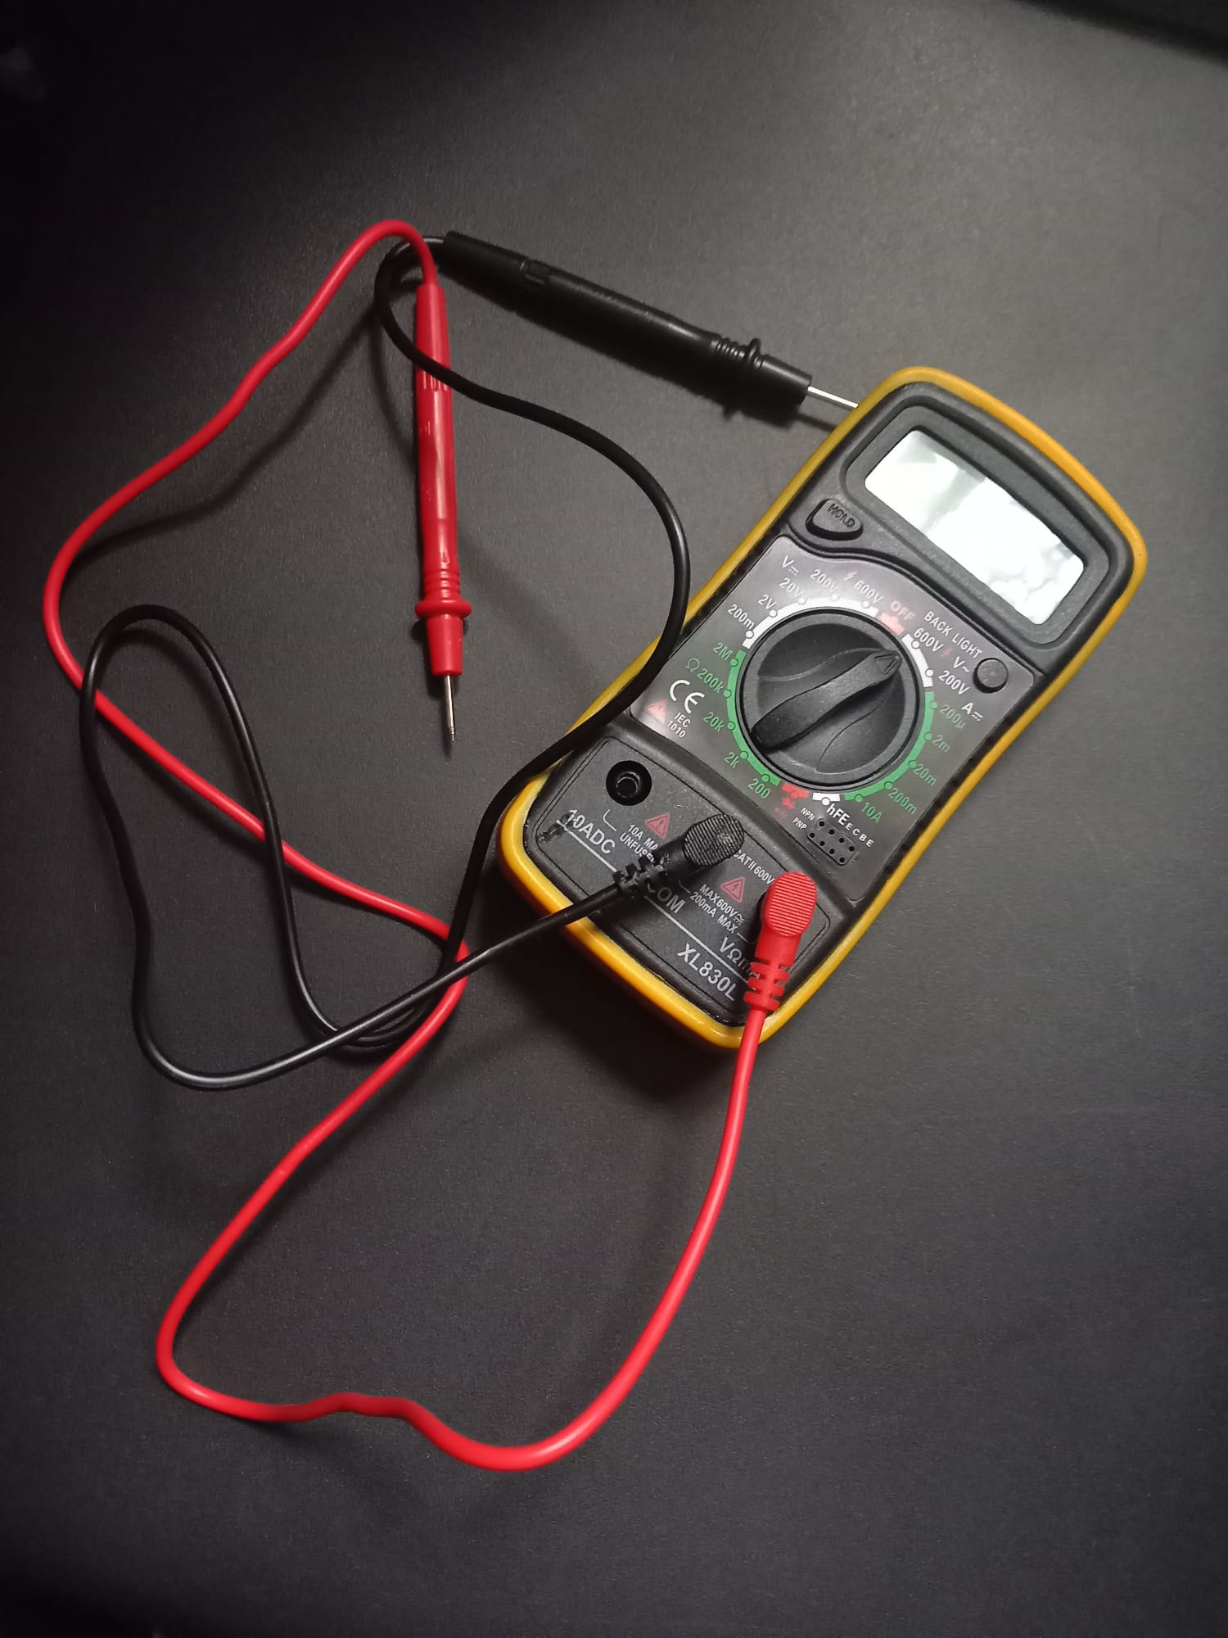

Professional MULTIMETER Operation course

Learn the uses of a professional digital MULTIMETER.

The accurate and safe use.

The functionality.

Anwar Hussein-Abdullah
15.11.2022
UWTSD
15th November 2022

MULTIMETER

