Student Name: Nicoleta Dumitroae |  | Student ID number: 2416665
Programme: |  | BA (Hons) Leadership and Management Skills for the Workplace
Module: |  | Organisational Culture
Module code: | LCLM 5005 | Contribution to Overall Module Assessment (%): | 70%
Module Leader: | David Oyebisi  Rameses Manalang | Internal Verifier: | MD Kalam  Samuel Ofori
Assignment Title: | Component 1  Organisational Culture:  Individual Report | Word count (or equivalent): 3085 | 3,000 ±10%  words
Submission deadline: | Individual Report 12/08/ 2026 | Return date of provisional marks & written feedback: | Friday, September 11,

A Critical Evaluation of Organisational Culture and Its Impact on Organisational Performance: A Case Study of John Lewis Partnership

Contents
Introduction 3
Organisational Culture of John Lewis Partnership 5
How Organisational Culture Shapes Structure and Decision-Making 6
Application of Relevant Frameworks and Theories to John Lewis Partnership 8
Schein's Three Levels of Organisational Culture 9
Handy's Cultural Types 9
Organisational Culture and Adaptation to the External Environment 10
Organisational Culture and Effective Organisational Functioning 12
Evaluation of the Impact of Organisational Culture on Organisational Performance 13
Conclusion 14
References 15

Introduction
One of the most important factors deciding how an organization functions, takes decisions and achieves strategic objectives, is their organizational culture. It encompasses the beliefs, assumptions and behaviours that are shared among group members and which impact employees-their actions and practices within the organisation (Mullins and Christy, 2016). An organization strengthens engagement, innovation and improvement in customer satisfaction with the strong organizational culture. On the other hand, weak and misaligned cultures lessen the organizational effectiveness and create hurdles for change. (Schein and Schein 2021) In competitive and dynamic business environments, it has become important to evaluate organisational performance in the organisation.
The report will discuss the only organisation of UK with employee owned structure, John Lewis Partnership Limited (JLP) . The report explores how people’s culture impacts the organisations’ structure and decision making. This is followed by the application of Schein’s Three Levels of Culture and Handy’s Cultural Types to identify the organisation’s existing culture. The organisation’s culture helps them respond to the pressure of the external environment. Further, evaluate whether the existing culture is an organisational enabler or barrier and how each culture has an impact on the organisation’s performance. Based on relevant organizational behaviour theories and current academic literature recommendations are made.
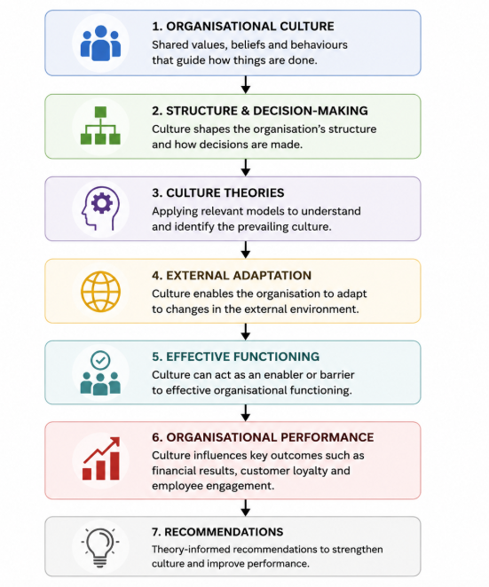
(Figure 1 -Report Framework at John Lewis)
The structure of this report is shown in Figure 1. The organisational culture of John Lewis Partnership has an effect on its organisational structure, decision making etc. Also, it will be analysed using relevant cultural models. Moreover, it helps in adapting to changes in the external environment. Further, it affects organisational effectiveness. Ultimately, organisational effectiveness will impact organisational performance. The report concludes with recommendations informed by theory to enhance organisational culture and strengthen long-term performance.

Organisational Culture of John Lewis Partnership

Organisational culture is defined by Mullins and Christy (2016) as the values, beliefs, norm and behavior that shape the way employees interact and work within an organization. A strong culture in an organization offers employees a greater sense of purpose. Moreover, culture supports the objectives of a strategy. Further, it leads to a sustainable competitive advantage (Schein and Schein, 2021). Organisational culture may play a very important role in a retail business’ long-term success as we’ll witness below, it is crucial in the insurgent of client experience and the engagement of employees.
The employee ownership model of John Lewis Partnership (JLP) helped develop a unique organisational culture. In stark contrast to conventional retailers, the firm is owned by its employees – the Partners. Accordingly, Partners share in the success of the organisation through profit-sharing and decision-making (John Lewis Partnership, 2025). This ownership arrangement nurtures an environment founded on trust, accountability, collaboration and mutual respect to foster a strong sense of commitment.
The organization purpose “Working in Partnership for a Happier World” reflects the values that lie beyond financial performance: fairness and integrity and outstanding customer service (John Lewis Partnership, 2025). The administrators have devised policies to deal with possible incidents, such as accidents and non-conformities, as well as environmental issues. As per Schein and Schein (2021), organisational values come to fruition only when employees actually exhibit such behaviour. At John Lewis, the Partnership model reflects this connection. It encourages employees to contribute to the organisation’s success rather than just completing the tasks assigned to them.
John Lewis has a collaborative working environment that values employee well-being, emphasis on diversity, and continuous learning as key organizational priorities. This organization promotes participation and shared responsibility through communication, staff forums and opportunities for feedback. As per the research conducted by CIPD in the year 2024, the organisation involving practices enhance employee engagement and boosts organisational commitment. Also, organisations with inclusive culture possess a greater tendency towards higher motivation and productivity.
While the Partnership culture engages employees, it also has drawbacks that must be managed. The retail sector is highly competitive and requiring rapid organisational change slowness in decision making because of the focus on consultation and consensus. According to Burnes (2020), organizations with participative cultures may display higher levels of resistance when it comes to difficult strategic decisions like restructuring and cost reductions. Thus, while John Lewis' culture has a positive influence on his business strengths, there is a need for suitable equilibrium between participation and flexibility to remain competitive.
Cultural Characteristic | Evidence at John Lewis | Organisational Benefit
- Employee ownership | - Partners own the business | - Higher commitment and accountability
- Trust and integrity | - Shared values and ethical leadership | - Strong organisational relationships
- Collaboration | - Employee participation in decision-making | - Improved teamwork and knowledge sharing
- Customer focus | - Commitment to exceptional service | - Increased customer satisfaction and loyalty
- Continuous improvement | - Learning and development opportunities | - Greater innovation and adaptability
(Table 1 -Key Characteristics of John Lewis Partnership's Organisational Culture)
Table 1 provides an overview of John Lewis Partnership’s culture and explains how these cultural values enhance employee engagement and allow the organisation to be effective over the long run.

How Organisational Culture Shapes Structure and Decision-Making
Organisational culture shapes organisational structure and strategic and operational decisions in a significant way. According to Mullins and Christy (2016), culture shapes business practices: it determines authority, communication and behaviour. At John Lewis Partnership (JLP), the employee-owned business model has produced a participative culture that enhances shared governance. In particular, it encourages employees to contribute to organisational decision making.

Opposing most traditional retailers with a high degree of centralisation in their hierarchical structure, John Lewis is relatively decentralised in its approach. Employees called Partners can voice opinions through a representative body called the Partnership Council and local forums (John Lewis Partnership, 2025). The structure reflects the cultural values of trust, transparency and shared responsibility. Thus, employees taking part in decision-making results in more involvement in the organisation, better communication, and a stronger commitment to the goals of the enterprise.
Collaborative practices also inform leadership practice by encouraging managers to facilitate as opposed to control.
Decision-making is often through consultation and at least consensus so that more employees take part in the decision and their commitment to the organization improves. Participative decision making increases the motivation of employees because employees are committed to decisions in which they have participated. Robbins and Judge (2023) Inside John Lewis, this approach helps to achieve high levels of employee engagement and reinforces the customer-focused strategy of the organisation.
Though, highly participative culture may create some challenges Consulting different stakeholders can delay decisions especially during uncertain economic times or rapid market fluctuations. For instance, John Lewis was forced to make tough calls on store closures, restructuring and cost-cutting as competition from online retailers increased and consumer behaviour changed. Even though employee consultation was able to maintain trust within the organization, it limited the organization’s agility compared to competitors. (21)
Overall, John Lewis shows that organisational culture does influence organisational structure and decision-making processes. Though its participative culture increases employee commitment, innovation and transparency, a careful balance between collaboration and speed of decisions is essential for sustained competitiveness.
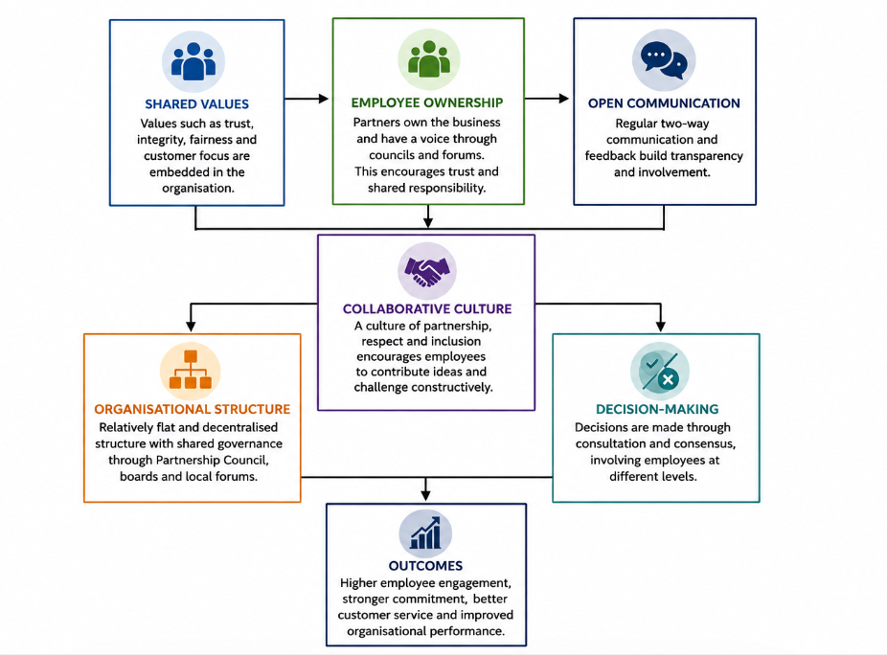
(Figure 2 -Influence of Organisational Culture on Structure and Decision-Making)
As illustrated in Figure 2, the organisational culture of John Lewis Partnership shapes its organisational structure and decision making. The organization’s common values, employee ownership and communication culture support a collaborative environment that enables decentralized governance and participative decision-making. These cultural traits assist in engaging employees, boosting the commitment of the organisation, enhancing customer service, and so on. Despite their credibility, the consultation and consensus emphasis can also lead to slower strategic decision-making in times of rapid change. This highlights their organisational culture strength and weakness.

Application of Relevant Frameworks and Theories to John Lewis Partnership
The organisational culture of John Lewis Partnership can be assessed effectively using Schein’s Three Levels of Organisational Culture and Handy’s Cultural Types. Theories about how organisation’s values impact employee behaviour and organisation’s performance.

Schein's Three Levels of Organisational Culture
According to Schein and Schein (2021), organisational culture includes different types of artefacts and basic underlying assumptions. At John Lewis, artefacts include employee ownership, the Partnership Council, and cooperative working practices. As per the 2025 publication by the John Lewis Partnership, the company's values are around trust, equity, integrity, and customers' experience. It is assumed that if the employees are empowered, they will better the working of the organisation. This alignment among these three levels creates a strong organisational culture that encourages commitment and responsibility.

Handy's Cultural Types
According to Handy (1993), organisations may exhibit power, role, task or person cultures. John Lewis mainly shows a Task Culture where teams are supported to work together. This is supplemented with a Person Culture where employees are engaged through the Partnership.
Both theories indicate that John Lewis’ culture is collaborative and people-centred to support employee engagement and customer satisfaction. However the focus on consultation may impede organisational agility during times in which rapid strategic decisions are needed (Burnes, 2020) .
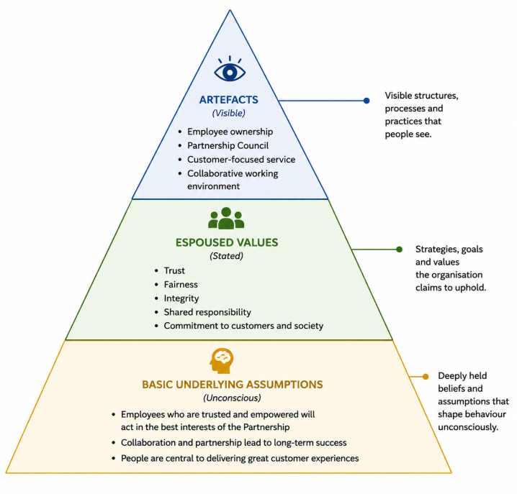
(Figure 3- Schein's Three Levels of Organisational Culture Applied to John Lewis Partnership)
Illustrated in Figure 3 is Schein’s Three Levels of Organisational Culture as applied to the John Lewis Partnership. The model shows that visible organisational practices (artefacts) are sustained by a shared organisational value and deep underlying assumptions (commonly referred to as ‘the culture’). A strong culture drives employee commitment, customer service excellence and long-term success of the organisation (Schein and Schein, 2021).

Organisational Culture and Adaptation to the External Environment
Organizational culture is instrumental in helping organizations adapt to shifts in their external environment. As per Johnson et al. (2020), adaptable cultural organisations are better at using technological advances to respond to what customers really want and reduce competitive pressure. At John Lewis Partnership (JLP), their collaboratively and customer-centric culture has provided a steadfast foundation to adapt without losing sight of their values.
One of the major challenges is the growth of e-commerce and change in shopping habits. Consequently, John Lewis devoted themselves to investment in online platforms, omnichannel retailing and improved customer services to keep pace with Amazon. The culture of the organisation instilled a spirit of innovation and improvement in those that worked there, encouraging employees to adopt new technologies and ways of working while maintaining high standards of customer (John Lewis Partnership, 2025).
John Lewis has adapted to growing expectations around sustainability and ethical business practices. The organisation’s culture encourages sourcing from responsible sources, reducing carbon emissions and supporting munities which shows that being socially responsible is part of the organisation. These efforts can reinforce customer trust and improve the reputation of the organisation, creating a sustainable advantage.
Due to COVID-19 pandemic, there was rapid organizational change. This response in a new article refers to John Lewis expanding online operations, making work flexible, and a digital customer engagement improvement. The organisation adapted effectively, although as a participative culture slowed down strategic decisions, consultation of employees remained an important part of decision-making (Burnes, 2020).
In conclusion, John Lewis shows that a strong organisation culture supports organisational resilience and organisational adaptability. Despite slow decisions, ability to innovate has helped the organization remain competitive. Involving employees is key for the organization, and all employees contribute to innovation. Employees also like this innovative culture.
External Environment
- Digital transformation
- Changing customer expectations
- Sustainability
- Economic competition

- John Lewis Organisational Culture
- Innovation
- Collaboration
- Customer focus
- Employee engagement

- Organisational Outcomes
- Business resilience
- Improved customer satisfaction
- Competitive advantage
- Sustainable performance

(Figure 4-Organisational Culture and Adaptation to the External Environment)
Figure 4 illustrates the approach that John Lewis Partnership employs in relation to it’s culture and its changing environment. The organization promotes innovation, collaboration and customer focus. As a result, it adapts to technological, economic and social challenges. Moreover, it improves resilience and maintains competitiveness. Ultimately, it supports long-term organizational performance (Johnson et al., 2020; John Lewis Partnership, 2025).

Organisational Culture and Effective Organisational Functioning
The culture of an organization can enable as well as inhibit effective functioning of organization. According to Mullins and Christy (2016), a positive culture is one that improves employees’ motivation, collaboration and organisational performance. Conversely – inflexible culture may limit innovation and slow down organisational change. JLP has a culture arising from the employee ownership model which largely supports effective organisational functioning.
The John Lewis culture fosters trust and collaboration and engages workers. Giving our partners freedom to give ideas and participate in decision-making, promotes ownership and accountability. Robbins and Judge (2023) describe how employees are committed and motivated if they feel valued and help company productivity as well as customer service. Thanks to this culture, John Lewis has developed a solid reputation for good quality of service and employee satisfaction.
The Partnership culture, however, can lead to challenges. The need for consultation and agreement may make decisions slow especially when there’s need for quick response in retail. Companies undergoing restructuring and financial pressure may slow their organisational agility when they try to combine employee participation with the need for swift strategic decision-making (Burnes, 2020). It shows that participation can build trust, but it may slow down the change.
John Lewis’ organisational culture serves primarily as an enabler because its benefits outweigh its drawbacks. The culture builds employee commitment, encourages collaboration, and supports customer-first decision making. Regardless, to remain competitive in retail that is increasingly dynamic, the organisation will need to maintain flexibility to improve the speed of its strategic decisions.
Enablers | Barriers
High employee engagement | Slower decision-making
Strong collaboration | Consensus may delay change
Customer-focused culture | Reduced organisational agility
High trust and commitment | Difficult restructuring during uncertainty
(Table 2 -Organisational Culture as an Enabler and Barrier)
As shown in Table 3, main strengths and weaknesses of John Lewis’ organizational culture. The engaging workplace culture of collaboration drives employee engagement and customer satisfaction. Still, agility is essential to meeting challenges of the future.

Evaluation of the Impact of Organisational Culture on Organisational Performance

The culture of the company significantly influences the performance of the business through employee engagement, innovation, customer satisfaction, and business success. According to Schein and Schein (2021), employees better understand and accept the goals of an organization with a strong and aligned culture.
At John Lewis Partnership (JLP), the employee ownership model creates a culture that influences the operational and financial performance in a positive way
One of the key strengths of John Lewis’ culture is to enhance employee commitment and motivation. Encouraging partners to contribute helps them to become more engaged with and accountable for success. The quality of customer service has improved. Also, the organisation enhanced its reputation on trustworthiness and reliability (John Lewis Partnership, 2025). Likewise, the culture of cooperation in a business facilitates the generation of novel ideas and the sharing of knowledge.
Organisational culture may not guarantee success despite its strengths. John Lewis has been seriously impacted by online competition, rising costs of employing people and changing consumer behaviour. As a result, the organisation has to keep on adapting its culture while preserving the core values which set it apart from competitors (Johnson et al., 2020).
The top priorities for John Lewis in strengthening organisational performance are investment in digital skills and employee development, encouraging faster decision-making through greater managerial empowerment, and cross-functional collaboration to support innovation. This recommendation is consistent with Schein’s emphasis on continuous cultural learning as well as Handy’s view that flexibility and collaboration will improve organisational effectiveness (Schein and Schein, 2021; Handy, 1993).
Ultimately, the organisational culture at John Lewis has contributed greatly to its success over time. Even as organisational agility is improved, the Partnership’s culture is an important strategic resource. Culture enables employee engagement, customer loyalty and sustainable organisational performance.

Conclusion
Organisational culture influences how organisations operate, make decisions and achieve long-term success. The report indicates that the employee ownership model of John Lewis Partnership has created a trusting and collaborative organisational culture based on shared responsibility and focus on customers. An analysis using Schein’s Three Levels of Organisational Culture and Handy’s Cultural Types, shows that there is a prevalent collaborative and people-centred culture that engages employees, offers innovations and promotes organisational performance.
The study also found that John Lewis used its culture to respond to external challenges, including digitalisation, changing customer expectations and the intensification of market competition.
The disadvantages of requiring employee commitment, cooperation and customer service, in spite of the danger that the participative method may prolong decision-making process during periods of rapid change, are likely to be outweighed by the situation. Organisational culture is one major enabler of organisational effectiveness and competitive advantage. Continued investment in employee development, innovation, and organizational agility will help John Lewis maintain its strong market position and achieve sustainable long-term performance.

References
Burnes, B. (2020) Managing Change. 8th edn. Harlow: Pearson.
CIPD (2024) Good Work Index 2024. London: Chartered Institute of Personnel and Development.
Handy, C. (1993) Understanding Organisations. 4th edn. London: Penguin Books.
John Lewis Partnership (2025) Annual Report and Accounts 2025. London: John Lewis Partnership.
Johnson, G., Scholes, K., Whittington, R., Angwin, D. and Regnér, P. (2020) Exploring Strategy. 12th edn. Harlow: Pearson.
Kotter, J.P. (2012) Leading Change. Boston: Harvard Business Review Press.
Mullins, L.J. and Christy, G. (2016) Management and Organisational Behaviour. 11th edn. Harlow: Pearson Education.
Robbins, S.P. and Judge, T.A. (2023) Organizational Behavior. 19th edn. Harlow: Pearson.
Schein, E.H. and Schein, P.A. (2021) Organizational Culture and Leadership. 5th edn. Hoboken: John Wiley & Sons.
Cameron, K.S. and Quinn, R.E. (2011) Diagnosing and Changing Organizational Culture. 3rd edn. San Francisco: Jossey-Bass.
Deloitte (2024) Global Human Capital Trends 2024. London: Deloitte.
Harvard Business Review (2023) ‘The Value of Organisational Culture’, Harvard Business Review, 101(4), pp. 44–53.

