University of Wales Trinity Saint David, School of Engineering BEng Motorcycle Engineering

Jason Sorg
Student Number: 1700589
Heat exchanger laboratory analysis
Thermofluid Mechanics, (M5X00406)

Contents

Introduction - 2 -
Theory - 3 -
Procedure - 4 -
Experiment 1 - 4 -
Experiment 2 - 4 -
Experiment 3 - 5 -
Results - 6 -
Experiment 1 - 6 -
Experiment 2 - 8 -
Experiment 3 - 10 -
Assumptions - 12 -
Improvements - 12 -
Conclusion - 13 -
References - 14 -
Appendix A - 15 -

Figure 1: Experiment 1 Energy Transfer - 6 -
Figure 2: Experiment 1 Temp Efficiency - 7 -
Figure 3: Experiment 1 Heat Transfer - 7 -
Figure 4: Experiment 2 Energy Transfer - 8 -
Figure 5: Experiment 2 Temp Efficiency - 8 -
Figure 6: Experiment 2 Heat Transfer - 9 -
Figure 7: Experiment 3 Energy Transfer - 10 -
Figure 8: Experiment 2 & 3 Water Power Comparison - 10 -
Figure 9: Experiment 3 Temp Efficiency - 11 -
Figure 10: Experiment 3 Heat Transfer - 11 -

Introduction
Heat exchangers are commonly used for a wide variety of applications which include, heating or air-conditioning systems for household or car applications, along with commercial applications that involve chemical processing and power generation. The purpose of this report is to describe the fundamental principles associated with water to air heat exchangers and to confirm these underlying principles with three laboratory experiments. These experiments were completed by using the TD1007 water to air heat exchanger in conjunction with a standard 32 tube heat exchange set up in a cross flow configuration. The results achieved from the three experiments were also used to highlight any discrepancies or errors caused by real world testing.

Theory
In order for heat transfer to take place between one fluid to another fluid (in this case a liquid to gas) the fluids must come in contact with each other via an interface wall. This interface wall allows for thermal energy transfer, but no mass transfer is capable of occurring. The three experiments that were used to prove heat transfer between an interface wall was comprised of a shell and tube type exchanger. The reason why a shell and tube type heat exchange are commonly used for laboratory experiments is due to the fact that they typically cost less, can be serviced much easier, represent how car radiators work and classically much easier to build and operate in a learning environment. The disadvantages are that they are less effective in heat transfer when compared to a plate type cooler, the capacity of the tube cooler cannot be expanded and requires more space then plate coolers (Seamless, 2018).
The TD1007 water to air heat exchange used for the experiments utilized a cross flow type heat exchanger, which allows the cooler air to pass perpendicularly across the hotter water flowing through the 32 tube and shell heat exchanger. The reason why a cross flow set up was used is because it creates a more efficient way of transferring heat due to the average temperature between the fluids being maximized because of the larger transfer surface area. This is why the log mean temperature for cross flow type heat exchangers are higher than parallel flow exchangers (Edge, 2000). In order to determine the overall heat transfer, the coefficient U will be used to compare the overall efficiencies that are generated from the different experiments, and these values will then be used to determine if constant pressure or constant flow yields a higher efficiency.
The experiments used to confirm the fundamental principles of heat exchangers are outlined below and will be discussed further on in the report in greater detail:
- The effect of varying water flow rate – constant water temp (60°C), constant change in pressure (252 Pa), varying water flow from 2.25 L/min to 0.25L /min.
- The effect of varying air flow rate – constant water temp (60°C), constant water flow (0.24 L/min), varying change in pressure from 250 Pa to 50 Pa.
- The effect of varying temperature (driving force) – constant water temp (45°C), constant water flow (0.24 L/min), varying change in pressure from 250 Pa to 50 Pa.

Procedure

Experiment 1
- Set up and connect the 32 tube standard heat exchanger attachment. Connect in a parallel flow configuration with a water temperature of 60°C. (Not to be confused with the crossflow method of heat exchange).
- Document the ambient air pressure and ambient room temperature. Check the diameter of the air inlet pipe.
- Turn the fan on and use the slide valve to set the airflow to achieve a pressure drop of 250 Pa, tolerance is (+/- 5 Pa).
- Turn on the water pump and set the water flow to 2.25 L/minute, tolerance is (+/- 0.01 L/minute).
- Allow at least 5 minutes for the heat exchanger to stabilize upon initial start-up and in between the change in water flow rates.
- Repeat step 4 for water flow rates of 1.75, 1.25, 0.75 and 0.25 L/minute. (make sure to regularly check the water and air flow rates during the experiments, as they can vary. Make adjustments as necessary).

Experiment 2
- Set up and connect the 32 tube standard heat exchanger attachment. Connect in a parallel flow configuration with a water temperature of 60°C. (Not to be confused with the crossflow method of heat exchange).
- Document the ambient air pressure and ambient room temperature. Check the diameter of the air inlet pipe.
- Turn the fan on and use the slide valve to set the airflow to achieve a pressure drop of 250 Pa, tolerance is (+/- 5 Pa).
- Turn on the water pump and set the water flow to 0.25 L/minute, tolerance is (+/- 0.01 L/minute).
- Allow at least 5 minutes for the heat exchanger to stabilize upon initial start-up and in between the change in air flow rates.
- Repeat step 4 for air flow rates of 200, 150, 100 and 50 Pa pressure drops. (make sure to regularly check the water and air flow rates during the experiments, as they can vary. Make adjustments as necessary).

Experiment 3
- Set up and connect the 32 tube standard heat exchanger attachment. Connect in a parallel flow configuration with a water temperature of 45°C. (Not to be confused with the crossflow method of heat exchange).
- Document the ambient air pressure and ambient room temperature. Check the diameter of the air inlet pipe.
- Turn the fan on and use the slide valve to set the airflow to achieve a pressure drop of 250 Pa, tolerance is (+/- 5 Pa).
- Turn on the water pump and set the water flow to 0.25 L/minute, tolerance is (+/- 0.01 L/minute).
- Allow at least 5 minutes for the heat exchanger to stabilize upon initial start-up and in between the change in air flow rates.
- Repeat step 4 for air flow rates of 200, 150, 100 and 50 Pa pressure drops. (make sure to regularly check the water and air flow rates during the experiments, as they can vary. Make adjustments as necessary).

Results
The following results were obtained on March 5th, 2019 with an ambient air temperature of 21°C and an ambient pressure of 1000 hPa. Reference Appendix A for the documented and generated results for all three experiments.

Experiment 1
The purpose of experiment 1 was to determine how different water flow rates affect the performance of the heat exchanger for a given fixed air flow and water temperature (Ltd, 2014).
The graph below demonstrates that the power transfer increases when the water flow increases figure 1.
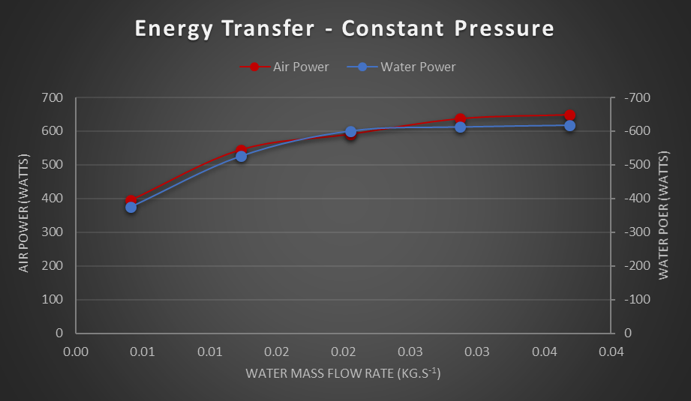
Figure 1: Experiment 1 Energy Transfer
It is interesting to note that the slope begins to decrease with a higher water flow rate and thus indicating that the maximum power transfer will reach a plateau just above 0.04 kg/s. The heat absorbed by the air and produced by the water show a consistent energy balance coefficient of around (-0.98 to -1.05). This can vary due to the external conditions adding or subtracting energy into the system, which is why a value greater than 1 is possible.
The efficiencies at different water flow rates are shown below in figure 2. The results produced demonstrate a higher water efficiency and a lower air efficiency at a lower water flow rate. This is due to the mass of the water having more time to effectively transfer heat to the air stream because of the slower rate in which the water is travelling across the flow of cooler air. While at a higher water flow rate the efficiencies are opposite, which is why the mean temperature efficiency gradually decreases with higher water flow rates.
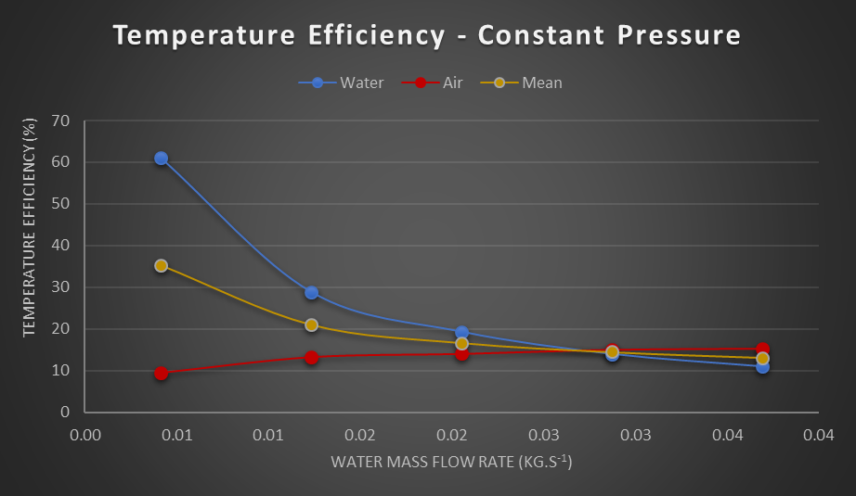
Figure 2: Experiment 1 Temp Efficiency
When compared to figure 1, these results make sense because the gradual drop in power is due to the gradual drop in the systems overall efficiency. The heat transfer coefficient (figure 3) demonstrates that at certain water flow rate the performance of the heat exchanger will not increase proportionally to the higher water flow rates and will eventually level out. This is evident in figure 1, which shows the gradual decrease in power transfer.
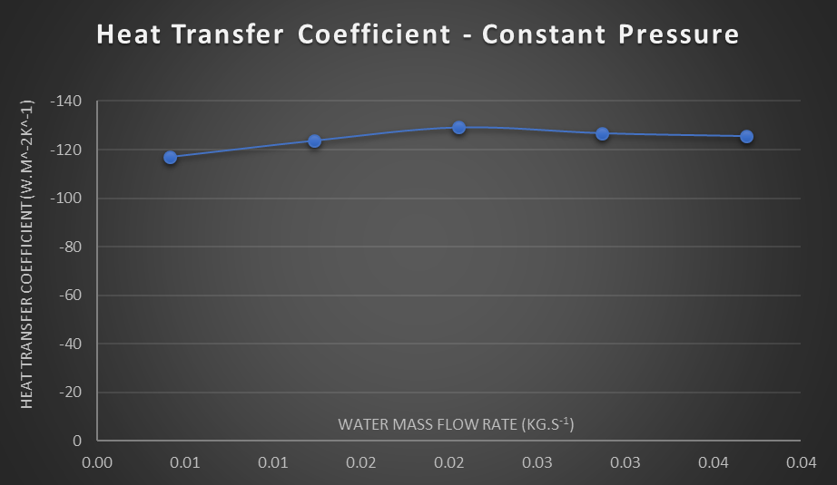
Figure 3: Experiment 1 Heat Transfer

Experiment 2
The purpose of experiment 2 was to determine how different air flow rates affect the performance of the heat exchanger for a given fixed water flow and temperature (Ltd, 2014).The graph below demonstrates that the power transfer increases fairly linearly with the increase of air flow, figure 4.
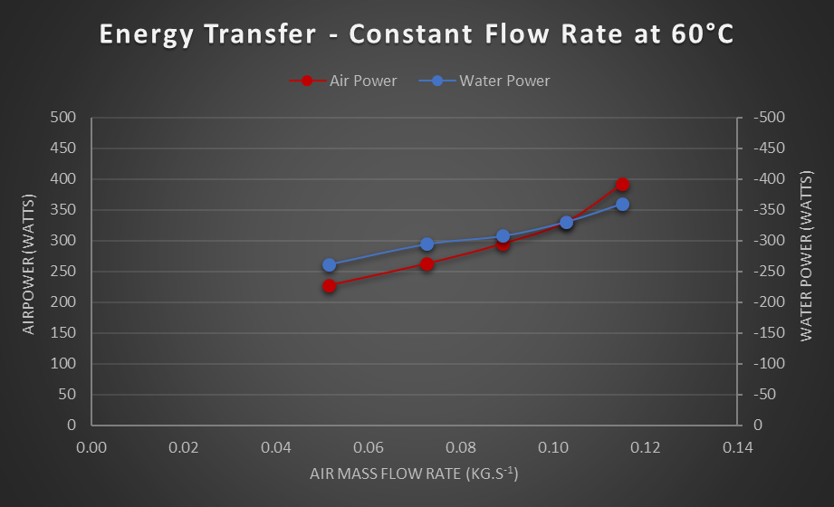
Figure 4: Experiment 2 Energy Transfer
At a lower air flow the water power is slightly higher than the air power which suggests that there are higher loses in the system caused by other forms of heat exchange via the framework of the device at lower air flow rates. The energy balance coefficient changes from (-0.87 to -1.09) with an increase of air flow which is caused by the external losses becoming less of a factor with an increase of air flow. Figure 5 demonstrates the change in temperature efficiencies with the increase of air flow.
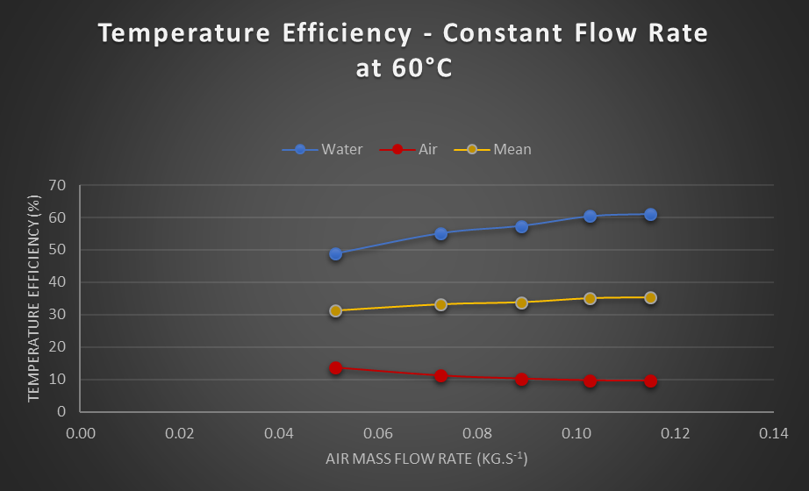
Figure 5: Experiment 2 Temp Efficiency
The water system efficiency gradually increases while the air system gradually decreases, which equates to an overall system efficiency that gradually increases with an increase of air flow.
The heat transfer coefficient for experiment 2 shows an overall linearly increase with the increase of air flow and allows advocates that with more air flow the heat transfer would increase which is evident by the general upswing in the power emitted in figure 4.
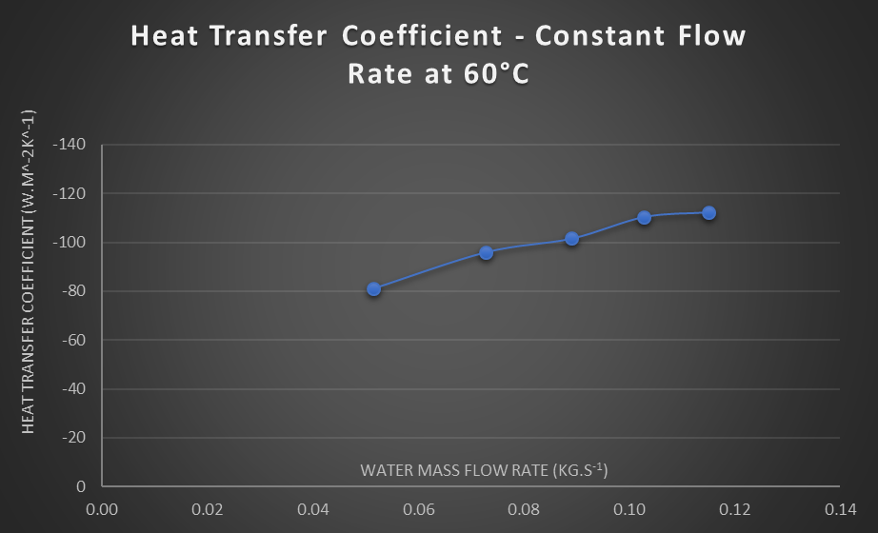
Figure 6: Experiment 2 Heat Transfer

Experiment 3
The purpose of experiment 3 was to determine how different water supply temperatures affect the performance for a fixed water flow (Ltd, 2014). Figure 7 establishes that with a lower driving force (45°C), the power output tends to fall when compared to experiment 2, which advocates that with a starting temperature of 45°C the system is approaching the limit for this arrangement. This is evident below in figure 8, which shows that the total water power output is consistently lower with a lower starting temperature when compared to a higher temperature (driving force).
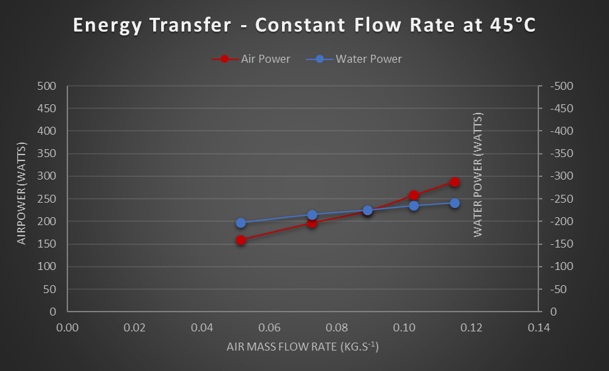
Figure 7: Experiment 3 Energy Transfer
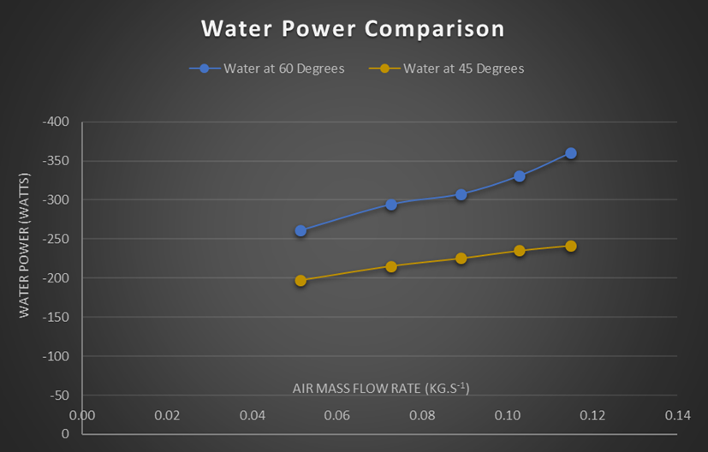
Figure 8: Experiment 2 & 3 Water Power Comparison
The following two graphs (figure 9 and 10) are very similar to experiment 2 because the rate in which heat is transferred is very similar and basically unchanged. The main change that occurs with a different driving force is the total energy output which was discussed previously.
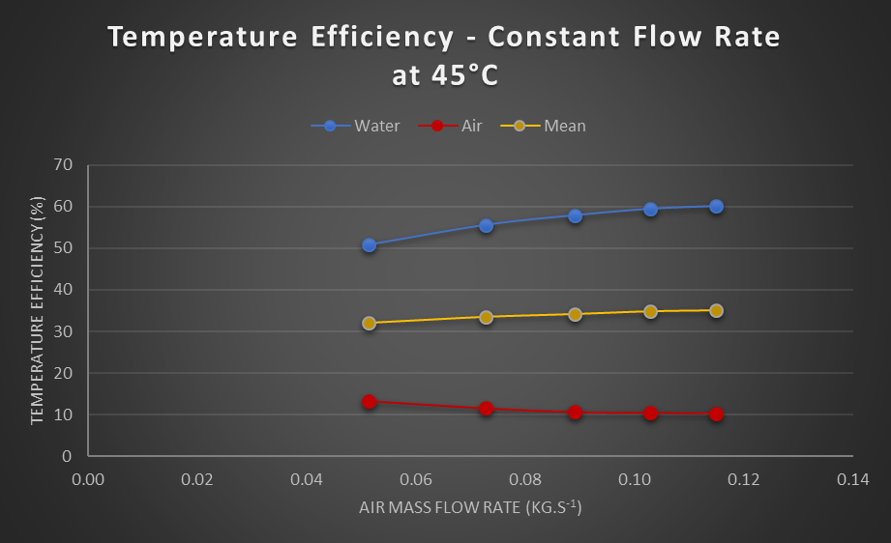
Figure 9: Experiment 3 Temp Efficiency
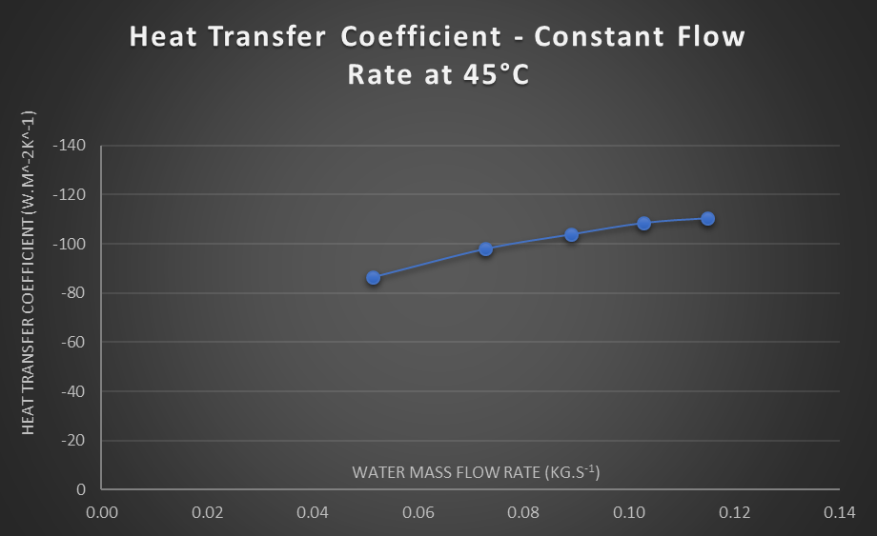
Figure 10: Experiment 3 Heat Transfer

Assumptions
The list below outlines the assumptions that were taken in order to produce the results generated for all three experiments:
- The ambient air pressure was only taken at the start of the laboratory experiments and was not checked throughout the experiment. This could cause small compounding errors when calculating the results.
- The room temperature was also only taken at the beginning of the laboratory session and was not corrected throughout. The temperature most likely increased due to the heat given off by the students preforming the experiments, which was not taken into consideration.
- The density of water was calculated by using the average water temperatures and then extrapolated by using the online calculator provided by engineering toolbox (Toolbox, 2019).
- The readings were taken after only a waiting period of 4 minutes which might have been too soon because thermal equilibrium might not have taken place yet. Meaning that the results might be slight skewed.

Improvements
- During experiment two the temperature needed to remain constant and instead the first value was recorded at 60ºc and then the rest were recorded at around 57ºc. Meaning the group did not wait long enough for thermal equilibrium to occur. Moving forward if the experiment was to be carried out again the key factor would be to wait long enough of thermal equilibrium to occur.
- To reduce the heat loss to the surrounds the heat exchanger could be insulated more around the transfer pipes and the sensor locations. This would produce readings that are more stable and less susceptible to errors.
- In order to minimize user errors, in the future it would be recommended that only one person would be assigned to reading / documenting the gauges results as to minimizing sampling errors.
- Another way to minimize errors when fluctuating the change in pressure would be to create a system that would allow the plate to be moved in linear increments rather than crudely moving the plate by hand.

Conclusion
The results generated from these experiments have demonstrated that the process of exchanging heat between hot water and colder moving air through a cross flow type heat exchanger is more efficient when the system is generating a constant pressure over a constant water flow rate. The reason why a constant pressure generates a higher overall heat transfer coefficient is due to the fact that the logarithmic mean temperature difference is on average around 33% higher when compared to a variation in water flow. The other important conclusion that can be made from these experiments is that the driving force (varying temperature) does not affect the overall heat transfer coefficient as much as the power output because the starting temperature is taken into effect when calculating the logarithmic mean temperature difference. Thus, it can be concluded that a cross-flow type heat exchanger is more efficient and produces more power output when in a constant pressure state.

References

Edge, E., 2000. Engineers Edge. [Online]
Available at: https://www.engineersedge.com/heat_exchanger/Camparison_heat_exchanger_types.htm
[Accessed 13 03 2019].
Ltd, T., 2014. TD 1007 User Guide. s.l.:TecQuipment Ltd.
Seamless, A., 2018. Cold Drawn Seamless Tube. [Online]
Available at: http://boilertubes.weebly.com/blog/advantages-and-disadvantages-of-shell-and-tube-and-plate-type-heat-exchangers
[Accessed 13 03 2019].
Toolbox, E., 2019. The Engineering Toolbox. [Online]
Available at: https://www.engineeringtoolbox.com/water-density-specific-weight-d_595.html

Appendix A

Table 1: Constant Values

Table 2: Experiment 1 Results
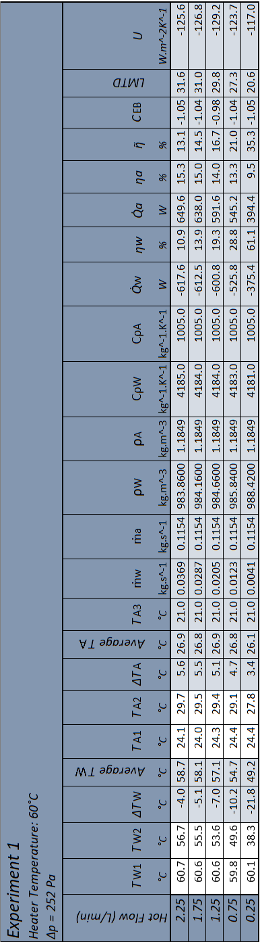
Table 3: Experiment 2 Results
Table 4: Experiment 3 Results

