Name: Nadine Gayle
Student Number: 1816824
Module Code: BMHP5005_BIRM
Title: Introduction and Research
Topic: What are the Causes, Effects, and Treatments of Bipolar Disorder.
Lecturer’s Name: Dr Tayo Korede
Title: Written Assignment

Table of content
Contents
Title 1
Table of content 2
Introduction 3
Bipolar Disorder 4
Causes and effects Bipolar Disorder. 5
Treatment: 7
Methodology and methods: 9
Ethical issues 11
Conclusion 13
References 14
Appendix 16
Figure1 16
Figure 2 17
Figure 3 18
Figure 4 19
Figure 5 19

Introduction
The primary signs of the mental health condition of bipolar disorder are identified as high and low mood periods. This will include a difference in energy levels, rest habits, as well capability to to concentrate, and other traits may extremely affect the actions, career, relationships, and other life facts of an individual. Often most people undergo mood swings, which are linked to bipolar is more. (National Institute of Mental Health, 2018)
A mental health condition such as bipolar (hyper burdensome ailment) Such a complex hereditary problem known as an emotional wellness issue (Anderson, Haddad, and Scott, 2012)
This is a chronic mental health illness that shows different characterized periods at different and depressed moods of one's life the modern concept of the event. Bipolar disorder is an illness that has been backdated as far as the Nineteenth century (Saunders and Goodwin, 2010). The centre component is an unsettling neurotic influence in temperament that can be diverse for individuals going from outrageous joy or madness (a scene of Bipolar issue) to extreme sorrow typically joined by aggravations in reasoning and conduct. (NHS Choices, 2019)
Bipolar is listed into four categories (different levels), which will be assessed to confirm the bipolar disorder level one may have.

- Bipolar 1 -In an event that has encountered a rate one scene of madness which has kept going longer than seven days. (you may likewise endure a kind of depressive stage, but not everyone does. (Judd et al., 2003)
- Bipolar 2 - Conclusion of bipolar Two on the off chance that encountered both, in any event, one scene of extreme discouragement and hypomania manifestations (Manic episode). (Judd et al., 2003)
- Cyclothymia - Conclusion of cyclothymia have encountered both hypomanic and burdensome temperament states throughout two years, or more and side effects are not severe adequate that measures up finding bipolar One or bipolar Two (www.mind.org.uk, 2021)
- Bipolar disorder due to another clinical or substance misuse issue- There is not a clear trend for certain bipolar disorders. The other three conditions still do not balance them. Nevertheless, for abnormal mood swings, they do have to follow the requirements (Nikravan Hayes, 2019)

Mental health condition

Bipolar Disorder is known as psychotic mental health condition that affects the brain, also known as Chemical Imbalance, as having a manic also could be viewed as the hyper scenes that happen after some time, after which they may change. These scenes may prompt overpowering sensations of uselessness, which regularly lead to contemplations of self-destruction. The hyper stage may cause a person to feel inventive and see lunacy as a good encounter. At this point or may likewise have side effects that affected the mind. Throughout this stage, one may feel overwhelmed with have loads of aspirations, ideas, and thoughts. Absence of rest and hunger are other likewise normal qualities of bipolar issues. (NHS Choices, 2019)
Bipolar, initially called hyper burdensome ailment, is quite possibly the most moving mental issues to oversee. Even though it is related with creativity, it harms most patients' lives, which more than around six% pass away through suicide in the two decades after diagnosis. One authoritative change implies that expert administrations generally treat intense scenes, leaving essential consideration with long haul the executives. This survey sums up current accepted procedures in Diagnosing and overseeing bipolar turmoil, signposting zones of vulnerability (Anderson, Haddad and Scott, 2012)

in Its lifetime, around 3% of people worldwide suffers from the illness (Aldinger and Schulze, 2016). This is perhaps the most well-known mental sicknesses,
This disorder is viewed as one of the most established known ailments. Bipolar side effects have been referenced in the soonest clinical records as far back as the subsequent century. Indeed, Aristaeus of Cappadocia, Turkey, first perceived the manifestations of craziness and discouragement and found the connection between them. (Angst and Sellaro, 2000)

The Mental health disorder is not entirely known but is often hereditary (Craddock and Jones, 1999). Other emotional well-being issues, for example, tension problems and substance use issues, are usually connected with bipolar. Different conditions are having bipolar confusion incorporate consideration deficiency hyperactivity issue, character problems, schizophrenia substance use disorder, and many other medical conditions. A cluster of genetic and environmental factors, such as personal traumas or stress, can positively influence systems.

The underlying hyper or burdensome scenes (bipolar confusion) of bipolar problem ordinarily happen from the get-go in the adolescent years or early adulthood. Most cases start before the age of 25 (Kleinman,1978). The indications of the problem can be moderately inconspicuous and may bring about being disregarded or misdiagnosed. That could bring about anguish, while, then again, satisfying daily routine can be experienced with appropriate treatment and backing.

Causes and effects Bipolar Disorder.
According to many researchers cannot pinpoint the exacted reason of bipolar disorder, the cause of the disorder is unknown, but researchers have found many Causes that may be involved which are listed below (Smitha Bhandari, MD, 2005)
Genetics:
A person might be more helpless against Bipolar disorder if a relative such as a mother or father suffer with bipolar disorder. There is no proof however, of a specific quality for the mental health disorder.
There is not ONE clear cause of Bipolar Disorder. According to much research it shows that a mixture of multiple things will make it more likely to have the mental health disorder will occur. There is no specific reason for bipolar disorder is obscure (Nih.gov, 2019) In any case, research proposes that there is no single reason.

Environment:
The environment factors are showed to be a big factor in many people that suffer with BD (bipolar disorder) These can included:
Along time enduring physical or sexual abuse (Goldberg et al., 1999)
encountering long haul heartache or misery as a youngster,
being ignored by a parent or career, or both, of your guardians as a youngster, and
growing up with a relative who had a genuine psychological wellness condition. Like bipolar issue or an issue with abusing liquor or medications (Aldinger and Schulze, 2016)

Chemical imbalances:
Where the chemicals in the brain can affected the mood and unwanted displays of conduct that are been displayed, when a person does not have the right amount this can cause a negative outburst otherwise known as Mania (Affected of bipolar disorder) Or could cause major depression (Cafasso, 2021)

Effects:
Many who suffer with bipolar disorder, have been affected from teenage years, or early adulthood, by this time they many have encountered many of the affects that comes with having the disorder. Clinical examination considers have shown that bipolar issue patients display disturbances in their behavior (Rosenthal et al., 2020)
Bipolar confusion is portrayed by outrageous emotional episodes. These can go from extraordinary highs (craziness) to outrageous lows (discouragement) (Pierson, 2019)

Loss of interest:
Not wanting to do the day-to-day task that you would normally do such as brush your teeth, have a shower, or even cook, suffering with bipolar can make the normal daily task harder to complete.
Without therapy, an individual with bipolar confusion may encounter serious scenes of discouragement. Manifestations of bipolar problem incorporate misery, uneasiness, loss of energy, sadness, and wild crying. One may lose interest in an action that they used to discover agreeable. They may acquire or get thinner, rest excessively or excessively little, and even ponder self-destruction (Rosenthal et al., 2020)

Suicidal thoughts:
According to the Journal of Psychiatric Research Many people that suffer with bipolar disorder tend to have a lot of thoughts about harming their self or even killing there self, but it also says that it mainly effects the individuals who have not receive treatment for the disorder (Simon et al., 2007)

Manic episode:
When a person has Manic episodes (Bipolar Disorder), it can last up to seven days, which can be more serious that can even lead to one been admitted into the hospital to adjust the mood stabilizers. One who is suffering a manic episode can lead to strange conduct, fantasies, and suspicion. A manic episode can also be triggered by not having enough sleep, as well as other signs such as Fast-talking, not as focused and racing (Purse,2019) (Figure1+2). It needs to be noted that a manic episode is different from a depression episode.
The start of a manic or depressive episode is often foreshadowed by sleep disturbance. Mood changes and the way you eat all changes, and then a sudden increase of anxiety can also start up to three weeks before a manic episode develops. Manic individuals often have a history of substance abuse developed over the years as a form of "self-medication." while others are irritable or demonstrate poor judgment. (Goldberg et al., 1999)

Hypomanic:
A study by
A hypomanic episode is a form of bipolar, that is more of and psychological mind frame. Hypomanic affects the mood and the way one thinks, but a person with a hypomanic episode is a very noticeable change. Many symptoms of Manic and Hypomanic disorders are very similar (Pietrangelo, 2018)
Outburst can either take place in different periods of one’s episodes. which does not mean that you do not have any emotions during this time. but a person is not currently experiencing mania, hypomania, or depression, or managing symptoms virtually. It might also feel stable for years between episodes, although periods of stability can be much shorter for some people (Boyd and Dunn, 2015)

Treatment:
According to the medical news, there is Currently, do not have a fast cure for Bipolar,
But treatment is available. To help to suppress the disorder for an individual to be able to have some control over their Mantel health condition allowing them to have a normal life (Medical news, 2019)

If an individual isn't dealt with Received treatment, scenes of bipolar(Mania) can keep going for somewhere in the range of 3 to 6months, Yet if an individual has the right treatment, their manic episodes tend to start improving within 3moths of taking the right medication, Many people with bipolar disorder, will be treated with a mixture of medication that will help the disorder (Hilty, Brady and Hales, 1999)
Medication:
Lithium is a drug that many doctors recommended to individuals with bipolar, this is a drug that stabilizes the patient’s mood also known as a mood stabilizer.
According to many research lithium has been known to help patients with (BD) long term (Chiu et al., 2013)
Lithium is a drug that can help a person, feel like they do not have to cause any harm to their self or in extreme cases suicide, Lithium has been a well-researched drug and according to H K Manji and R S Duman has been around for around 60 years helping patients with bipolar disorder (Manji and Duman, 2001)

Lithium has been utilized clinically for a very long time, basically to treat bipolar turmoil. Contending medicines and misrepresented impressions about intricacy and dangers of lithium treatment have prompted its declining use in certain nations, empowering this update about its safe clinical use (Tondo et al., 2019)

Antipsychotics
are a sort of mental medicine which are accessible on solution to treat psychosis. They are authorized to treat specific kinds of psychological well-being issue whose side effects incorporate insane encounters. Antipsychotics can be recommended to be taken in various manners. Most normally you will take them by gulping them in tablet or fluid structure. However, some of them can likewise be recommended as a station infusion. This is a lethargic delivery, moderate acting type of the drug, given as an infusion like clockwork (Bjornestad et al., 2019)
Antipsychotics are a sort of mental medicine which are accessible on solution to treat psychosis. They are authorized to treat specific kinds of psychological well-being issue whose side effects incorporate insane encounters. Antipsychotics can be recommended to be taken in various manners. Most normally you will take them by gulping them in tablet or fluid structure. However, some of them can likewise be recommended as a station infusion. This is a lethargic delivery, moderate acting type of the drug, given as an infusion like clockwork (Bjornestad et al., 2019)
Psychological Treatment:
Psychological treatment is therapy to help you aim to keep you well and to support you from becoming unwell again also known as a relapse.

In therapy such things can help talking about your feelings, or tremor that you have experienced, could help to understand what bipolar disorder is, help to understand the effects it has on you and the people around you.
Talking in therapy could also help to keep you safe, by talking about plans and goals you may have, but most importantly help you to mange the disorder you have (Gutierrez and Scott, 2004)

Methodology and methods:

Why this topic?
The reason I, decided to pick Bipolar, was I already had a brief understanding on the mental health condition, due to my mother having the disorder before she died and found that it was a perfected opportunity for me to do more research on the disorder, after growing up with not understanding why, she had so many down moments, after doing the research I have now understood that, she was suffering a manic episode, for whatever reason(I will not know) but medical speaking this could have been a number of environmental factors or even her medication needed adjusting (Gayle, 2021)

Method:
The method that was used within this paper was a literature review that will show my reader that I have gone into a good amount of depth and research on my subject of bipolar disorder and that the reader will understand my findings and the knowledge and understanding of my chosen subject. The question that was researched about is What are the causes, effects, and treatments of Bipolar Disorder?

Methodology:

What, how, and why were the questions that I used for the methodology that was used to conduct my primary research which was a large range of reading of relevant Journals and papers on Bipolar disorder, as well as doing some visual research such as watching documentaries and series on people suffering from Bipolar disorder, and the cause that has led for the mental health illness to become visual in one's life.

The first step- That was taken to write this paper was, watching several series and a documentary figure (5+6) that helped me to understand what bipolar disorder is more and helped me have a better understanding. Of the trigger points that could causes an episode and how much taking the right dose of medication can help keep the disorder under control.

Second step- That was taken was finding the write journals by using google scholar and YouTube and other search engines and keeping the tabs open writing notes that could help to write the research paper on the chosen subject.

Third step- was searching key words that could help me find the best information to, to understanding bipolar; the key points are.
- What are the causes of bipolar disorder…
- What are the effects and what are the treatments of bipolar disorder…
- Genetics of bipolar
- Clinical cause
- Environmental factors
- Literature review

Fourth step- Was re-reading many of the journals and articles that was tabbed on the internet page, only using the ones that were found to have the most information, making sure the information that is kept is useful but most had repeating information been making it harder to pick the parts of information that were useful to me adding more notes.

Fifth step- Was to start organising the sections of my paper, writing a first draft, making sure there was enough information.

Sixth step- Was to adding information to the draft and making sure the information is answering the question that is been asked.

Seventh step–That was taken was bring all the information that was collected, re reading my work to make sure that all key points was addressed.

Eighth step- Finding references and opening another word document to write these down to add into my final draft when its time.

Nineth step– Continuing to read journals and re-watching series on the disorder, it was hard to grasp a single reason that causes bipolar, but then later understood that bipolar is made up of different factors and not just only to do with the chemical imbalance of the brain (Leo and Lacasse, 2007)

Tenth step- Was to set the layout to my final draft, adding all the sections of my work, to keep track on my progression.

Eleventh step - Write my final draft, checking spelling, and creating subtitles unto my work to break up the bulk of the work for a better understanding.

Last step – Will be to check my work and submit to Turnitin.

Ethical issues
Nonetheless, there are moral issues that may emerge in the finding of bipolar issue itself; in the determination of treatment; and in the correspondence with the patient of the objectives, expected advantages, and dangers of treatment choice of which the cautious clinician should know (Ostacher, 2019)
Having the mental health condition can make it hard to make everyday decisions, when discussing sensitivity conditions, such as BD its best to make sure the patient is in the right frame of mind and have a full understanding in what has been said.

Findings and discussion
Environmental factors
The environmental factors and clinical course of bipolar issues are also linked to genetics and environmental factors bipolar issue can run in families albeit not every person with a family ancestry will build up this problem (Aldinger and Schulze, 2016) the results are a clinical, course that have been inadequately settled, there have been various examinations to attempt the research of the effects of the natural elements on the clinical, course of the sickness Bipolar disorder. The point of the diagram ongoing examination on the effect of natural determinants on the clinical course of bipolar issue (Aldinger and Schulze, 2016)
Manic episode
According (Torales et al., 2018) The evidence for mania is an illness that is caused from the imbalance within the brain, the clinical diagnosis is mainly based on experiences. When it comes to BD more research has to be conducted.
Manic episode can be controlled with the right treatment such as taking Lithium, and having therapy to help to speak about the difficulties they have experienced in their life(Yang and Wichser, 2020)

In much research regarding bipolar disorder is has shown that the disorder is a condition that is mainly found in adults than in children. Across the united states, there have been originations set up to help the public that has Bipolar disorder, according to (National Institute of Mental Health) A person who at the age of 25 are seeing more signs of the disorder within a 12month gap of 2.6% then showing that a large population of the united states been diagnosed with bipolar disorder with 83% of cases being severe. In agreement with this data, 49% are currently in treatment (National Institute of Mental Health, 2017)

The short answer is bipolar disorder is genetic, and It is likewise thought the bipolar problem is connected to hereditary qualities, as it appears to run in families. The relatives of an individual with bipolar turmoil have an expanded danger of creating it themselves. Be that as it may, no single quality is answerable for bipolar disorder (NHS.UK, 2018)

Recommendations
Below is some recommendations on bipolar disorder
There is also the links to the documentary and series that was proven helpful while doing research on this written assignment, As well as other link that can help.
- https://www.nami.org/About-Mental-Illness/Mental-Health-Conditions/Bipolar-Disorder (National Alliance on Mental Illness, 2020)

- https://onlinelibrary.wiley.com/doi/abs/10.1111/j.1600-0447.2009.01383.x
(Malhi et al., 2009)

- Series called Spinning Out https://www.imdb.com/title/tt9117054/

- Behind her eyes https://www.netflix.com/gb/title/80244630

- Hotel Cecil documentary https://www.netflix.com/gb/title/81183727

Conclusion
Bipolar Disorder impacts the patient just as the family moreover. Therefore, family members should be associated with treatment and care. As referred to previously, results incorporating a finding of bipolar issue may mean interference of any socialization with friends and family. Habitually treatment joins gatherings that incorporate family. While picking what therapy is ideal, clinical consideration workers should reliably move toward the patient's arrangement of encounters. Since there is no known finding for this issue, more inaccessible family people, for instance, Myself as well as other people should continue searching for tutoring and perception of the affliction to help our loved ones. The pressing factor that watchmen are under may provoke missed work or because of young people missed school, lost additional time, and focused on associations. Bipolar disturbance may cause physical and mental exhaustion, which is consistently confounded by friends and family. Stress from care giving can make it hard to adjust to a companion or relative's bipolar signs. It is huge that people truly zeroing in on those with bipolar disarray moreover manage themselves and keep up their mental constancy.

References
Reference list
Aldinger, F. and Schulze, T.G. (2016). Environmental factors, life events, and trauma in the course of bipolar disorder. Psychiatry and Clinical Neurosciences, 71(1), pp.6–17.
Aldinger, F. and Schulze, T.G. (2016). Environmental factors, life events, and trauma in the course of bipolar disorder. Psychiatry and Clinical Neurosciences, pp.6–17.
Aldinger, F. and Schulze, T.G. (2016). Environmental factors, life events, and trauma in the course of bipolar disorder. Psychiatry and Clinical Neurosciences, 71(1), pp.6–17.
Aldinger, F. and Schulze, T.G. (2016). Environmental factors, life events, and trauma in the course of bipolar disorder. Psychiatry and Clinical Neurosciences, 71(1), pp.6–17.
Aldinger, F. and Schulze, T.G. (2016). Environmental factors, life events, and trauma in the course of bipolar disorder. Psychiatry and Clinical Neurosciences, 71(1), pp.6–17.
Alloy, L.B., Abramson, L.Y., Urosevic, S., Walshaw, P.D., Nusslock, R. and Neeren, A.M. (2005). The psychosocial context of bipolar disorder: Environmental, cognitive, and developmental risk factors. Clinical Psychology Review, [online] 25(8), pp.1043–1075. Available at: https://www.sciencedirect.com/science/article/pii/S0272735805000966 [Accessed 12 Feb. 2021].
Anderson, I.M., Haddad, P.M. and Scott, J. (2012). Bipolar disorder. BMJ, [online] 345(dec27 3), pp.e8508–e8508. Available at: https://www.bmj.com/content/345/bmj.e8508 [Accessed 4 Feb. 2021].
Anderson, I.M., Haddad, P.M. and Scott, J. (2012). Bipolar disorder. BMJ, [online] 345(dec27 3), pp.e8508–e8508. Available at: https://www.bmj.com/content/345/bmj.e8508.

Angst, J. and Sellaro, R. (2000). Historical perspectives and natural history of bipolar disorder. Biological Psychiatry, 48(6), pp.445–457.
Bjornestad, J., Lavik, K.O., Davidson, L., Hjeltnes, A., Moltu, C. and Veseth, M. (2019). Antipsychotic treatment – a systematic literature review and meta-analysis of qualitative studies. Journal of Mental Health, pp.1–11.
Boyd, R. and Dunn, K. (2015). Understanding bipolar disorder understanding bipolar disorder. [online] . Available at: https://www.craigbarlow.co.uk/_webedit/uploaded-files/All%20Files/Mental%20Health/mind_bipolar_web.pdf [Accessed 4 Feb. 2021].
Cafasso, J. (2021). Chemical Imbalance in the Brain: Anxiety, Symptoms, and Depression. [online] Healthline. Available at: https://www.healthline.com/health/chemical-imbalance-in-the-brain#symptoms [Accessed 16 Mar. 2021].
Chiu, C.-T. ., Wang, Z., Hunsberger, J.G. and Chuang, D.-M. . (2013). Therapeutic Potential of Mood Stabilizers Lithium and Valproic Acid: Beyond Bipolar Disorder. Pharmacological Reviews, [online] 65(1), pp.105–142. Available at: https://www.ncbi.nlm.nih.gov/pmc/articles/PMC3565922/ [Accessed 13 Mar. 2021].
Craddock, N. (2005). The genetics of schizophrenia and bipolar disorder: dissecting psychosis. Journal of Medical Genetics, [online] 42(3), pp.193–204. Available at: https://jmg.bmj.com/content/42/3/193#ref-64 [Accessed 23 Feb. 2021].
Craddock, N. and Jones, I. (1999). Genetics of bipolar disorder. Journal of Medical Genetics, [online] 36(8), pp.585–594. Available at: https://jmg.bmj.com/content/36/8/585 [Accessed 19 Feb. 2021].
Craddock, N. and Jones, I. (1999). Genetics of bipolar disorder. Journal of Medical Genetics, [online] 36(8), pp.585–594. Available at: https://jmg.bmj.com/content/36/8/585 [Accessed 19 Feb. 2021].
Gayle, N. (2021). Why this topic.
Geddes, J.R. and Miklowitz, D.J. (2013a). Treatment of bipolar disorder. The Lancet, [online] 381(9878), pp.1672–1682. Available at: https://www.ncbi.nlm.nih.gov/pmc/articles/PMC3876031/
Geddes, J.R. and Miklowitz, D.J. (2013b). Treatment of bipolar disorder. The Lancet, [online] 381(9878), pp.1672–1682. Available at: https://www.ncbi.nlm.nih.gov/pmc/articles/PMC3876031/
Goldberg, J.F., Garno, J.L., Leon, A.C. and Portera, L. (1999). A History of Substance Abuse Complicates Remission From Acute Mania in Bipolar Disorder. The Journal of Clinical Psychiatry, [online] 60(11), pp.733–740. Available at: https://www.psychiatrist.com/JCP/article/Pages/history-substance-abuse-complicates-remission-acute.aspx [Accessed 17 Feb. 2021].
Gutierrez, M.J. and Scott, J. (2004). Psychological treatment for bipolar disorders. European Archives of Psychiatry and Clinical Neuroscience, 254(2), pp.92–98.
Hilty, D.M., Brady, K.T. and Hales, R.E. (1999). A Review of Bipolar Disorder Among Adults. Psychiatric Services, 50(2), pp.201–213.
Judd, L.L., Akiskal, H.S., Schettler, P.J., Coryell, W., Maser, J., Rice, J.A., Solomon, D.A. and Keller, M.B. (2003a). The comparative clinical phenotype and long term longitudinal episode course of bipolar I and II: a clinical spectrum or distinct disorders? Journal of Affective Disorders, [online] 73(1-2), pp.19–32. Available at: https://www.sciencedirect.com/science/article/abs/pii/S0165032702003245 [Accessed 15 Feb. 2020].
Judd, L.L., Akiskal, H.S., Schettler, P.J., Coryell, W., Maser, J., Rice, J.A., Solomon, D.A. and Keller, M.B. (2003b). The comparative clinical phenotype and long term longitudinal episode course of bipolar I and II: a clinical spectrum or distinct disorders? Journal of Affective Disorders, 73(1-2), pp.19–32.
Kelsoe, J.R. (2003). Arguments for the genetic basis of the bipolar spectrum. Journal of Affective Disorders, [online] 73(1-2), pp.183–197. Available at: https://www.nimhgenetics.org/data/resources/publications/kelsoe_03.pdf [Accessed 19 Feb. 2020].
KLEINMAN, A. (1978). Culture, Illness, and Care. Annals of Internal Medicine, 88(2), p.251.
Leo, J. and Lacasse, J.R. (2007). The Media and the Chemical Imbalance Theory of Depression. Society, 45(1), pp.35–45.
Lin., H. (2015). Assessing Symptoms. Very well mind. Available at: https://www.verywellmind.com/bipolar-disorder-symptoms-and-diagnosis-379962 [Accessed 16 Feb. 2021].
Malhi, G.S., Adams, D., Lampe, L., Paton, M., O’Connor, N., Newton, L.A., Walter, G., Taylor, A., Porter, R., Mulder, R.T. and Berk, M. (2009). Clinical practice recommendations for bipolar disorder. Acta Psychiatrica Scandinavica, 119, pp.27–46.
Malhi, G.S. and Bell, E. (2020). New windows on the treatment of bipolar disorder. Bipolar Disorders, 22(1), pp.7–10.
Manji, H.K. and Duman, R.S. (2001). Impairments of neuroplasticity and cellular resilience in severe mood disorders: implications for the development of novel therapeutics. Psychopharmacology Bulletin, [online] 35(2), pp.5–49. Available at: https://pubmed.ncbi.nlm.nih.gov/12397885/ [Accessed 17 Mar. 2021].
Mayo Clinic (2018). Bipolar disorder - Symptoms and causes. [online] Mayo Clinic. Available at: https://www.mayoclinic.org/diseases-conditions/bipolar-disorder/symptoms-causes/syc-20355955 [Accessed 10 Feb. 2021].
Medical news (2019). Is bipolar disorder curable? Treatment and long term management. [online] www.medicalnewstoday.com. Available at: https://www.medicalnewstoday.com/articles/324349#:~:text=Share%20on%20Pinterest%20Bipolar%20disorder [Accessed 7 Feb. 2021].
Misiak, B., Stramecki, F., Gawęda, Ł., Prochwicz, K., Sąsiadek, M.M., Moustafa, A.A. and Frydecka, D. (2017). Interactions Between Variation in Candidate Genes and Environmental Factors in the Etiology of Schizophrenia and Bipolar Disorder: a Systematic Review. Molecular Neurobiology, 55(6), pp.5075–5100.
National Alliance on Mental Illness (2020). Bipolar disorder | NAMI: National Alliance on Mental Illness. Nami.org. Available at: https://www.nami.org/About-Mental-Illness/Mental-Health-Conditions/Bipolar-Disorder [Accessed 17 Mar. 2021].
National Institute of Mental Health (2017). NIMH» Bipolar Disorder. [online] Nih.gov. Available at: https://www.nimh.nih.gov/health/statistics/bipolar-disorder.shtml [Accessed 20 Feb. 2021].
National Institute of Mental Health (2018). Bipolar disorder. [online] Nih.gov. Available at: https://www.nimh.nih.gov/health/topics/bipolar-disorder/index.shtml [Accessed 9 Feb. 2021].
NHS Choices (2019). Overview - Bipolar disorder. [online] NHS. Available at: https://www.nhs.uk/conditions/bipolar-disorder / [Accessed 4 Feb. 2021].
NHS Choices (2019). Overview - Bipolar disorder. [online] NHS. Available at: https://www.nhs.uk/conditions/bipolar-disorder/ [Accessed 5 Feb. 2021].
nhs.uk. (2018). Bipolar disorder - Causes. [online] Available at: https://www.nhs.uk/conditions/bipolar-disorder/causes/#:~:text=It [Accessed 20 Feb. 2021].
Nih.gov. (2019). NIMH» Bipolar Disorder. [online] Available at: https://www.nimh.nih.gov/health/publications/bipolar-disorder/index.shtml#pub3 [Accessed 19 Feb. 2021].
Nikravan Hayes, L. (2019). 4 Different Types of Bipolar Disorder, and How They’re Treated | Talkspace. [online] Talkspace. Available at: https://www.talkspace.com/blog/types-of-bipolar-disorder/ [Accessed 9 Feb. 2021].
Ostacher, M.J. (2019). Ethical Issues in the Diagnosis and Treatment of Bipolar Disorders. FOCUS, 17(3), pp.265–268.
Pierson, E. (2019). What Is Crazy? Using Multiple Case Studies to Explore an Adjunctive Treatment for Bipolar Disorder - ProQuest. [online] search.proquest.com. Available at: https://search.proquest.com/openview/cb9c743fe32e43e7b000afffa5b898fe/1.pdf?pq-origsite=gscholar&cbl=18750&diss=y [Accessed 17 Mar. 2021].
Pietrangelo, A. (2018). Mania vs. Hypomania: What’s the Difference? [online] Healthline. Available at: https://www.healthline.com/health/mania-vs-hypomania [Accessed 5 Feb. 2021].
Purse, M. ed., (2019). These Are the Most Common Symptoms of Bipolar Disorder. [online] Verywell Mind. Available at: https://www.verywellmind.com/bipolar-disorder-symptoms-and-diagnosis-379962 [Accessed 6 Feb. 2021].
Rosenthal, S.J., Josephs, T., Kovtun, O. and McCarty, R. (2020). Seasonal effects on bipolar disorder: A closer look. Neuroscience & Biobehavioral Reviews, [online] 115(), pp.199–219. Available at: https://www.sciencedirect.com/science/article/abs/pii/S0149763420304206 [Accessed 21 Feb. 2021].
Rowland, T.A. and Marwaha, S. (2018). Epidemiology and risk factors for bipolar disorder. Therapeutic Advances in Psychopharmacology, [online] 8(9), pp.251–269. Available at: https://www.ncbi.nlm.nih.gov/pmc/articles/PMC6116765/.
Saunders, K.E.A. and Goodwin, G.M. (2010). The course of bipolar disorder. Advances in Psychiatric Treatment, [online] 16(5), pp.318–328. Available at: https://www.cambridge.org/core/journals/advances-in-psychiatric-treatment/article/course-of-bipolar-disorder/58EDBBA7422C12C4D4FB52306446E971 [Accessed 21 Feb. 2021].
Simon, N.M., Zalta, A.K., Otto, M.W., Ostacher, M.J., Fischmann, D., Chow, C.W., Thompson, E.H., Stevens, J.C., Demopulos, C.M., Nierenberg, A.A. and Pollack, M.H. (2007). The association of comorbid anxiety disorders with suicide attempts and suicidal ideation in outpatients with bipolar disorder. Journal of Psychiatric Research, 41(3-4), pp.255–264.
Smitha Bhandari, MD (2005). Causes of Bipolar Disorder. [online] WebMD. Available at: https://www.webmd.com/bipolar-disorder/guide/bipolar-disorder-causes [Accessed 17 Mar. 2021].
Stratton, S., Scodelario, K., Jones, J., Shields, W. and Roderick, E. (2020). Spinning Out. [online] IMDb. Available at: https://www.imdb.com/title/tt9117054/ [Accessed 17 Mar. 2021].
Tondo, L., Alda, M., Bauer, M., Bergink, V., Grof, P., Hajek, T., Lewitka, U., Licht, R.W., Manchia, M., Müller-Oerlinghausen, B., Nielsen, R.E., Selo, M., Simhandl, C. and Baldessarini, R.J. (2019). Clinical use of lithium salts: guide for users and prescribers. International Journal of Bipolar Disorders, 7(1).
Tondo, L., Alda, M., Bauer, M., Bergink, V., Grof, P., Hajek, T., Lewitka, U., Licht, R.W., Manchia, M., Müller-Oerlinghausen, B., Nielsen, R.E., Selo, M., Simhandl, C. and Baldessarini, R.J. (2019). Clinical use of lithium salts: guide for users and prescribers. International Journal of Bipolar Disorders, 7(1).
Torales, J., Barrios, I., Gonzalez, I. and Ventriglio, A. (2018). Manic Episodes Due to Medical Illnesses: A Literature Review. [online] pp.733–738. Available at: https://www.researchgate.net/publication/327116576_Manic_Episodes_Due_to_Medical_Illnesses_A_Literature_Review [Accessed 17 Mar. 2021].
www.mind.org.uk. (2021). Types of bipolar. [online] Available at: https://www.mind.org.uk/information-support/types-of-mental-health-problems/bipolar-disorder/types-of-bipolar/ [Accessed 4 Feb. 2021].
www.netflix.com. (2021). Crime Scene: The Vanishing at the Cecil Hotel | Netflix Official Site. [online] Available at: https://www.netflix.com/gb/title/81183727 [Accessed 17 Mar. 2021].
Yang, S. and Wichser, L. (2020). Manic episode in patient with bipolar disorder and recent multiple sclerosis diagnosis. Medicine, 99(42), p.e22823.
YoungMinds. (2020). Lithium. [online] Available at: https://youngminds.org.uk/find-help/medications/lithium/?gclid=Cj0KCQiA962BBhCzARIsAIpWEL01KjmaSJUkqIvZTpvtjHmh8Tk8RajwfN1ssBbMiiz_j2qehecF6WUaAnyvEALw_wcB [Accessed 17 Feb. 2021].

Appendix

Figure1
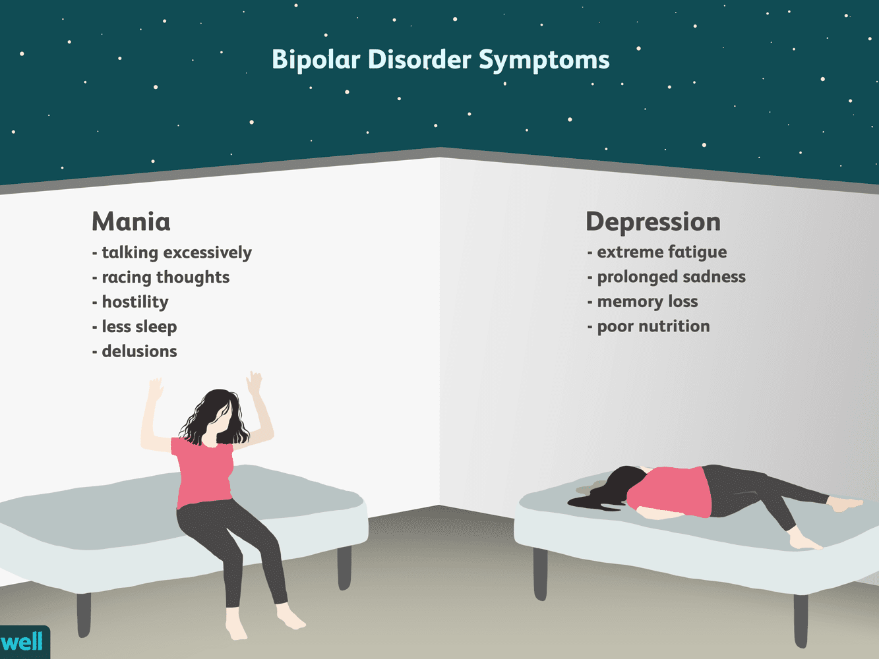

(Lin., 2015)

Figure 2
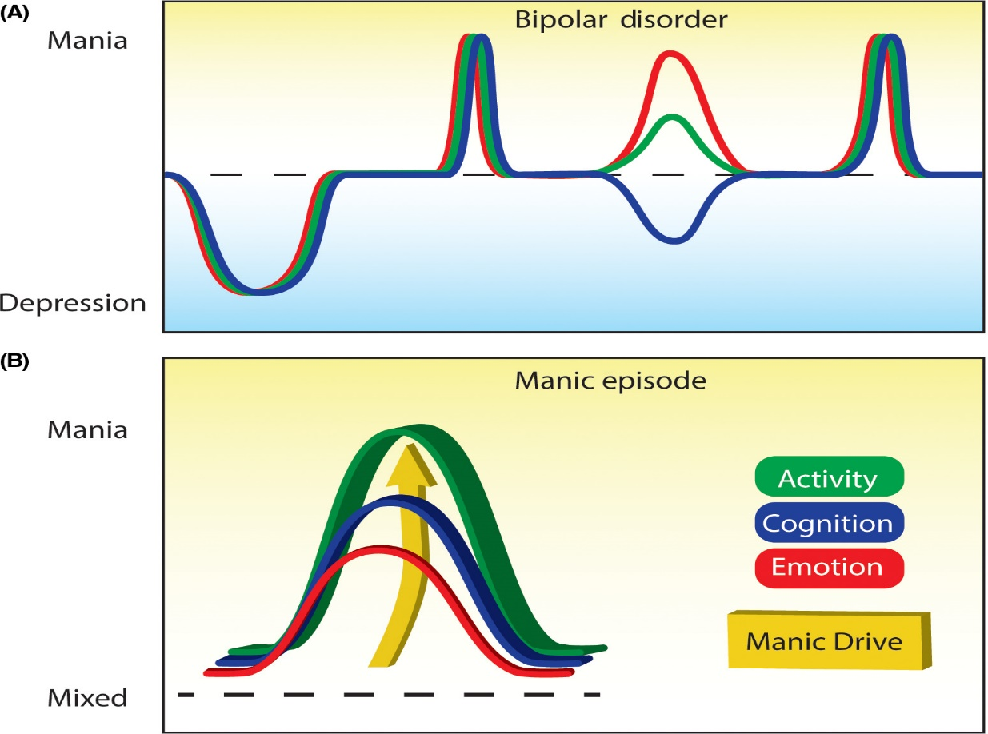

(Malhi and Bell, 2020)

Figure 3
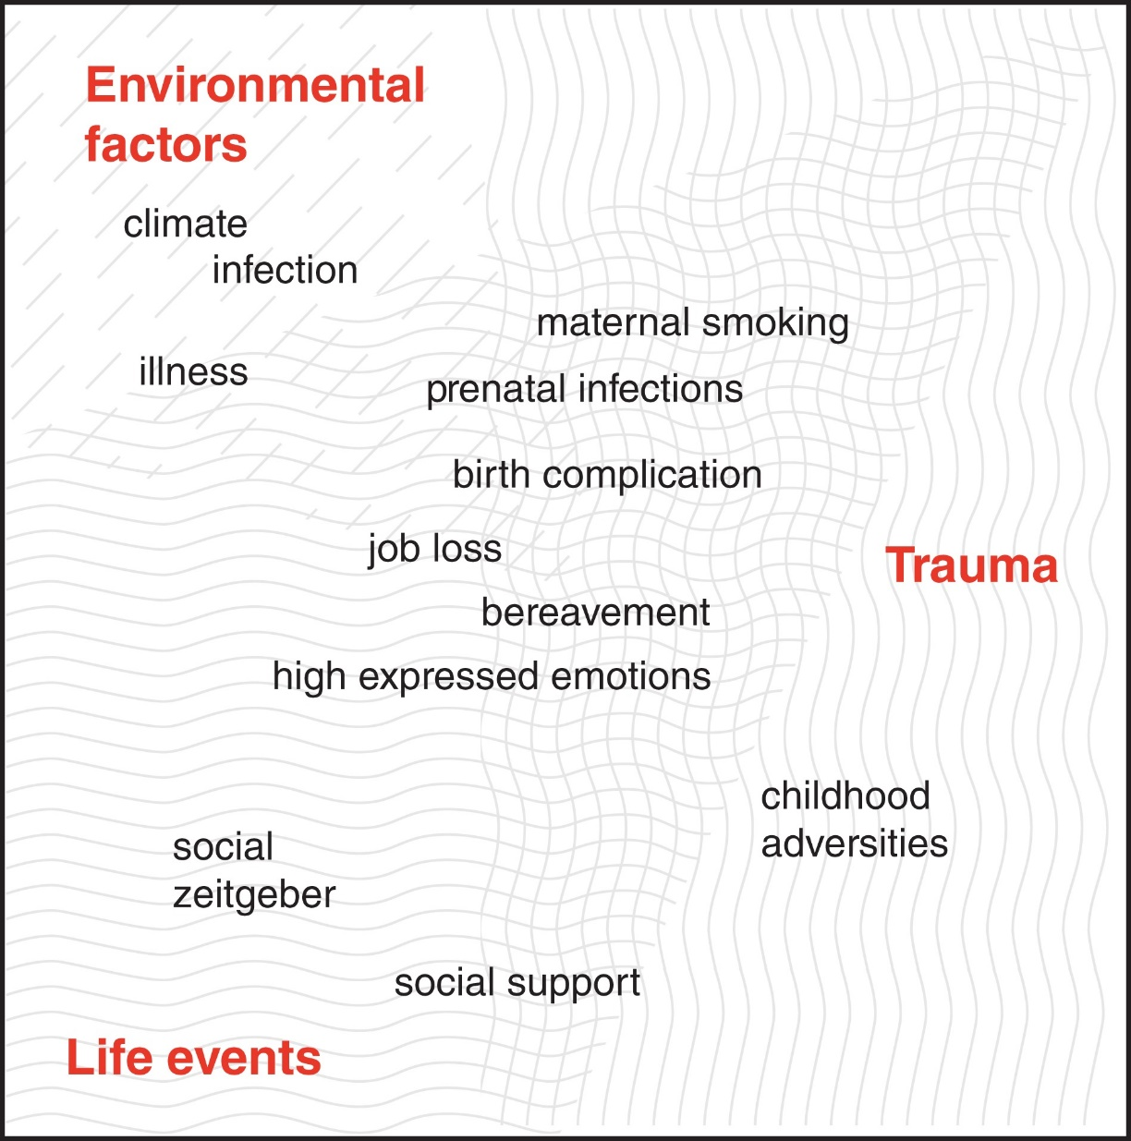

(Aldinger and Schulze, 2016

Figure 4
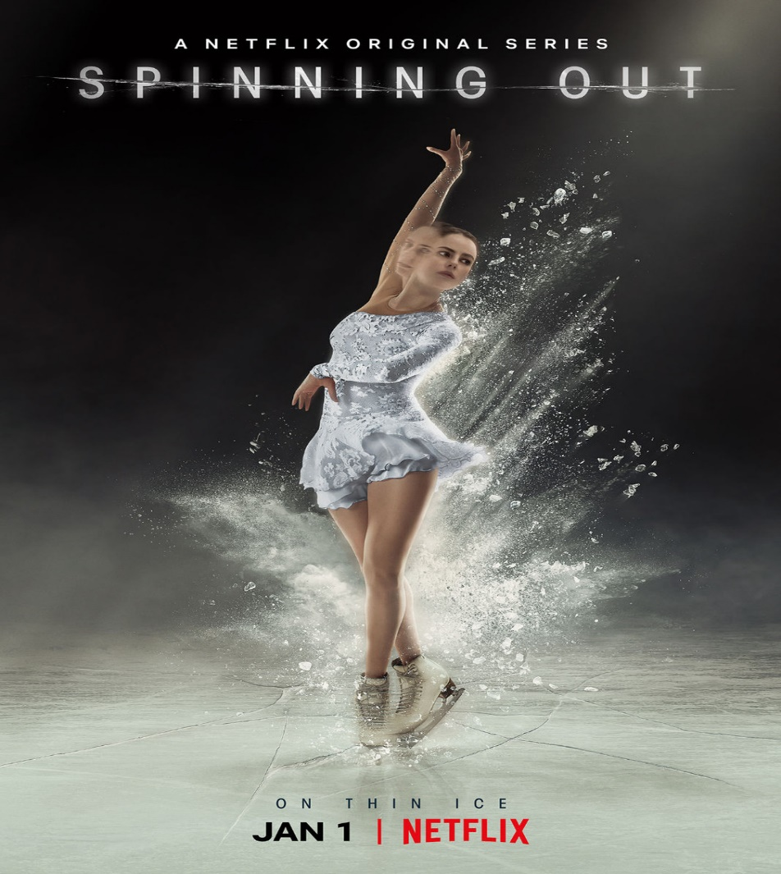

(Stratton et al., 2020)

Figure 5



(www.netflix.com, 2021)

