L4- Database Analysis and Design

ACCA4023

Lecturer: Adrian Chapman

Submission Deadline: May 14th 2023

BAL18847452 (Stephanie Ball)
University of wales trinity saint David
Table of Contents
Introduction 3
Database Management System 3
Department Analysis 4
Entity Relationship Diagram Analysis 5
Microsoft Access 5
Conclusion 6
Appendix 1- Database Creation Screenshots 7
Appendix 2- Data Dictionary 22
Appendix 3- Normalisation 23
Appendix 4- Entity Relationship Diagram 25
Appendix 5- Database Diagram 25
Appendix 6- SQL Script 26

Introduction

A Swansea-based event planning business called Northern Lights pvt Ltd focuses on conferences, workshops, seminars, and music festivals. Their businesses have lately been expanded to Neath and Carmarthen. With the use of a database management system, the organisation hopes to go from a manual administration procedure to an electronic one. The system's ability to efficiently capture customer information and event requests, as well as the automatic issuance of customer bills for correct accounting records, will assist assure the success of events.
The business is aware of the value of having an online presence in acquiring new clients and broadening their market. They are looking for a system that will enable online customer registration and give staff and customers a place to look up and examine event-related data. The system should also make it possible for the concerned departments to access, track, and create invoices for purchases made from suppliers.
The creation of appropriate tables that adhere to the third normal form (3NF) principles and have the proper fields and relationships will be done in order to satisfy these requirements. To graphically illustrate the entities, relationships, and degree of relationships involved, an entity relationship diagram (ERD) will be created.

Database Management System

A thorough understanding of the many users who will access the system is necessary for the Northern Lights event organising company's Database Management System (DBMS) to be implemented successfully. We can create a DBMS that meets their demands, improves their workflow, and ultimately helps the business succeed by understanding their roles and responsibilities. The branch managers who are in charge of their separate branches in Swansea, Neath, and Carmarthen are an essential user group. They are responsible for overseeing the workforce, planning events, and serving as the main point of contact for the clients. Branch managers need access to the DBMS in order to carry out their responsibilities well. They will be able to monitor progress, delegate responsibilities to department heads, and arrive at well-informed judgements thanks to the system's real-time event information. This feature simplifies event administration, encourages effective resource management, and provides prompt answers to shifting demands.
The Northern Lights crew is essential to providing high-quality event experiences. They are in charge of duties including selling tickets, setting up audio-visual equipment, and maintaining and cleaning event venues. The workflow of staff employees can be greatly enhanced by giving them access to the DBMS. They can interact with other team members, receive task assignments, and update event statuses all from within the system. This centralised strategy improves coordination, makes effective communication easier, and does away with manual record-keeping, which saves time and minimises mistakes.
Clients can use the DBMS as a platform to discuss event requirements, evaluate proposals, and track event development. Customers can easily interact with branch managers using the system, facilitating quick updates and productive collaboration. Additionally, they have the ability to search for and view event-related data, promoting openness and confidence in the company's offerings. The DBMS's user-friendly dashboards and interfaces cater to clients' needs, giving them the freedom to take an active part in event planning..
The DBMS integrates a number of crucial features to cater to the various needs of these users. Navigation is made simple through user-friendly interfaces, and customised dashboards show pertinent data suited to each user's role. Branch managers can assign assignments and keep track of their fulfilment thanks to task management tools. Users can collaborate easily thanks to communication tools like notifications and messaging services. Real-time data access guarantees the availability of current information, assisting in the making of well-informed decisions.

Department Analysis

Each branch of Northern Lights Pvt Ltd has a variety of departments in order to manage the wide range of tasks involved in event planning. These divisions are essential to ensuring the effective performance of numerous tasks and duties inside the company. The organisation can reduce departmental operations and make it easier for departments to coordinate by using the database management system.
Each branch's sections offer services for multiple aspects of event planning. Customer Services, IT, Environmental, Legal, Communications, Research and Analytics, Registration, Audiovisual and Production, Logistics, Marketing, Public Relations, Finance, and Human Resources are a few of them.
The department responsible for customer service deals with registrations, questions, and attendees for events. The technological software and infrastructure required for smooth event operations are managed by the IT Department. Waste management and energy saving fall within the purview of the Environmental Department. Risk management, permits, and contracts are all within the legal department's control. Press announcements and media coverage are handled by the communications division.
Staff and volunteers are trained as needed thanks to training and development. The department of research and analytics analyses events and does market research. The registration department oversees the ticketing systems and keeps a record of attendance. Lighting, staging, and presentations using many media are handled by audiovisual and production. The department of logistics is in charge of transportation, setup, and teardown. The establishment of campaigns and social media presence are key aspects of marketing. Press releases and media relations are managed by the public relations department. Budgeting, invoicing, and revenue management are handled by the finance department. The hiring process, contracts, and training are handled by human resources.
Northern Lights Pvt Ltd is able to centralise and combine the operations of each department by adopting a database management system. Data pertaining to customer services, IT infrastructure, environmental practises, legal compliance, communications, training, research, registration, audiovisual production, logistics, marketing, public relations, finance, and human resources may be efficiently stored and retrieved thanks to the system. This centralised strategy promotes collaboration, streamlines processes, and assures efficient departmental coordination, all of which contribute to successful event management.
Overall, the database management system of Northern Lights Pvt Ltd. is essential in supporting the various duties carried out by each department. It facilitates effective data management, improves coordination and communication, and adds to the management and organisation of events as a whole.

Entity Relationship Diagram Analysis

The entity relationship diagram created shows the relationships created between various tables in my database. Within the database are Suppliers, Departments, Events, Staff and Customers. These tables were chosen as they represent the necessary data within the database
Information about the many vendors the company has hired is kept in the "Suppliers" entity. It has characteristics like Products, Delivery_Date, Payment_Terms, SupplierID, SupplierName, and SupplierNo. A connection between the "Suppliers" and "Event" entities is shown by the ERD. The "one-to-many" linkage used to describe this relationship denotes the possibility of numerous suppliers being involved in a single occurrence. In other words, more than one entry in the "Suppliers" entity, each referring to a different supplier, may be present for an event.
The various company departments are represented by the "Department" entity. It has characteristics like Branch, Manager, ManagerName, DepartmentID, EventID, Responsibilities, and DepartmentName. The "Department" and "Event" entities are related, as shown by the ERD. The fact that this linkage is "one-to-many" means that different entries for the same event may appear in different "Department" entities. This illustrates how various departments could work together to plan, carry out, and administer a single event.
Also, the "Staff" entity keeps records of the personnel who work for the business. It contains information on staff members including their StaffID, EventID, StaffName, Position, Staff Phone Number, Staff Email Address, Branch Location, Hire Date, and Salary. The "Staff" and "Event" entities are related, as shown by the ERD. This relationship is shown as a "one-to-many" association, suggesting that a staff person may be connected to several events, while several staff members may be involved in one event.
Furthermore, Information on the customers connected to the events the business organises is stored in the "Customers" entity. CustID, EventID, CustName, CustAddress, PhoneNo, Email, Company, Marketing_Preferences, Payment_Methods, and CustPreferences are just a few of the attributes it contains. The "Customers" and "Event" entities are related, as shown by the ERD. This link is also a "one-to-many" association, meaning that different events can have different customers attending them, and vice versa.

Microsoft Access
Microsoft Access, a sophisticated database management solution, provides Northern Lights Pvt Ltd with a number of crucial functions to improve their event administration procedures. Because the system can make computations for reports, the business is able to produce precise financial data, including profit margins, revenue streams, and cost analysis. This feature provides effective quarterly and annual tracking and evaluation of the company's financial performance. Access also gives the company the ability to design master and embedded forms, enabling easy data entry and manipulation for a variety of tasks like collecting customer information, processing event requests, and making supplier purchases. These user-friendly forms increase workflow productivity while simultaneously enhancing data accuracy.
Additionally, Northern Lights may create detailed and personalised reports using Access's ability to generate reports and forms from macro queries. These reports offer important details about different parts of their events, client preferences, and supplier transactions. These reports help the corporation make well-informed decisions that optimise resource allocation, raise customer happiness, and spur corporate expansion. Furthermore, Access guarantees a user-friendly interface, allowing simple navigation and access to crucial capabilities, by incorporating menus to be displayed right away as the database opens. By giving users rapid access to frequently used procedures and reports, this feature streamlines user interactions and improves user experience.

Conclusion
In conclusion, the implementation of a database management system (DBMS) using Microsoft Access has significantly benefited Northern Lights Pvt Ltd in their event planning business. The DBMS has facilitated efficient data management, streamlined processes, and improved coordination and communication among various departments and stakeholders. By adopting a centralized approach, the DBMS has enabled the company to capture and organize customer information, automate billing processes, and enhance financial analysis. The generation of accurate reports and forms from macro queries has provided valuable insights into event-related data, customer preferences, and supplier transactions, enabling informed decision-making and resource optimization.
Furthermore, the user-friendly interfaces, master forms, and embedded forms offered by Access have improved data entry, manipulation, and accessibility for staff, clients, and department heads. The system's menus displayed upon database opening have simplified navigation and provided quick access to essential functionalities, enhancing user experience and productivity. Through effective utilization of the DBMS, Northern Lights has witnessed improved workflow efficiency, minimized manual record-keeping errors, and enhanced overall event management capabilities.
Moreover, the development and analysis of the Entity Relationship Diagram (ERD) have facilitated a comprehensive understanding of the relationships between different tables and entities within the database. The ERD has visually represented the connections between suppliers, departments, events, staff, and customers, enabling efficient data retrieval, tracking, and coordination.
Overall, the implementation of Microsoft Access as a DBMS has equipped Northern Lights Pvt Ltd with valuable skills and tools that can be leveraged in the future. The company has gained expertise in data management, report generation, form creation, and user interface design, enhancing their competitive edge in the event planning industry. The successful integration of the DBMS has not only improved operational efficiency but also enhanced customer satisfaction, contributing to the overall growth and success of Northern Lights Pvt Ltd.

Appendix 1- Database Creation Screenshots
Creating an Events Table
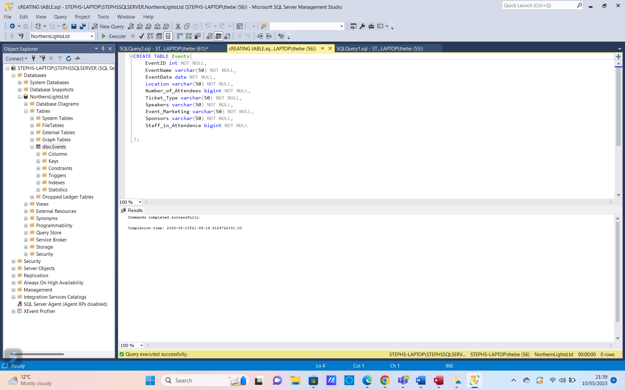
Entering Data
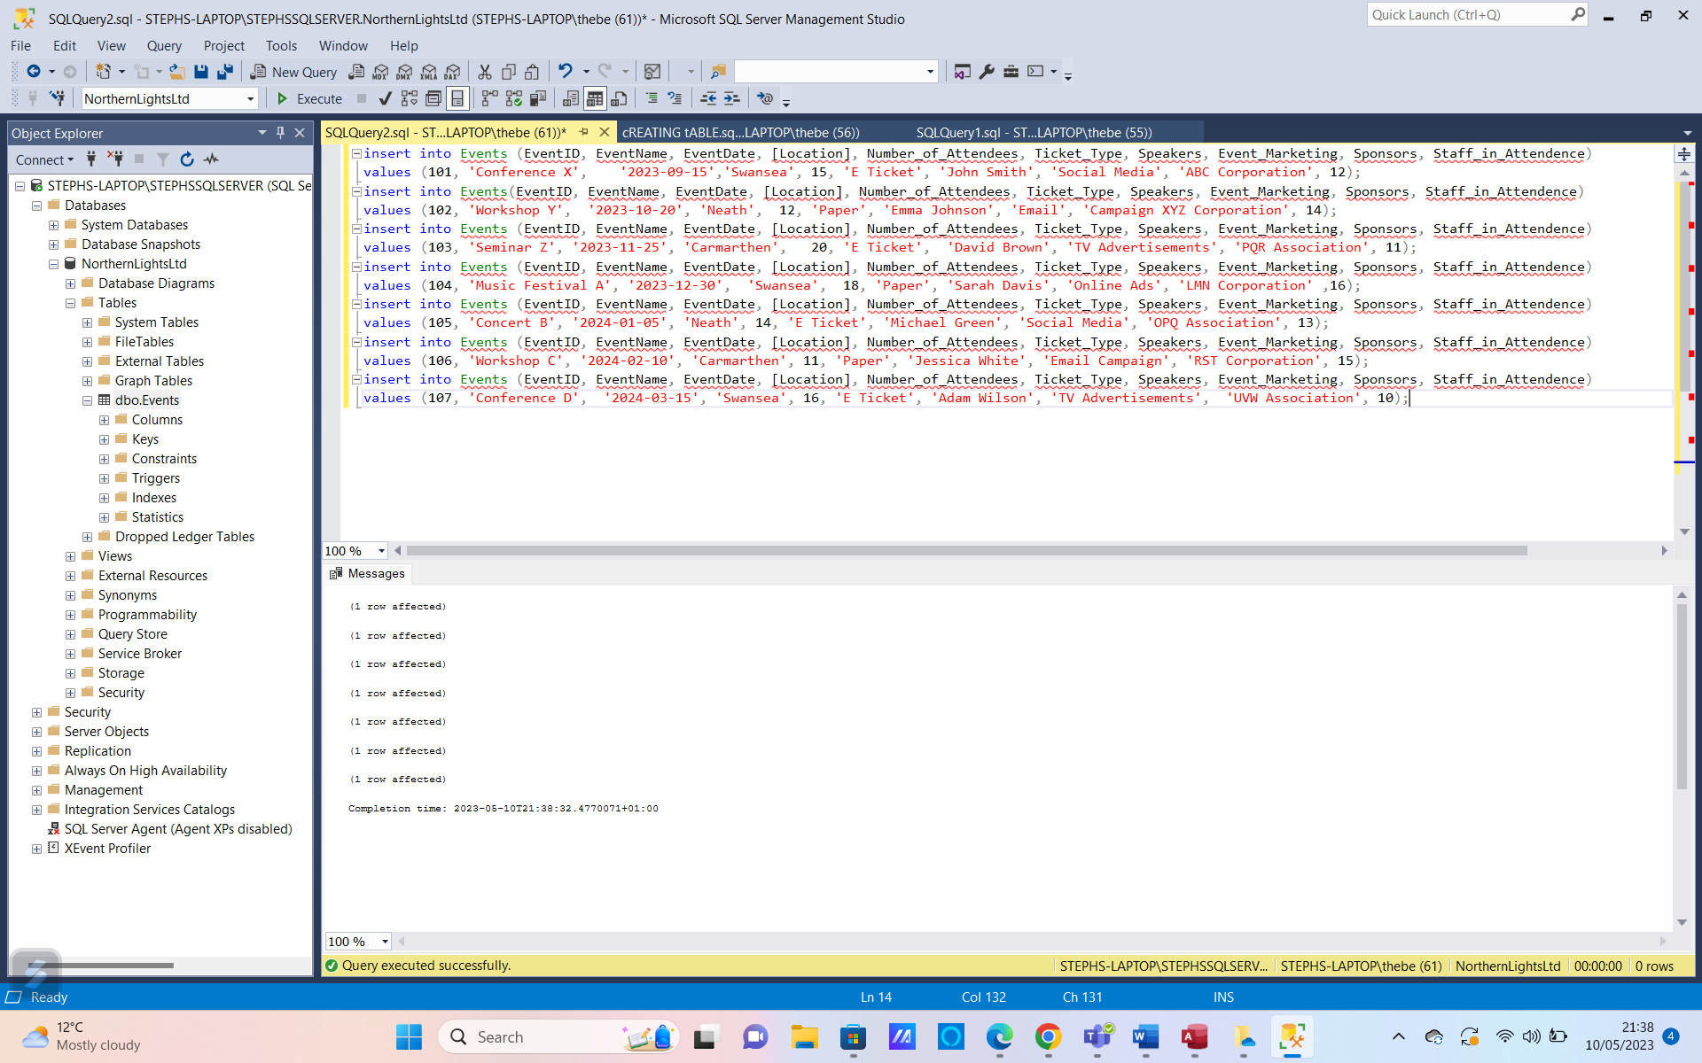
Completed Events Table
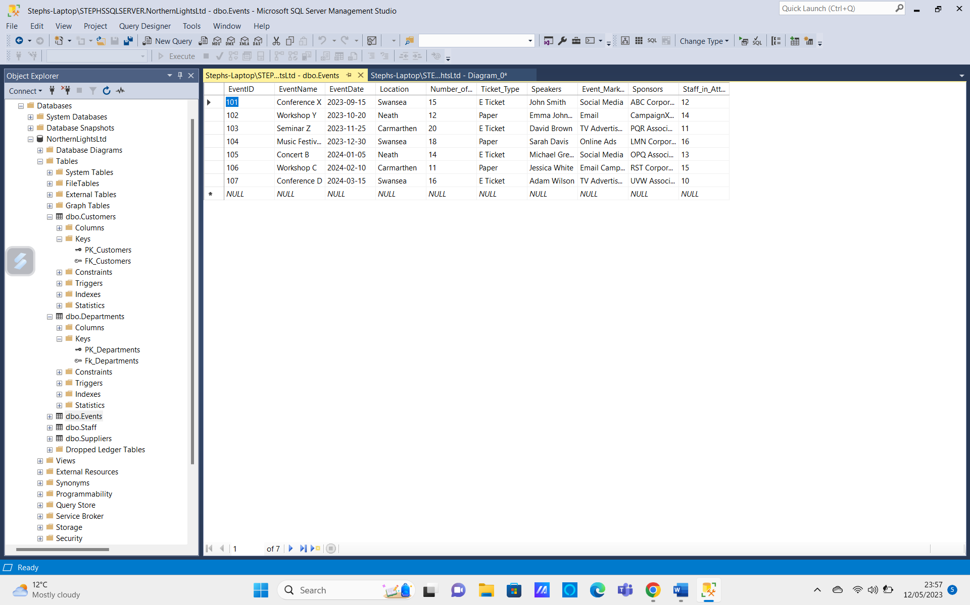
Adding Primary Key
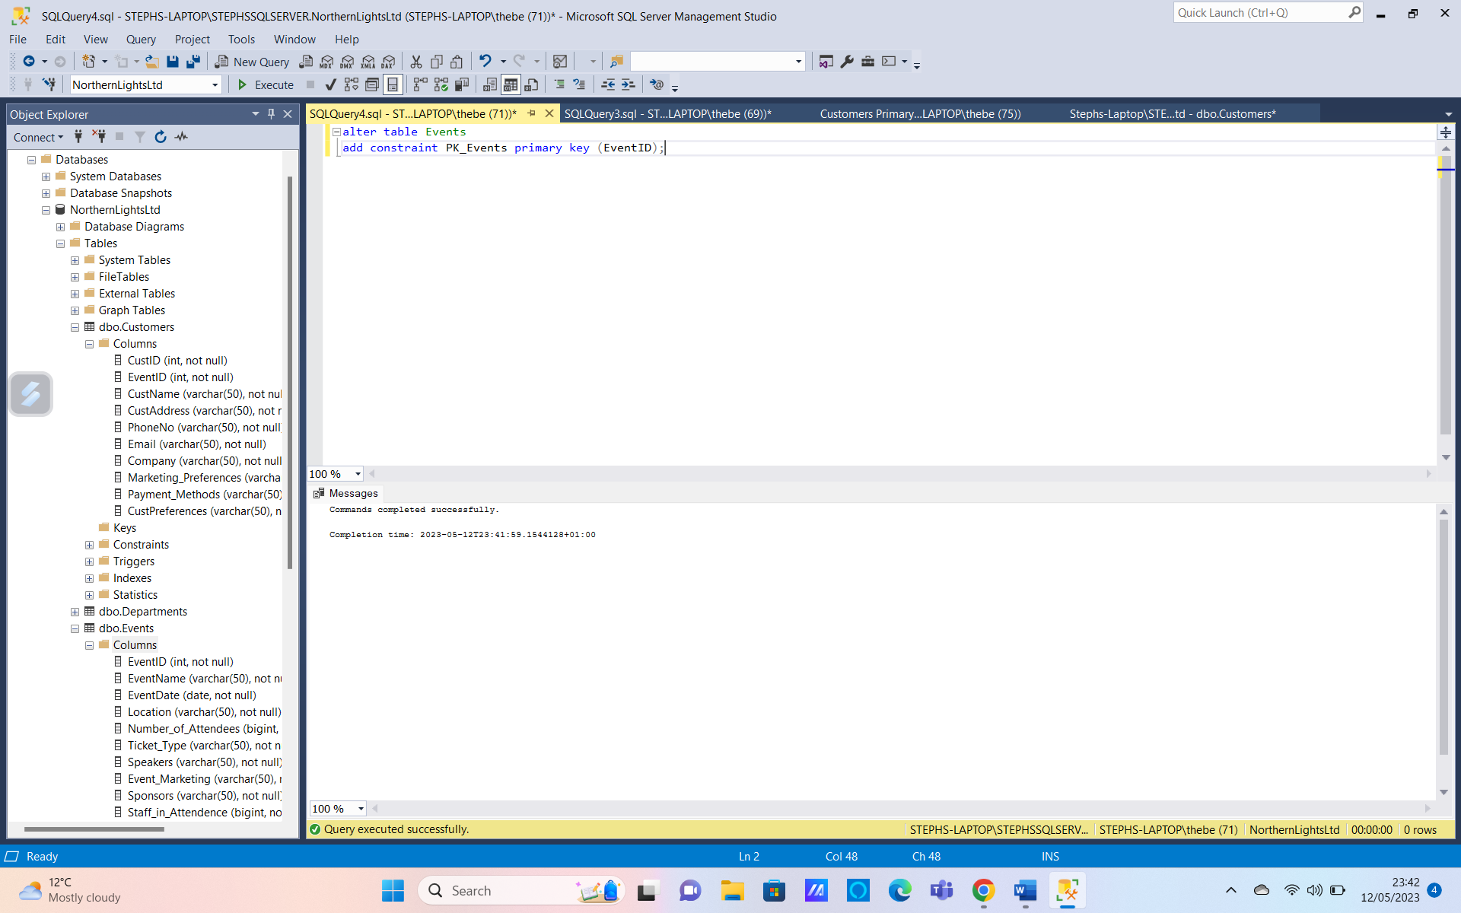
Customer Table

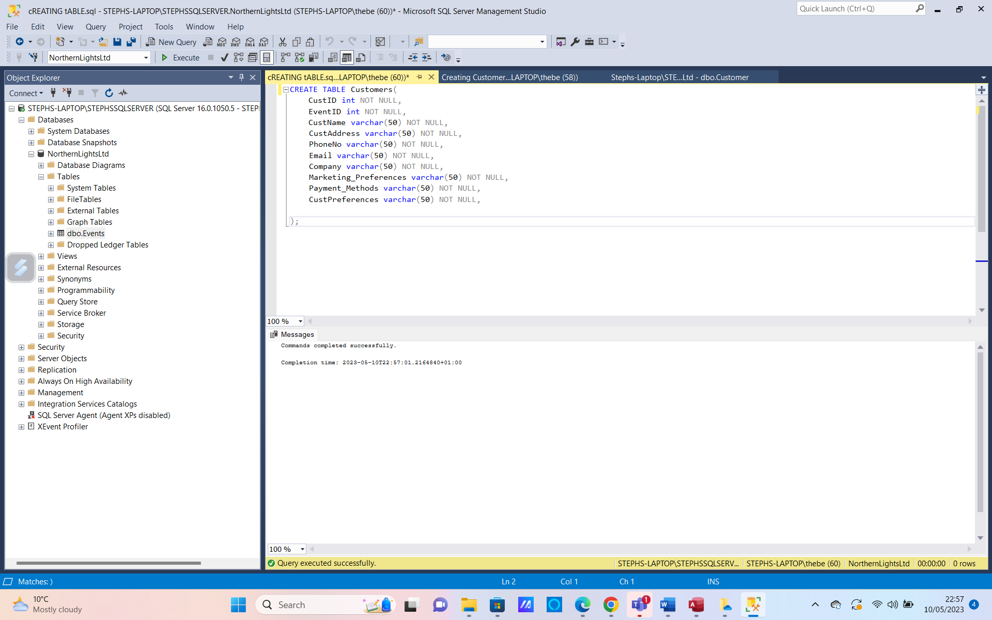
Adding Data
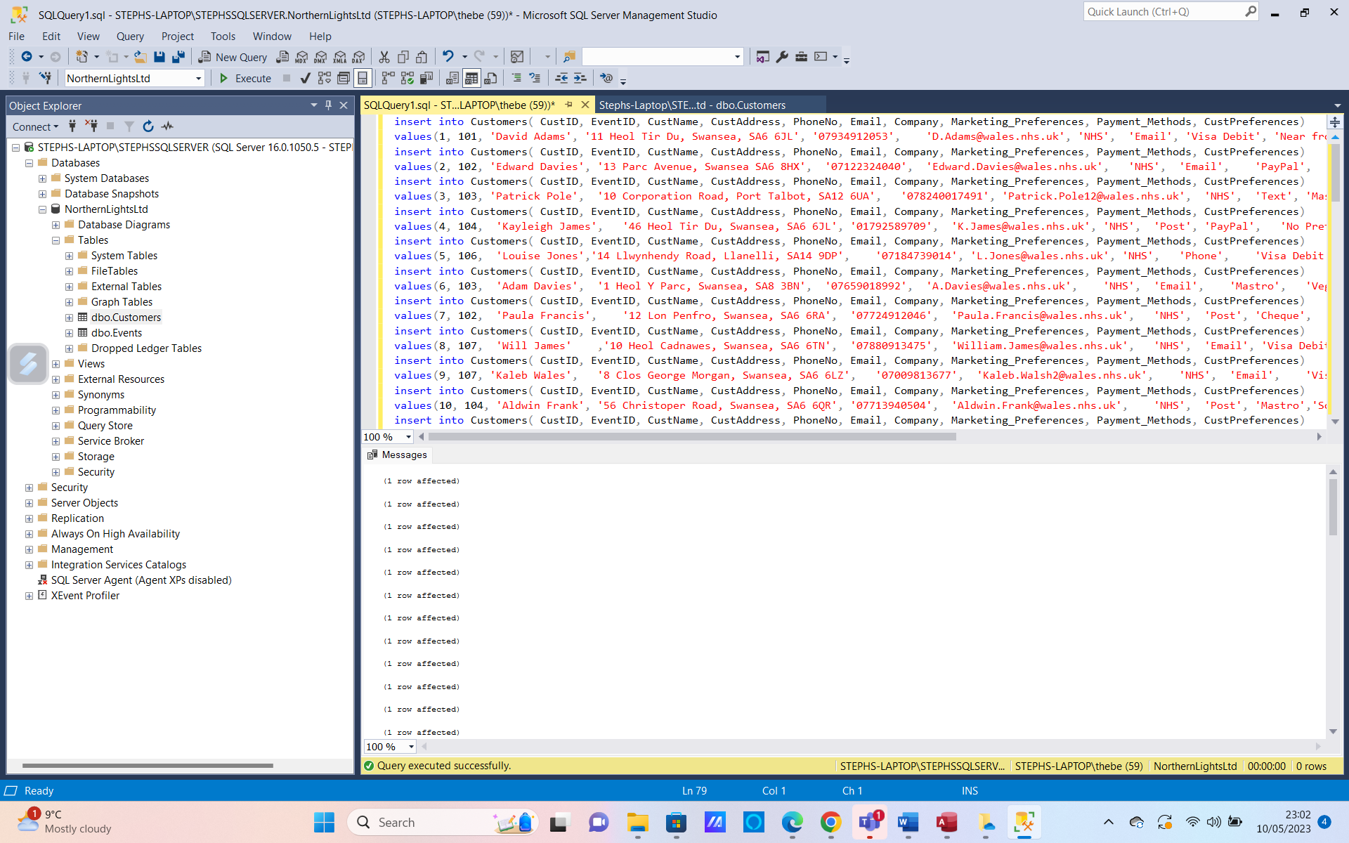
Completed Customers Table
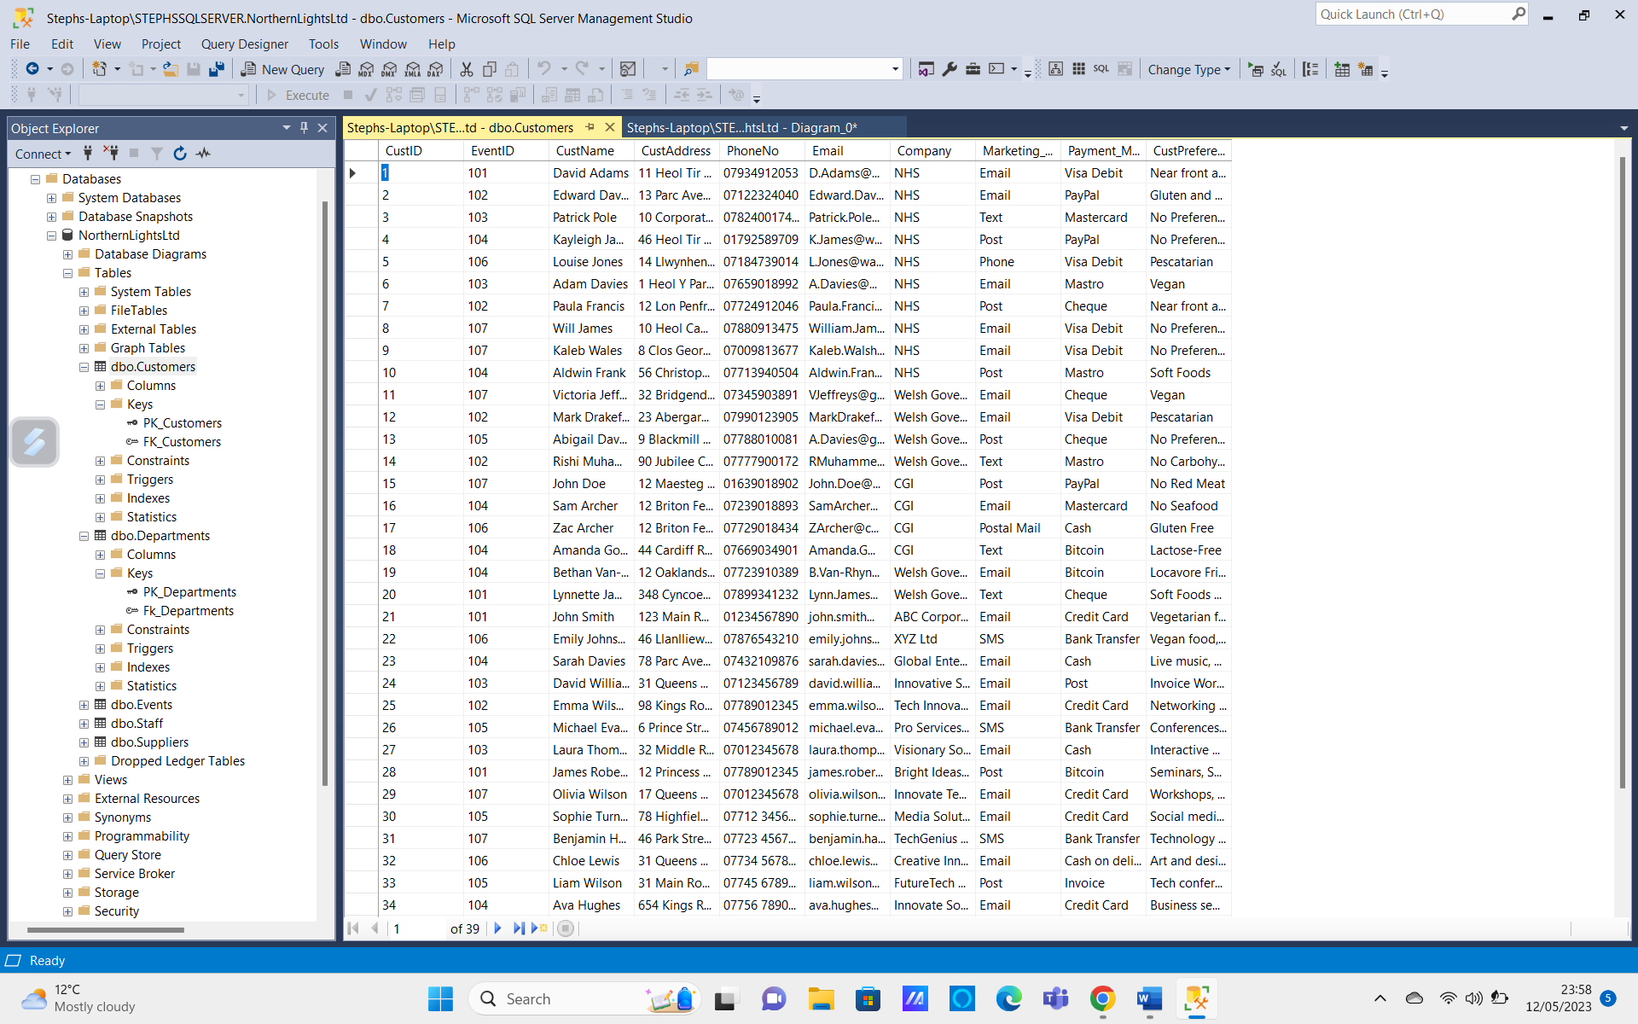
Adding Primary Key
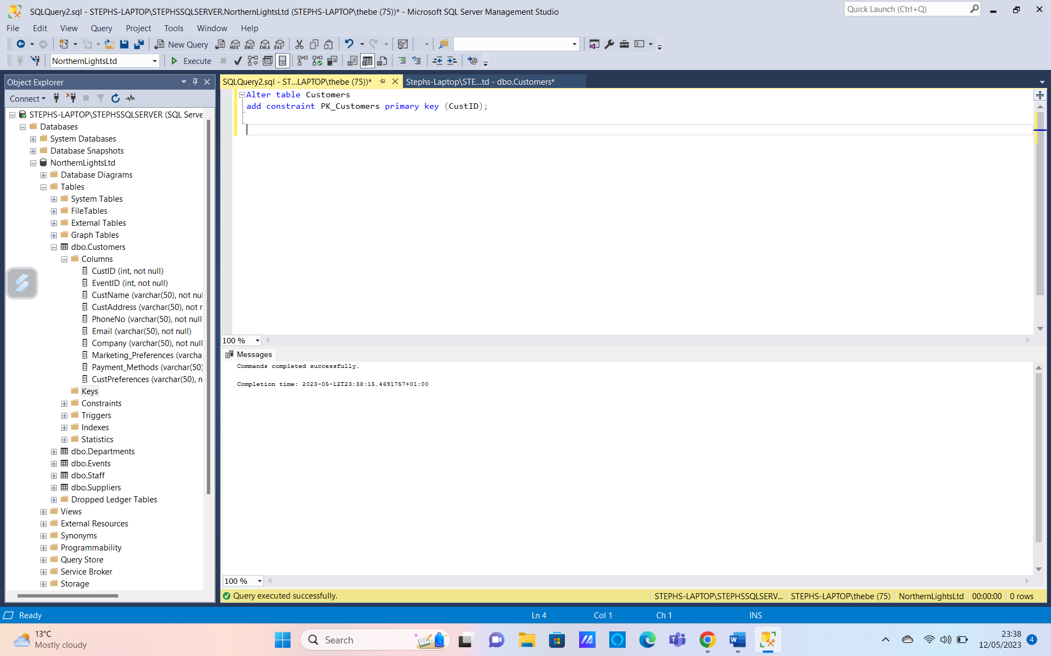
Adding Foreign Key
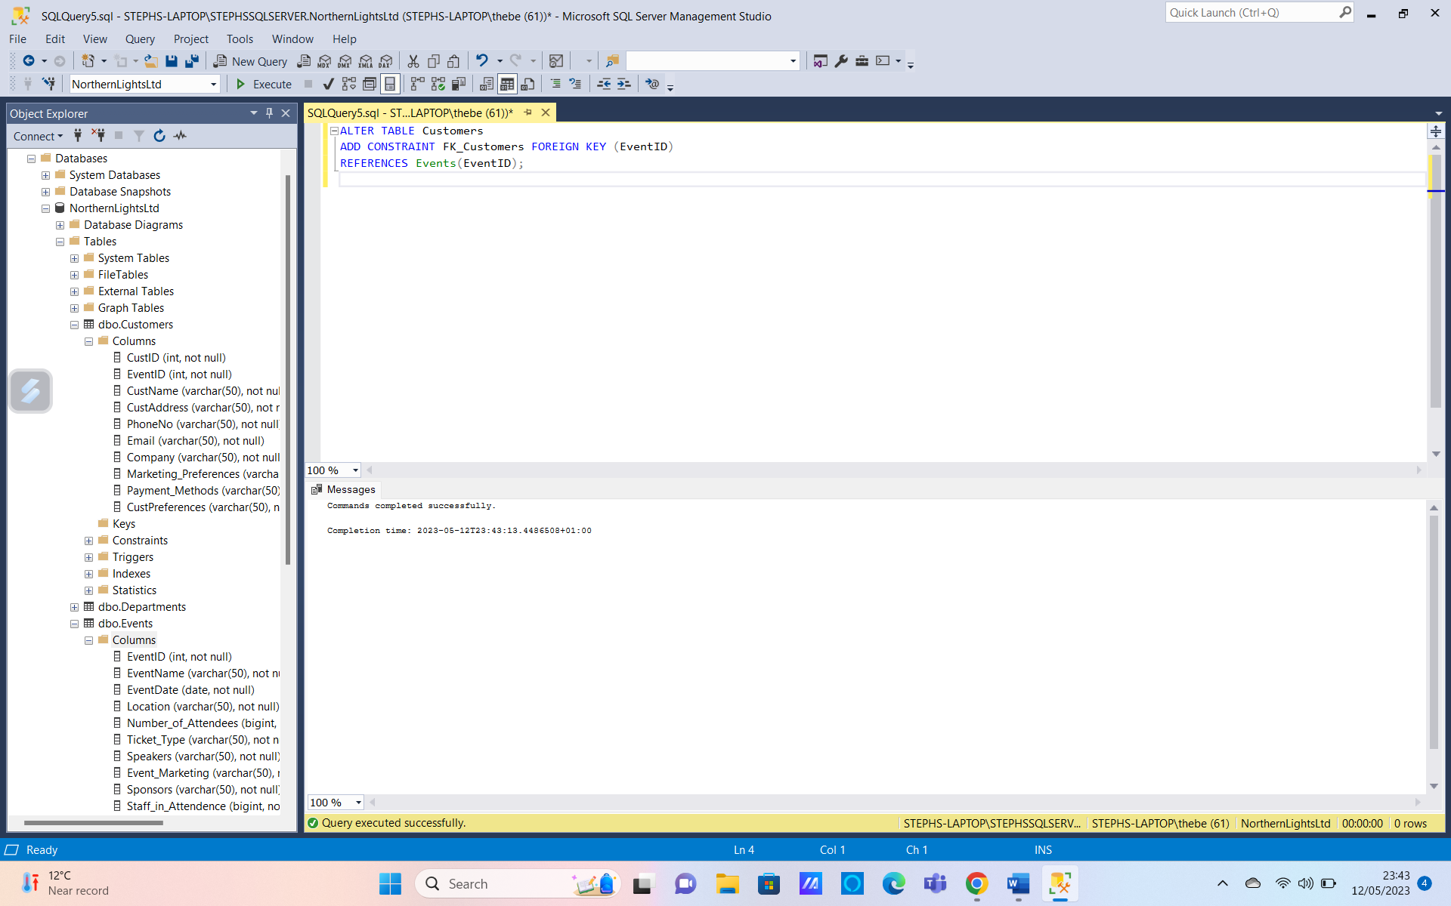
Creating a Staff Table
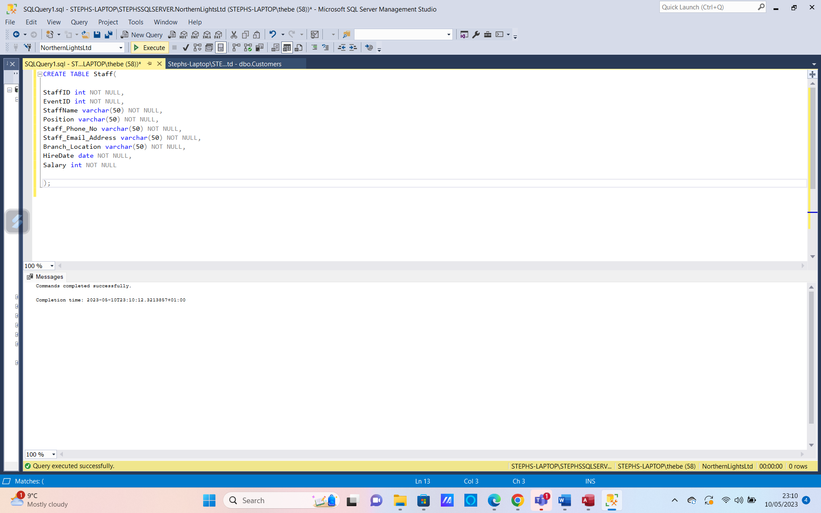
Adding Data
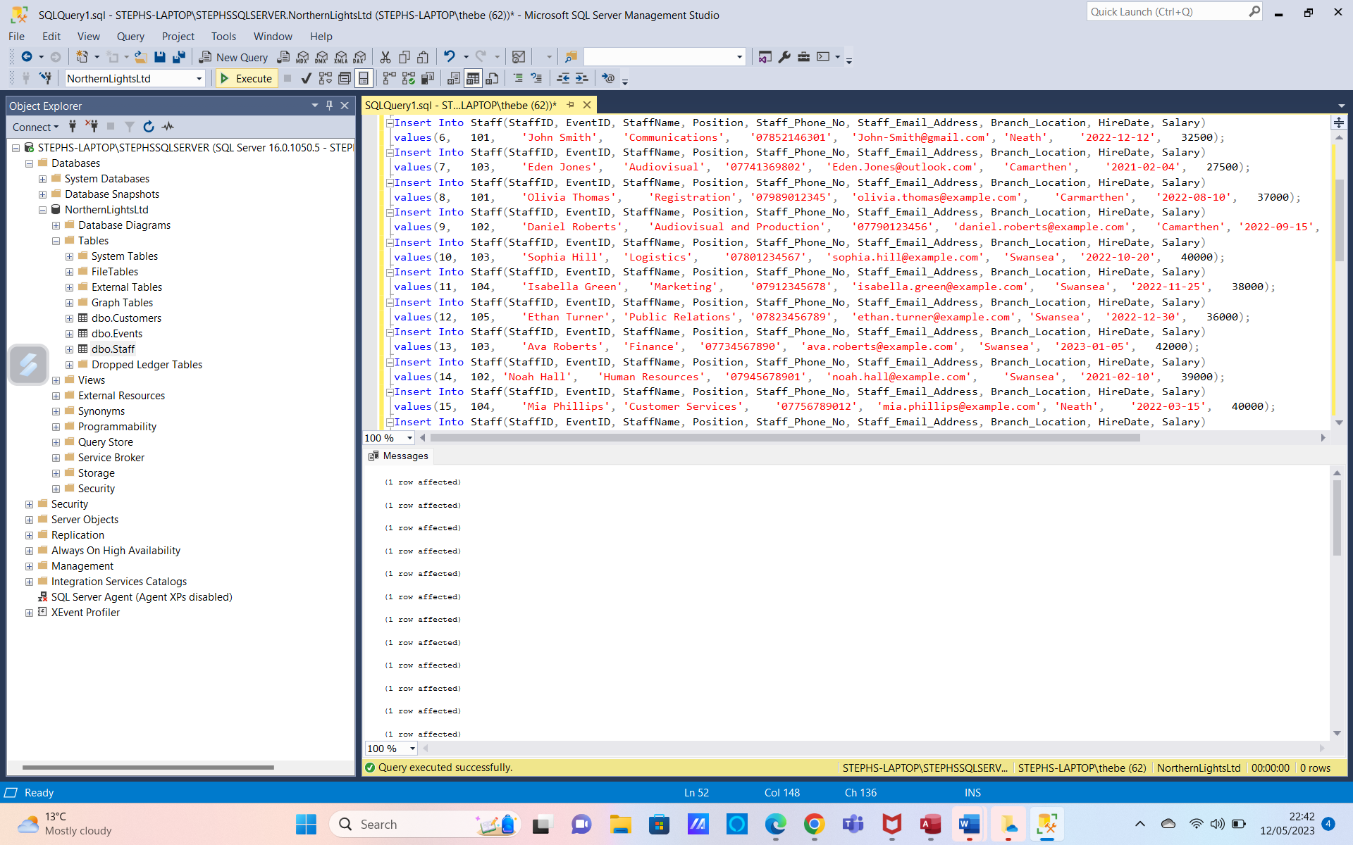
Completed Staff Table
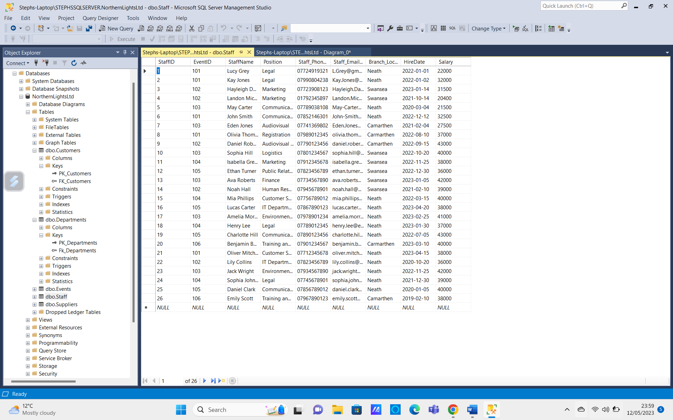
Staff Table Primary Key
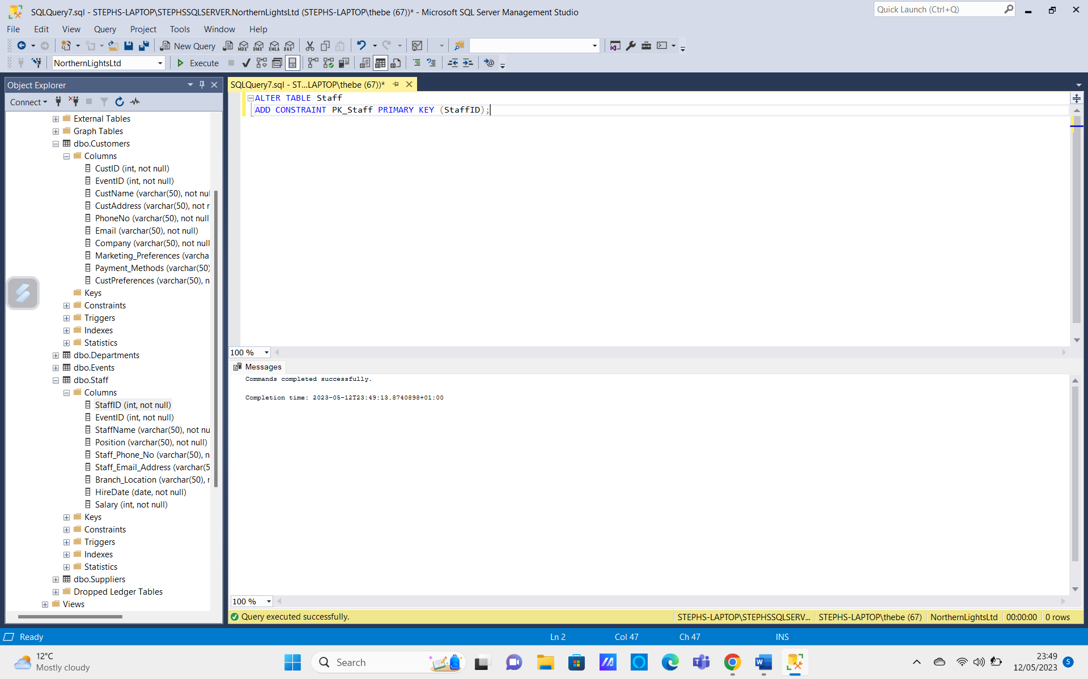
Staff Table Foreign Key
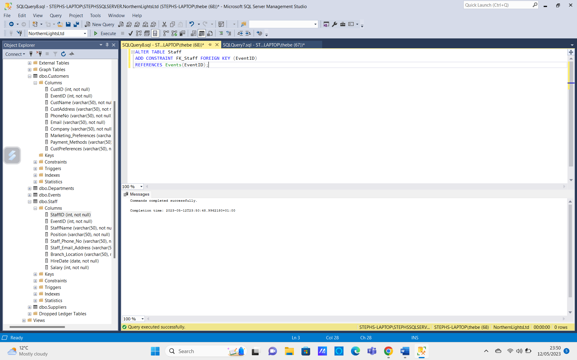
Creating Department Table
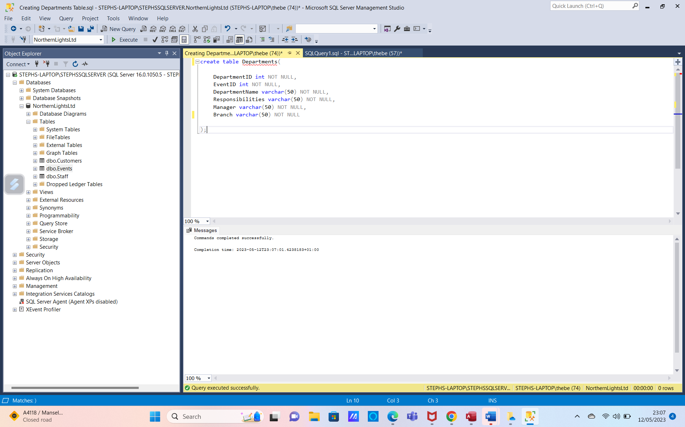
Adding Data
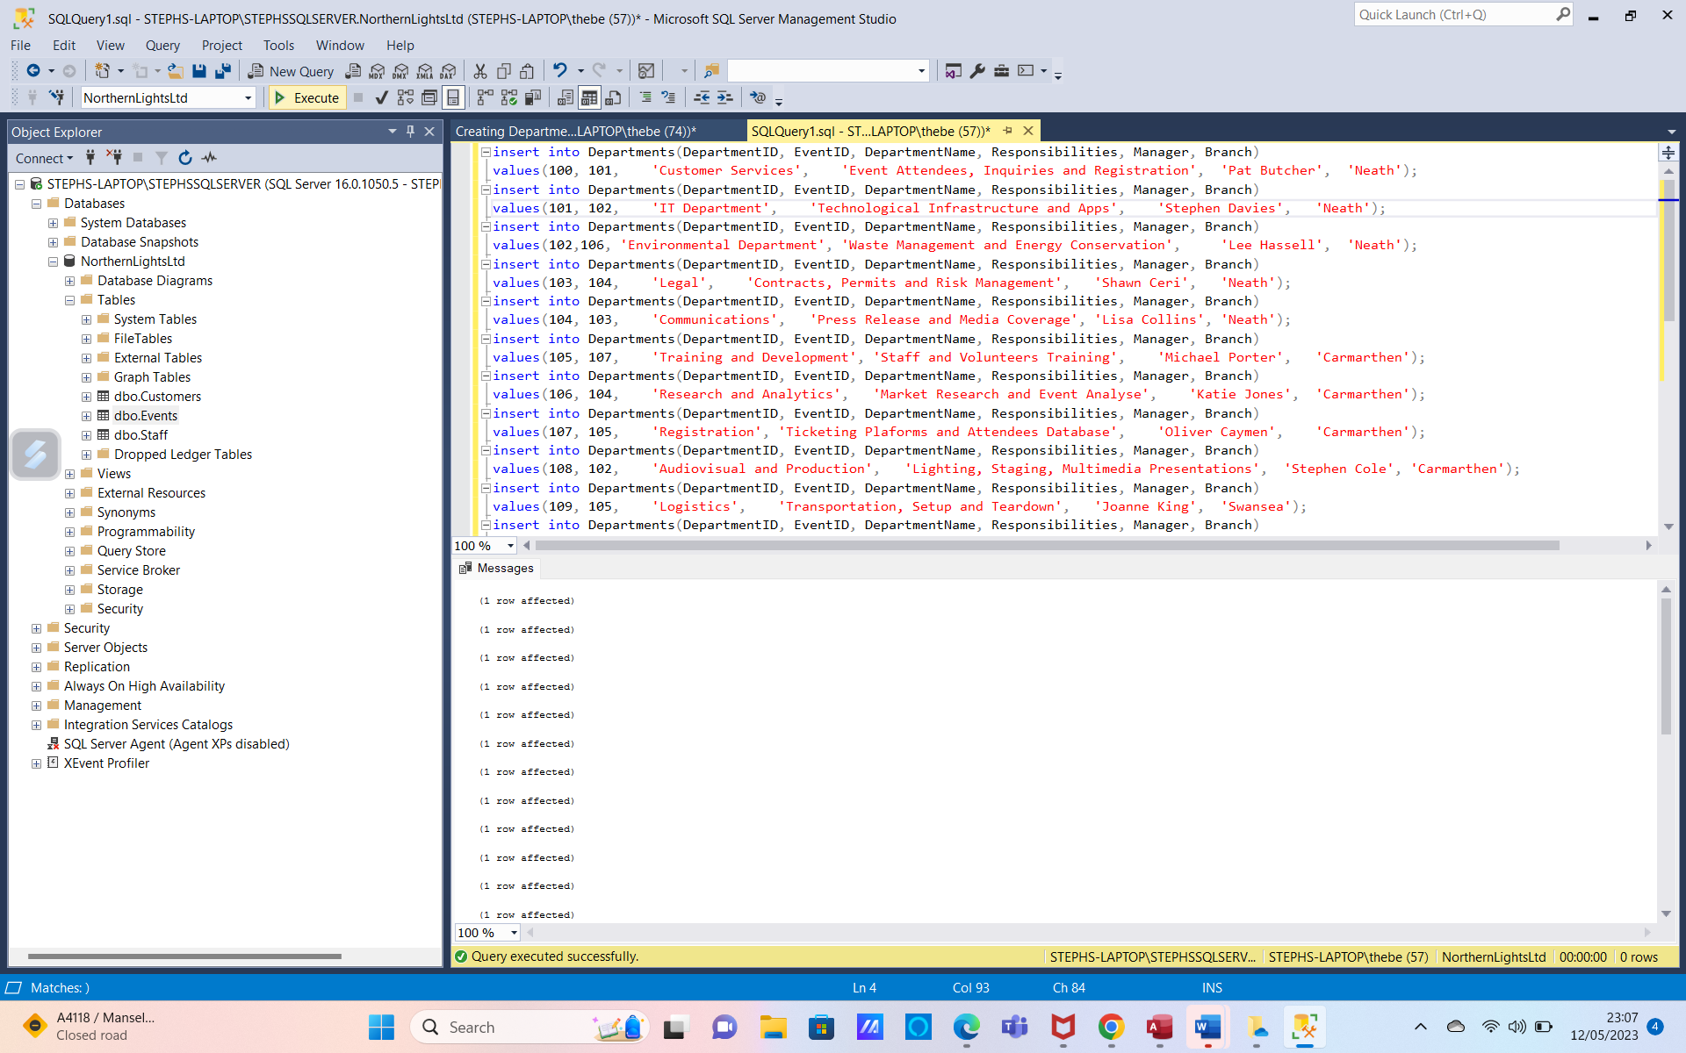
Completed Departments Table
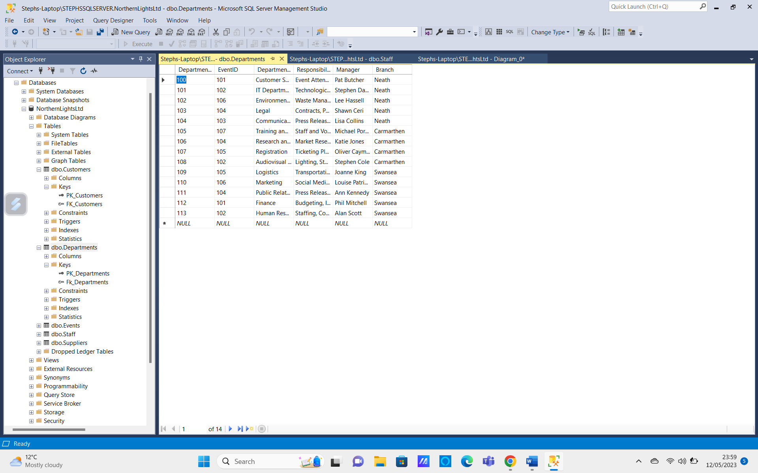
Department Table Primary Key
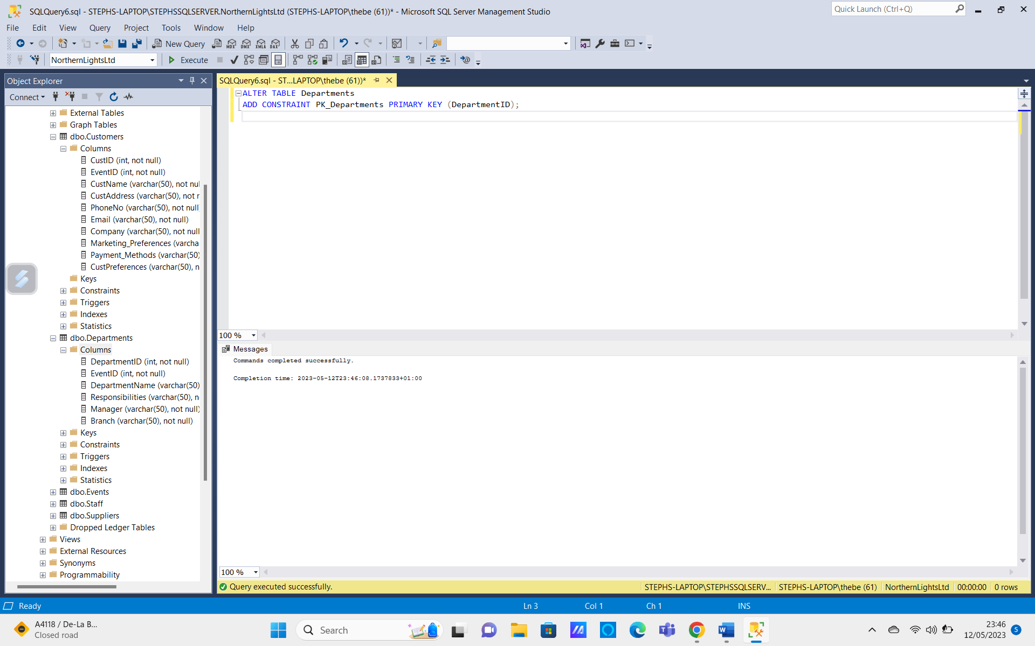
Department Table Foreign Key
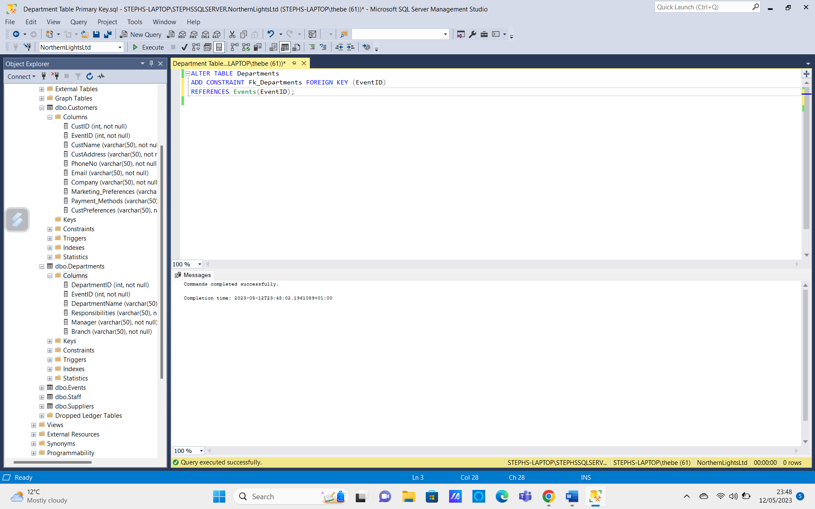
Creating Suppliers Table
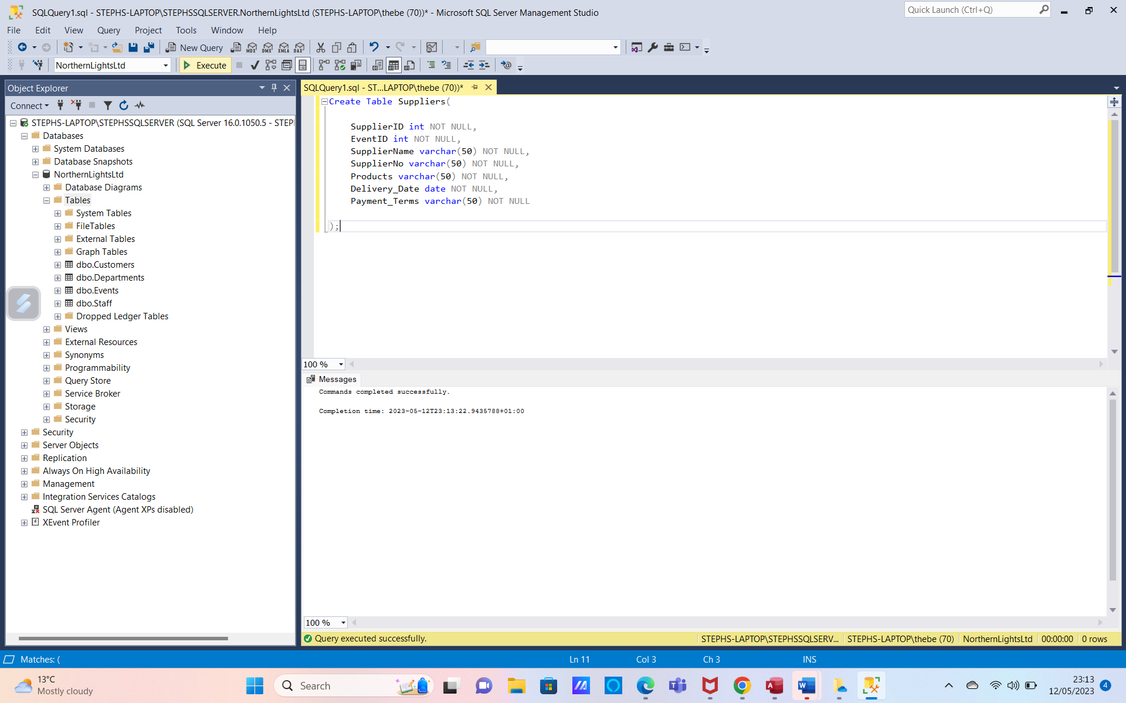
Adding Data
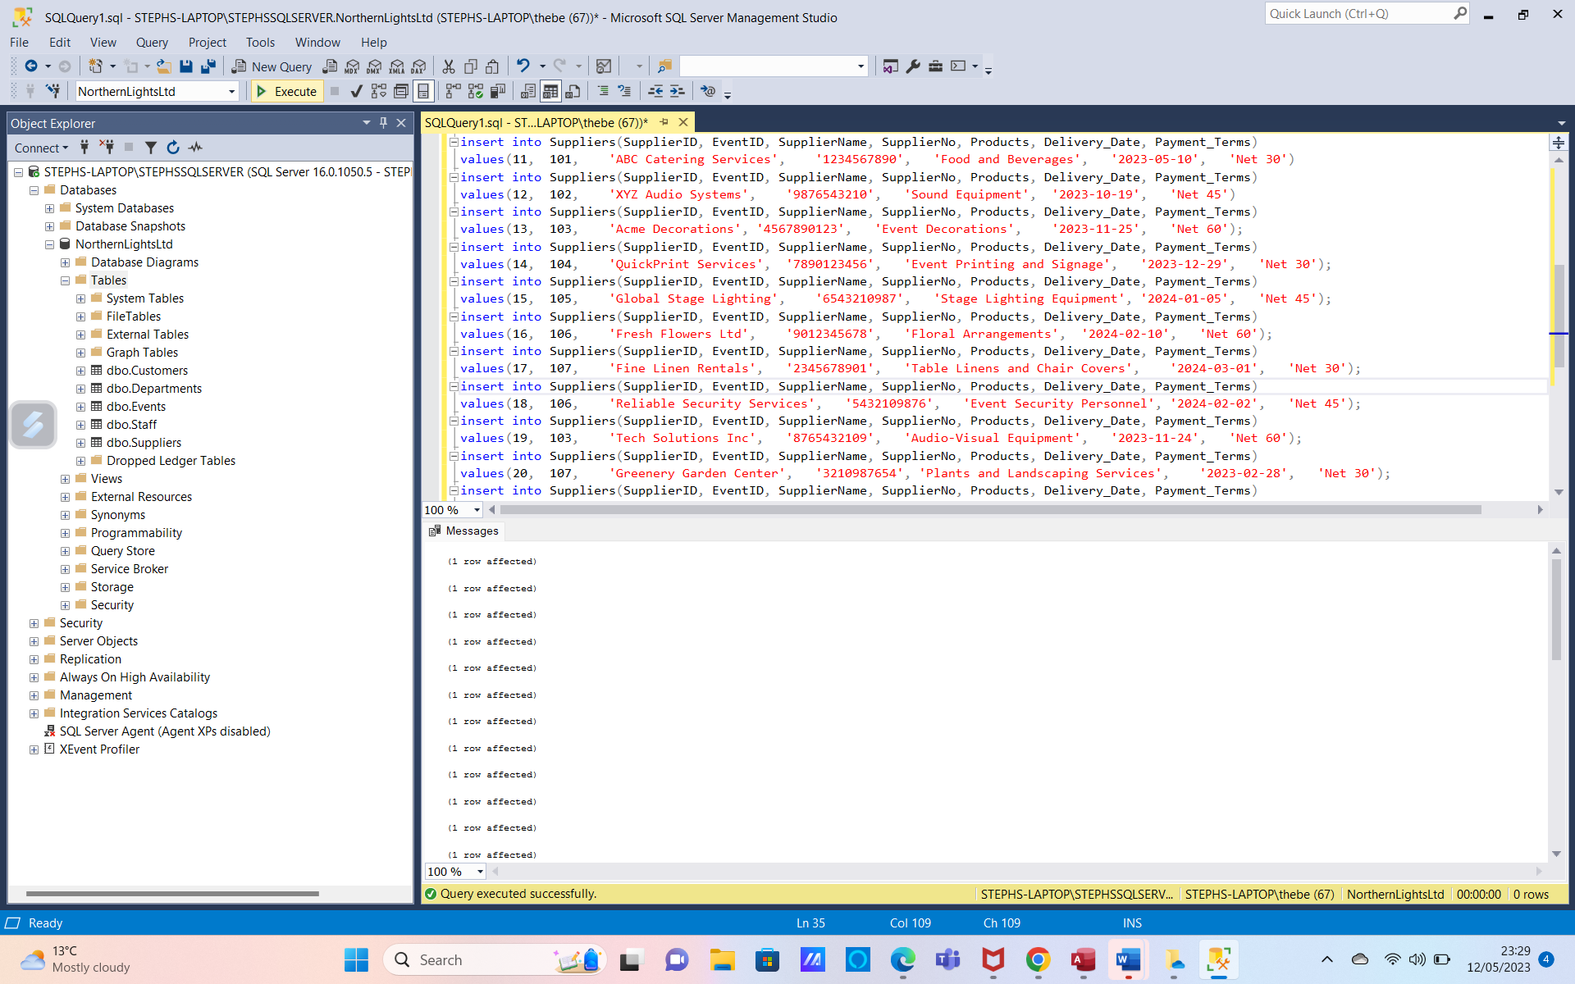
Completing Suppliers Table
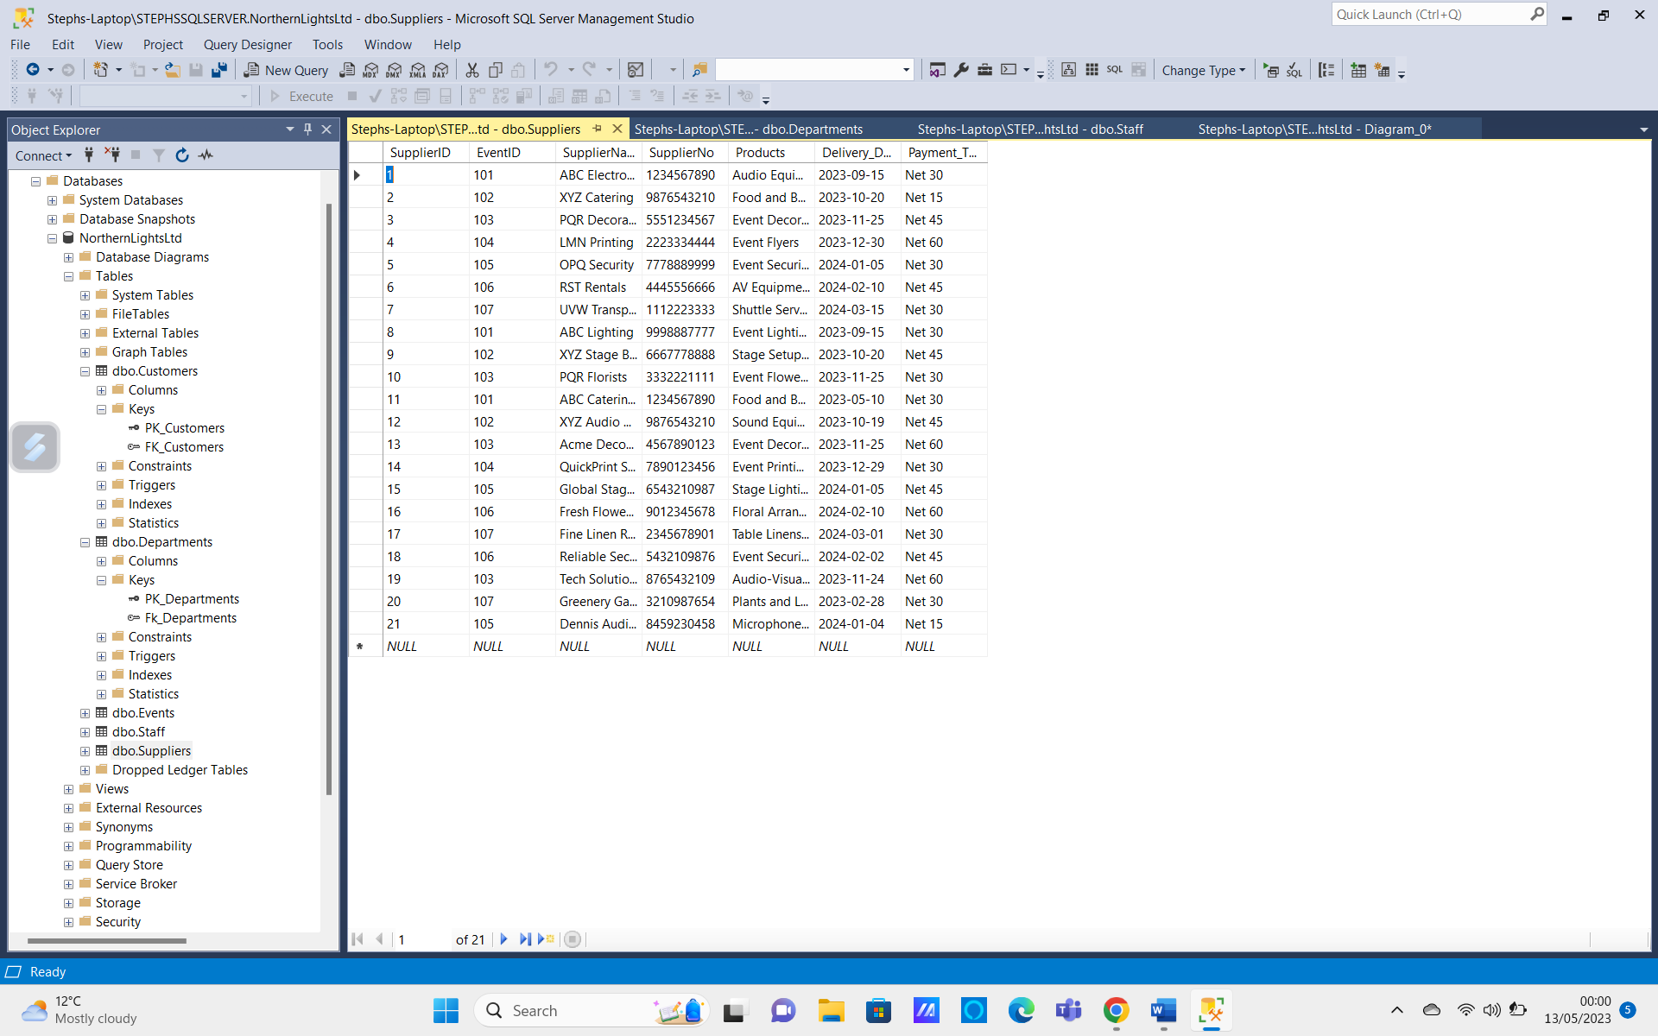
Suppliers Table Primary Key
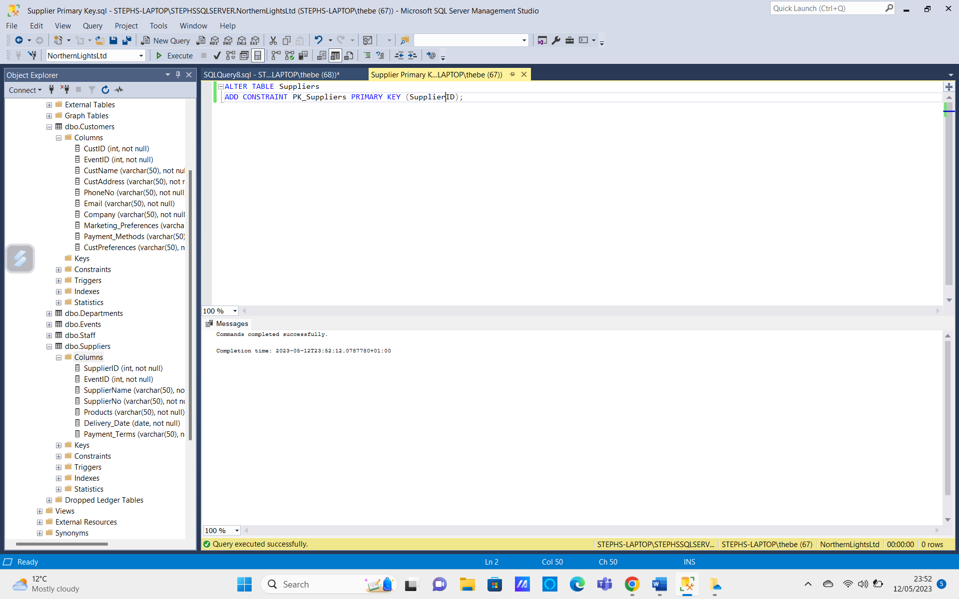
Suppliers Table Foreign Key
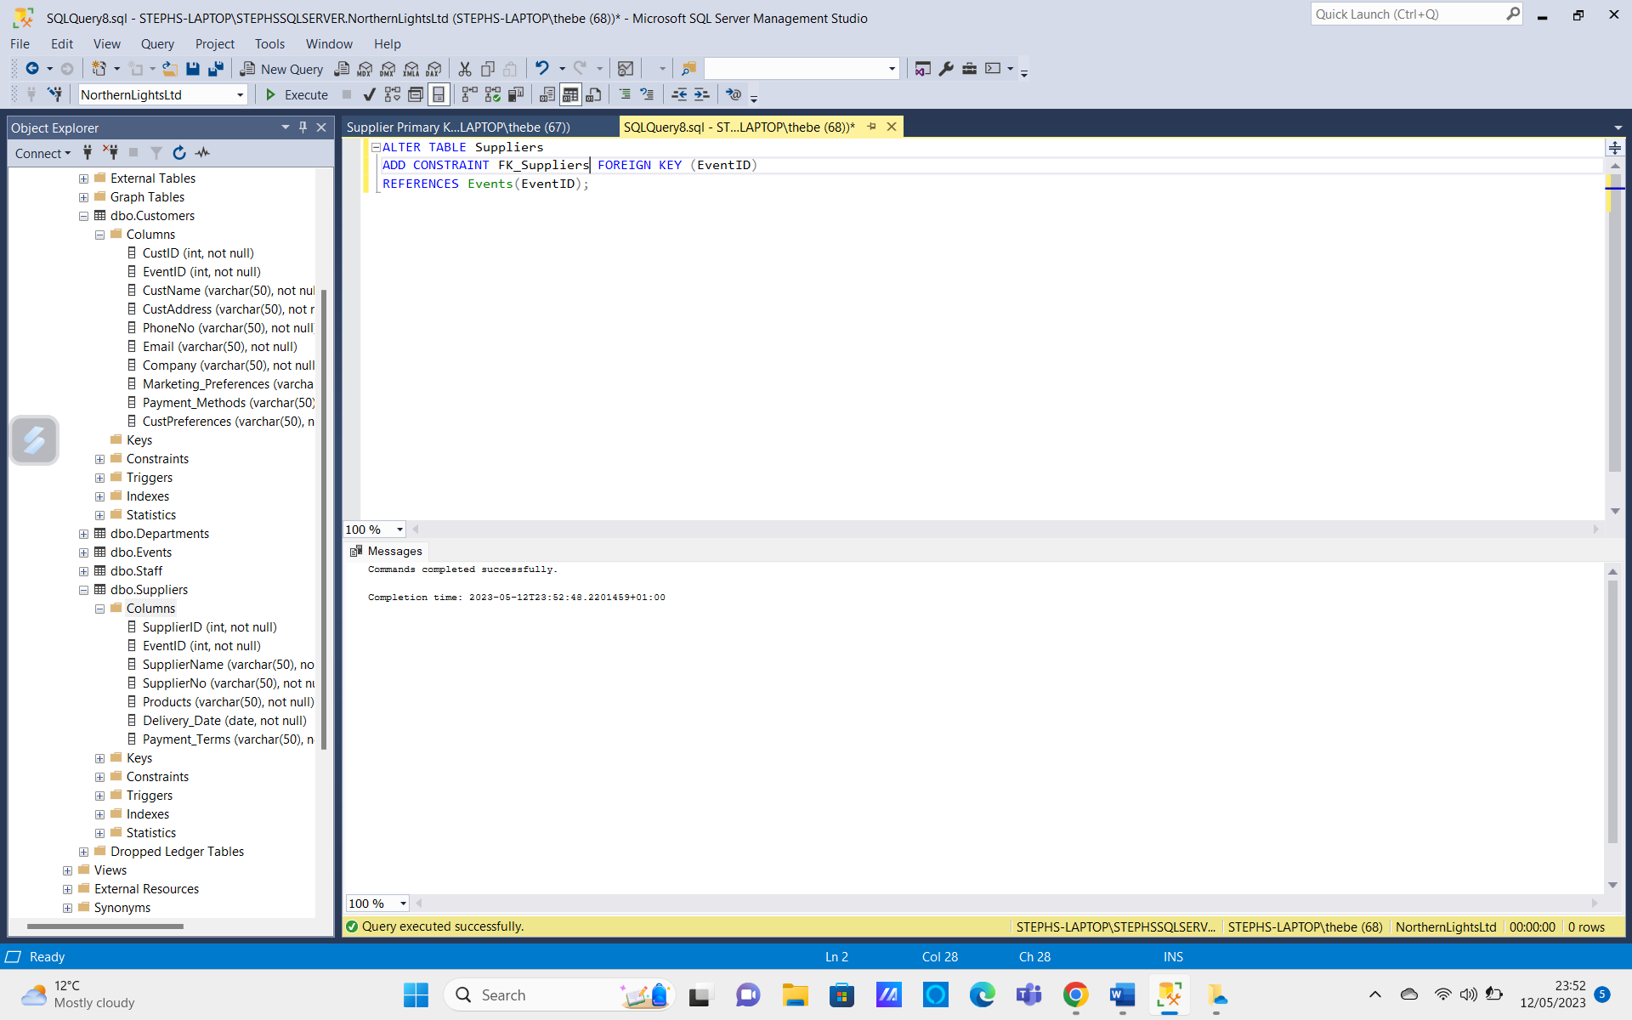
Retrieving Customers who used Visa Debit
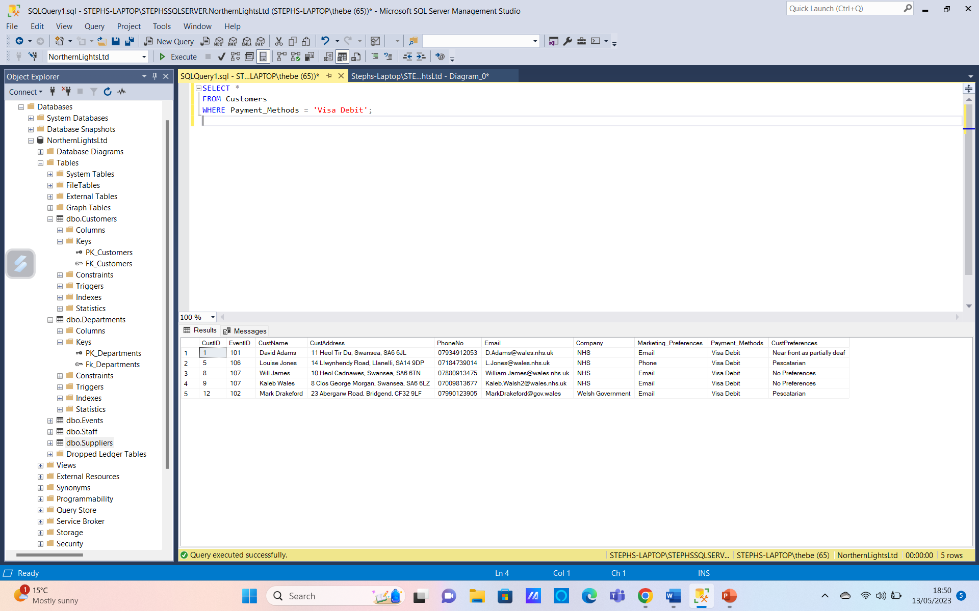
Retrieving Staff working in legal
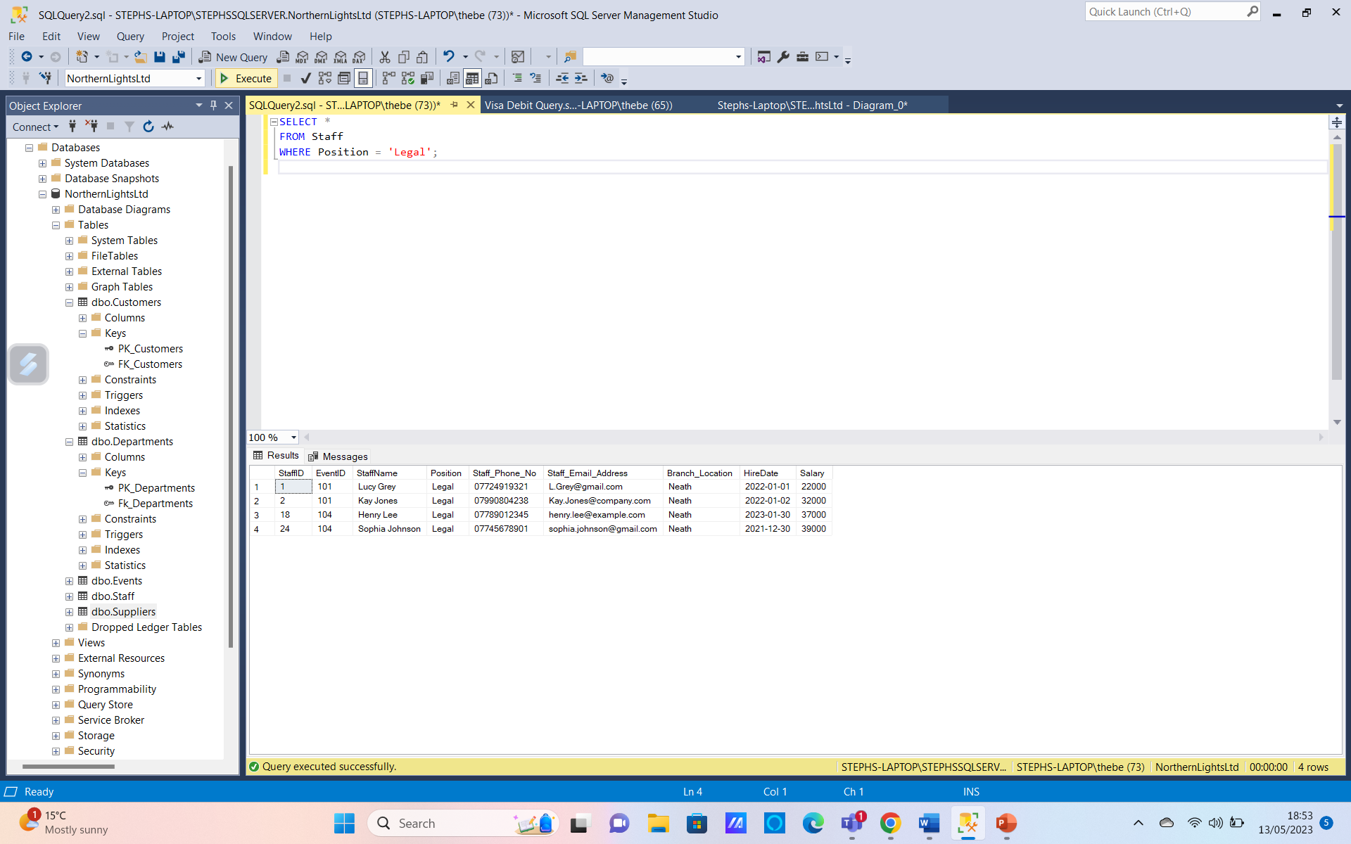
Retrieving Customers Details
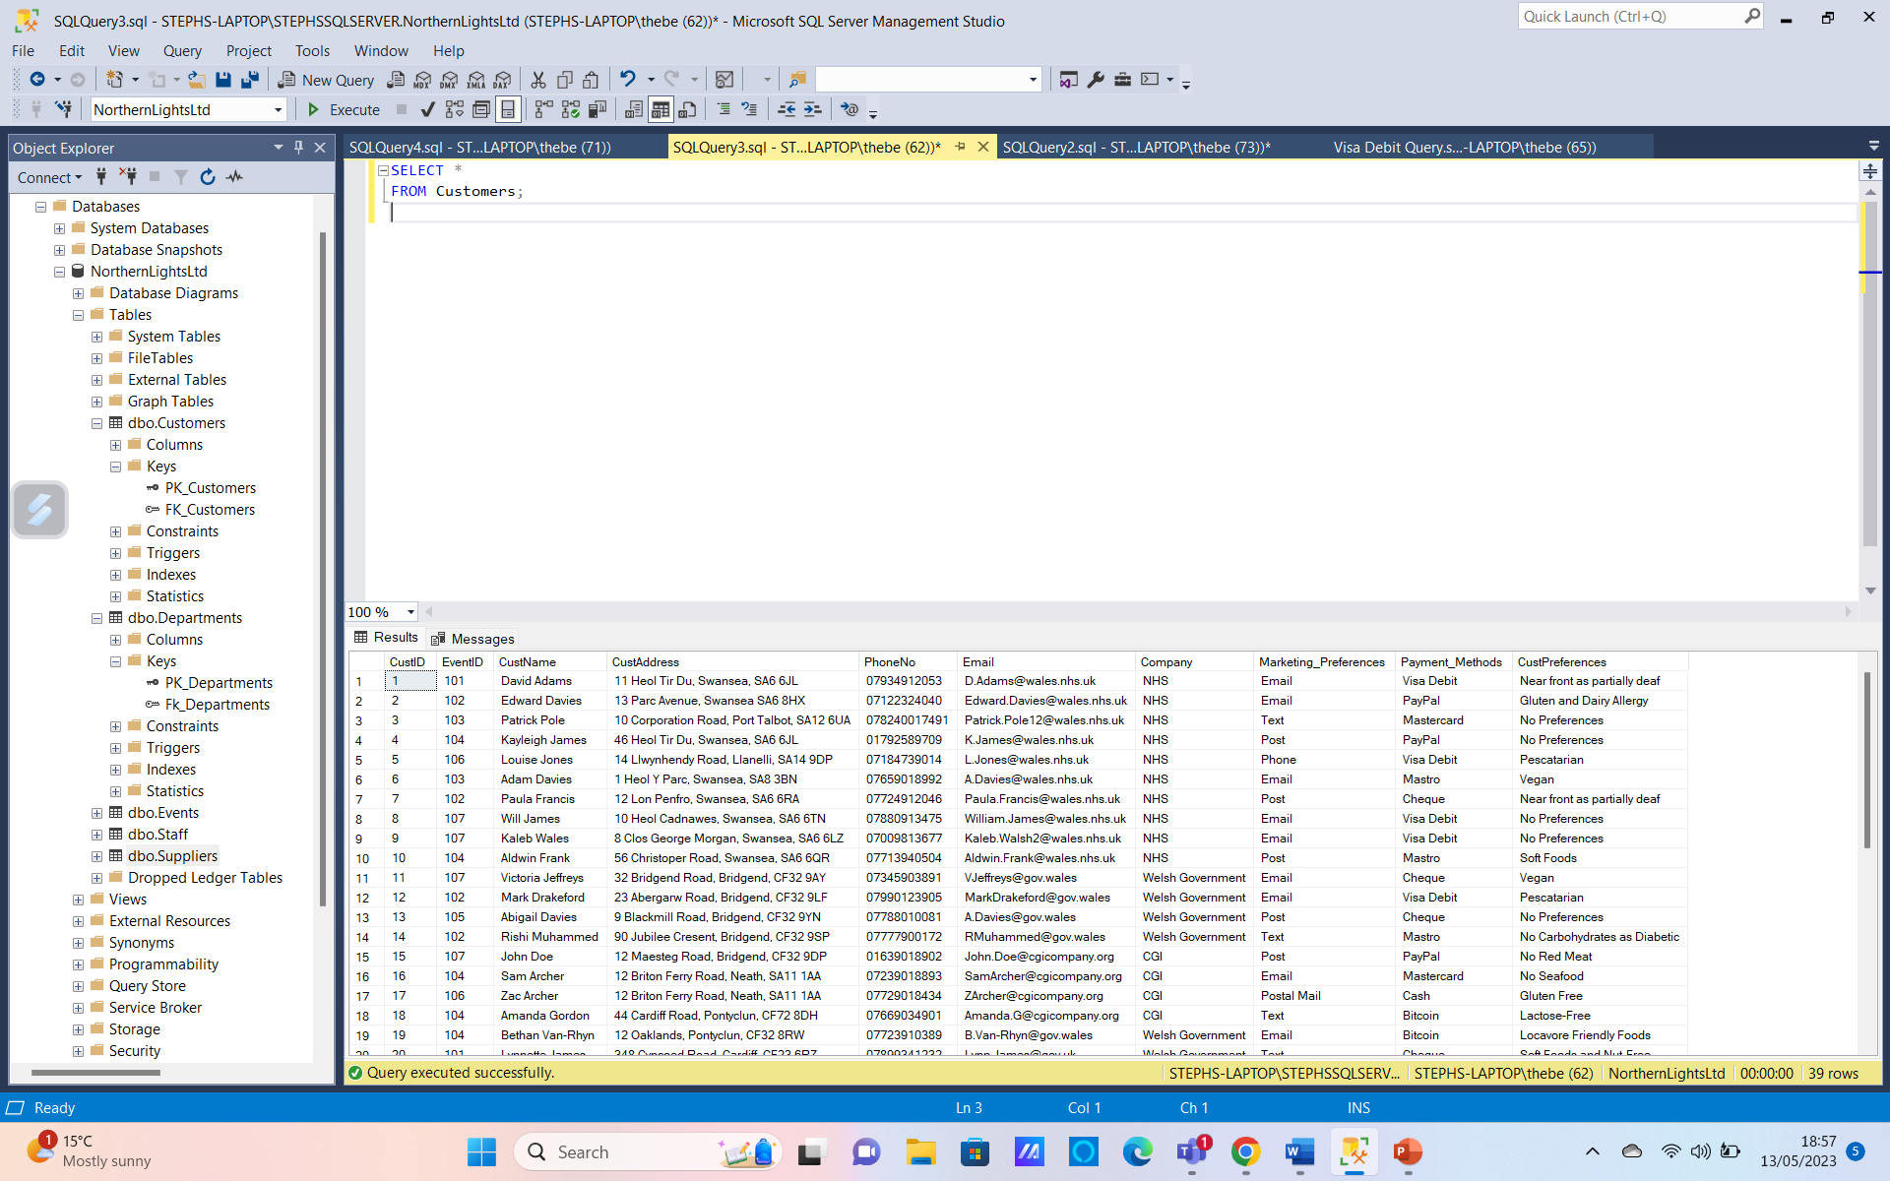
Events with Number of Attendees more than 10
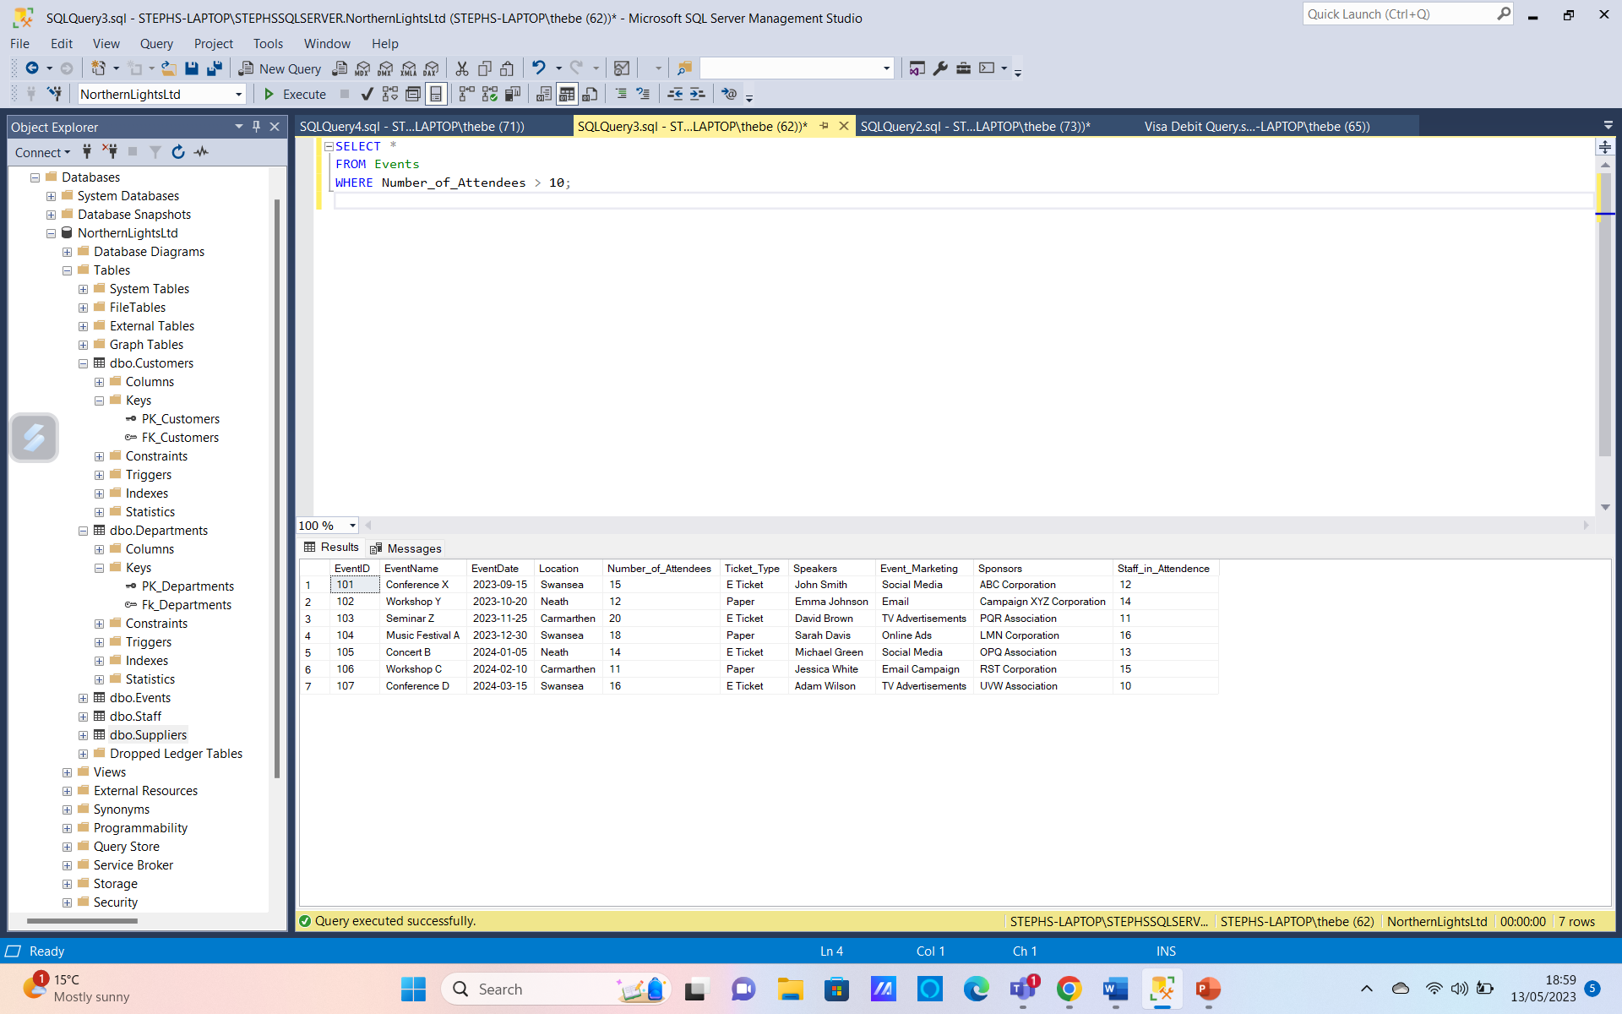
Customers who have a Vegan preference
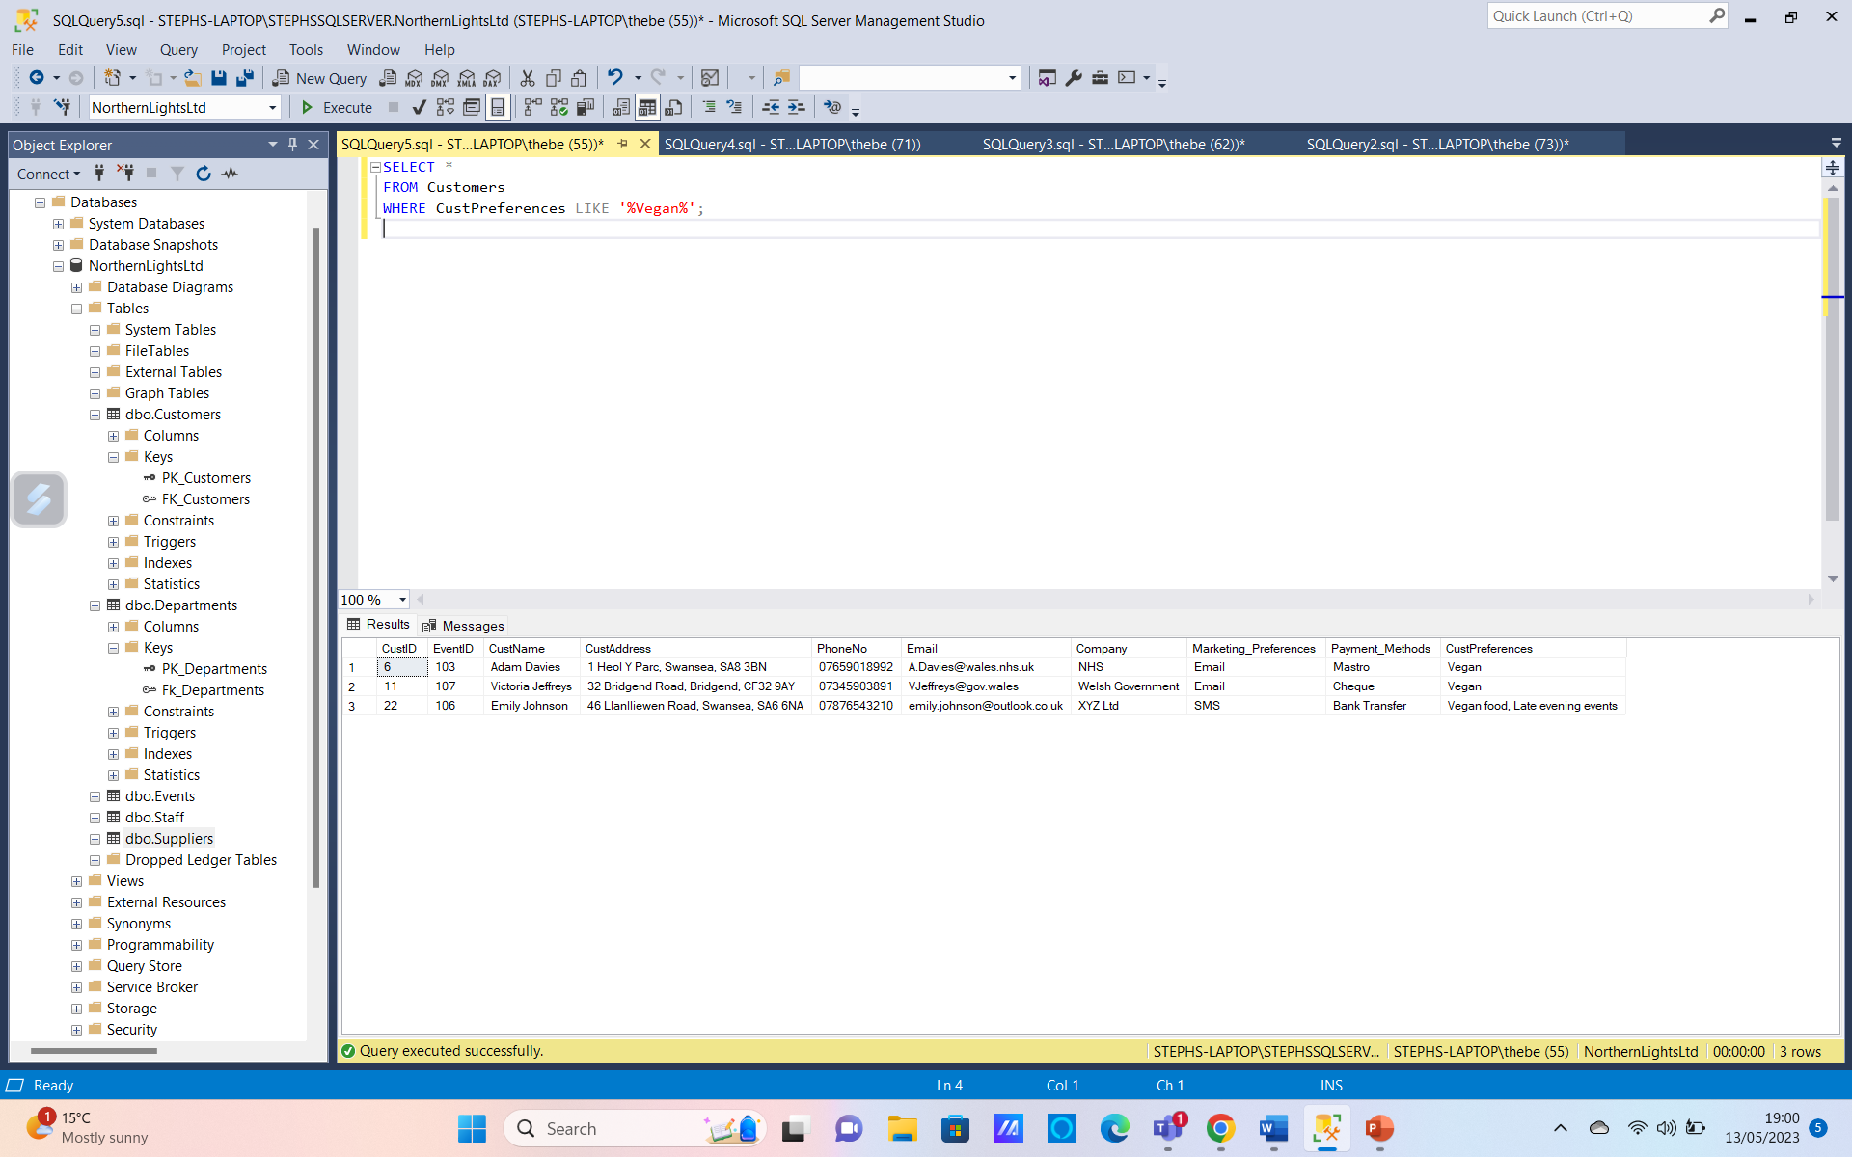
Staff hired in 2022
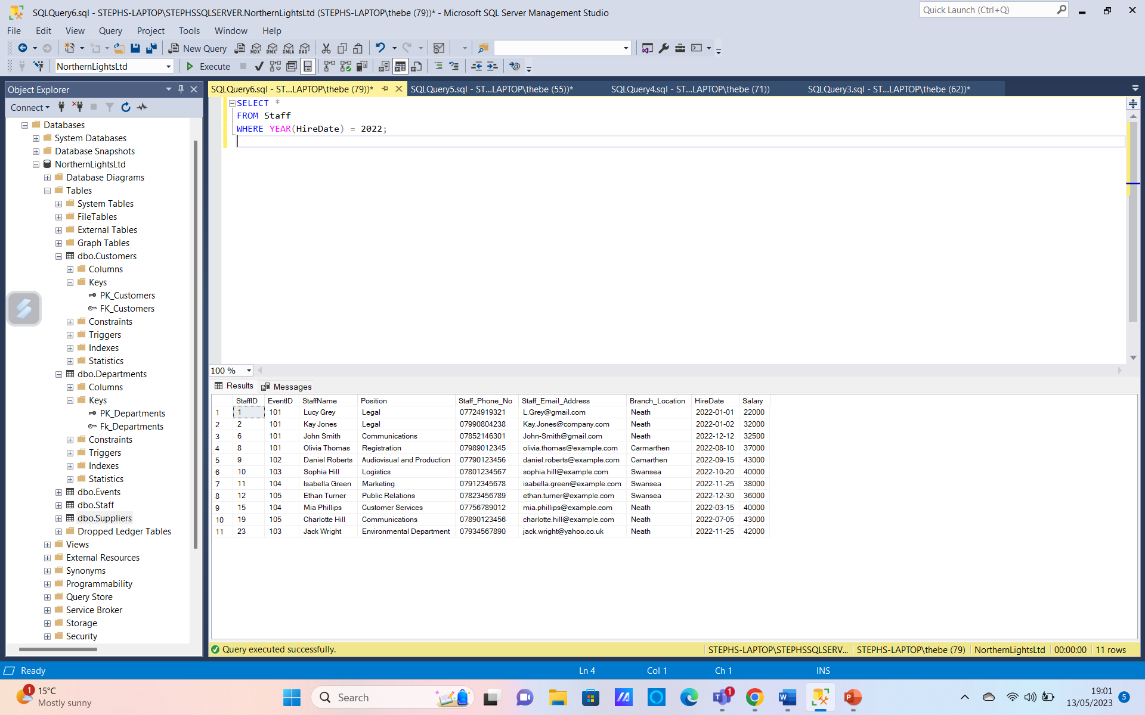
Retrieving Data on events that took place in the Swansea branch
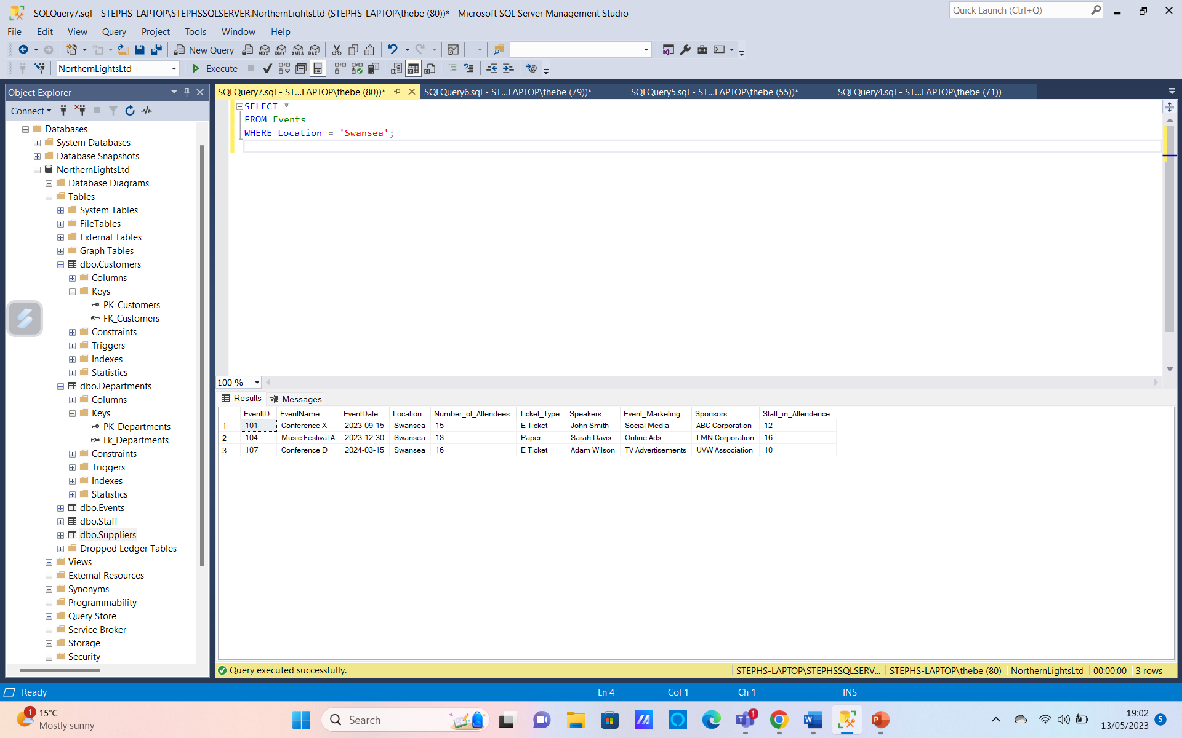

Appendix 2- Data Dictionary
Unique | Table | Column | Data Type
PK | Event | EventID | Int
Key | Event | EventName | Varchar(50)
Key | Event | EventDate | Varchar(50)
Key | Event | Location | Varchar(50)
Key | Event | Number_of_Attendees | Int
Key | Event | Ticket_Type | Varchar(50)
Key | Event | Speakers | Varchar(50)
Key | Event | Event_Marketing | Varchar(50)
Key | Event | Sponsors | Varchar(50)
Key | Event | Staff_in_Attendence | Int
PK | Customer | CustID | Int
Key | Customer | CustName | Varchar(50)
Key | Customer | CustAddress | Varchar(50)
Key | Customer | PhoneNo | Int
Key | Customer | Email | Varchar(50)
Key | Customer | Company | Varchar(50)
Key | Customer | Marketing_Preferences | Varchar(50)
Key | Customer | Payment_Method | Varchar(50)
Key | Customer | CustPreferences | Varchar(50)
PK | Staff | StaffID | Int
FK | Staff | EventID | Int
Key | Staff | StaffName | Varchar(50)
Key | Staff | Position | Varchar(50)
Key | Staff | Staff_PhoneNo | Varchar(50)
Key | Staff | Staff_Email_Address | Varchar(50)
Key | Staff | Branch_Location | Varchar(50)
Key | Staff | HireDate | Date
Key | Staff | Salary | Int
PK | Department | DepartmentID | Int
Key | Department | DepartmentName | Varchar(50)
Key | Department | Responsibilities | Varchar(50)
Key | Department | Manager | Varchar(50)
Key | Department | Branch | Varchar(50)
PK | Supplier | SupplierID | Int
FK | Supplier | EventID | Int
Key | Supplier | SupplierName | Varchar(50)
Key | Supplier | SupplierNo | Int
Key | Supplier | Products | Varchar(50)
Key | Supplier | Delivery_Date | Date
Key | Supplier | Payment_Terms | Varchar(50)
Unique Keys
Type | Table | Key | Columns
primary | Events | Pk_Events | EventID
primary | Customers | Pk_Customers | CustomerID
primary | Departments | Pk_Departments | DepartmentID
primary | Staff | Pk_Staff | StaffID
Primary | Suppliers | PK_Suppliers | SupplierID

Foreign Keys
Key | Table | Columns | Ref Table
Fk_Customers | Customers | EventID | Event
FK_Staff | Staff | EventID | Event
FK_Suppliers | Suppliers | EventID | Event
FK_Departments | Departments | EventID | Event

Appendix 3- Normalisation
Unnormalised Data
Event(EventID, Event Name, Event Date, Location, Number of Attendees, Sponsors, Speakers, Marketing, Budget
(customerID, CustName, CustAddress, phoneNo, email, company, Marketing Preferences, Payment Method, Ticket Type, Attendance, CustPreferences, StaffID, StaffName, Position, Staff PhoneNo, Staff Email Address, Branch Location, Hire Date, Salary, DepartmentID, DepartmentName, Responsibilities, Manager, Branch, SupplierID, SupplierName, SupplierNo, Products, Delivery Date, Payment Terms
)
First Normal Form (1NF)
Event(EventID, EventName, EventDate, Location, Number of Attendees, Sponsors, Speakers, Marketing, Budget, StaffID, StaffName, Position, Staff PhoneNo, Staff Email Address, Branch Location, Hire Date, Salary, customerID, DepartmentID, DepartmentName, Responsibilities, Manager, Branch, SupplierID SupplierName, SupplierNo, Products, Delivery Date, Payment Terms
Customer(CustID, CustName, CustAddress, PhoneNo, Email, Company, Marketing Preference, Payment Method, CustPreferences

)

Customer
Event

Second Normal Form (2NF)
Event(EventID, EventName, EventDate, Location, Number of Attendees, Sponsors, Speakers, Marketing, Budget StaffID, StaffName, Position, Staff PhoneNo, Staff Email Address, Branch Location, Hire Date, Salary, DepartmentID, DepartmentName, Responsibilities, Manager, Branch
Customer(CustID, CustName, CustAddress, PhoneNo, Email, Company, Marketing Preference, Payment Method, CustPreferences
Supplier(SupplierID, EventID, SupplierName, SupplierNo, Products, Delivery Date, Payment Terms

Customer
Event
Supplier

Third Normal Form (3NF)

Event(EventID, EventName, EventDate, Location, Number of Attendees, Sponsors, Speakers, Marketing, Budget,
Staff( StaffID, EventID, StaffName, Position, Staff PhoneNo, Staff Email Address, Branch Location, Hire Date, Salary,
Department(DepartmentID, DepartmentName, Responsibilities, Manager, Branch
Customer(CustID, CustName, CustAddress, PhoneNo, Email, Company, Marketing Preference, Payment Method, CustPreferences
Supplier(SupplierID, SupplierName, SupplierNo, Products, Delivery Date, Payment Terms

Supplier
Department
Customer
Event
Staff

Appendix 4- Entity Relationship Diagram
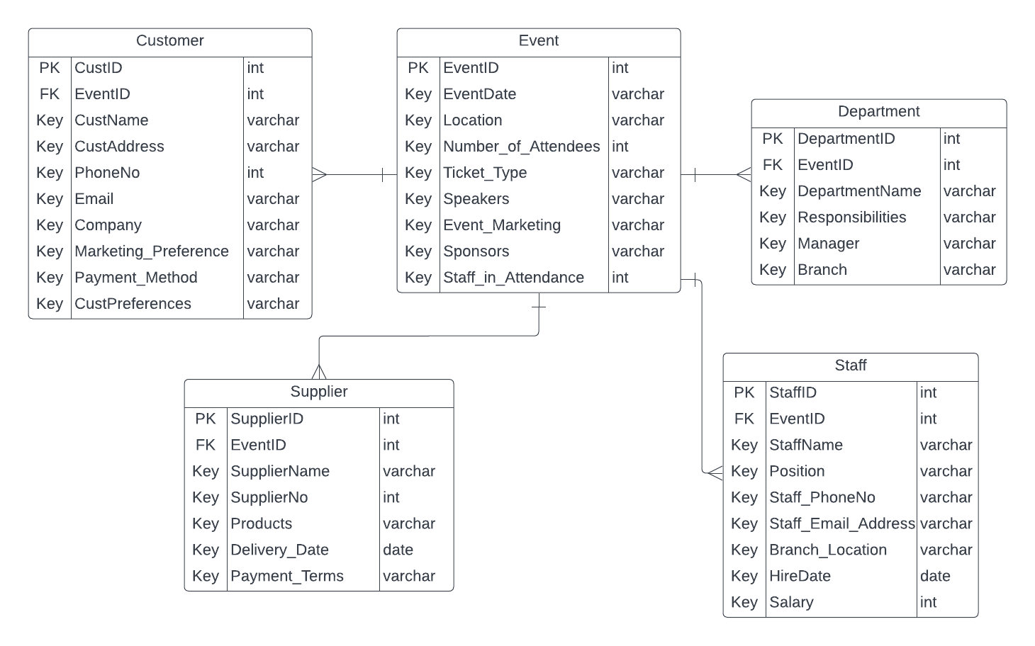

Appendix 5- Database Diagram

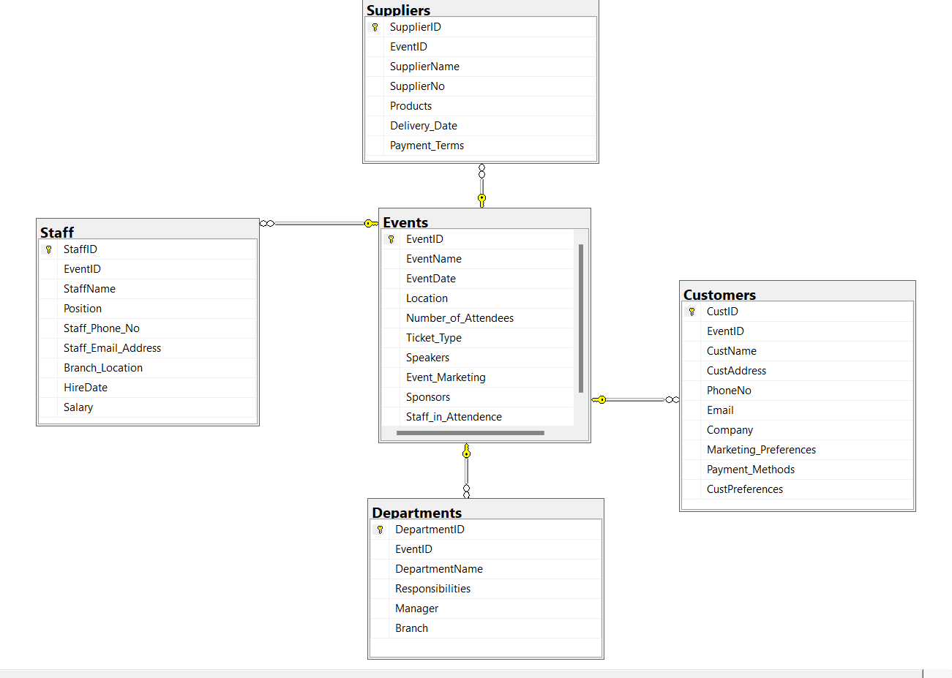

Appendix 6- SQL Script

USE [master]
GO
/****** Object: Database [NorthernLightsLtd] Script Date: 14/05/2023 19:02:56 ******/
CREATE DATABASE [NorthernLightsLtd]
CONTAINMENT = NONE
ON PRIMARY
( NAME = N'NorthernLightsLtd', FILENAME = N'C:\Program Files\Microsoft SQL Server\MSSQL16.STEPHSSQLSERVER\MSSQL\DATA\NorthernLightsLtd.mdf' , SIZE = 8192KB , MAXSIZE = UNLIMITED, FILEGROWTH = 65536KB )
LOG ON
( NAME = N'NorthernLightsLtd_log', FILENAME = N'C:\Program Files\Microsoft SQL Server\MSSQL16.STEPHSSQLSERVER\MSSQL\DATA\NorthernLightsLtd_log.ldf' , SIZE = 8192KB , MAXSIZE = 2048GB , FILEGROWTH = 65536KB )
WITH CATALOG_COLLATION = DATABASE_DEFAULT, LEDGER = OFF
GO
ALTER DATABASE [NorthernLightsLtd] SET COMPATIBILITY_LEVEL = 160
GO
IF (1 = FULLTEXTSERVICEPROPERTY('IsFullTextInstalled'))
begin
EXEC [NorthernLightsLtd].[dbo].[sp_fulltext_database] @action = 'enable'
end
GO
ALTER DATABASE [NorthernLightsLtd] SET ANSI_NULL_DEFAULT OFF
GO
ALTER DATABASE [NorthernLightsLtd] SET ANSI_NULLS OFF
GO
ALTER DATABASE [NorthernLightsLtd] SET ANSI_PADDING OFF
GO
ALTER DATABASE [NorthernLightsLtd] SET ANSI_WARNINGS OFF
GO
ALTER DATABASE [NorthernLightsLtd] SET ARITHABORT OFF
GO
ALTER DATABASE [NorthernLightsLtd] SET AUTO_CLOSE OFF
GO
ALTER DATABASE [NorthernLightsLtd] SET AUTO_SHRINK OFF
GO
ALTER DATABASE [NorthernLightsLtd] SET AUTO_UPDATE_STATISTICS ON
GO
ALTER DATABASE [NorthernLightsLtd] SET CURSOR_CLOSE_ON_COMMIT OFF
GO
ALTER DATABASE [NorthernLightsLtd] SET CURSOR_DEFAULT GLOBAL
GO
ALTER DATABASE [NorthernLightsLtd] SET CONCAT_NULL_YIELDS_NULL OFF
GO
ALTER DATABASE [NorthernLightsLtd] SET NUMERIC_ROUNDABORT OFF
GO
ALTER DATABASE [NorthernLightsLtd] SET QUOTED_IDENTIFIER OFF
GO
ALTER DATABASE [NorthernLightsLtd] SET RECURSIVE_TRIGGERS OFF
GO
ALTER DATABASE [NorthernLightsLtd] SET DISABLE_BROKER
GO
ALTER DATABASE [NorthernLightsLtd] SET AUTO_UPDATE_STATISTICS_ASYNC OFF
GO
ALTER DATABASE [NorthernLightsLtd] SET DATE_CORRELATION_OPTIMIZATION OFF
GO
ALTER DATABASE [NorthernLightsLtd] SET TRUSTWORTHY OFF
GO
ALTER DATABASE [NorthernLightsLtd] SET ALLOW_SNAPSHOT_ISOLATION OFF
GO
ALTER DATABASE [NorthernLightsLtd] SET PARAMETERIZATION SIMPLE
GO
ALTER DATABASE [NorthernLightsLtd] SET READ_COMMITTED_SNAPSHOT OFF
GO
ALTER DATABASE [NorthernLightsLtd] SET HONOR_BROKER_PRIORITY OFF
GO
ALTER DATABASE [NorthernLightsLtd] SET RECOVERY FULL
GO
ALTER DATABASE [NorthernLightsLtd] SET MULTI_USER
GO
ALTER DATABASE [NorthernLightsLtd] SET PAGE_VERIFY CHECKSUM
GO
ALTER DATABASE [NorthernLightsLtd] SET DB_CHAINING OFF
GO
ALTER DATABASE [NorthernLightsLtd] SET FILESTREAM( NON_TRANSACTED_ACCESS = OFF )
GO
ALTER DATABASE [NorthernLightsLtd] SET TARGET_RECOVERY_TIME = 60 SECONDS
GO
ALTER DATABASE [NorthernLightsLtd] SET DELAYED_DURABILITY = DISABLED
GO
ALTER DATABASE [NorthernLightsLtd] SET ACCELERATED_DATABASE_RECOVERY = OFF
GO
EXEC sys.sp_db_vardecimal_storage_format N'NorthernLightsLtd', N'ON'
GO
ALTER DATABASE [NorthernLightsLtd] SET QUERY_STORE = ON
GO
ALTER DATABASE [NorthernLightsLtd] SET QUERY_STORE (OPERATION_MODE = READ_WRITE, CLEANUP_POLICY = (STALE_QUERY_THRESHOLD_DAYS = 30), DATA_FLUSH_INTERVAL_SECONDS = 900, INTERVAL_LENGTH_MINUTES = 60, MAX_STORAGE_SIZE_MB = 1000, QUERY_CAPTURE_MODE = AUTO, SIZE_BASED_CLEANUP_MODE = AUTO, MAX_PLANS_PER_QUERY = 200, WAIT_STATS_CAPTURE_MODE = ON)
GO
USE [NorthernLightsLtd]
GO
/****** Object: Table [dbo].[Customers] Script Date: 14/05/2023 19:02:57 ******/
SET ANSI_NULLS ON
GO
SET QUOTED_IDENTIFIER ON
GO
CREATE TABLE [dbo].[Customers](
[CustID] [int] NOT NULL,
[EventID] [int] NOT NULL,
[CustName] [varchar](50) NOT NULL,
[CustAddress] [varchar](50) NOT NULL,
[PhoneNo] [varchar](50) NOT NULL,
[Email] [varchar](50) NOT NULL,
[Company] [varchar](50) NOT NULL,
[Marketing_Preferences] [varchar](50) NOT NULL,
[Payment_Methods] [varchar](50) NOT NULL,
[CustPreferences] [varchar](50) NOT NULL,
CONSTRAINT [PK_Customers] PRIMARY KEY CLUSTERED
(
[CustID] ASC
)WITH (PAD_INDEX = OFF, STATISTICS_NORECOMPUTE = OFF, IGNORE_DUP_KEY = OFF, ALLOW_ROW_LOCKS = ON, ALLOW_PAGE_LOCKS = ON, OPTIMIZE_FOR_SEQUENTIAL_KEY = OFF) ON [PRIMARY]
) ON [PRIMARY]
GO
/****** Object: Table [dbo].[Departments] Script Date: 14/05/2023 19:02:57 ******/
SET ANSI_NULLS ON
GO
SET QUOTED_IDENTIFIER ON
GO
CREATE TABLE [dbo].[Departments](
[DepartmentID] [int] NOT NULL,
[EventID] [int] NOT NULL,
[DepartmentName] [varchar](50) NOT NULL,
[Responsibilities] [varchar](50) NOT NULL,
[Manager] [varchar](50) NOT NULL,
[Branch] [varchar](50) NOT NULL,
CONSTRAINT [PK_Departments] PRIMARY KEY CLUSTERED
(
[DepartmentID] ASC
)WITH (PAD_INDEX = OFF, STATISTICS_NORECOMPUTE = OFF, IGNORE_DUP_KEY = OFF, ALLOW_ROW_LOCKS = ON, ALLOW_PAGE_LOCKS = ON, OPTIMIZE_FOR_SEQUENTIAL_KEY = OFF) ON [PRIMARY]
) ON [PRIMARY]
GO
/****** Object: Table [dbo].[Events] Script Date: 14/05/2023 19:02:57 ******/
SET ANSI_NULLS ON
GO
SET QUOTED_IDENTIFIER ON
GO
CREATE TABLE [dbo].[Events](
[EventID] [int] NOT NULL,
[EventName] [varchar](50) NOT NULL,
[EventDate] [date] NOT NULL,
[Location] [varchar](50) NOT NULL,
[Number_of_Attendees] [bigint] NOT NULL,
[Ticket_Type] [varchar](50) NOT NULL,
[Speakers] [varchar](50) NOT NULL,
[Event_Marketing] [varchar](50) NOT NULL,
[Sponsors] [varchar](50) NOT NULL,
[Staff_in_Attendence] [bigint] NOT NULL,
CONSTRAINT [PK_Events] PRIMARY KEY CLUSTERED
(
[EventID] ASC
)WITH (PAD_INDEX = OFF, STATISTICS_NORECOMPUTE = OFF, IGNORE_DUP_KEY = OFF, ALLOW_ROW_LOCKS = ON, ALLOW_PAGE_LOCKS = ON, OPTIMIZE_FOR_SEQUENTIAL_KEY = OFF) ON [PRIMARY]
) ON [PRIMARY]
GO
/****** Object: Table [dbo].[Staff] Script Date: 14/05/2023 19:02:57 ******/
SET ANSI_NULLS ON
GO
SET QUOTED_IDENTIFIER ON
GO
CREATE TABLE [dbo].[Staff](
[StaffID] [int] NOT NULL,
[EventID] [int] NOT NULL,
[StaffName] [varchar](50) NOT NULL,
[Position] [varchar](50) NOT NULL,
[Staff_Phone_No] [varchar](50) NOT NULL,
[Staff_Email_Address] [varchar](50) NOT NULL,
[Branch_Location] [varchar](50) NOT NULL,
[HireDate] [date] NOT NULL,
[Salary] [int] NOT NULL,
CONSTRAINT [PK_Staff] PRIMARY KEY CLUSTERED
(
[StaffID] ASC
)WITH (PAD_INDEX = OFF, STATISTICS_NORECOMPUTE = OFF, IGNORE_DUP_KEY = OFF, ALLOW_ROW_LOCKS = ON, ALLOW_PAGE_LOCKS = ON, OPTIMIZE_FOR_SEQUENTIAL_KEY = OFF) ON [PRIMARY]
) ON [PRIMARY]
GO
/****** Object: Table [dbo].[Suppliers] Script Date: 14/05/2023 19:02:57 ******/
SET ANSI_NULLS ON
GO
SET QUOTED_IDENTIFIER ON
GO
CREATE TABLE [dbo].[Suppliers](
[SupplierID] [int] NOT NULL,
[EventID] [int] NOT NULL,
[SupplierName] [varchar](50) NOT NULL,
[SupplierNo] [varchar](50) NOT NULL,
[Products] [varchar](50) NOT NULL,
[Delivery_Date] [date] NOT NULL,
[Payment_Terms] [varchar](50) NOT NULL,
CONSTRAINT [PK_Suppliers] PRIMARY KEY CLUSTERED
(
[SupplierID] ASC
)WITH (PAD_INDEX = OFF, STATISTICS_NORECOMPUTE = OFF, IGNORE_DUP_KEY = OFF, ALLOW_ROW_LOCKS = ON, ALLOW_PAGE_LOCKS = ON, OPTIMIZE_FOR_SEQUENTIAL_KEY = OFF) ON [PRIMARY]
) ON [PRIMARY]
GO
ALTER TABLE [dbo].[Customers] WITH CHECK ADD CONSTRAINT [FK_Customers] FOREIGN KEY([EventID])
REFERENCES [dbo].[Events] ([EventID])
GO
ALTER TABLE [dbo].[Customers] CHECK CONSTRAINT [FK_Customers]
GO
ALTER TABLE [dbo].[Departments] WITH CHECK ADD CONSTRAINT [Fk_Departments] FOREIGN KEY([EventID])
REFERENCES [dbo].[Events] ([EventID])
GO
ALTER TABLE [dbo].[Departments] CHECK CONSTRAINT [Fk_Departments]
GO
ALTER TABLE [dbo].[Staff] WITH CHECK ADD CONSTRAINT [FK_Staff] FOREIGN KEY([EventID])
REFERENCES [dbo].[Events] ([EventID])
GO
ALTER TABLE [dbo].[Staff] CHECK CONSTRAINT [FK_Staff]
GO
ALTER TABLE [dbo].[Suppliers] WITH CHECK ADD CONSTRAINT [FK_Suppliers] FOREIGN KEY([EventID])
REFERENCES [dbo].[Events] ([EventID])
GO
ALTER TABLE [dbo].[Suppliers] CHECK CONSTRAINT [FK_Suppliers]
GO
USE [master]
GO
ALTER DATABASE [NorthernLightsLtd] SET READ_WRITE
GO

