Introduction
Sustainability is now a major discourse in the business places and at homes across the developed world. The public and the firms conceptualizing ways to protect and manage the environment and, and organisations are also thinking about operational effectiveness in resource and energy consumption (Chabowski, 2011). Therefore, Company’s activities must be seen to be sustainable.
This paper asked business if their business is sustainable and how they are attending to sustainability. Qualitative research method will be used, the interviews that is recorded and collected will provide rich and practical facts and examples on how these companies view sustainability. (Silverman, 2006, p. 204) Proposed that the taped interview can be replayed, and the transcribed materials can be reviewed and can still be re interpreted. The respondents will be asked about their history or behavioral pattern (Silverman, 2006, p. 34). A Semi-Structured interview style will be used (Silverman, 2006, p. 110). The Voices of the participants are grouped, analyzed and finally concepts and themes are identified.
However, for the individual person, quantitate research method will be used. This will allow the measurement of behavior in the key strategic areas. The survey seeks to test the way the public reacts to questions posted to them (Silverman, 2006, p. 35). The respondents are expected to know about the questions be asked as they the questions they can relate to. Such as how they view the environment, the consumption of energy, or will they change their lifestyle for the sake of the environment. Quantitative research method will allow the study to compare data with similar data of a different times (Silverman, 2006, p. 36)

Qualitative Research
During the interviewing process, the interviewees were asked similar questions that were constructed in advance but there were follow on questions. In qualitative research, however, the process is a lot messier, and it's common for the theory, design, collection and analysis phases to overlap. (Silverman, 2006). About 30 minutes of interview was transcribed, with 2 participants. The University ethics guideline was adhered to. The study followed the analytical pattern prescribed by (Charmaz, 2006). Six themes were identified, they are Keeping cost down, Staff rationalization, Reliability on the franchisor on innovation and direction, Government policy, Internet services/ study/ finance and Trust, motivation and relationship.
Keeping cost down, Staff rationalization
For companies to remain competitive, they must continually be looking inward to reduce cost in as much as they are looking at their direct material cost. Michael Porter suggested that:

‘Competitive advantage is a function of either providing comparable buyer value more efficiently than competitors (low cost), or performing activities at comparable cost but in unique ways that create more buyer value than competitors and, hence, command a premium price (differentiation)’ (The Economist, 2008)
Companies can only succeed either being cheaper or by being different and the customers must view the company as being more relevant than the competition (The Economist, 2008). Therefore, companies must constantly review cost or act to keep up or overtake the competition. One interviewee suggested,

‘Yes, it is sustainable because of our online presence we make sure we have enough people here to cope when it is busy not too many people obviously, we lose out when is not busy’
‘we did go through an actual phase of looking through how much we could reduce because we thought the paper copies of the certificates and now we scanned them and save them this helps us to keep the cost down’

‘we have cut down a lot so it has affected staff that we don’t need '

The ideas in “Competitive Advantage” persuaded managers to undertake more internal reflection. (The Economist, 2008). These companies seek to keep idle time and cost to the minimum to be financially sustainable.

Research, development, innovation and direction
Environmental social responsibility is shaping technology, and in turn encourages product innovations. (Reast, 2013) and as products improves the knowledge is passed on to suppliers and consumer.
‘I think for us we are learning more from the manufacturers the warranties are becoming longer because the cars are becoming more reliable’
‘This is lovely…... really, 'P' as a brand is changing, we take orders from the franchisor’
‘that’s on the advice of The Corporate and the branch the, franchise if run enough well could be run by one person because everything is done online now and we do have the online electronic support’

Government policy
Government policies shapes the industrial and economic direction of a nation. The UK currently have ambitious decarbonisation targets by any country in the world: by 2050, the greenhouse gas emissions of the UK must be reduced by 80% (Committee on Climate Change, 2008). However, to meet the target, the energy mix of the country must be managed. (Lorenzoni, 2006)
‘They can help and they cannot help as well for example because of the emissions at the moment. ……from March this year end of March the road tax is gonna go up so you got a …..so the government helps years ago to get people in but now they are stopping people from getting in the door’
‘years ago, government put incentive for if you have an old scrap cars they give you resell value minimum government’
Presently, the government is offering a Plug-in Car Grant to reduce the initial cost of purchasing a new ultra-low emission vehicle. (Transport for London, 2017).
Road transport is the major source of air pollution in cities and towns, consequently, government have power to reduce pollution by using their traffic control powers. The government use traffic Regulation Orders (TROs) to reduce traffic congestion and improve air quality. (UK Environmental Law Association, 2017), and in so doing the government influences the cars the public buys.

Internet services/ study/ finance
The internet and related technology have had a massive impact on businesses in general. The financial services have been the significant IT user for some time, money can be transferred by the touch of a button. Companies can engage in E-commerce easily. (Chen, 2005) One responded said,

‘and that is a massive change compared to the amount of pieces of paper you would have to signed before, now everything is online and at the press of a button. is not just the car that is changing to help the environment but the technology side of things ‘

‘and for the environment and not only that the electronic side I think.... so finance deals and things years ago if you coming to get finance you have to sign endless list is of papers in order to get finance and now it's just a scan of your driving licence ‘

(Chen, 2005) mentioned the role the internet learning will play in education, Chen suggested that internet courses cannot fully replace face-to-face courses in the educational sector, but online study will be an important part of the overall curriculum. On line studying is becoming more prevalent.

‘we no longer issuing paper documents anymore, everything is e-reader’

‘everything can be accessed online from different locations and there is considerably less need for large training offices’
‘so, we are trying to keep up with the new trend of doing training or online training’

Customer service and Staff relationship.
customer service is a means for a company to gain a competitive advantage over its competitors. (Drucker, 1999) declared that the purpose of business is ‘to create a customer.' He said that an organization's ability to remain in business is a function of its competitiveness and its ability to win customers from the competition. Therefore, business need to do whatever it can to attract and retain customers in an ethical way, and they need experienced or well trained staff to accomplish this objective. The interviewee commented,
‘so, what we look for when we went find people is people who have been in this trade before and they have got experience’
Moreover, improve staff morale will lead to increase employee satisfaction and retention and consequently it will increase productivity. Happy staff can create a reputation for being a caring, customer-oriented company (Cook, 2008.)
‘if you got staff that have got positive attitude and their relationship with the customer when they come is good as well and obviously and your relationship with the customer is better because they know they can meet the boss, they know the business hopefully the same staff will be here for a long time’
(Heskett, 2008) believes loyal customer will drive profitability and growth.
‘you’ve got that relationship and you hope that you have customer that that kids will come to buy from you grandparent the whole family buying from you’.
‘if a customer turns up at 5:30 on Friday evening and in the trouble, you do whatever you can to try and help them out...because they won't buy from you again with a is all about’

‘everyone has good make money somehow is all about doing it in the right way people will buy from you just’

Quantitative Research
Sometimes you are dealing with a complex subject or topic. The questions being asked are have multiple parts and the respondents are expected to know about the issues. With quantitative research, the researcher will normally decide on the method of analysis, including statistical technique, before even data collection starts. (Silverman, 2006). Out of the questionnaires sent out, 11 responded, 5males and 6 females.
Most of the respondents drove to work, but the survey failed to ask which type of cars they drove. More than 35,000 plug-in cars were registered by the end of the 2016. and that was about 1.3 per cent of the total new car market in the UK. That figure for the first three months of 2017 sits at 1.5 per cent (Nextgreencar, 2017).

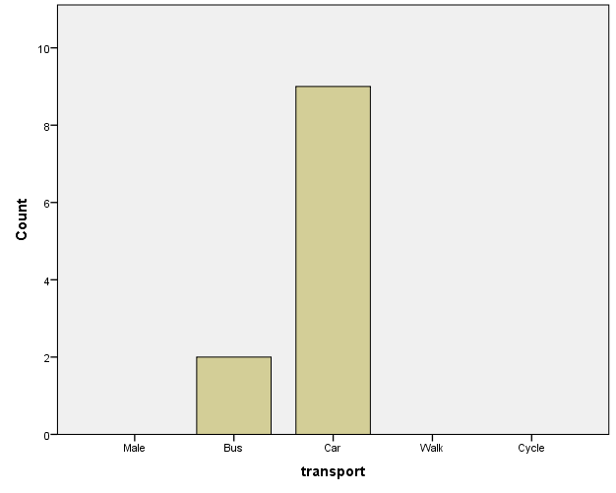

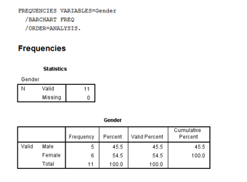
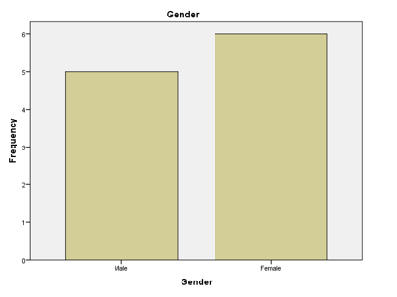

But when the respondents were asked whether the energy suppliers were innovative, 54.5% viewed the energy suppliers as innovative and just under 10% believe the energy providers are not innovative. A total of 90.9% believes the energy companies are either innovative or mostly innovative. The questionnaire could have asked the respondent about the types of innovation they have noticed.
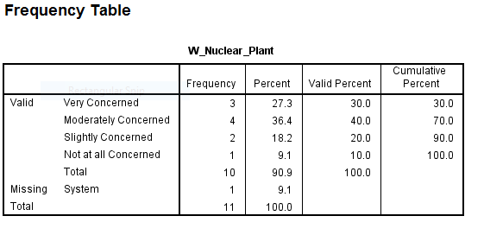
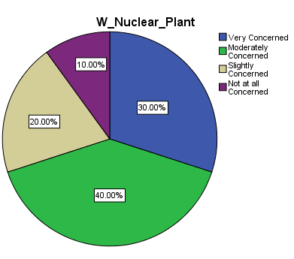

As more emphasis is drawn to sustainably especially the environmental impact of energy consumption and fossil fuel (Pidgeon, 2008). Nuclear plant is low-carbon energy and the nuclear reactors have a significant fuel cost advantage over coal and gas fired plants (Lei, 2017), but the earthquake induced nuclear accident at the Fukushima Daiichi of March 11, 2011 at Nuclear Power Station in Tokyo that discharged a large quantity of radioactive substances into the environment is affecting public support for Nuclear plants. The results of surveys conducted in both Britain and Japan suggested that the Japanese public showed lower acceptance of nuclear power after the accident, while the British public still support. (Corner, 2011) (Poortinga, 2013)

Furthermore, the environmental concern is having a positive impact on support for renewable energy and a negative impact on support for nuclear energy (Lei, 2017, p. 101). This public perception is reflected in the survey as renewable energy sources, wind (45.4%) and solar (36.36%) are seen to be the future dominant energy sources.
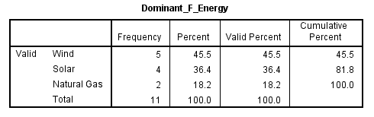
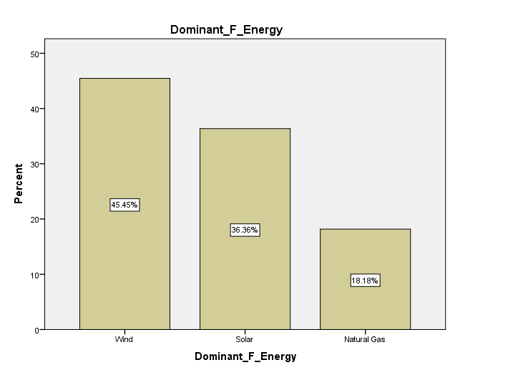
In a similar research by the Department of Energy and Climate Change ( Department of Energy and Climate Change , 2012) discovered that 79% of their respondent supported and 5% opposed the use of renewable energy.
Yet again, when respondents were asked about how moderate they were in domestic energy consumption, more than 63% sees themselves as being moderate and 36.36% said they were very moderate.
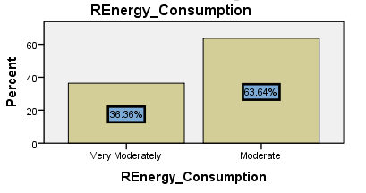
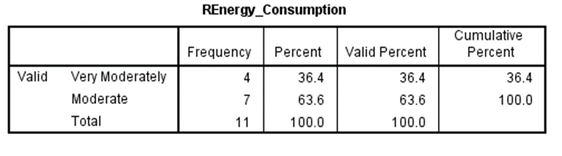
The public’s concern about sufficiency of supplies of fuels to meet the UK's demand may also be influencing the public’s willingness to change. ( Department of Energy and Climate Change , 2012). From the graph beneath, 72.73% of respondents were moderately willing to change because of the environment. According to the survey more than 90% of the people are willing to change their lifestyle because for the environment. There are different factors that affects the attitudes towards energy consume and these can be a combination of what are my friends and neighbors doing, and available information about how much energy is consumed and costs. (Muûls, 2017).
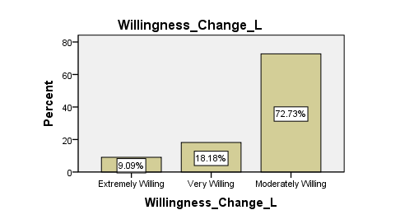
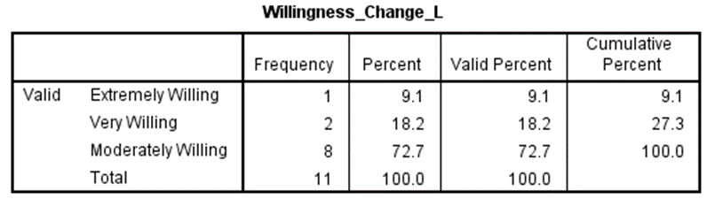
40% of UK energy consumption and 20% of greenhouse gas emissions are from heating and hot water (Committee on Climate Change, 2016). The graph below, shows more than 90% of respondents view the energy suppliers as innovative. It is interesting to note that few of the respondent mentioned Tidal power. Tidal power is in the UK’s energy mix and the Swansea Bay tidal lagoon is set to go ahead (Wade, 2017).

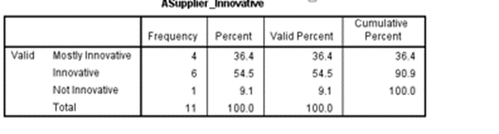
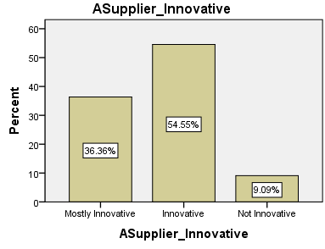

Natural gas and electricity are the preffered sources of heating of respondents which is eveident in the graph below. This result is similar to the survey by ( Department of Energy and Climate Change , 2012) report that says the majority of their respondents put electricity (90%) and gas (84%) as either their first or second source, unfortunately, this paper did not give the public the dual option.

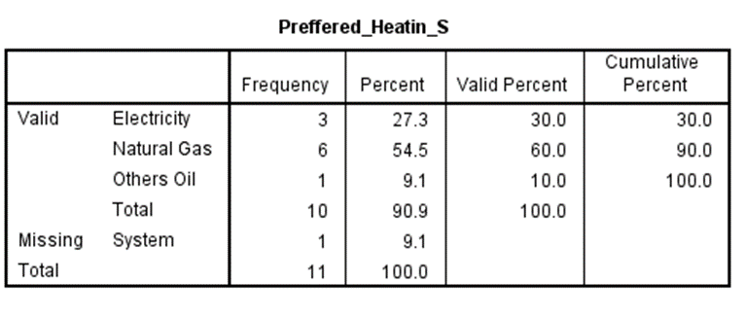
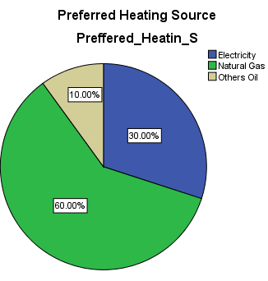

Furthermore, respondents are worried about air pollution. From the graph shown underneath, 60% of respondents were concered, 18.2% are very concerned, and 18.2% are not concerend. (UK Environmental Law Association, 2017) defines air pollution as ‘dirty air which damages human health, plant and animal life or property’.
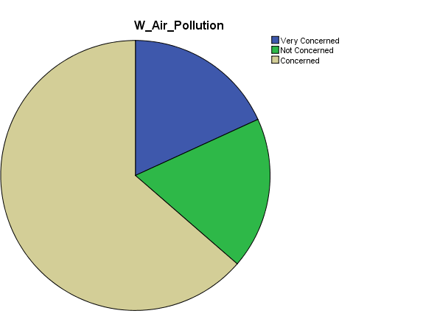
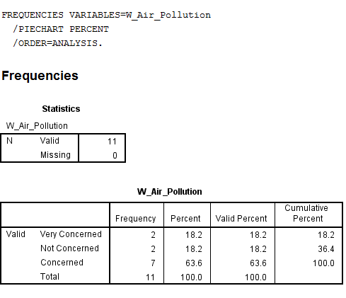

Discussion
As businesses looking inward and outwards to have a competitive edge either by reducing cost or improving operational activity. Similarly, the public also constantly evaluate their products and cost. The government plays a big role in the direction of the economy or the emerging industries and they influence the business and the public through policies and incentives. The government is ‘promoting renewable energy sources such as solar and wind’ (Corner, 2011, p. 4829) and government influences the auto companies to focus more on producing environmentally friendly cars by their policy. Diesel cars made by 2005 are being phased out (Transport for London, 2017). Especially in the cities people are considering environmentally friendly cars and dealers and merchants are responding to the needs and sustainable demands of the customers.
Furthermore, majorities of the UK population have positive attitudes towards the ideas of generating electricity using solar energy, off-shore wind energy, and ocean energy. Likewise, it suggests that smaller majorities hold positive attitudes towards the use of on-shore wind energy and bioenergy ( Department of Energy and Climate Change , 2012).

Again, as business seeks ways to attracts and retain customers, the public also look for companies that will meet their need at a fair price, ethical and treats the environment and the staff right. Staff that are well treated have improve morale (Cook, 2008.). (Heskett, 2008) Established a ‘link between profit and value and how employees are treated in the organization and it further affects the employee and customer retention’. Again, Information Technology(IT) is playing a big role in business environment, private lives. The advent of IT has created new industries, it has also made the market more accessible to customers, suppliers, manufactures. A business can supply across the world, a consumer can shop from anywhere in the world (Chen, 2005). Consumers can shop and compare prices, information is available about any company online. Transactions are now conducted quickly; less paper is being consumed. A car loan or finance loan can now be granted within minutes of application. More and more people are buying and studying on line as well.
As companies adapt to the new business environment, the public changes and adapt as well. The concern about the environment can no longer be ignored, and this is clearly affecting the types of environmentally products that are being produced and demanded, the public is looking for fuel efficient cars, products that are grown and brought from ethical sources. The people are prepared to change their lifestyles because of the environment, firms are now integrating issues that relates to the environment in their business strategies to enhance the brand image, renew product, and increase productivity (Chen Y. S., 2008) . Consumers demand companies to change the way they do business and likewise the companies must adapt and respond (Heskett, 2008).

References
Department of Energy and Climate Change . (2012). ENERGY AND CLIMATE CHANGE PUBLIC ATTITUDE TRACKER Wave 19 . London : The National Archives.
Chabowski, B. R.-P. (2011). The structure of sustainability research in marketing, 1958–2008. Journal of the Academy of Marketing Science, 55–70.
Charmaz, K. (2006). Constructing grounded theory: A practical guide through qualitative analysis. London: Sage.
Chen, S. (2005). Strategic management of e-business. New York: Chichester: Wiley.
Chen, Y. S. (2008). The driver of green innovation and green. Journal of Business Ethics, 531–543.
Committee on Climate Change. (2008). Tackling climate change. Retrieved from Committee on Climate Change: https://www.theccc.org.uk/tackling-climate-change/
Committee on Climate Change. (2016, October 13). Retrieved from theccc.org.uk: https://www.theccc.org.uk/publication/next-steps-for-uk-heat-policy/
Cook, S. (2008.). Customer Care Excellence :How to Create an Effective Customer Focus. London: Kogan Page Ltd.
Corner, A. V. (2011). Nuclear power, climate change and energy security: Exploring British public attitudes. Energy Policy, 4826.
Drucker, P. (1999). The practice of management. London: Oxford: Butterworth-Heinemann.
Heskett, J. L. (2008). Putting the Service-Profit Chain to Work. Havard Business Review.
Lei, Z. T. (2017). Deregulation and Investment in Generation Capacity: Evidence from Nuclear Power Upgrades in the United States. The Energy Journal, 114.
Lorenzoni, I. P. (2006). Dangerous Climate Change: The Role for Risk Research. Risk Analysis, 1394.
Muûls, M. (2017, February 28). Can an app be win-win for energy companies, customers and the climate? London: Imperial College Business School.
Nextgreencar. (2017, April). Electric car market statistics. Retrieved from Nextgreencar.com: http://www.nextgreencar.com/electric-cars/statistics/
Pidgeon, N. L. (2008). Climate change or nuclearpower—no thanks! a quantitative study of public perceptions and risk framingin Britain. Global Environmental Change. Global Environmental Change.
Poortinga, W. A. (2013). Public perceptions of climate change and energy futures before and after the Fukushima accident: A comparison between Britain and Japan. Energy Policy, 7.
Reast, J. M. (2013). Legitimacy-seeking organizational strategies in controversial industries: A case study analysis and a bidimensional model. Journal of Business Ethics, 43–73.
Silverman, D. (2006). Interpreting qualitative data. London: Sage.
The Economist. (2008, August 8). Competitive advantage. Retrieved from The Economist: http://www.economist.com/node/11869910
Transport for London. (2017, April). Ultra Low Emission Zone. Retrieved from Transport for London: https://tfl.gov.uk/modes/driving/ultra-low-emission-zone
UK Environmental Law Association. (2017, April 19). Air Pollution. Retrieved from UK Environmental Law Association: http://www.environmentlaw.org.uk/rte.asp?id=2
UK Environmental Law Association. (2017, April 19). Road Traffic. Retrieved from http://www.environmentlaw.org.uk: http://www.environmentlaw.org.uk/rte.asp?id=38
Wade, A. (2017). Tidal power is firmly in the energy mix. The Engineer, 6.

