
Programme: BSc (Hons) Health and Social Care
Module Name: Introduction to independent Research Skills

Module Code: BMHP5019
Lecture Name: Itse Olaoye
Assignment Title: Component 1 Written Assignment {Research proposal}
Student Name: Maria Elisa Jose Dos Santos
Student ID: 2327313

Topic of this research Breast Cancer in the uk adult women

What is the impact of breast cancer in the uk adult women
Even though 98% of women who receive a stage 1 diagnosis go on to live for five years or longer, we cannot afford to take breast cancer lightly because it is the most prevalent cancer worldwide and its incidence is on the rise. Over 11,000 people die from breast cancer every year in the UK alone, and there are about
55,000 new cases. About 26% of women, or a quarter, survive for five years or longer after receiving a stage 4 diagnosis, which indicates that the cancer has spread to another part of the body and is now incurable. However, there are now doable actions that can be taken to assist those who are most impacted. There has been a huge impact of breast cancer in women who are ages 30-45, is the most common type of cancer in the women in Uk. (NHS, 2024).
By detecting breast cancer that is too small to feel or see a breast screening mammogram may increase the likelihood that treatment will be successful. Secondary breast cancer is the term for when breast cancer spreads to another area of body. (BBC 2025)

Objective
- To identify digital interventions used in breast cancer in the UK.
- Identify patient outcomes, experiences and quality of care
- To make research and practice.

RATIONALE
Population is taken into account. As a result, we have calculated that the lifetime risk of getting the disease is 1 in 8. Although more and more women are surviving, the number of cases of breast cancer, the most common cancer in the UK, has been rising for a number of years.
As we age, we are at risk for most types of cancer. The 1 in 8 risk is a lifetime risk, though, and risk varies over the course of a lifetime. Around menopause, the risk of breast cancer rises significantly. Cancer (ResearchUK.ORG 2011).

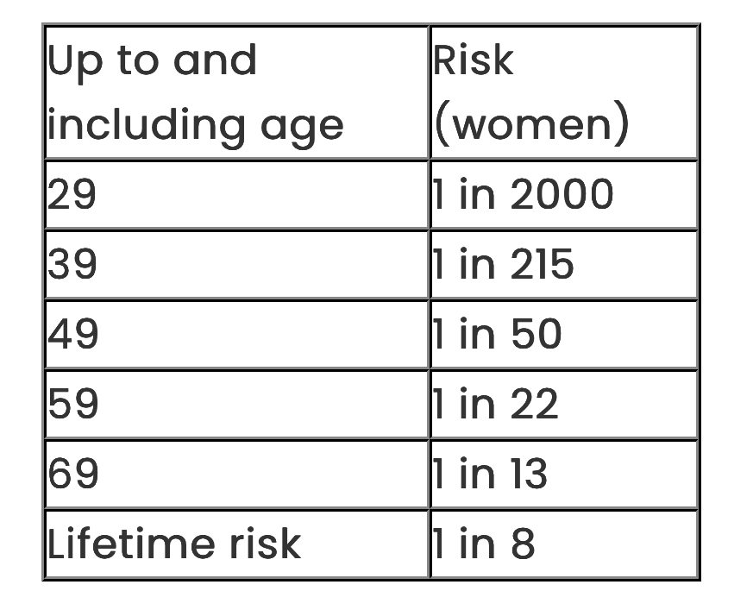
.

The report also reveals the true human cost of breast cancer, which is estimated to be a startling £17.5 billion in 2024 in wellbeing costs.
This underscores the urgent need for action.

Methodology

Scooping review, longitudinal cohort studies, laboratory. and imaging-based techniques, and Al-powered diagnostic trials.

Ethical Considerations
This report is secondary research based in published literature. The according with the university Harvard citation needs to be applied, avoid plagiarism.

Reference
Whin, W., Shin, J., Kim, J., (2025)
Prognostic value of FDG PET/CT in de novo stage IV breast cancer patients treated with cyclin-dependent kinase 4/6 inhibitors | Breast Cancer Research | Full Text
Available at:http://er-research.biomedcentral.com
(Accessed: 21st October 2025)

Gudge, E., (2025) Survivors' cancer risk lower than thought stud Available at: http://bbc.co.uk (Accessed: 21st October 2025)

Barclay, N, L., Burn, E., OPTIMA
Consortium, Newby, D., et al. Atl.Scientific (2024) Trends in incidence, prevalence, and survival of breast cancer in the United Kingdom Available at: http://nature.com (Accessed; 23rd October 2025)

Scawcroft,H., (2011) Why are breast cancer rates increasing
Available at: http://news.cancerresearchuk.org (Accessed 21st October 2025)

Breast Cancer Now (2024) Breast cancer will cost UK economy £2.6bn in 2024, rising to £3.6bn by 2034, if nothing changes in next decade, Demos research shows
Available at:
http://breastcancernow.org (Accessed: 21st October 2025).

NHS (2024) What is breast cancer in women Available at: http://www.nhs.uk (Accessed:22nd October 2025)

